UNITED STATES
SECURITIES AND EXCHANGE COMMISSION
Washington, D.C. 20549
________________________________________________________________________________
Form 10-Q
________________________________________________________________________________
☒ |  |  | QUARTERLY REPORT PURSUANT TO SECTION 13 OR 15(d) OF THE SECURITIES EXCHANGE ACT OF 1934
FOR THE QUARTERLY PERIOD ENDED MARCH 31, 2025
☐ |  |  | TRANSITION REPORT PURSUANT TO SECTION 13 OR 15(d) OF THE SECURITIES EXCHANGE ACT OF 1934
FOR THE TRANSITION PERIOD FROM TO
Commission file number: 001-35647
________________________________________________________________________________

LIFEVANTAGE CORPORATION
(Exact name of Registrant as specified in its charter)
________________________________________________________________________________
Delaware |  |  |  |  |  | 90-0224471
(State or other jurisdiction of incorporation or organization) |  |  |  |  |  | (IRS Employer Identification No.)
3300 Triumph Blvd, Suite 700, Lehi, UT 84043
(Address of principal executive offices, including zip code)
(801) 432-9000
(Registrant’s telephone number, including area code)

Securities registered pursuant to Section 12(b) of the Act:
Common Stock, par value $0.0001 |  |  |  |  |  | LFVN |  |  |  |  |  | The Nasdaq Stock Market LLC
Title of each class |  |  |  |  |  | Trading Symbol(s) |  |  |  |  |  | Name of each exchange on which registered
________________________________________________________________________________
Indicate by check mark whether the registrant (1) has filed all reports required to be filed by Section 13 or 15(d) of the Securities Exchange Act of 1934 during the preceding 12 months (or for such shorter period that the registrant was required to file such reports), and (2) has been subject to such filing requirements for the past 90 days. Yes ☒ No ☐
Indicate by check mark whether the registrant has submitted electronically every Interactive Data File required to be submitted pursuant to Rule 405 of Regulation S-T (§232.405 of this chapter) during the preceding 12 months (or for such shorter period that the registrant was required to submit such files). Yes ☒ No ☐
Indicate by check mark whether the registrant is a large accelerated filer, an accelerated filer, a non-accelerated filer, a smaller reporting company, or an emerging growth company. See the definitions of “large accelerated filer,” “accelerated filer,” “smaller reporting company” and “emerging growth company,” in Rule 12b-2 of the Exchange Act.
Large accelerated filer |  |  | ☐ |  |  | Accelerated filer |  |  | ☐
Non-accelerated filer |  |  | ☒ |  |  | Smaller reporting company |  |  | ☒
Emerging growth company |  |  | ☐
If an emerging growth company, indicate by check mark if the registrant has elected not to use the extended transition period for complying with any new or revised financial accounting standards provided pursuant to Section 13(a) of the Exchange Act. ☐
Indicate by check mark whether the registrant is a shell company (as defined in Rule 12b-2 of the Exchange Act). Yes ☐ No ☒
The number of shares outstanding of the issuer’s common stock, par value $0.0001 per share, as of May 5, 2025 was 12,588,183.

CAUTIONARY NOTE REGARDING FORWARD-LOOKING STATEMENTS
This quarterly report on Form 10-Q, in particular “Item 2. Management’s Discussion and Analysis of Financial Condition and Results of Operations,” and the information incorporated by reference herein contains “forward-looking statements” (as such term is defined in Section 27A of the Securities Act of 1933, as amended and Section 21E of the Securities Exchange Act of 1934, as amended). These statements, which involve risks and uncertainties, reflect our current expectations, intentions, or strategies regarding our possible future results of operations, performance, and achievements. Forward-looking statements include, without limitation: statements regarding future products or product development; statements regarding future selling, general and administrative costs and research and development spending; statements regarding the future performance of our network marketing efforts; statements regarding our expectations regarding ongoing litigation; statements regarding international growth; and statements regarding future financial performance, results of operations, capital expenditures and sufficiency of capital resources to fund our operating requirements. These forward-looking statements are made pursuant to the safe harbor provisions of the Private Securities Litigation Reform Act of 1995 and applicable rules of the Securities and Exchange Commission and common law.
These forward-looking statements may be identified in this report and the information incorporated by reference by words such as “anticipate,” “believe,” “could,” “estimate,” “expect,” “intend,” “plan,” “predict,” “project,” “should” and similar terms and expressions, including references to assumptions and strategies. These statements reflect our current beliefs and are based on information currently available to us. Accordingly, these statements are subject to certain risks, uncertainties, and contingencies, which could cause our actual results, performance, or achievements to differ materially from those expressed in, or implied by, such statements.
The following factors are among those that may cause actual results to differ materially from our forward-looking statements:
•Inability to properly manage, motivate and retain our independent consultants (which we previously referred to as “distributors” in our prior filings) or to attract new customers and independent consultants on an ongoing basis;
•Non-compliance by our independent consultants with applicable legal requirements or our policies and procedures;
•Changes to our independent consultant compensation plans;
•Dependence upon a few products for revenue;
•Dependence on third parties to manufacture our products;
•Sourcing and pricing of high quality materials for our products;
•Disruptions to the transportation channels used to distribute our products;
•Risk of being subject to a product recall;
•Product liability claims against us;
•Competition in the dietary supplement and personal care markets;
•Unfavorable publicity on our business or products;
•Actions by activist stockholders;
•Loss of or inability to attract key personnel;
•Risk of being held responsible for certain taxes or assessments and other obligations relating to the activity of our independent consultants;
•Risk related to Global Not For Resale program;
•Inability to comply with evolving laws, regulations, standards, policies, and contractual obligations related to data privacy and security, including cybersecurity;
•Inability to manage existing markets, open new international markets or expand our operations;
•Inability of new products and technological innovations to gain customer or independent consultant or market acceptance;
2

•Inability to execute our product launch process due to increased pressure on our supply chain, information systems and management;
•Inability to appropriately manage our inventory;
•Disruptions in our information technology (“IT”) systems, including as a result of cybersecurity incidents;
•Inability to comply with financial covenants imposed by our credit facility and the impact of debt service obligations and restrictive debt covenants;
•International trade or foreign exchange restrictions, increased tariffs, foreign currency exchange fluctuations;
•Inability to raise additional capital or complete desired acquisitions;
•Strict government regulations on our business;
•Regulations governing the production or marketing of our products;
•Risk of investigatory and enforcement action;
•Risk of our direct selling program being found non-compliant with current or newly adopted laws or regulations in various markets;
•Laws and regulations prohibiting or severely restricting direct selling;
•International regulatory and business risks, including failure to comply with anti-corruption laws;
•Inability to protect our intellectual property rights;
•Third party intellectual property infringement claims;
•Volatility of the market price of our common stock;
•Risk of substantial sales of shares negatively impacting the market price of our common stock;
•Inability of share repurchase program to enhance long-term stockholder value;
•Risk of additional shares issued diluting voting power of current outstanding common stock or causing decline in stock price;
•Potential delisting of our common stock due to non-compliance with Nasdaq’s continued listing requirements;
•Risks related to being a smaller reporting company;
•Limitations for disputes, mergers, tender offers, or proxy contests under Delaware law;
•Expensive and time consuming legal proceedings;
•Ineffectiveness of internal controls over financial reporting;
•Challenges to tax positions or transfer pricing policies or change in laws;
•Economic, political, foreign exchange and other risks associated with international operations, including consumer discretionary spending habits;
•Unfavorable global economic conditions;
•Securities class action litigation; and
•Securities or industry analysts ceasing coverage or publishing inaccurate or unfavorable research.
When considering these forward-looking statements, you should keep in mind the cautionary statements in this report and the documents incorporated by reference. Except as required by law, we have no obligation and do not undertake to update or revise any such forward-looking statements to reflect events or circumstances after the date of this report.

3

LIFEVANTAGE CORPORATION
INDEX

 |  |  |  |  |  | PAGE
PART I. Financial Information |  |  |  |  |  | 5
Item 1. |  |  | Financial Statements: |  |  | 5
 |  |  | Condensed Consolidated Balance Sheets (unaudited) |  |  | 5
 |  |  | Condensed Consolidated Statements of Operations and Comprehensive Income (Loss) (unaudited) |  |  | 6
 |  |  | Condensed Consolidated Statement of Stockholders’ Equity (unaudited) |  |  | 7
 |  |  | Condensed Consolidated Statements of Cash Flows (unaudited) |  |  | 9
 |  |  | Notes to Condensed Consolidated Financial Statements (unaudited) |  |  | 10
Item 2. |  |  | Management’s Discussion and Analysis of Financial Condition and Results of Operations |  |  | 19
Item 3. |  |  | Quantitative and Qualitative Disclosures About Market Risk |  |  | 26
Item 4. |  |  | Controls and Procedures |  |  | 26
PART II. Other Information |  |  |  |  |  | 26
Item 1. |  |  | Legal Proceedings |  |  | 26
Item 1A. |  |  | Risk Factors |  |  | 26
Item 2. |  |  | Unregistered Sales of Equity Securities and Use of Proceeds |  |  | 27
Item 3. |  |  | Defaults Upon Senior Securities |  |  | 27
Item 4. |  |  | Mine Safety Disclosures |  |  | 27
Item 5. |  |  | Other Information |  |  | 27
Item 6. |  |  | Exhibits |  |  | 27
Signatures |  |  |  |  |  | 30

4

PART I. Financial Information

Item 1. Financial Statements

LIFEVANTAGE CORPORATION AND SUBSIDIARIES
CONDENSED CONSOLIDATED BALANCE SHEETS
(Unaudited)
 |  |  | March 31, 2025 |  |  |  |  |  | June 30, 2024
(In thousands, except per share data)
ASSETS
Current assets
Cash and cash equivalents |  |  | $ | 22,469 |  |  |  |  | $ | 16,886
Accounts receivable |  |  | 3,240 |  |  |  |  |  | 2,949
Income tax receivable |  |  | — |  |  |  |  |  | 313
Inventory, net |  |  | 22,221 |  |  |  |  |  | 15,055
Prepaid expenses and other |  |  | 6,184 |  |  |  |  |  | 2,443
Total current assets |  |  | 54,114 |  |  |  |  |  | 37,646
Property and equipment, net |  |  | 6,730 |  |  |  |  |  | 7,813
Right-of-use assets |  |  | 8,607 |  |  |  |  |  | 9,569
Intangible assets, net |  |  | 224 |  |  |  |  |  | 323
Deferred income tax asset |  |  | 6,888 |  |  |  |  |  | 4,268
Other long-term assets |  |  | 674 |  |  |  |  |  | 680
TOTAL ASSETS |  |  | $ | 77,237 |  |  |  |  | $ | 60,299
LIABILITIES AND STOCKHOLDERS’ EQUITY
Current liabilities
Accounts payable |  |  | $ | 7,038 |  |  |  |  | $ | 5,853
Commissions payable |  |  | 8,175 |  |  |  |  |  | 6,569
Income tax payable |  |  | 955 |  |  |  |  |  | 202
Lease liabilities |  |  | 1,933 |  |  |  |  |  | 1,811
Other accrued expenses |  |  | 14,482 |  |  |  |  |  | 7,874
Total current liabilities |  |  | 32,583 |  |  |  |  |  | 22,309
Long-term lease liabilities |  |  | 10,425 |  |  |  |  |  | 11,801
Other long-term liabilities |  |  | 218 |  |  |  |  |  | 198
Total liabilities |  |  | 43,226 |  |  |  |  |  | 34,308
Commitments and contingencies - Note 7
Stockholders’ equity
Preferred stock — par value $0.0001 per share, 5,000 shares authorized, no shares issued or outstanding |  |  | — |  |  |  |  |  | —
Common stock — par value $0.0001 per share, 40,000 shares authorized and 12,581 and 12,510 issued and outstanding as of March 31, 2025 and June 30, 2024, respectively |  |  | 1 |  |  |  |  |  | 1
Additional paid-in capital |  |  | 139,068 |  |  |  |  |  | 136,644
Accumulated deficit |  |  | (103,511) |  |  |  |  |  | (108,738)
Accumulated other comprehensive loss |  |  | (1,547) |  |  |  |  |  | (1,916)
Total stockholders’ equity |  |  | 34,011 |  |  |  |  |  | 25,991
TOTAL LIABILITIES AND STOCKHOLDERS’ EQUITY |  |  | $ | 77,237 |  |  |  |  | $ | 60,299
The accompanying notes are an integral part of these condensed consolidated financial statements.
5

LIFEVANTAGE CORPORATION AND SUBSIDIARIES
CONDENSED CONSOLIDATED STATEMENTS OF OPERATIONS AND COMPREHENSIVE INCOME
(Unaudited)
 |  |  | Three Months Ended March 31, |  |  |  |  |  |  |  |  |  |  |  | Nine Months Ended March 31,
 |  |  | 2025 |  |  |  |  |  | 2024 |  |  |  |  |  | 2025 |  |  |  |  |  | 2024
(In thousands, except per share data)
Revenue, net |  |  | $ | 58,440 |  |  |  |  | $ | 48,245 |  |  |  |  | $ | 173,416 |  |  |  |  | $ | 151,233
Cost of sales |  |  | 11,113 |  |  |  |  |  | 10,172 |  |  |  |  |  | 33,799 |  |  |  |  |  | 31,418
Gross profit |  |  | 47,327 |  |  |  |  |  | 38,073 |  |  |  |  |  | 139,617 |  |  |  |  |  | 119,815
Operating expenses:
Commissions and incentives |  |  | 26,208 |  |  |  |  |  | 19,714 |  |  |  |  |  | 79,038 |  |  |  |  |  | 63,941
Selling, general and administrative |  |  | 17,066 |  |  |  |  |  | 16,425 |  |  |  |  |  | 50,528 |  |  |  |  |  | 54,452
Total operating expenses |  |  | 43,274 |  |  |  |  |  | 36,139 |  |  |  |  |  | 129,566 |  |  |  |  |  | 118,393
Operating income |  |  | 4,053 |  |  |  |  |  | 1,934 |  |  |  |  |  | 10,051 |  |  |  |  |  | 1,422
Other income (expense):
Interest income, net |  |  | 131 |  |  |  |  |  | 76 |  |  |  |  |  | 320 |  |  |  |  |  | 352
Other expense, net |  |  | (4) |  |  |  |  |  | (89) |  |  |  |  |  | (524) |  |  |  |  |  | (135)
Total other income (expense) |  |  | 127 |  |  |  |  |  | (13) |  |  |  |  |  | (204) |  |  |  |  |  | 217
Income before income taxes |  |  | 4,180 |  |  |  |  |  | 1,921 |  |  |  |  |  | 9,847 |  |  |  |  |  | 1,639
Income tax expense |  |  | (710) |  |  |  |  |  | (262) |  |  |  |  |  | (2,001) |  |  |  |  |  | (7)
Net income |  |  | $ | 3,470 |  |  |  |  | $ | 1,659 |  |  |  |  | $ | 7,846 |  |  |  |  | $ | 1,632
Net income per share:
Basic |  |  | $ | 0.28 |  |  |  |  | $ | 0.13 |  |  |  |  | $ | 0.64 |  |  |  |  | $ | 0.13
Diluted |  |  | $ | 0.26 |  |  |  |  | $ | 0.13 |  |  |  |  | $ | 0.60 |  |  |  |  | $ | 0.13
Weighted-average shares outstanding:
Basic |  |  | 12,350 |  |  |  |  |  | 12,424 |  |  |  |  |  | 12,227 |  |  |  |  |  | 12,525
Diluted |  |  | 13,300 |  |  |  |  |  | 12,986 |  |  |  |  |  | 12,985 |  |  |  |  |  | 13,010
Other comprehensive income (loss), net of tax:
Foreign currency translation adjustment |  |  | $ | 258 |  |  |  |  | $ | (529) |  |  |  |  | $ | 369 |  |  |  |  | $ | (360)
Other comprehensive income (loss), net of tax |  |  | 258 |  |  |  |  |  | (529) |  |  |  |  |  | 369 |  |  |  |  |  | (360)
Comprehensive income |  |  | $ | 3,728 |  |  |  |  | $ | 1,130 |  |  |  |  | $ | 8,215 |  |  |  |  | $ | 1,272
The accompanying notes are an integral part of these condensed consolidated financial statements.

6

LIFEVANTAGE CORPORATION AND SUBSIDIARIES
CONDENSED CONSOLIDATED STATEMENT OF STOCKHOLDERS’ EQUITY
(Unaudited)
 |  |  | Common Stock |  |  |  |  |  |  |  |  |  |  |  | Additional  Paid-In  Capital |  |  |  |  |  | Accumulated  Deficit |  |  |  |  |  | Accumulated  Other  Comprehensive Income (Loss) |  |  |  |  |  | Total
 |  |  | Shares |  |  |  |  |  | Amount
(In thousands)
Balances, June 30, 2024 |  |  | 12,510 |  |  |  |  |  | $ | 1 |  |  |  |  | $ | 136,644 |  |  |  |  | $ | (108,738) |  |  |  |  | $ | (1,916) |  |  |  |  | $ | 25,991
Stock-based compensation |  |  | — |  |  |  |  |  | — |  |  |  |  |  | 917 |  |  |  |  |  | — |  |  |  |  |  | — |  |  |  |  |  | 917
Common stock issued under equity award plans |  |  | 140 |  |  |  |  |  | — |  |  |  |  |  | — |  |  |  |  |  | — |  |  |  |  |  | — |  |  |  |  |  | —
Shares canceled or surrendered as payment of tax withholding and other |  |  | (48) |  |  |  |  |  | — |  |  |  |  |  | (347) |  |  |  |  |  | — |  |  |  |  |  | — |  |  |  |  |  | (347)
Repurchase of company stock |  |  | (140) |  |  |  |  |  | — |  |  |  |  |  | — |  |  |  |  |  | (1,114) |  |  |  |  |  | — |  |  |  |  |  | (1,114)
Common stock issued under employee stock purchase plan |  |  | 22 |  |  |  |  |  | — |  |  |  |  |  | 133 |  |  |  |  |  | — |  |  |  |  |  | — |  |  |  |  |  | 133
Cash dividends |  |  | — |  |  |  |  |  | — |  |  |  |  |  | — |  |  |  |  |  | (500) |  |  |  |  |  | — |  |  |  |  |  | (500)
Currency translation adjustment |  |  | — |  |  |  |  |  | — |  |  |  |  |  | — |  |  |  |  |  | — |  |  |  |  |  | 791 |  |  |  |  |  | 791
Net income |  |  | — |  |  |  |  |  | — |  |  |  |  |  | — |  |  |  |  |  | 1,826 |  |  |  |  |  | — |  |  |  |  |  | 1,826
Balances, September 30, 2024 |  |  | 12,484 |  |  |  |  |  | $ | 1 |  |  |  |  | $ | 137,347 |  |  |  |  | $ | (108,526) |  |  |  |  | $ | (1,125) |  |  |  |  | $ | 27,697
Stock-based compensation |  |  | — |  |  |  |  |  | — |  |  |  |  |  | 1,722 |  |  |  |  |  | — |  |  |  |  |  | — |  |  |  |  |  | 1,722
Common stock issued under equity award plans |  |  | 133 |  |  |  |  |  | — |  |  |  |  |  | — |  |  |  |  |  | — |  |  |  |  |  | — |  |  |  |  |  | —
Shares canceled or surrendered as payment of tax withholding and other |  |  | (67) |  |  |  |  |  | — |  |  |  |  |  | (898) |  |  |  |  |  | — |  |  |  |  |  | — |  |  |  |  |  | (898)
Cash dividends |  |  | — |  |  |  |  |  | — |  |  |  |  |  | — |  |  |  |  |  | (502) |  |  |  |  |  | — |  |  |  |  |  | (502)
Currency translation adjustment |  |  | — |  |  |  |  |  | — |  |  |  |  |  | — |  |  |  |  |  | — |  |  |  |  |  | (680) |  |  |  |  |  | (680)
Net income |  |  | — |  |  |  |  |  | — |  |  |  |  |  | — |  |  |  |  |  | 2,550 |  |  |  |  |  | — |  |  |  |  |  | 2,550
Balances, December 31, 2024 |  |  | 12,550 |  |  |  |  |  | $ | 1 |  |  |  |  | $ | 138,171 |  |  |  |  | $ | (106,478) |  |  |  |  | $ | (1,805) |  |  |  |  | $ | 29,889
Stock-based compensation |  |  | — |  |  |  |  |  | — |  |  |  |  |  | 1,521 |  |  |  |  |  | — |  |  |  |  |  | — |  |  |  |  |  | 1,521
Common stock issued under equity award plans |  |  | 53 |  |  |  |  |  | — |  |  |  |  |  | — |  |  |  |  |  | — |  |  |  |  |  | — |  |  |  |  |  | —
Shares canceled or surrendered as payment of tax withholding and other |  |  | (44) |  |  |  |  |  | — |  |  |  |  |  | (771) |  |  |  |  |  | — |  |  |  |  |  | — |  |  |  |  |  | (771)
Common stock issued under employee stock purchase plan |  |  | 22 |  |  |  |  |  | — |  |  |  |  |  | 147 |  |  |  |  |  | — |  |  |  |  |  | — |  |  |  |  |  | 147
Cash dividends |  |  | — |  |  |  |  |  | — |  |  |  |  |  | — |  |  |  |  |  | (503) |  |  |  |  |  | — |  |  |  |  |  | (503)
Currency translation adjustment |  |  | — |  |  |  |  |  | — |  |  |  |  |  | — |  |  |  |  |  | — |  |  |  |  |  | 258 |  |  |  |  |  | 258
Net income |  |  | — |  |  |  |  |  | — |  |  |  |  |  | — |  |  |  |  |  | 3,470 |  |  |  |  |  | — |  |  |  |  |  | 3,470
Balances, March 31, 2025 |  |  | 12,581 |  |  |  |  |  | $ | 1 |  |  |  |  | $ | 139,068 |  |  |  |  | $ | (103,511) |  |  |  |  | $ | (1,547) |  |  |  |  | $ | 34,011
The accompanying notes are an integral part of these condensed consolidated financial statements.

7

LIFEVANTAGE CORPORATION AND SUBSIDIARIES
CONDENSED CONSOLIDATED STATEMENT OF STOCKHOLDERS’ EQUITY (CONTINUED)
(Unaudited)
 |  |  | Common Stock |  |  |  |  |  |  |  |  |  |  |  | Additional  Paid-In  Capital |  |  |  |  |  | Accumulated  Deficit |  |  |  |  |  | Accumulated  Other  Comprehensive Income (Loss) |  |  |  |  |  | Total
 |  |  | Shares |  |  |  |  |  | Amount
(In thousands)
Balances, June 30, 2023 |  |  | 12,622 |  |  |  |  |  | $ | 1 |  |  |  |  | $ | 134,314 |  |  |  |  | $ | (98,305) |  |  |  |  | $ | (1,361) |  |  |  |  | $ | 34,649
Stock-based compensation |  |  | — |  |  |  |  |  | — |  |  |  |  |  | 978 |  |  |  |  |  | — |  |  |  |  |  | — |  |  |  |  |  | 978
Common stock issued under equity award plans |  |  | 281 |  |  |  |  |  | — |  |  |  |  |  | — |  |  |  |  |  | — |  |  |  |  |  | — |  |  |  |  |  | —
Shares canceled or surrendered as payment of tax withholding and other |  |  | (90) |  |  |  |  |  | — |  |  |  |  |  | (465) |  |  |  |  |  | — |  |  |  |  |  | — |  |  |  |  |  | (465)
Repurchase of company stock |  |  | (145) |  |  |  |  |  | — |  |  |  |  |  | — |  |  |  |  |  | (795) |  |  |  |  |  | — |  |  |  |  |  | (795)
Common stock issued under employee stock purchase plan |  |  | 39 |  |  |  |  |  | — |  |  |  |  |  | 126 |  |  |  |  |  | — |  |  |  |  |  | — |  |  |  |  |  | 126
Cash dividends |  |  | — |  |  |  |  |  | — |  |  |  |  |  | — |  |  |  |  |  | (5,534) |  |  |  |  |  | — |  |  |  |  |  | (5,534)
Currency translation adjustment |  |  | — |  |  |  |  |  | — |  |  |  |  |  | — |  |  |  |  |  | — |  |  |  |  |  | (294) |  |  |  |  |  | (294)
Net income |  |  | — |  |  |  |  |  | — |  |  |  |  |  | — |  |  |  |  |  | 629 |  |  |  |  |  | — |  |  |  |  |  | 629
Balances, September 30, 2023 |  |  | 12,707 |  |  |  |  |  | $ | 1 |  |  |  |  | $ | 134,953 |  |  |  |  | $ | (104,005) |  |  |  |  | $ | (1,655) |  |  |  |  | $ | 29,294
Stock-based compensation |  |  | — |  |  |  |  |  | — |  |  |  |  |  | 750 |  |  |  |  |  | — |  |  |  |  |  | — |  |  |  |  |  | 750
Exercise of options |  |  | — |  |  |  |  |  | — |  |  |  |  |  | — |  |  |  |  |  | — |  |  |  |  |  | — |  |  |  |  |  | —
Common stock issued under equity award plans |  |  | 495 |  |  |  |  |  | — |  |  |  |  |  | — |  |  |  |  |  | — |  |  |  |  |  | — |  |  |  |  |  | —
Shares canceled or surrendered as payment of tax withholding and other |  |  | (34) |  |  |  |  |  | — |  |  |  |  |  | (213) |  |  |  |  |  | — |  |  |  |  |  | — |  |  |  |  |  | (213)
Repurchase of company stock |  |  | (288) |  |  |  |  |  | — |  |  |  |  |  | — |  |  |  |  |  | (1,876) |  |  |  |  |  | — |  |  |  |  |  | (1,876)
Cash dividends |  |  | — |  |  |  |  |  | — |  |  |  |  |  | — |  |  |  |  |  | (455) |  |  |  |  |  | — |  |  |  |  |  | (455)
Currency translation adjustment |  |  | — |  |  |  |  |  | — |  |  |  |  |  | — |  |  |  |  |  | — |  |  |  |  |  | 463 |  |  |  |  |  | 463
Net loss |  |  | — |  |  |  |  |  | — |  |  |  |  |  | — |  |  |  |  |  | (656) |  |  |  |  |  | — |  |  |  |  |  | (656)
Balances, December 31, 2023 |  |  | 12,880 |  |  |  |  |  | $ | 1 |  |  |  |  | $ | 135,490 |  |  |  |  | $ | (106,992) |  |  |  |  | $ | (1,192) |  |  |  |  | $ | 27,307
Stock-based compensation |  |  | — |  |  |  |  |  | — |  |  |  |  |  | 796 |  |  |  |  |  | — |  |  |  |  |  | — |  |  |  |  |  | 796
Common stock issued under equity award plans |  |  | 113 |  |  |  |  |  | — |  |  |  |  |  | — |  |  |  |  |  | — |  |  |  |  |  | — |  |  |  |  |  | —
Shares canceled or surrendered as payment of tax withholding and other |  |  | (38) |  |  |  |  |  | — |  |  |  |  |  | (233) |  |  |  |  |  | — |  |  |  |  |  | — |  |  |  |  |  | (233)
Repurchase of company stock |  |  | (292) |  |  |  |  |  | — |  |  |  |  |  | — |  |  |  |  |  | (1,928) |  |  |  |  |  | — |  |  |  |  |  | (1,928)
Common stock issued under employee stock purchase plan |  |  | 25 |  |  |  |  |  | — |  |  |  |  |  | 145 |  |  |  |  |  | — |  |  |  |  |  | — |  |  |  |  |  | 145
Cash dividends |  |  | — |  |  |  |  |  | — |  |  |  |  |  | — |  |  |  |  |  | (448) |  |  |  |  |  | — |  |  |  |  |  | (448)
Currency translation adjustment |  |  | — |  |  |  |  |  | — |  |  |  |  |  | — |  |  |  |  |  | — |  |  |  |  |  | (529) |  |  |  |  |  | (529)
Net income |  |  | — |  |  |  |  |  | — |  |  |  |  |  | — |  |  |  |  |  | 1,659 |  |  |  |  |  | — |  |  |  |  |  | 1,659
Balances, March 31, 2024 |  |  | 12,688 |  |  |  |  |  | $ | 1 |  |  |  |  | $ | 136,198 |  |  |  |  | $ | (107,709) |  |  |  |  | $ | (1,721) |  |  |  |  | $ | 26,769
The accompanying notes are an integral part of these condensed consolidated financial statements.

8

LIFEVANTAGE CORPORATION AND SUBSIDIARIES
CONDENSED CONSOLIDATED STATEMENTS OF CASH FLOWS
(Unaudited)
 |  |  | Nine Months Ended March 31,
 |  |  | 2025 |  |  |  |  |  | 2024
(In thousands)
Cash Flows from Operating Activities:
Net income |  |  | $ | 7,846 |  |  |  |  | $ | 1,632
Adjustments to reconcile net income to net cash provided by (used in) operating activities:
Depreciation and amortization |  |  | 2,406 |  |  |  |  |  | 2,775
Stock-based compensation |  |  | 4,160 |  |  |  |  |  | 2,524
Non-cash operating lease expense |  |  | 1,068 |  |  |  |  |  | 920
Gain on disposal of assets |  |  | (4) |  |  |  |  |  | —
Amortization of debt discount |  |  | 24 |  |  |  |  |  | —
Deferred income tax |  |  | (2,620) |  |  |  |  |  | (1,936)
Changes in operating assets and liabilities:
Accounts receivable |  |  | (237) |  |  |  |  |  | (552)
Income tax receivable |  |  | 313 |  |  |  |  |  | (118)
Inventory, net |  |  | (7,076) |  |  |  |  |  | 725
Prepaid expenses and other |  |  | (3,727) |  |  |  |  |  | 1,983
Other long-term assets |  |  | 10 |  |  |  |  |  | 59
Accounts payable |  |  | 1,169 |  |  |  |  |  | 3,385
Income tax payable |  |  | 753 |  |  |  |  |  | 772
Other accrued expenses |  |  | 8,124 |  |  |  |  |  | (1,549)
Lease liabilities |  |  | (1,365) |  |  |  |  |  | (1,120)
Other long-term liabilities |  |  | — |  |  |  |  |  | 115
Net Cash Provided by Operating Activities |  |  | 10,844 |  |  |  |  |  | 9,615
Cash Flows from Investing Activities:
Proceeds from sale of property and equipment |  |  | 4 |  |  |  |  |  | —
Purchase of property and equipment |  |  | (1,172) |  |  |  |  |  | (1,967)
Net Cash Used in Investing Activities |  |  | (1,168) |  |  |  |  |  | (1,967)
Cash Flows from Financing Activities:
Repurchase of company stock |  |  | (1,114) |  |  |  |  |  | (4,599)
Payment of cash dividends |  |  | (1,505) |  |  |  |  |  | (6,437)
Shares canceled or surrendered as payment of tax withholding and other |  |  | (2,016) |  |  |  |  |  | (911)
Proceeds from common stock issued under employee stock purchase plan |  |  | 280 |  |  |  |  |  | 271
Net Cash Used in Financing Activities |  |  | (4,355) |  |  |  |  |  | (11,676)
Foreign Currency Effect on Cash |  |  | 262 |  |  |  |  |  | (200)
Increase (decrease) in Cash and Cash Equivalents: |  |  | 5,583 |  |  |  |  |  | (4,228)
Cash and Cash Equivalents — beginning of period |  |  | 16,886 |  |  |  |  |  | 21,605
Cash and Cash Equivalents — end of period |  |  | $ | 22,469 |  |  |  |  | $ | 17,377
SUPPLEMENTAL DISCLOSURE OF CASH FLOW INFORMATION
Cash paid for interest |  |  | $ | 1 |  |  |  |  | $ | 5
Cash paid for income taxes |  |  | $ | 3,585 |  |  |  |  | $ | 1,381
The accompanying notes are an integral part of these condensed consolidated financial statements.

9

LIFEVANTAGE CORPORATION AND SUBSIDIARIES
NOTES TO CONDENSED CONSOLIDATED FINANCIAL STATEMENTS
(Unaudited)
These unaudited condensed consolidated financial statements and notes should be read in conjunction with the audited financial statements and notes of LifeVantage Corporation (“LifeVantage” or the “Company”) as of and for the year ended June 30, 2024 included in the annual report on Form 10-K filed with the Securities and Exchange Commission (“SEC”) on August 28, 2024.

Note 1 — Organization and Basis of Presentation
LifeVantage is a company focused on nutrigenomics, the study of how nutrition and naturally occurring compounds affect human genes to support good health. The Company is dedicated to helping people achieve their health, wellness and financial goals. The Company provides quality, scientifically-validated products to customers and independent consultants as well as a financially rewarding commission-based direct sales opportunity to its independent consultants. LifeVantage sells its products in the United States, Mexico, Japan, Australia, Hong Kong, Canada, Thailand, the United Kingdom, the Netherlands, Germany, Taiwan, Austria, Spain, Ireland, Belgium, New Zealand, Singapore, and the Philippines.
The Company engages in the identification, research, development, formulation and sale of advanced nutrigenomic activators, dietary supplements, weight management products, skin and hair care products, nootropics, and pre- and pro-biotics. The Company’s line of scientifically validated dietary supplements includes its flagship Protandim® family of products, the MindBody GLP-1 System™, LifeVantage® Omega+, ProBio, IC Bright®, the Rise AM & Reset PM System®, D3+, Daily Wellness, PhysIQ Fat Burn and Prebiotic dietary supplements. TrueScience® is the Company’s line of skin and hair care products and Liquid Collagen. The Company also markets and sells Petandim®, its companion pet supplement formulated to combat oxidative stress in dogs; and AXIO®, its nootropic energy drink mixes.
The condensed consolidated financial statements included herein have been prepared by the Company’s management, without audit, pursuant to the rules and regulations of the SEC. In the opinion of the Company’s management, these interim financial statements include all adjustments that are considered necessary for a fair presentation of its financial position as of March 31, 2025, and the results of operations for the three and nine months ended March 31, 2025 and 2024, and the cash flows for the nine months ended March 31, 2025 and 2024. Interim results are not necessarily indicative of results for a full year or for any future period.
The condensed consolidated financial statements and notes included herein are presented as required by Form 10-Q, and do not contain certain information included in the Company’s audited financial statements and notes for the fiscal year ended June 30, 2024, pursuant to the rules and regulations of the SEC. For further information, refer to the financial statements and notes thereto as of and for the year ended June 30, 2024, and included in the annual report on Form 10-K on file with the SEC.

Note 2 — Summary of Significant Accounting Policies
Consolidation
The condensed consolidated financial statements include the accounts of the Company and its wholly-owned subsidiaries. All significant intercompany accounts and transactions are eliminated in consolidation.
Use of Estimates
The Company prepares the condensed consolidated financial statements and related disclosures in conformity with accounting principles generally accepted in the United States of America (“GAAP”). In preparing these statements, the Company is required to use estimates and assumptions that affect the reported amounts of assets and liabilities, the disclosure of contingent assets and liabilities at the date of the financial statements and the reported amounts of revenue and expenses during the reporting period. Actual results could differ materially from those estimates and assumptions. On an ongoing basis, the Company reviews its estimates, including, but not limited to, those related to inventory valuation and obsolescence, sales returns, income taxes and tax valuation reserves, transfer pricing methodology and positions, impairment of assets, share-based compensation, and loss contingencies.
Foreign Currency Translation
A portion of the Company’s business operations occurs outside the United States. The local currency of each of the Company’s subsidiaries is generally its functional currency. All assets and liabilities are translated into U.S. dollars at exchange rates existing at the balance sheet dates, revenue and expenses are translated at weighted-average exchange rates and stockholders’ equity is recorded at historical exchange rates. The resulting foreign currency translation adjustments are recorded as a separate component of stockholders’ equity in the condensed consolidated balance sheets and as a component of
10

comprehensive income. Transaction gains and losses are included in other expense, net in the condensed consolidated statements of operations and comprehensive income. For the three months ended March 31, 2025 and 2024, net foreign currency losses of approximately $3,000 and $0.1 million, respectively, are recorded in other expense, net. For the nine months ended March 31, 2025 and 2024, net foreign currency losses of approximately $0.5 million and $0.2 million, respectively, are recorded in other expense, net.
Cash and Cash Equivalents
The Company considers only its monetary liquid assets with original maturities of three months or less as cash and cash equivalents.
Concentration of Credit Risk
Accounting guidance for financial instruments requires disclosure of significant concentrations of credit risk regardless of the degree of such risk. Financial instruments with significant credit risk include cash and investments. At March 31, 2025, the Company had $19.3 million in cash accounts at one financial institution and $3.2 million in accounts at other financial institutions. At June 30, 2024, the Company had $12.6 million in cash accounts at one financial institution and $4.3 million in accounts at other financial institutions. As of March 31, 2025 and June 30, 2024, and during the periods then ended, the Company’s cash balances exceeded federally insured limits.
Accounts Receivable
The Company’s accounts receivable as of March 31, 2025 and June 30, 2024 consist primarily of credit card receivables. Based on the Company’s verification process for customer credit cards and historical information available, management has determined that an allowance for doubtful accounts on credit card sales related to its customer sales as of March 31, 2025 and June 30, 2024 is not necessary. No bad debt expense was recorded during the three and nine months ended March 31, 2025 and 2024.
Inventory
As of March 31, 2025 and June 30, 2024, inventory consisted of (in thousands):
 |  |  | March 31,  2025 |  |  |  |  |  |  |  |  |  |  |  | June 30,  2024
Finished goods |  |  | $ | 18,799 |  |  |  |  | 84.6 |  | % |  |  |  | $ | 11,841 |  |  |  |  | 78.7 |  | %
Raw materials |  |  | 3,422 |  |  |  |  |  | 15.4 |  | % |  |  |  | 3,214 |  |  |  |  |  | 21.3 |  | %
Total inventory |  |  | $ | 22,221 |  |  |  |  | 100.0 |  | % |  |  |  | $ | 15,055 |  |  |  |  | 100.0 |  | %
Inventories are carried at the lower of cost or net realizable value, using the first-in, first-out method, which includes a reduction in inventory values of $1.0 million and $1.3 million at March 31, 2025 and June 30, 2024, respectively, related to obsolete and slow-moving inventory.
Fair Value of Financial Instruments
The Company accounts for assets and liabilities using a hierarchy of valuation techniques based on whether the inputs to those valuation techniques are observable or unobservable. Observable inputs reflect market data obtained from independent sources, while unobservable inputs reflect the Company’s market assumptions. These two types of inputs have created the fair-value hierarchy below. This hierarchy requires the Company to minimize the use of unobservable inputs and to use observable market data, if available, when determining fair value.
•Level 1—Quoted prices for identical instruments in active markets;
•Level 2—Quoted prices for similar instruments in active markets, quoted prices for identical or similar instruments in markets that are not active, and model-derived valuations in which all significant inputs and significant value drivers are observable in active markets; and
•Level 3—Valuations derived from valuation techniques in which one or more significant inputs or significant value drivers are unobservable.
Our financial instruments, consisting primarily of cash and cash equivalents, accounts receivable, and accounts payable, approximate fair value due to their short-term nature.
11

Revenue Recognition
Revenue is recognized when control of the promised goods or services is transferred to the customer, in an amount that reflects the consideration the Company expects to be entitled to in exchange for those goods or services. Sales, value-added, and other taxes the Company collects concurrent with revenue-producing activities are excluded from revenue.
The Company generates the majority of its revenue through product sales to customers. These products include the Protandim® line of dietary supplements, the MindBody GLP-1 System™, LifeVantage® Omega+, ProBio, IC Bright®, the Rise AM & Reset PM System®, D3+, Daily Wellness, PhysIQ Fat Burn and Prebiotic dietary supplements, TrueScience® skin and hair care products and Liquid Collagen, Petandim®, and AXIO® nootropic energy drink mixes. The Company ships most of its product directly to the consumer and receives substantially all payment for product sales in the form of credit card receipts. Revenue from direct product sales to customers is recognized upon shipment, which is when passage of title and risk of loss occurs. For items sold in packs and bundles, the Company determines the standalone selling price at contract inception for each distinct good and then allocates the transaction price on a relative standalone selling price basis. Any discounts are accounted for as a direct reduction to the transaction price. Shipping and handling revenue is recognized upon shipment when the performance obligation is completed.
Contract liabilities, recorded as deferred revenue, include loyalty program credit deferrals with certain customers which are accounted for as a reduction in the transaction price and are generally recognized as credits which are redeemed for additional products at a later date. The Company also records deferred revenue when cash payments are received or due in advance of performance, including amounts which are refundable. In addition, the Company pre-sells tickets to its events. When cash payments are received in advance of events, the cash received is recorded to deferred revenue until the event is held, at which time the Company has performed its obligations under the contract and the revenue is recognized.
Deferred revenue is included in accrued expenses in the consolidated balance sheets. The balance of deferred revenue related to contract liabilities was $1.3 million and $0.9 million as of March 31, 2025 and June 30, 2024, respectively. The contract liabilities impact to revenue for the three months ended March 31, 2025 and 2024 was a increase of $0.1 million and an increase of $0.2 million, respectively. The contract liabilities impact to revenue for the nine months ended March 31, 2025 and 2024 was a decrease of $0.5 million and $0.1 million, respectively.
Estimated returns are recorded when a product is shipped. Subject to some exceptions based on local regulations, the Company’s return policy is to provide a full refund for a product returned within 30 days. After 30 days of purchase, only unopened product that is in a resalable and restockable condition may be returned within twelve months of purchase and shall receive a 100% refund, less a 10% handling and restocking fee and any shipping and handling costs. The Company establishes a refund liability reserve, and an asset reserve for its right to recover products, based on historical experience. The returns asset reserve and returns liability reserve are evaluated on a quarterly basis. As of March 31, 2025 and June 30, 2024, the returns liability reserve, net was $0.2 million and $0.1 million, respectively.
Shipping and Handling
Shipping and handling costs associated with inbound freight and freight out to customers and independent consultants are included in cost of sales. Shipping and handling fees charged to customers and independent consultants are included in revenue.
Research and Development Costs
The Company expenses all costs related to research and development activities, as incurred. Research and development expenses for the three months ended March 31, 2025 and 2024 were $0.4 million and $0.2 million, respectively. Research and development expenses for the nine months ended March 31, 2025 and 2024 were $1.0 million and $0.5 million, respectively.
Leases
The Company accounts for leases in accordance with Accounting Standards Codification (“ASC”) 842. The Company reviews all contracts and determines if the arrangement is or contains a lease, at inception. Operating leases are included in right-of-use (“ROU”) assets, current lease liabilities and long-term lease liabilities on the condensed consolidated balance sheets. The Company does not have any finance leases.
Operating lease ROU assets represent the Company’s right to use an underlying asset for the lease term and lease liabilities represent the Company’s obligation to make lease payments arising from the lease. ROU assets and lease liabilities are recognized at the lease commencement date based on the estimated present value of lease payments over the lease term. The Company uses its estimated incremental borrowing rate based on the information available at commencement date in determining the present value of future payments. The operating lease ROU asset also includes any upfront lease payments made and excludes lease incentives and initial direct costs incurred. The Company’s lease terms may include options to extend or terminate the lease when it is reasonably certain that the Company will exercise that option. Lease expense for minimum
12

lease payments is recognized on a straight-line basis over the lease term. Leases with a term of 12 months or less are not recorded on the balance sheet. The Company’s lease agreements do not contain any residual value guarantees.
Stock-Based Compensation
The Company recognizes stock-based compensation by measuring the cost of services to be rendered based on the grant date fair value of the equity award. The Company recognizes stock-based compensation, net of any estimated forfeitures, over the period an employee is required to provide service in exchange for the award, generally referred to as the requisite service period. The Company estimates forfeitures based on historical information and other management assumptions.
The Black-Scholes option pricing model is used to estimate the fair value of stock options and options under the Company’s 2019 Employee Stock Purchase Plan (as amended, the “2019 ESPP”). The determination of the fair value of options is affected by the Company’s stock price and a number of assumptions, including expected volatility, expected life, risk-free interest rate and expected dividends. The Company uses historical data for estimating the expected volatility and expected life of stock options required in the Black-Scholes model. The risk-free interest rate assumption is based on observed interest rates appropriate for the expected terms of the stock options.
The fair value of restricted stock grants, including performance restricted stock units that include non-market based performance conditions, is based on the closing market price of the Company’s stock on the date of grant less the Company’s expected dividend yield. The Company recognizes compensation costs for awards with performance conditions when it concludes it is probable that the performance conditions will be achieved. The Company reassesses the probability of vesting at each balance sheet date and adjusts compensation costs accordingly.
Income Taxes
Income taxes are accounted for under the asset and liability method. Deferred tax assets and liabilities are recognized for the future tax consequences attributable to differences between the financial statement carrying amounts of existing assets and liabilities and their respective tax bases and operating loss and tax credit carry-forwards. Deferred tax assets and liabilities are measured using statutory tax rates expected to apply to taxable income in the years in which those temporary differences are expected to be recovered or settled, updated as needed for changes in corporate tax rates. The effect on deferred tax assets and liabilities from a change in tax rates is recognized in income in the period that includes the effective date of the change. The Company recognizes tax liabilities or benefits from an uncertain position only if it is more likely than not that the position will be sustained upon examination by taxing authorities based on the technical merits of the issue. The amount recognized would be the largest liability or benefit that the Company believes has greater than a 50% likelihood of being realized upon settlement.
For the three months ended March 31, 2025 and 2024, the Company recognized income tax expense of $0.7 million and $0.3 million, respectively. For the nine months ended March 31, 2025 and 2024, the Company recognized income tax expense of $2.0 million and $7,000, respectively. Tax expenses are reflective of the Company’s current estimated federal, state and foreign effective tax rate. Realization of deferred tax assets is dependent upon future earnings in specific tax jurisdictions, the timing and amount of which are uncertain.
Income Per Share
Basic income per common share is computed by dividing the net income by the weighted-average number of common shares outstanding during the period, less unvested restricted stock awards. Diluted income per common share is computed by dividing net income by the weighted-average common shares and potentially dilutive common share equivalents using the treasury stock method.
For the three months ended March 31, 2025 and 2024, the effects of approximately zero and 8,000 common shares, respectively, issuable upon exercise of options and non-vested shares of restricted stock are not included in computations as their effect was anti-dilutive. For the nine months ended March 31, 2025 and 2024, the effects of approximately 0.1 million and 34,000 common shares, respectively, issuable upon exercise of options and non-vested shares of restricted stock are not included in computations as their effect was anti-dilutive.
13

The following is a reconciliation of net income per share and the weighted-average common shares outstanding for purposes of computing basic and diluted net income per share (in thousands, except per share amounts):
 |  |  | Three Months Ended March 31, |  |  |  |  |  |  |  |  |  |  |  | Nine Months Ended March 31,
 |  |  | 2025 |  |  |  |  |  | 2024 |  |  |  |  |  | 2025 |  |  |  |  |  | 2024
Numerator:
Net income |  |  | $ | 3,470 |  |  |  |  | $ | 1,659 |  |  |  |  | $ | 7,846 |  |  |  |  | $ | 1,632
Denominator:
Basic weighted-average common shares outstanding |  |  | 12,350 |  |  |  |  |  | 12,424 |  |  |  |  |  | 12,227 |  |  |  |  |  | 12,525
Effect of dilutive securities:
Stock awards and options |  |  | 950 |  |  |  |  |  | 562 |  |  |  |  |  | 758 |  |  |  |  |  | 485
Diluted weighted-average common shares outstanding |  |  | 13,300 |  |  |  |  |  | 12,986 |  |  |  |  |  | 12,985 |  |  |  |  |  | 13,010
Net income per share, basic |  |  | $ | 0.28 |  |  |  |  | $ | 0.13 |  |  |  |  | $ | 0.64 |  |  |  |  | $ | 0.13
Net income per share, diluted |  |  | $ | 0.26 |  |  |  |  | $ | 0.13 |  |  |  |  | $ | 0.60 |  |  |  |  | $ | 0.13
Segment Information and Disaggregated Revenue
The Company operates in a single operating segment by selling products directly to customers and through an international network of independent consultants that operates in an integrated manner from market to market. Commissions and incentives expenses are the Company’s largest expense comprised of the commissions paid to its independent consultants. The Company manages its business primarily by managing its international network of independent consultants. The Company disaggregates revenue in two geographic regions: the Americas region and the Asia/Pacific & Europe region.
The following table presents the Company’s revenue disaggregated by these two geographic regions (in thousands):
 |  |  | Three Months Ended March 31, |  |  |  |  |  |  |  |  |  |  |  | Nine Months Ended March 31,
 |  |  | 2025 |  |  |  |  |  | 2024 |  |  |  |  |  | 2025 |  |  |  |  |  | 2024
Americas |  |  | $ | 48,201 |  |  |  |  | $ | 37,215 |  |  |  |  | $ | 142,246 |  |  |  |  | $ | 114,795
Asia/Pacific & Europe |  |  | 10,239 |  |  |  |  |  | 11,030 |  |  |  |  |  | 31,170 |  |  |  |  |  | 36,438
Total revenue |  |  | $ | 58,440 |  |  |  |  | $ | 48,245 |  |  |  |  | $ | 173,416 |  |  |  |  | $ | 151,233
Additional information as to the Company’s revenue from operations in the most significant geographical areas is set forth below (in thousands):
 |  |  | Three Months Ended March 31, |  |  |  |  |  |  |  |  |  |  |  | Nine Months Ended March 31,
 |  |  | 2025 |  |  |  |  |  | 2024 |  |  |  |  |  | 2025 |  |  |  |  |  | 2024
United States |  |  | $ | 46,433 |  |  |  |  | $ | 35,333 |  |  |  |  | $ | 137,082 |  |  |  |  | $ | 109,448
Japan |  |  | $ | 6,239 |  |  |  |  | $ | 6,223 |  |  |  |  | $ | 18,499 |  |  |  |  | $ | 21,051
The following table presents the Company’s long-lived assets for its most significant geographic markets (in thousands):
 |  |  | March 31,  2025 |  |  |  |  |  | June 30,  2024
United States |  |  | $ | 20,094 |  |  |  |  | $ | 19,216
Japan |  |  | $ | 1,844 |  |  |  |  | $ | 1,925
New Accounting Pronouncements
In November 2023, the Financial Accounting Standards Board (“FASB”) issued Accounting Standards Update (“ASU”) 2023-07, Segment Reporting (Topic 280): Improvements to Reportable Segment Disclosures (“ASU 2023-07”), expanding segment disclosure requirements. The amendments require enhanced disclosure for certain segment items and required disclosure on how management uses reported measures to assess segment performance. The amendments do not change how segments are determined, aggregated, or how thresholds are applied to determine reportable segments. ASU 2023-07 is effective for the Company’s annual periods beginning July 1, 2024, and for interim periods beginning July 1, 2025, with early adoption permitted. The Company is currently evaluating the potential effect that the updated standard will have on its financial statement disclosures.
In December 2023, the FASB issued ASU 2023-09, Income Taxes (Topic 740): Improvements to Income Tax Disclosures (“ASU 2023-09”). The guidance requires disclosure of disaggregated income taxes paid, prescribes standardized categories for
14

the components of the effective tax rate reconciliation, and modifies other income tax-related disclosures. ASU 2023-09 is effective for the Company’s annual periods beginning July 1, 2025, with early adoption permitted. The Company is currently evaluating the potential effect that the updated standard will have on its financial statement disclosures.
In November 2024, the FASB issued ASU 2024-03, Income Statement—Reporting Comprehensive Income—Expense Disaggregation Disclosures (Subtopic 220-40): Disaggregation of Income Statement Expenses (“ASU 2024-03”). The guidance requires disclosure, in the notes to financial statements, of specific information about certain costs and expenses at each interim and annual reporting period. ASU 2024-03 is effective for the Company’s annual periods beginning July 1, 2027, with early adoption permitted. The Company is currently evaluating the potential effect that the updated standard will have on its financial statement disclosures.
Other recently issued accounting pronouncements did not or are not believed by management to have a material impact on the Company’s present or future financial statements.

Note 3 — Leases
The Company has operating leases for current corporate offices and certain equipment. These leases have remaining terms of approximately one to seven years. As of March 31, 2025, the weighted average remaining lease term and weighted average discount rate for operating leases was 6.20 years and 3.43%, respectively. As of June 30, 2024, the weighted average remaining lease term and weighted average discount rate for operating leases was 6.90 years and 3.46%, respectively.
For the three months ended March 31, 2025 and 2024, operating lease expense was $0.5 million and $0.5 million, respectively. For the nine months ended March 31, 2025 and 2024, operating lease expense was $1.5 million and $1.6 million, respectively.
The components of lease expense for the three and nine months ended March 31, 2025 and 2024, were as follows (in thousands):
 |  |  | Three Months Ended March 31, |  |  |  |  |  |  |  |  |  |  |  | Nine Months Ended March 31,
 |  |  | 2025 |  |  |  |  |  | 2024 |  |  |  |  |  | 2025 |  |  |  |  |  | 2024
Operating lease expense
Operating lease cost |  |  | $ | 468 |  |  |  |  | $ | 459 |  |  |  |  | $ | 1,406 |  |  |  |  | $ | 1,451
Variable lease cost |  |  | 44 |  |  |  |  |  | 42 |  |  |  |  |  | 118 |  |  |  |  |  | 136
Short-term lease costs |  |  | 1 |  |  |  |  |  | 12 |  |  |  |  |  | 10 |  |  |  |  |  | 35
Total lease expense |  |  | $ | 513 |  |  |  |  | $ | 513 |  |  |  |  | $ | 1,534 |  |  |  |  | $ | 1,622
Supplemental cash flow information related to operating leases was as follows (in thousands):
 |  |  | Three Months Ended March 31, |  |  |  |  |  |  |  |  |  |  |  | Nine Months Ended March 31,
 |  |  | 2025 |  |  |  |  |  | 2024 |  |  |  |  |  | 2025 |  |  |  |  |  | 2024
Operating cash outflows from operating leases |  |  | $ | 573 |  |  |  |  | $ | 560 |  |  |  |  | $ | 1,703 |  |  |  |  | $ | 1,651
Right-of-use assets obtained in exchange for lease obligations |  |  | $ | — |  |  |  |  | $ | 265 |  |  |  |  | $ | — |  |  |  |  | $ | 1,767
Maturity of lease liabilities at March 31, 2025 are as follows (in thousands):
Year ended June 30, |  |  |  |  |  | Amount
2025 (remaining three months ending June 30, 2025) |  |  |  |  |  | $ | 576
2026 |  |  |  |  |  | 2,332
2027 |  |  |  |  |  | 2,333
2028 |  |  |  |  |  | 2,061
2029 |  |  |  |  |  | 1,772
Thereafter |  |  |  |  |  | 4,621
Total |  |  |  |  |  | 13,695
Less: imputed interest |  |  |  |  |  | (1,337)
Present value of lease liabilities |  |  |  |  |  | $ | 12,358

15

Note 4 — Long-Term Debt
On April 12, 2024, the Company entered into a Loan Agreement (the “Loan Agreement”) with Bank of America, N.A., as Lender (the “Lender”). In connection with the Loan Agreement and on the same date, the Company, Lifeline Nutraceuticals Corporation, as Guarantor (the “Guarantor”), and the Lender also entered into a Continuing and Unconditional Guaranty (the “Continuing and Unconditional Guaranty”) and a Security and Pledge Agreement (the “Security and Pledge Agreement”). The Loan Agreement provides for a revolving line of credit in an aggregate principal amount not to exceed $5.0 million (the “Line of Credit” and collectively with the Loan Agreement, Continuing and Unconditional Guaranty and the Security and Pledge Agreement the “2024 Credit Facility”).
In the event the Company borrows under the Line of Credit, interest will be payable commencing on the last day of each month following such borrowing until payment in full of all principal outstanding under the Line of Credit, with all unpaid principal and interest due on April 12, 2027 (the “Expiration Date”). The Line of Credit will bear interest at a rate per year equal to the sum of (i) the greater of the Term Secured Overnight Financing Rate Daily Floating Rate (as defined in the Loan Agreement) or 0.00%, plus (ii) 2.00%. Amounts under the Line of Credit may be repaid and re-borrowed from time to time until the Expiration Date. As of March 31, 2025, the effective interest rate is 6.41%.
The Company’s obligations under the Loan Agreement are secured by a security interest in substantially all of the assets of the Company and the Guarantor, and by a pledge of the membership interests of the Company’s subsidiaries, as further provided for in the Security and Pledge Agreement. Pursuant to the Continuing and Unconditional Guaranty, the Guarantor guarantees and promises to pay promptly to the Lender all indebtedness of the Company when due.
The Loan Agreement contains customary covenants, both affirmative and negative, that, among other things, restrict the Company’s ability to deal with the Company’s assets outside of the ordinary course, incur additional indebtedness, grant liens on the Company’s assets, make certain investments, purchase or otherwise acquire all or substantially all the assets or equity interests of other companies, and enter into consolidations, mergers or other combinations. The Loan Agreement requires that the Company maintain specified financial ratios and satisfy certain financial condition tests.
The Loan Agreement contains certain customary events of default, including, among other things, failure of the Company to make required payments under the Loan Agreement, certain breaches of representations made by the Company or the Guarantor, insolvency or bankruptcy of the Company or the Guarantor, failure to have an enforceable first lien or security interest in any property given as security for the Loan Agreement, or failure of the Company to comply with covenants set forth in the Loan Agreement. If an event of default occurs under the Loan Agreement, the obligation of the Lender to make any additional credit available to the Company may be terminated and the amounts outstanding may become immediately due and payable in the discretion of the Lender, provided that in the event of insolvency or bankruptcy of the Company or the Guarantor, all debts outstanding under the Loan Agreement will automatically become due and payable. Upon the occurrence of any default or after maturity, all amounts outstanding under the Loan Agreement will, at the option of the Lender, bear interest at a rate which is 2.00% higher than the rate of interest otherwise provided under the Loan Agreement.
As of March 31, 2025, the Company was in compliance with its financial covenants under the 2024 Credit Facility. As of March 31, 2025, there was no balance outstanding on the 2024 Credit Facility.

Note 5 — Stockholders’ Equity
During the three months ended March 31, 2025 and 2024, the Company issued 0.1 million and 0.1 million shares of common stock, respectively, under Company stock plans. During the three months ended March 31, 2025 and 2024, the Company issued zero shares of common stock upon the exercise of stock options. During the three months ended March 31, 2025 and 2024, 44,000 and 38,000 shares of restricted stock, respectively, were canceled or surrendered as payment of tax withholding upon vesting of equity awards.
During the nine months ended March 31, 2025 and 2024, the Company issued 0.3 million and 0.9 million shares of common stock, respectively, under Company stock plans. During the nine months ended March 31, 2025 and 2024, the Company issued zero shares of common stock upon the exercise of stock options. During the nine months ended March 31, 2025 and 2024, 0.2 million and 0.2 million shares of restricted stock, respectively, were canceled or surrendered as payment of tax withholding upon vesting of equity awards.
On February 17, 2022, the Company’s board of directors (the “Board of Directors”) approved an amendment to its then-existing share repurchase program to increase the authorized share repurchase amount from $35.0 million to $60.0 million. On June 12, 2023, the Board of Directors approved an amendment to extend the duration of the repurchase program period to December 31, 2026. During the three and nine months ended March 31, 2025, the Company purchased zero shares and 0.1 million shares of common stock at an aggregate price of zero and $1.1 million, respectively, under this repurchase program. During the three and nine months ended March 31, 2024, the Company purchased 0.3 million shares and 0.7 million shares of
16

common stock at an aggregate price of $1.9 million and $4.6 million, respectively, under this repurchase program. At March 31, 2025, there was $19.3 million remaining under this repurchase program.
On August 30, 2023, the Board of Directors approved a stockholder rights agreement (the “Rights Plan”) and declared a dividend of one right for each outstanding share of common stock to stockholders of record on September 11, 2023. Each right entitled holders to purchase one newly issued share of preferred stock at an exercise price of $20 per right, subject to adjustment. Initially, the rights were not exercisable and traded with shares of the Company’s common stock.
In general, the rights would have become exercisable following a public announcement that a person acquires 12% (or, in the case of passive investors, 20%) or more of the outstanding shares of the Company’s common stock. If a person became an acquiring person, each holder of rights (except the acquiring person) would have had the right to purchase, for the purchase price, a number of shares of the Company’s common stock at a 50% discount to the then-current trading price. Rather than allowing the rights to be exercised in those circumstances, the Board of Directors could exchange each right, other than the rights owned by the acquiring person, for a share of the Company’s common stock. The agreement provided for exceptions and additional terms for other certain situations and circumstances.
The Rights Plan was intended to protect the interests of LifeVantage and its stockholders by reducing the likelihood that any entity, person or group gains control of the Company through open-market accumulation or other means without payment of an adequate control premium and expired on August 28, 2024. There was no impact to the Company’s Consolidated Financial Statements.
The Company’s Certificate of Incorporation authorizes the issuance of preferred stock. However, as of March 31, 2025, none have been issued nor have any rights or preferences been assigned to the preferred stock by the Board of Directors.
Dividends
In August 2024, the Board of Directors declared a quarterly cash dividend of $0.04 per share of common stock to be paid on September 17, 2024 to stockholders of record on September 9, 2024. In October 2024, the Board of Directors declared a quarterly cash dividend of $0.04 per share of common stock to be paid on December 16, 2024 to stockholders of record on December 2, 2024. In February 2025, the Board of Directors declared a quarterly cash dividend of $0.04 per share of common stock to be paid on March 17, 2025 to stockholders of record on March 3, 2025. Cash dividends for the three and nine months ended March 31, 2025 totaled $0.5 million and $1.5 million, or $0.04 and $0.12 per share, respectively. Cash dividends for the three and nine months ended March 31, 2024 totaled $0.4 million and $6.4 million, or $0.035 and $0.505 per share, respectively.
The declaration of dividends is subject to the discretion of the Board of Directors and will depend upon various factors, including the Company’s earnings, financial condition, restrictions imposed by any indebtedness that may be outstanding, cash requirements, future prospects and other factors deemed relevant by the Board of Directors.

Note 6 — Stock-Based Compensation
Long-Term Incentive Plans
Equity-Settled Plans
The Board of Directors adopted, and the Company’s stockholders approved, the 2017 Long-Term Incentive Plan (as amended, the “2017 Plan”), effective February 16, 2017, to provide incentives to eligible employees, directors and consultants. The initial shares reserved under the 2017 Plan was (i) 650,000 shares plus (ii) 475,000 shares previously reserved for issuance under the Company’s 2010 Long Term Incentive Plan (the “2010 Plan”), including upon cancellation, termination or forfeiture of awards previously granted under the 2010 Plan, plus (iii) shares subject to forfeited or terminated awards, or shares that are withheld or surrendered from an award to pay an award’s exercise price or tax withholding obligations, in each case where such awards have been granted under the 2017 Plan. In February 2018, November 2018, November 2020, November 2022 and November 2023, the Company’s stockholders approved amendments to the 2017 Plan to increase the number of shares of the Company’s common stock that are available for issuance under the 2017 Plan by 425,000, 715,000, 650,000, 1,052,000, and 1,138,000 shares, respectively. Further, in November 2024, the Company’s stockholders approved an amendment to remove individual grant limitations under the 2017 Plan and certain performance-based provisions, both of which are no longer applicable following the repeal of the performance-based exemption in Section 162(m) of the Internal Revenue Code, as amended. As of March 31, 2025, an aggregate of 5.1 million shares of the Company’s common stock were authorized to be issued under the 2017 Plan in connection with the grant of awards which is calculated as the sum of (i) 4,630,000 shares and (ii) up to 475,000 shares previously reserved for issuance under the 2010 Plan, including shares returned upon cancellation, termination or forfeiture of awards that were previously granted under that plan.
17

As of March 31, 2025, there were stock option awards outstanding under the 2017 Plan, net of awards expired, for an aggregate of 0.1 million shares of the Company’s common stock. Outstanding stock options awarded under the 2017 Plan have exercise prices of $4.44 per share, and vest over a three-year vesting period. Awards expire in accordance with the terms of each award and, upon expiration of the award, the shares subject to the award are added back to the 2017 Plan. The contractual term of stock options granted is generally ten years.
Employee Stock Purchase Plan
General. The Company’s 2019 ESPP was adopted by the Board of Directors in September 2018 and the Company’s stockholders approved it in November 2018. In August 2024, the Board of Directors approved an amendment to the 2019 ESPP to increase the share reserve thereunder by 0.4 million shares, which amendment and increase was approved by the Company’s stockholders in November 2024. The 2019 ESPP is intended to qualify under Section 423 of the Internal Revenue Code.
Share Reserve. The Company has reserved a total of 0.8 million shares of its common stock for issuance under the 2019 ESPP. As of March 31, 2025, 0.4 million shares were available for issuance. The number of shares reserved under the 2019 ESPP will automatically be adjusted in the event of a stock split, stock dividend or a reverse stock split (including an adjustment to the per-purchase period share limit).
Purchase Price. Employees may purchase each share of common stock under the 2019 ESPP at a price equal to 85% of the lower of the fair market values of the stock as of the beginning or the end of the six-month offering periods. An employee’s contributions to the 2019 ESPP are limited to 15% of their regular hourly or salary compensation, and up to a maximum of 3,000 shares may be purchased during any offering period. A participant shall not be granted an option under the 2019 ESPP if such option would permit the participant’s rights to purchase stock to accrue at a rate exceeding $25,000 grant date fair market value of stock for each calendar year in which such option is outstanding at any time.
Offering Periods. Unless otherwise determined by the compensation committee, the 2019 ESPP will be operated through a series of successive six-month offering periods, which will begin each year on March 1 and September 1.
During the three months ended March 31, 2025 and 2024, approximately 22,000 and 25,000 shares of common stock were issued under the 2019 ESPP, respectively. During the nine months ended March 31, 2025 and 2024, approximately 44,000 and 64,000 shares of common stock were issued under the 2019 ESPP, respectively.
Stock-Based Compensation
For the three months ended March 31, 2025 and 2024, compensation of $1.5 million and $0.8 million, respectively, was reflected as an increase to additional paid-in capital, all of which was employee related. For the nine months ended March 31, 2025 and 2024, compensation of $4.2 million and $2.5 million, respectively, was reflected as an increase to additional paid-in capital, all of which was employee related.

Note 7 — Commitments and Contingencies
Contingencies
The Company accounts for contingent liabilities in accordance with ASC 450, Contingencies. This guidance requires management to assess potential contingent liabilities that may exist as of the date of the financial statements to determine the probability and amount of loss that may have occurred, which inherently involves an exercise of judgment. If the assessment of a contingency indicates that it is probable that a material loss has been incurred and the amount of the liability can be estimated, then the estimated liability would be accrued in the Company’s financial statements. If the assessment indicates that a potential material loss contingency is not probable but is reasonably possible, or is probable but cannot be estimated, then the nature of the contingent liability, and an estimate of the range of possible losses, if determinable and material, would be disclosed. For loss contingencies considered remote, no accrual or disclosures are generally made. Management has assessed potential contingent liabilities as of March 31, 2025, and based on the assessment, there are no probable loss contingencies requiring accrual or disclosures within its financial statements.
Legal Accruals
In addition to commitments and obligations in the ordinary course of business, from time to time, the Company is subject to various claims, pending and potential legal actions, investigations relating to governmental laws and regulations and other matters arising out of the normal conduct of its business. Management assesses contingencies to determine the degree of probability and range of possible loss for potential accrual in the consolidated financial statements. An estimated loss contingency is accrued in the consolidated financial statements if it is probable that a liability has been incurred and the amount of the loss can be reasonably estimated. Because evaluating legal claims and litigation results are inherently unpredictable and
18

unfavorable results could occur, assessing contingencies is highly subjective and requires judgments about future events. When evaluating contingencies, management may be unable to provide a meaningful estimate due to a number of factors, including the procedural status of the matter in question, the presence of complex or novel legal theories, and/or the ongoing discovery and development of information important to the matters. In addition, damage amounts claimed or asserted against the Company may be unsupported, exaggerated or unrelated to possible outcomes, and as such are not meaningful indicators of a potential liability. Management regularly reviews contingencies to determine the adequacy of financial statement accruals and related disclosures. The amount of ultimate loss may differ from these estimates. It is possible that cash flows or results of operations could be materially affected in any particular period by the unfavorable publicity or resolution of one or more of these contingencies. Whether any losses finally determined in any claim, action, investigation or proceeding or publicity related to such could reasonably have a material effect on the Company’s business, financial condition, results of operations or cash flows will depend on a number of variables, including: the timing and amount of such losses; the structure and type of any remedies; the significance of the impact of any such losses, damages or remedies may have on the consolidated financial statements; and the unique facts and circumstances of the particular matter that may give rise to additional factors.
Other Matters. In addition to the matters described above, the Company also may become involved in other litigation and regulatory matters incidental to its business and the matters disclosed in this quarterly report on Form 10-Q, including, but not limited to, product liability claims, regulatory actions, employment matters and commercial disputes. The Company intends to defend itself in any such matters and does not currently believe that the outcome of any such matters will have a material adverse effect on the Company’s business, financial condition, results of operations and cash flows.

Item 2. Management’s Discussion and Analysis of Financial Condition and Results of Operations

Overview
LifeVantage Corporation (the “Company,” “we,” “us,” or “our”) is a company focused on nutrigenomics, the study of how nutrition and naturally occurring compounds affect human genes to support good health. We are dedicated to helping people achieve their health, wellness and financial goals. We provide quality, scientifically-validated products to customers and independent consultants as well as a financially rewarding commission-based direct sales opportunity to our independent consultants. We engage in the identification, research, development, formulation and sale of advanced nutrigenomic activators, dietary supplements, weight management products, skin and hair care products, nootropics, and pre- and pro-biotics. We currently sell our products to customers and independent consultants in two geographic regions that we have classified as the Americas region and the Asia/Pacific & Europe region.
The success and growth of our business is primarily based on the effectiveness of our independent consultants to attract and retain customers in order to sell our products and our ability to attract and retain independent consultants. When we are successful in attracting and retaining independent consultants and customers, it is largely because of:
•Our products, including our flagship Protandim® family of scientifically validated dietary supplements, the MindBody GLP-1 System™, LifeVantage® Omega+, ProBio, IC Bright®, the Rise AM & Reset PM System®, Daily Wellness, D3+, PhysIQ Fat Burn and Prebiotic dietary supplements, our line of TrueScience® skin and hair care products and Liquid Collagen, Petandim®, our companion pet supplement formulated to combat oxidative stress in dogs, and AXIO®, our nootropic energy drink mixes;
•Our sales compensation plan and other sales initiatives and incentives; and
•Our delivery of superior customer service.
As a result, it is vital to our success that we leverage our product development resources to develop and introduce compelling and innovative products and provide opportunities for our independent consultants to sell these products in a variety of markets. We sell our products in the United States, Mexico, Japan, Australia, Hong Kong, Canada, Thailand, the United Kingdom, the Netherlands, Germany, Taiwan, Austria, Spain, Ireland, Belgium, New Zealand, Singapore, and the Philippines. In addition, we sell our products in a number of countries for personal consumption only. Entering a new market requires a considerable amount of time, resources and continued support. If we are unable to properly support an existing or new market, our revenue growth may be negatively impacted.

Our Products
Our products are the Protandim® line of scientifically validated dietary supplements, the new MindBody GLP-1 System™, LifeVantage® Omega+, ProBio, IC Bright®, the Rise AM & Reset PM System®, D3+, Daily Wellness, and PhysIQ Fat Burn and Prebiotic dietary supplements, TrueScience®, our line of skin and hair care products and Liquid Collagen, Petandim®, our companion pet supplement formulated to combat oxidative stress in dogs, and AXIO®, our nootropic energy drink mixes. The Protandim® product line includes Protandim® NRF1 Synergizer®, Protandim® Nrf2 Synergizer®, and Protandim® NAD
19

Synergizer®. The Protandim® NRF1 Synergizer® is formulated to increase cellular energy and performance by boosting mitochondria production to improve cellular repair and slow cellular aging. The Protandim® Nrf2 Synergizer® contains a proprietary blend of ingredients and has been shown to combat oxidative stress and enhance energy production by increasing the body’s natural antioxidant protection at the genetic level, inducing the production of naturally occurring protective antioxidant enzymes, including superoxide dismutase, catalase, and glutathione synthase. The Protandim® NAD Synergizer® was specifically formulated to target cell signaling pathways involved in the synthesis and recycling of a specific molecule called NAD (nicotinamide adenine dinucleotide), and it has been shown to double sirtuin activity, supporting increased health, focus, energy, mental clarity, and mood. Use of the three Protandim® products together, marketed as the Protandim® Tri-Synergizer®, has been shown to produce synergistic benefits greater than using the single products on their own. Our new MindBody GLP-1 System™ is a dietary supplement that combines two products MB Core™ and MB Enhance™ designed to support weight loss and wellness by activating GLP-1 naturally and balancing signals along the gut-brain axis. LifeVantage® Omega+ is a dietary supplement that combines DHA and EPA Omega-3 fatty acids, omega-7 fatty acids, and vitamin D3 to support cognitive health, cardiovascular health, skin health, and the immune system. LifeVantage® ProBio is a dietary supplement designed to support optimal digestion and immune system function. LifeVantage® Daily Wellness is a dietary supplement designed to support immune health. IC Bright® is a dietary supplement to help support eye and brain health, reduce eye fatigue and strain, support cognitive functions, and may help support normal sleep patterns. PhysIQ Fat Burn is a dietary supplement designed to support weight management, and PhysIQ Prebiotic is a dietary supplement designed to support a healthy digestive tract. Our Nrf2 enhanced TrueScience® line of anti-aging skin and hair care products includes TrueScience® TrueClean Refining Cleanser, TrueScience® TrueRenew Daily Firming Complex, TrueScience® TrueLift Illuminating Eye Cream, TrueScience® TrueHydrate Brightening Moisturizer, TrueScience® TrueTone Perfecting Lotion, TrueScience® TrueProtect Daily Mineral Sunstick SPF 30, TrueScience® Perfecting Lotion, TrueScience® Hand Cream, TrueScience® Invigorating Shampoo, TrueScience® Nourishing Conditioner, TrueScience® Scalp Serum, and TrueScience® Liquid Collagen. TrueScience® Liquid Collagen activates, replenishes, and maintains collagen to support firmness and elasticity from within. Petandim® is a supplement specially formulated to combat oxidative stress in dogs through Nrf2 activation. AXIO® is our line of our nootropic energy drink mixes formulated to promote alertness and support mental performance. We believe our significant number of customers who regularly and repeatedly purchase our products is a strong indicator of the health benefits of our products.
We sell our products both individually and in stacks. A stack consists of multiple products bundled together that are designed to achieve a specific result. In fiscal year 2024, our stack strategy evolved with a focus on the brand message of Activation with three stacks that tell the unique LifeVantage Activation story from an inside-out approach. This builds upon the synergistic benefits that were demonstrated in fiscal year 2023 with our Healthy Glow Essentials stack. The Inside-Out Activation Duo features Protandim® Nrf2 Synergizer® and TrueScience® TrueRenew Daily Firming Complex. This duo activates antioxidants for good health on the inside and a cleaner, kinder retinol alternative for skin that looks and feels healthy and youthful on the outside. The LifeVantage Activation Essentials Stack contains Protandim® Nrf2 Synergizer® TrueScience® Liquid Collagen, and TrueScience® TrueRenew Daily Firming Complex. Finally, our Healthy Glow + Activated Skin Care Collection contains Protandim® Nrf2 Synergizer®, TrueScience® Liquid Collagen, and the TrueScience® Activated Skin Care Collection, which contains TrueScience® TrueClean Refining Cleanser, TrueScience® TrueRenew Daily Firming Complex, TrueScience® TrueLift Illuminating Eye Cream, TrueScience® TrueHydrate Brightening Moisturizer. To build upon the energy created by our U.S. launch of MindBody GLP-1 System™ in October 2024, we introduced the Healthy Weight Stack containing the MindBody GLP-1 System™ and Protandim® Nrf2 Synergizer®, the Executive Stack containing the MindBody GLP-1 System™, TrueScience® Liquid Collagen, Protandim® Nrf2 Synergizer®, AXIO®, PhyisIQ Fat Burn and TrueScience® True Renew, the Premium Stack containing the MindBody GLP-1 System™, Protandim® Nrf2 Synergizer®, and TrueScience® Liquid Collagen and the Healthy Weight Pro Stack containing the MindBody GLP-1 System™, Protandim® Nrf2 Synergizer®, AXIO® and PhysIQ Fat Burn. We continue to offer other popular packs such as the Vitality Stack (Protandim® NRF1 Synergizer®, Protandim® Nrf2 Synergizer®, LifeVantage® Omega+ and LifeVantage® ProBio), and Protandim® Tri-Synergizer® (Protandim® NRF1 Synergizer®, Protandim® Nrf2 Synergizer®, and Protandim® NAD Synergizer®).
We currently have additional products in development. Any delays or difficulties in introducing compelling products or attractive initiatives or tools into our markets may have a negative impact on our revenue and our ability to attract new independent consultants and customers.
Compensation Plan for our Independent Consultants
On March 1, 2023, we launched a new compensation plan for our independent consultants in the United States, Japan, Australia, and New Zealand markets. We refer to this compensation plan as our Evolve Compensation Plan. On February 1, 2024, we launched the Evolve Compensation Plan in the Canada, Mexico, and Europe markets. On November 1, 2024 we launched an optimized version of the Evolve Compensation Plan in the United States, Japan, Australia, New Zealand, Canada, Mexico, and Europe markets. On March 1, 2025, we launched the Evolve Compensation Plan in the Philippines, Taiwan, Hong Kong, and Singapore markets.

20

Accounts
Because we primarily utilize a direct selling model for the distribution of a majority of our products, the success and growth of our business depends in large part on the effectiveness of our independent consultants to attract and retain customers to purchase our products and our ability to attract new and retain existing independent consultants. Changes in our product sales typically are the result of variations in product sales volume relating to fluctuations in the number of active independent consultants and customers purchasing our products. The number of active independent consultants and customers is, therefore, used by management as a key non-financial measure.
The following tables summarize the changes in our active accounts base by geographic region. These numbers have been rounded to the nearest thousand as of the dates indicated. For purposes of this report, we define “Active Accounts” as only those independent consultants and customers who have purchased from us at any time during the most recent three-month period, either for personal use or for resale.
 |  |  | As of March 31,
 |  |  | 2025 |  |  |  |  |  |  |  |  |  |  |  | 2024 |  |  |  |  |  |  |  |  |  |  |  | Change from Prior Year |  |  |  |  |  | Percent Change
Active Independent Consultants
Americas |  |  | 35,000 |  |  |  |  |  | 67.3 |  | % |  |  |  | 31,000 |  |  |  |  |  | 63.3 |  | % |  |  |  | 4,000 |  |  |  |  |  | 12.9 |  | %
Asia/Pacific & Europe |  |  | 17,000 |  |  |  |  |  | 32.7 |  | % |  |  |  | 18,000 |  |  |  |  |  | 36.7 |  | % |  |  |  | (1,000) |  |  |  |  |  | (5.6) |  | %
Total Active Independent Consultants |  |  | 52,000 |  |  |  |  |  | 100.0 |  | % |  |  |  | 49,000 |  |  |  |  |  | 100.0 |  | % |  |  |  | 3,000 |  |  |  |  |  | 6.1 |  | %
Active Customers
Americas |  |  | 74,000 |  |  |  |  |  | 84.1 |  | % |  |  |  | 62,000 |  |  |  |  |  | 79.5 |  | % |  |  |  | 12,000 |  |  |  |  |  | 19.4 |  | %
Asia/Pacific & Europe |  |  | 14,000 |  |  |  |  |  | 15.9 |  | % |  |  |  | 16,000 |  |  |  |  |  | 20.5 |  | % |  |  |  | (2,000) |  |  |  |  |  | (12.5) |  | %
Total Active Customers |  |  | 88,000 |  |  |  |  |  | 100.0 |  | % |  |  |  | 78,000 |  |  |  |  |  | 100.0 |  | % |  |  |  | 10,000 |  |  |  |  |  | 12.8 |  | %
Active Accounts
Americas |  |  | 109,000 |  |  |  |  |  | 77.9 |  | % |  |  |  | 93,000 |  |  |  |  |  | 73.2 |  | % |  |  |  | 16,000 |  |  |  |  |  | 17.2 |  | %
Asia/Pacific & Europe |  |  | 31,000 |  |  |  |  |  | 22.1 |  | % |  |  |  | 34,000 |  |  |  |  |  | 26.8 |  | % |  |  |  | (3,000) |  |  |  |  |  | (8.8) |  | %
Total Active Accounts |  |  | 140,000 |  |  |  |  |  | 100.0 |  | % |  |  |  | 127,000 |  |  |  |  |  | 100.0 |  | % |  |  |  | 13,000 |  |  |  |  |  | 10.2 |  | %

Results of Operations
Three and Nine Months Ended March 31, 2025 and 2024
Revenue. We generated net revenue of $58.4 million and $48.2 million during the three months ended March 31, 2025 and 2024, respectively. We generated net revenue of $173.4 million and $151.2 million during the nine months ended March 31, 2025 and 2024, respectively. The increase in revenue for the three and nine months ended March 31, 2025 was primarily driven by sales of our MindBody GLP-1 System™, which launched in the U.S. market in October 2024 and in the Japan market and exclusively to independent consultants in the Australia, New Zealand, Europe, United Kingdom, Mexico and Thailand markets in March 2025. Foreign currency fluctuations negatively impacted our revenue by $0.5 million, or 1.0%, and $1.0 million, or 0.7%, during the three and nine months ended March 31, 2025, respectively.
Americas. The following table sets forth revenue for the three and nine months ended March 31, 2025 and 2024 for the Americas region (in thousands):
 |  |  | Three Months Ended March 31, |  |  |  |  |  |  |  |  |  |  |  |  |  |  |  |  |  | Nine Months Ended March 31,
 |  |  | 2025 |  |  |  |  |  | 2024 |  |  |  |  |  | % Change |  |  |  |  |  | 2025 |  |  |  |  |  | 2024 |  |  |  |  |  | % Change
United States |  |  | $ | 46,433 |  |  |  |  | $ | 35,333 |  |  |  |  | 31.4 |  | % |  |  |  | $ | 137,082 |  |  |  |  | $ | 109,448 |  |  |  |  | 25.2 |  | %
Other |  |  | 1,768 |  |  |  |  |  | 1,882 |  |  |  |  |  | (6.1) |  | % |  |  |  | 5,164 |  |  |  |  |  | 5,347 |  |  |  |  |  | (3.4) |  | %
Americas Total |  |  | $ | 48,201 |  |  |  |  | $ | 37,215 |  |  |  |  | 29.5 |  | % |  |  |  | $ | 142,246 |  |  |  |  | $ | 114,795 |  |  |  |  | 23.9 |  | %
Revenue in the Americas region for the three and nine months ended March 31, 2025 increased $11.0 million, or 29.5%, and $27.5 million, or 23.9%, respectively from the prior year periods. In October 2024, we launched our MindBody GLP-1
21

System™ in the United States. The increase in revenue for the three and nine months ended March 31, 2025 was primarily driven by sales of our MindBody GLP-1 System™. The increase in revenue from our MindBody GLP-1 System™ was offset slightly by decreases in other product lines. With this new launch, total Active Accounts increased 17.2% in the region compared to the prior year period.
Asia/Pacific & Europe. The following table sets forth revenue for the three and nine months ended March 31, 2025 and 2024 for the Asia/Pacific & Europe region and its principal markets (in thousands):
 |  |  | Three Months Ended March 31, |  |  |  |  |  |  |  |  |  |  |  |  |  |  |  |  |  | Nine Months Ended March 31,
 |  |  | 2025 |  |  |  |  |  | 2024 |  |  |  |  |  | % Change |  |  |  |  |  | 2025 |  |  |  |  |  | 2024 |  |  |  |  |  | % Change
Japan |  |  | $ | 6,239 |  |  |  |  | $ | 6,223 |  |  |  |  | 0.3 |  | % |  |  |  | $ | 18,499 |  |  |  |  | $ | 21,051 |  |  |  |  | (12.1) |  | %
Australia & New Zealand |  |  | 1,543 |  |  |  |  |  | 1,789 |  |  |  |  |  | (13.8) |  | % |  |  |  | 4,864 |  |  |  |  |  | 6,200 |  |  |  |  |  | (21.5) |  | %
Greater China |  |  | 670 |  |  |  |  |  | 966 |  |  |  |  |  | (30.6) |  | % |  |  |  | 2,064 |  |  |  |  |  | 2,163 |  |  |  |  |  | (4.6) |  | %
Other |  |  | 1,787 |  |  |  |  |  | 2,052 |  |  |  |  |  | (12.9) |  | % |  |  |  | 5,743 |  |  |  |  |  | 7,024 |  |  |  |  |  | (18.2) |  | %
Asia/Pacific & Europe Total |  |  | $ | 10,239 |  |  |  |  | $ | 11,030 |  |  |  |  | (7.2) |  | % |  |  |  | $ | 31,170 |  |  |  |  | $ | 36,438 |  |  |  |  | (14.5) |  | %
Revenue in the Asia/Pacific & Europe region decreased $0.8 million, or 7.2%, and $5.3 million, or 14.5%, respectively, for the three and nine months ended March 31, 2025, as compared to the prior year periods. Total Active Accounts in the region decreased 8.8% compared to the prior year period. In March 2025, we launched our MindBody GLP-1 System™ in Japan and exclusively to our independent consultants in Australia, New Zealand, Europe, United Kingdom, Mexico and Thailand. Decreases in total Active Accounts, along with negative impacts from foreign currency exchange rate fluctuations, have contributed to the overall decrease in revenue within the Asia/Pacific & Europe region while slightly offset by sales of our MindBody GLP-1 System™.
Overall, revenue in the Asia/Pacific & Europe region was negatively impacted by foreign currency exchange rate fluctuations in the amount of approximately $0.3 million, or 2.5%, and $0.6 million, or 1.7%, during the three and nine months ended March 31, 2025, respectively, as compared to the prior year periods, mainly due to currency fluctuations in Japan. Revenue in Japan was negatively impacted by foreign exchange rate fluctuations in the amount of approximately $0.2 million, or 2.4%, and $0.5 million, or 2.5%, during the three and nine months ended March 31, 2025, respectively, as compared to the prior year periods. On a constant currency basis, revenue in Japan increased 2.7% and decreased 9.6% for the three and nine months ended March 31, 2025, respectively, as compared to the prior year periods. The increase in revenue on a constant currency basis in Japan during three months ended March 31, 2025 was due the launch of our MindBody GLP-1 System™ in March 2025. The decrease in revenue on a constant currency basis in Japan during the nine months ended March 31, 2025 was due to the overall decrease in our Active Accounts in that region of 2.0% during the period.
Globally, our sales and marketing efforts continue to be directed toward strengthening our core business through our fiscal year initiatives and building our worldwide sales. We plan to continue the refinement and expansion of our product offerings internationally, including our MindBody GLP-1 System™, during the fourth quarter of fiscal year 2025 and beyond. We expect this expansion will continue to drive revenue growth globally through increased average order size and increased ability to attract and retain new independent consultants and customers with a compelling product lineup.
Cost of Sales. Cost of sales were $11.1 million and $10.2 million for the three months ended March 31, 2025 and 2024, respectively, resulting in gross profit percentages of 81.0% and 78.9%, respectively. Cost of sales were $33.8 million and $31.4 million for the nine months ended March 31, 2025 and 2024, respectively, resulting in gross profit percentages of 80.5% and 79.2%, respectively. The decrease in cost of sales as a percentage of revenue is primarily due to a shift in product sales mix, lower inventory obsolescence expense, and lower inventory variance expenses during the three and nine months ended March 31, 2025.
Commissions and Incentives. Commissions and incentives expenses during the three months ended March 31, 2025 were $26.2 million, or 44.8% of revenue as compared to $19.7 million, or 40.9% of revenue, for the three months ended March 31, 2024. Commissions and incentives expenses during the nine months ended March 31, 2025 were $79.0 million, or 45.6% of revenue, as compared to $63.9 million, or 42.3% of revenue, for the nine months ended March 31, 2024. The increase in commissions and incentives expenses as a percentage of revenue compared to the prior year period is due to higher qualifications within existing promotional and incentive programs and changes in the sales mix within our Active Accounts between our independent consultants and customers.
Commissions and incentives expenses, as a percentage of revenue, may fluctuate in future periods based on our ability to hold incentive trips and events and the timing and magnitude of compensation, incentive and promotional programs.
22

Selling, General and Administrative. Selling, general and administrative expenses during the three months ended March 31, 2025 were $17.1 million, or 29.2% of revenue, as compared to $16.4 million, or 34.0% of revenue, for the three months ended March 31, 2024. Selling, general and administrative expenses during the nine months ended March 31, 2025 were $50.5 million, or 29.1% of revenue, as compared to $54.5 million, or 36.0% of revenue, for the nine months ended March 31, 2024. The decrease in selling, general and administrative expenses as a percentage of revenue during the three and nine months ended March 31, 2025 compared to the prior year period is primarily due to decreased proxy contest related expenses, the termination of our endorsement agreement with Real Salt Lake in December 2023, and timing of our annual convention. These decreases were partially offset by increases in the variable portion of employee related compensation expenses.
Total Other Income (Expense). During the three months ended March 31, 2025 we recognized total net other income of $0.1 million as compared to total net other loss of $13,000 for the three months ended March 31, 2024. During the nine months ended March 31, 2025 we recognized total net other expense of $0.2 million as compared to total net other income of $0.2 million for the nine months ended March 31, 2024. Total net other income (expense) for the three and nine months ended March 31, 2025 and 2024 consisted primarily of interest income, offset by foreign currency gains and losses.
Income Tax Expense. We recognized income tax expense of $0.7 million and $2.0 million for the three and nine months ended March 31, 2025, as compared to an income tax expense of $0.3 million and $7,000 for the three and nine months ended March 31, 2024. The effective tax rate for the three and nine months ended March 31, 2025 was 17.0% and 20.3%, respectively, compared to 13.6% and 0.4% for the three and nine months ended March 31, 2024, respectively.
The change in the effective tax rate for the three and nine months ended March 31, 2025 compared to the prior year period was primarily due to changes in taxable income and the impact of discrete items.
We expect that our effective tax rate will fluctuate slightly during the remainder of fiscal 2025 as the impact of discrete items and other permanent differences are recognized during the year; however, our tax rate can be impacted by various book to tax differences and fluctuations in our stock price that occur during the year which are difficult to forecast.

Liquidity and Capital Resources
Liquidity
Our primary liquidity and capital resource requirements are to finance the cost of our planned operating expenses and working capital (principally inventory purchases), fund capital expenditures, and service our debt, which includes any outstanding balances under our credit facility. We have generally relied on cash flow from operations to fund operating activities and we have, at times, incurred long-term debt in order to fund stock repurchases and strategic transactions.
As of March 31, 2025, our available liquidity was $22.5 million, which consisted of available cash and cash equivalents. This represents an increase of $5.6 million from the $16.9 million in cash and cash equivalents as of June 30, 2024.
During the nine months ended March 31, 2025, our net cash provided by operating activities was $10.8 million as compared to $9.6 million during the nine months ended March 31, 2024.
During the nine months ended March 31, 2025, our net cash used in investing activities was $1.2 million, as a result of the purchase of fixed assets. During the nine months ended March 31, 2024, our net cash used in investing activities was $2.0 million, as a result of the purchase of fixed assets.
Cash used in financing activities during the nine months ended March 31, 2025 was $4.4 million as a result of our payment of cash dividends, repurchases of common stock, and shares purchased as payment of tax withholding upon vesting of equity awards, partially offset by proceeds from stock issued under our 2019 Employee Stock Purchase Plan (as amended, the “2019 ESPP”). Cash used in financing activities during the nine months ended March 31, 2024 was $11.7 million as a result of our payment of cash dividends, including a special one-time dividend, the repurchase of common stock, and shares purchased as payment of tax withholding upon vesting of equity awards, partially offset by proceeds from stock issued under our 2019 ESPP and stock option exercises.
At March 31, 2025 and June 30, 2024, the total amount of our foreign subsidiary cash was $6.9 million and $7.3 million, respectively. The federal tax reform legislation that was passed into law during December 2017 enacted a 100% dividend deduction for greater than 10% owned foreign corporations. Therefore, in the future, if needed, we expect to be able to repatriate cash from foreign subsidiaries without paying additional U.S. taxes.
At March 31, 2025, we had working capital (current assets minus current liabilities) of $21.5 million, compared to working capital of $15.3 million at June 30, 2024. We believe that our cash and cash equivalents balances and our ongoing cash flow from operations will be sufficient to satisfy our cash requirements for at least the next 12 months. The majority of our historical expenses have been variable in nature and as such, a potential reduction in the level of revenue would reduce our cash
23

flow needs. In the event that our current cash balances and future cash flow from operations are not sufficient to meet our obligations or strategic needs, we would consider raising additional funds, which may not be available on terms that are acceptable to us, or at all. Our 2024 Credit Facility (as defined below), provides for a revolving line of credit in an aggregate principal amount not to exceed $5.0 million. We would also consider realigning our strategic plans including a reduction in capital spending and expenses.
Capital Resources
Shelf Registration Statement
On March 31, 2023, we filed a shelf registration statement on Form S-3 (the “2023 Shelf Registration”) with the Securities and Exchange Commission (“SEC”) that was declared effective on April 6, 2023, which permits us to offer up to $75 million of common stock, preferred stock, debt securities and warrants in one or more offerings and in any combination, including in units from time to time. Our 2023 Shelf Registration is intended to provide us with additional flexibility to access capital markets for general corporate purposes, which may include, among other purposes, working capital, capital expenditures, other corporate expenses and acquisitions of assets, licenses, products, technologies or businesses.
2024 Credit Facility
On April 12, 2024, we entered into a Loan Agreement (the “Loan Agreement”) with Bank of America, N.A., as Lender (the “Lender”). In connection with the Loan Agreement and on the same date, we, Lifeline Nutraceuticals Corporation, as Guarantor (the “Guarantor”), and the Lender also entered into a Continuing and Unconditional Guaranty (the “Continuing and Unconditional Guaranty”) and a Security and Pledge Agreement (the “Security and Pledge Agreement”). The Loan Agreement provides for a revolving line of credit in an aggregate principal amount not to exceed $5.0 million (the “Line of Credit” and collectively with the Loan Agreement, the Continuing and Unconditional Guaranty and the Security and Pledge Agreement, the “2024 Credit Facility”).
In the event we borrow under the Line of Credit, interest will be payable commencing on the last day of each month following such borrowing until payment in full of all principal outstanding under the Line of Credit, with all unpaid principal and interest due on April 12, 2027 (the “Expiration Date”). The Line of Credit will bear interest at a rate per year equal to the sum of (i) the greater of the Term Secured Overnight Financing Rate Daily Floating Rate (as defined in the Loan Agreement) or 0.00%, plus (ii) 2.00%. Amounts under the Line of Credit may be repaid and re-borrowed from time to time until the Expiration Date.
Our obligations under the Loan Agreement are secured by a security interest in substantially all of the assets of the Company and the Guarantor, as further provided for in the Security and Pledge Agreement. Pursuant to the Continuing and Unconditional Guaranty, the Guarantor guarantees and promises to pay promptly to the Lender all indebtedness of the Company when due.
The Loan Agreement contains customary covenants, including affirmative and negative covenants that in certain circumstances restrict our ability to incur additional indebtedness, make certain investments, purchase or otherwise acquire all or substantially all the assets or equity interests of other companies, or transfer any part of the business or any assets of the Company or the Guarantor. The Loan Agreement requires us to maintain specified financial ratios and satisfy certain financial condition tests.
The Loan Agreement contains certain customary events of default, including, among other things, our failure to make required payments under the Loan Agreement, certain breaches of representations made by us or the Guarantor, insolvency or bankruptcy of the Company or the Guarantor, failure to have an enforceable first lien or security interest in any property given as security for the Loan Agreement, or our failure to comply with covenants set forth in the Loan Agreement. If an event of default occurs under the Loan Agreement, the obligation of the Lender to make any additional credit available to us may be terminated and the amounts outstanding may become immediately due and payable in the discretion of the Lender, provided that in the event of insolvency or bankruptcy of the Company or the Guarantor, all debts outstanding under the Loan Agreement will automatically become due and payable. Upon the occurrence of any default or after maturity, all amounts outstanding under the Loan Agreement will at the option of the Lender bear interest at a rate which is 2.00% higher than the rate of interest otherwise provided under the Loan Agreement.
As of the date of this report, we have not borrowed under the 2024 Credit Facility.
Commitments and Obligations
Please refer to Note 7 to the condensed consolidated financial statements contained in this report for information regarding our contingent liabilities.

24

Critical Accounting Policies and Estimates
We prepare our financial statements in conformity with accounting principles generally accepted in the United States of America. As such, we are required to make certain estimates, judgments, and assumptions that we believe are reasonable based upon the information available. These estimates and assumptions affect the reported amounts of assets and liabilities at the date of the financial statements and the reported amounts of revenue and expenses during the periods presented. Actual results could differ from these estimates. Our significant accounting policies are described in Note 2 to our consolidated financial statements. Certain of these significant accounting policies require us to make difficult, subjective, or complex judgments or estimates. We consider an accounting estimate to be critical if (1) the accounting estimate requires us to make assumptions about matters that were highly uncertain at the time the accounting estimate was made and (2) changes in the estimate that are reasonably likely to occur from period to period, or use of different estimates that we reasonably could have used in the current period, would have a material impact on our financial condition or results of operations.
There are other items within our financial statements that require estimation but are not deemed critical as defined above. Changes in estimates used in these and other items could have a material impact on our financial statements. Management has discussed the development and selection of these critical accounting estimates with our Board of Directors, and our audit committee has reviewed the disclosures noted below.
Inventory Valuation
We value our inventory at the lower of cost or net realizable value on a first-in first-out basis. Accordingly, we reduce our inventories for the diminution of value resulting from product obsolescence, damage or other issues affecting marketability equal to the difference between the cost of the inventory and its net realizable value. Factors utilized in the determination of net realizable value include: (i) current sales data and historical return rates, (ii) estimates of future demand, (iii) competitive pricing pressures, (iv) new production introductions, (v) product expiration dates, and (vi) component and packaging obsolescence.
Stock-Based Compensation
We use the fair value approach to account for stock-based compensation in accordance with current accounting guidance. We recognize compensation costs for awards with performance conditions when we conclude it is probable that the performance conditions will be achieved. We reassess the probability of vesting at each balance sheet date and adjust compensation costs based on our probability assessment.
Historically, our estimates and underlying assumptions have not materially deviated from our actual reported results and rates. However, we base the assumptions we use on our best estimates, which involves inherent uncertainties based on market conditions that are outside of our control. If actual results are not consistent with the assumptions we use, the stock-based compensation expense reported in our consolidated financial statements may not be representative of the actual economic cost of stock-based compensation. For example, if actual employee forfeitures significantly differ from our estimated forfeitures, we may be required to adjust our consolidated financial statements in future periods.
Income Taxes
The provision for income taxes includes income from U.S. and foreign subsidiaries taxed at statutory rates, the accrual or release of amounts for tax uncertainties, and U.S. tax impacts of foreign income in the U.S.
Deferred tax assets and liabilities are recognized for the future tax consequences attributable to temporary differences between the carrying amounts of assets and liabilities on the financial statements and their respective tax bases. Deferred tax assets also are recognized for net operating losses and credit carryforwards. Deferred tax assets and liabilities are measured using the enacted rates applicable to taxable income in the years in which the temporary differences are expected to reverse and the credits are expected to be used. The effect on deferred tax assets and liabilities of a change in tax rates is recognized in income in the period that includes the enactment date. An assessment is made as to whether or not a valuation allowance is required to offset deferred tax assets. This assessment requires estimates as to future operating results, as well as an evaluation of the effectiveness of our tax planning strategies. These estimates are made on an ongoing basis based upon our business plans and growth strategies in each market and consequently, future material changes in the valuation allowance are possible. The valuation allowance reduces the deferred tax assets to an amount that management determined is more-likely-than-not to be realized.
We operate in and file income tax returns in the U.S. and numerous foreign jurisdictions with complex tax laws and regulations, which are subject to examination by tax authorities. The complexity of our global structure requires specialized knowledge and judgment in determining the application of tax laws in various jurisdictions. Years open to examination contain matters that could be subject to differing interpretations of applicable tax laws and regulations related to the amount and/or
25

timing of income, deductions, and tax credits. We account for uncertain tax positions in accordance with Accounting Standards Codification 740, Income Taxes. This guidance prescribes a minimum probability threshold that a tax position must meet before a financial statement benefit is recognized. The minimum threshold is defined as a tax position that is more likely than not to be sustained upon examination by the applicable taxing authority, including resolution of any related appeals or litigation processes, based on the technical merits of the position. The tax benefit to be recognized is measured as the largest amount of benefit that is greater than 50 percent likely of being realized upon ultimate settlement.
Interest and penalties related to tax contingency or settlement items are recorded as a component of the provision for income taxes in our Consolidated Statements of Operations and Comprehensive Income. We record accruals for tax contingencies as a component of accrued liabilities or other long-term liabilities on our Consolidated Balance Sheet.

Item 3. Quantitative and Qualitative Disclosures About Market Risk
This item is not required for smaller reporting companies.

Item 4. Controls and Procedures
Disclosure Controls and Procedures
We maintain disclosure controls and procedures (as defined in Rules 13a-15(e) and 15d-15(e) of the Exchange Act of 1934, as amended) that are designed to ensure that the information required to be disclosed in the reports we file or submit under the Exchange Act of 1934, as amended, is (a) recorded, processed, summarized and reported within the time periods specified in the rules and forms of the SEC and (b) accumulated and communicated to management, including our Chief Executive Officer and Chief Financial Officer, as appropriate, to allow timely decisions regarding required disclosure. As of the end of the period covered by this quarterly report on Form 10-Q, we carried out an evaluation, under the supervision and with the participation of our management, including our Chief Executive Officer and Chief Financial Officer, of the effectiveness and design and operation of such disclosure controls and procedures, as defined in Rules 13a-15(e) and 15d-15(e) under the Exchange Act of 1934, as amended. Based on that evaluation, our Chief Executive Officer and Chief Financial Officer concluded that our disclosure controls and procedures were designed and operating effectively as of March 31, 2025.
Changes in Internal Control over Financial Reporting
An evaluation required by paragraph (d) of Rules 13a-15 and 15d-15 of the Exchange Act of 1934, as amended, was also performed under the supervision and with the participation of our management, including our Chief Executive Officer and Chief Financial Officer, of any change in our internal control over financial reporting that occurred during our last fiscal quarter. That evaluation did not identify any changes in our internal control over financial reporting during the three months ended March 31, 2025 that have materially affected, or are reasonably likely to materially affect, our internal control over financial reporting.
Inherent Limitations of Internal Control Over Financial Reporting
Because of the inherent limitations of internal control over financial reporting, including the possibility of collusion or improper management override of controls, material misstatements due to error or fraud may not be prevented or detected on a timely basis. Also, projections of any evaluation of the effectiveness of the internal control over financial reporting to future periods are subject to the risk that the controls may become inadequate because of changes in conditions, or that the degree of compliance with the policies or procedures may deteriorate.

PART II. Other Information

Item 1. Legal Proceedings
See Note 7 to our unaudited condensed consolidated financial statements contained within this quarterly report on Form 10-Q for a discussion of our legal proceedings.

Item 1A. Risk Factors
In addition to the other information set forth in this report, you should carefully consider the risk factors discussed in “Part I. Item 1A — Risk Factors” in our annual report on Form 10-K for the fiscal year ended June 30, 2024, filed on August 28, 2024. The risks and uncertainties described in such risk factors and elsewhere in this report have the potential to materially affect our business, financial condition, results of operations, cash flows, projected results and future prospects. We do not believe that there have been any material changes to the risk factors previously disclosed in our recent SEC filings, including our most recently filed Form 10-K, as referenced above.

26

Item 2. Unregistered Sales of Equity Securities and Use of Proceeds
The following table provides information with respect to all purchases of our common stock made by or on behalf of the Company or any “affiliated purchaser,” as defined in Rule 10b-18 under the Exchange Act, during the three months ended March 31, 2025. All purchases listed below were made in the open market at prevailing market prices.
Period |  |  |  |  |  | Total Number of Shares Purchased |  |  |  |  |  | Average Price Paid Per Share |  |  |  |  |  | Total Number of Shares Purchased as Part of Publicly Announced Plans or Programs(1) |  |  |  |  |  | Maximum Dollar Value of Shares that May Yet Be Purchased Under the Plans or Programs(1)
January 1 - January 31 |  |  |  |  |  | — |  |  |  |  |  | $ | — |  |  |  |  | — |  |  |  |  |  | $ | 19,307,478
February 1 - February 28 |  |  |  |  |  | — |  |  |  |  |  | $ | — |  |  |  |  | — |  |  |  |  |  | $ | 19,307,478
March 1 - March 31 |  |  |  |  |  | — |  |  |  |  |  | $ | — |  |  |  |  | — |  |  |  |  |  | $ | 19,307,478
Total |  |  |  |  |  | — |  |  |  |  |  |  |  |  |  |  |  | —
1.On November 27, 2017, our Board of Directors approved a stock repurchase program, as amended on February 1, 2019, August 27, 2020, February 17, 2022, and June 12, 2023. Under the program, we are authorized to repurchase up to $60.0 million of our outstanding shares through December 31, 2026. The repurchase program permits us to purchase shares from time to time through a variety of methods, including in the open market, through privately negotiated transactions or other means as determined by our management, in accordance with applicable securities laws. As part of the repurchase program, we have authorized a pre-arranged stock repurchase plan which operates in accordance with guidelines specified under Rule 10b5-1 of the Securities Exchange Act of 1934, as amended. Accordingly, any transactions under such stock repurchase plan will be completed in accordance with the terms of the plan, including specified price, volume and timing conditions. The authorization may be suspended or discontinued at any time.

Item 3. Defaults Upon Senior Securities
None.

Item 4. Mine Safety Disclosures
Not applicable.

Item 5. Other Information
On February 10, 2025, Darwin Lewis, a director, adopted a stock purchase plan designed to comply with Rule 10b5-1 under the Exchange Act. The purchase plan, which Mr. Lewis adopted in compliance with restrictions imposed by our Insider Trading Policy, provides for purchase of LifeVantage Corporation common stock, at market price, upon the receipt of quarterly cash dividends, beginning in the fourth quarter of fiscal year 2025 and continuing until the purchase of stock in the second quarter of fiscal year 2026.
On February 10, 2025, Michael Beindorff, a director, adopted a sales plan designed to comply with Rule 10b5-1 under the Exchange Act. The sales plan, which Mr. Beindorff adopted in compliance with restrictions imposed by our Insider Trading Policy, provides for sales of shares of LifeVantage Corporation common stock owned by Mr. Beindorff. Total sales on Mr. Beindorff’s behalf under the sales plan are limited to 1,000 shares per month, beginning in May 2025 and continuing through October 2026, and up to a maximum of 18,000 shares may be sold under the plan.
During the three months ended March 31, 2025, no other Company director or officer (as defined in Rule 16a-1(f) of the Exchange Act) informed the Company of adoption, modification or termination of a “Rule 10b5-1 trading arrangement” or non-Rule 10b5-1 trading arrangement,” as defined in Item 408 of Regulation S-K.

Item 6. Exhibits
Exhibit No. |  |  |  |  |  | Document Description |  |  |  |  |  | Filed Herewith or Incorporate by Reference From
3.1 |  |  |  |  |  | Certificate of Incorporation, as filed with the Delaware Secretary of State on March 9, 2018 |  |  |  |  |  | Exhibit 3.1 to the Current Report on Form 8-K filed with the SEC on March 13, 2018.
3.2 |  |  |  |  |  | Amended and Restated Bylaws, dated as of August 9, 2019 |  |  |  |  |  | Exhibit 3.1 to the Current Report on Form 8-K filed with the SEC on August 15, 2019.
27

3.3 |  |  |  |  |  | Certificate of Designation of Series A Junior Participating Preferred Stock of Registrant |  |  |  |  |  | Exhibit 3.1 to the Current Report on Form 8-K filed with the SEC on August 31, 2023.
3.3 |  |  |  |  |  | Certificate of Elimination of Series A Junior Participating Preferred Stock of Registrant, filed November 18, 2024 |  |  |  |  |  | Exhibit 3.1 to the Current Report on Form 8-K filed with the SEC on November 19, 2024.
10.1 |  |  |  |  |  | LifeVantage Corporation 2017 Long-Term Incentive Plan, as amended |  |  |  |  |  | Annex A to the Registrant’s Proxy Statement on Schedule 14A, filed on September 20, 2024.
10.2 |  |  |  |  |  | LifeVantage Corporation 2019 Employee Stock Purchase Plan, as amended |  |  |  |  |  | Annex B to the Registrant’s Proxy Statement on Schedule 14A, filed on September 20, 2024.
10.3 |  |  |  |  |  | Evolve Compensation Plan (United States), as amended on November 1, 2024 |  |  |  |  |  | Exhibit 10.3 to Form 10-Q filed for the fiscal quarter ended December 31, 2024 filed on February 5, 2025.
10.4 |  |  |  |  |  | Evolve Compensation Plan (Australia), as amended on November 1, 2024 |  |  |  |  |  | Exhibit 10.4 to Form 10-Q filed for the fiscal quarter ended December 31, 2024 filed on February 5, 2025.
10.5 |  |  |  |  |  | Evolve Compensation Plan (New Zealand), as amended on November 1, 2024 |  |  |  |  |  | Exhibit 10.5 to Form 10-Q filed for the fiscal quarter ended December 31, 2024 filed on February 5, 2025.
10.6 |  |  |  |  |  | Evolve Compensation Plan (Japan), as amended on November 1, 2024 |  |  |  |  |  | Exhibit 10.6 to Form 10-Q filed for the fiscal quarter ended December 31, 2024 filed on February 5, 2025.
10.7 |  |  |  |  |  | Evolve Compensation Plan (Canada), as amended on November 1, 2024 |  |  |  |  |  | Exhibit 10.7 to Form 10-Q filed for the fiscal quarter ended December 31, 2024 filed on February 5, 2025.
10.8 |  |  |  |  |  | Evolve Compensation Plan (Mexico), as amended on November 1, 2024 |  |  |  |  |  | Exhibit 10.8 to Form 10-Q filed for the fiscal quarter ended December 31, 2024 filed on February 5, 2025.
10.9 |  |  |  |  |  | Evolve Compensation Plan (UK), as amended on November 1, 2024 |  |  |  |  |  | Exhibit 10.9 to Form 10-Q filed for the fiscal quarter ended December 31, 2024 filed on February 5, 2025.
10.10 |  |  |  |  |  | Evolve Compensation Plan (EU), as amended on November 1, 2024 |  |  |  |  |  | Exhibit 10.10 to Form 10-Q filed for the fiscal quarter ended December 31, 2024 filed on February 5, 2025.
10.11 |  |  |  |  |  | Evolve Compensation Plan (Philippines) |  |  |  |  |  | Filed herewith.
10.12 |  |  |  |  |  | Evolve Compensation Plan (Taiwan) |  |  |  |  |  | Filed herewith.
10.13 |  |  |  |  |  | Evolve Compensation Plan (Hong Kong) |  |  |  |  |  | Filed herewith.
10.14 |  |  |  |  |  | Evolve Compensation Plan (Singapore) |  |  |  |  |  | Filed herewith.
31.1 |  |  |  |  |  | Certification of principal executive officer pursuant to Rule 13a-14(a)/15d-14(a) |  |  |  |  |  | Filed herewith.
31.2 |  |  |  |  |  | Certification of principal financial officer pursuant to Rule 13a-14(a)/15d-14(a) |  |  |  |  |  | Filed herewith.
32.1* |  |  |  |  |  | Certification of principal executive officer pursuant to 18 U.S.C. 1350, as adopted pursuant to Section 906 of the Sarbanes-Oxley Act of 2002 |  |  |  |  |  | Furnished herewith.
32.2* |  |  |  |  |  | Certification of principal financial officer pursuant to 18 U.S.C. 1350, as adopted pursuant to Section 906 of the Sarbanes-Oxley Act of 2002 |  |  |  |  |  | Furnished herewith.
28

101 |  |  |  |  |  | The following financial information from the Company’s quarterly report on Form 10-Q for the quarter ended March 31, 2025 formatted in Inline XBRL (extensible Business Reporting Language): (i) Unaudited Condensed Consolidated Balance Sheets at March 31, 2025 and June 30, 2024; (ii) Unaudited Condensed Consolidated Statements of Operations and Other Comprehensive Income for the three and nine months ended March 31, 2025 and 2024; (iii) Unaudited Condensed Consolidated Statement of Stockholders’ Equity for the three and nine months ended March 31, 2025 and 2024; (iv) Unaudited Condensed Consolidated Statements of Cash Flows for the nine months ended March 31, 2025 and 2024; and (v) Notes to Unaudited Condensed Consolidated Financial Statements, tagged as blocks of text. |  |  |  |  |  | Filed herewith.
104 |  |  |  |  |  | Cover Page Interactive Data File (formatted as Inline XBRL and contained in Exhibit 101 |  |  |  |  |  | Filed herewith
* |  |  |  |  |  | This certification is being furnished solely to accompany this report pursuant to 18 U.S.C. 1350, and is not being filed for purposes of Section 18 of the Exchange Act and is not to be incorporated by reference into any filing of the registrant, whether made before or after the date hereof, regardless of any general incorporation language in such filing

29

SIGNATURES
Pursuant to the requirements of the Securities Exchange Act of 1934, the Registrant has duly caused this report to be signed on its behalf by the undersigned thereunto duly authorized.
 |  |  |  |  |  | LIFEVANTAGE CORPORATION
Date: |  |  | May 6, 2025 |  |  | /s/ Steven R. Fife
Steven R. Fife
President and Chief Executive Officer
(Principal Executive Officer)
Date: |  |  | May 6, 2025 |  |  | /s/ Carl A. Aure
Carl A. Aure
Chief Financial Officer
(Principal Financial Officer and Principal Accounting Officer)


30
COMPENSATION PLAN GUIDE FOR INDEPENDENT LIFEVANTAGE CONSULTANTS PHILIPPINES Effective 01 March 2025

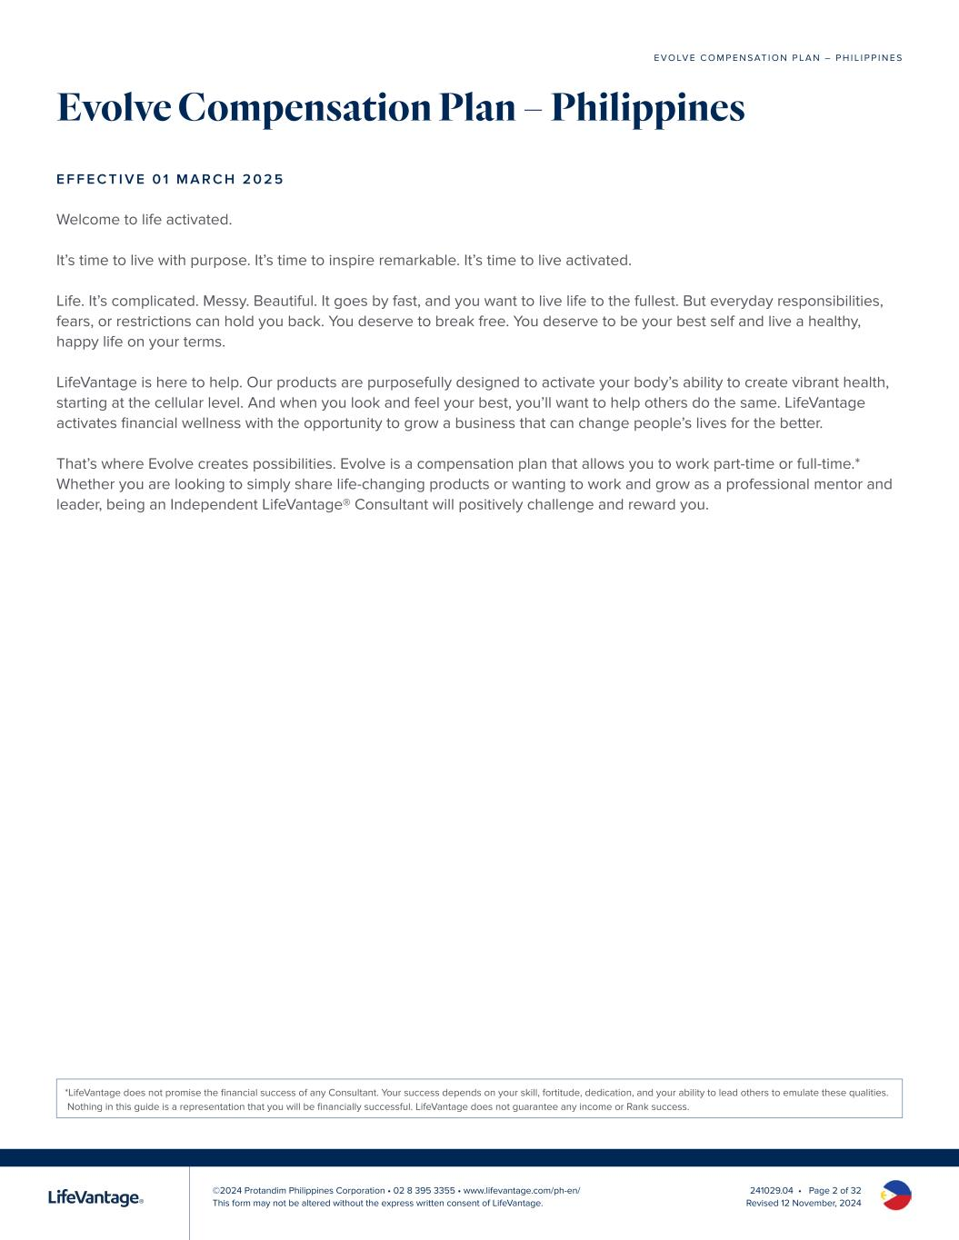
©2024 Protandim Philippines Corporation • 02 8 395 3355 • www.lifevantage.com/ph-en/ This form may not be altered without the express written consent of LifeVantage. E V O LV E C O M P E N S AT I O N P L A N – P H I L I P P I N E S 241029.04 • Page 2 of 32 Revised 12 November, 2024 Evolve Compensation Plan – Philippines E F F E C T I V E 0 1 M A R C H 2 0 2 5 Welcome to life activated. It’s time to live with purpose. It’s time to inspire remarkable. It’s time to live activated. Life. It’s complicated. Messy. Beautiful. It goes by fast, and you want to live life to the fullest. But everyday responsibilities, fears, or restrictions can hold you back. You deserve to break free. You deserve to be your best self and live a healthy, happy life on your terms. LifeVantage is here to help. Our products are purposefully designed to activate your body’s ability to create vibrant health, starting at the cellular level. And when you look and feel your best, you’ll want to help others do the same. LifeVantage activates financial wellness with the opportunity to grow a business that can change people’s lives for the better. That’s where Evolve creates possibilities. Evolve is a compensation plan that allows you to work part-time or full-time.* Whether you are looking to simply share life-changing products or wanting to work and grow as a professional mentor and leader, being an Independent LifeVantage® Consultant will positively challenge and reward you. *LifeVantage does not promise the financial success of any Consultant. Your success depends on your skill, fortitude, dedication, and your ability to lead others to emulate these qualities. Nothing in this guide is a representation that you will be financially successful. LifeVantage does not guarantee any income or Rank success.

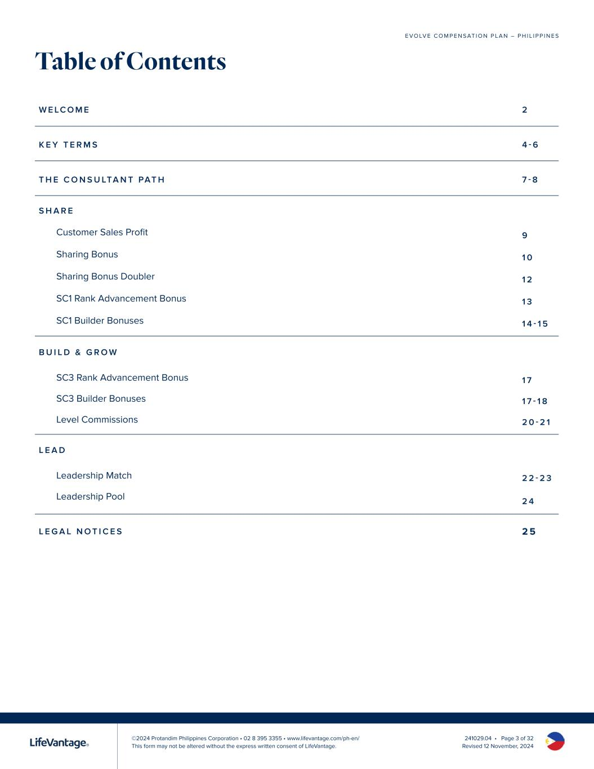
©2024 Protandim Philippines Corporation • 02 8 395 3355 • www.lifevantage.com/ph-en/ This form may not be altered without the express written consent of LifeVantage. E V O LV E C O M P E N S AT I O N P L A N – P H I L I P P I N E S 241029.04 • Page 3 of 32 Revised 12 November, 2024 Table of Contents W E LC O M E 2 K E Y T E R M S 4 - 6 T H E C O N S U LTA N T PAT H 7 - 8 S H A R E Customer Sales Profit 9 Sharing Bonus 1 0 Sharing Bonus Doubler 1 2 SC1 Rank Advancement Bonus 1 3 SC1 Builder Bonuses 1 4 - 1 5 B U I L D & G R O W SC3 Rank Advancement Bonus 1 7 SC3 Builder Bonuses 1 7 - 1 8 Level Commissions 2 0 - 2 1 L E A D Leadership Match 2 2 - 2 3 Leadership Pool 2 4 L E G A L N O T I C E S 2 5

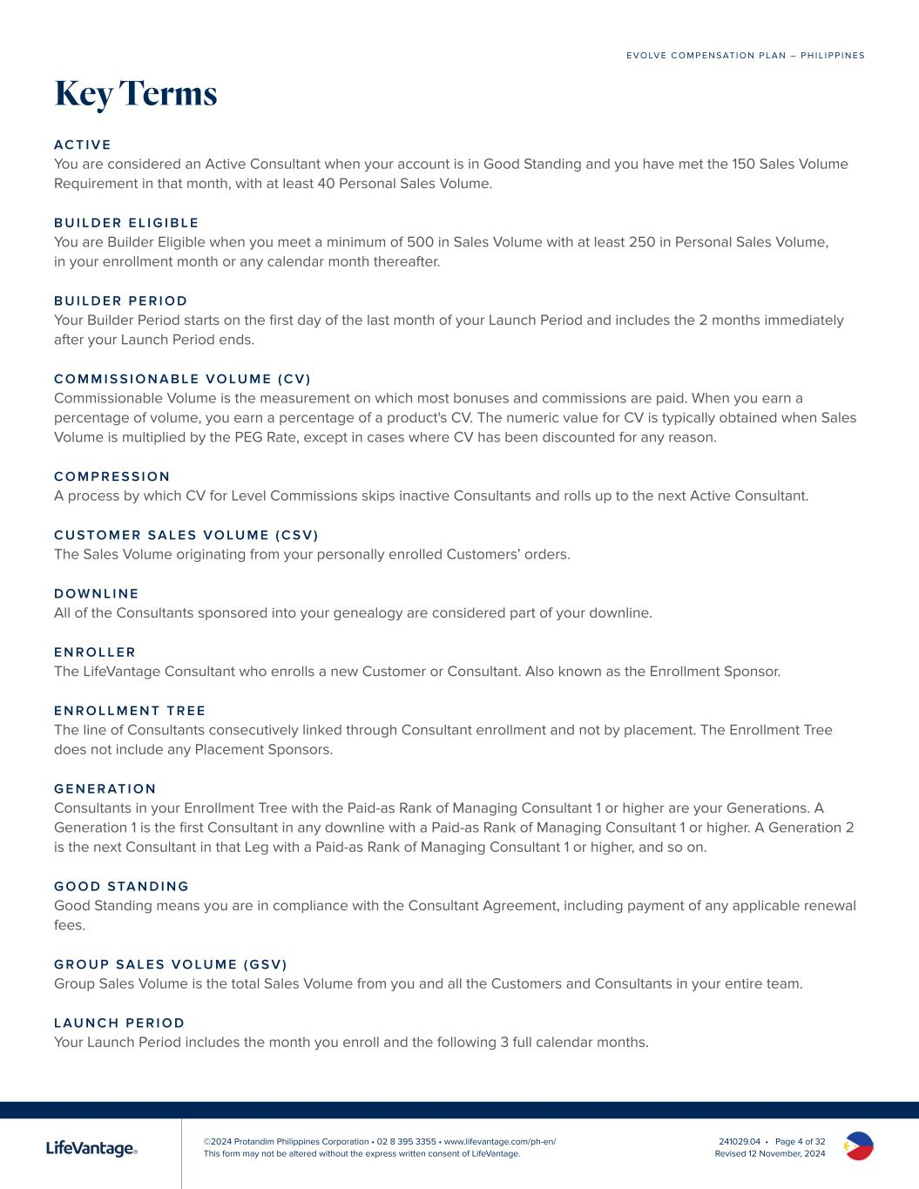
©2024 Protandim Philippines Corporation • 02 8 395 3355 • www.lifevantage.com/ph-en/ This form may not be altered without the express written consent of LifeVantage. E V O LV E C O M P E N S AT I O N P L A N – P H I L I P P I N E S 241029.04 • Page 4 of 32 Revised 12 November, 2024 Key Terms AC T I V E You are considered an Active Consultant when your account is in Good Standing and you have met the 150 Sales Volume Requirement in that month, with at least 40 Personal Sales Volume. B U I L D E R E L I G I B L E You are Builder Eligible when you meet a minimum of 500 in Sales Volume with at least 250 in Personal Sales Volume, in your enrollment month or any calendar month thereafter. B U I L D E R P E R I O D Your Builder Period starts on the first day of the last month of your Launch Period and includes the 2 months immediately after your Launch Period ends. C O M M I S S I O N A B L E V O LU M E ( C V ) Commissionable Volume is the measurement on which most bonuses and commissions are paid. When you earn a percentage of volume, you earn a percentage of a product's CV. The numeric value for CV is typically obtained when Sales Volume is multiplied by the PEG Rate, except in cases where CV has been discounted for any reason. C O M P R E S S I O N A process by which CV for Level Commissions skips inactive Consultants and rolls up to the next Active Consultant. C U S TO M E R S A L E S V O LU M E ( C S V ) The Sales Volume originating from your personally enrolled Customers’ orders. D O W N L I N E All of the Consultants sponsored into your genealogy are considered part of your downline. E N R O L L E R The LifeVantage Consultant who enrolls a new Customer or Consultant. Also known as the Enrollment Sponsor. E N R O L L M E N T T R E E The line of Consultants consecutively linked through Consultant enrollment and not by placement. The Enrollment Tree does not include any Placement Sponsors. G E N E R AT I O N Consultants in your Enrollment Tree with the Paid-as Rank of Managing Consultant 1 or higher are your Generations. A Generation 1 is the first Consultant in any downline with a Paid-as Rank of Managing Consultant 1 or higher. A Generation 2 is the next Consultant in that Leg with a Paid-as Rank of Managing Consultant 1 or higher, and so on. G O O D S TA N D I N G Good Standing means you are in compliance with the Consultant Agreement, including payment of any applicable renewal fees. G R O U P S A L E S V O LU M E ( G S V ) Group Sales Volume is the total Sales Volume from you and all the Customers and Consultants in your entire team. L AU N C H P E R I O D Your Launch Period includes the month you enroll and the following 3 full calendar months.

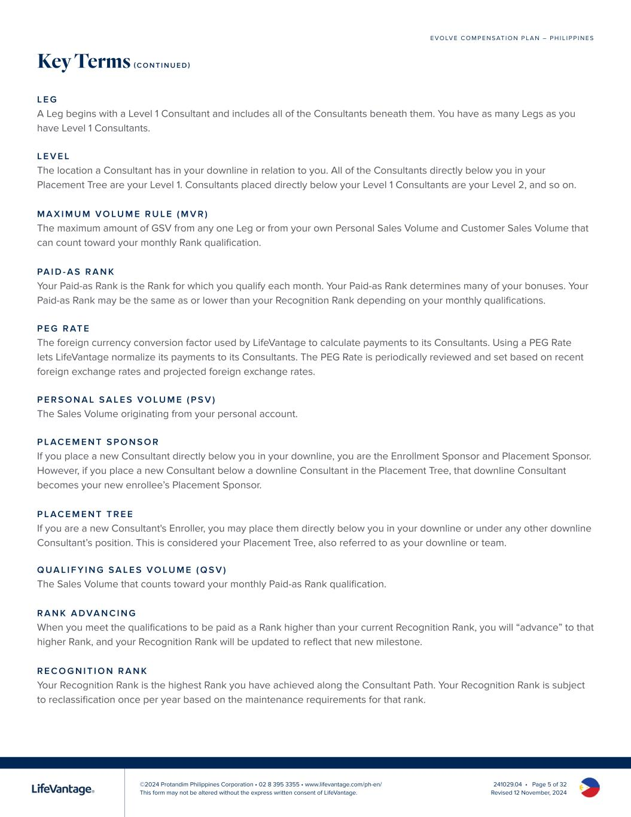
©2024 Protandim Philippines Corporation • 02 8 395 3355 • www.lifevantage.com/ph-en/ This form may not be altered without the express written consent of LifeVantage. E V O LV E C O M P E N S AT I O N P L A N – P H I L I P P I N E S 241029.04 • Page 5 of 32 Revised 12 November, 2024 Key Terms ( C O N T I N U E D ) L E G A Leg begins with a Level 1 Consultant and includes all of the Consultants beneath them. You have as many Legs as you have Level 1 Consultants. L E V E L The location a Consultant has in your downline in relation to you. All of the Consultants directly below you in your Placement Tree are your Level 1. Consultants placed directly below your Level 1 Consultants are your Level 2, and so on. M A X I M U M V O LU M E R U L E ( M V R ) The maximum amount of GSV from any one Leg or from your own Personal Sales Volume and Customer Sales Volume that can count toward your monthly Rank qualification. PA I D - A S R A N K Your Paid-as Rank is the Rank for which you qualify each month. Your Paid-as Rank determines many of your bonuses. Your Paid-as Rank may be the same as or lower than your Recognition Rank depending on your monthly qualifications. P E G R AT E The foreign currency conversion factor used by LifeVantage to calculate payments to its Consultants. Using a PEG Rate lets LifeVantage normalize its payments to its Consultants. The PEG Rate is periodically reviewed and set based on recent foreign exchange rates and projected foreign exchange rates. P E R S O N A L S A L E S V O LU M E ( P S V ) The Sales Volume originating from your personal account. P L AC E M E N T S P O N S O R If you place a new Consultant directly below you in your downline, you are the Enrollment Sponsor and Placement Sponsor. However, if you place a new Consultant below a downline Consultant in the Placement Tree, that downline Consultant becomes your new enrollee’s Placement Sponsor. P L AC E M E N T T R E E If you are a new Consultant's Enroller, you may place them directly below you in your downline or under any other downline Consultant’s position. This is considered your Placement Tree, also referred to as your downline or team. Q UA L I F Y I N G S A L E S V O LU M E ( Q S V ) The Sales Volume that counts toward your monthly Paid-as Rank qualification. R A N K A D VA N C I N G When you meet the qualifications to be paid as a Rank higher than your current Recognition Rank, you will “advance” to that higher Rank, and your Recognition Rank will be updated to reflect that new milestone. R E C O G N I T I O N R A N K Your Recognition Rank is the highest Rank you have achieved along the Consultant Path. Your Recognition Rank is subject to reclassification once per year based on the maintenance requirements for that rank.

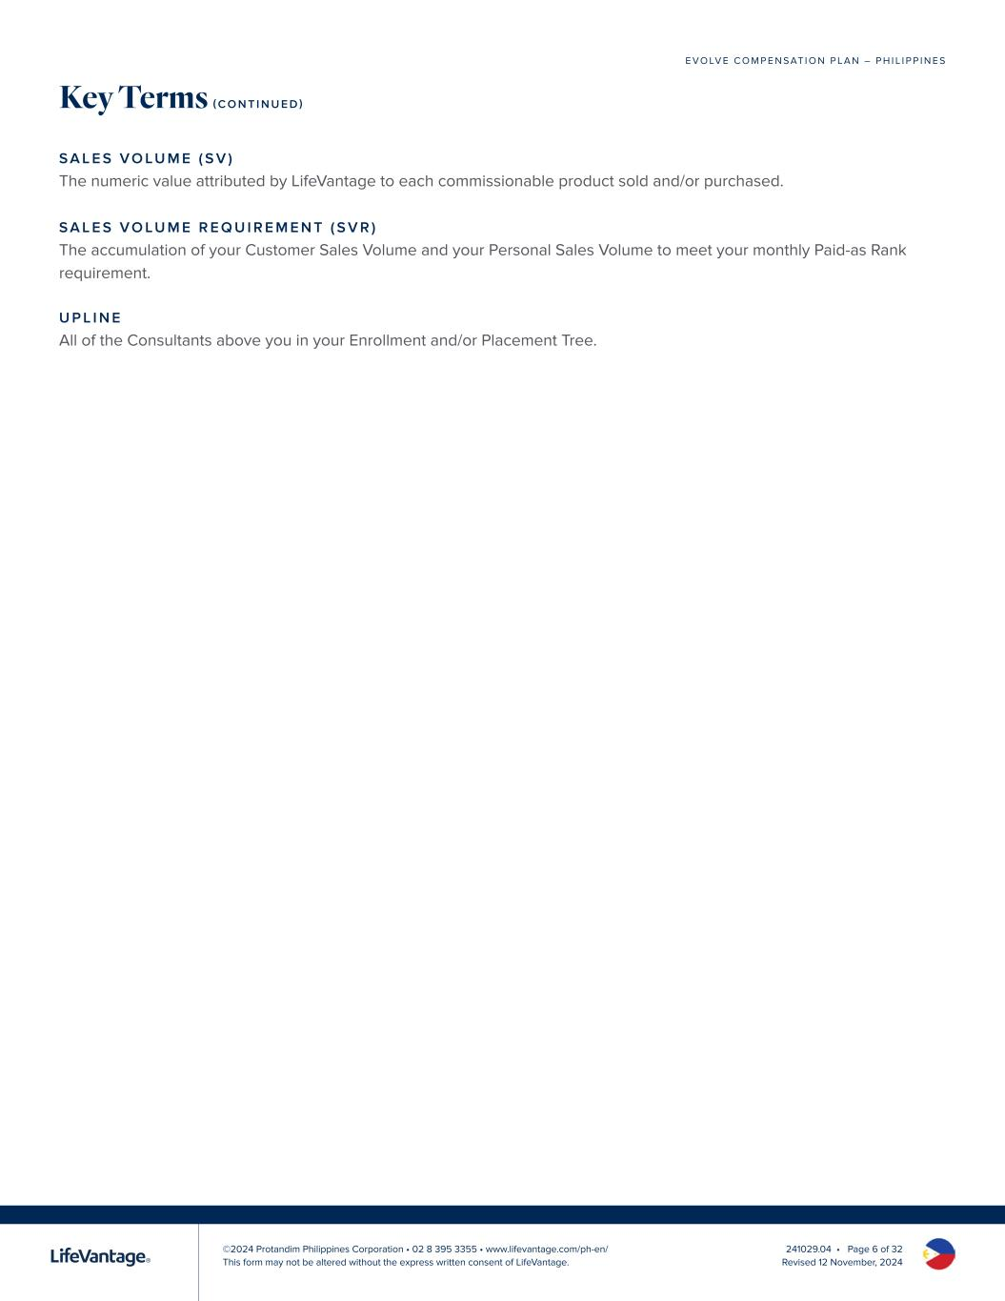
©2024 Protandim Philippines Corporation • 02 8 395 3355 • www.lifevantage.com/ph-en/ This form may not be altered without the express written consent of LifeVantage. E V O LV E C O M P E N S AT I O N P L A N – P H I L I P P I N E S 241029.04 • Page 6 of 32 Revised 12 November, 2024 Key Terms ( C O N T I N U E D ) S A L E S V O LU M E ( S V ) The numeric value attributed by LifeVantage to each commissionable product sold and/or purchased. S A L E S V O LU M E R E Q U I R E M E N T ( S V R ) The accumulation of your Customer Sales Volume and your Personal Sales Volume to meet your monthly Paid-as Rank requirement. U P L I N E All of the Consultants above you in your Enrollment and/or Placement Tree.


©2024 Protandim Philippines Corporation • 02 8 395 3355 • www.lifevantage.com/ph-en/ This form may not be altered without the express written consent of LifeVantage. E V O LV E C O M P E N S AT I O N P L A N – P H I L I P P I N E S 241029.04 • Page 7 of 32 Revised 12 November, 2024 Your path as an Independent LifeVantage Consultant can lead to a world of possibilities. Start by sharing the LifeVantage products that you love with Customers to help them activate wellness and improve their health. The more you share, the more you’ll grow as you find others who want to join you on the path with a business of their own. As you progress along the Consultant Path, your attention will shift to building and leading Consultants on your team who are ready to grow to the next stage of success. At every stage you’ll evolve your earnings, yourself, and your life. H O W I T W O R K S You must meet certain volume requirements to stay Active and earn bonuses and commissions. These requirements will change, along with the bonuses and commissions you can qualify for, as you move along the path and earn Rank advancements. As you reach the qualifications for a specific Rank, you will be recognized with your “Recognition Rank” at that level for as long as you remain Active. However, your “Paid-as Rank” will fluctuate with your qualifications from month to month. Evolve is uniquely designed to help LifeVantage Consultants develop confidence, community, and leadership. Each Rank advancement offers the opportunity to celebrate with increased earning possibilities. Share. Build & Grow. Lead. Evolve.

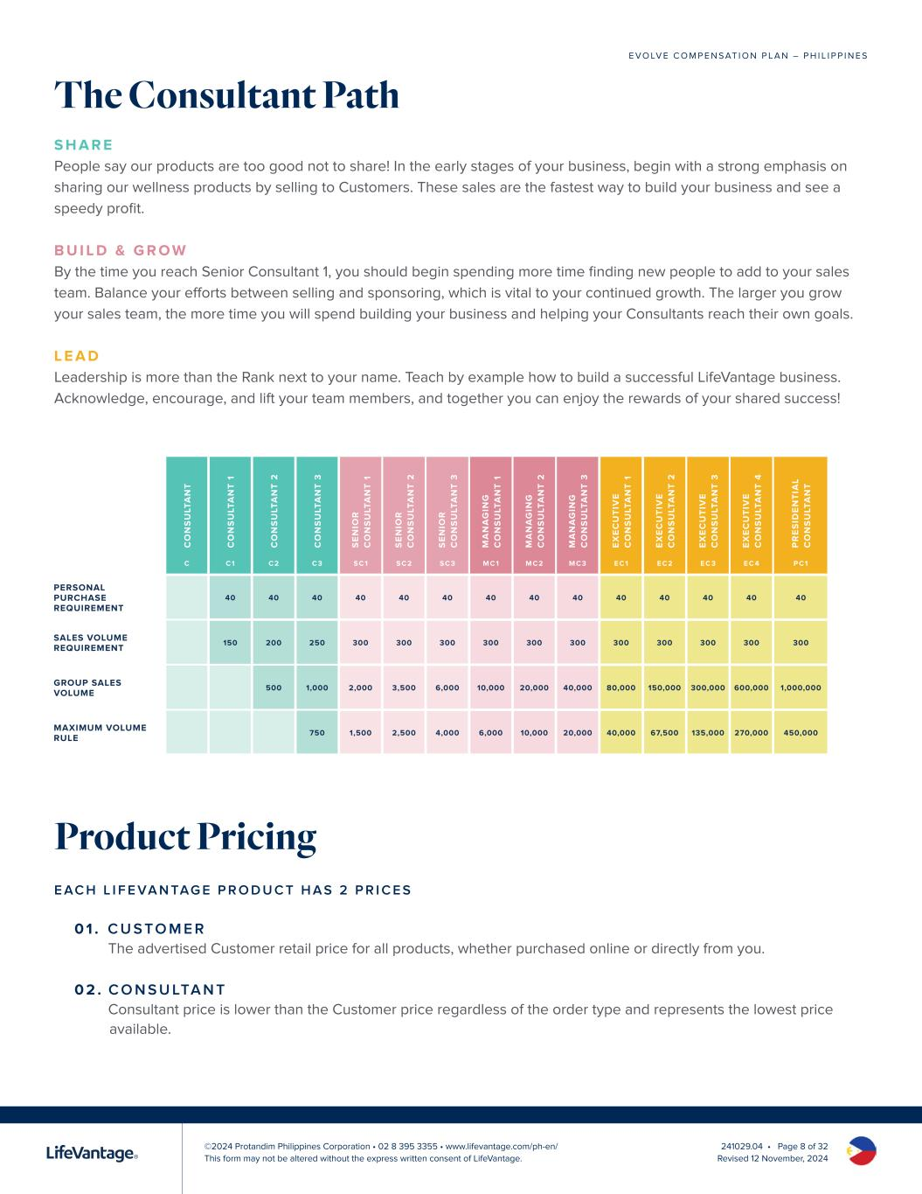
©2024 Protandim Philippines Corporation • 02 8 395 3355 • www.lifevantage.com/ph-en/ This form may not be altered without the express written consent of LifeVantage. E V O LV E C O M P E N S AT I O N P L A N – P H I L I P P I N E S 241029.04 • Page 8 of 32 Revised 12 November, 2024 The Consultant Path S H A R E People say our products are too good not to share! In the early stages of your business, begin with a strong emphasis on sharing our wellness products by selling to Customers. These sales are the fastest way to build your business and see a speedy profit. B U I L D & G R O W By the time you reach Senior Consultant 1, you should begin spending more time finding new people to add to your sales team. Balance your efforts between selling and sponsoring, which is vital to your continued growth. The larger you grow your sales team, the more time you will spend building your business and helping your Consultants reach their own goals. L E A D Leadership is more than the Rank next to your name. Teach by example how to build a successful LifeVantage business. Acknowledge, encourage, and lift your team members, and together you can enjoy the rewards of your shared success! Product Pricing E AC H L I F E VA N TAG E P R O D U C T H A S 2 P R I C E S 0 1 . C U S TO M E R The advertised Customer retail price for all products, whether purchased online or directly from you. 0 2 . C O N S U LTA N T Consultant price is lower than the Customer price regardless of the order type and represents the lowest price available. C O N S U LT A N T C O N S U LT A N T 1 C O N S U LT A N T 2 C O N S U LT A N T 3 S E N IO R C O N S U LT A N T 1 S E N IO R C O N S U LT A N T 2 S E N IO R C O N S U LT A N T 3 M A N A G IN G C O N S U LT A N T 1 M A N A G IN G C O N S U LT A N T 2 M A N A G IN G C O N S U LT A N T 3 E X E C U T IV E C O N S U LT A N T 1 E X E C U T IV E C O N S U LT A N T 2 E X E C U T IV E C O N S U LT A N T 3 E X E C U T IV E C O N S U LT A N T 4 P R E S ID E N T IA L C O N S U LT A N T C C1 C2 C3 SC1 SC2 SC3 MC1 MC2 MC3 EC1 EC2 EC3 EC 4 PC1 PERSONAL PURCHASE REQUIREMENT 40 40 40 40 40 40 40 40 40 40 40 40 40 40 SALES VOLUME REQUIREMENT 150 200 250 300 300 300 300 300 300 300 300 300 300 300 GROUP SALES VOLUME 500 1,000 2,000 3,500 6,000 10,000 20,000 40,000 80,000 150,000 300,000 600,000 1,000,000 MAXIMUM VOLUME RULE 750 1,500 2,500 4,000 6,000 10,000 20,000 40,000 67,500 135,000 270,000 450,000

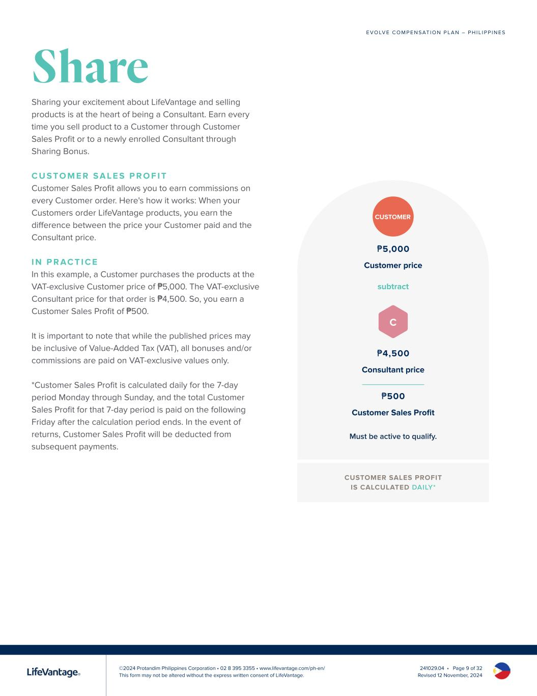
©2024 Protandim Philippines Corporation • 02 8 395 3355 • www.lifevantage.com/ph-en/ This form may not be altered without the express written consent of LifeVantage. E V O LV E C O M P E N S AT I O N P L A N – P H I L I P P I N E S 241029.04 • Page 9 of 32 Revised 12 November, 2024 Share Sharing your excitement about LifeVantage and selling products is at the heart of being a Consultant. Earn every time you sell product to a Customer through Customer Sales Profit or to a newly enrolled Consultant through Sharing Bonus. C U S TO M E R S A L E S P R O F I T Customer Sales Profit allows you to earn commissions on every Customer order. Here's how it works: When your Customers order LifeVantage products, you earn the difference between the price your Customer paid and the Consultant price. I N P R AC T I C E In this example, a Customer purchases the products at the VAT-exclusive Customer price of ₱5,000. The VAT-exclusive Consultant price for that order is ₱4,500. So, you earn a Customer Sales Profit of ₱500. It is important to note that while the published prices may be inclusive of Value-Added Tax (VAT), all bonuses and/or commissions are paid on VAT-exclusive values only. *Customer Sales Profit is calculated daily for the 7-day period Monday through Sunday, and the total Customer Sales Profit for that 7-day period is paid on the following Friday after the calculation period ends. In the event of returns, Customer Sales Profit will be deducted from subsequent payments. ₱5,000 Customer price subtract ₱4,500 Consultant price ₱500 Customer Sales Profit CUSTOMER SALES PROFIT IS CALCULATED DAILY* CUSTOMER C Must be active to qualify.

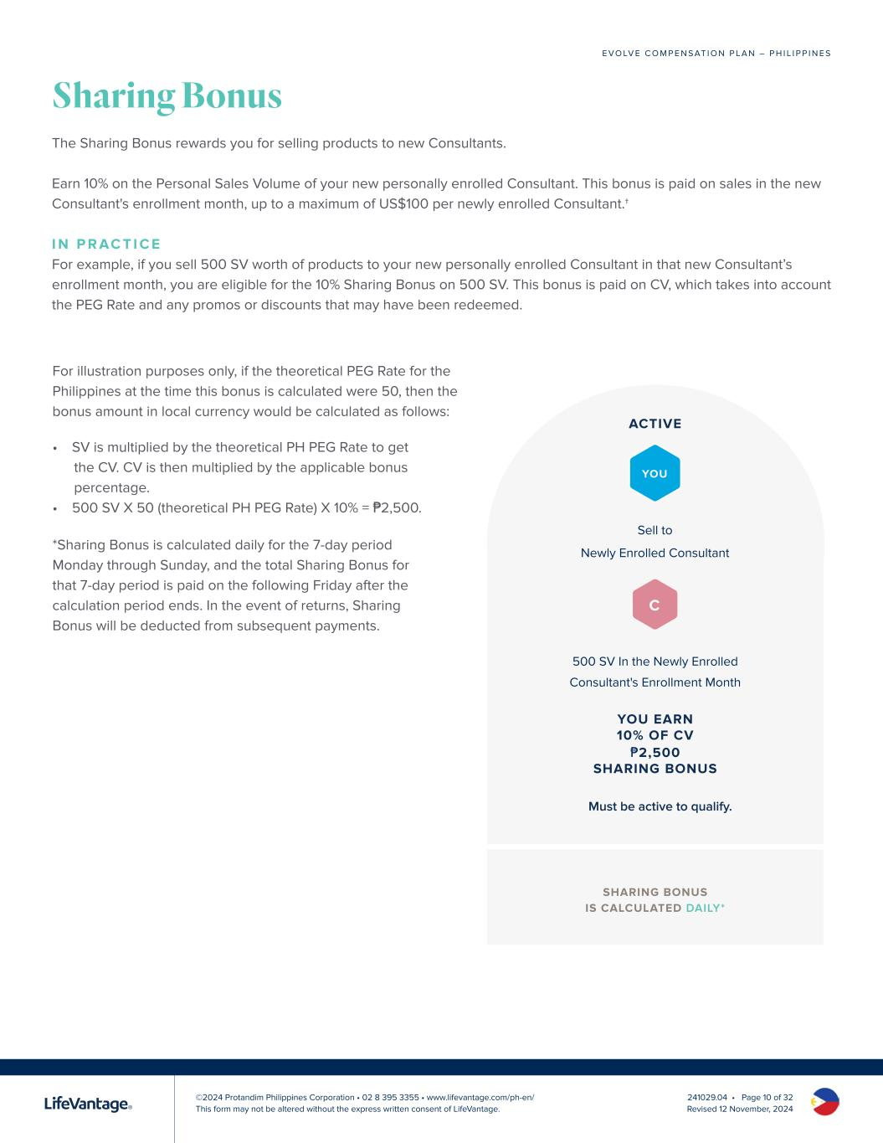
©2024 Protandim Philippines Corporation • 02 8 395 3355 • www.lifevantage.com/ph-en/ This form may not be altered without the express written consent of LifeVantage. E V O LV E C O M P E N S AT I O N P L A N – P H I L I P P I N E S 241029.04 • Page 10 of 32 Revised 12 November, 2024 Sharing Bonus The Sharing Bonus rewards you for selling products to new Consultants. Earn 10% on the Personal Sales Volume of your new personally enrolled Consultant. This bonus is paid on sales in the new Consultant's enrollment month, up to a maximum of US$100 per newly enrolled Consultant.† I N P R AC T I C E For example, if you sell 500 SV worth of products to your new personally enrolled Consultant in that new Consultant’s enrollment month, you are eligible for the 10% Sharing Bonus on 500 SV. This bonus is paid on CV, which takes into account the PEG Rate and any promos or discounts that may have been redeemed. For illustration purposes only, if the theoretical PEG Rate for the Philippines at the time this bonus is calculated were 50, then the bonus amount in local currency would be calculated as follows: SHARING BONUS IS CALCULATED DAILY* Sell to Newly Enrolled Consultant 500 SV In the Newly Enrolled Consultant's Enrollment Month ACTIVE YOU EARN 10% OF CV ₱2,500 SHARING BONUS YOU Must be active to qualify. C • SV is multiplied by the theoretical PH PEG Rate to get the CV. CV is then multiplied by the applicable bonus percentage. • 500 SV X 50 (theoretical PH PEG Rate) X 10% = ₱2,500. *Sharing Bonus is calculated daily for the 7-day period Monday through Sunday, and the total Sharing Bonus for that 7-day period is paid on the following Friday after the calculation period ends. In the event of returns, Sharing Bonus will be deducted from subsequent payments.

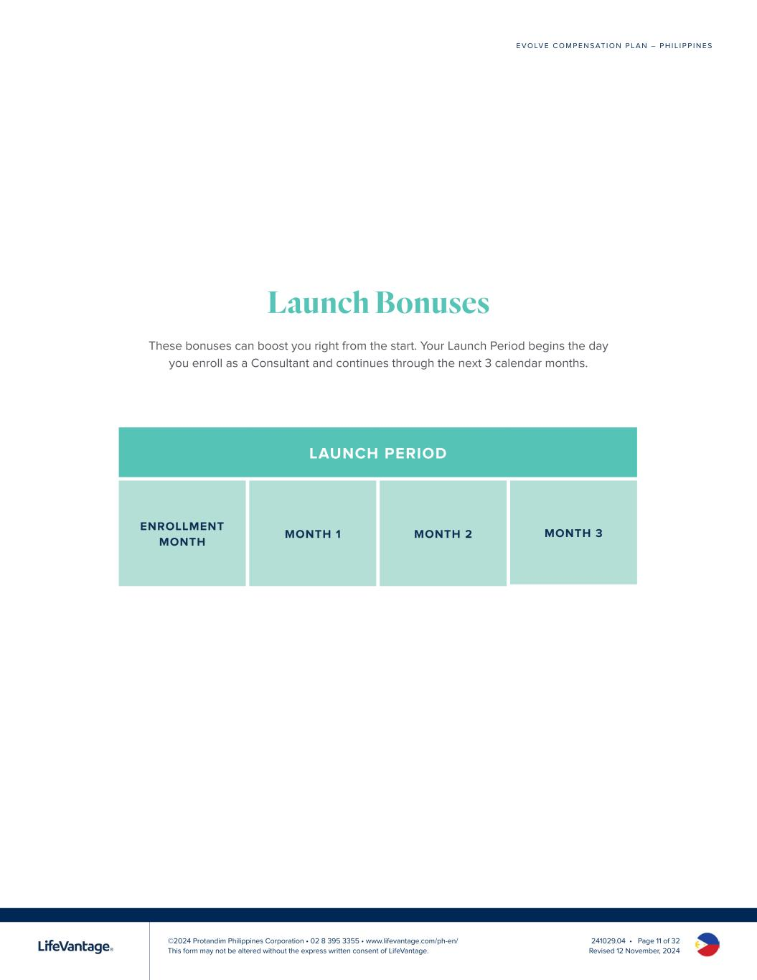
©2024 Protandim Philippines Corporation • 02 8 395 3355 • www.lifevantage.com/ph-en/ This form may not be altered without the express written consent of LifeVantage. E V O LV E C O M P E N S AT I O N P L A N – P H I L I P P I N E S 241029.04 • Page 11 of 32 Revised 12 November, 2024 Launch Bonuses These bonuses can boost you right from the start. Your Launch Period begins the day you enroll as a Consultant and continues through the next 3 calendar months. LAUNCH PERIOD

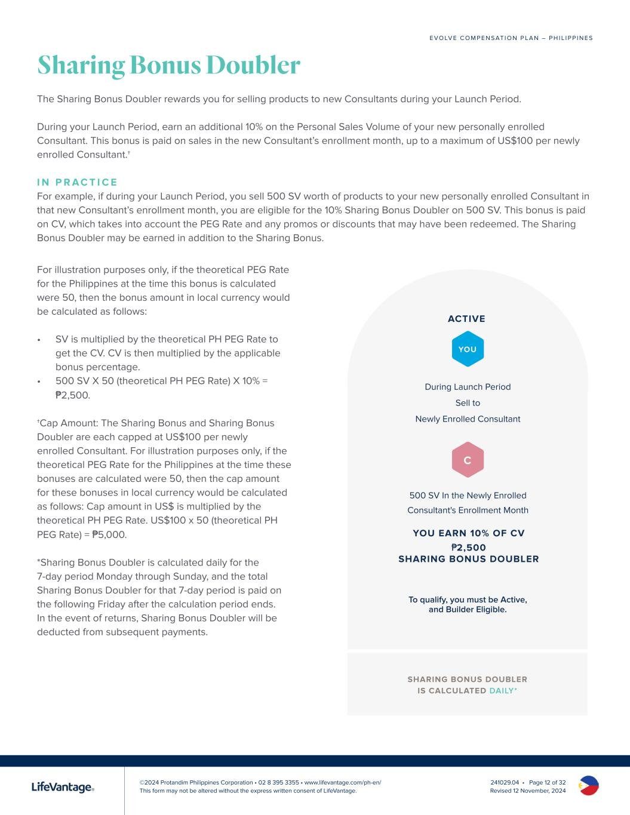
©2024 Protandim Philippines Corporation • 02 8 395 3355 • www.lifevantage.com/ph-en/ This form may not be altered without the express written consent of LifeVantage. E V O LV E C O M P E N S AT I O N P L A N – P H I L I P P I N E S 241029.04 • Page 12 of 32 Revised 12 November, 2024 Sharing Bonus Doubler The Sharing Bonus Doubler rewards you for selling products to new Consultants during your Launch Period. During your Launch Period, earn an additional 10% on the Personal Sales Volume of your new personally enrolled Consultant. This bonus is paid on sales in the new Consultant’s enrollment month, up to a maximum of US$100 per newly enrolled Consultant.† I N P R A C T I C E For example, if during your Launch Period, you sell 500 SV worth of products to your new personally enrolled Consultant in that new Consultant’s enrollment month, you are eligible for the 10% Sharing Bonus Doubler on 500 SV. This bonus is paid on CV, which takes into account the PEG Rate and any promos or discounts that may have been redeemed. The Sharing Bonus Doubler may be earned in addition to the Sharing Bonus. For illustration purposes only, if the theoretical PEG Rate for the Philippines at the time this bonus is calculated were 50, then the bonus amount in local currency would be calculated as follows: • SV is multiplied by the theoretical PH PEG Rate to get the CV. CV is then multiplied by the applicable bonus percentage. • 500 SV X 50 (theoretical PH PEG Rate) X 10% = ₱2,500. †Cap Amount: The Sharing Bonus and Sharing Bonus Doubler are each capped at US$100 per newly enrolled Consultant. For illustration purposes only, if the theoretical PEG Rate for the Philippines at the time these bonuses are calculated were 50, then the cap amount for these bonuses in local currency would be calculated as follows: Cap amount in US$ is multiplied by the theoretical PH PEG Rate. US$100 x 50 (theoretical PH PEG Rate) = ₱5,000. *Sharing Bonus Doubler is calculated daily for the 7-day period Monday through Sunday, and the total Sharing Bonus Doubler for that 7-day period is paid on the following Friday after the calculation period ends. In the event of returns, Sharing Bonus Doubler will be deducted from subsequent payments. During Launch Period Sell to Newly Enrolled Consultant 500 SV In the Newly Enrolled Consultant's Enrollment Month ACTIVE YOU EARN 10% OF CV ₱2,500 SHARING BONUS DOUBLER YOU C To qualify, you must be Active, and Builder Eligible. SHARING BONUS DOUBLER IS CALCULATED DAILY*

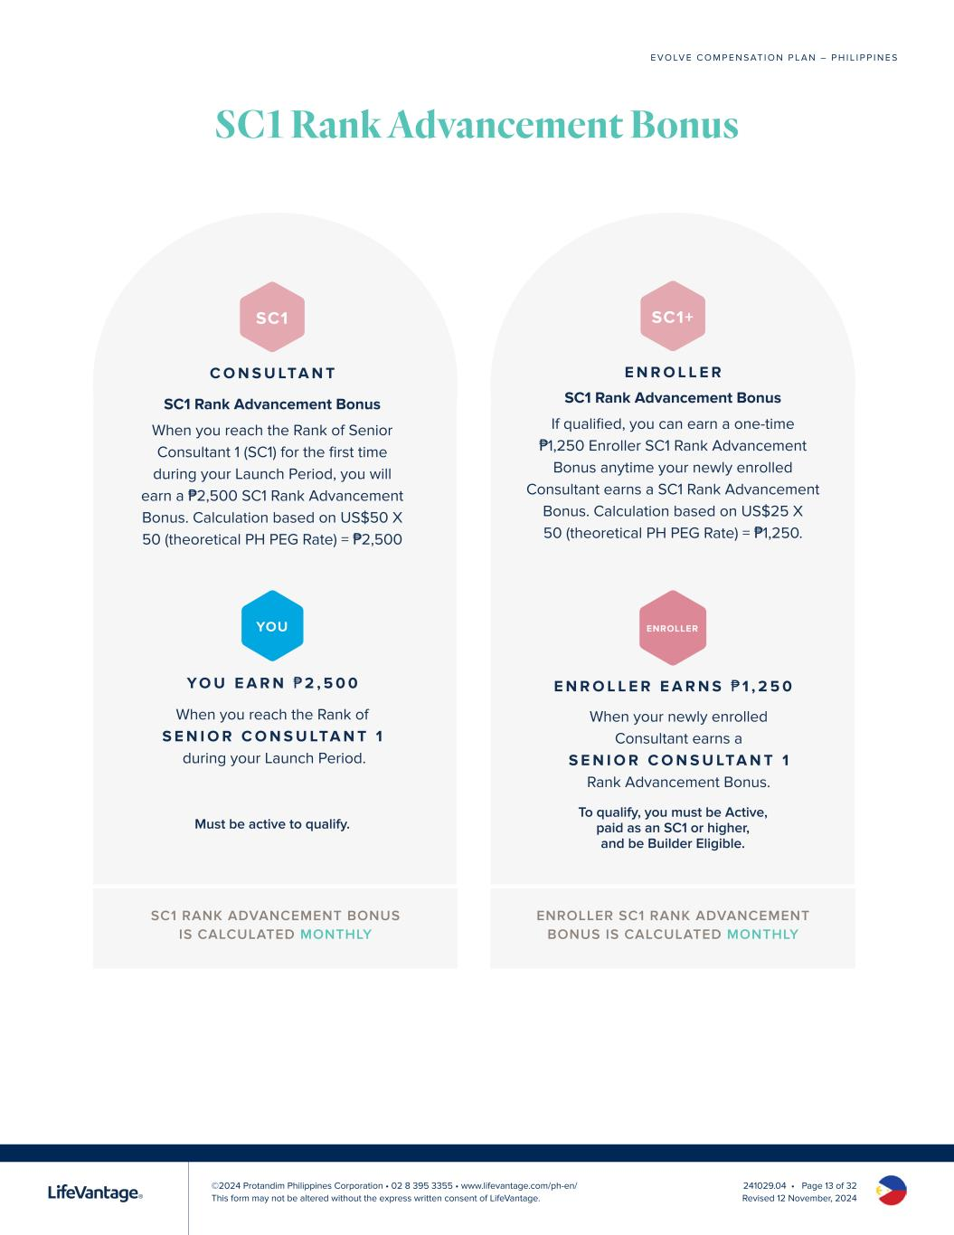
©2024 Protandim Philippines Corporation • 02 8 395 3355 • www.lifevantage.com/ph-en/ This form may not be altered without the express written consent of LifeVantage. E V O LV E C O M P E N S AT I O N P L A N – P H I L I P P I N E S 241029.04 • Page 13 of 32 Revised 12 November, 2024 SC1 RANK ADVANCEMENT BONUS IS CALCULATED MONTHLY SC1 Rank Advancement Bonus ENROLLER SC1 RANK ADVANCEMENT BONUS IS CALCULATED MONTHLY Y O U E A R N ₱2 , 5 0 0 When you reach the Rank of S E N I O R C O N S U LTA N T 1 during your Launch Period. YOU Must be active to qualify. SC1 C O N S U LTA N T SC1 Rank Advancement Bonus When you reach the Rank of Senior Consultant 1 (SC1) for the first time during your Launch Period, you will earn a ₱2,500 SC1 Rank Advancement Bonus. Calculation based on US$50 X 50 (theoretical PH PEG Rate) = ₱2,500 E N R O L L E R E A R N S ₱ 1 , 2 5 0 When your newly enrolled Consultant earns a S E N I O R C O N S U LTA N T 1 Rank Advancement Bonus. ENROLLER SC1+ E N R O L L E R SC1 Rank Advancement Bonus If qualified, you can earn a one-time ₱1,250 Enroller SC1 Rank Advancement Bonus anytime your newly enrolled Consultant earns a SC1 Rank Advancement Bonus. Calculation based on US$25 X 50 (theoretical PH PEG Rate) = ₱1,250. To qualify, you must be Active, paid as an SC1 or higher, and be Builder Eligible.

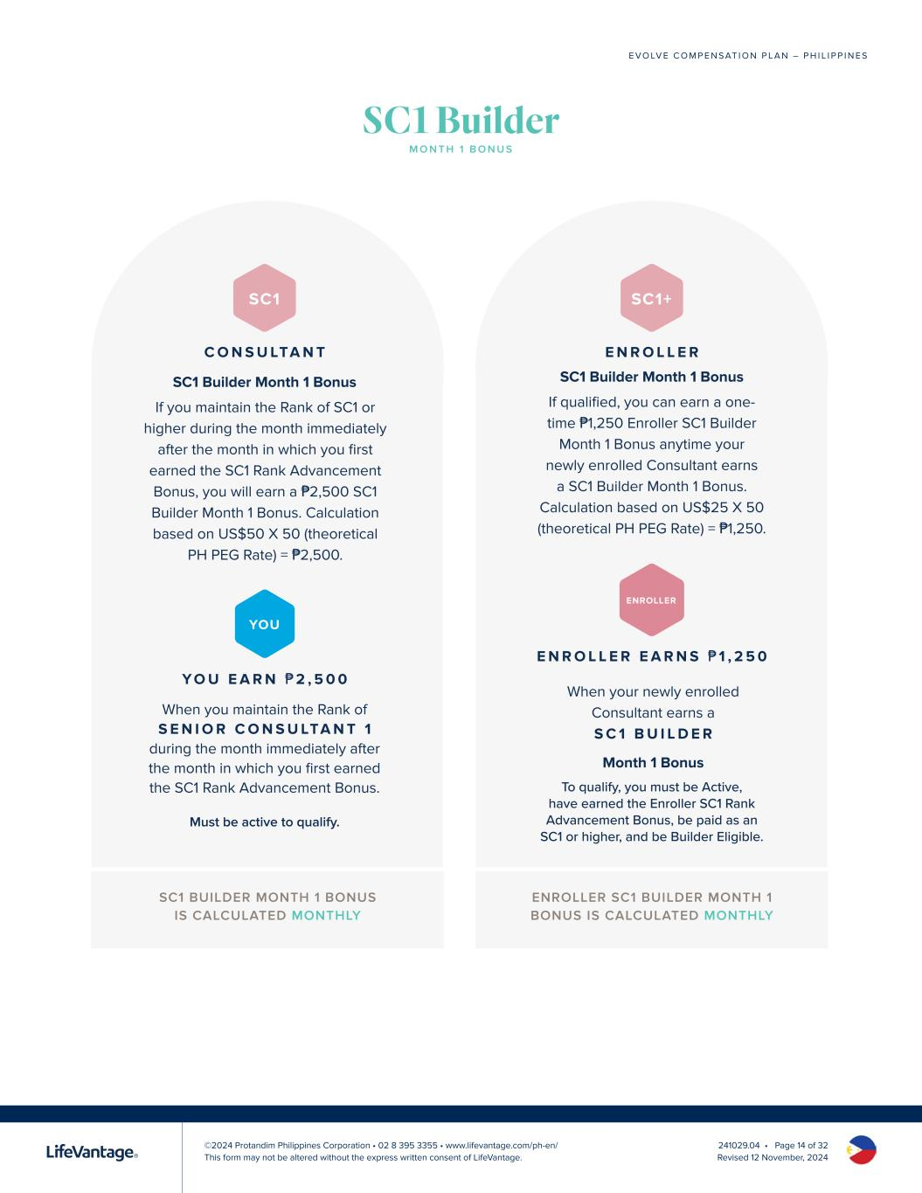
©2024 Protandim Philippines Corporation • 02 8 395 3355 • www.lifevantage.com/ph-en/ This form may not be altered without the express written consent of LifeVantage. E V O LV E C O M P E N S AT I O N P L A N – P H I L I P P I N E S 241029.04 • Page 14 of 32 Revised 12 November, 2024 SC1 BUILDER MONTH 1 BONUS IS CALCULATED MONTHLY ENROLLER SC1 BUILDER MONTH 1 BONUS IS CALCULATED MONTHLY Y O U E A R N ₱2 , 5 0 0 When you maintain the Rank of S E N I O R C O N S U LTA N T 1 during the month immediately after the month in which you first earned the SC1 Rank Advancement Bonus. YOU Must be active to qualify. SC1 C O N S U LTA N T SC1 Builder Month 1 Bonus If you maintain the Rank of SC1 or higher during the month immediately after the month in which you first earned the SC1 Rank Advancement Bonus, you will earn a ₱2,500 SC1 Builder Month 1 Bonus. Calculation based on US$50 X 50 (theoretical PH PEG Rate) = ₱2,500. E N R O L L E R E A R N S ₱ 1 , 2 5 0 When your newly enrolled Consultant earns a S C 1 B U I L D E R Month 1 Bonus ENROLLER SC1+ E N R O L L E R SC1 Builder Month 1 Bonus If qualified, you can earn a one- time ₱1,250 Enroller SC1 Builder Month 1 Bonus anytime your newly enrolled Consultant earns a SC1 Builder Month 1 Bonus. Calculation based on US$25 X 50 (theoretical PH PEG Rate) = ₱1,250. To qualify, you must be Active, have earned the Enroller SC1 Rank Advancement Bonus, be paid as an SC1 or higher, and be Builder Eligible. SC1 Builder M O N T H 1 B O N U S

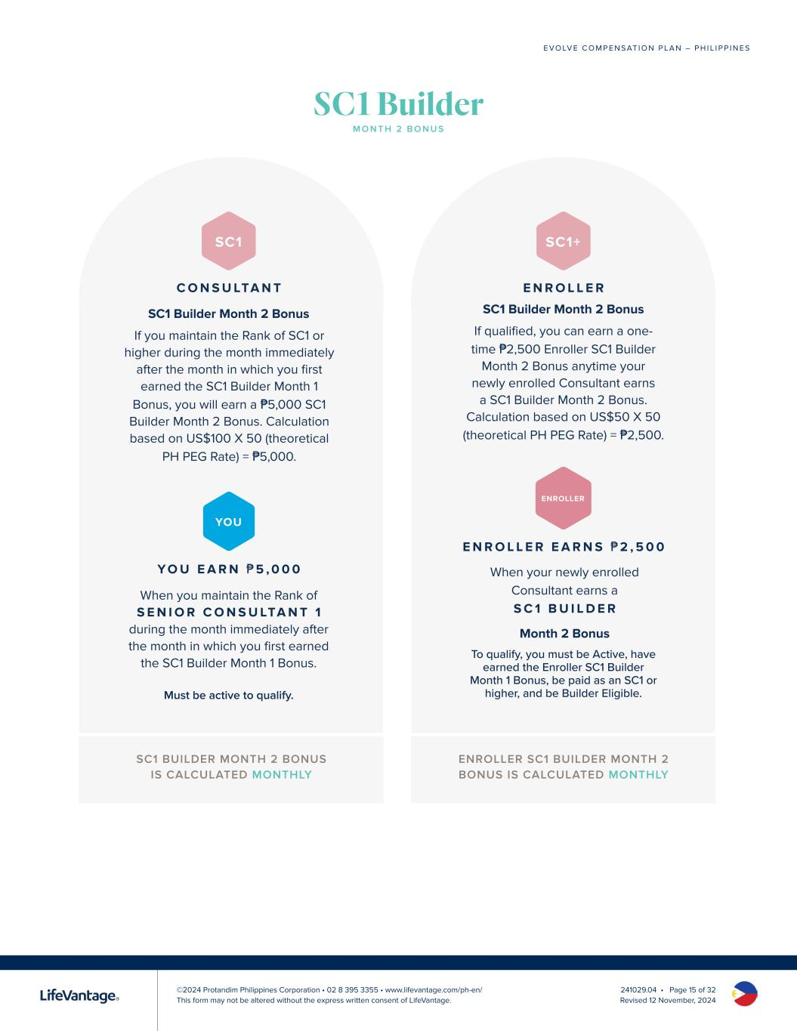
©2024 Protandim Philippines Corporation • 02 8 395 3355 • www.lifevantage.com/ph-en/ This form may not be altered without the express written consent of LifeVantage. E V O LV E C O M P E N S AT I O N P L A N – P H I L I P P I N E S 241029.04 • Page 15 of 32 Revised 12 November, 2024 SC1 Builder M O N T H 2 B O N U S SC1 BUILDER MONTH 2 BONUS IS CALCULATED MONTHLY ENROLLER SC1 BUILDER MONTH 2 BONUS IS CALCULATED MONTHLY Y O U E A R N ₱5 , 0 0 0 When you maintain the Rank of S E N I O R C O N S U LTA N T 1 during the month immediately after the month in which you first earned the SC1 Builder Month 1 Bonus. YOU Must be active to qualify. SC1 C O N S U LTA N T SC1 Builder Month 2 Bonus If you maintain the Rank of SC1 or higher during the month immediately after the month in which you first earned the SC1 Builder Month 1 Bonus, you will earn a ₱5,000 SC1 Builder Month 2 Bonus. Calculation based on US$100 X 50 (theoretical PH PEG Rate) = ₱5,000. E N R O L L E R E A R N S ₱2 , 5 0 0 When your newly enrolled Consultant earns a S C 1 B U I L D E R Month 2 Bonus ENROLLER SC1+ E N R O L L E R SC1 Builder Month 2 Bonus If qualified, you can earn a one- time ₱2,500 Enroller SC1 Builder Month 2 Bonus anytime your newly enrolled Consultant earns a SC1 Builder Month 2 Bonus. Calculation based on US$50 X 50 (theoretical PH PEG Rate) = ₱2,500. To qualify, you must be Active, have earned the Enroller SC1 Builder Month 1 Bonus, be paid as an SC1 or higher, and be Builder Eligible.

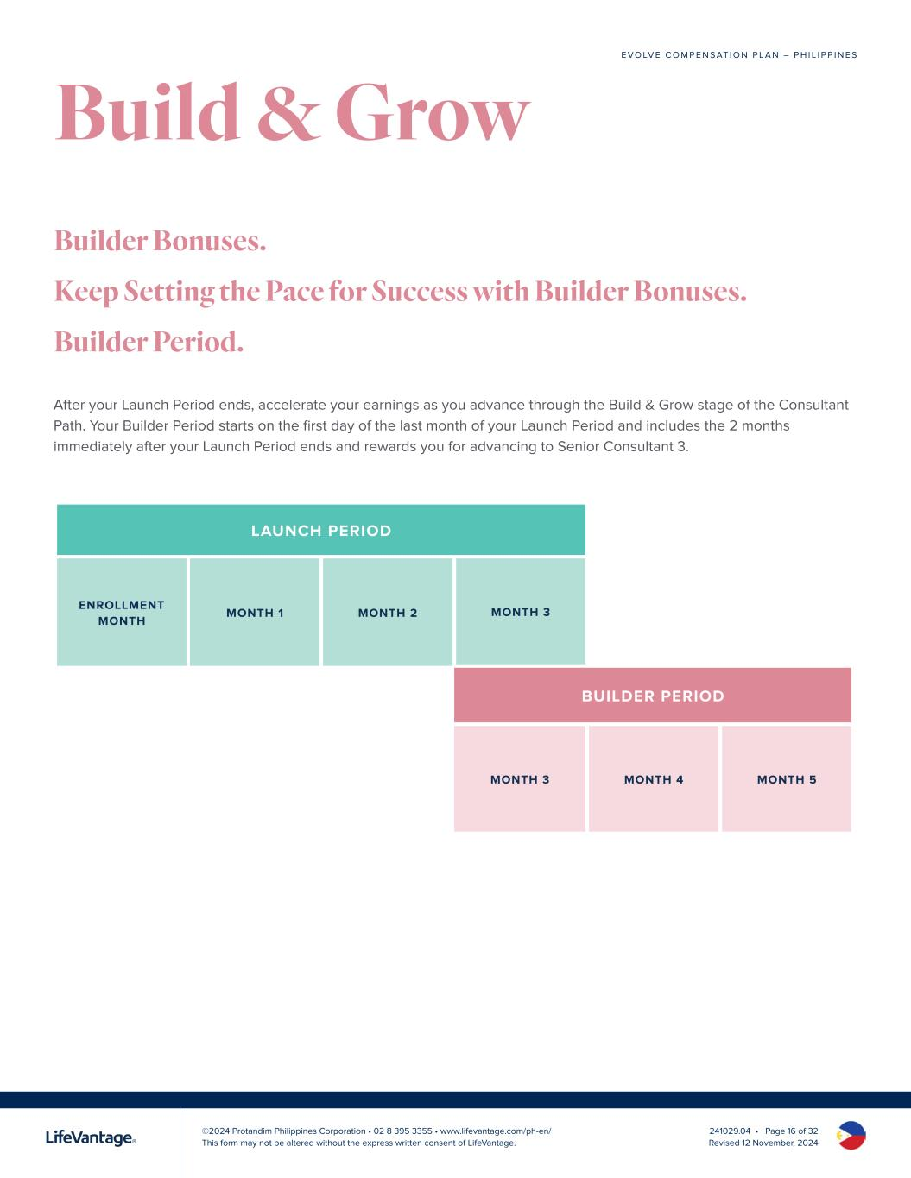
©2024 Protandim Philippines Corporation • 02 8 395 3355 • www.lifevantage.com/ph-en/ This form may not be altered without the express written consent of LifeVantage. E V O LV E C O M P E N S AT I O N P L A N – P H I L I P P I N E S 241029.04 • Page 16 of 32 Revised 12 November, 2024 After your Launch Period ends, accelerate your earnings as you advance through the Build & Grow stage of the Consultant Path. Your Builder Period starts on the first day of the last month of your Launch Period and includes the 2 months immediately after your Launch Period ends and rewards you for advancing to Senior Consultant 3. Builder Bonuses. Keep Setting the Pace for Success with Builder Bonuses. Builder Period. LAUNCH PERIOD BUILDER PERIOD MONTH 3 MONTH 4 MONTH 5 Build & Grow

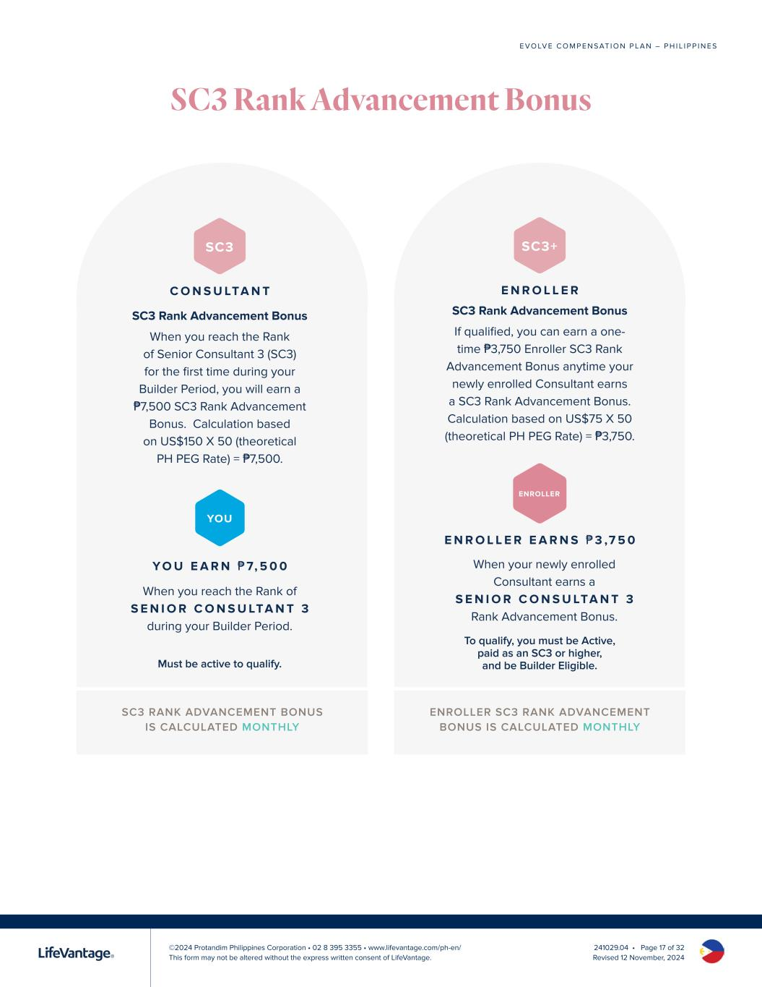
©2024 Protandim Philippines Corporation • 02 8 395 3355 • www.lifevantage.com/ph-en/ This form may not be altered without the express written consent of LifeVantage. E V O LV E C O M P E N S AT I O N P L A N – P H I L I P P I N E S 241029.04 • Page 17 of 32 Revised 12 November, 2024 SC3 Rank Advancement Bonus SC3 RANK ADVANCEMENT BONUS IS CALCULATED MONTHLY ENROLLER SC3 RANK ADVANCEMENT BONUS IS CALCULATED MONTHLY Y O U E A R N ₱ 7, 5 0 0 When you reach the Rank of S E N I O R C O N S U LTA N T 3 during your Builder Period. YOU Must be active to qualify. SC3 C O N S U LTA N T SC3 Rank Advancement Bonus When you reach the Rank of Senior Consultant 3 (SC3) for the first time during your Builder Period, you will earn a ₱7,500 SC3 Rank Advancement Bonus. Calculation based on US$150 X 50 (theoretical PH PEG Rate) = ₱7,500. E N R O L L E R E A R N S ₱3 ,7 5 0 When your newly enrolled Consultant earns a S E N I O R C O N S U LTA N T 3 Rank Advancement Bonus. ENROLLER SC3+ E N R O L L E R SC3 Rank Advancement Bonus If qualified, you can earn a one- time ₱3,750 Enroller SC3 Rank Advancement Bonus anytime your newly enrolled Consultant earns a SC3 Rank Advancement Bonus. Calculation based on US$75 X 50 (theoretical PH PEG Rate) = ₱3,750. To qualify, you must be Active, paid as an SC3 or higher, and be Builder Eligible.

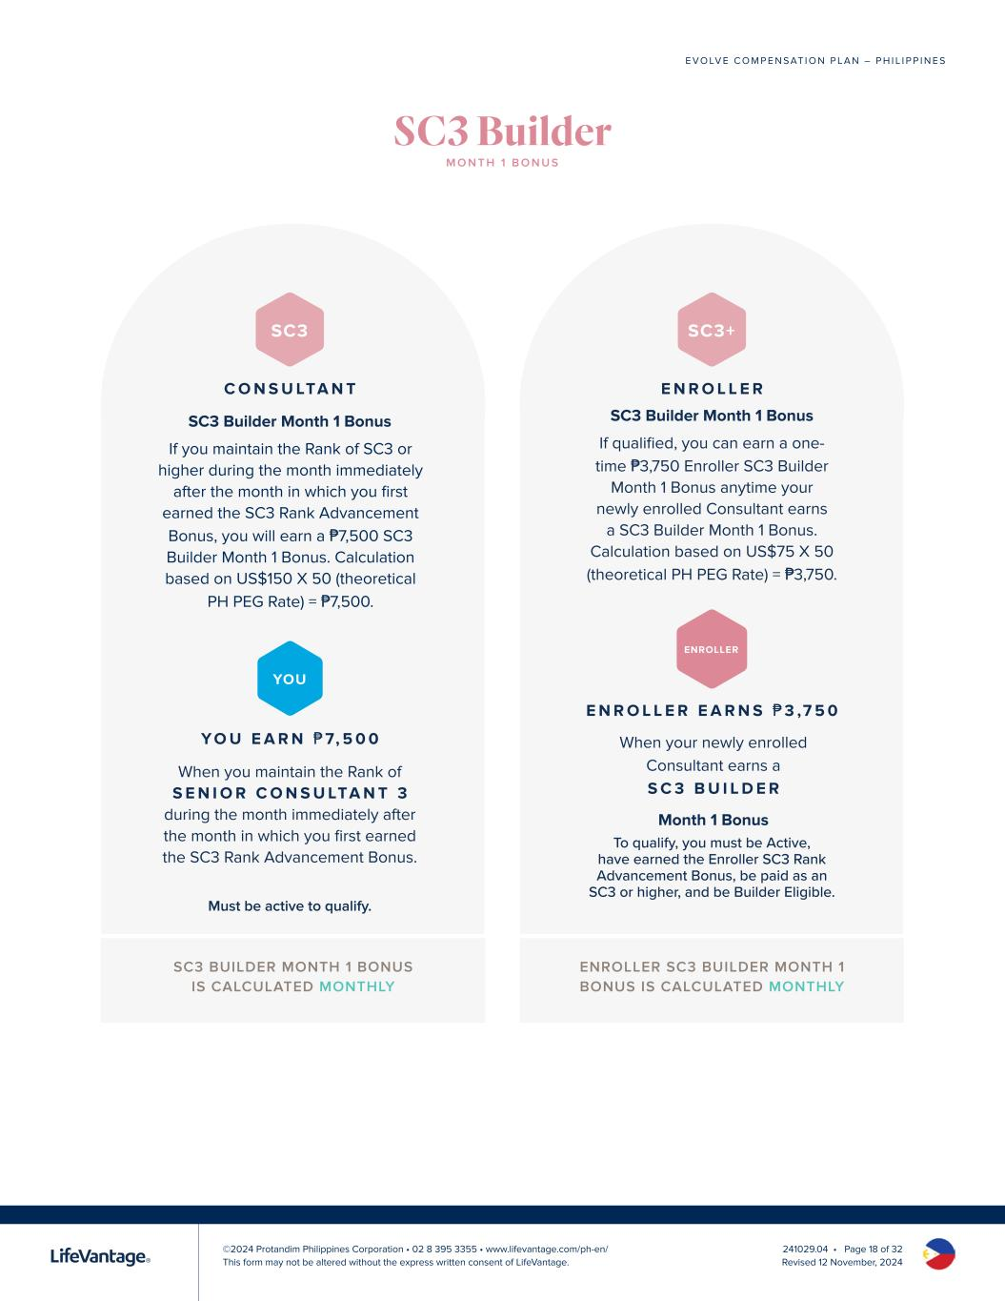
©2024 Protandim Philippines Corporation • 02 8 395 3355 • www.lifevantage.com/ph-en/ This form may not be altered without the express written consent of LifeVantage. E V O LV E C O M P E N S AT I O N P L A N – P H I L I P P I N E S 241029.04 • Page 18 of 32 Revised 12 November, 2024 SC3 BUILDER MONTH 1 BONUS IS CALCULATED MONTHLY ENROLLER SC3 BUILDER MONTH 1 BONUS IS CALCULATED MONTHLY Y O U E A R N ₱ 7, 5 0 0 When you maintain the Rank of S E N I O R C O N S U LTA N T 3 during the month immediately after the month in which you first earned the SC3 Rank Advancement Bonus. YOU Must be active to qualify. SC3 C O N S U LTA N T SC3 Builder Month 1 Bonus If you maintain the Rank of SC3 or higher during the month immediately after the month in which you first earned the SC3 Rank Advancement Bonus, you will earn a ₱7,500 SC3 Builder Month 1 Bonus. Calculation based on US$150 X 50 (theoretical PH PEG Rate) = ₱7,500. E N R O L L E R E A R N S ₱3 ,7 5 0 When your newly enrolled Consultant earns a S C 3 B U I L D E R Month 1 Bonus ENROLLER SC3+ E N R O L L E R SC3 Builder Month 1 Bonus If qualified, you can earn a one- time ₱3,750 Enroller SC3 Builder Month 1 Bonus anytime your newly enrolled Consultant earns a SC3 Builder Month 1 Bonus. Calculation based on US$75 X 50 (theoretical PH PEG Rate) = ₱3,750. To qualify, you must be Active, have earned the Enroller SC3 Rank Advancement Bonus, be paid as an SC3 or higher, and be Builder Eligible. SC3 Builder M O N T H 1 B O N U S

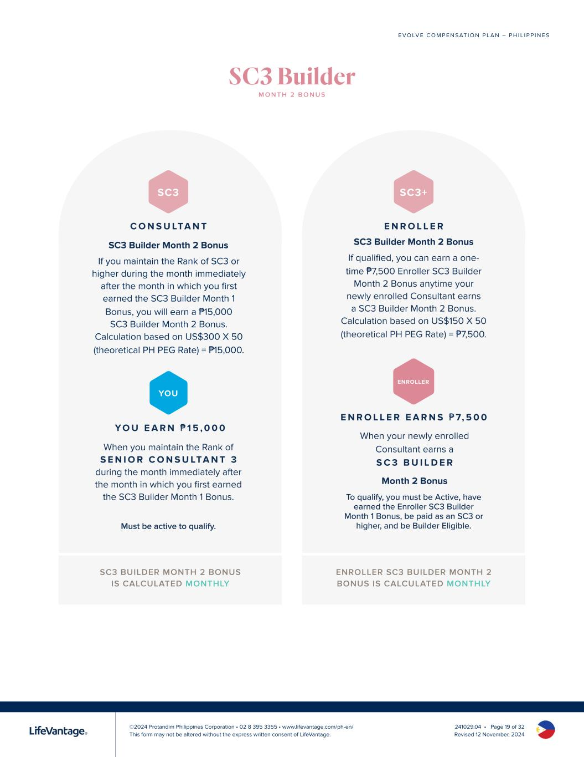
©2024 Protandim Philippines Corporation • 02 8 395 3355 • www.lifevantage.com/ph-en/ This form may not be altered without the express written consent of LifeVantage. E V O LV E C O M P E N S AT I O N P L A N – P H I L I P P I N E S 241029.04 • Page 19 of 32 Revised 12 November, 2024 SC3 BUILDER MONTH 2 BONUS IS CALCULATED MONTHLY ENROLLER SC3 BUILDER MONTH 2 BONUS IS CALCULATED MONTHLY Y O U E A R N ₱ 1 5 , 0 0 0 When you maintain the Rank of S E N I O R C O N S U LTA N T 3 during the month immediately after the month in which you first earned the SC3 Builder Month 1 Bonus. YOU Must be active to qualify. SC3 C O N S U LTA N T SC3 Builder Month 2 Bonus If you maintain the Rank of SC3 or higher during the month immediately after the month in which you first earned the SC3 Builder Month 1 Bonus, you will earn a ₱15,000 SC3 Builder Month 2 Bonus. Calculation based on US$300 X 50 (theoretical PH PEG Rate) = ₱15,000. E N R O L L E R E A R N S ₱ 7, 5 0 0 When your newly enrolled Consultant earns a S C 3 B U I L D E R Month 2 Bonus ENROLLER SC3+ E N R O L L E R SC3 Builder Month 2 Bonus If qualified, you can earn a one- time ₱7,500 Enroller SC3 Builder Month 2 Bonus anytime your newly enrolled Consultant earns a SC3 Builder Month 2 Bonus. Calculation based on US$150 X 50 (theoretical PH PEG Rate) = ₱7,500. To qualify, you must be Active, have earned the Enroller SC3 Builder Month 1 Bonus, be paid as an SC3 or higher, and be Builder Eligible. SC3 Builder M O N T H 2 B O N U S

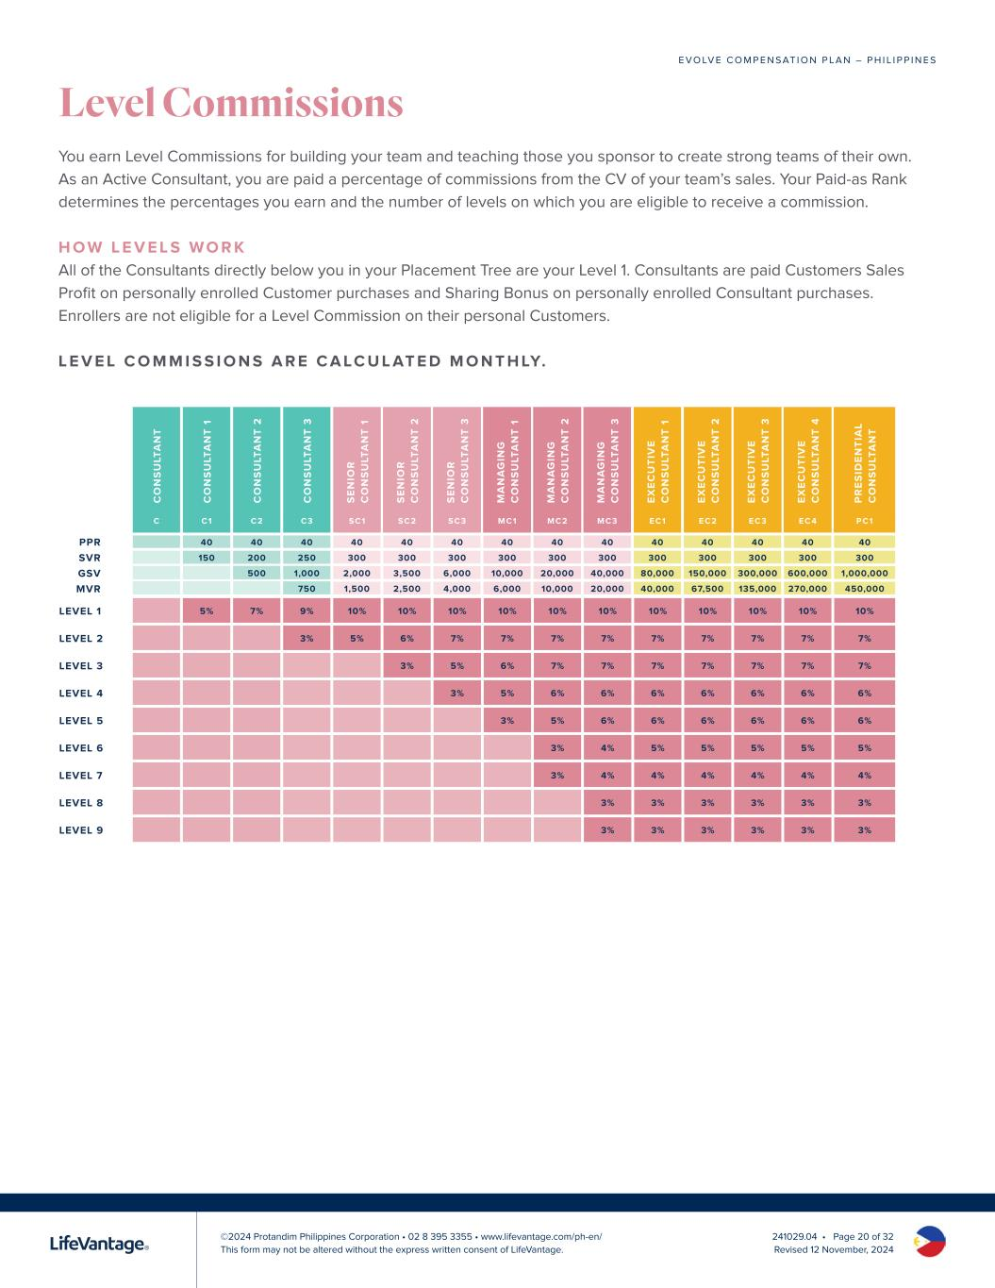
©2024 Protandim Philippines Corporation • 02 8 395 3355 • www.lifevantage.com/ph-en/ This form may not be altered without the express written consent of LifeVantage. E V O LV E C O M P E N S AT I O N P L A N – P H I L I P P I N E S 241029.04 • Page 20 of 32 Revised 12 November, 2024 Level Commissions You earn Level Commissions for building your team and teaching those you sponsor to create strong teams of their own. As an Active Consultant, you are paid a percentage of commissions from the CV of your team’s sales. Your Paid-as Rank determines the percentages you earn and the number of levels on which you are eligible to receive a commission. H O W L E V E L S W O R K All of the Consultants directly below you in your Placement Tree are your Level 1. Consultants are paid Customers Sales Profit on personally enrolled Customer purchases and Sharing Bonus on personally enrolled Consultant purchases. Enrollers are not eligible for a Level Commission on their personal Customers. L E V E L C O M M I S S I O N S A R E C A LC U L AT E D M O N T H LY. C O N S U LT A N T C O N S U LT A N T 1 C O N S U LT A N T 2 C O N S U LT A N T 3 S E N IO R C O N S U LT A N T 1 S E N IO R C O N S U LT A N T 2 S E N IO R C O N S U LT A N T 3 M A N A G IN G C O N S U LT A N T 1 M A N A G IN G C O N S U LT A N T 2 M A N A G IN G C O N S U LT A N T 3 E X E C U T IV E C O N S U LT A N T 1 E X E C U T IV E C O N S U LT A N T 2 E X E C U T IV E C O N S U LT A N T 3 E X E C U T IV E C O N S U LT A N T 4 P R E S ID E N T IA L C O N S U LT A N T C C1 C2 C3 SC1 SC2 SC3 MC1 MC2 MC3 EC1 EC2 EC3 EC 4 PC1 40 40 40 40 40 40 40 40 40 40 40 40 40 40 150 200 250 300 300 300 300 300 300 300 300 300 300 300 500 1,000 2,000 3,500 6,000 10,000 20,000 40,000 80,000 150,000 300,000 600,000 1,000,000 750 1,500 2,500 4,000 6,000 10,000 20,000 40,000 67,500 135,000 270,000 450,000 LEVEL 1 5% 7% 9% 10% 10% 10% 10% 10% 10% 10% 10% 10% 10% 10% LEVEL 2 3% 5% 6% 7% 7% 7% 7% 7% 7% 7% 7% 7% LEVEL 3 3% 5% 6% 7% 7% 7% 7% 7% 7% 7% LEVEL 4 3% 5% 6% 6% 6% 6% 6% 6% 6% LEVEL 5 3% 5% 6% 6% 6% 6% 6% 6% LEVEL 6 3% 4% 5% 5% 5% 5% 5% LEVEL 7 3% 4% 4% 4% 4% 4% 4% LEVEL 8 3% 3% 3% 3% 3% 3% LEVEL 9 3% 3% 3% 3% 3% 3% PPR SVR GSV MVR

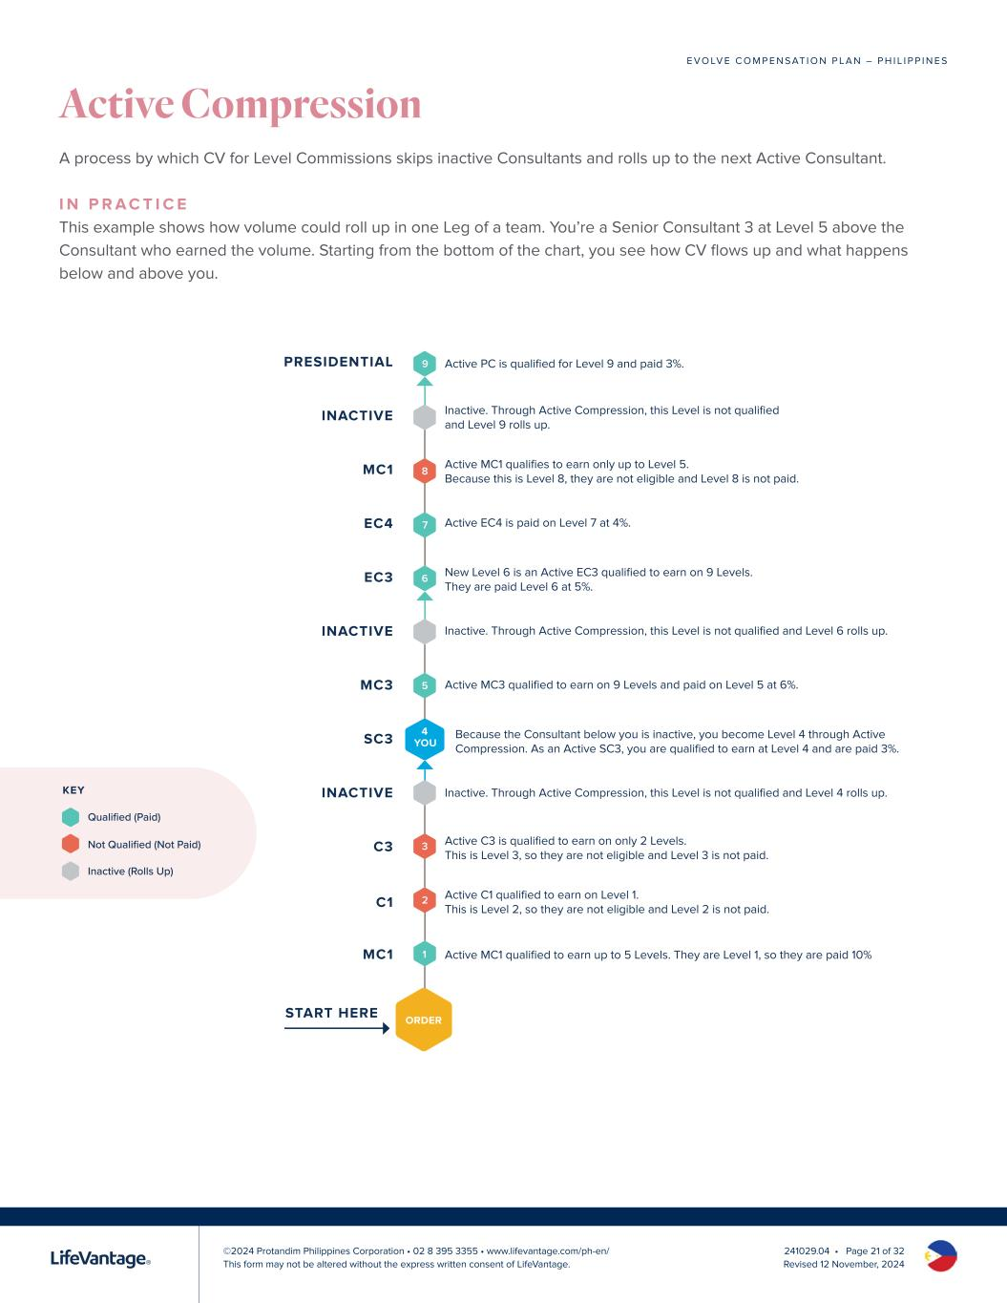
©2024 Protandim Philippines Corporation • 02 8 395 3355 • www.lifevantage.com/ph-en/ This form may not be altered without the express written consent of LifeVantage. E V O LV E C O M P E N S AT I O N P L A N – P H I L I P P I N E S 241029.04 • Page 21 of 32 Revised 12 November, 2024 Active Compression A process by which CV for Level Commissions skips inactive Consultants and rolls up to the next Active Consultant. I N P R A C T I C E This example shows how volume could roll up in one Leg of a team. You’re a Senior Consultant 3 at Level 5 above the Consultant who earned the volume. Starting from the bottom of the chart, you see how CV flows up and what happens below and above you. 9 8 5 3 7 2 6 1 ORDER MC1 START HERE C1 C3 INACTIVE SC3 MC3 INACTIVE EC3 EC4 MC1 INACTIVE PRESIDENTIAL 4 YOU Active MC1 qualified to earn up to 5 Levels. They are Level 1, so they are paid 10% Active C1 qualified to earn on Level 1. This is Level 2, so they are not eligible and Level 2 is not paid. Active C3 is qualified to earn on only 2 Levels. This is Level 3, so they are not eligible and Level 3 is not paid. Inactive. Through Active Compression, this Level is not qualified and Level 4 rolls up. Because the Consultant below you is inactive, you become Level 4 through Active Compression. As an Active SC3, you are qualified to earn at Level 4 and are paid 3%. Active MC3 qualified to earn on 9 Levels and paid on Level 5 at 6%. Inactive. Through Active Compression, this Level is not qualified and Level 6 rolls up. New Level 6 is an Active EC3 qualified to earn on 9 Levels. They are paid Level 6 at 5%. Active EC4 is paid on Level 7 at 4%. Active MC1 qualifies to earn only up to Level 5. Because this is Level 8, they are not eligible and Level 8 is not paid. Inactive. Through Active Compression, this Level is not qualified and Level 9 rolls up. Active PC is qualified for Level 9 and paid 3%. KEY Qualified (Paid) Not Qualified (Not Paid) Inactive (Rolls Up)

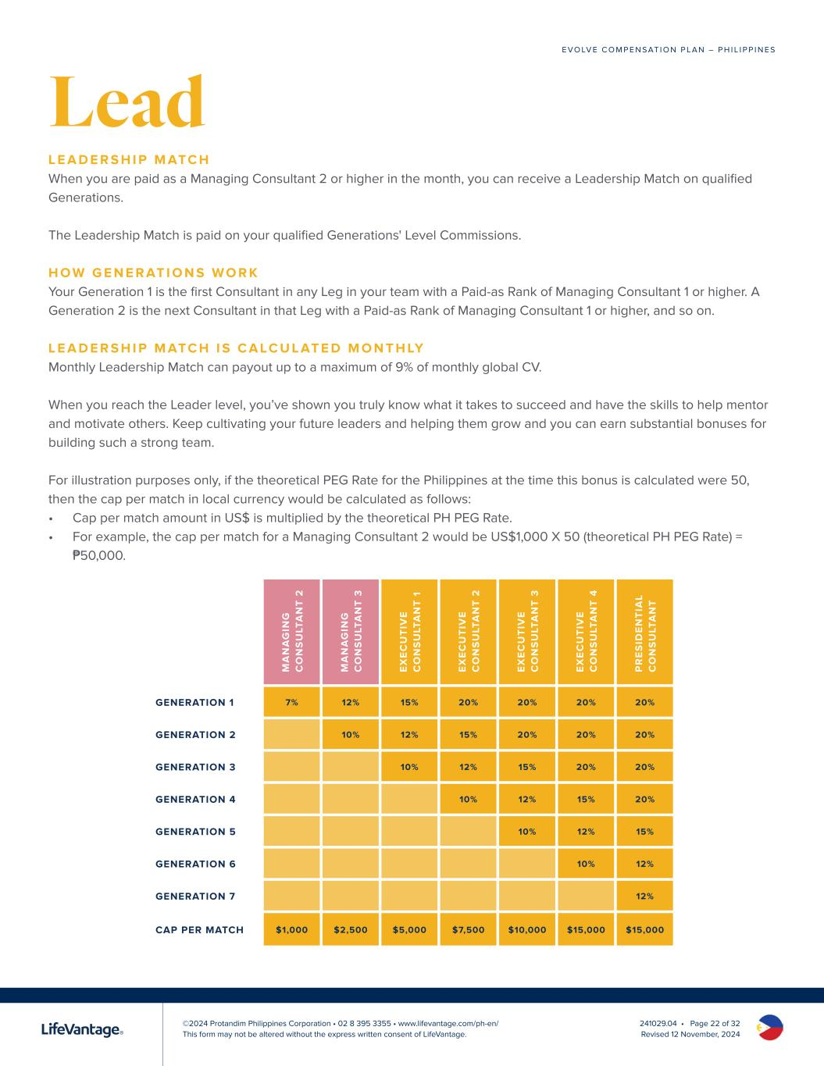
©2024 Protandim Philippines Corporation • 02 8 395 3355 • www.lifevantage.com/ph-en/ This form may not be altered without the express written consent of LifeVantage. E V O LV E C O M P E N S AT I O N P L A N – P H I L I P P I N E S 241029.04 • Page 22 of 32 Revised 12 November, 2024 Lead L E A D E R S H I P M ATC H When you are paid as a Managing Consultant 2 or higher in the month, you can receive a Leadership Match on qualified Generations. The Leadership Match is paid on your qualified Generations' Level Commissions. H O W G E N E R AT I O N S W O R K Your Generation 1 is the first Consultant in any Leg in your team with a Paid-as Rank of Managing Consultant 1 or higher. A Generation 2 is the next Consultant in that Leg with a Paid-as Rank of Managing Consultant 1 or higher, and so on. L E A D E R S H I P M ATC H I S C A LC U L AT E D M O N T H LY Monthly Leadership Match can payout up to a maximum of 9% of monthly global CV. When you reach the Leader level, you’ve shown you truly know what it takes to succeed and have the skills to help mentor and motivate others. Keep cultivating your future leaders and helping them grow and you can earn substantial bonuses for building such a strong team. For illustration purposes only, if the theoretical PEG Rate for the Philippines at the time this bonus is calculated were 50, then the cap per match in local currency would be calculated as follows: • Cap per match amount in US$ is multiplied by the theoretical PH PEG Rate. • For example, the cap per match for a Managing Consultant 2 would be US$1,000 X 50 (theoretical PH PEG Rate) = ₱50,000. M A N A G IN G C O N S U LT A N T 2 M A N A G IN G C O N S U LT A N T 3 E X E C U T IV E C O N S U LT A N T 1 E X E C U T IV E C O N S U LT A N T 2 E X E C U T IV E C O N S U LT A N T 3 E X E C U T IV E C O N S U LT A N T 4 P R E S ID E N T IA L C O N S U LT A N T GENERATION 1 7% 12% 15% 20% 20% 20% 20% GENERATION 2 10% 12% 15% 20% 20% 20% GENERATION 3 10% 12% 15% 20% 20% GENERATION 4 10% 12% 15% 20% GENERATION 5 10% 12% 15% GENERATION 6 10% 12% GENERATION 7 12% CAP PER MATCH $1,000 $2,500 $5,000 $7,500 $10,000 $15,000 $15,000

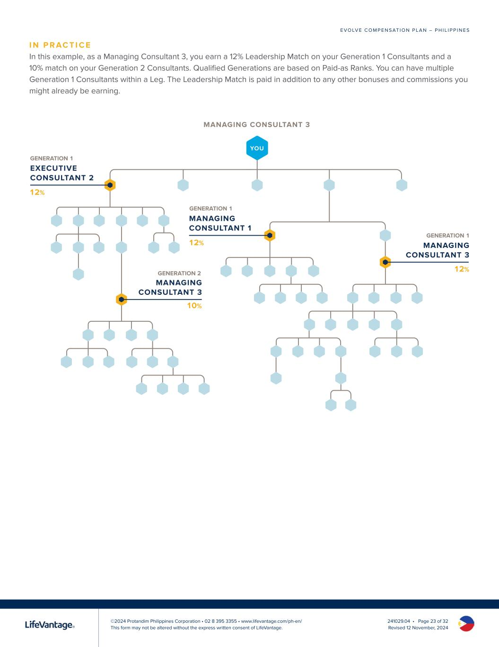
©2024 Protandim Philippines Corporation • 02 8 395 3355 • www.lifevantage.com/ph-en/ This form may not be altered without the express written consent of LifeVantage. E V O LV E C O M P E N S AT I O N P L A N – P H I L I P P I N E S 241029.04 • Page 23 of 32 Revised 12 November, 2024 I N P R AC T I C E In this example, as a Managing Consultant 3, you earn a 12% Leadership Match on your Generation 1 Consultants and a 10% match on your Generation 2 Consultants. Qualified Generations are based on Paid-as Ranks. You can have multiple Generation 1 Consultants within a Leg. The Leadership Match is paid in addition to any other bonuses and commissions you might already be earning. YOU MANAGING CONSULTANT 3 10% 12% EXECUTIVE CONSULTANT 2 12% MANAGING CONSULTANT 1 12% MANAGING CONSULTANT 3 MANAGING CONSULTANT 3 GENERATION 1 GENERATION 1 GENERATION 2 GENERATION 1

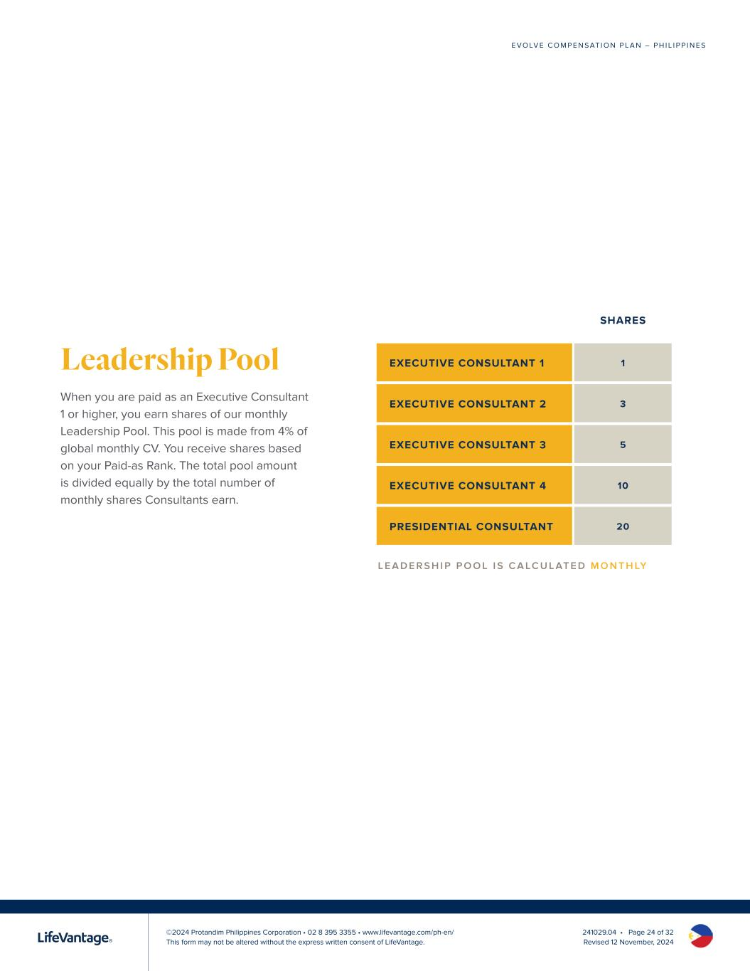
©2024 Protandim Philippines Corporation • 02 8 395 3355 • www.lifevantage.com/ph-en/ This form may not be altered without the express written consent of LifeVantage. E V O LV E C O M P E N S AT I O N P L A N – P H I L I P P I N E S 241029.04 • Page 24 of 32 Revised 12 November, 2024 Leadership Pool When you are paid as an Executive Consultant 1 or higher, you earn shares of our monthly Leadership Pool. This pool is made from 4% of global monthly CV. You receive shares based on your Paid-as Rank. The total pool amount is divided equally by the total number of monthly shares Consultants earn. SHARES EXECUTIVE CONSULTANT 1 1 EXECUTIVE CONSULTANT 2 3 EXECUTIVE CONSULTANT 3 5 EXECUTIVE CONSULTANT 4 10 PRESIDENTIAL CONSULTANT 20 L E A D E R S H I P P O O L I S C A LC U L AT E D M O N T H LY

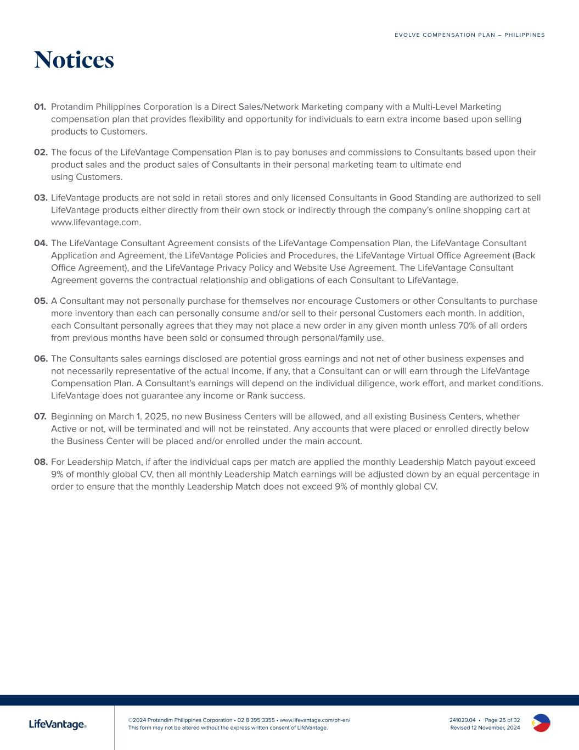
©2024 Protandim Philippines Corporation • 02 8 395 3355 • www.lifevantage.com/ph-en/ This form may not be altered without the express written consent of LifeVantage. E V O LV E C O M P E N S AT I O N P L A N – P H I L I P P I N E S 241029.04 • Page 25 of 32 Revised 12 November, 2024 Notices 01. Protandim Philippines Corporation is a Direct Sales/Network Marketing company with a Multi-Level Marketing compensation plan that provides flexibility and opportunity for individuals to earn extra income based upon selling products to Customers. 02. The focus of the LifeVantage Compensation Plan is to pay bonuses and commissions to Consultants based upon their product sales and the product sales of Consultants in their personal marketing team to ultimate end using Customers. 03. LifeVantage products are not sold in retail stores and only licensed Consultants in Good Standing are authorized to sell LifeVantage products either directly from their own stock or indirectly through the company’s online shopping cart at www.lifevantage.com. 04. The LifeVantage Consultant Agreement consists of the LifeVantage Compensation Plan, the LifeVantage Consultant Application and Agreement, the LifeVantage Policies and Procedures, the LifeVantage Virtual Office Agreement (Back Office Agreement), and the LifeVantage Privacy Policy and Website Use Agreement. The LifeVantage Consultant Agreement governs the contractual relationship and obligations of each Consultant to LifeVantage. 05. A Consultant may not personally purchase for themselves nor encourage Customers or other Consultants to purchase more inventory than each can personally consume and/or sell to their personal Customers each month. In addition, each Consultant personally agrees that they may not place a new order in any given month unless 70% of all orders from previous months have been sold or consumed through personal/family use. 06. The Consultants sales earnings disclosed are potential gross earnings and not net of other business expenses and not necessarily representative of the actual income, if any, that a Consultant can or will earn through the LifeVantage Compensation Plan. A Consultant's earnings will depend on the individual diligence, work effort, and market conditions. LifeVantage does not guarantee any income or Rank success. 07. Beginning on March 1, 2025, no new Business Centers will be allowed, and all existing Business Centers, whether Active or not, will be terminated and will not be reinstated. Any accounts that were placed or enrolled directly below the Business Center will be placed and/or enrolled under the main account. 08. For Leadership Match, if after the individual caps per match are applied the monthly Leadership Match payout exceed 9% of monthly global CV, then all monthly Leadership Match earnings will be adjusted down by an equal percentage in order to ensure that the monthly Leadership Match does not exceed 9% of monthly global CV.




LIFEVANTAGE獨立顧問獎金計畫 台灣 2025年3月1日下午3時生效

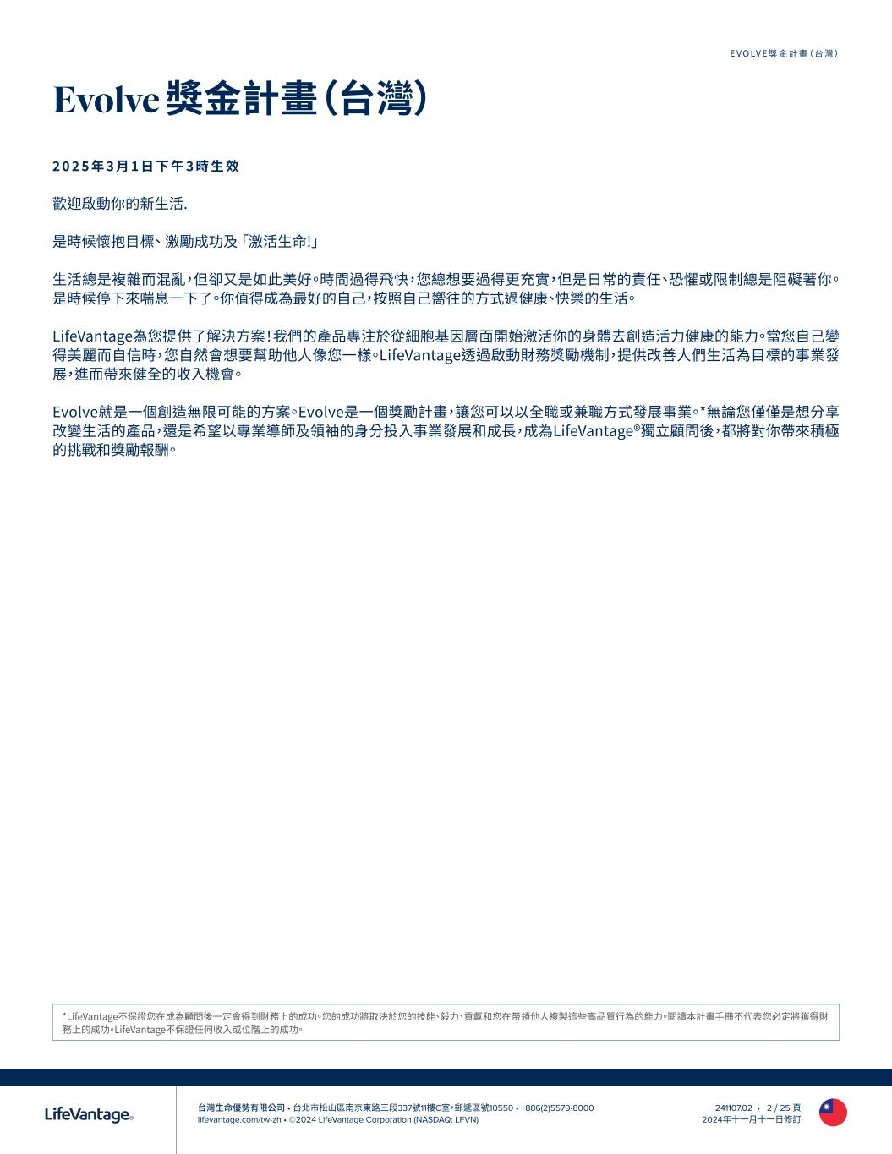
台灣生命優勢有限公司 • 台北市松山區南京東路三段337號11樓C室，郵遞區號10550 • +886(2)5579-8000 lifevantage.com/tw-zh • ©2024 LifeVantage Corporation (NASDAQ: LFVN) EVOLVE獎金計畫（台灣） 241107.02 • 2 / 25 頁 2024年十一月十一日修訂 Evolve 獎金計畫（台灣） 2 0 2 5 年 3 月 1 日 下 午 3 時 生 效 歡迎啟動你的新生活. 是時候懷抱目標、 激勵成功及 「激活生命!」 生活總是複雜而混亂，但卻又是如此美好。時間過得飛快，您總想要過得更充實，但是日常的責任、恐懼或限制總是阻礙著你。 是時候停下來喘息一下了。你值得成為最好的自己，按照自己嚮往的方式過健康、快樂的生活。 LifeVantage為您提供了解決方案！我們的產品專注於從細胞基因層面開始激活你的身體去創造活力健康的能力。當您自己變 得美麗而自信時，您自然會想要幫助他人像您一樣。LifeVantage透過啟動財務獎勵機制，提供改善人們生活為目標的事業發 展，進而帶來健全的收入機會。 Evolve就是一個創造無限可能的方案。Evolve是一個獎勵計畫，讓您可以以全職或兼職方式發展事業。*無論您僅僅是想分享 改變生活的產品，還是希望以專業導師及領袖的身分投入事業發展和成長，成為LifeVantage®獨立顧問後，都將對你帶來積極 的挑戰和獎勵報酬。 *LifeVantage不保證您在成為顧問後一定會得到財務上的成功。您的成功將取決於您的技能、毅力、貢獻和您在帶領他人複製這些高品質行為的能力。閱讀本計畫手冊不代表您必定將獲得財 務上的成功。LifeVantage不保證任何收入或位階上的成功。

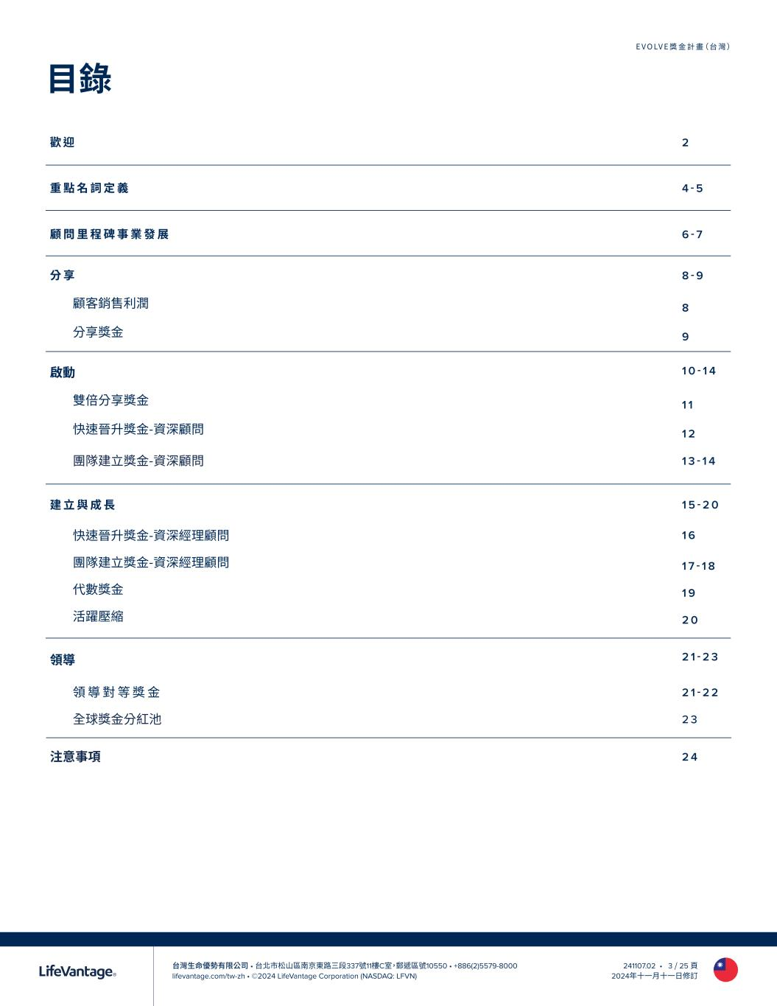
台灣生命優勢有限公司 • 台北市松山區南京東路三段337號11樓C室，郵遞區號10550 • +886(2)5579-8000 lifevantage.com/tw-zh • ©2024 LifeVantage Corporation (NASDAQ: LFVN) EVOLVE獎金計畫（台灣） 241107.02 • 3 / 25 頁 2024年十一月十一日修訂 歡 迎 2 重 點 名 詞 定 義 4 - 5 顧 問 里 程 碑 事 業 發 展 6 - 7 分 享 8 - 9 顧客銷售利潤 8 分享獎金 9 啟動 1 0 - 1 4 雙倍分享獎金 1 1 快速晉升獎金-資深顧問 1 2 團隊建立獎金-資深顧問 1 3 - 1 4 建 立 與 成 長 1 5 - 2 0 快速晉升獎金-資深經理顧問 1 6 團隊建立獎金-資深經理顧問 1 7 - 1 8 代數獎金 1 9 活躍壓縮 2 0 領導 2 1 - 2 3 領 導 對 等 獎 金 2 1 - 2 2 全球獎金分紅池 2 3 注意事項 2 4 目錄

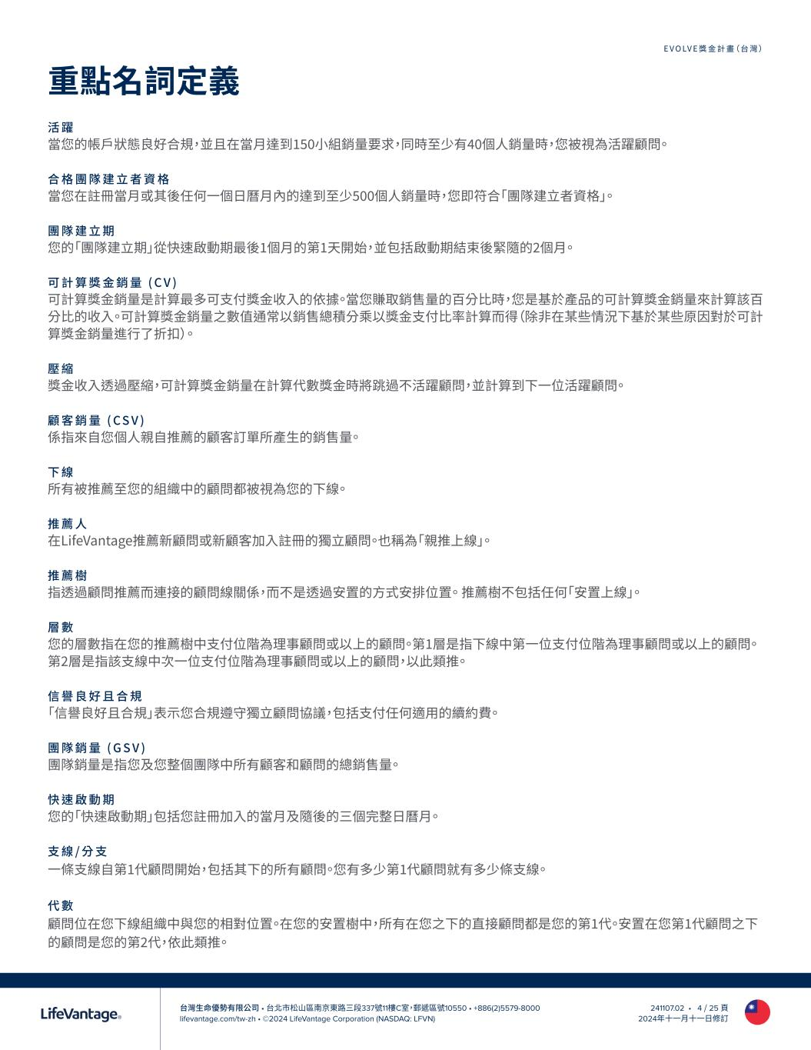
台灣生命優勢有限公司 • 台北市松山區南京東路三段337號11樓C室，郵遞區號10550 • +886(2)5579-8000 lifevantage.com/tw-zh • ©2024 LifeVantage Corporation (NASDAQ: LFVN) EVOLVE獎金計畫（台灣） 241107.02 • 4 / 25 頁 2024年十一月十一日修訂 重點名詞定義 活 躍 當您的帳戶狀態良好合規，並且在當月達到150小組銷量要求，同時至少有40個人銷量時，您被視為活躍顧問。 合 格 團 隊 建 立 者 資 格 當您在註冊當月或其後任何一個日曆月內的達到至少500個人銷量時，您即符合「團隊建立者資格」。 團 隊 建 立 期 您的「團隊建立期」從快速啟動期最後1個月的第1天開始，並包括啟動期結束後緊隨的2個月。 可 計 算 獎 金 銷 量 ( C V ) 可計算獎金銷量是計算最多可支付獎金收入的依據。當您賺取銷售量的百分比時，您是基於產品的可計算獎金銷量來計算該百 分比的收入。可計算獎金銷量之數值通常以銷售總積分乘以獎金支付比率計算而得（除非在某些情況下基於某些原因對於可計 算獎金銷量進行了折扣）。 壓 縮 獎金收入透過壓縮，可計算獎金銷量在計算代數獎金時將跳過不活躍顧問，並計算到下一位活躍顧問。 顧 客 銷 量 ( C S V ) 係指來自您個人親自推薦的顧客訂單所產生的銷售量。 下 線 所有被推薦至您的組織中的顧問都被視為您的下線。 推 薦 人 在LifeVantage推薦新顧問或新顧客加入註冊的獨立顧問。也稱為「親推上線」。 推 薦 樹 指透過顧問推薦而連接的顧問線關係，而不是透過安置的方式安排位置。 推薦樹不包括任何「安置上線」。 層 數 您的層數指在您的推薦樹中支付位階為理事顧問或以上的顧問。第1層是指下線中第一位支付位階為理事顧問或以上的顧問。 第2層是指該支線中次一位支付位階為理事顧問或以上的顧問，以此類推。 信 譽 良 好 且 合 規 「信譽良好且合規」表示您合規遵守獨立顧問協議，包括支付任何適用的續約費。 團 隊 銷 量 ( G S V ) 團隊銷量是指您及您整個團隊中所有顧客和顧問的總銷售量。 快 速 啟 動 期 您的「快速啟動期」包括您註冊加入的當月及隨後的三個完整日曆月。 支 線 / 分 支 一條支線自第1代顧問開始，包括其下的所有顧問。您有多少第1代顧問就有多少條支線。 代 數 顧問位在您下線組織中與您的相對位置。在您的安置樹中，所有在您之下的直接顧問都是您的第1代。安置在您第1代顧問之下 的顧問是您的第2代，依此類推。

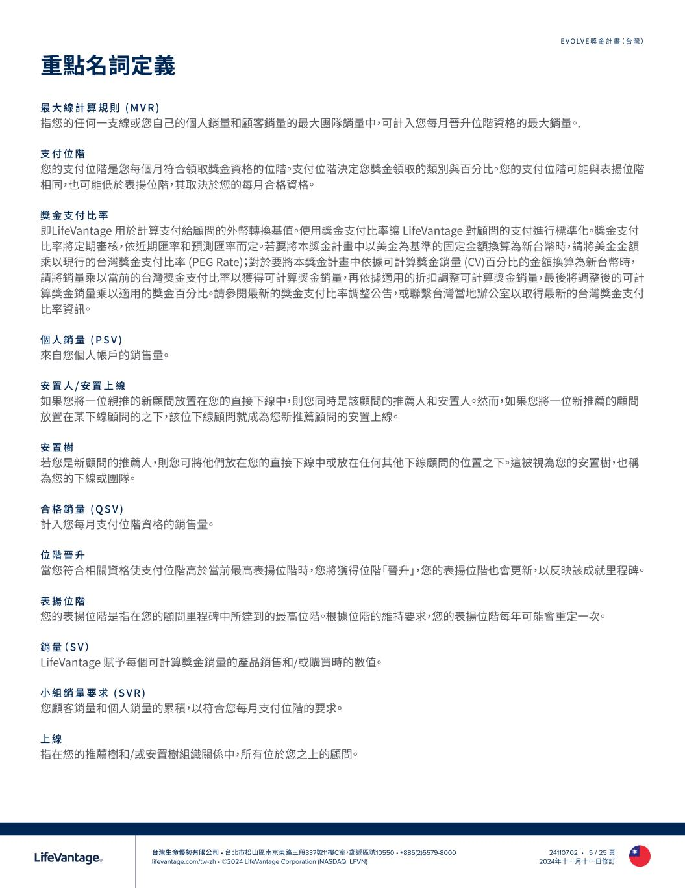
台灣生命優勢有限公司 • 台北市松山區南京東路三段337號11樓C室，郵遞區號10550 • +886(2)5579-8000 lifevantage.com/tw-zh • ©2024 LifeVantage Corporation (NASDAQ: LFVN) EVOLVE獎金計畫（台灣） 241107.02 • 5 / 25 頁 2024年十一月十一日修訂 重點名詞定義 最 大 線 計 算 規 則 ( M V R ) 指您的任何一支線或您自己的個人銷量和顧客銷量的最大團隊銷量中，可計入您每月晉升位階資格的最大銷量。. 支 付 位 階 您的支付位階是您每個月符合領取獎金資格的位階。支付位階決定您獎金領取的類別與百分比。您的支付位階可能與表揚位階 相同，也可能低於表揚位階，其取決於您的每月合格資格。 獎 金 支 付 比 率 即LifeVantage 用於計算支付給顧問的外幣轉換基值。使用獎金支付比率讓 LifeVantage 對顧問的支付進行標準化。獎金支付 比率將定期審核，依近期匯率和預測匯率而定。若要將本獎金計畫中以美金為基準的固定金額換算為新台幣時，請將美金金額 乘以現行的台灣獎金支付比率 (PEG Rate)；對於要將本獎金計畫中依據可計算獎金銷量 (CV)百分比的金額換算為新台幣時， 請將銷量乘以當前的台灣獎金支付比率以獲得可計算獎金銷量，再依據適用的折扣調整可計算獎金銷量，最後將調整後的可計 算獎金銷量乘以適用的獎金百分比。請參閱最新的獎金支付比率調整公告，或聯繫台灣當地辦公室以取得最新的台灣獎金支付 比率資訊。 個 人 銷 量 ( P S V ) 來自您個人帳戶的銷售量。 安 置 人 / 安 置 上 線 如果您將一位親推的新顧問放置在您的直接下線中，則您同時是該顧問的推薦人和安置人。然而，如果您將一位新推薦的顧問 放置在某下線顧問的之下，該位下線顧問就成為您新推薦顧問的安置上線。 安 置 樹 若您是新顧問的推薦人，則您可將他們放在您的直接下線中或放在任何其他下線顧問的位置之下。這被視為您的安置樹，也稱 為您的下線或團隊。 合 格 銷 量 ( Q S V ) 計入您每月支付位階資格的銷售量。 位 階 晉 升 當您符合相關資格使支付位階高於當前最高表揚位階時，您將獲得位階「晉升」，您的表揚位階也會更新，以反映該成就里程碑。 表 揚 位 階 您的表揚位階是指在您的顧問里程碑中所達到的最高位階。根據位階的維持要求，您的表揚位階每年可能會重定一次。 銷 量（ S V ） LifeVantage 賦予每個可計算獎金銷量的產品銷售和/或購買時的數值。 小 組 銷 量 要 求 ( S V R ) 您顧客銷量和個人銷量的累積，以符合您每月支付位階的要求。 上 線 指在您的推薦樹和/或安置樹組織關係中，所有位於您之上的顧問。

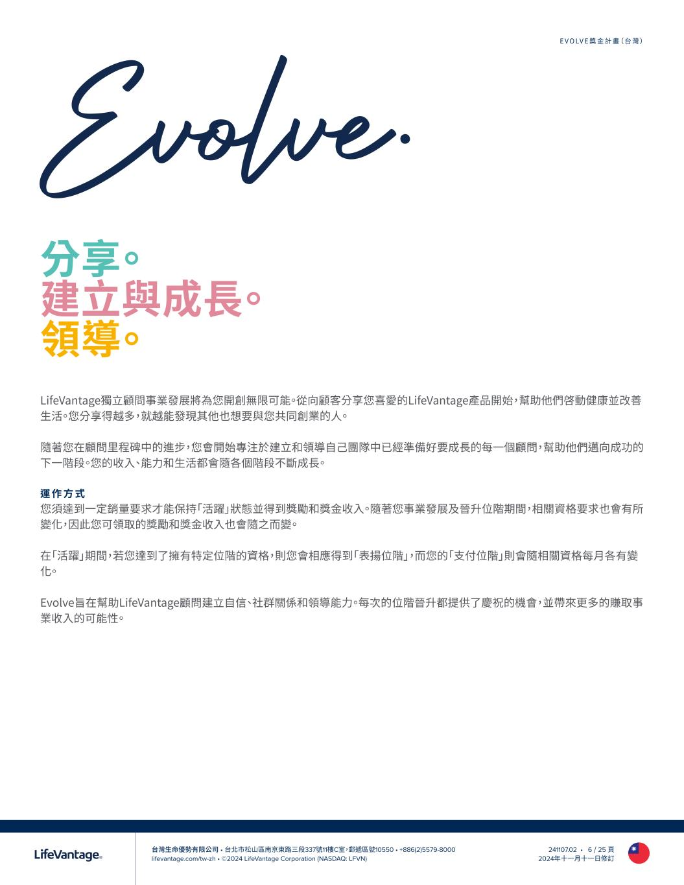
台灣生命優勢有限公司 • 台北市松山區南京東路三段337號11樓C室，郵遞區號10550 • +886(2)5579-8000 lifevantage.com/tw-zh • ©2024 LifeVantage Corporation (NASDAQ: LFVN) EVOLVE獎金計畫（台灣） 241107.02 • 6 / 25 頁 2024年十一月十一日修訂 LifeVantage獨立顧問事業發展將為您開創無限可能。從向顧客分享您喜愛的LifeVantage產品開始，幫助他們啓動健康並改善 生活。您分享得越多，就越能發現其他也想要與您共同創業的人。 隨著您在顧問里程碑中的進步，您會開始專注於建立和領導自己團隊中已經準備好要成長的每一個顧問，幫助他們邁向成功的 下一階段。您的收入、能力和生活都會隨各個階段不斷成長。 運 作 方 式 您須達到一定銷量要求才能保持「活躍」狀態並得到獎勵和獎金收入。隨著您事業發展及晉升位階期間，相關資格要求也會有所 變化，因此您可領取的獎勵和獎金收入也會隨之而變。 在「活躍」期間，若您達到了擁有特定位階的資格，則您會相應得到「表揚位階」，而您的「支付位階」則會隨相關資格每月各有變 化。 Evolve旨在幫助LifeVantage顧問建立自信、社群關係和領導能力。每次的位階晉升都提供了慶祝的機會，並帶來更多的賺取事 業收入的可能性。 分享。 建立與成長。 領導。 Evolve.

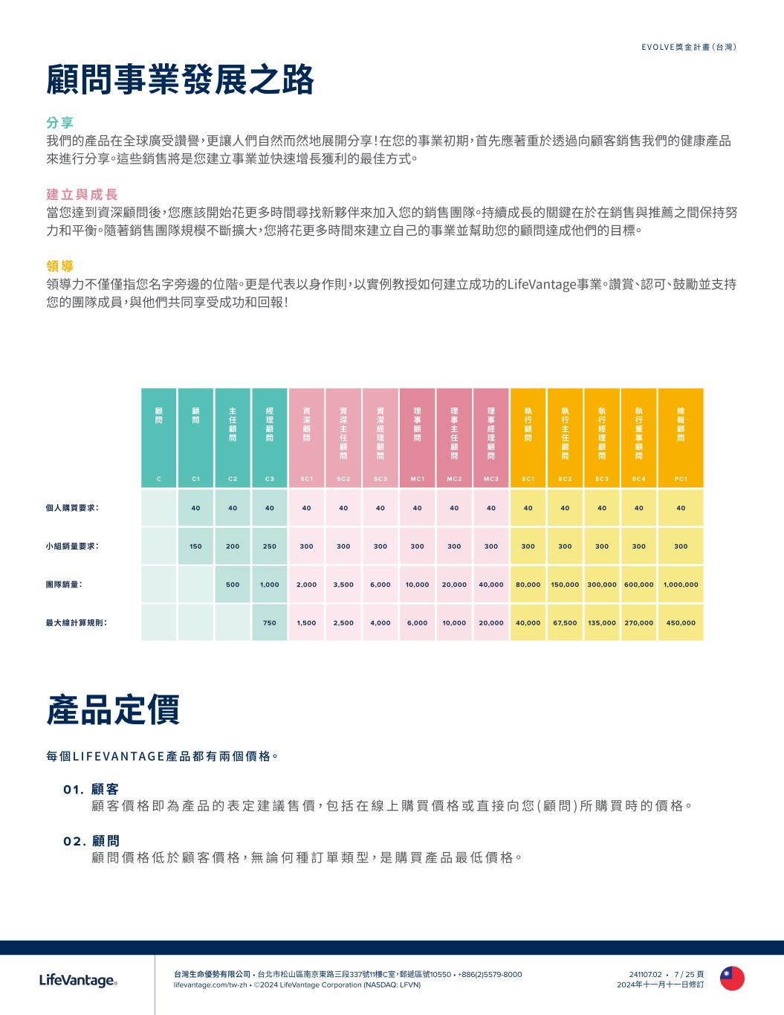
台灣生命優勢有限公司 • 台北市松山區南京東路三段337號11樓C室，郵遞區號10550 • +886(2)5579-8000 lifevantage.com/tw-zh • ©2024 LifeVantage Corporation (NASDAQ: LFVN) EVOLVE獎金計畫（台灣） 241107.02 • 7 / 25 頁 2024年十一月十一日修訂 顧問事業發展之路 分 享 我們的產品在全球廣受讚譽，更讓人們自然而然地展開分享！在您的事業初期，首先應著重於透過向顧客銷售我們的健康產品 來進行分享。這些銷售將是您建立事業並快速增長獲利的最佳方式。 建 立 與 成 長 當您達到資深顧問後，您應該開始花更多時間尋找新夥伴來加入您的銷售團隊。持續成長的關鍵在於在銷售與推薦之間保持努 力和平衡。隨著銷售團隊規模不斷擴大，您將花更多時間來建立自己的事業並幫助您的顧問達成他們的目標。 領 導 領導力不僅僅指您名字旁邊的位階。更是代表以身作則，以實例教授如何建立成功的LifeVantage事業。讚賞、認可、鼓勵並支持 您的團隊成員，與他們共同享受成功和回報！ 產品定價 每 個 L I F E V A N TA G E 產 品 都 有 兩 個 價 格。 0 1 . 顧 客 顧 客 價 格 即 為 產 品 的 表 定 建 議 售 價，包 括 在 線 上 購 買 價 格 或 直 接 向 您 ( 顧 問 ) 所 購 買 時 的 價 格。 0 2 . 顧 問 顧 問 價 格 低 於 顧 客 價 格，無 論 何 種 訂 單 類 型，是 購 買 產 品 最 低 價 格。 顧 問 顧 問 主 任 顧 問 經 理 顧 問 資 深 顧 問 資 深 主 任 顧 問 資 深 經 理 顧 問 理 事 顧 問 理 事 主 任 顧 問 理 事 經 理 顧 問 執 行 顧 問 執 行 主 任 顧 問 執 行 經 理 顧 問 執 行 董 事 顧 問 總 裁 顧 問 C C1 C2 C3 SC1 SC2 SC3 MC1 MC2 MC3 EC1 EC2 EC3 EC 4 PC1 個人購買要求： 40 40 40 40 40 40 40 40 40 40 40 40 40 40 小組銷量要求： 150 200 250 300 300 300 300 300 300 300 300 300 300 300 團隊銷量： 500 1,000 2,000 3,500 6,000 10,000 20,000 40,000 80,000 150,000 300,000 600,000 1,000,000 最大線計算規則： 750 1,500 2,500 4,000 6,000 10,000 20,000 40,000 67,500 135,000 270,000 450,000

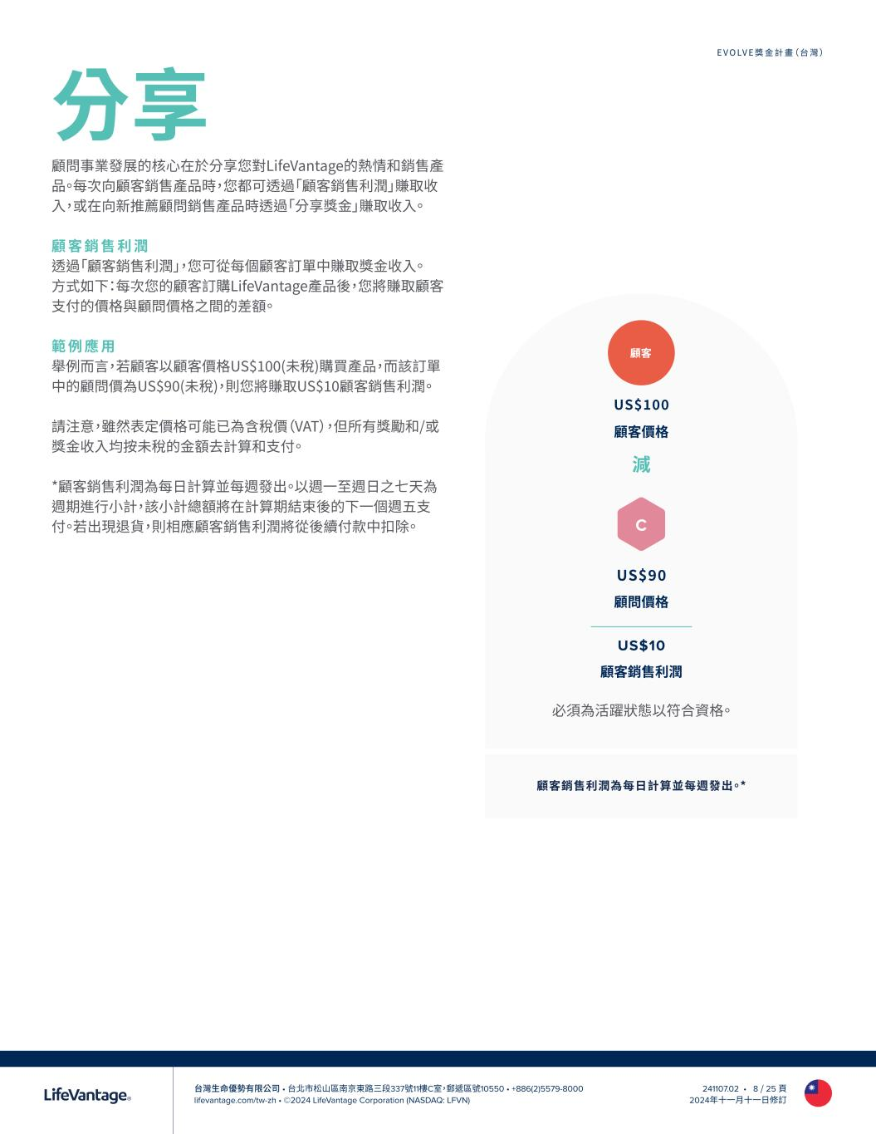
台灣生命優勢有限公司 • 台北市松山區南京東路三段337號11樓C室，郵遞區號10550 • +886(2)5579-8000 lifevantage.com/tw-zh • ©2024 LifeVantage Corporation (NASDAQ: LFVN) EVOLVE獎金計畫（台灣） 241107.02 • 8 / 25 頁 2024年十一月十一日修訂 分享 顧問事業發展的核心在於分享您對LifeVantage的熱情和銷售產 品。每次向顧客銷售產品時，您都可透過「顧客銷售利潤」賺取收 入，或在向新推薦顧問銷售產品時透過「分享獎金」賺取收入。 顧 客 銷 售 利 潤 透過「顧客銷售利潤」，您可從每個顧客訂單中賺取獎金收入。 方式如下：每次您的顧客訂購LifeVantage產品後，您將賺取顧客 支付的價格與顧問價格之間的差額。 範 例 應 用 舉例而言，若顧客以顧客價格US$100(未稅)購買產品，而該訂單 中的顧問價為US$90(未稅)，則您將賺取US$10顧客銷售利潤。 請注意，雖然表定價格可能已為含稅價（VAT），但所有獎勵和/或 獎金收入均按未稅的金額去計算和支付。 *顧客銷售利潤為每日計算並每週發出。以週一至週日之七天為 週期進行小計，該小計總額將在計算期結束後的下一個週五支 付。若出現退貨，則相應顧客銷售利潤將從後續付款中扣除。 US$100 顧客價格 減 US$90 顧問價格 US$10 顧客銷售利潤 顧客銷售利潤為每日計算並每週發出。* 顧客 C 必須為活躍狀態以符合資格。

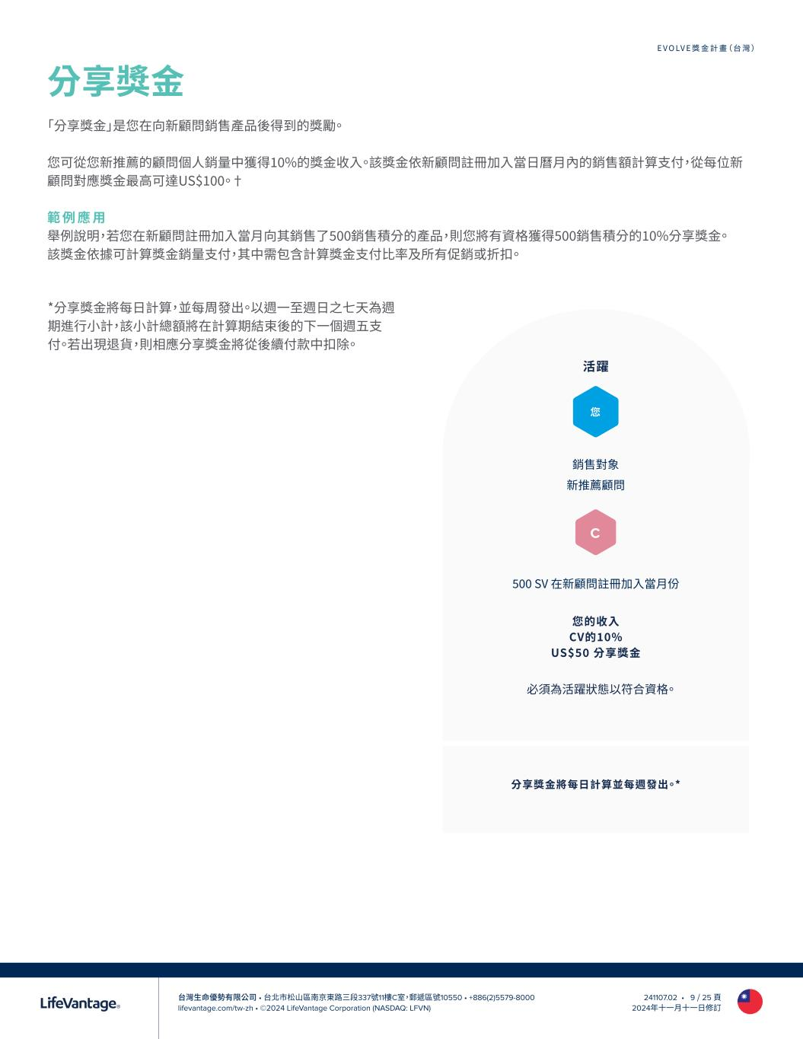
台灣生命優勢有限公司 • 台北市松山區南京東路三段337號11樓C室，郵遞區號10550 • +886(2)5579-8000 lifevantage.com/tw-zh • ©2024 LifeVantage Corporation (NASDAQ: LFVN) EVOLVE獎金計畫（台灣） 241107.02 • 9 / 25 頁 2024年十一月十一日修訂 分享獎金 「分享獎金」是您在向新顧問銷售產品後得到的獎勵。 您可從您新推薦的顧問個人銷量中獲得10%的獎金收入。該獎金依新顧問註冊加入當日曆月內的銷售額計算支付，從每位新 顧問對應獎金最高可達US$100。† 範 例 應 用 舉例說明，若您在新顧問註冊加入當月向其銷售了500銷售積分的產品，則您將有資格獲得500銷售積分的10%分享獎金。 該獎金依據可計算獎金銷量支付，其中需包含計算獎金支付比率及所有促銷或折扣。 分享獎金將每日計算並每週發出。* 銷售對象 新推薦顧問 500 SV 在新顧問註冊加入當月份 活躍 您的收入 CV的10% US$50 分享獎金 您 必須為活躍狀態以符合資格。 C *分享獎金將每日計算，並每周發出。以週一至週日之七天為週 期進行小計，該小計總額將在計算期結束後的下一個週五支 付。若出現退貨，則相應分享獎金將從後續付款中扣除。

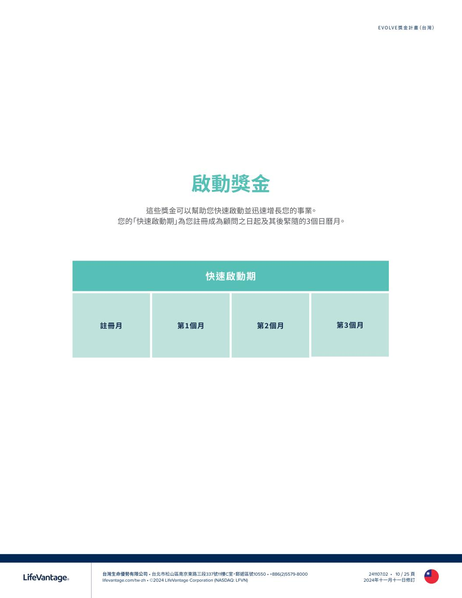
台灣生命優勢有限公司 • 台北市松山區南京東路三段337號11樓C室，郵遞區號10550 • +886(2)5579-8000 lifevantage.com/tw-zh • ©2024 LifeVantage Corporation (NASDAQ: LFVN) EVOLVE獎金計畫（台灣） 241107.02 • 10 / 25 頁 2024年十一月十一日修訂 啟動獎金 這些獎金可以幫助您快速啟動並迅速增長您的事業。 您的「快速啟動期」為您註冊成為顧問之日起及其後緊隨的3個日曆月。 快速啟動期 註冊月 第1個月 第2個月 第3個月

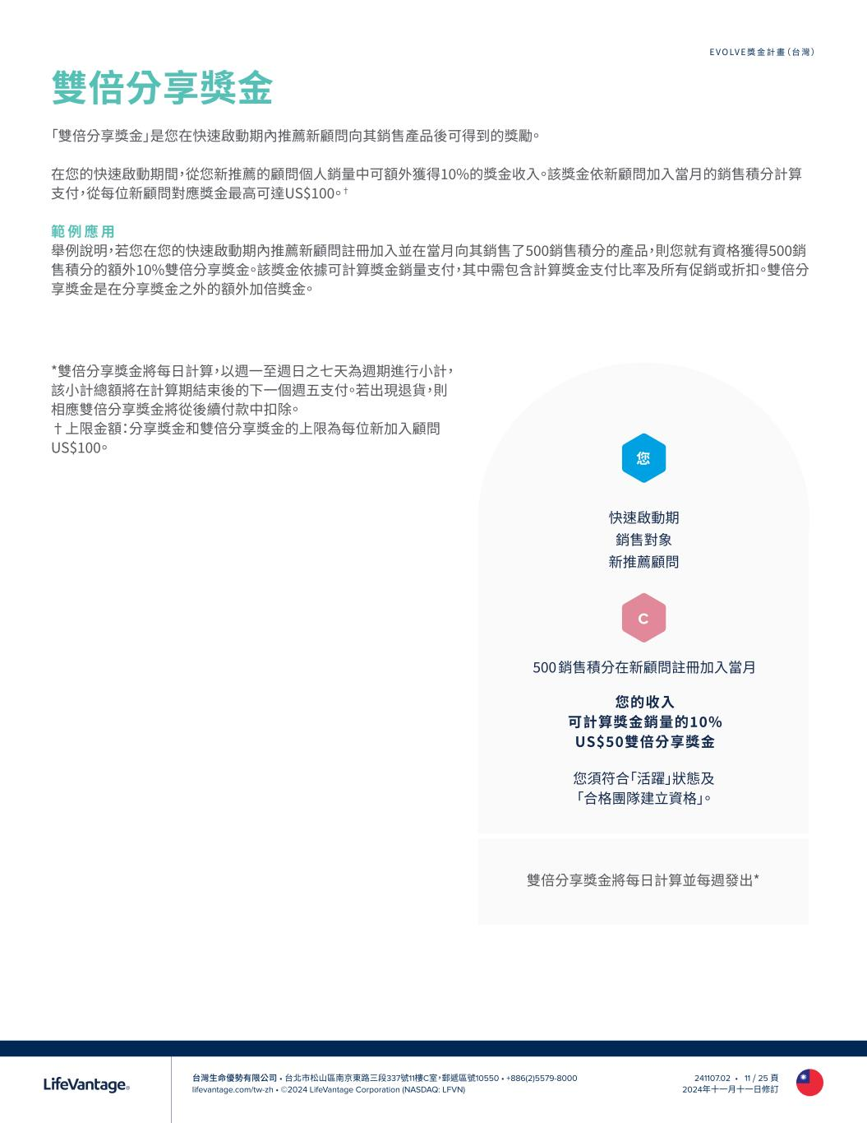
台灣生命優勢有限公司 • 台北市松山區南京東路三段337號11樓C室，郵遞區號10550 • +886(2)5579-8000 lifevantage.com/tw-zh • ©2024 LifeVantage Corporation (NASDAQ: LFVN) EVOLVE獎金計畫（台灣） 241107.02 • 11 / 25 頁 2024年十一月十一日修訂 雙倍分享獎金 「雙倍分享獎金」是您在快速啟動期內推薦新顧問向其銷售產品後可得到的獎勵。 在您的快速啟動期間，從您新推薦的顧問個人銷量中可額外獲得10%的獎金收入。該獎金依新顧問加入當月的銷售積分計算 支付，從每位新顧問對應獎金最高可達US$100。† 範 例 應 用 舉例說明，若您在您的快速啟動期內推薦新顧問註冊加入並在當月向其銷售了500銷售積分的產品，則您就有資格獲得500銷 售積分的額外10%雙倍分享獎金。該獎金依據可計算獎金銷量支付，其中需包含計算獎金支付比率及所有促銷或折扣。雙倍分 享獎金是在分享獎金之外的額外加倍獎金。 *雙倍分享獎金將每日計算，以週一至週日之七天為週期進行小計， 該小計總額將在計算期結束後的下一個週五支付。若出現退貨，則 相應雙倍分享獎金將從後續付款中扣除。 †上限金額：分享獎金和雙倍分享獎金的上限為每位新加入顧問 US$100。 快速啟動期 銷售對象 新推薦顧問 500 銷售積分在新顧問註冊加入當月 您的收入 可計算獎金銷量的10% US$50雙倍分享獎金 您 C 您須符合「活躍」狀態及 「合格團隊建立資格」。 雙倍分享獎金將每日計算並每週發出*

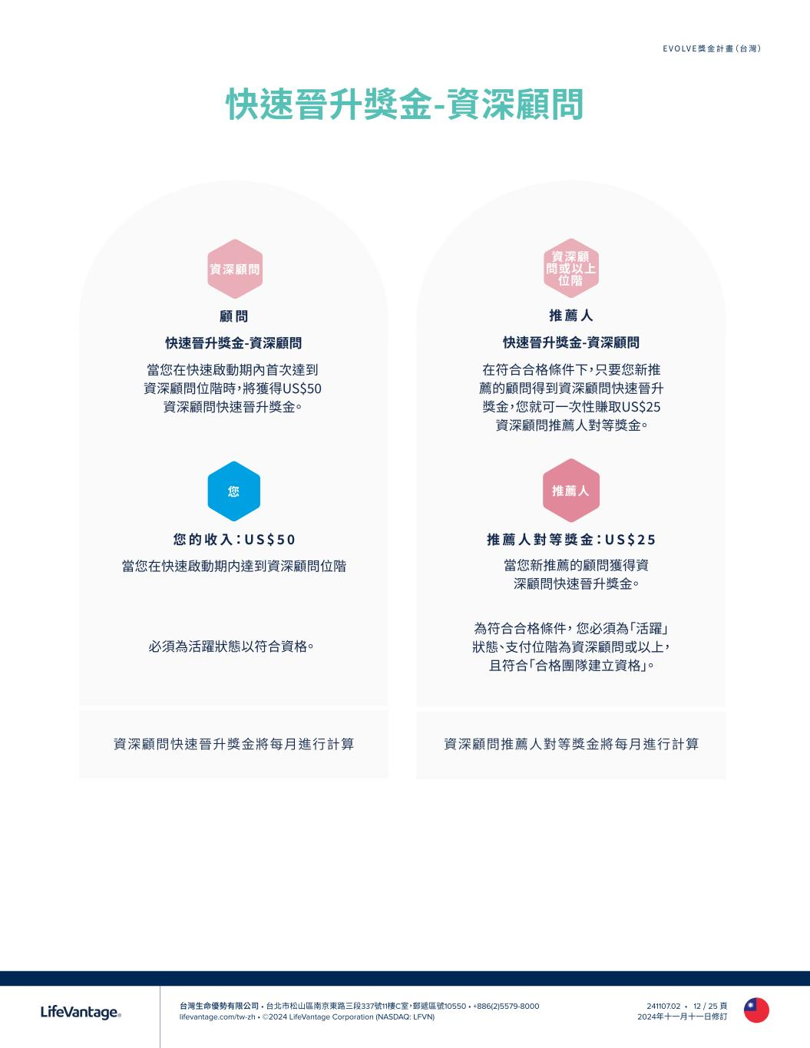
台灣生命優勢有限公司 • 台北市松山區南京東路三段337號11樓C室，郵遞區號10550 • +886(2)5579-8000 lifevantage.com/tw-zh • ©2024 LifeVantage Corporation (NASDAQ: LFVN) EVOLVE獎金計畫（台灣） 241107.02 • 12 / 25 頁 2024年十一月十一日修訂 資深顧問快速晉升獎金將每月進行計算 快速晉升獎金-資深顧問 資深顧問推薦人對等獎金將每月進行計算 您 的 收 入：U S $ 5 0 當您在快速啟動期内達到資深顧問位階 您 必須為活躍狀態以符合資格。 資深顧問 顧 問 快速晉升獎金-資深顧問 當您在快速啟動期內首次達到 資深顧問位階時，將獲得US$50 資深顧問快速晉升獎金。 推 薦 人 對 等 獎 金：U S $ 2 5 當您新推薦的顧問獲得資 深顧問快速晉升獎金。 推薦人 資深顧 問或以上 位階 推 薦 人 快速晉升獎金-資深顧問 在符合合格條件下，只要您新推 薦的顧問得到資深顧問快速晉升 獎金，您就可一次性賺取US$25 資深顧問推薦人對等獎金。 為符合合格條件， 您必須為「活躍」 狀態、支付位階為資深顧問或以上， 且符合「合格團隊建立資格」。

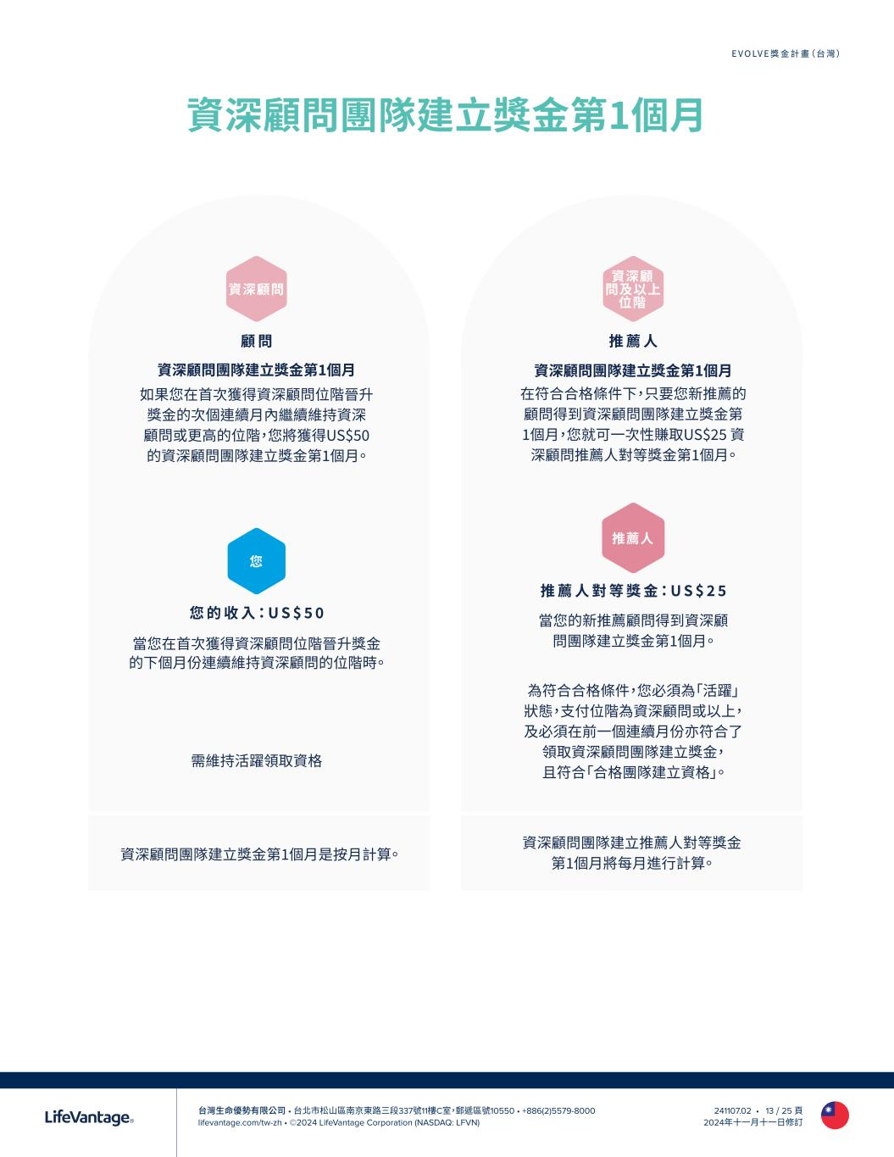
台灣生命優勢有限公司 • 台北市松山區南京東路三段337號11樓C室，郵遞區號10550 • +886(2)5579-8000 lifevantage.com/tw-zh • ©2024 LifeVantage Corporation (NASDAQ: LFVN) EVOLVE獎金計畫（台灣） 241107.02 • 13 / 25 頁 2024年十一月十一日修訂 資深顧問團隊建立獎金第1個月 資深顧問團隊建立獎金第1個月是按月計算。 資深顧問團隊建立推薦人對等獎金 第1個月將每月進行計算。 您 的 收 入：U S $ 5 0 當您在首次獲得資深顧問位階晉升獎金 的下個月份連續維持資深顧問的位階時。 您 需維持活躍領取資格 資深顧問 顧 問 資深顧問團隊建立獎金第1個月 如果您在首次獲得資深顧問位階晉升 獎金的次個連續月內繼續維持資深 顧問或更高的位階，您將獲得US$50 的資深顧問團隊建立獎金第1個月。 推 薦 人 對 等 獎 金：U S $ 2 5 當您的新推薦顧問得到資深顧 問團隊建立獎金第1個月。 推薦人 資深顧 問及以上 位階 推 薦 人 資深顧問團隊建立獎金第1個月 在符合合格條件下，只要您新推薦的 顧問得到資深顧問團隊建立獎金第 1個月，您就可一次性賺取US$25 資 深顧問推薦人對等獎金第1個月。 為符合合格條件，您必須為「活躍」 狀態，支付位階為資深顧問或以上， 及必須在前一個連續月份亦符合了 領取資深顧問團隊建立獎金， 且符合「合格團隊建立資格」。

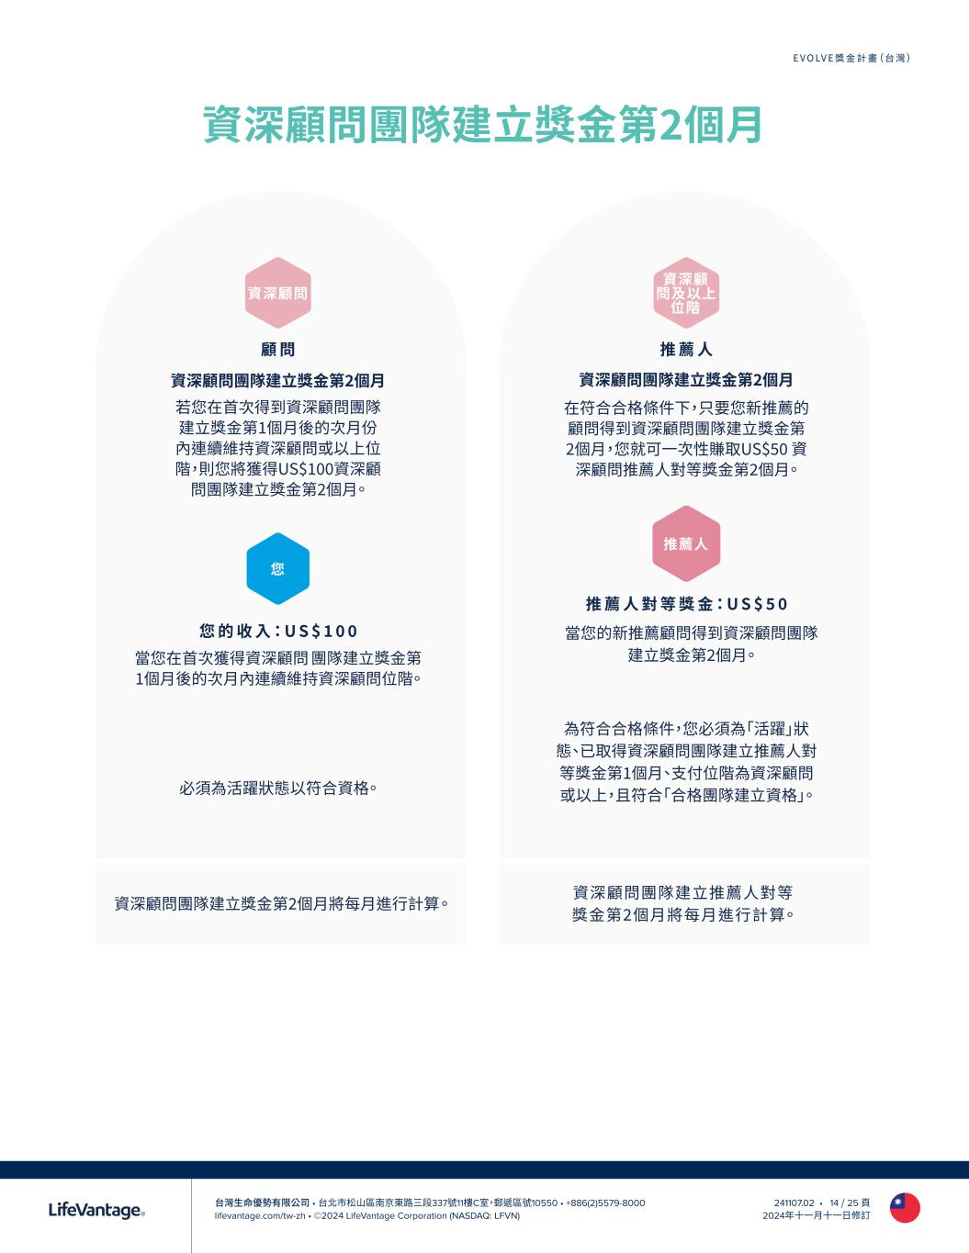
台灣生命優勢有限公司 • 台北市松山區南京東路三段337號11樓C室，郵遞區號10550 • +886(2)5579-8000 lifevantage.com/tw-zh • ©2024 LifeVantage Corporation (NASDAQ: LFVN) EVOLVE獎金計畫（台灣） 241107.02 • 14 / 25 頁 2024年十一月十一日修訂 資深顧問團隊建立獎金第2個月 資深顧問團隊建立獎金第2個月將每月進行計算 。 資深顧問團隊建立推薦人對等 獎金第2個月將每月進行計算 。 您 的 收 入：U S $ 1 0 0 當您在首次獲得資深顧問 團隊建立獎金第 1個月後的次月內連續維持資深顧問位階。 您 必須為活躍狀態以符合資格。 資深顧問 顧 問 資深顧問團隊建立獎金第2個月 若您在首次得到資深顧問團隊 建立獎金第1個月後的次月份 內連續維持資深顧問或以上位 階，則您將獲得US$100資深顧 問團隊建立獎金第2個月。 推 薦 人 對 等 獎 金：U S $ 5 0 當您的新推薦顧問得到資深顧問團隊 建立獎金第2個月。 推薦人 資深顧 問及以上 位階 推 薦 人 資深顧問團隊建立獎金第2個月 在符合合格條件下，只要您新推薦的 顧問得到資深顧問團隊建立獎金第 2個月，您就可一次性賺取US$50 資 深顧問推薦人對等獎金第2個月。 為符合合格條件，您必須為「活躍」狀 態、已取得資深顧問團隊建立推薦人對 等獎金第1個月、支付位階為資深顧問 或以上，且符合「合格團隊建立資格」。

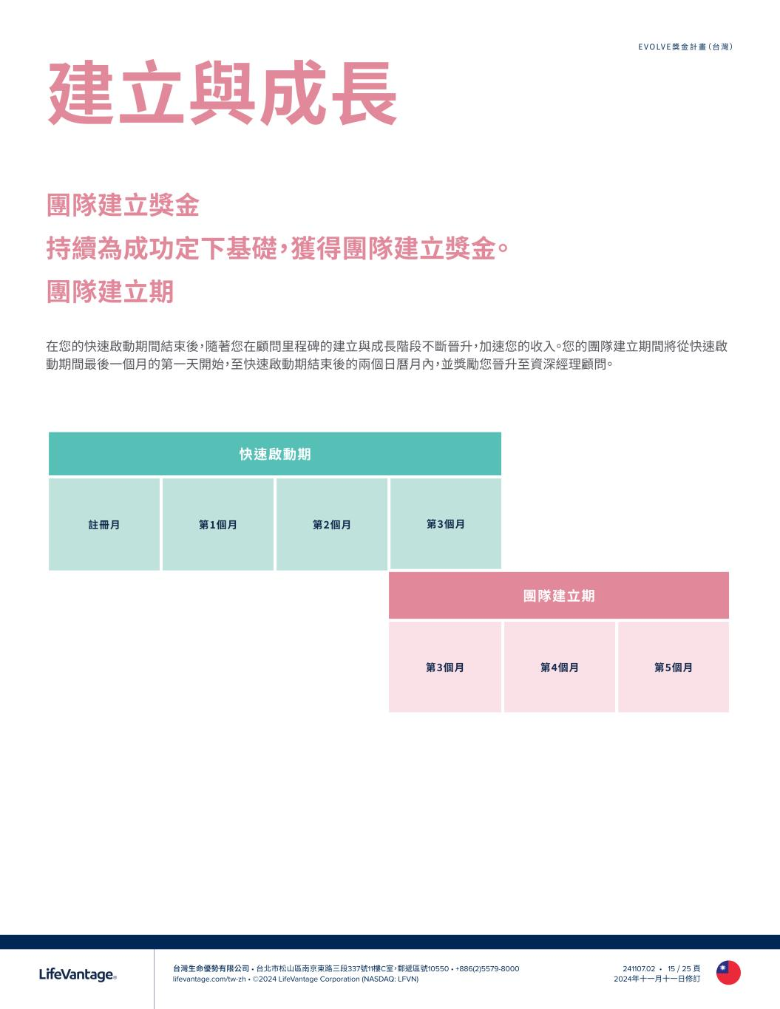
台灣生命優勢有限公司 • 台北市松山區南京東路三段337號11樓C室，郵遞區號10550 • +886(2)5579-8000 lifevantage.com/tw-zh • ©2024 LifeVantage Corporation (NASDAQ: LFVN) EVOLVE獎金計畫（台灣） 241107.02 • 15 / 25 頁 2024年十一月十一日修訂 在您的快速啟動期間結束後，隨著您在顧問里程碑的建立與成長階段不斷晉升，加速您的收入。您的團隊建立期間將從快速啟 動期間最後一個月的第一天開始，至快速啟動期結束後的兩個日曆月內，並獎勵您晉升至資深經理顧問。 團隊建立獎金 持續為成功定下基礎，獲得團隊建立獎金。 團隊建立期 快速啟動期 註冊月 第1個月 第2個月 第3個月 團隊建立期 第3個月 第4個月 第5個月 建立與成長

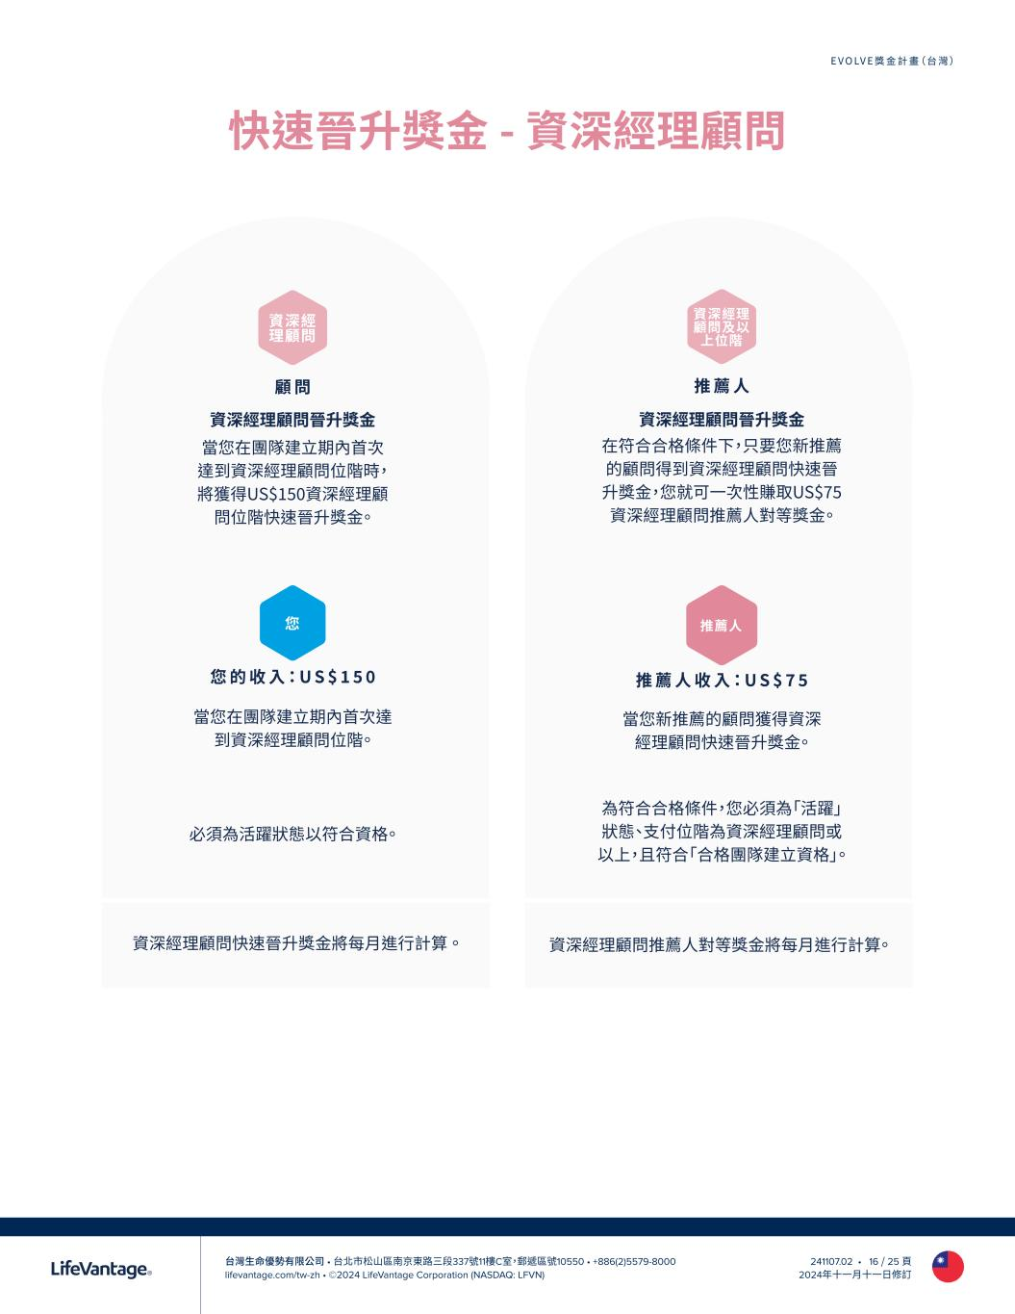
台灣生命優勢有限公司 • 台北市松山區南京東路三段337號11樓C室，郵遞區號10550 • +886(2)5579-8000 lifevantage.com/tw-zh • ©2024 LifeVantage Corporation (NASDAQ: LFVN) EVOLVE獎金計畫（台灣） 241107.02 • 16 / 25 頁 2024年十一月十一日修訂 快速晉升獎金 - 資深經理顧問 資深經理顧問快速晉升獎金將每月進行計算 。 資深經理顧問推薦人對等獎金將每月進行計算。 您 的 收 入：U S $ 1 5 0 當您在團隊建立期內首次達 到資深經理顧問位階。 您 必須為活躍狀態以符合資格。 資深經 理顧問 顧 問 資深經理顧問晉升獎金 當您在團隊建立期內首次 達到資深經理顧問位階時， 將獲得US$150資深經理顧 問位階快速晉升獎金。 推 薦 人 收 入：U S $ 7 5 當您新推薦的顧問獲得資深 經理顧問快速晉升獎金。 推薦人 資深經理 顧問及以 上位階 推 薦 人 資深經理顧問晉升獎金 在符合合格條件下，只要您新推薦 的顧問得到資深經理顧問快速晉 升獎金，您就可一次性賺取US$75 資深經理顧問推薦人對等獎金。 為符合合格條件，您必須為「活躍」 狀態、支付位階為資深經理顧問或 以上，且符合「合格團隊建立資格」。

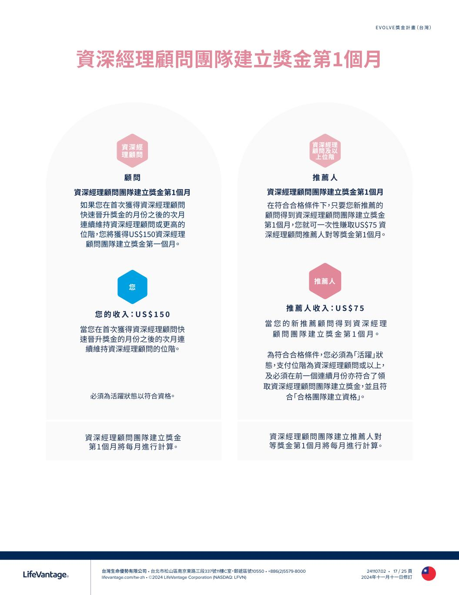
台灣生命優勢有限公司 • 台北市松山區南京東路三段337號11樓C室，郵遞區號10550 • +886(2)5579-8000 lifevantage.com/tw-zh • ©2024 LifeVantage Corporation (NASDAQ: LFVN) EVOLVE獎金計畫（台灣） 241107.02 • 17 / 25 頁 2024年十一月十一日修訂 資深經理顧問團隊建立獎金第1個月 資深經理顧問團隊建立獎金 第1個月將每月進行計算。 資深經理顧問團隊建立推薦人對 等獎金第1個月將每月進行計算。 您 的 收 入：U S $ 1 5 0 當您在首次獲得資深經理顧問快 速晉升獎金的月份之後的次月連 續維持資深經理顧問的位階。 您 必須為活躍狀態以符合資格。 資深經 理顧問 顧 問 資深經理顧問團隊建立獎金第1個月 如果您在首次獲得資深經理顧問 快速晉升獎金的月份之後的次月 連續維持資深經理顧問或更高的 位階，您將獲得US$150資深經理 顧問團隊建立獎金第一個月。 推 薦 人 收 入：U S $ 7 5 當 您 的 新 推 薦 顧 問 得 到 資 深 經 理 顧 問 團 隊 建 立 獎 金 第 1 個 月。 推薦人 資深經理 顧問及以 上位階 推 薦 人 資深經理顧問團隊建立獎金第1個月 在符合合格條件下，只要您新推薦的 顧問得到資深經理顧問團隊建立獎金 第1個月，您就可一次性賺取US$75 資 深經理顧問推薦人對等獎金第1個月。 為符合合格條件，您必須為「活躍」狀 態，支付位階為資深經理顧問或以上， 及必須在前一個連續月份亦符合了領 取資深經理顧問團隊建立獎金，並且符 合「合格團隊建立資格」。

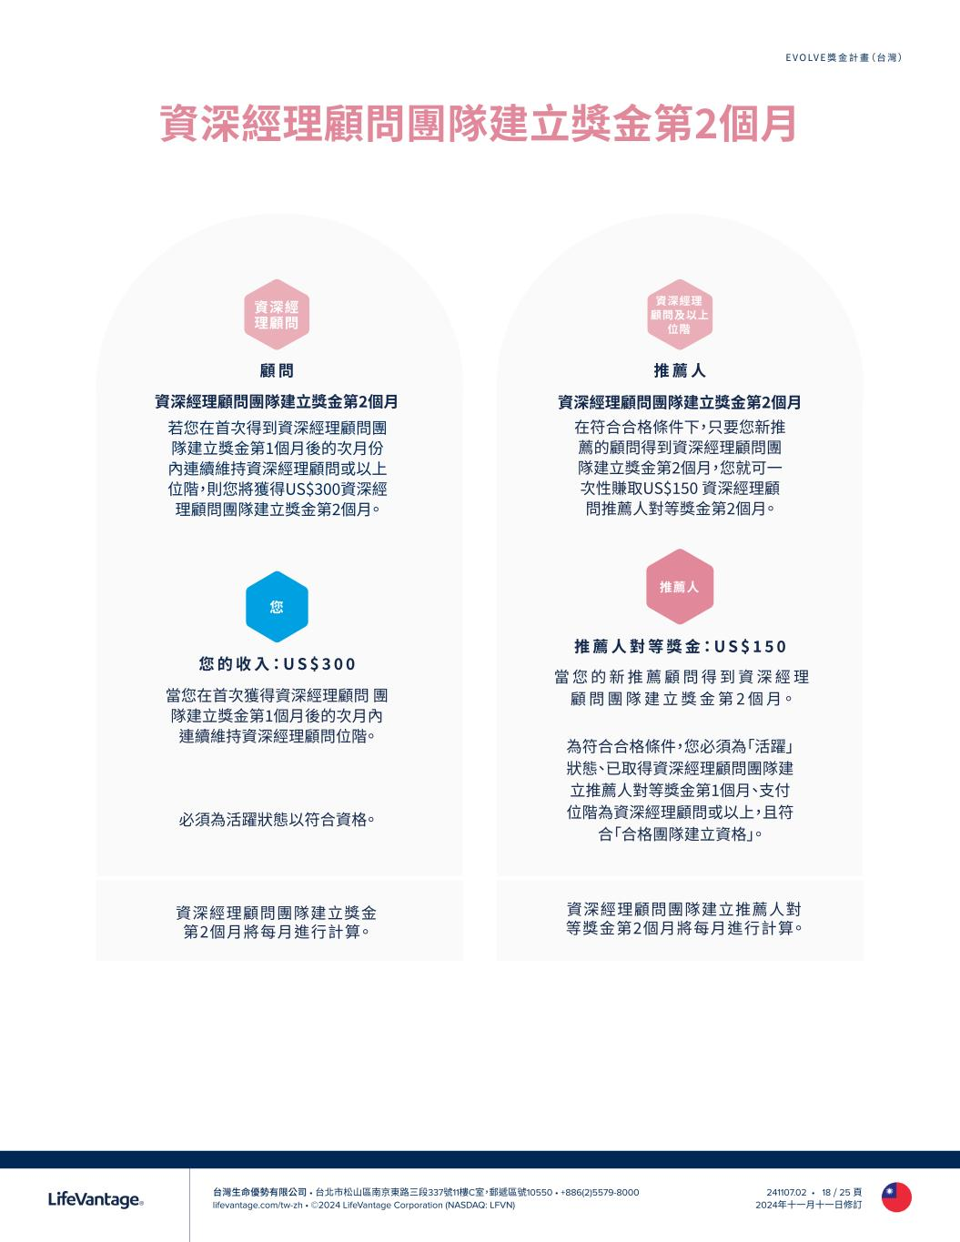
台灣生命優勢有限公司 • 台北市松山區南京東路三段337號11樓C室，郵遞區號10550 • +886(2)5579-8000 lifevantage.com/tw-zh • ©2024 LifeVantage Corporation (NASDAQ: LFVN) EVOLVE獎金計畫（台灣） 241107.02 • 18 / 25 頁 2024年十一月十一日修訂 資深經理顧問團隊建立獎金第2個月 資深經理顧問團隊建立獎金 第2個月將每月進行計算。 資深經理顧問團隊建立推薦人對 等獎金第2個月將每月進行計算 。 您 的 收 入：U S $ 3 0 0 當您在首次獲得資深經理顧問 團 隊建立獎金第1個月後的次月內 連續維持資深經理顧問位階。 您 必須為活躍狀態以符合資格。 資深經 理顧問 顧 問 資深經理顧問團隊建立獎金第2個月 若您在首次得到資深經理顧問團 隊建立獎金第1個月後的次月份 內連續維持資深經理顧問或以上 位階，則您將獲得US$300資深經 理顧問團隊建立獎金第2個月。 推 薦 人 對 等 獎 金：U S $ 1 5 0 當 您 的 新 推 薦 顧 問 得 到 資 深 經 理 顧 問 團 隊 建 立 獎 金 第 2 個 月。 推薦人 資深經理 顧問及以上 位階 推 薦 人 資深經理顧問團隊建立獎金第2個月 在符合合格條件下，只要您新推 薦的顧問得到資深經理顧問團 隊建立獎金第2個月，您就可一 次性賺取US$150 資深經理顧 問推薦人對等獎金第2個月。 為符合合格條件，您必須為「活躍」 狀態、已取得資深經理顧問團隊建 立推薦人對等獎金第1個月、支付 位階為資深經理顧問或以上，且符 合「合格團隊建立資格」。

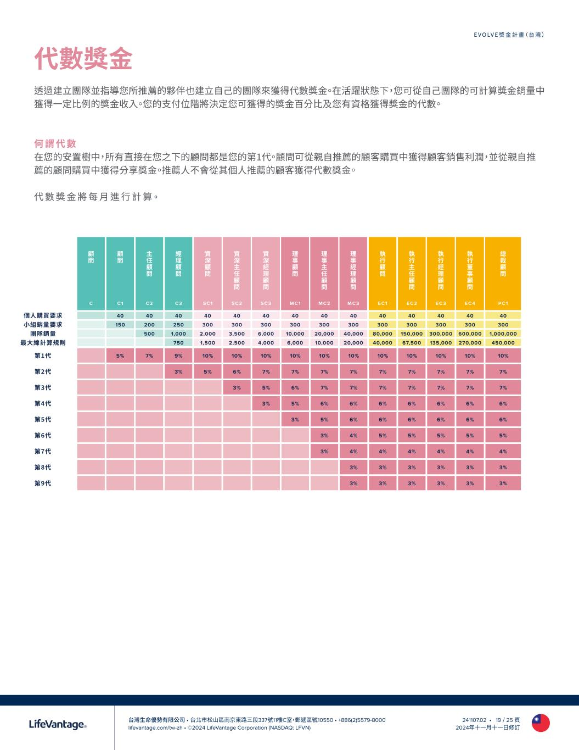
台灣生命優勢有限公司 • 台北市松山區南京東路三段337號11樓C室，郵遞區號10550 • +886(2)5579-8000 lifevantage.com/tw-zh • ©2024 LifeVantage Corporation (NASDAQ: LFVN) EVOLVE獎金計畫（台灣） 241107.02 • 19 / 25 頁 2024年十一月十一日修訂 代數獎金 透過建立團隊並指導您所推薦的夥伴也建立自己的團隊來獲得代數獎金。在活躍狀態下，您可從自己團隊的可計算獎金銷量中 獲得一定比例的獎金收入。您的支付位階將決定您可獲得的獎金百分比及您有資格獲得獎金的代數。 何 謂 代 數 在您的安置樹中，所有直接在您之下的顧問都是您的第1代。顧問可從親自推薦的顧客購買中獲得顧客銷售利潤，並從親自推 薦的顧問購買中獲得分享獎金。推薦人不會從其個人推薦的顧客獲得代數獎金。 代 數 獎 金 將 每 月 進 行 計 算。 顧 問 顧 問 主 任 顧 問 經 理 顧 問 資 深 顧 問 資 深 主 任 顧 問 資 深 經 理 顧 問 理 事 顧 問 理 事 主 任 顧 問 理 事 經 理 顧 問 執 行 顧 問 執 行 主 任 顧 問 執 行 經 理 顧 問 執 行 董 事 顧 問 總 裁 顧 問 C C1 C2 C3 SC1 SC2 SC3 MC1 MC2 MC3 EC1 EC2 EC3 EC 4 PC1 40 40 40 40 40 40 40 40 40 40 40 40 40 40 150 200 250 300 300 300 300 300 300 300 300 300 300 300 500 1,000 2,000 3,500 6,000 10,000 20,000 40,000 80,000 150,000 300,000 600,000 1,000,000 750 1,500 2,500 4,000 6,000 10,000 20,000 40,000 67,500 135,000 270,000 450,000 第1代 5% 7% 9% 10% 10% 10% 10% 10% 10% 10% 10% 10% 10% 10% 第2代 3% 5% 6% 7% 7% 7% 7% 7% 7% 7% 7% 7% 第3代 3% 5% 6% 7% 7% 7% 7% 7% 7% 7% 第4代 3% 5% 6% 6% 6% 6% 6% 6% 6% 第5代 3% 5% 6% 6% 6% 6% 6% 6% 第6代 3% 4% 5% 5% 5% 5% 5% 第7代 3% 4% 4% 4% 4% 4% 4% 第8代 3% 3% 3% 3% 3% 3% 第9代 3% 3% 3% 3% 3% 3% 個人購買要求 小組銷量要求 團隊銷量 最大線計算規則

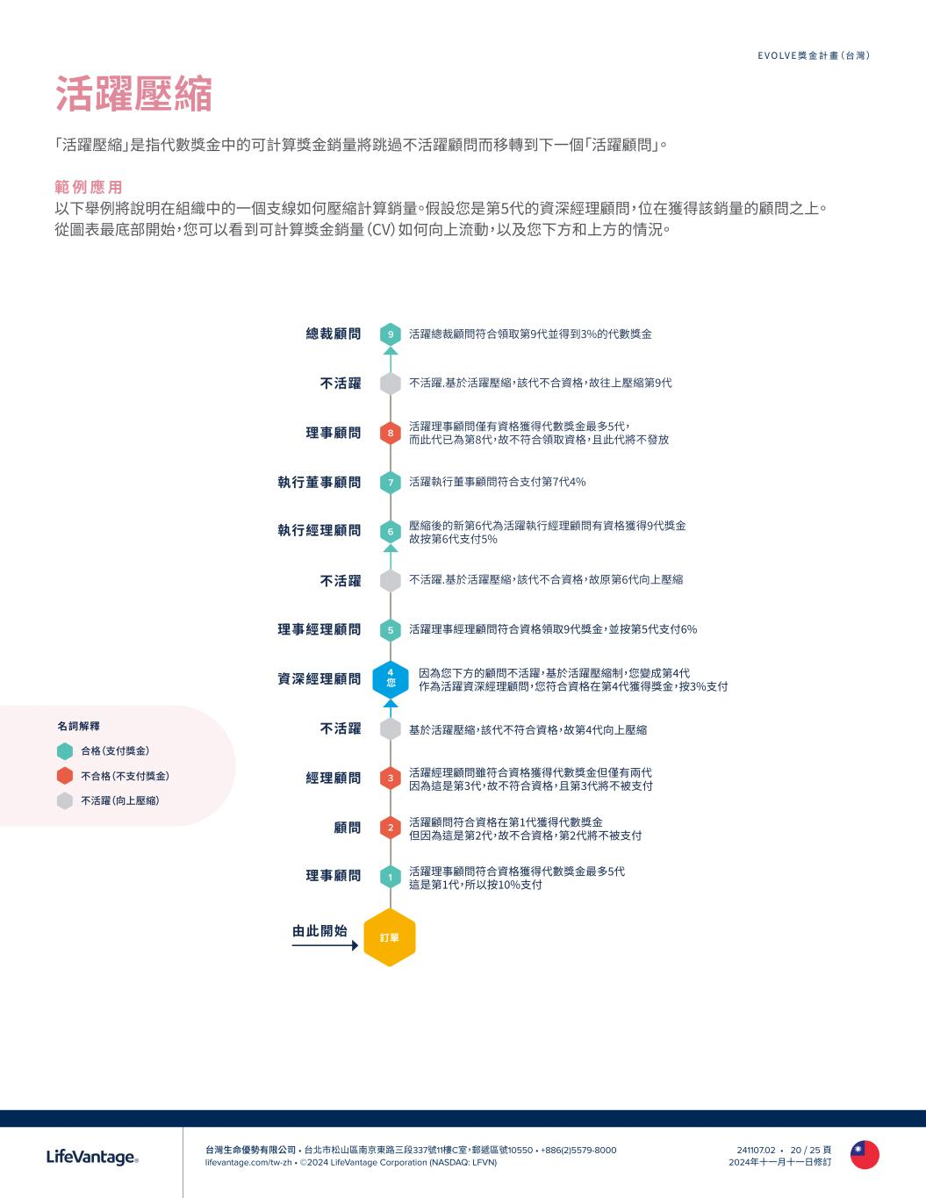
台灣生命優勢有限公司 • 台北市松山區南京東路三段337號11樓C室，郵遞區號10550 • +886(2)5579-8000 lifevantage.com/tw-zh • ©2024 LifeVantage Corporation (NASDAQ: LFVN) EVOLVE獎金計畫（台灣） 241107.02 • 20 / 25 頁 2024年十一月十一日修訂 活躍壓縮 「活躍壓縮」是指代數獎金中的可計算獎金銷量將跳過不活躍顧問而移轉到下一個「活躍顧問」。 範 例 應 用 以下舉例將說明在組織中的一個支線如何壓縮計算銷量。假設您是第5代的資深經理顧問，位在獲得該銷量的顧問之上。 從圖表最底部開始，您可以看到可計算獎金銷量（CV）如何向上流動，以及您下方和上方的情況。 9 8 5 3 7 2 6 1 訂單 理事顧問 由此開始 顧問 經理顧問 不活躍 資深經理顧問 理事經理顧問 不活躍 執行經理顧問 執行董事顧問 理事顧問 不活躍 總裁顧問 4 您 活躍理事顧問符合資格獲得代數獎金最多5代 這是第1代，所以按10%支付 活躍顧問符合資格在第1代獲得代數獎金 但因為這是第2代，故不合資格，第2代將不被支付 活躍經理顧問雖符合資格獲得代數獎金但僅有兩代 因為這是第3代，故不符合資格，且第3代將不被支付 基於活躍壓縮，該代不符合資格，故第4代向上壓縮 因為您下方的顧問不活躍，基於活躍壓縮制，您變成第4代 作為活躍資深經理顧問，您符合資格在第4代獲得獎金，按3%支付 活躍理事經理顧問符合資格領取9代獎金，並按第5代支付6% 不活躍.基於活躍壓縮，該代不合資格，故原第6代向上壓縮 壓縮後的新第6代為活躍執行經理顧問有資格獲得9代獎金 故按第6代支付5% 活躍執行董事顧問符合支付第7代4% 活躍理事顧問僅有資格獲得代數獎金最多5代， 而此代已為第8代，故不符合領取資格，且此代將不發放 不活躍.基於活躍壓縮，該代不合資格，故往上壓縮第9代 活躍總裁顧問符合領取第9代並得到3%的代數獎金 名詞解釋 合格（支付獎金） 不合格（不支付獎金） 不活躍（向上壓縮）

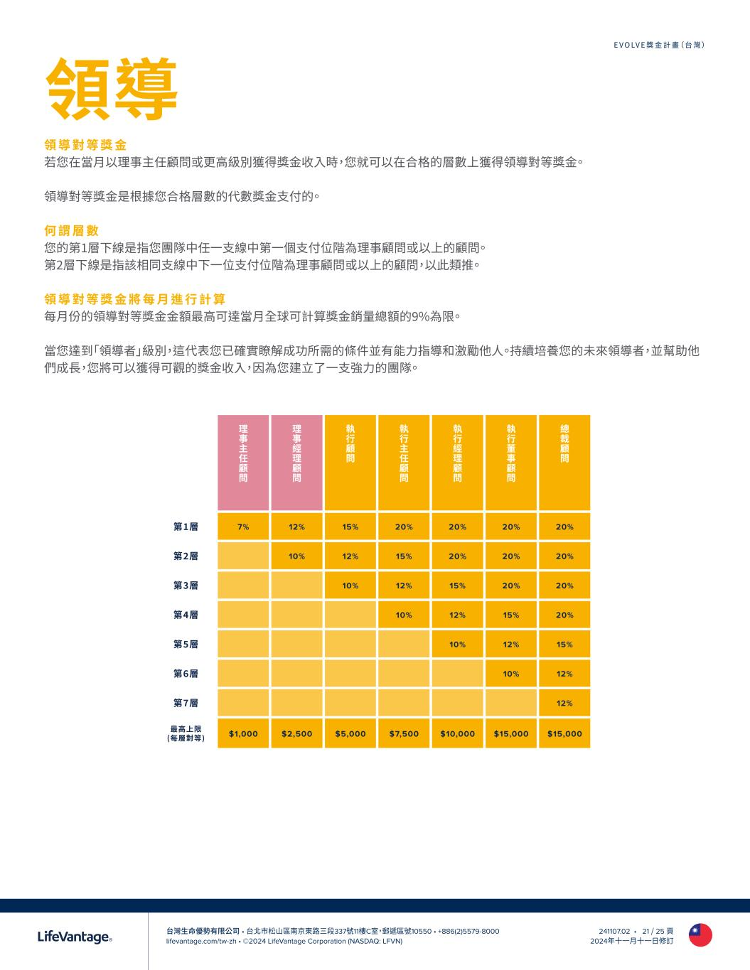
台灣生命優勢有限公司 • 台北市松山區南京東路三段337號11樓C室，郵遞區號10550 • +886(2)5579-8000 lifevantage.com/tw-zh • ©2024 LifeVantage Corporation (NASDAQ: LFVN) EVOLVE獎金計畫（台灣） 241107.02 • 21 / 25 頁 2024年十一月十一日修訂 領導 領 導 對 等 獎 金 若您在當月以理事主任顧問或更高級別獲得獎金收入時，您就可以在合格的層數上獲得領導對等獎金。 領導對等獎金是根據您合格層數的代數獎金支付的。 何 謂 層 數 您的第1層下線是指您團隊中任一支線中第一個支付位階為理事顧問或以上的顧問。 第2層下線是指該相同支線中下一位支付位階為理事顧問或以上的顧問，以此類推。 領 導 對 等 獎 金 將 每 月 進 行 計 算 每月份的領導對等獎金金額最高可達當月全球可計算獎金銷量總額的9%為限。 當您達到「領導者」級別，這代表您已確實瞭解成功所需的條件並有能力指導和激勵他人。持續培養您的未來領導者，並幫助他 們成長，您將可以獲得可觀的獎金收入，因為您建立了一支強力的團隊。 理 事 主 任 顧 問 理 事 經 理 顧 問 執 行 顧 問 執 行 主 任 顧 問 執 行 經 理 顧 問 執 行 董 事 顧 問 總 裁 顧 問 第1層 7% 12% 15% 20% 20% 20% 20% 第2層 10% 12% 15% 20% 20% 20% 第3層 10% 12% 15% 20% 20% 第4層 10% 12% 15% 20% 第5層 10% 12% 15% 第6層 10% 12% 第7層 12% 最高上限 (每層對等) $1,000 $2,500 $5,000 $7,500 $10,000 $15,000 $15,000

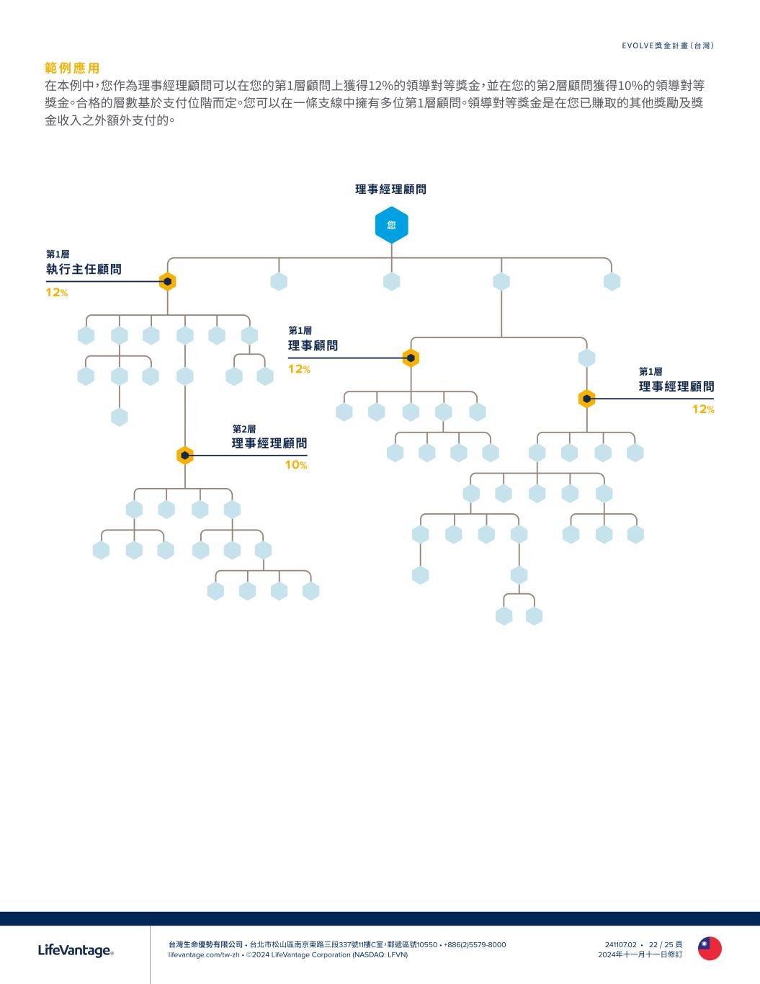
台灣生命優勢有限公司 • 台北市松山區南京東路三段337號11樓C室，郵遞區號10550 • +886(2)5579-8000 lifevantage.com/tw-zh • ©2024 LifeVantage Corporation (NASDAQ: LFVN) EVOLVE獎金計畫（台灣） 241107.02 • 22 / 25 頁 2024年十一月十一日修訂 範 例 應 用 在本例中，您作為理事經理顧問可以在您的第1層顧問上獲得12%的領導對等獎金，並在您的第2層顧問獲得10%的領導對等 獎金。合格的層數基於支付位階而定。您可以在一條支線中擁有多位第1層顧問。領導對等獎金是在您已賺取的其他獎勵及獎 金收入之外額外支付的。 您 理事經理顧問 10% 12% 執行主任顧問 12% 理事顧問 12% 理事經理顧問 理事經理顧問 第1層 第1層 第2層 第1層

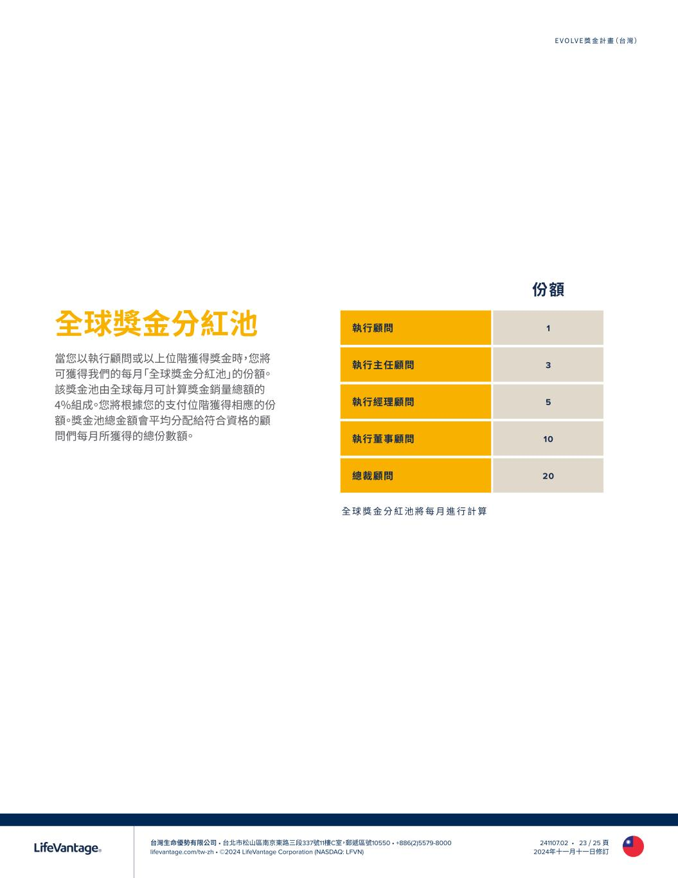
台灣生命優勢有限公司 • 台北市松山區南京東路三段337號11樓C室，郵遞區號10550 • +886(2)5579-8000 lifevantage.com/tw-zh • ©2024 LifeVantage Corporation (NASDAQ: LFVN) EVOLVE獎金計畫（台灣） 241107.02 • 23 / 25 頁 2024年十一月十一日修訂 全球獎金分紅池 當您以執行顧問或以上位階獲得獎金時，您將 可獲得我們的每月「全球獎金分紅池」的份額。 該獎金池由全球每月可計算獎金銷量總額的 4%組成。您將根據您的支付位階獲得相應的份 額。獎金池總金額會平均分配給符合資格的顧 問們每月所獲得的總份數額。 份額 執行顧問 1 執行主任顧問 3 執行經理顧問 5 執行董事顧問 10 總裁顧問 20 全 球 獎 金 分 紅 池 將 每 月 進 行 計 算

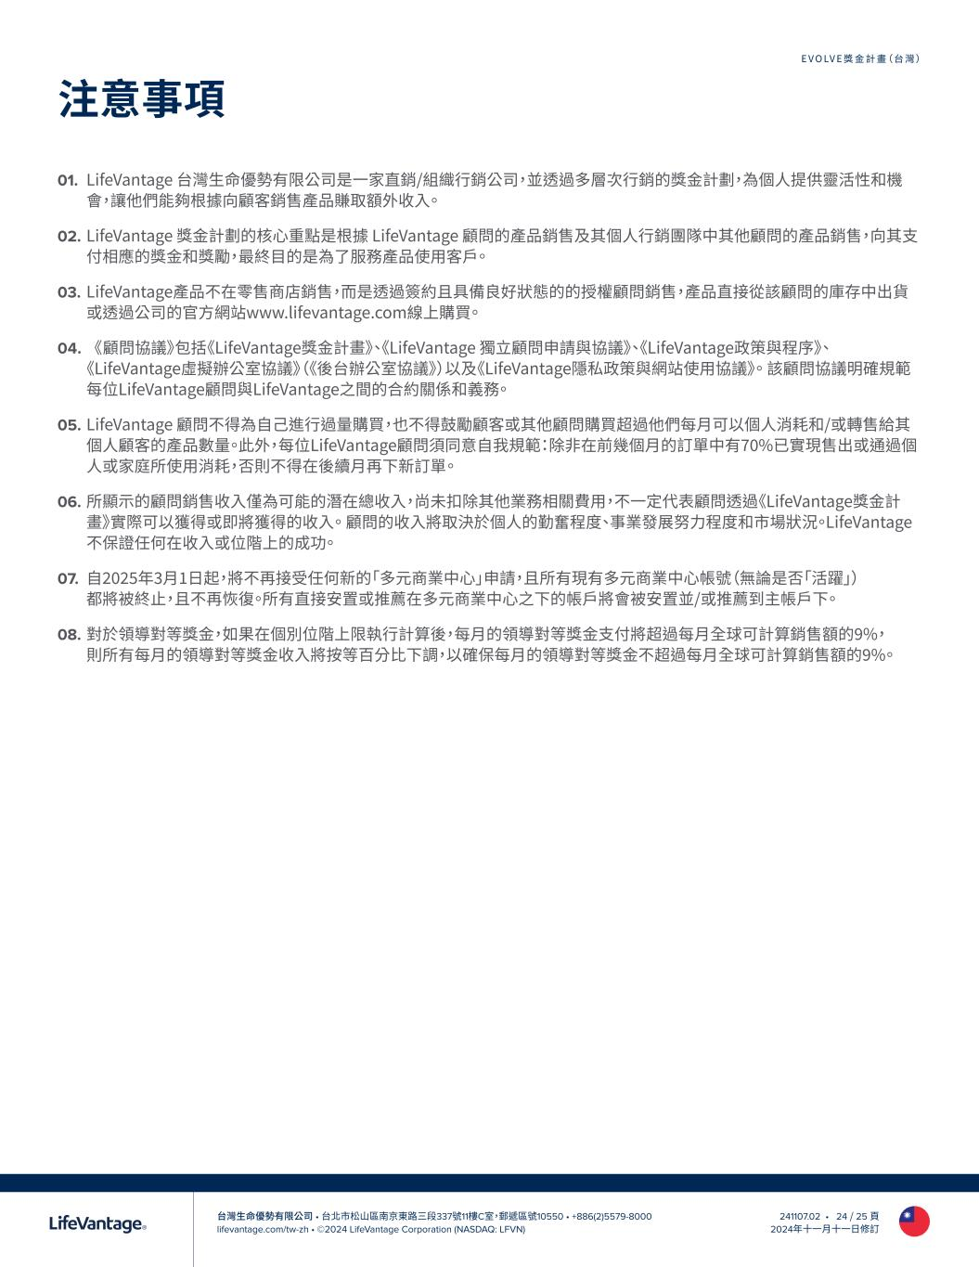
台灣生命優勢有限公司 • 台北市松山區南京東路三段337號11樓C室，郵遞區號10550 • +886(2)5579-8000 lifevantage.com/tw-zh • ©2024 LifeVantage Corporation (NASDAQ: LFVN) EVOLVE獎金計畫（台灣） 241107.02 • 24 / 25 頁 2024年十一月十一日修訂 注意事項 01. LifeVantage 台灣生命優勢有限公司是一家直銷/組織行銷公司，並透過多層次行銷的獎金計劃，為個人提供靈活性和機 會，讓他們能夠根據向顧客銷售產品賺取額外收入。 02. LifeVantage 獎金計劃的核心重點是根據 LifeVantage 顧問的產品銷售及其個人行銷團隊中其他顧問的產品銷售，向其支 付相應的獎金和獎勵，最終目的是為了服務產品使用客戶。 03. LifeVantage產品不在零售商店銷售，而是透過簽約且具備良好狀態的的授權顧問銷售，產品直接從該顧問的庫存中出貨 或透過公司的官方網站www.lifevantage.com線上購買。 04. 《顧問協議》包括《LifeVantage獎金計畫》、《LifeVantage 獨立顧問申請與協議》、《LifeVantage政策與程序》、 《LifeVantage虛擬辦公室協議》（《後台辦公室協議》）以及《LifeVantage隱私政策與網站使用協議》。 該顧問協議明確規範 每位LifeVantage顧問與LifeVantage之間的合約關係和義務。 05. LifeVantage 顧問不得為自己進行過量購買，也不得鼓勵顧客或其他顧問購買超過他們每月可以個人消耗和/或轉售給其 個人顧客的產品數量。此外，每位LifeVantage顧問須同意自我規範：除非在前幾個月的訂單中有70%已實現售出或通過個 人或家庭所使用消耗，否則不得在後續月再下新訂單 。 06. 所顯示的顧問銷售收入僅為可能的潛在總收入，尚未扣除其他業務相關費用，不一定代表顧問透過《LifeVantage獎金計 畫》實際可以獲得或即將獲得的收入。 顧問的收入將取決於個人的勤奮程度、事業發展努力程度和市場狀況。LifeVantage 不保證任何在收入或位階上的成功。 07. 自2025年3月1日起，將不再接受任何新的「多元商業中心」申請，且所有現有多元商業中心帳號（無論是否「活躍」） 都將被終止，且不再恢復。所有直接安置或推薦在多元商業中心之下的帳戶將會被安置並/或推薦到主帳戶下。 08. 對於領導對等獎金，如果在個別位階上限執行計算後，每月的領導對等獎金支付將超過每月全球可計算銷售額的9%， 則所有每月的領導對等獎金收入將按等百分比下調，以確保每月的領導對等獎金不超過每月全球可計算銷售額的9%。




COMPENSATION PLAN GUIDE FOR INDEPENDENT LIFEVANTAGE CONSULTANTS HONG KONG Effective 01 March 2025

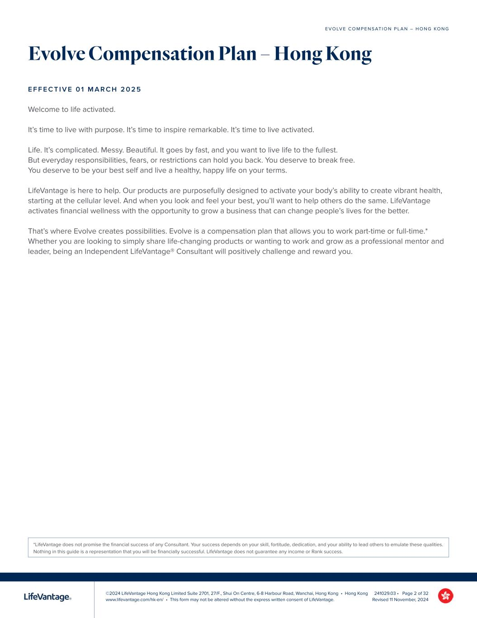
©2024 LifeVantage Hong Kong Limited Suite 2701, 27/F., Shui On Centre, 6-8 Harbour Road, Wanchai, Hong Kong • Hong Kong www.lifevantage.com/hk-en/ • This form may not be altered without the express written consent of LifeVantage. E V O LV E C O M P E N S AT I O N P L A N – H O N G KO N G 241029.03 • Page 2 of 32 Revised 11 November, 2024 Evolve Compensation Plan – Hong Kong E F F E C T I V E 0 1 M A R C H 2 0 2 5 Welcome to life activated. It’s time to live with purpose. It’s time to inspire remarkable. It’s time to live activated. Life. It’s complicated. Messy. Beautiful. It goes by fast, and you want to live life to the fullest. But everyday responsibilities, fears, or restrictions can hold you back. You deserve to break free. You deserve to be your best self and live a healthy, happy life on your terms. LifeVantage is here to help. Our products are purposefully designed to activate your body’s ability to create vibrant health, starting at the cellular level. And when you look and feel your best, you’ll want to help others do the same. LifeVantage activates financial wellness with the opportunity to grow a business that can change people’s lives for the better. That’s where Evolve creates possibilities. Evolve is a compensation plan that allows you to work part-time or full-time.* Whether you are looking to simply share life-changing products or wanting to work and grow as a professional mentor and leader, being an Independent LifeVantage® Consultant will positively challenge and reward you. *LifeVantage does not promise the financial success of any Consultant. Your success depends on your skill, fortitude, dedication, and your ability to lead others to emulate these qualities. Nothing in this guide is a representation that you will be financially successful. LifeVantage does not guarantee any income or Rank success.

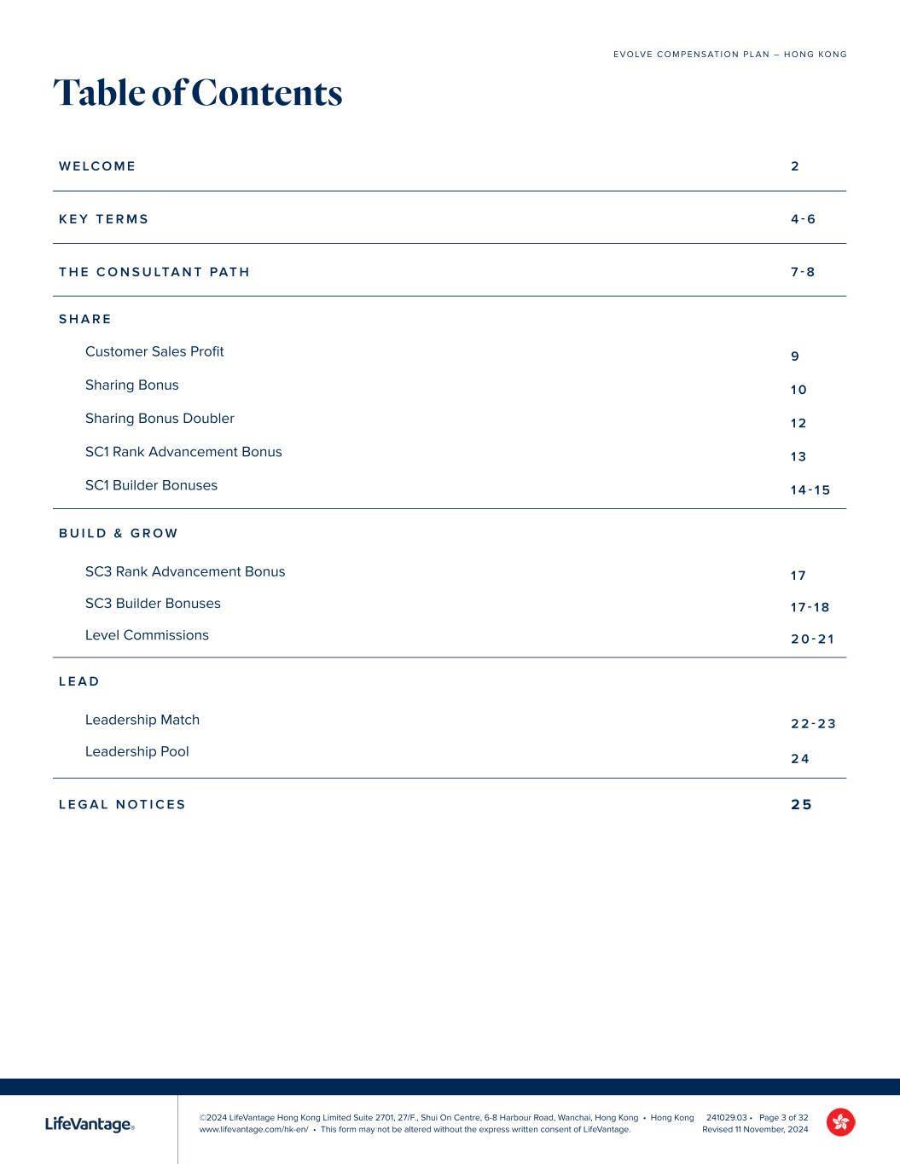
©2024 LifeVantage Hong Kong Limited Suite 2701, 27/F., Shui On Centre, 6-8 Harbour Road, Wanchai, Hong Kong • Hong Kong www.lifevantage.com/hk-en/ • This form may not be altered without the express written consent of LifeVantage. E V O LV E C O M P E N S AT I O N P L A N – H O N G KO N G 241029.03 • Page 3 of 32 Revised 11 November, 2024 Table of Contents W E LC O M E 2 K E Y T E R M S 4 - 6 T H E C O N S U LTA N T PAT H 7 - 8 S H A R E Customer Sales Profit 9 Sharing Bonus 1 0 Sharing Bonus Doubler 1 2 SC1 Rank Advancement Bonus 1 3 SC1 Builder Bonuses 1 4 - 1 5 B U I L D & G R O W SC3 Rank Advancement Bonus 1 7 SC3 Builder Bonuses 1 7 - 1 8 Level Commissions 2 0 - 2 1 L E A D Leadership Match 2 2 - 2 3 Leadership Pool 2 4 L E G A L N O T I C E S 2 5

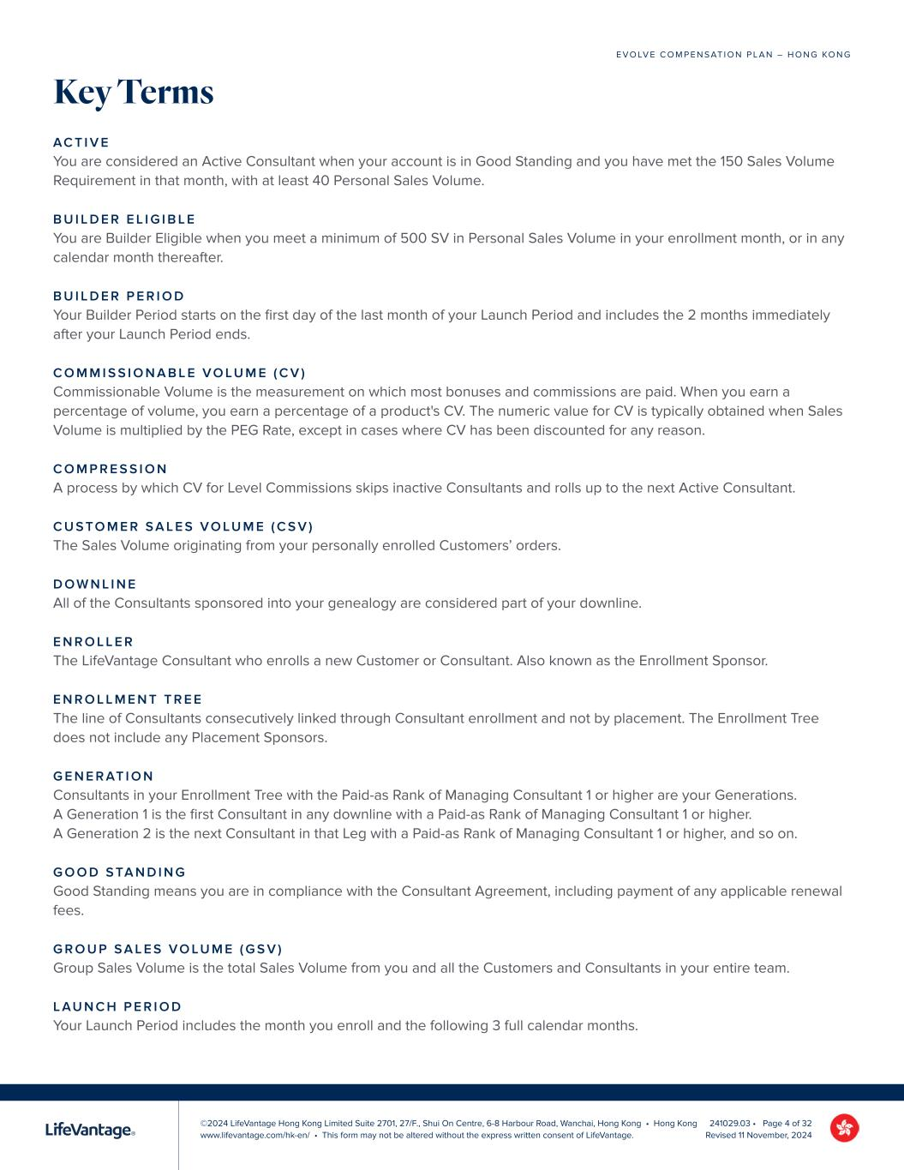
©2024 LifeVantage Hong Kong Limited Suite 2701, 27/F., Shui On Centre, 6-8 Harbour Road, Wanchai, Hong Kong • Hong Kong www.lifevantage.com/hk-en/ • This form may not be altered without the express written consent of LifeVantage. E V O LV E C O M P E N S AT I O N P L A N – H O N G KO N G 241029.03 • Page 4 of 32 Revised 11 November, 2024 Key Terms AC T I V E You are considered an Active Consultant when your account is in Good Standing and you have met the 150 Sales Volume Requirement in that month, with at least 40 Personal Sales Volume. B U I L D E R E L I G I B L E You are Builder Eligible when you meet a minimum of 500 SV in Personal Sales Volume in your enrollment month, or in any calendar month thereafter. B U I L D E R P E R I O D Your Builder Period starts on the first day of the last month of your Launch Period and includes the 2 months immediately after your Launch Period ends. C O M M I S S I O N A B L E V O LU M E ( C V ) Commissionable Volume is the measurement on which most bonuses and commissions are paid. When you earn a percentage of volume, you earn a percentage of a product's CV. The numeric value for CV is typically obtained when Sales Volume is multiplied by the PEG Rate, except in cases where CV has been discounted for any reason. C O M P R E S S I O N A process by which CV for Level Commissions skips inactive Consultants and rolls up to the next Active Consultant. C U S TO M E R S A L E S V O LU M E ( C S V ) The Sales Volume originating from your personally enrolled Customers’ orders. D O W N L I N E All of the Consultants sponsored into your genealogy are considered part of your downline. E N R O L L E R The LifeVantage Consultant who enrolls a new Customer or Consultant. Also known as the Enrollment Sponsor. E N R O L L M E N T T R E E The line of Consultants consecutively linked through Consultant enrollment and not by placement. The Enrollment Tree does not include any Placement Sponsors. G E N E R AT I O N Consultants in your Enrollment Tree with the Paid-as Rank of Managing Consultant 1 or higher are your Generations. A Generation 1 is the first Consultant in any downline with a Paid-as Rank of Managing Consultant 1 or higher. A Generation 2 is the next Consultant in that Leg with a Paid-as Rank of Managing Consultant 1 or higher, and so on. G O O D S TA N D I N G Good Standing means you are in compliance with the Consultant Agreement, including payment of any applicable renewal fees. G R O U P S A L E S V O LU M E ( G S V ) Group Sales Volume is the total Sales Volume from you and all the Customers and Consultants in your entire team. L AU N C H P E R I O D Your Launch Period includes the month you enroll and the following 3 full calendar months.

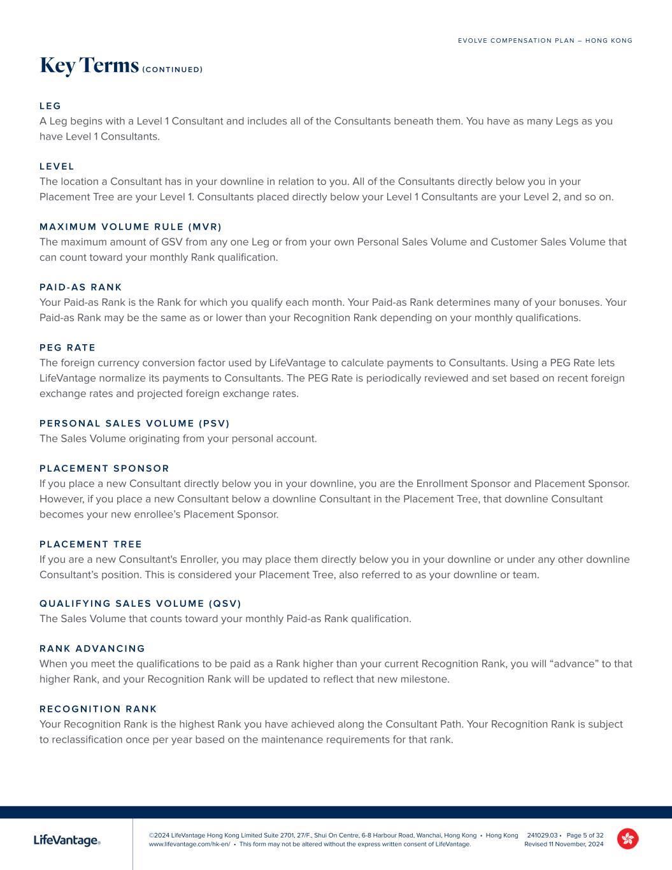
©2024 LifeVantage Hong Kong Limited Suite 2701, 27/F., Shui On Centre, 6-8 Harbour Road, Wanchai, Hong Kong • Hong Kong www.lifevantage.com/hk-en/ • This form may not be altered without the express written consent of LifeVantage. E V O LV E C O M P E N S AT I O N P L A N – H O N G KO N G 241029.03 • Page 5 of 32 Revised 11 November, 2024 Key Terms ( C O N T I N U E D ) L E G A Leg begins with a Level 1 Consultant and includes all of the Consultants beneath them. You have as many Legs as you have Level 1 Consultants. L E V E L The location a Consultant has in your downline in relation to you. All of the Consultants directly below you in your Placement Tree are your Level 1. Consultants placed directly below your Level 1 Consultants are your Level 2, and so on. M A X I M U M V O LU M E R U L E ( M V R ) The maximum amount of GSV from any one Leg or from your own Personal Sales Volume and Customer Sales Volume that can count toward your monthly Rank qualification. PA I D - A S R A N K Your Paid-as Rank is the Rank for which you qualify each month. Your Paid-as Rank determines many of your bonuses. Your Paid-as Rank may be the same as or lower than your Recognition Rank depending on your monthly qualifications. P E G R AT E The foreign currency conversion factor used by LifeVantage to calculate payments to Consultants. Using a PEG Rate lets LifeVantage normalize its payments to Consultants. The PEG Rate is periodically reviewed and set based on recent foreign exchange rates and projected foreign exchange rates. P E R S O N A L S A L E S V O LU M E ( P S V ) The Sales Volume originating from your personal account. P L AC E M E N T S P O N S O R If you place a new Consultant directly below you in your downline, you are the Enrollment Sponsor and Placement Sponsor. However, if you place a new Consultant below a downline Consultant in the Placement Tree, that downline Consultant becomes your new enrollee’s Placement Sponsor. P L AC E M E N T T R E E If you are a new Consultant's Enroller, you may place them directly below you in your downline or under any other downline Consultant’s position. This is considered your Placement Tree, also referred to as your downline or team. Q UA L I F Y I N G S A L E S V O LU M E ( Q S V ) The Sales Volume that counts toward your monthly Paid-as Rank qualification. R A N K A D VA N C I N G When you meet the qualifications to be paid as a Rank higher than your current Recognition Rank, you will “advance” to that higher Rank, and your Recognition Rank will be updated to reflect that new milestone. R E C O G N I T I O N R A N K Your Recognition Rank is the highest Rank you have achieved along the Consultant Path. Your Recognition Rank is subject to reclassification once per year based on the maintenance requirements for that rank.


©2024 LifeVantage Hong Kong Limited Suite 2701, 27/F., Shui On Centre, 6-8 Harbour Road, Wanchai, Hong Kong • Hong Kong www.lifevantage.com/hk-en/ • This form may not be altered without the express written consent of LifeVantage. E V O LV E C O M P E N S AT I O N P L A N – H O N G KO N G 241029.03 • Page 6 of 32 Revised 11 November, 2024 Key Terms ( C O N T I N U E D ) S A L E S V O LU M E ( S V ) The numeric value attributed by LifeVantage to each commissionable product sold and/or purchased. S A L E S V O LU M E R E Q U I R E M E N T ( S V R ) The accumulation of your Customer Sales Volume and your Personal Sales Volume to meet your monthly Paid-as Rank requirement. U P L I N E All of the Consultants above you in your Enrollment and/or Placement Tree.


©2024 LifeVantage Hong Kong Limited Suite 2701, 27/F., Shui On Centre, 6-8 Harbour Road, Wanchai, Hong Kong • Hong Kong www.lifevantage.com/hk-en/ • This form may not be altered without the express written consent of LifeVantage. E V O LV E C O M P E N S AT I O N P L A N – H O N G KO N G 241029.03 • Page 7 of 32 Revised 11 November, 2024 Your path as an Independent LifeVantage Consultant can lead to a world of possibilities. Start by sharing the LifeVantage products that you love with Customers to help them activate wellness and improve their health. The more you share, the more you’ll grow as you find others who want to join you on the path with a business of their own. As you progress along the Consultant Path, your attention will shift to building and leading Consultants on your team who are ready to grow to the next stage of success. At every stage you’ll evolve your earnings, yourself, and your life. . H O W I T W O R K S You must meet certain volume requirements to stay Active and earn bonuses and commissions. These requirements will change, along with the bonuses and commissions you can qualify for, as you move along the path and earn Rank advancements. As you reach the qualifications for a specific Rank, you will be recognized with your “Recognition Rank” at that level for as long as you remain Active. However, your “Paid-as Rank” will fluctuate with your qualifications from month to month. Evolve is uniquely designed to help LifeVantage Consultants develop confidence, community, and leadership. Each Rank advancement offers the opportunity to celebrate with increased earning possibilities. Share. Build & Grow. Lead. Evolve.

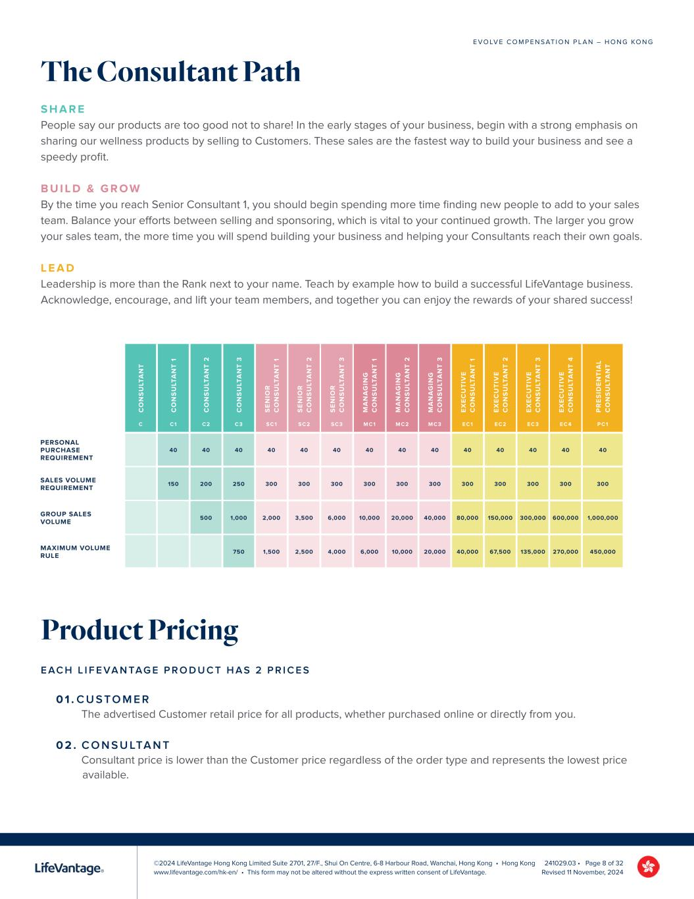
©2024 LifeVantage Hong Kong Limited Suite 2701, 27/F., Shui On Centre, 6-8 Harbour Road, Wanchai, Hong Kong • Hong Kong www.lifevantage.com/hk-en/ • This form may not be altered without the express written consent of LifeVantage. E V O LV E C O M P E N S AT I O N P L A N – H O N G KO N G 241029.03 • Page 8 of 32 Revised 11 November, 2024 The Consultant Path S H A R E People say our products are too good not to share! In the early stages of your business, begin with a strong emphasis on sharing our wellness products by selling to Customers. These sales are the fastest way to build your business and see a speedy profit. B U I L D & G R O W By the time you reach Senior Consultant 1, you should begin spending more time finding new people to add to your sales team. Balance your efforts between selling and sponsoring, which is vital to your continued growth. The larger you grow your sales team, the more time you will spend building your business and helping your Consultants reach their own goals. L E A D Leadership is more than the Rank next to your name. Teach by example how to build a successful LifeVantage business. Acknowledge, encourage, and lift your team members, and together you can enjoy the rewards of your shared success! Product Pricing E AC H L I F E VA N TAG E P R O D U C T H A S 2 P R I C E S 0 1 . C U S TO M E R The advertised Customer retail price for all products, whether purchased online or directly from you. 0 2 . C O N S U LTA N T Consultant price is lower than the Customer price regardless of the order type and represents the lowest price available. C O N S U LT A N T C O N S U LT A N T 1 C O N S U LT A N T 2 C O N S U LT A N T 3 S E N IO R C O N S U LT A N T 1 S E N IO R C O N S U LT A N T 2 S E N IO R C O N S U LT A N T 3 M A N A G IN G C O N S U LT A N T 1 M A N A G IN G C O N S U LT A N T 2 M A N A G IN G C O N S U LT A N T 3 E X E C U T IV E C O N S U LT A N T 1 E X E C U T IV E C O N S U LT A N T 2 E X E C U T IV E C O N S U LT A N T 3 E X E C U T IV E C O N S U LT A N T 4 P R E S ID E N T IA L C O N S U LT A N T C C1 C2 C3 SC1 SC2 SC3 MC1 MC2 MC3 EC1 EC2 EC3 EC 4 PC1 PERSONAL PURCHASE REQUIREMENT 40 40 40 40 40 40 40 40 40 40 40 40 40 40 SALES VOLUME REQUIREMENT 150 200 250 300 300 300 300 300 300 300 300 300 300 300 GROUP SALES VOLUME 500 1,000 2,000 3,500 6,000 10,000 20,000 40,000 80,000 150,000 300,000 600,000 1,000,000 MAXIMUM VOLUME RULE 750 1,500 2,500 4,000 6,000 10,000 20,000 40,000 67,500 135,000 270,000 450,000

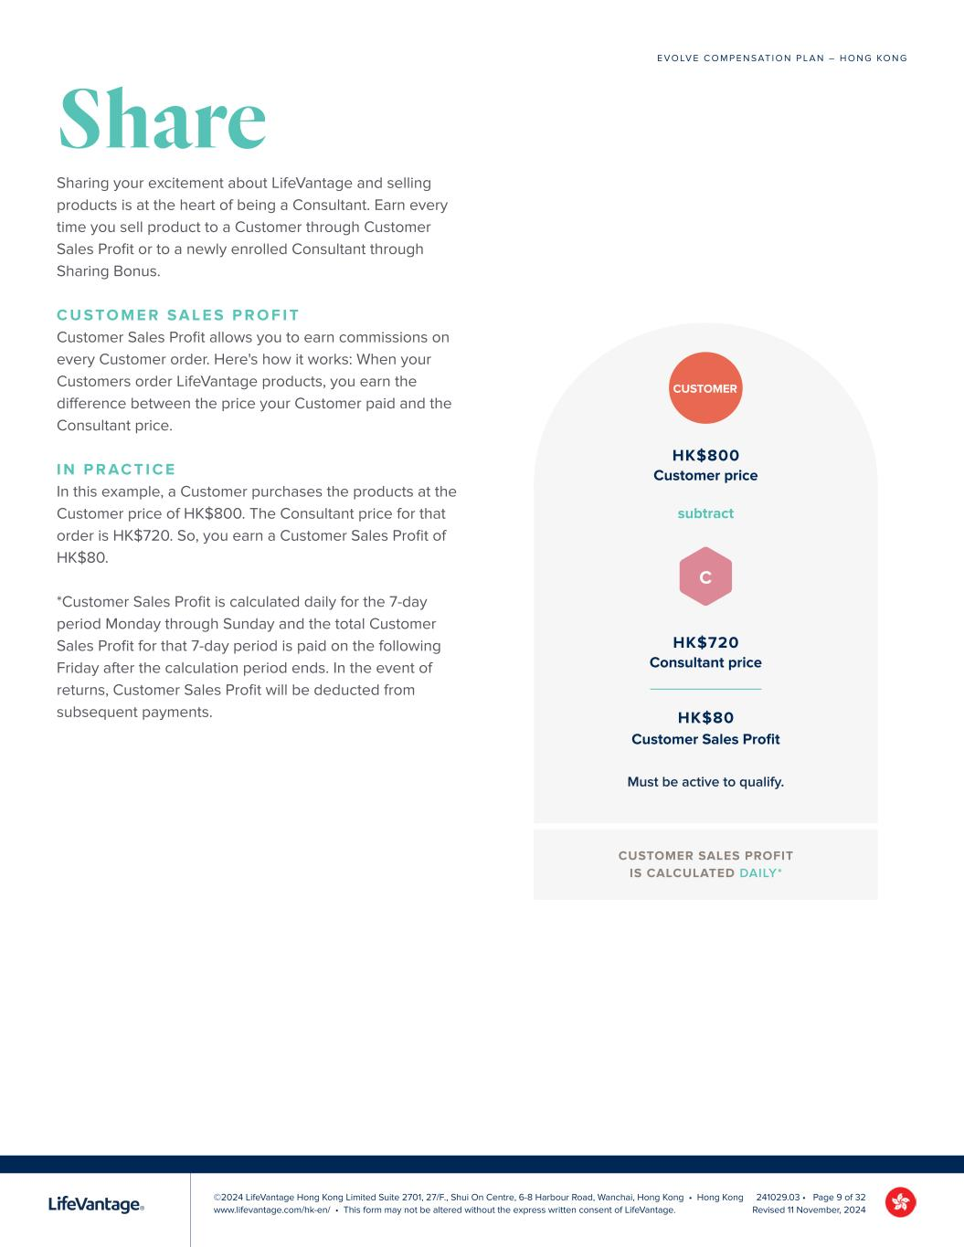
©2024 LifeVantage Hong Kong Limited Suite 2701, 27/F., Shui On Centre, 6-8 Harbour Road, Wanchai, Hong Kong • Hong Kong www.lifevantage.com/hk-en/ • This form may not be altered without the express written consent of LifeVantage. E V O LV E C O M P E N S AT I O N P L A N – H O N G KO N G 241029.03 • Page 9 of 32 Revised 11 November, 2024 Share Sharing your excitement about LifeVantage and selling products is at the heart of being a Consultant. Earn every time you sell product to a Customer through Customer Sales Profit or to a newly enrolled Consultant through Sharing Bonus. C U S TO M E R S A L E S P R O F I T Customer Sales Profit allows you to earn commissions on every Customer order. Here's how it works: When your Customers order LifeVantage products, you earn the difference between the price your Customer paid and the Consultant price. I N P R AC T I C E In this example, a Customer purchases the products at the Customer price of HK$800. The Consultant price for that order is HK$720. So, you earn a Customer Sales Profit of HK$80. *Customer Sales Profit is calculated daily for the 7-day period Monday through Sunday and the total Customer Sales Profit for that 7-day period is paid on the following Friday after the calculation period ends. In the event of returns, Customer Sales Profit will be deducted from subsequent payments. HK$800 Customer price subtract HK$720 Consultant price HK$80 Customer Sales Profit CUSTOMER SALES PROFIT IS CALCULATED DAILY* CUSTOMER C Must be active to qualify.

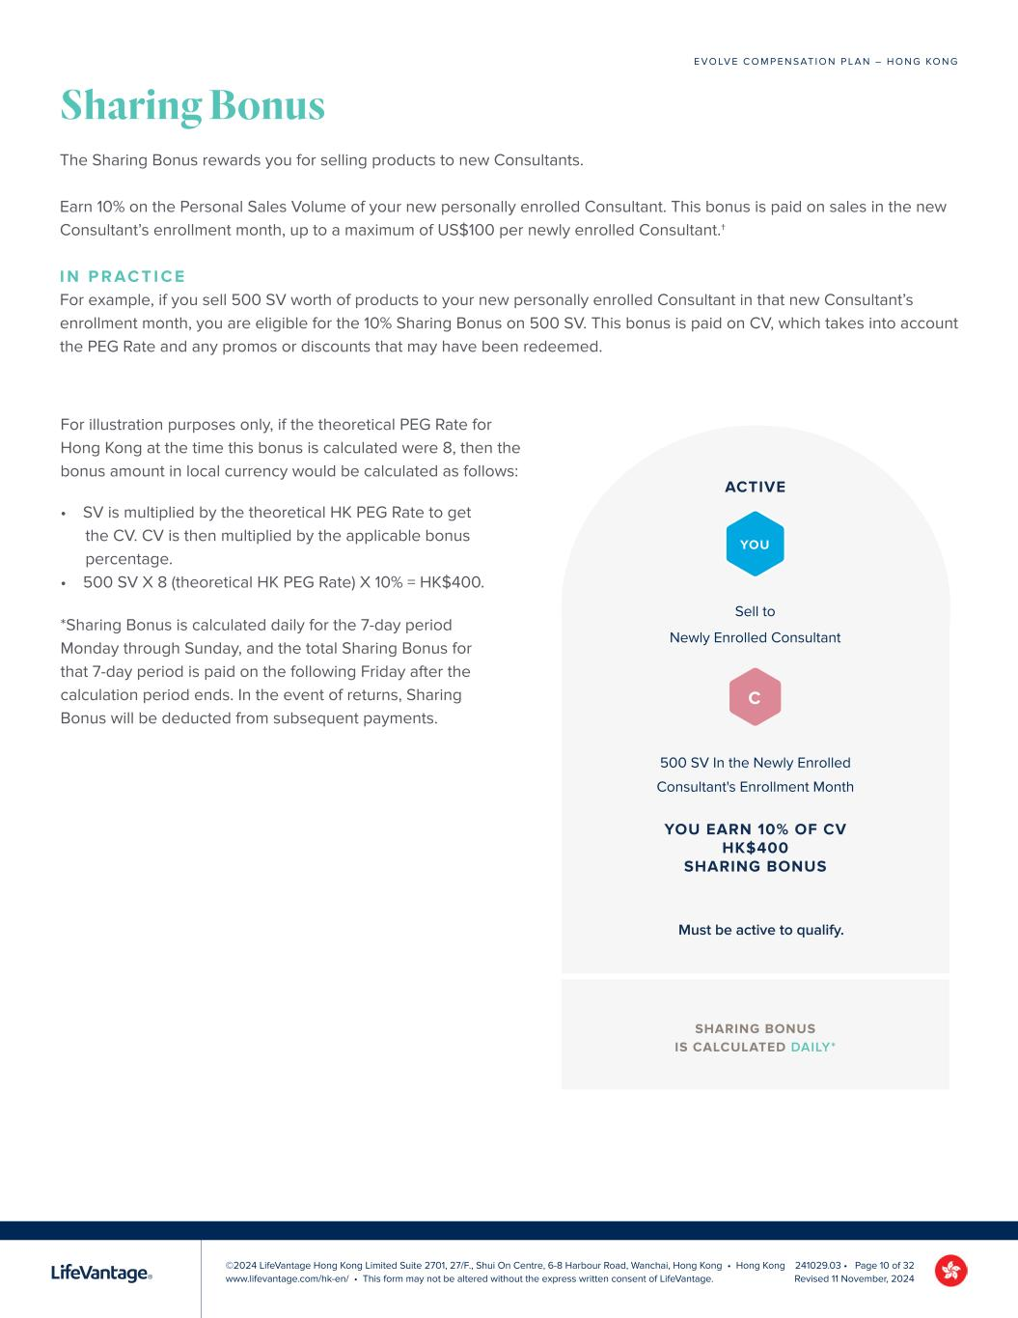
©2024 LifeVantage Hong Kong Limited Suite 2701, 27/F., Shui On Centre, 6-8 Harbour Road, Wanchai, Hong Kong • Hong Kong www.lifevantage.com/hk-en/ • This form may not be altered without the express written consent of LifeVantage. E V O LV E C O M P E N S AT I O N P L A N – H O N G KO N G 241029.03 • Page 10 of 32 Revised 11 November, 2024 Sharing Bonus The Sharing Bonus rewards you for selling products to new Consultants. Earn 10% on the Personal Sales Volume of your new personally enrolled Consultant. This bonus is paid on sales in the new Consultant’s enrollment month, up to a maximum of US$100 per newly enrolled Consultant.† I N P R AC T I C E For example, if you sell 500 SV worth of products to your new personally enrolled Consultant in that new Consultant’s enrollment month, you are eligible for the 10% Sharing Bonus on 500 SV. This bonus is paid on CV, which takes into account the PEG Rate and any promos or discounts that may have been redeemed. For illustration purposes only, if the theoretical PEG Rate for Hong Kong at the time this bonus is calculated were 8, then the bonus amount in local currency would be calculated as follows: SHARING BONUS IS CALCULATED DAILY* Sell to Newly Enrolled Consultant 500 SV In the Newly Enrolled Consultant's Enrollment Month ACTIVE YOU EARN 10% OF CV HK$400 SHARING BONUS YOU Must be active to qualify. C • SV is multiplied by the theoretical HK PEG Rate to get the CV. CV is then multiplied by the applicable bonus percentage. • 500 SV X 8 (theoretical HK PEG Rate) X 10% = HK$400. *Sharing Bonus is calculated daily for the 7-day period Monday through Sunday, and the total Sharing Bonus for that 7-day period is paid on the following Friday after the calculation period ends. In the event of returns, Sharing Bonus will be deducted from subsequent payments.

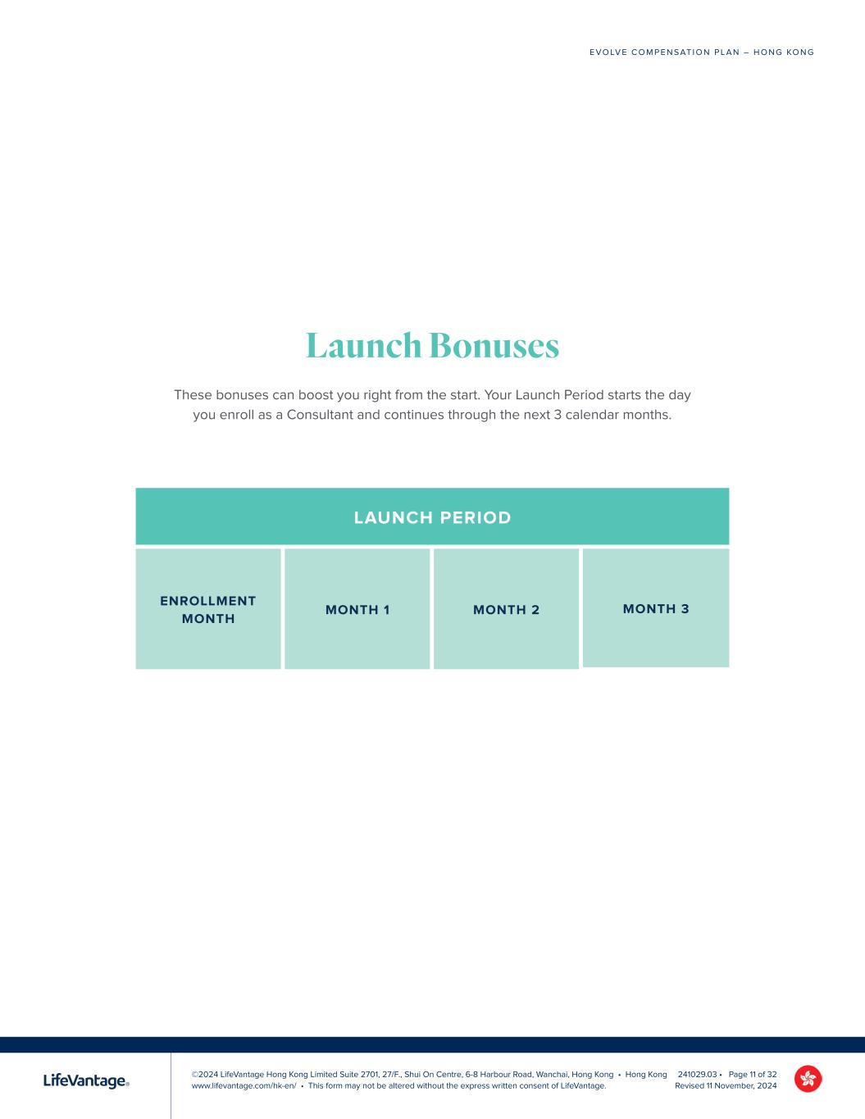
©2024 LifeVantage Hong Kong Limited Suite 2701, 27/F., Shui On Centre, 6-8 Harbour Road, Wanchai, Hong Kong • Hong Kong www.lifevantage.com/hk-en/ • This form may not be altered without the express written consent of LifeVantage. E V O LV E C O M P E N S AT I O N P L A N – H O N G KO N G 241029.03 • Page 11 of 32 Revised 11 November, 2024 Launch Bonuses These bonuses can boost you right from the start. Your Launch Period starts the day you enroll as a Consultant and continues through the next 3 calendar months. LAUNCH PERIOD

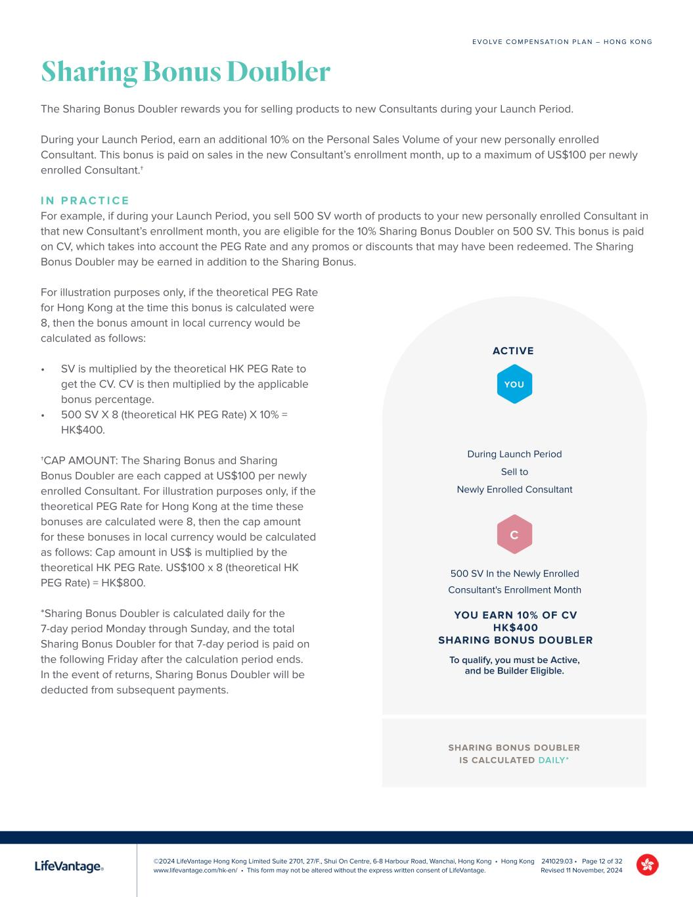
©2024 LifeVantage Hong Kong Limited Suite 2701, 27/F., Shui On Centre, 6-8 Harbour Road, Wanchai, Hong Kong • Hong Kong www.lifevantage.com/hk-en/ • This form may not be altered without the express written consent of LifeVantage. E V O LV E C O M P E N S AT I O N P L A N – H O N G KO N G 241029.03 • Page 12 of 32 Revised 11 November, 2024 Sharing Bonus Doubler The Sharing Bonus Doubler rewards you for selling products to new Consultants during your Launch Period. During your Launch Period, earn an additional 10% on the Personal Sales Volume of your new personally enrolled Consultant. This bonus is paid on sales in the new Consultant’s enrollment month, up to a maximum of US$100 per newly enrolled Consultant.† I N P R A C T I C E For example, if during your Launch Period, you sell 500 SV worth of products to your new personally enrolled Consultant in that new Consultant’s enrollment month, you are eligible for the 10% Sharing Bonus Doubler on 500 SV. This bonus is paid on CV, which takes into account the PEG Rate and any promos or discounts that may have been redeemed. The Sharing Bonus Doubler may be earned in addition to the Sharing Bonus. For illustration purposes only, if the theoretical PEG Rate for Hong Kong at the time this bonus is calculated were 8, then the bonus amount in local currency would be calculated as follows: • SV is multiplied by the theoretical HK PEG Rate to get the CV. CV is then multiplied by the applicable bonus percentage. • 500 SV X 8 (theoretical HK PEG Rate) X 10% = HK$400. †CAP AMOUNT: The Sharing Bonus and Sharing Bonus Doubler are each capped at US$100 per newly enrolled Consultant. For illustration purposes only, if the theoretical PEG Rate for Hong Kong at the time these bonuses are calculated were 8, then the cap amount for these bonuses in local currency would be calculated as follows: Cap amount in US$ is multiplied by the theoretical HK PEG Rate. US$100 x 8 (theoretical HK PEG Rate) = HK$800. *Sharing Bonus Doubler is calculated daily for the 7-day period Monday through Sunday, and the total Sharing Bonus Doubler for that 7-day period is paid on the following Friday after the calculation period ends. In the event of returns, Sharing Bonus Doubler will be deducted from subsequent payments. During Launch Period Sell to Newly Enrolled Consultant 500 SV In the Newly Enrolled Consultant's Enrollment Month ACTIVE YOU EARN 10% OF CV HK$400 SHARING BONUS DOUBLER YOU C To qualify, you must be Active, and be Builder Eligible. SHARING BONUS DOUBLER IS CALCULATED DAILY*

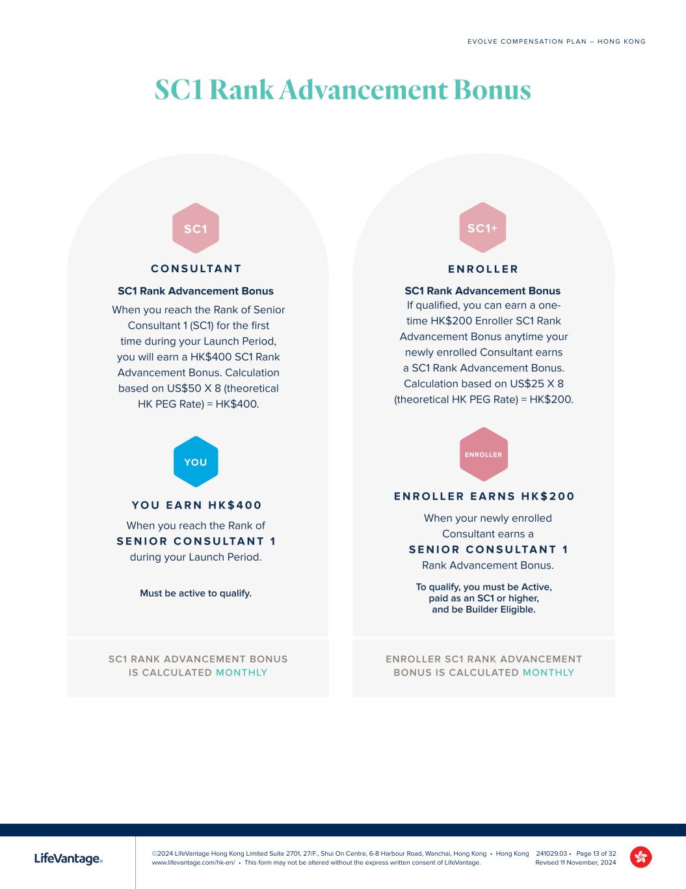
©2024 LifeVantage Hong Kong Limited Suite 2701, 27/F., Shui On Centre, 6-8 Harbour Road, Wanchai, Hong Kong • Hong Kong www.lifevantage.com/hk-en/ • This form may not be altered without the express written consent of LifeVantage. E V O LV E C O M P E N S AT I O N P L A N – H O N G KO N G 241029.03 • Page 13 of 32 Revised 11 November, 2024 SC1 RANK ADVANCEMENT BONUS IS CALCULATED MONTHLY SC1 Rank Advancement Bonus ENROLLER SC1 RANK ADVANCEMENT BONUS IS CALCULATED MONTHLY Y O U E A R N H K $ 4 0 0 When you reach the Rank of S E N I O R C O N S U LTA N T 1 during your Launch Period. YOU Must be active to qualify. SC1 C O N S U LTA N T SC1 Rank Advancement Bonus When you reach the Rank of Senior Consultant 1 (SC1) for the first time during your Launch Period, you will earn a HK$400 SC1 Rank Advancement Bonus. Calculation based on US$50 X 8 (theoretical HK PEG Rate) = HK$400. E N R O L L E R E A R N S H K $ 2 0 0 When your newly enrolled Consultant earns a S E N I O R C O N S U LTA N T 1 Rank Advancement Bonus. ENROLLER SC1+ E N R O L L E R SC1 Rank Advancement Bonus If qualified, you can earn a one- time HK$200 Enroller SC1 Rank Advancement Bonus anytime your newly enrolled Consultant earns a SC1 Rank Advancement Bonus. Calculation based on US$25 X 8 (theoretical HK PEG Rate) = HK$200. To qualify, you must be Active, paid as an SC1 or higher, and be Builder Eligible.

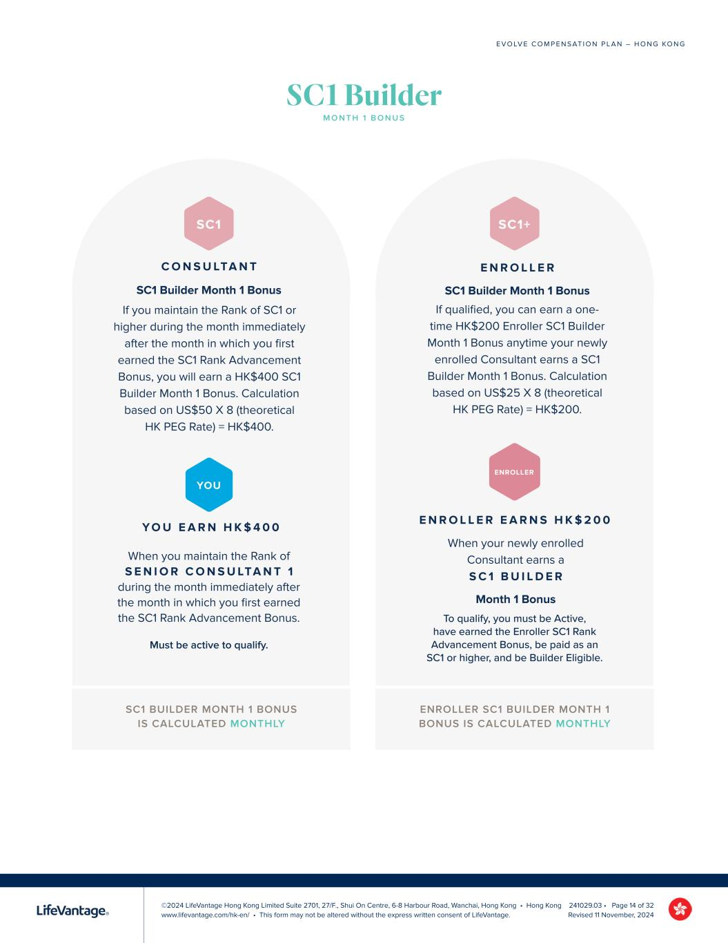
©2024 LifeVantage Hong Kong Limited Suite 2701, 27/F., Shui On Centre, 6-8 Harbour Road, Wanchai, Hong Kong • Hong Kong www.lifevantage.com/hk-en/ • This form may not be altered without the express written consent of LifeVantage. E V O LV E C O M P E N S AT I O N P L A N – H O N G KO N G 241029.03 • Page 14 of 32 Revised 11 November, 2024 SC1 BUILDER MONTH 1 BONUS IS CALCULATED MONTHLY ENROLLER SC1 BUILDER MONTH 1 BONUS IS CALCULATED MONTHLY Y O U E A R N H K $ 4 0 0 When you maintain the Rank of S E N I O R C O N S U LTA N T 1 during the month immediately after the month in which you first earned the SC1 Rank Advancement Bonus. YOU Must be active to qualify. SC1 C O N S U LTA N T SC1 Builder Month 1 Bonus If you maintain the Rank of SC1 or higher during the month immediately after the month in which you first earned the SC1 Rank Advancement Bonus, you will earn a HK$400 SC1 Builder Month 1 Bonus. Calculation based on US$50 X 8 (theoretical HK PEG Rate) = HK$400. E N R O L L E R E A R N S H K $ 2 0 0 When your newly enrolled Consultant earns a S C 1 B U I L D E R Month 1 Bonus ENROLLER SC1+ E N R O L L E R SC1 Builder Month 1 Bonus If qualified, you can earn a one- time HK$200 Enroller SC1 Builder Month 1 Bonus anytime your newly enrolled Consultant earns a SC1 Builder Month 1 Bonus. Calculation based on US$25 X 8 (theoretical HK PEG Rate) = HK$200. To qualify, you must be Active, have earned the Enroller SC1 Rank Advancement Bonus, be paid as an SC1 or higher, and be Builder Eligible. SC1 Builder M O N T H 1 B O N U S

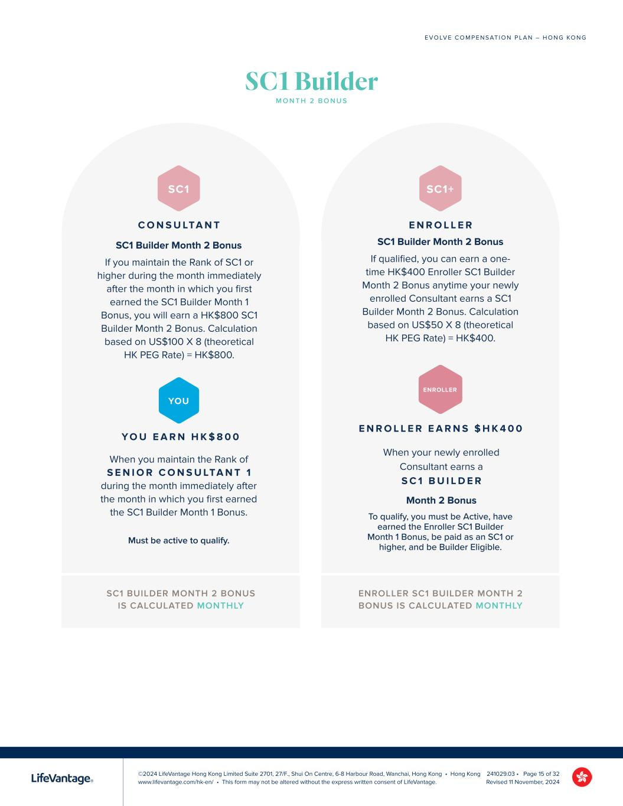
©2024 LifeVantage Hong Kong Limited Suite 2701, 27/F., Shui On Centre, 6-8 Harbour Road, Wanchai, Hong Kong • Hong Kong www.lifevantage.com/hk-en/ • This form may not be altered without the express written consent of LifeVantage. E V O LV E C O M P E N S AT I O N P L A N – H O N G KO N G 241029.03 • Page 15 of 32 Revised 11 November, 2024 SC1 BUILDER MONTH 2 BONUS IS CALCULATED MONTHLY ENROLLER SC1 BUILDER MONTH 2 BONUS IS CALCULATED MONTHLY Y O U E A R N H K $ 8 0 0 When you maintain the Rank of S E N I O R C O N S U LTA N T 1 during the month immediately after the month in which you first earned the SC1 Builder Month 1 Bonus. YOU Must be active to qualify. SC1 C O N S U LTA N T SC1 Builder Month 2 Bonus If you maintain the Rank of SC1 or higher during the month immediately after the month in which you first earned the SC1 Builder Month 1 Bonus, you will earn a HK$800 SC1 Builder Month 2 Bonus. Calculation based on US$100 X 8 (theoretical HK PEG Rate) = HK$800. E N R O L L E R E A R N S $ H K 4 0 0 When your newly enrolled Consultant earns a S C 1 B U I L D E R Month 2 Bonus ENROLLER SC1+ E N R O L L E R SC1 Builder Month 2 Bonus If qualified, you can earn a one- time HK$400 Enroller SC1 Builder Month 2 Bonus anytime your newly enrolled Consultant earns a SC1 Builder Month 2 Bonus. Calculation based on US$50 X 8 (theoretical HK PEG Rate) = HK$400. To qualify, you must be Active, have earned the Enroller SC1 Builder Month 1 Bonus, be paid as an SC1 or higher, and be Builder Eligible. SC1 Builder M O N T H 2 B O N U S

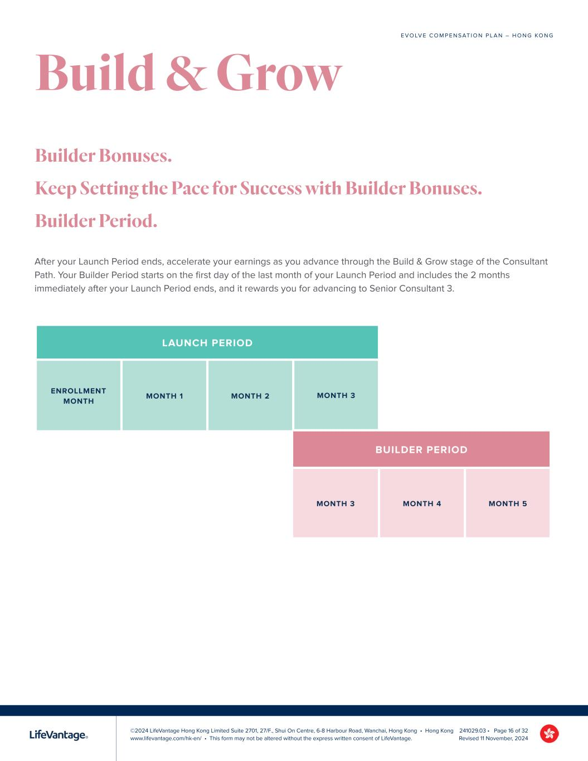
©2024 LifeVantage Hong Kong Limited Suite 2701, 27/F., Shui On Centre, 6-8 Harbour Road, Wanchai, Hong Kong • Hong Kong www.lifevantage.com/hk-en/ • This form may not be altered without the express written consent of LifeVantage. E V O LV E C O M P E N S AT I O N P L A N – H O N G KO N G 241029.03 • Page 16 of 32 Revised 11 November, 2024 After your Launch Period ends, accelerate your earnings as you advance through the Build & Grow stage of the Consultant Path. Your Builder Period starts on the first day of the last month of your Launch Period and includes the 2 months immediately after your Launch Period ends, and it rewards you for advancing to Senior Consultant 3. Builder Bonuses. Keep Setting the Pace for Success with Builder Bonuses. Builder Period. LAUNCH PERIOD BUILDER PERIOD MONTH 3 MONTH 4 MONTH 5 Build & Grow

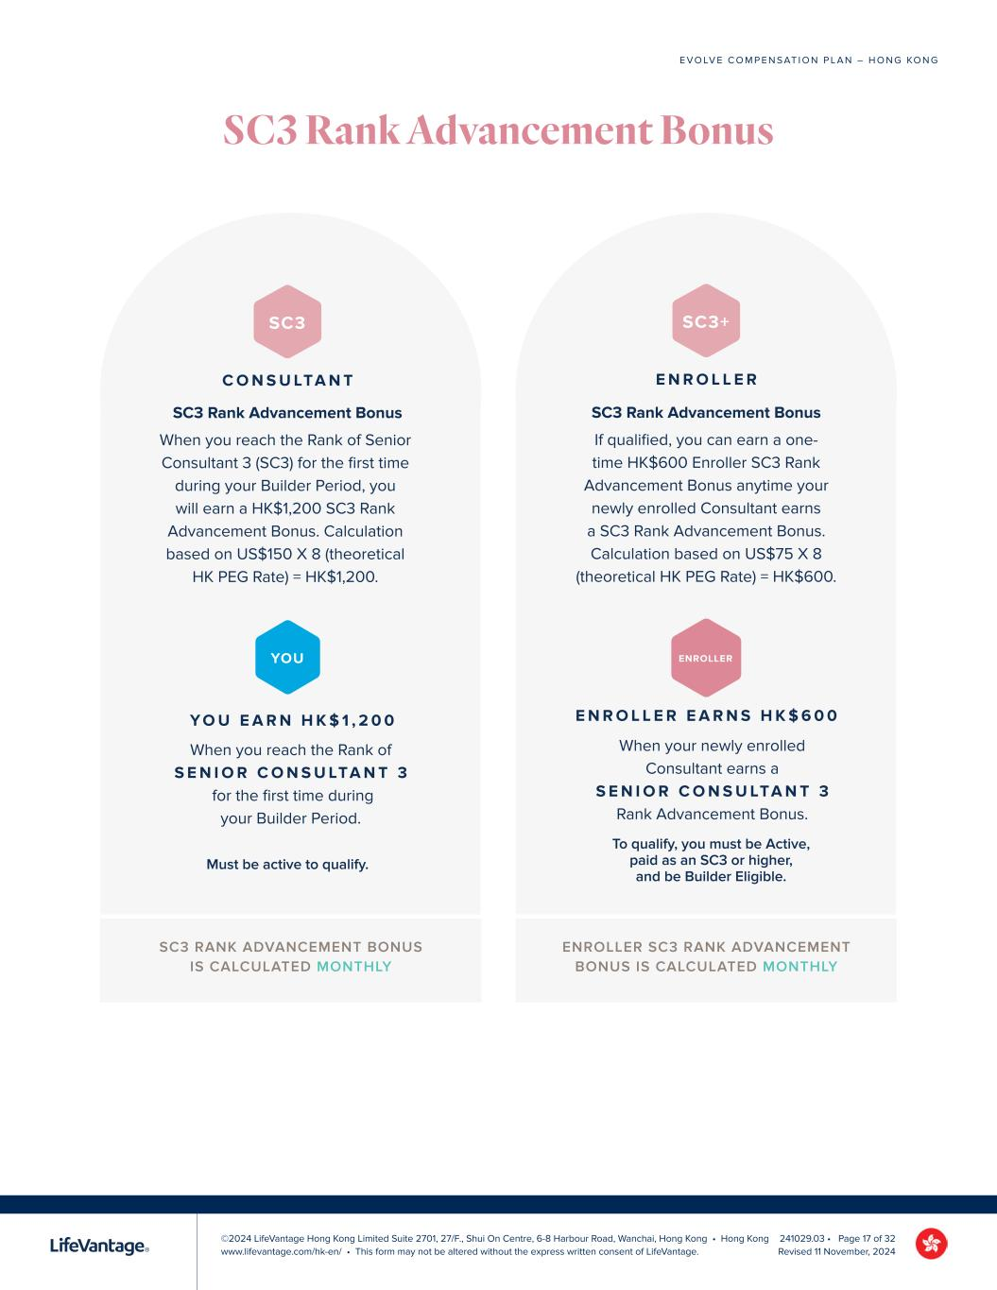
©2024 LifeVantage Hong Kong Limited Suite 2701, 27/F., Shui On Centre, 6-8 Harbour Road, Wanchai, Hong Kong • Hong Kong www.lifevantage.com/hk-en/ • This form may not be altered without the express written consent of LifeVantage. E V O LV E C O M P E N S AT I O N P L A N – H O N G KO N G 241029.03 • Page 17 of 32 Revised 11 November, 2024 SC3 Rank Advancement Bonus SC3 RANK ADVANCEMENT BONUS IS CALCULATED MONTHLY ENROLLER SC3 RANK ADVANCEMENT BONUS IS CALCULATED MONTHLY Y O U E A R N H K $ 1 , 2 0 0 When you reach the Rank of S E N I O R C O N S U LTA N T 3 for the first time during your Builder Period. YOU Must be active to qualify. SC3 C O N S U LTA N T SC3 Rank Advancement Bonus When you reach the Rank of Senior Consultant 3 (SC3) for the first time during your Builder Period, you will earn a HK$1,200 SC3 Rank Advancement Bonus. Calculation based on US$150 X 8 (theoretical HK PEG Rate) = HK$1,200. E N R O L L E R E A R N S H K $ 6 0 0 When your newly enrolled Consultant earns a S E N I O R C O N S U LTA N T 3 Rank Advancement Bonus. ENROLLER SC3+ E N R O L L E R SC3 Rank Advancement Bonus If qualified, you can earn a one- time HK$600 Enroller SC3 Rank Advancement Bonus anytime your newly enrolled Consultant earns a SC3 Rank Advancement Bonus. Calculation based on US$75 X 8 (theoretical HK PEG Rate) = HK$600. To qualify, you must be Active, paid as an SC3 or higher, and be Builder Eligible.

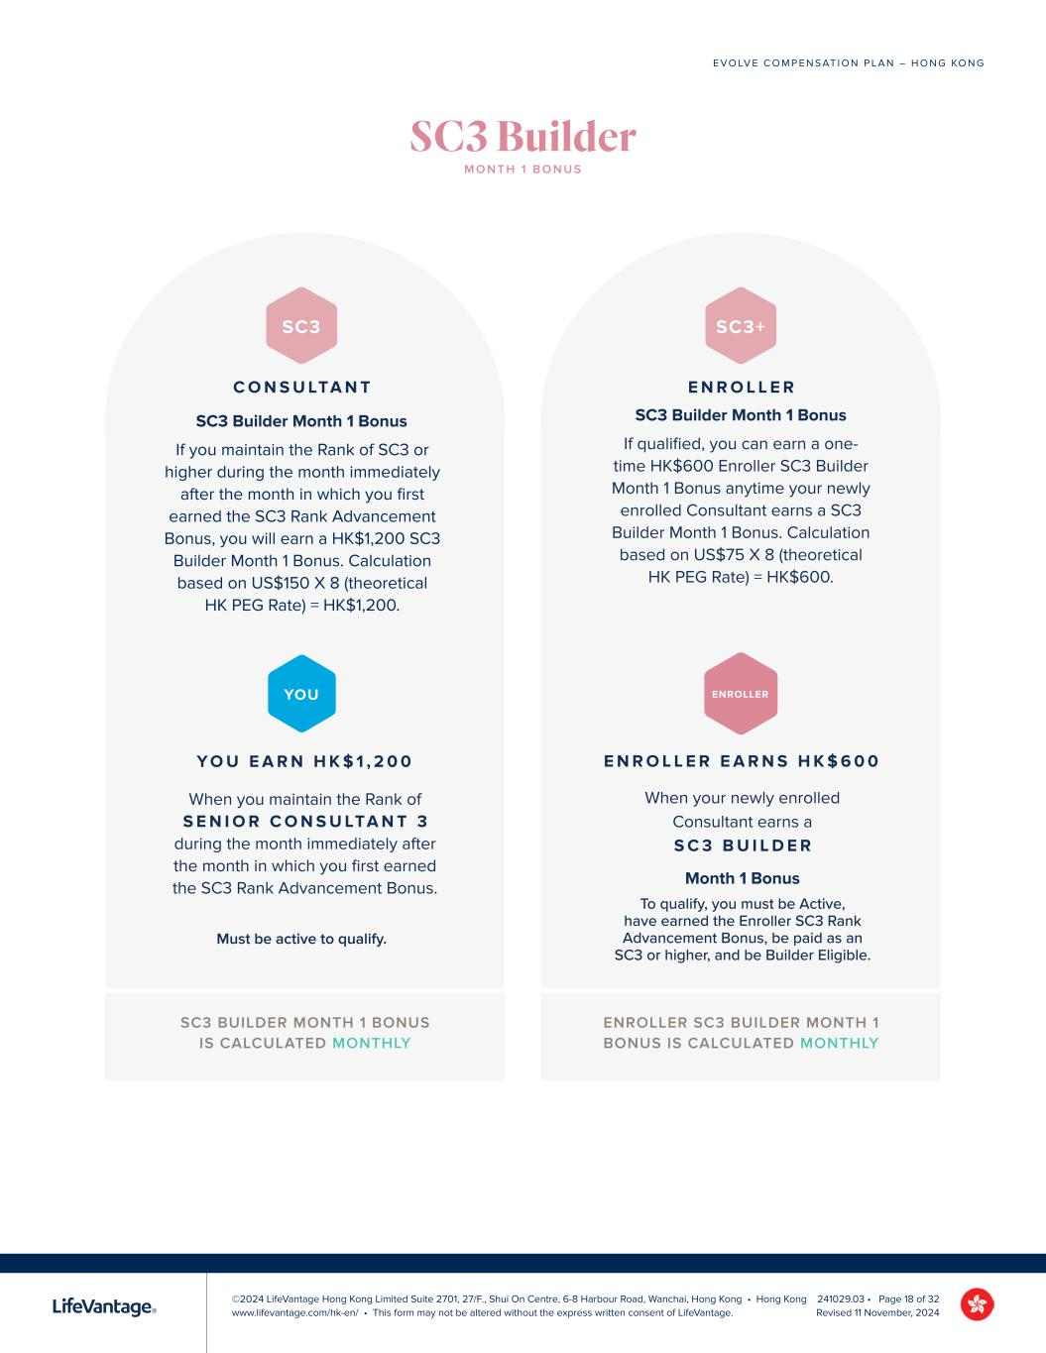
©2024 LifeVantage Hong Kong Limited Suite 2701, 27/F., Shui On Centre, 6-8 Harbour Road, Wanchai, Hong Kong • Hong Kong www.lifevantage.com/hk-en/ • This form may not be altered without the express written consent of LifeVantage. E V O LV E C O M P E N S AT I O N P L A N – H O N G KO N G 241029.03 • Page 18 of 32 Revised 11 November, 2024 SC3 BUILDER MONTH 1 BONUS IS CALCULATED MONTHLY ENROLLER SC3 BUILDER MONTH 1 BONUS IS CALCULATED MONTHLY Y O U E A R N H K $ 1 , 2 0 0 When you maintain the Rank of S E N I O R C O N S U LTA N T 3 during the month immediately after the month in which you first earned the SC3 Rank Advancement Bonus. YOU Must be active to qualify. SC3 C O N S U LTA N T SC3 Builder Month 1 Bonus If you maintain the Rank of SC3 or higher during the month immediately after the month in which you first earned the SC3 Rank Advancement Bonus, you will earn a HK$1,200 SC3 Builder Month 1 Bonus. Calculation based on US$150 X 8 (theoretical HK PEG Rate) = HK$1,200. E N R O L L E R E A R N S H K $ 6 0 0 When your newly enrolled Consultant earns a S C 3 B U I L D E R Month 1 Bonus ENROLLER SC3+ E N R O L L E R SC3 Builder Month 1 Bonus If qualified, you can earn a one- time HK$600 Enroller SC3 Builder Month 1 Bonus anytime your newly enrolled Consultant earns a SC3 Builder Month 1 Bonus. Calculation based on US$75 X 8 (theoretical HK PEG Rate) = HK$600. To qualify, you must be Active, have earned the Enroller SC3 Rank Advancement Bonus, be paid as an SC3 or higher, and be Builder Eligible. SC3 Builder M O N T H 1 B O N U S

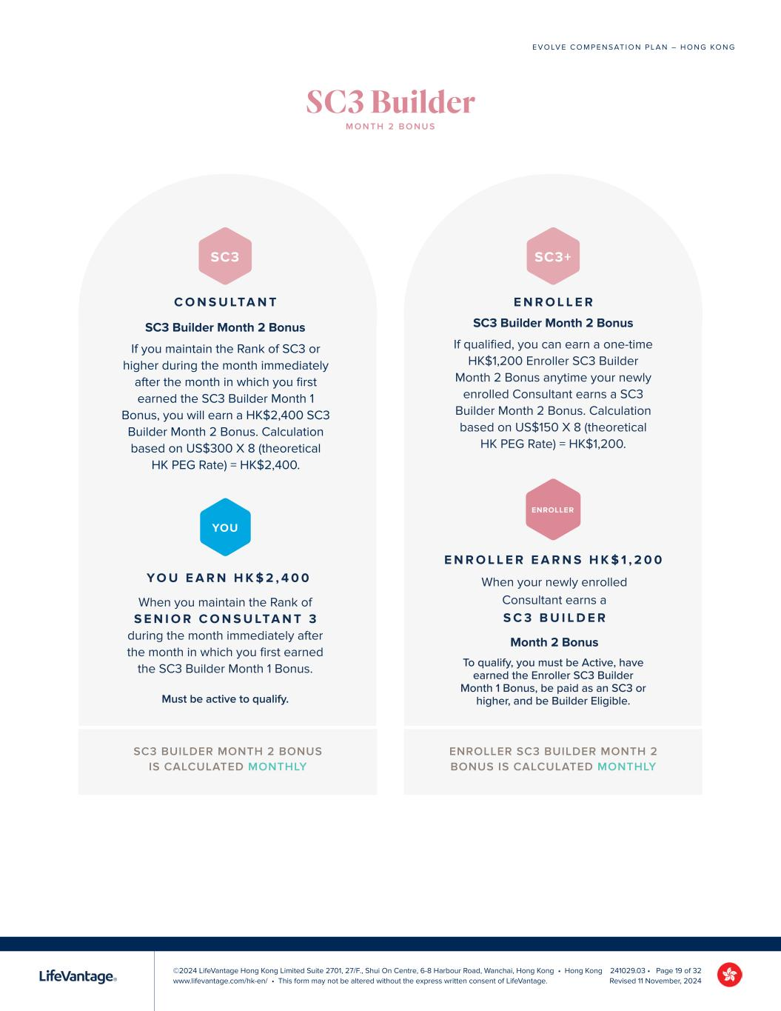
©2024 LifeVantage Hong Kong Limited Suite 2701, 27/F., Shui On Centre, 6-8 Harbour Road, Wanchai, Hong Kong • Hong Kong www.lifevantage.com/hk-en/ • This form may not be altered without the express written consent of LifeVantage. E V O LV E C O M P E N S AT I O N P L A N – H O N G KO N G 241029.03 • Page 19 of 32 Revised 11 November, 2024 SC3 BUILDER MONTH 2 BONUS IS CALCULATED MONTHLY ENROLLER SC3 BUILDER MONTH 2 BONUS IS CALCULATED MONTHLY Y O U E A R N H K $ 2 , 4 0 0 When you maintain the Rank of S E N I O R C O N S U LTA N T 3 during the month immediately after the month in which you first earned the SC3 Builder Month 1 Bonus. YOU Must be active to qualify. SC3 C O N S U LTA N T SC3 Builder Month 2 Bonus If you maintain the Rank of SC3 or higher during the month immediately after the month in which you first earned the SC3 Builder Month 1 Bonus, you will earn a HK$2,400 SC3 Builder Month 2 Bonus. Calculation based on US$300 X 8 (theoretical HK PEG Rate) = HK$2,400. E N R O L L E R E A R N S H K $ 1 , 2 0 0 When your newly enrolled Consultant earns a S C 3 B U I L D E R Month 2 Bonus ENROLLER SC3+ E N R O L L E R SC3 Builder Month 2 Bonus If qualified, you can earn a one-time HK$1,200 Enroller SC3 Builder Month 2 Bonus anytime your newly enrolled Consultant earns a SC3 Builder Month 2 Bonus. Calculation based on US$150 X 8 (theoretical HK PEG Rate) = HK$1,200. To qualify, you must be Active, have earned the Enroller SC3 Builder Month 1 Bonus, be paid as an SC3 or higher, and be Builder Eligible. SC3 Builder M O N T H 2 B O N U S

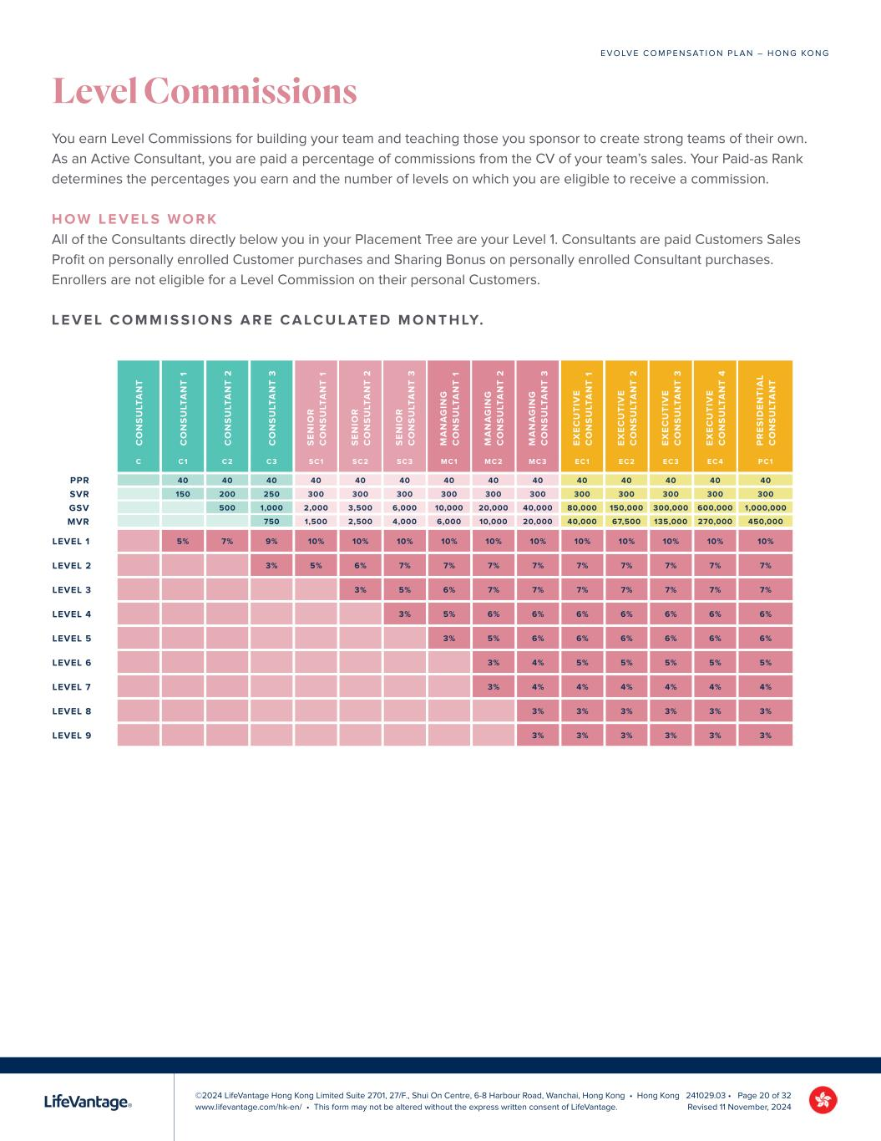
©2024 LifeVantage Hong Kong Limited Suite 2701, 27/F., Shui On Centre, 6-8 Harbour Road, Wanchai, Hong Kong • Hong Kong www.lifevantage.com/hk-en/ • This form may not be altered without the express written consent of LifeVantage. E V O LV E C O M P E N S AT I O N P L A N – H O N G KO N G 241029.03 • Page 20 of 32 Revised 11 November, 2024 Level Commissions You earn Level Commissions for building your team and teaching those you sponsor to create strong teams of their own. As an Active Consultant, you are paid a percentage of commissions from the CV of your team’s sales. Your Paid-as Rank determines the percentages you earn and the number of levels on which you are eligible to receive a commission. H O W L E V E L S W O R K All of the Consultants directly below you in your Placement Tree are your Level 1. Consultants are paid Customers Sales Profit on personally enrolled Customer purchases and Sharing Bonus on personally enrolled Consultant purchases. Enrollers are not eligible for a Level Commission on their personal Customers. L E V E L C O M M I S S I O N S A R E C A LC U L AT E D M O N T H LY. C O N S U LT A N T C O N S U LT A N T 1 C O N S U LT A N T 2 C O N S U LT A N T 3 S E N IO R C O N S U LT A N T 1 S E N IO R C O N S U LT A N T 2 S E N IO R C O N S U LT A N T 3 M A N A G IN G C O N S U LT A N T 1 M A N A G IN G C O N S U LT A N T 2 M A N A G IN G C O N S U LT A N T 3 E X E C U T IV E C O N S U LT A N T 1 E X E C U T IV E C O N S U LT A N T 2 E X E C U T IV E C O N S U LT A N T 3 E X E C U T IV E C O N S U LT A N T 4 P R E S ID E N T IA L C O N S U LT A N T C C1 C2 C3 SC1 SC2 SC3 MC1 MC2 MC3 EC1 EC2 EC3 EC 4 PC1 40 40 40 40 40 40 40 40 40 40 40 40 40 40 150 200 250 300 300 300 300 300 300 300 300 300 300 300 500 1,000 2,000 3,500 6,000 10,000 20,000 40,000 80,000 150,000 300,000 600,000 1,000,000 750 1,500 2,500 4,000 6,000 10,000 20,000 40,000 67,500 135,000 270,000 450,000 LEVEL 1 5% 7% 9% 10% 10% 10% 10% 10% 10% 10% 10% 10% 10% 10% LEVEL 2 3% 5% 6% 7% 7% 7% 7% 7% 7% 7% 7% 7% LEVEL 3 3% 5% 6% 7% 7% 7% 7% 7% 7% 7% LEVEL 4 3% 5% 6% 6% 6% 6% 6% 6% 6% LEVEL 5 3% 5% 6% 6% 6% 6% 6% 6% LEVEL 6 3% 4% 5% 5% 5% 5% 5% LEVEL 7 3% 4% 4% 4% 4% 4% 4% LEVEL 8 3% 3% 3% 3% 3% 3% LEVEL 9 3% 3% 3% 3% 3% 3% PPR SVR GSV MVR

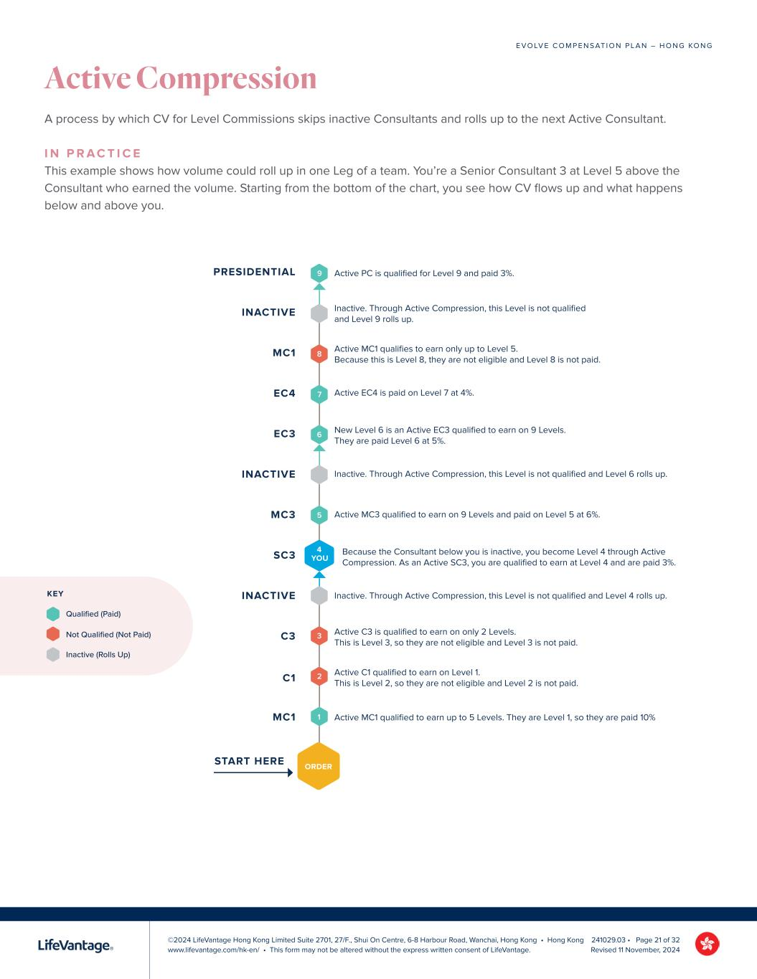
©2024 LifeVantage Hong Kong Limited Suite 2701, 27/F., Shui On Centre, 6-8 Harbour Road, Wanchai, Hong Kong • Hong Kong www.lifevantage.com/hk-en/ • This form may not be altered without the express written consent of LifeVantage. E V O LV E C O M P E N S AT I O N P L A N – H O N G KO N G 241029.03 • Page 21 of 32 Revised 11 November, 2024 Active Compression A process by which CV for Level Commissions skips inactive Consultants and rolls up to the next Active Consultant. I N P R A C T I C E This example shows how volume could roll up in one Leg of a team. You’re a Senior Consultant 3 at Level 5 above the Consultant who earned the volume. Starting from the bottom of the chart, you see how CV flows up and what happens below and above you. 9 8 5 3 7 2 6 1 ORDER MC1 START HERE C1 C3 INACTIVE SC3 MC3 INACTIVE EC3 EC4 MC1 INACTIVE PRESIDENTIAL 4 YOU Active MC1 qualified to earn up to 5 Levels. They are Level 1, so they are paid 10% Active C1 qualified to earn on Level 1. This is Level 2, so they are not eligible and Level 2 is not paid. Active C3 is qualified to earn on only 2 Levels. This is Level 3, so they are not eligible and Level 3 is not paid. Inactive. Through Active Compression, this Level is not qualified and Level 4 rolls up. Because the Consultant below you is inactive, you become Level 4 through Active Compression. As an Active SC3, you are qualified to earn at Level 4 and are paid 3%. Active MC3 qualified to earn on 9 Levels and paid on Level 5 at 6%. Inactive. Through Active Compression, this Level is not qualified and Level 6 rolls up. New Level 6 is an Active EC3 qualified to earn on 9 Levels. They are paid Level 6 at 5%. Active EC4 is paid on Level 7 at 4%. Active MC1 qualifies to earn only up to Level 5. Because this is Level 8, they are not eligible and Level 8 is not paid. Inactive. Through Active Compression, this Level is not qualified and Level 9 rolls up. Active PC is qualified for Level 9 and paid 3%. KEY Qualified (Paid) Not Qualified (Not Paid) Inactive (Rolls Up)

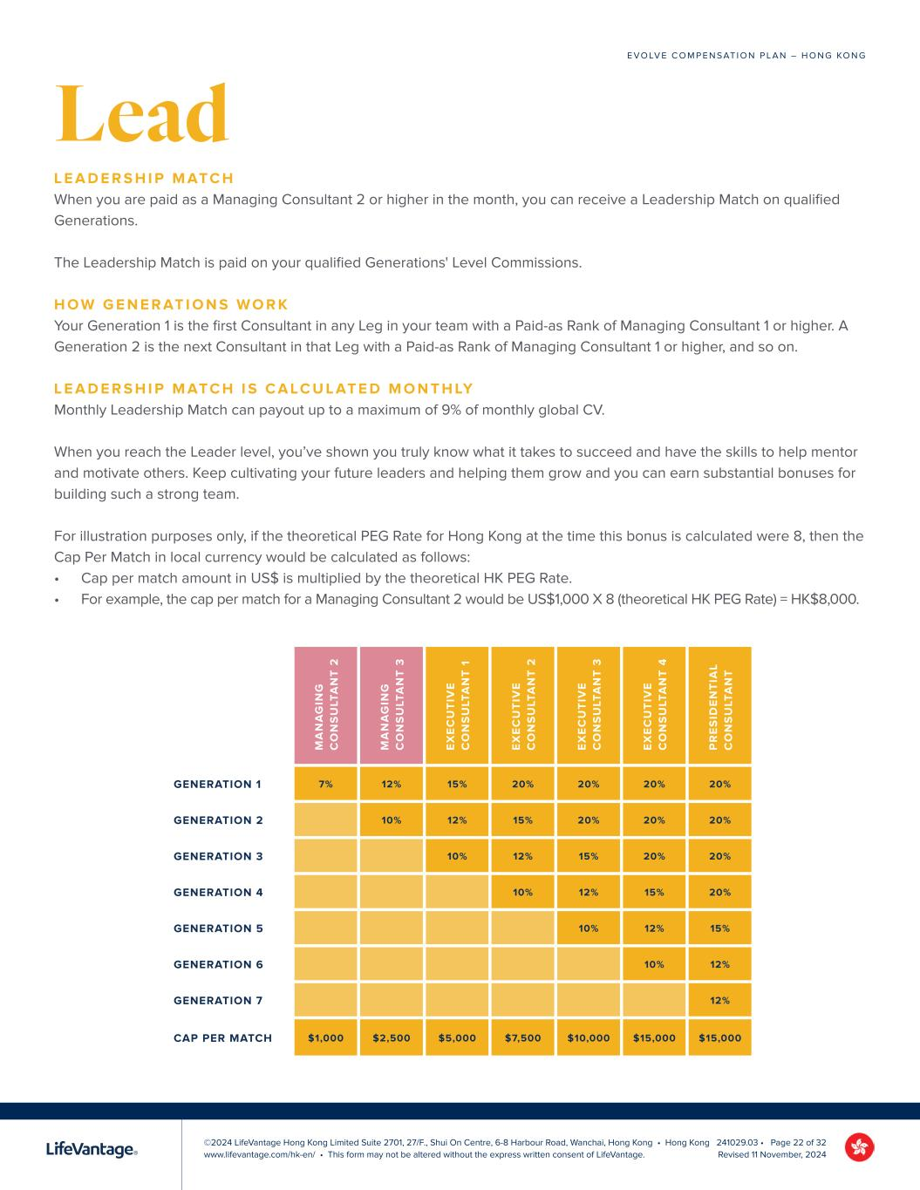
©2024 LifeVantage Hong Kong Limited Suite 2701, 27/F., Shui On Centre, 6-8 Harbour Road, Wanchai, Hong Kong • Hong Kong www.lifevantage.com/hk-en/ • This form may not be altered without the express written consent of LifeVantage. E V O LV E C O M P E N S AT I O N P L A N – H O N G KO N G 241029.03 • Page 22 of 32 Revised 11 November, 2024 Lead L E A D E R S H I P M ATC H When you are paid as a Managing Consultant 2 or higher in the month, you can receive a Leadership Match on qualified Generations. The Leadership Match is paid on your qualified Generations' Level Commissions. H O W G E N E R AT I O N S W O R K Your Generation 1 is the first Consultant in any Leg in your team with a Paid-as Rank of Managing Consultant 1 or higher. A Generation 2 is the next Consultant in that Leg with a Paid-as Rank of Managing Consultant 1 or higher, and so on. L E A D E R S H I P M ATC H I S C A LC U L AT E D M O N T H LY Monthly Leadership Match can payout up to a maximum of 9% of monthly global CV. When you reach the Leader level, you’ve shown you truly know what it takes to succeed and have the skills to help mentor and motivate others. Keep cultivating your future leaders and helping them grow and you can earn substantial bonuses for building such a strong team. For illustration purposes only, if the theoretical PEG Rate for Hong Kong at the time this bonus is calculated were 8, then the Cap Per Match in local currency would be calculated as follows: • Cap per match amount in US$ is multiplied by the theoretical HK PEG Rate. • For example, the cap per match for a Managing Consultant 2 would be US$1,000 X 8 (theoretical HK PEG Rate) = HK$8,000. M A N A G IN G C O N S U LT A N T 2 M A N A G IN G C O N S U LT A N T 3 E X E C U T IV E C O N S U LT A N T 1 E X E C U T IV E C O N S U LT A N T 2 E X E C U T IV E C O N S U LT A N T 3 E X E C U T IV E C O N S U LT A N T 4 P R E S ID E N T IA L C O N S U LT A N T GENERATION 1 7% 12% 15% 20% 20% 20% 20% GENERATION 2 10% 12% 15% 20% 20% 20% GENERATION 3 10% 12% 15% 20% 20% GENERATION 4 10% 12% 15% 20% GENERATION 5 10% 12% 15% GENERATION 6 10% 12% GENERATION 7 12% CAP PER MATCH $1,000 $2,500 $5,000 $7,500 $10,000 $15,000 $15,000

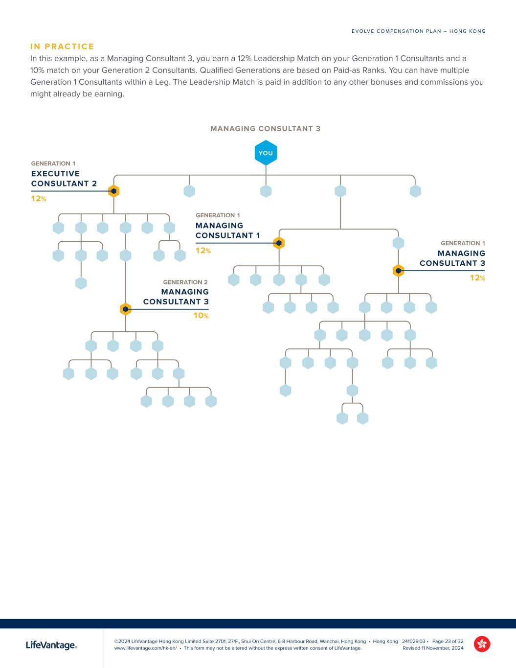
©2024 LifeVantage Hong Kong Limited Suite 2701, 27/F., Shui On Centre, 6-8 Harbour Road, Wanchai, Hong Kong • Hong Kong www.lifevantage.com/hk-en/ • This form may not be altered without the express written consent of LifeVantage. E V O LV E C O M P E N S AT I O N P L A N – H O N G KO N G 241029.03 • Page 23 of 32 Revised 11 November, 2024 I N P R AC T I C E In this example, as a Managing Consultant 3, you earn a 12% Leadership Match on your Generation 1 Consultants and a 10% match on your Generation 2 Consultants. Qualified Generations are based on Paid-as Ranks. You can have multiple Generation 1 Consultants within a Leg. The Leadership Match is paid in addition to any other bonuses and commissions you might already be earning. YOU MANAGING CONSULTANT 3 10% 12% EXECUTIVE CONSULTANT 2 12% MANAGING CONSULTANT 1 12% MANAGING CONSULTANT 3 MANAGING CONSULTANT 3 GENERATION 1 GENERATION 1 GENERATION 2 GENERATION 1

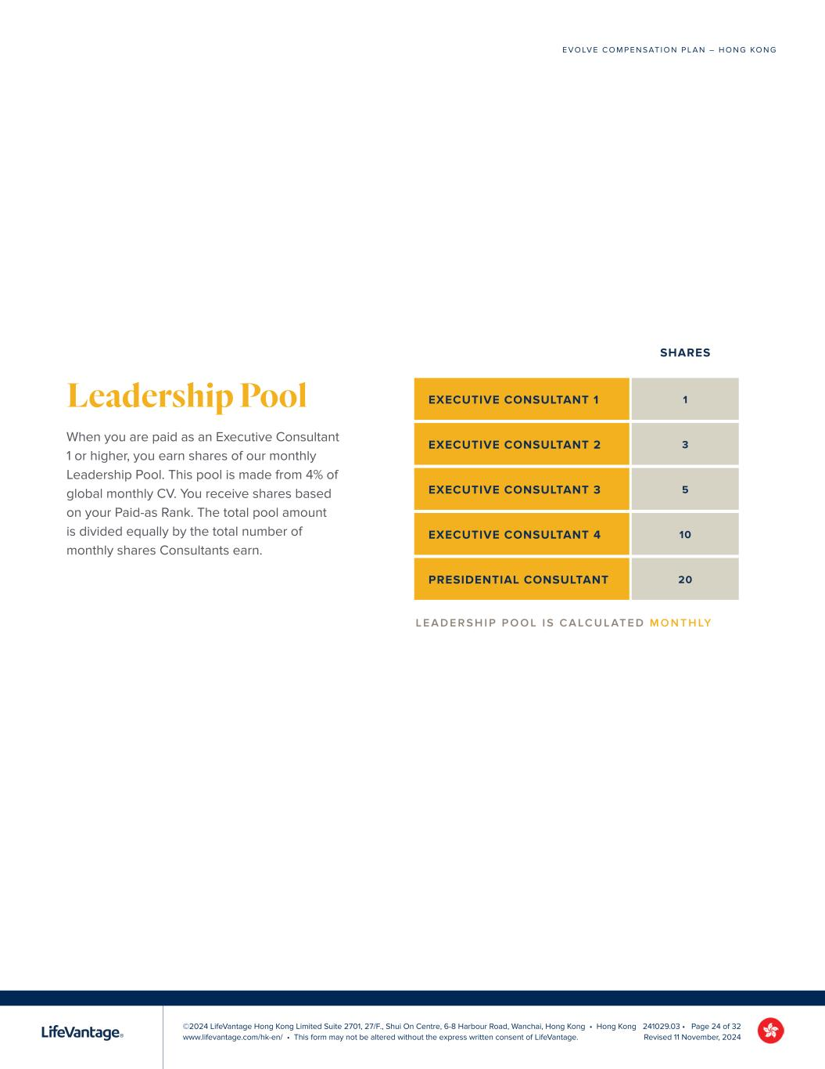
©2024 LifeVantage Hong Kong Limited Suite 2701, 27/F., Shui On Centre, 6-8 Harbour Road, Wanchai, Hong Kong • Hong Kong www.lifevantage.com/hk-en/ • This form may not be altered without the express written consent of LifeVantage. E V O LV E C O M P E N S AT I O N P L A N – H O N G KO N G 241029.03 • Page 24 of 32 Revised 11 November, 2024 Leadership Pool When you are paid as an Executive Consultant 1 or higher, you earn shares of our monthly Leadership Pool. This pool is made from 4% of global monthly CV. You receive shares based on your Paid-as Rank. The total pool amount is divided equally by the total number of monthly shares Consultants earn. SHARES EXECUTIVE CONSULTANT 1 1 EXECUTIVE CONSULTANT 2 3 EXECUTIVE CONSULTANT 3 5 EXECUTIVE CONSULTANT 4 10 PRESIDENTIAL CONSULTANT 20 L E A D E R S H I P P O O L I S C A LC U L AT E D M O N T H LY

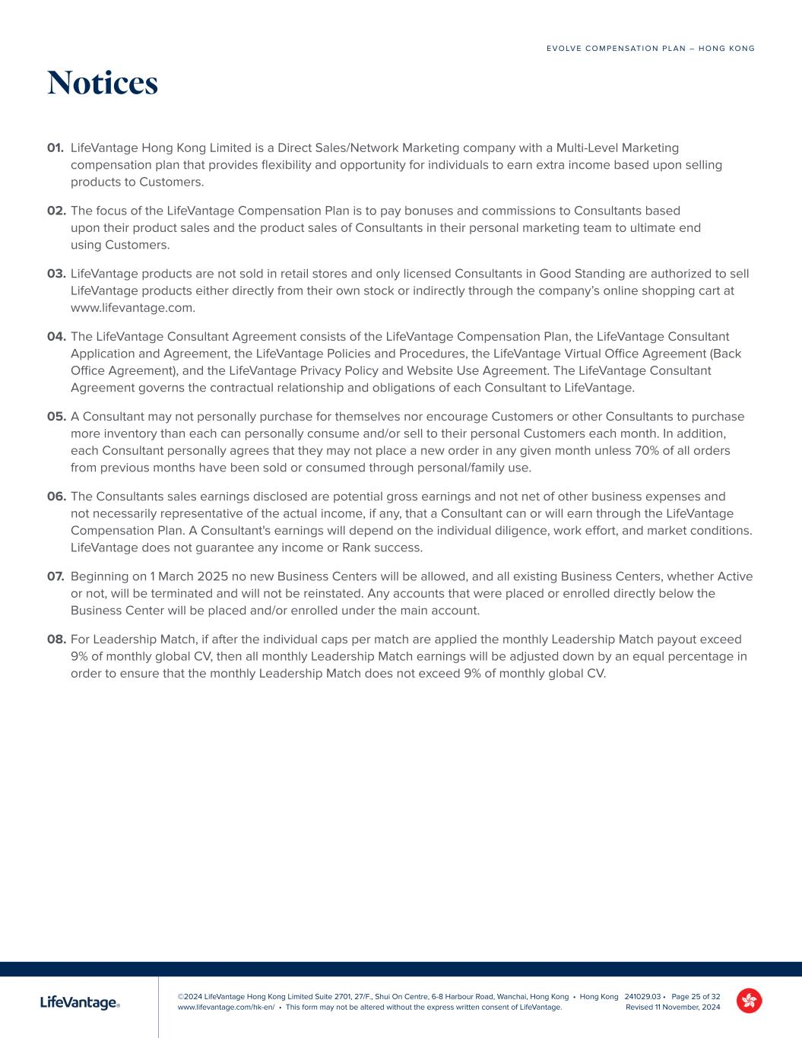
©2024 LifeVantage Hong Kong Limited Suite 2701, 27/F., Shui On Centre, 6-8 Harbour Road, Wanchai, Hong Kong • Hong Kong www.lifevantage.com/hk-en/ • This form may not be altered without the express written consent of LifeVantage. E V O LV E C O M P E N S AT I O N P L A N – H O N G KO N G 241029.03 • Page 25 of 32 Revised 11 November, 2024 Notices 01. LifeVantage Hong Kong Limited is a Direct Sales/Network Marketing company with a Multi-Level Marketing compensation plan that provides flexibility and opportunity for individuals to earn extra income based upon selling products to Customers. 02. The focus of the LifeVantage Compensation Plan is to pay bonuses and commissions to Consultants based upon their product sales and the product sales of Consultants in their personal marketing team to ultimate end using Customers. 03. LifeVantage products are not sold in retail stores and only licensed Consultants in Good Standing are authorized to sell LifeVantage products either directly from their own stock or indirectly through the company’s online shopping cart at www.lifevantage.com. 04. The LifeVantage Consultant Agreement consists of the LifeVantage Compensation Plan, the LifeVantage Consultant Application and Agreement, the LifeVantage Policies and Procedures, the LifeVantage Virtual Office Agreement (Back Office Agreement), and the LifeVantage Privacy Policy and Website Use Agreement. The LifeVantage Consultant Agreement governs the contractual relationship and obligations of each Consultant to LifeVantage. 05. A Consultant may not personally purchase for themselves nor encourage Customers or other Consultants to purchase more inventory than each can personally consume and/or sell to their personal Customers each month. In addition, each Consultant personally agrees that they may not place a new order in any given month unless 70% of all orders from previous months have been sold or consumed through personal/family use. 06. The Consultants sales earnings disclosed are potential gross earnings and not net of other business expenses and not necessarily representative of the actual income, if any, that a Consultant can or will earn through the LifeVantage Compensation Plan. A Consultant's earnings will depend on the individual diligence, work effort, and market conditions. LifeVantage does not guarantee any income or Rank success. 07. Beginning on 1 March 2025 no new Business Centers will be allowed, and all existing Business Centers, whether Active or not, will be terminated and will not be reinstated. Any accounts that were placed or enrolled directly below the Business Center will be placed and/or enrolled under the main account. 08. For Leadership Match, if after the individual caps per match are applied the monthly Leadership Match payout exceed 9% of monthly global CV, then all monthly Leadership Match earnings will be adjusted down by an equal percentage in order to ensure that the monthly Leadership Match does not exceed 9% of monthly global CV.


Evolve COMPENSATION PLAN GUIDE FOR INDEPENDENT LIFEVANTAGE CONSULTANTS SINGAPORE Effective 1 March 2025


Welcome 2


activatedLife. It’s complicated. Messy. Beautiful. It goes by fast, and you want to live life to the fullest. But everyday responsibilities, fears, or restrictions can hold you back. You deserve to break free. You deserve to be your best self and live a healthy, happy life on your terms. LifeVantage is here to help. Our products are purposefully designed to activate your body’s ability to create vibrant health, starting at the cellular level. And when you look and feel your best, you’ll want to help others do the same. LifeVantage activates financial wellness with the opportunity to grow a business that can change people’s lives for the better. That’s where Evolve creates possibilities. Evolve is a compensation plan that allows you to work part-time or full-time.* Whether you are looking to simply share life-changing products or wanting to work and grow as a professional mentor and leader, being an Independent LifeVantage® Consultant will positively challenge and reward you. to life IT’S TIME TO LIVE WITH PURPOSE. IT’S TIME TO INSPIRE REMARKABLE. IT’S TIME TO LIVE ACTIVATED. *LifeVantage does not promise the financial success of any Consultant. Your success depends on your skill, fortitude, dedication, and your ability to lead others to emulate these qualities. Nothing in this guide is a representation that you will be financially successful. LifeVantage does not guarantee any income or Rank success. 3

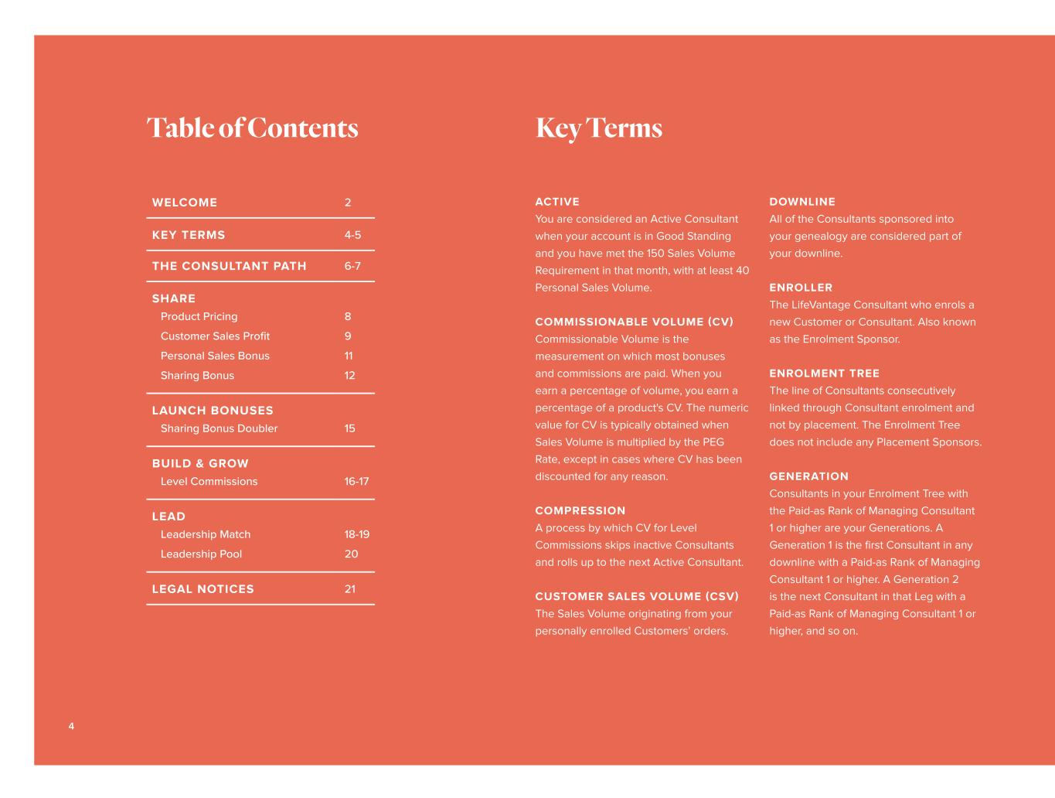
WELCOME 2 KEY TERMS 4-5 THE CONSULTANT PATH 6-7 SHARE Product Pricing Customer Sales Profit Personal Sales Bonus Sharing Bonus 8 9 11 12 LAUNCH BONUSES Sharing Bonus Doubler 15 BUILD & GROW Level Commissions 16-17 LEAD Leadership Match Leadership Pool 18-19 20 LEGAL NOTICES 21 ACTIVE You are considered an Active Consultant when your account is in Good Standing and you have met the 150 Sales Volume Requirement in that month, with at least 40 Personal Sales Volume. COMMISSIONABLE VOLUME (CV) Commissionable Volume is the measurement on which most bonuses and commissions are paid. When you earn a percentage of volume, you earn a percentage of a product's CV. The numeric value for CV is typically obtained when Sales Volume is multiplied by the PEG Rate, except in cases where CV has been discounted for any reason. COMPRESSION A process by which CV for Level Commissions skips inactive Consultants and rolls up to the next Active Consultant. CUSTOMER SALES VOLUME (CSV) The Sales Volume originating from your personally enrolled Customers’ orders. DOWNLINE All of the Consultants sponsored into your genealogy are considered part of your downline. ENROLLER The LifeVantage Consultant who enrols a new Customer or Consultant. Also known as the Enrolment Sponsor. ENROLMENT TREE The line of Consultants consecutively linked through Consultant enrolment and not by placement. The Enrolment Tree does not include any Placement Sponsors. GENERATION Consultants in your Enrolment Tree with the Paid-as Rank of Managing Consultant 1 or higher are your Generations. A Generation 1 is the first Consultant in any downline with a Paid-as Rank of Managing Consultant 1 or higher. A Generation 2 is the next Consultant in that Leg with a Paid-as Rank of Managing Consultant 1 or higher, and so on. Table of Contents Key Terms 4


GOOD STANDING Good Standing means you are in compliance with the Consultant Agreement, including payment of any applicable renewal fees. GROUP SALES VOLUME (GSV) Group Sales Volume is the total Sales Volume from you and all the Customers and Consultants in your entire team. LAUNCH PERIOD Your Launch Period including the month you enrol and the following 3 full calendar months. LEG A Leg begins with a Level 1 Consultant and includes all of the Consultants beneath them. You have as many Legs as you have Level 1 Consultants. LEVEL The location a Consultant has in your downline in relation to you. All of the Consultants directly below you in your Placement Tree are your Level 1. Consultants placed directly below your Level 1 Consultants are your Level 2, and so on. MAXIMUM VOLUME RULE (MVR) The maximum amount of GSV from any one Leg or from your own Personal Sales Volume and Customer Sales Volume that can count toward your monthly Rank qualification. PAID-AS RANK Your Paid-as Rank is the Rank for which you qualify each month. Your Paid-as Rank determines many of your bonuses. Your Paid-as Rank may be the same as or lower than your Recognition Rank depending on your monthly qualifications. PEG RATE The foreign currency conversion factor used by LifeVantage to calculate payments to Consultants. Using a PEG Rate allows LifeVantage to normalise payments to Consultants. The PEG Rate is periodically reviewed and set based on recent foreign exchange rates and projected foreign exchange rates. PERSONAL SALES VOLUME (PSV) The Sales Volume originating from your personal account. PLACEMENT SPONSOR If you place a new Consultant directly below you in your downline, you are the Enrolment Sponsor and Placement Sponsor. However, if you place a new Consultant below a downline Consultant in the Placement Tree, that downline Consultant becomes your new enrollee’s Placement Sponsor. PLACEMENT TREE If you are a new Consultant's Enroller, you may place them directly below you in your downline or under any other downline Consultant’s position. This is considered your Placement Tree, also referred to as your downline or team. QUALIFYING SALES VOLUME (QSV) The Sales Volume that counts toward your monthly Rank qualification. RANK ADVANCING When you meet the qualifications to be paid as a Rank higher than your current Recognition Rank, you will “advance” to that higher Rank, and your Recognition Rank will be updated to reflect that new milestone. RECOGNITION RANK Your Recognition Rank is the highest Rank you have achieved along the Consultant Path. Your Recognition Rank is subject to reclassification once per year based on the maintenance requirements for that Rank. SALES VOLUME (SV) The numeric value attributed by LifeVantage to each commissionable product sold and/or purchased. SALES VOLUME REQUIREMENT (SVR) The accumulation of your Customer Sales Volume and your Personal Sales Volume to meet your monthly Paid-as Rank requirement. UPLINE All of the Consultants above you in your Enrolment and/or Placement Tree. 5


Evolve. Share. Build & Grow. Lead. Your path as an Independent LifeVantage Consultant can lead to a world of possibilities. Start by sharing the LifeVantage products that you love with Customers to help them activate wellness and improve their health. The more you share, the more you’ll grow as you find others who want to join you on the path with a business of their own. As you progress along the Consultant Path, your attention will shift to building and leading Consultants on your team who are ready to grow to the next stage of success. At every stage you’ll evolve your earnings, yourself, and your life. HOW IT WORKS You must meet certain volume requirements to stay Active and earn bonuses and commissions. These requirements will change, along with the bonuses and commissions you can qualify for, as you move along the path and earn Rank advancements. As you reach the qualifications for a specific Rank, you will be recognized with your “Recognition Rank” at that level for as long as you remain Active. However, your “Paid-as Rank” will fluctuate with your qualifications from month to month. 6

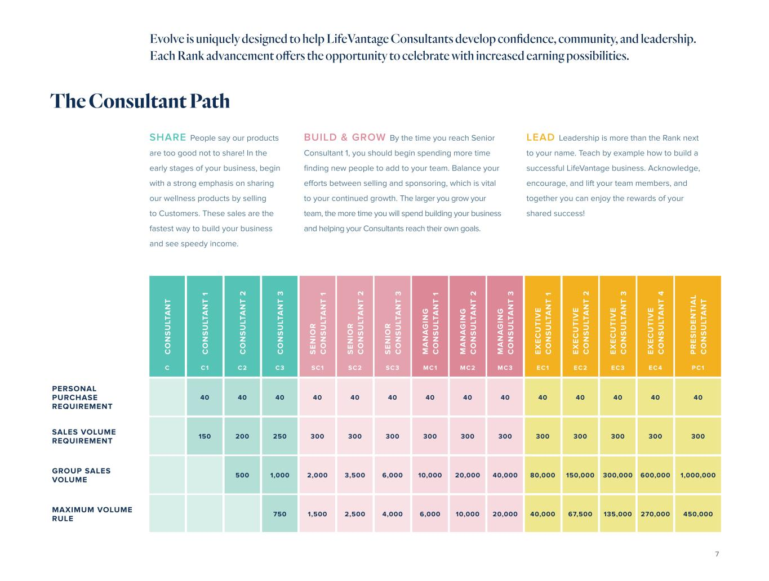
SHARE People say our products are too good not to share! In the early stages of your business, begin with a strong emphasis on sharing our wellness products by selling to Customers. These sales are the fastest way to build your business and see speedy income. BUILD & GROW By the time you reach Senior Consultant 1, you should begin spending more time finding new people to add to your team. Balance your efforts between selling and sponsoring, which is vital to your continued growth. The larger you grow your team, the more time you will spend building your business and helping your Consultants reach their own goals. C O N S U LT A N T C O N S U LT A N T 1 C O N S U LT A N T 2 C O N S U LT A N T 3 S E N IO R C O N S U LT A N T 1 S E N IO R C O N S U LT A N T 2 S E N IO R C O N S U LT A N T 3 M A N A G IN G C O N S U LT A N T 1 M A N A G IN G C O N S U LT A N T 2 M A N A G IN G C O N S U LT A N T 3 E X E C U T IV E C O N S U LT A N T 1 E X E C U T IV E C O N S U LT A N T 2 E X E C U T IV E C O N S U LT A N T 3 E X E C U T IV E C O N S U LT A N T 4 P R E S ID E N T IA L C O N S U LT A N T C C1 C2 C3 SC1 SC2 SC3 MC1 MC2 MC3 EC1 EC2 EC3 EC 4 PC1 PERSONAL PURCHASE REQUIREMENT 40 40 40 40 40 40 40 40 40 40 40 40 40 40 SALES VOLUME REQUIREMENT 150 200 250 300 300 300 300 300 300 300 300 300 300 300 GROUP SALES VOLUME 500 1,000 2,000 3,500 6,000 10,000 20,000 40,000 80,000 150,000 300,000 600,000 1,000,000 MAXIMUM VOLUME RULE 750 1,500 2,500 4,000 6,000 10,000 20,000 40,000 67,500 135,000 270,000 450,000 LEAD Leadership is more than the Rank next to your name. Teach by example how to build a successful LifeVantage business. Acknowledge, encourage, and lift your team members, and together you can enjoy the rewards of your shared success! The Consultant Path Evolve is uniquely designed to help LifeVantage Consultants develop confidence, community, and leadership. Each Rank advancement offers the opportunity to celebrate with increased earning possibilities. 7


EACH LIFEVANTAGE PRODUCT HAS 3 PRICES. 03. CONSULTANT Consultant price is lower than the One Time Retail price and the Subscription Price, regardless of the order type, and represents the lowest price available. 02. SUBSCRIPTION Subscription price is a discount from One-time Retail price. Products purchased by Customers on Subscription are eligible for the discount. 01. ONE-TIME RETAIL The advertised Customer price for all products, whether purchased online or directly from you. Product Pricing 8

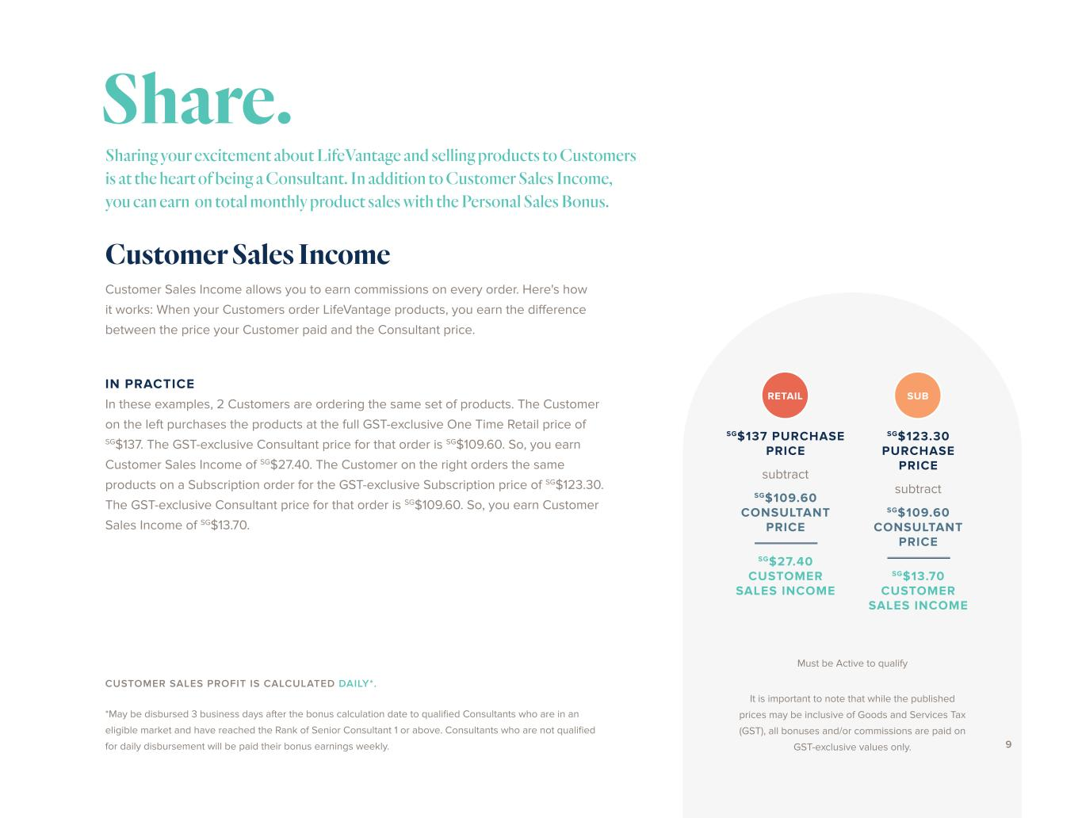
Customer Sales Income allows you to earn commissions on every order. Here's how it works: When your Customers order LifeVantage products, you earn the difference between the price your Customer paid and the Consultant price. IN PRACTICE In these examples, 2 Customers are ordering the same set of products. The Customer on the left purchases the products at the full GST-exclusive One Time Retail price of SG$137. The GST-exclusive Consultant price for that order is SG$109.60. So, you earn Customer Sales Income of SG$27.40. The Customer on the right orders the same products on a Subscription order for the GST-exclusive Subscription price of SG$123.30. The GST-exclusive Consultant price for that order is SG$109.60. So, you earn Customer Sales Income of SG$13.70. CUSTOMER SALES PROFIT IS CALCULATED DAILY*. *May be disbursed 3 business days after the bonus calculation date to qualified Consultants who are in an eligible market and have reached the Rank of Senior Consultant 1 or above. Consultants who are not qualified for daily disbursement will be paid their bonus earnings weekly. Sharing your excitement about LifeVantage and selling products to Customers is at the heart of being a Consultant. In addition to Customer Sales Income, you can earn on total monthly product sales with the Personal Sales Bonus. Customer Sales Income Share. Must be Active to qualify RETAIL SG$137 PURCHASE PRICE SG$27.40 CUSTOMER SALES INCOME subtract SG$109.60 CONSULTANT PRICE SUB SG$123.30 PURCHASE PRICE SG$13.70 CUSTOMER SALES INCOME subtract SG$109.60 CONSULTANT PRICE It is important to note that while the published prices may be inclusive of Goods and Services Tax (GST), all bonuses and/or commissions are paid on GST-exclusive values only. 9


10

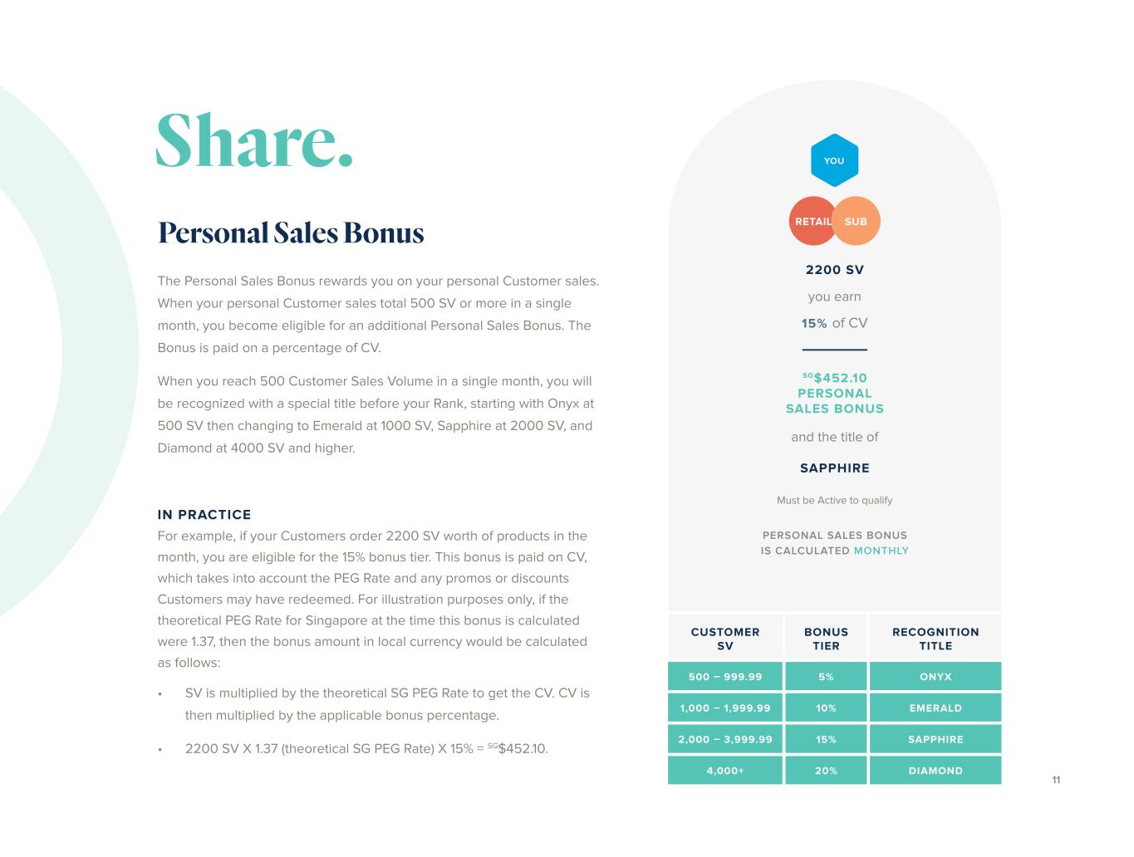
Must be Active to qualify CUSTOMER SV BONUS TIER RECOGNITION TITLE 500 – 999.99 5% ONYX 1,000 – 1,999.99 10% EMERALD 2,000 – 3,999.99 15% SAPPHIRE 4,000+ 20% DIAMOND Personal Sales Bonus The Personal Sales Bonus rewards you on your personal Customer sales. When your personal Customer sales total 500 SV or more in a single month, you become eligible for an additional Personal Sales Bonus. The Bonus is paid on a percentage of CV. When you reach 500 Customer Sales Volume in a single month, you will be recognized with a special title before your Rank, starting with Onyx at 500 SV then changing to Emerald at 1000 SV, Sapphire at 2000 SV, and Diamond at 4000 SV and higher. IN PRACTICE For example, if your Customers order 2200 SV worth of products in the month, you are eligible for the 15% bonus tier. This bonus is paid on CV, which takes into account the PEG Rate and any promos or discounts Customers may have redeemed. For illustration purposes only, if the theoretical PEG Rate for Singapore at the time this bonus is calculated were 1.37, then the bonus amount in local currency would be calculated as follows: • SV is multiplied by the theoretical SG PEG Rate to get the CV. CV is then multiplied by the applicable bonus percentage. • 2200 SV X 1.37 (theoretical SG PEG Rate) X 15% = SG$452.10. PERSONAL SALES BONUS IS CALCULATED MONTHLY Share. 11 2200 SV SAPPHIRE SG$452.10 PERSONAL SALES BONUS you earn 15% of CV and the title of RETAIL SUB YOU

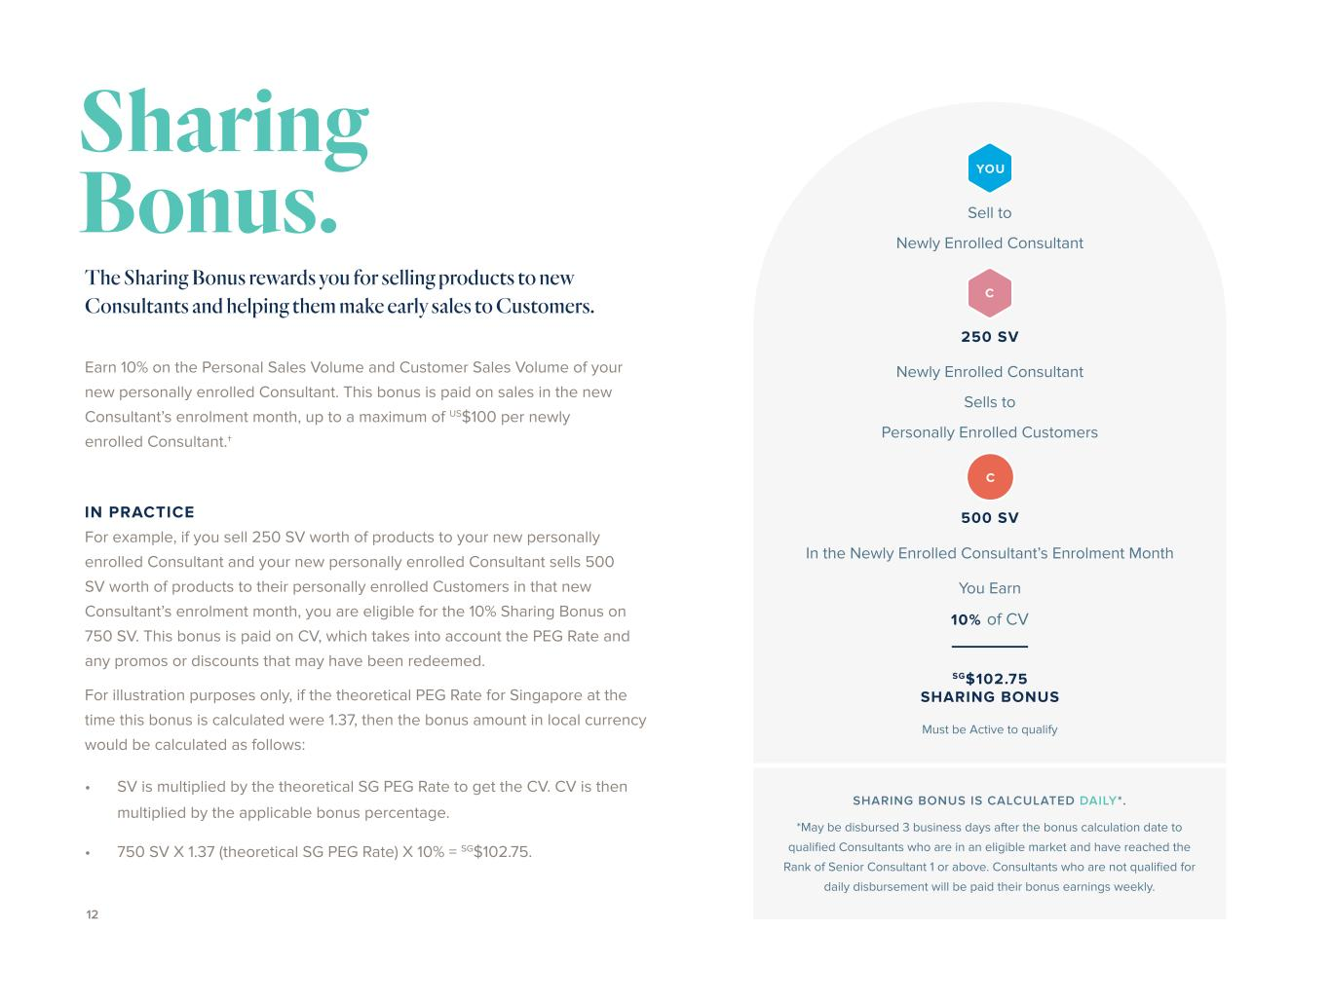
SHARING BONUS IS CALCULATED DAILY*. *May be disbursed 3 business days after the bonus calculation date to qualified Consultants who are in an eligible market and have reached the Rank of Senior Consultant 1 or above. Consultants who are not qualified for daily disbursement will be paid their bonus earnings weekly. The Sharing Bonus rewards you for selling products to new Consultants and helping them make early sales to Customers. Earn 10% on the Personal Sales Volume and Customer Sales Volume of your new personally enrolled Consultant. This bonus is paid on sales in the new Consultant’s enrolment month, up to a maximum of US$100 per newly enrolled Consultant.† IN PRACTICE For example, if you sell 250 SV worth of products to your new personally enrolled Consultant and your new personally enrolled Consultant sells 500 SV worth of products to their personally enrolled Customers in that new Consultant’s enrolment month, you are eligible for the 10% Sharing Bonus on 750 SV. This bonus is paid on CV, which takes into account the PEG Rate and any promos or discounts that may have been redeemed. For illustration purposes only, if the theoretical PEG Rate for Singapore at the time this bonus is calculated were 1.37, then the bonus amount in local currency would be calculated as follows: • SV is multiplied by the theoretical SG PEG Rate to get the CV. CV is then multiplied by the applicable bonus percentage. • 750 SV X 1.37 (theoretical SG PEG Rate) X 10% = SG$102.75. 12 Sharing Bonus. Sell to Newly Enrolled Consultant Newly Enrolled Consultant Sells to Personally Enrolled Customers In the Newly Enrolled Consultant’s Enrolment Month YOU C 250 SV 500 SV You Earn 10% of CV SG$102.75 SHARING BONUS Must be Active to qualify C


13


14

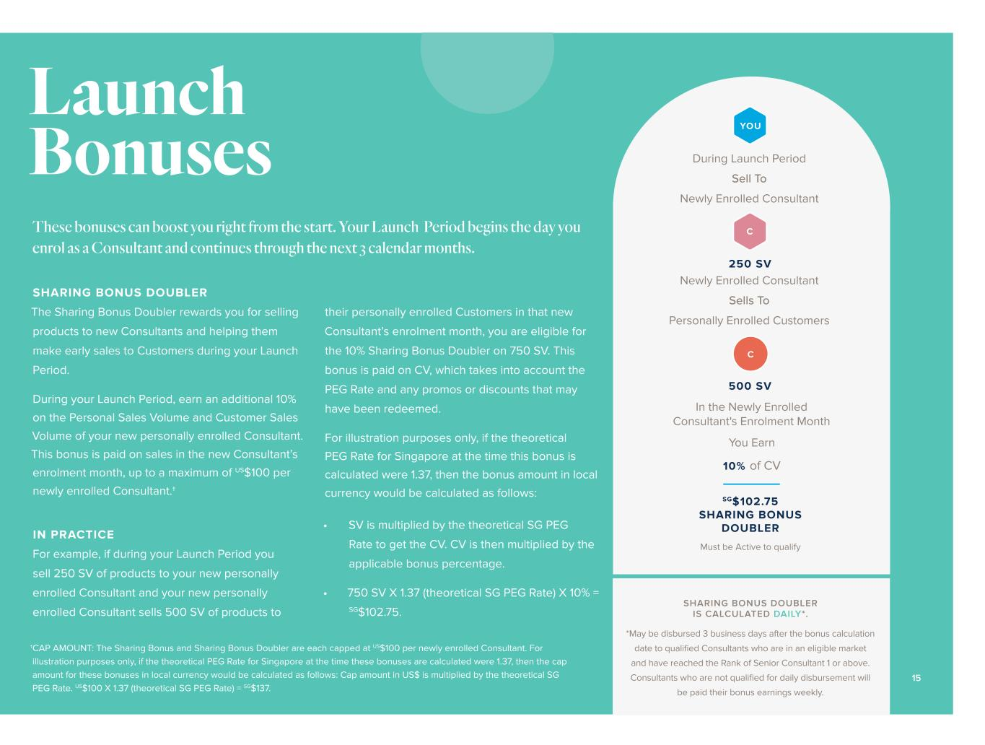
SHARING BONUS DOUBLER The Sharing Bonus Doubler rewards you for selling products to new Consultants and helping them make early sales to Customers during your Launch Period. During your Launch Period, earn an additional 10% on the Personal Sales Volume and Customer Sales Volume of your new personally enrolled Consultant. This bonus is paid on sales in the new Consultant’s enrolment month, up to a maximum of US$100 per newly enrolled Consultant.† IN PRACTICE For example, if during your Launch Period you sell 250 SV of products to your new personally enrolled Consultant and your new personally enrolled Consultant sells 500 SV of products to Launch Bonuses their personally enrolled Customers in that new Consultant’s enrolment month, you are eligible for the 10% Sharing Bonus Doubler on 750 SV. This bonus is paid on CV, which takes into account the PEG Rate and any promos or discounts that may have been redeemed. For illustration purposes only, if the theoretical PEG Rate for Singapore at the time this bonus is calculated were 1.37, then the bonus amount in local currency would be calculated as follows: • SV is multiplied by the theoretical SG PEG Rate to get the CV. CV is then multiplied by the applicable bonus percentage. • 750 SV X 1.37 (theoretical SG PEG Rate) X 10% = SG$102.75. During Launch Period Sell To Newly Enrolled Consultant Newly Enrolled Consultant Sells To Personally Enrolled Customers In the Newly Enrolled Consultant's Enrolment Month YOU C 250 SV 500 SV You Earn 10% of CV SG$102.75 SHARING BONUS DOUBLER Must be Active to qualify These bonuses can boost you right from the start. Your Launch Period begins the day you enrol as a Consultant and continues through the next 3 calendar months. SHARING BONUS DOUBLER IS CALCULATED DAILY*. *May be disbursed 3 business days after the bonus calculation date to qualified Consultants who are in an eligible market and have reached the Rank of Senior Consultant 1 or above. Consultants who are not qualified for daily disbursement will be paid their bonus earnings weekly. C 15 †CAP AMOUNT: The Sharing Bonus and Sharing Bonus Doubler are each capped at US$100 per newly enrolled Consultant. For illustration purposes only, if the theoretical PEG Rate for Singapore at the time these bonuses are calculated were 1.37, then the cap amount for these bonuses in local currency would be calculated as follows: Cap amount in US$ is multiplied by the theoretical SG PEG Rate. US$100 X 1.37 (theoretical SG PEG Rate) = SG$137.

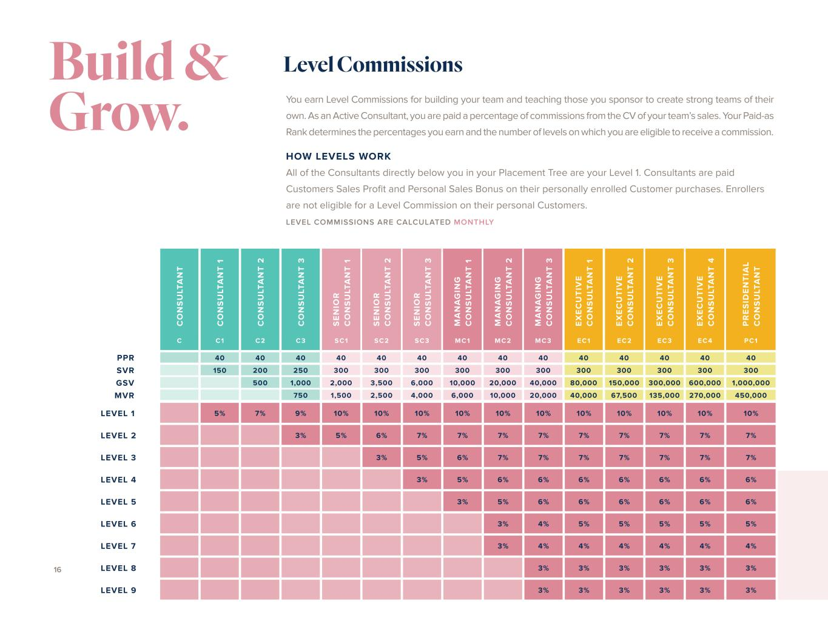
Level Commissions C O N S U LT A N T C O N S U LT A N T 1 C O N S U LT A N T 2 C O N S U LT A N T 3 S E N IO R C O N S U LT A N T 1 S E N IO R C O N S U LT A N T 2 S E N IO R C O N S U LT A N T 3 M A N A G IN G C O N S U LT A N T 1 M A N A G IN G C O N S U LT A N T 2 M A N A G IN G C O N S U LT A N T 3 E X E C U T IV E C O N S U LT A N T 1 E X E C U T IV E C O N S U LT A N T 2 E X E C U T IV E C O N S U LT A N T 3 E X E C U T IV E C O N S U LT A N T 4 P R E S ID E N T IA L C O N S U LT A N T C C1 C2 C3 SC1 SC2 SC3 MC1 MC2 MC3 EC1 EC2 EC3 EC 4 PC1 40 40 40 40 40 40 40 40 40 40 40 40 40 40 150 200 250 300 300 300 300 300 300 300 300 300 300 300 500 1,000 2,000 3,500 6,000 10,000 20,000 40,000 80,000 150,000 300,000 600,000 1,000,000 750 1,500 2,500 4,000 6,000 10,000 20,000 40,000 67,500 135,000 270,000 450,000 LEVEL 1 5% 7% 9% 10% 10% 10% 10% 10% 10% 10% 10% 10% 10% 10% LEVEL 2 3% 5% 6% 7% 7% 7% 7% 7% 7% 7% 7% 7% LEVEL 3 3% 5% 6% 7% 7% 7% 7% 7% 7% 7% LEVEL 4 3% 5% 6% 6% 6% 6% 6% 6% 6% LEVEL 5 3% 5% 6% 6% 6% 6% 6% 6% LEVEL 6 3% 4% 5% 5% 5% 5% 5% LEVEL 7 3% 4% 4% 4% 4% 4% 4% LEVEL 8 3% 3% 3% 3% 3% 3% LEVEL 9 3% 3% 3% 3% 3% 3% You earn Level Commissions for building your team and teaching those you sponsor to create strong teams of their own. As an Active Consultant, you are paid a percentage of commissions from the CV of your team’s sales. Your Paid-as Rank determines the percentages you earn and the number of levels on which you are eligible to receive a commission. HOW LEVELS WORK All of the Consultants directly below you in your Placement Tree are your Level 1. Consultants are paid Customers Sales Profit and Personal Sales Bonus on their personally enrolled Customer purchases. Enrollers are not eligible for a Level Commission on their personal Customers. LEVEL COMMISSIONS ARE CALCULATED MONTHLY 16 Build & Grow. PPR SVR GSV MVR

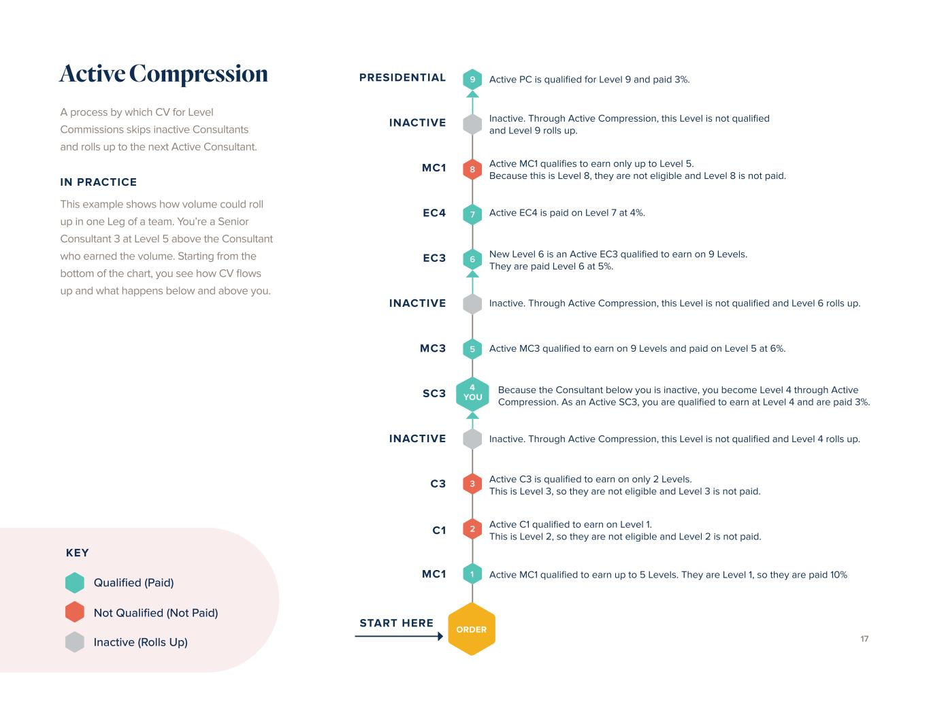
Active Compression 9 8 5 3 7 2 6 1 ORDER MC1 START HERE C1 C3 INACTIVE SC3 MC3 INACTIVE EC3 EC4 MC1 INACTIVE PRESIDENTIAL 4 YOU Active MC1 qualified to earn up to 5 Levels. They are Level 1, so they are paid 10% Active C1 qualified to earn on Level 1. This is Level 2, so they are not eligible and Level 2 is not paid. Active C3 is qualified to earn on only 2 Levels. This is Level 3, so they are not eligible and Level 3 is not paid. Inactive. Through Active Compression, this Level is not qualified and Level 4 rolls up. Because the Consultant below you is inactive, you become Level 4 through Active Compression. As an Active SC3, you are qualified to earn at Level 4 and are paid 3%. Active MC3 qualified to earn on 9 Levels and paid on Level 5 at 6%. Inactive. Through Active Compression, this Level is not qualified and Level 6 rolls up. New Level 6 is an Active EC3 qualified to earn on 9 Levels. They are paid Level 6 at 5%. Active EC4 is paid on Level 7 at 4%. Active MC1 qualifies to earn only up to Level 5. Because this is Level 8, they are not eligible and Level 8 is not paid. Inactive. Through Active Compression, this Level is not qualified and Level 9 rolls up. Active PC is qualified for Level 9 and paid 3%. A process by which CV for Level Commissions skips inactive Consultants and rolls up to the next Active Consultant. IN PRACTICE This example shows how volume could roll up in one Leg of a team. You’re a Senior Consultant 3 at Level 5 above the Consultant who earned the volume. Starting from the bottom of the chart, you see how CV flows up and what happens below and above you. KEY Qualified (Paid) Not Qualified (Not Paid) Inactive (Rolls Up) 17

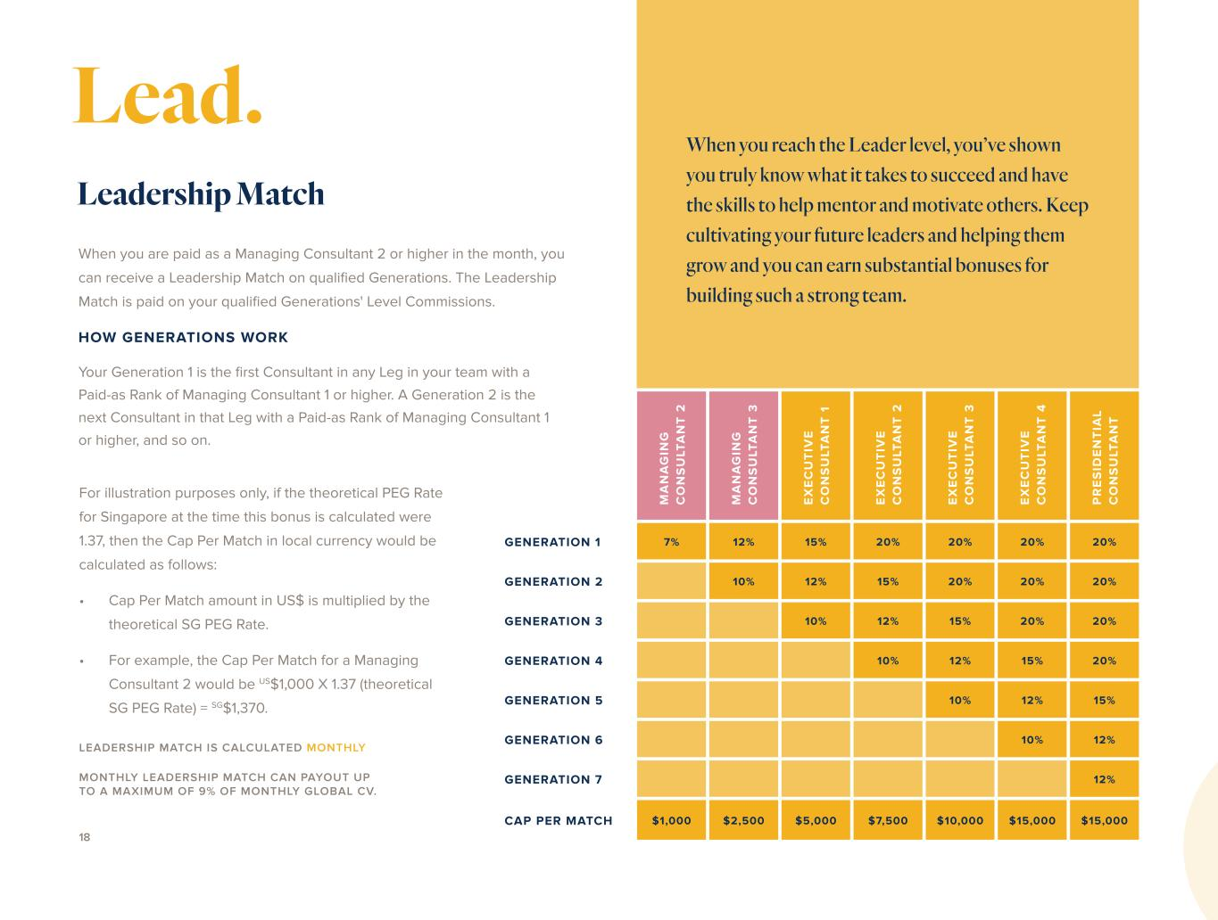
M A N A G IN G C O N S U LT A N T 2 M A N A G IN G C O N S U LT A N T 3 E X E C U T IV E C O N S U LT A N T 1 E X E C U T IV E C O N S U LT A N T 2 E X E C U T IV E C O N S U LT A N T 3 E X E C U T IV E C O N S U LT A N T 4 P R E S ID E N T IA L C O N S U LT A N T GENERATION 1 7% 12% 15% 20% 20% 20% 20% GENERATION 2 10% 12% 15% 20% 20% 20% GENERATION 3 10% 12% 15% 20% 20% GENERATION 4 10% 12% 15% 20% GENERATION 5 10% 12% 15% GENERATION 6 10% 12% GENERATION 7 12% CAP PER MATCH $1,000 $2,500 $5,000 $7,500 $10,000 $15,000 $15,000 When you are paid as a Managing Consultant 2 or higher in the month, you can receive a Leadership Match on qualified Generations. The Leadership Match is paid on your qualified Generations' Level Commissions. HOW GENERATIONS WORK Your Generation 1 is the first Consultant in any Leg in your team with a Paid-as Rank of Managing Consultant 1 or higher. A Generation 2 is the next Consultant in that Leg with a Paid-as Rank of Managing Consultant 1 or higher, and so on. LEADERSHIP MATCH IS CALCULATED MONTHLY MONTHLY LEADERSHIP MATCH CAN PAYOUT UP TO A MAXIMUM OF 9% OF MONTHLY GLOBAL CV. • Cap Per Match amount in US$ is multiplied by the theoretical SG PEG Rate. • For example, the Cap Per Match for a Managing Consultant 2 would be US$1,000 X 1.37 (theoretical SG PEG Rate) = SG$1,370. Leadership Match When you reach the Leader level, you’ve shown you truly know what it takes to succeed and have the skills to help mentor and motivate others. Keep cultivating your future leaders and helping them grow and you can earn substantial bonuses for building such a strong team. For illustration purposes only, if the theoretical PEG Rate for Singapore at the time this bonus is calculated were 1.37, then the Cap Per Match in local currency would be calculated as follows: 18 Lead.

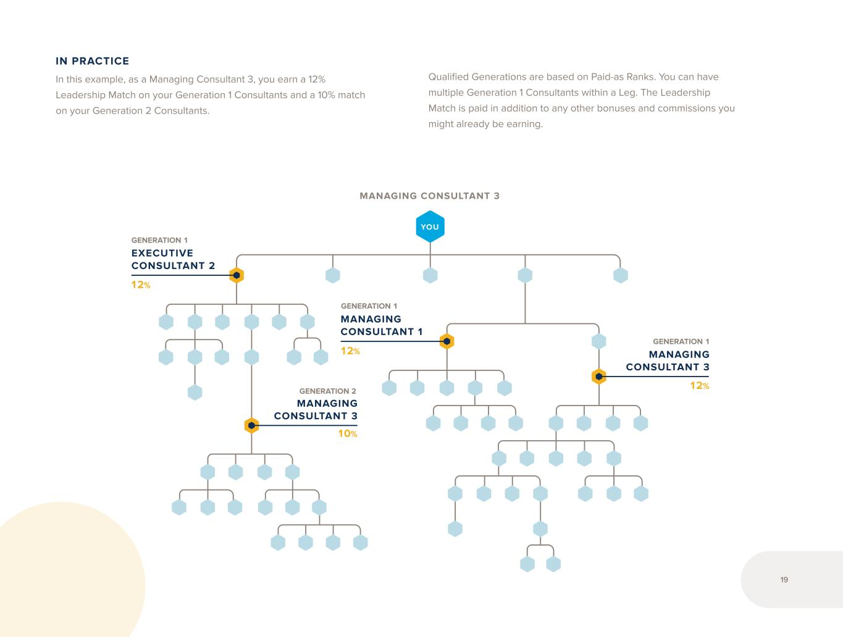
YOU MANAGING CONSULTANT 3 10% 12% EXECUTIVE CONSULTANT 2 12% MANAGING CONSULTANT 1 12% MANAGING CONSULTANT 3 MANAGING CONSULTANT 3 IN PRACTICE In this example, as a Managing Consultant 3, you earn a 12% Leadership Match on your Generation 1 Consultants and a 10% match on your Generation 2 Consultants. Qualified Generations are based on Paid-as Ranks. You can have multiple Generation 1 Consultants within a Leg. The Leadership Match is paid in addition to any other bonuses and commissions you might already be earning. GENERATION 1 GENERATION 1 GENERATION 2 GENERATION 1 19


When you are paid as an Executive Consultant 1 or higher, you earn shares of our monthly Leadership Pool. This pool is made from 4% of global monthly CV. You receive shares based on your Paid-as Rank. The total pool amount is divided equally by the total number of monthly shares Consultants earn. Leadership Pool SHARES EXECUTIVE CONSULTANT 1 1 EXECUTIVE CONSULTANT 2 3 EXECUTIVE CONSULTANT 3 5 EXECUTIVE CONSULTANT 4 10 PRESIDENTIAL CONSULTANT 20 LEADERSHIP POOL IS CALCULATED MONTHLY Lead. 20


Legal Notices 1. LifeVantage Singapore Pte. Ltd. is a Direct Sales/Network Marketing company with a Multi-Level Marketing compensation plan that provides flexibility and opportunity for individuals to earn extra income based upon selling products to Customers. 2. The focus of the LifeVantage Compensation Plan is to pay bonuses and commissions to Consultants based upon their product sales and the product sales of Consultants in their personal marketing team to ultimate end using Customers. 3. LifeVantage products are not sold in retail stores and only licensed Consultants in Good Standing are authorized to sell LifeVantage products either directly from their own stock or indirectly through the company’s online shopping cart at www.lifevantage.com. 4. The LifeVantage Consultant Agreement consists of the LifeVantage Compensation Plan, the LifeVantage Consultant Application and Agreement, the LifeVantage Policies and Procedures, the LifeVantage Virtual Office Agreement (Back Office Agreement), and the LifeVantage Privacy Policy and Website Use Agreement. The LifeVantage Consultant Agreement governs the contractual relationship and obligations of each Consultant to LifeVantage. 5. A Consultant may not personally purchase for themselves nor encourage Customers or other Consultants to purchase more inventory than each can personally consume and/or sell to their personal Customers each month. In addition, each Consultant personally agrees that they may not place a new order in any given month unless 70% of all orders from previous months have been sold or consumed through personal/family use. 6. The Consultants sales earnings disclosed are potential gross earnings and not net of other business expenses and not necessarily representative of the actual income, if any, that a Consultant can or will earn through the LifeVantage Compensation Plan. A Consultant's earnings will depend on the individual diligence, work effort, and market conditions. LifeVantage does not guarantee any income or Rank success. 7. Beginning on 1 March 2025 no new Business Centers will be allowed, and all existing Business Centers, whether Active or not, will be terminated and will not be reinstated. Any accounts that were placed or enrolled directly below the Business Center will be placed and/or enrolled under the main account. 8. For Leadership Match, if after the individual caps per match are applied the monthly Leadership Match payout exceed 9% of monthly global CV, then all monthly Leadership Match earnings will be adjusted down by an equal percentage in order to ensure that the monthly Leadership Match does not exceed 9% of monthly global CV. 21


Notes 22


23


Evolve © 2 0 24 L ife V an ta ge C or po ra tio n. A ll rig ht s re se rv ed . 24 11 0 6 .0 3

Exhibit 31.1
CERTIFICATION OF PRINCIPAL EXECUTIVE OFFICER
I, Steven R. Fife, certify that:
1.I have reviewed this quarterly report on Form 10-Q of LifeVantage Corporation;
2.Based on my knowledge, this report does not contain any untrue statement of a material fact or omit to state a material fact necessary to make the statements made, in light of the circumstances under which such statements were made, not misleading with respect to the period covered by this report;
3.Based on my knowledge, the financial statements, and other financial information included in this report, fairly present in all material respects the financial condition, results of operations and cash flows of the registrant as of, and for, the periods presented in this report;
4.The registrant’s other certifying officer and I are responsible for establishing and maintaining disclosure controls and procedures (as defined in Exchange Act Rules 13a-15(e) and 15d-15(e)) and internal control over financial reporting (as defined in Exchange Act Rules 13a-15(f) and 15d-15(f)) for the registrant and have:
a.Designed such disclosure controls and procedures, or caused such disclosure controls and procedures to be designed under our supervision, to ensure that material information relating to the registrant, including its consolidated subsidiaries, is made known to us by others within those entities, particularly during the period in which this report is being prepared;
b.Designed such internal control over financial reporting, or caused such internal control over financial reporting to be designed under our supervision, to provide reasonable assurance regarding the reliability of financial reporting and the preparation of financial statements for external purposes in accordance with generally accepted accounting principles;
c.Evaluated the effectiveness of the registrant’s disclosure controls and procedures and presented in this report our conclusions about the effectiveness of the disclosure controls and procedures, as of the end of the period covered by this report based on such evaluation; and
d.Disclosed in this report any change in the registrant’s internal control over financial reporting that occurred during the registrant’s most recent fiscal quarter (the registrant’s fourth fiscal quarter in the case of an annual report) that has materially affected, or is reasonably likely to materially affect, the registrant’s internal control over financial reporting; and
5.The registrant’s other certifying officer and I have disclosed, based on our most recent evaluation of internal control over financial reporting, to the registrant’s auditors and the audit committee of the registrant’s board of directors (or persons performing the equivalent functions):
a.All significant deficiencies and material weaknesses in the design or operation of internal control over financial reporting which are reasonably likely to adversely affect the registrant’s ability to record, process, summarize and report financial information; and
b.Any fraud, whether or not material, that involves management or other employees who have a significant role in the registrant’s internal control over financial reporting.
Date: May 6, 2025
/s/ Steven R. Fife
Steven R. Fife
President and Chief Executive Officer
(Principal Executive Officer)

Exhibit 31.2
CERTIFICATION OF PRINCIPAL FINANCIAL OFFICER
I, Carl A. Aure, certify that:
1.I have reviewed this quarterly report on Form 10-Q of LifeVantage Corporation;
2.Based on my knowledge, this report does not contain any untrue statement of a material fact or omit to state a material fact necessary to make the statements made, in light of the circumstances under which such statements were made, not misleading with respect to the period covered by this report;
3.Based on my knowledge, the financial statements, and other financial information included in this report, fairly present in all material respects the financial condition, results of operations and cash flows of the registrant as of, and for, the periods presented in this report;
4.The registrant’s other certifying officer and I are responsible for establishing and maintaining disclosure controls and procedures (as defined in Exchange Act Rules 13a-15(e) and 15d-15(e)) and internal control over financial reporting (as defined in Exchange Act Rules 13a-15(f) and 15d-15(f)) for the registrant and have:
a.Designed such disclosure controls and procedures, or caused such disclosure controls and procedures to be designed under our supervision, to ensure that material information relating to the registrant, including its consolidated subsidiaries, is made known to us by others within those entities, particularly during the period in which this report is being prepared;
b.Designed such internal control over financial reporting, or caused such internal control over financial reporting to be designed under our supervision, to provide reasonable assurance regarding the reliability of financial reporting and the preparation of financial statements for external purposes in accordance with generally accepted accounting principles;
c.Evaluated the effectiveness of the registrant’s disclosure controls and procedures and presented in this report our conclusions about the effectiveness of the disclosure controls and procedures, as of the end of the period covered by this report based on such evaluation; and
d.Disclosed in this report any change in the registrant’s internal control over financial reporting that occurred during the registrant’s most recent fiscal quarter (the registrant’s fourth fiscal quarter in the case of an annual report) that has materially affected, or is reasonably likely to materially affect, the registrant’s internal control over financial reporting; and
5.The registrant’s other certifying officer and I have disclosed, based on our most recent evaluation of internal control over financial reporting, to the registrant’s auditors and the audit committee of the registrant’s board of directors (or persons performing the equivalent functions):
a.All significant deficiencies and material weaknesses in the design or operation of internal control over financial reporting which are reasonably likely to adversely affect the registrant’s ability to record, process, summarize and report financial information; and
b.Any fraud, whether or not material, that involves management or other employees who have a significant role in the registrant’s internal control over financial reporting.
Date: May 6, 2025
/s/ Carl A. Aure
Carl A. Aure
Chief Financial Officer
(Principal Financial Officer)

Exhibit 32.1
CERTIFICATION PURSUANT TO 18 U.S.C. SECTION 1350, AS ADOPTED
PURSUANT TO SECTION 906 OF THE SARBANES-OXLEY ACT OF 2002
In connection with the filing of this quarterly report on Form 10-Q of LifeVantage Corporation (the “Company”) for the period ended March 31, 2025, with the Securities and Exchange Commission on the date hereof (the “report”), I, Steven R. Fife, Principal Executive Officer of the Company, certify, pursuant to 18 U.S.C. Section 1350, as adopted pursuant to Section 906 of the Sarbanes-Oxley Act of 2002, that:
1)The report fully complies with the requirements of section 13(a) or 15(d) of the Securities Exchange Act of 1934; and
2)The information contained in the report fairly presents, in all material respects, the financial condition and results of operations of the Company.
The foregoing certification is being furnished solely pursuant to 18 U.S.C. § 1350 and is not being filed as part of the report or as a separate disclosure document.
Date: May 6, 2025
/s/ Steven R. Fife
Steven R. Fife
President and Chief Executive Officer
(Principal Executive Officer)
A signed original of this written statement required by Section 906 has been provided to the Company and will be retained by the Company and furnished to the Securities and Exchange Commission or its staff upon request.

Exhibit 32.2
CERTIFICATION PURSUANT TO 18 U.S.C. SECTION 1350, AS ADOPTED
PURSUANT TO SECTION 906 OF THE SARBANES-OXLEY ACT OF 2002
In connection with the filing of this quarterly report on Form 10-Q of LifeVantage Corporation (the “Company”) for the period ended March 31, 2025, with the Securities and Exchange Commission on the date hereof (the “report”), I, Carl A. Aure, Principal Financial Officer of the Company, certify, pursuant to 18 U.S.C. Section 1350, as adopted pursuant to Section 906 of the Sarbanes-Oxley Act of 2002, that:
1)The report fully complies with the requirements of section 13(a) or 15(d) of the Securities Exchange Act of 1934; and
2)The information contained in the report fairly presents, in all material respects, the financial condition and results of operations of the Company.
The foregoing certification is being furnished solely pursuant to 18 U.S.C. § 1350 and is not being filed as part of the report or as a separate disclosure document.
Date: May 6, 2025
/s/ Carl A. Aure
Carl A. Aure
Chief Financial Officer
(Principal Financial Officer)
A signed original of this written statement required by Section 906 has been provided to the Company and will be retained by the Company and furnished to the Securities and Exchange Commission or its staff upon request.

