UNITED STATES
SECURITIES AND EXCHANGE COMMISSION
Washington, D.C. 20549
________________________________________________________________________________
Form 10-Q
________________________________________________________________________________
☒ |  |  | QUARTERLY REPORT UNDER SECTION 13 OR 15 (d) OF THE SECURITIES EXCHANGE ACT OF 1934
FOR THE QUARTERLY PERIOD ENDED SEPTEMBER 30, 2023
☐ |  |  | TRANSITION REPORT PURSUANT TO SECTION 13 OR 15 (d) OF THE SECURITIES EXCHANGE ACT OF 1934
FOR THE TRANSITION PERIOD FROM TO
Commission file number 001-35647
________________________________________________________________________________

LIFEVANTAGE CORPORATION
(Exact name of Registrant as specified in its charter)
________________________________________________________________________________
Delaware |  |  |  |  |  | 90-0224471
(State or other jurisdiction of incorporation or organization) |  |  |  |  |  | (IRS Employer Identification No.)
3300 Triumph Blvd, Suite 700, Lehi, UT 84043
(Address of principal executive offices, including zip code)
(801) 432-9000
(Registrant’s telephone number)

Securities registered pursuant to Section 12(b) of the Act:
Common Stock, par value $0.0001 |  |  |  |  |  | LFVN |  |  |  |  |  | The Nasdaq Stock Market LLC
Title of each class |  |  |  |  |  | Trading Symbol(s) |  |  |  |  |  | Name of each exchange on which registered
________________________________________________________________________________
Indicate by check mark whether the registrant (1) has filed all reports required to be filed by Section 13 or 15 (d) of the Securities Exchange Act of 1934 during the preceding 12 months (or for such shorter period that the registrant was required to file such reports), and (2) has been subject to such filing requirements for the past 90 days. Yes ☒ No ☐
Indicate by check mark whether the registrant has submitted electronically every Interactive Data File required to be submitted pursuant to Rule 405 of Regulation S-T (§232.405 of this chapter) during the preceding 12 months (or for such shorter period that the registrant was required to submit such files). Yes ☒ No ☐
Indicate by check mark whether the registrant is a large accelerated filer, an accelerated filer, a non-accelerated filer, a smaller reporting company, or an emerging growth company. See the definitions of “large accelerated filer,” “accelerated filer,” “smaller reporting company” and “emerging growth company” in Rule 12b-2 of the Exchange Act.
Large accelerated filer |  |  | ☐ |  |  | Accelerated filer |  |  | ☐
Non-accelerated filer |  |  | ☒ |  |  | Smaller reporting company |  |  | ☒
Emerging Growth Company |  |  | ☐
If an emerging growth company, indicate by check mark if the registrant has elected not to use the extended transition period for complying with any new or revised financial accounting standards provided pursuant to Section 13(a) of the Exchange Act. ☐
Indicate by check mark whether the registrant is a shell company (as defined in Rule 12b-2 of the Exchange Act). Yes ☐ No ☒
The number of shares outstanding of the issuer’s common stock, par value $0.0001 per share, as of November 8, 2023 was 12,713,887.

CAUTIONARY NOTE REGARDING FORWARD-LOOKING STATEMENTS
This quarterly report on Form 10-Q, in particular “Item 2. Management’s Discussion and Analysis of Financial Condition and Results of Operations,” and the information incorporated by reference herein contains “forward-looking statements” (as such term is defined in Section 27A of the Securities Act of 1933, as amended and Section 21E of the Securities Exchange Act of 1934, as amended). These statements, which involve risks and uncertainties, reflect our current expectations, intentions, or strategies regarding our possible future results of operations, performance, and achievements. Forward-looking statements include, without limitation: statements regarding future products or product development; statements regarding future selling, general and administrative costs and research and development spending; statements regarding the future performance of our network marketing efforts; statements regarding our expectations regarding ongoing litigation; statements regarding international growth; and statements regarding future financial performance, results of operations, capital expenditures and sufficiency of capital resources to fund our operating requirements. These forward-looking statements are made pursuant to the safe harbor provisions of the Private Securities Litigation Reform Act of 1995 and applicable rules of the Securities and Exchange Commission and common law.
These forward-looking statements may be identified in this report and the information incorporated by reference by words such as “anticipate,” “believe,” “could,” “estimate,” “expect,” “intend,” “plan,” “predict,” “project,” “should” and similar terms and expressions, including references to assumptions and strategies. These statements reflect our current beliefs and are based on information currently available to us. Accordingly, these statements are subject to certain risks, uncertainties, and contingencies, which could cause our actual results, performance, or achievements to differ materially from those expressed in, or implied by, such statements.
The following factors are among those that may cause actual results to differ materially from our forward-looking statements:
•Inability to properly manage, motivate and retain our independent consultants (which we previously referred to as “distributors” in our prior filings) or to attract new customers and independent consultants on an ongoing basis;
•The widespread outbreak of an illness or communicable disease or any other public health crisis, similar to the recent COVID-19 pandemic, could adversely affect our business, results of operations and financial condition;
•Inability to protect against cyber security risks and to maintain the integrity of data;
•Inability to manage existing markets, open new international markets or expand our operations;
•Non-compliance by our independent consultants with applicable legal requirements or our policies and procedures, including making improper and/or illegal claims about our products or earnings opportunity;
•Inability of new products and technological innovations to gain customer or independent consultant or market acceptance;
•Our business and stock price may be adversely affected if our internal controls over financial reporting is not effective;
•Inability to execute our product launch process due to increased pressure on our supply chain, information systems and management;
•Inability to appropriately manage our inventory;
•Disruptions in our information technology systems;
•International trade or foreign exchange restrictions, increased tariffs, foreign currency exchange fluctuations;
•Inability to raise additional capital or complete desired acquisitions;
•Inability to comply with financial covenants imposed by our credit facility and the impact of debt service obligations and restrictive debt covenants;
•Dependence upon a few products for revenue;
•We may be unable to retain our existing consultant force or customer base or attract additional customers and/or independent consultants;
•Changes to the Company’s independent consultant compensation plans;
•High quality materials for our products may become difficult to obtain or expensive;
2

•Improper actions by our independent consultants that violate laws or regulations could harm our business;
•Dependence on third parties to manufacture our products;
•Disruptions to the transportation channels used to distribute our products;
•We may be subject to a product recall;
•Unfavorable publicity on our business or products;
•Risks related to Global Not For Resale programs;
•Our direct selling program could be found to not be in compliance with current or newly adopted laws or regulations in various markets;
•The impact of actions by activist stockholders;
•Legal proceedings may be expensive and time consuming;
•Strict government regulations on our business;
•Our Cannabidiol (“CBD”) products are subject to varying and changing federal, state or local laws, which could adversely affect our results of operations and financial condition;
•Regulations governing the production or marketing of our products;
•Risk of investigatory and enforcement action;
•Government authorities may question our tax positions or transfer pricing policies or change their laws in a manner that could increase our effective tax rate or otherwise harm our business;
•Failure to comply with anti-corruption laws;
•Loss of or inability to attract key personnel;
•We may be held responsible for certain taxes or assessments and other obligations relating to the activity of our independent consultants;
•Competition in the dietary supplement and personal care markets;
•Our inability to protect our intellectual property rights;
•Third party claims that we infringe on their intellectual property;
•Product liability claims against us;
•Consumer discretionary spending habits factor into our economic success;
•Economic, political, foreign exchange and other risks associated with international operations;
•Potential delisting of our common stock due to non-compliance with Nasdaq's continued listing requirements;
•Volatility of the market price of our common stock; and
•Substantial sales of shares may negatively impact the market price of our common stock.
When considering these forward-looking statements, you should keep in mind the cautionary statements in this report and the documents incorporated by reference. Except as required by law, we have no obligation and do not undertake to update or revise any such forward-looking statements to reflect events or circumstances after the date of this report.

3

LIFEVANTAGE CORPORATION
INDEX

 |  |  |  |  |  | PAGE
PART I. Financial Information |  |  |  |  |  | 5
Item 1. |  |  | Financial Statements: |  |  | 5
 |  |  | Condensed Consolidated Balance Sheets (unaudited) |  |  | 5
 |  |  | Condensed Consolidated Statements of Operations and Comprehensive Income (Loss) (unaudited) |  |  | 6
 |  |  | Condensed Consolidated Statement of Stockholders’ Equity (unaudited) |  |  | 7
 |  |  | Condensed Consolidated Statements of Cash Flows (unaudited) |  |  | 9
 |  |  | Notes to Condensed Consolidated Financial Statements (unaudited) |  |  | 10
Item 2. |  |  | Management's Discussion and Analysis of Financial Condition and Results of Operations |  |  | 18
Item 3. |  |  | Quantitative and Qualitative Disclosures About Market Risk |  |  | 25
Item 4. |  |  | Controls and Procedures |  |  | 25
PART II. Other Information |  |  |  |  |  | 26
Item 1. |  |  | Legal Proceedings |  |  | 26
Item 1A. |  |  | Risk Factors |  |  | 26
Item 2. |  |  | Unregistered Sales of Equity Securities and Use of Proceeds |  |  | 26
Item 3. |  |  | Defaults Upon Senior Securities |  |  | 26
Item 4. |  |  | Mine Safety Disclosures |  |  | 26
Item 5. |  |  | Other Information |  |  | 26
Item 6. |  |  | Exhibits |  |  | 27
Signatures |  |  |  |  |  | 28

4

PART I. Financial Information

Item 1. Financial Statements

LIFEVANTAGE CORPORATION AND SUBSIDIARIES
CONDENSED CONSOLIDATED BALANCE SHEETS
(Unaudited)
 |  |  | September 30, 2023 |  |  |  |  |  | June 30, 2023
(In thousands, except per share data)
ASSETS
Current assets
Cash and cash equivalents |  |  | $ | 18,405 |  |  |  |  | $ | 21,605
Accounts receivable |  |  | 2,504 |  |  |  |  |  | 1,612
Income tax receivable |  |  | 149 |  |  |  |  |  | 241
Inventory, net |  |  | 15,706 |  |  |  |  |  | 16,073
Prepaid expenses and other |  |  | 5,137 |  |  |  |  |  | 4,753
Total current assets |  |  | 41,901 |  |  |  |  |  | 44,284
Property and equipment, net |  |  | 9,310 |  |  |  |  |  | 9,086
Right-of-use assets |  |  | 9,801 |  |  |  |  |  | 8,738
Intangible assets, net |  |  | 422 |  |  |  |  |  | 455
Deferred income tax asset |  |  | 4,694 |  |  |  |  |  | 2,991
Other long-term assets |  |  | 476 |  |  |  |  |  | 569
TOTAL ASSETS |  |  | $ | 66,604 |  |  |  |  | $ | 66,123
LIABILITIES AND STOCKHOLDERS’ EQUITY
Current liabilities
Accounts payable |  |  | $ | 6,763 |  |  |  |  | $ | 3,505
Commissions payable |  |  | 6,788 |  |  |  |  |  | 6,651
Income tax payable |  |  | 1,522 |  |  |  |  |  | —
Lease liabilities |  |  | 1,660 |  |  |  |  |  | 1,521
Other accrued expenses |  |  | 7,966 |  |  |  |  |  | 7,932
Total current liabilities |  |  | 24,699 |  |  |  |  |  | 19,609
Long-term lease liabilities |  |  | 12,460 |  |  |  |  |  | 11,566
Other long-term liabilities |  |  | 151 |  |  |  |  |  | 299
Total liabilities |  |  | 37,310 |  |  |  |  |  | 31,474
Commitments and contingencies - Note 7
Stockholders’ equity
Preferred stock — par value $0.0001 per share, 5,000 shares authorized, no shares issued or outstanding |  |  | — |  |  |  |  |  | —
Common stock — par value $0.0001 per share, 40,000 shares authorized and 12,707 and 12,622 issued and outstanding as of September 30, 2023 and June 30, 2023, respectively |  |  | 1 |  |  |  |  |  | 1
Additional paid-in capital |  |  | 134,953 |  |  |  |  |  | 134,314
Accumulated deficit |  |  | (104,005) |  |  |  |  |  | (98,305)
Accumulated other comprehensive loss |  |  | (1,655) |  |  |  |  |  | (1,361)
Total stockholders’ equity |  |  | 29,294 |  |  |  |  |  | 34,649
TOTAL LIABILITIES AND STOCKHOLDERS’ EQUITY |  |  | $ | 66,604 |  |  |  |  | $ | 66,123
The accompanying notes are an integral part of these condensed consolidated financial statements.
5

LIFEVANTAGE CORPORATION AND SUBSIDIARIES
CONDENSED CONSOLIDATED STATEMENTS OF OPERATIONS AND COMPREHENSIVE INCOME (LOSS)
(Unaudited)
 |  |  | Three Months Ended September 30,
 |  |  | 2023 |  |  |  |  |  | 2022
(In thousands, except per share data)
Revenue, net |  |  | $ | 51,364 |  |  |  |  | $ | 51,774
Cost of sales |  |  | 10,180 |  |  |  |  |  | 9,942
Gross profit |  |  | 41,184 |  |  |  |  |  | 41,832
Operating expenses:
Commissions and incentives |  |  | 22,473 |  |  |  |  |  | 23,813
Selling, general and administrative |  |  | 17,962 |  |  |  |  |  | 16,729
Total operating expenses |  |  | 40,435 |  |  |  |  |  | 40,542
Operating income |  |  | 749 |  |  |  |  |  | 1,290
Other income (expense):
Interest income, net |  |  | 168 |  |  |  |  |  | —
Other income (expense), net |  |  | (88) |  |  |  |  |  | (438)
Total other income (expense) |  |  | 80 |  |  |  |  |  | (438)
Income before income taxes |  |  | 829 |  |  |  |  |  | 852
Income tax expense |  |  | (200) |  |  |  |  |  | (242)
Net income |  |  | $ | 629 |  |  |  |  | $ | 610
Net income per share:
Basic |  |  | $ | 0.05 |  |  |  |  | $ | 0.05
Diluted |  |  | $ | 0.05 |  |  |  |  | $ | 0.05
Weighted-average shares outstanding:
Basic |  |  | 12,537 |  |  |  |  |  | 12,457
Diluted |  |  | 13,109 |  |  |  |  |  | 12,495
Other comprehensive loss, net of tax:
Foreign currency translation adjustment |  |  | $ | (294) |  |  |  |  | $ | (510)
Other comprehensive loss, net of tax |  |  | (294) |  |  |  |  |  | (510)
Comprehensive income |  |  | $ | 335 |  |  |  |  | $ | 100
The accompanying notes are an integral part of these condensed consolidated financial statements.

6

LIFEVANTAGE CORPORATION AND SUBSIDIARIES
CONDENSED CONSOLIDATED STATEMENT OF STOCKHOLDERS’ EQUITY
(Unaudited)
 |  |  | Common Stock |  |  |  |  |  |  |  |  |  |  |  | Additional  Paid-In  Capital |  |  |  |  |  | Accumulated  Deficit |  |  |  |  |  | Accumulated  Other  Comprehensive Loss |  |  |  |  |  | Total
 |  |  | Shares |  |  |  |  |  | Amount
(In thousands, except per share data)
Balances, June 30, 2023 |  |  | 12,622 |  |  |  |  |  | $ | 1 |  |  |  |  | $ | 134,314 |  |  |  |  | $ | (98,305) |  |  |  |  | $ | (1,361) |  |  |  |  | $ | 34,649
Stock-based compensation |  |  | — |  |  |  |  |  | — |  |  |  |  |  | 978 |  |  |  |  |  | — |  |  |  |  |  | — |  |  |  |  |  | 978
Common stock issued under equity award plans |  |  | 281 |  |  |  |  |  | — |  |  |  |  |  | — |  |  |  |  |  | — |  |  |  |  |  | — |  |  |  |  |  | —
Shares canceled or surrendered as payment of tax withholding and other |  |  | (90) |  |  |  |  |  | — |  |  |  |  |  | (465) |  |  |  |  |  | — |  |  |  |  |  | — |  |  |  |  |  | (465)
Repurchase of company stock |  |  | (145) |  |  |  |  |  | — |  |  |  |  |  | — |  |  |  |  |  | (795) |  |  |  |  |  | — |  |  |  |  |  | (795)
Common stock issued under employee stock purchase plan |  |  | 39 |  |  |  |  |  | — |  |  |  |  |  | 126 |  |  |  |  |  | — |  |  |  |  |  | — |  |  |  |  |  | 126
Cash dividends |  |  | — |  |  |  |  |  | — |  |  |  |  |  | — |  |  |  |  |  | (5,534) |  |  |  |  |  | — |  |  |  |  |  | (5,534)
Currency translation adjustment |  |  | — |  |  |  |  |  | — |  |  |  |  |  | — |  |  |  |  |  | — |  |  |  |  |  | (294) |  |  |  |  |  | (294)
Net income |  |  | — |  |  |  |  |  | — |  |  |  |  |  | — |  |  |  |  |  | 629 |  |  |  |  |  | — |  |  |  |  |  | 629
Balances, September 30, 2023 |  |  | 12,707 |  |  |  |  |  | $ | 1 |  |  |  |  | $ | 134,953 |  |  |  |  | $ | (104,005) |  |  |  |  | $ | (1,655) |  |  |  |  | $ | 29,294
The accompanying notes are an integral part of these condensed consolidated financial statements.

7

LIFEVANTAGE CORPORATION AND SUBSIDIARIES
CONDENSED CONSOLIDATED STATEMENT OF STOCKHOLDERS’ EQUITY (CONTINUED)
(Unaudited)
 |  |  | Common Stock |  |  |  |  |  |  |  |  |  |  |  | Additional  Paid-In  Capital |  |  |  |  |  | Accumulated  Deficit |  |  |  |  |  | Accumulated  Other  Comprehensive Loss |  |  |  |  |  | Total
 |  |  | Shares |  |  |  |  |  | Amount
(In thousands, except per share data)
Balances, June 30, 2022 |  |  | 12,493 |  |  |  |  |  | $ | 1 |  |  |  |  | $ | 131,075 |  |  |  |  | $ | (98,437) |  |  |  |  | $ | (1,123) |  |  |  |  | $ | 31,516
Stock-based compensation |  |  | — |  |  |  |  |  | — |  |  |  |  |  | 602 |  |  |  |  |  | — |  |  |  |  |  | — |  |  |  |  |  | 602
Common stock issued under equity award plans |  |  | 48 |  |  |  |  |  | — |  |  |  |  |  | — |  |  |  |  |  | — |  |  |  |  |  | — |  |  |  |  |  | —
Shares canceled or surrendered as payment of tax withholding and other |  |  | (17) |  |  |  |  |  | — |  |  |  |  |  | (72) |  |  |  |  |  | — |  |  |  |  |  | — |  |  |  |  |  | (72)
Common stock issued under employee stock purchase plan |  |  | 36 |  |  |  |  |  | — |  |  |  |  |  | 121 |  |  |  |  |  | — |  |  |  |  |  | — |  |  |  |  |  | 121
Cash dividends |  |  | — |  |  |  |  |  | — |  |  |  |  |  | — |  |  |  |  |  | (377) |  |  |  |  |  | — |  |  |  |  |  | (377)
Currency translation adjustment |  |  | — |  |  |  |  |  | — |  |  |  |  |  | — |  |  |  |  |  | — |  |  |  |  |  | (510) |  |  |  |  |  | (510)
Net income |  |  | — |  |  |  |  |  | — |  |  |  |  |  | — |  |  |  |  |  | 610 |  |  |  |  |  | — |  |  |  |  |  | 610
Balances, September 30, 2022 |  |  | 12,560 |  |  |  |  |  | $ | 1 |  |  |  |  | $ | 131,726 |  |  |  |  | $ | (98,204) |  |  |  |  | $ | (1,633) |  |  |  |  | $ | 31,890
The accompanying notes are an integral part of these condensed consolidated financial statements.

8

LIFEVANTAGE CORPORATION AND SUBSIDIARIES
CONDENSED CONSOLIDATED STATEMENTS OF CASH FLOWS
(Unaudited)
 |  |  | Three Months Ended September 30,
 |  |  | 2023 |  |  |  |  |  | 2022
(In thousands)
Cash Flows from Operating Activities:
Net income |  |  | $ | 629 |  |  |  |  | $ | 610
Adjustments to reconcile net income to net cash provided by (used in) operating activities:
Depreciation and amortization |  |  | 918 |  |  |  |  |  | 841
Stock-based compensation |  |  | 978 |  |  |  |  |  | 602
Non-cash operating lease expense |  |  | 216 |  |  |  |  |  | 143
Deferred income tax |  |  | (1,703) |  |  |  |  |  | (1,755)
Changes in operating assets and liabilities:
Accounts receivable |  |  | (922) |  |  |  |  |  | 1,326
Income tax receivable |  |  | 92 |  |  |  |  |  | 1,751
Inventory, net |  |  | 180 |  |  |  |  |  | (2,568)
Prepaid expenses and other |  |  | (395) |  |  |  |  |  | 415
Other long-term assets |  |  | 83 |  |  |  |  |  | 1
Accounts payable |  |  | 3,140 |  |  |  |  |  | 429
Income tax payable |  |  | 1,522 |  |  |  |  |  | (346)
Other accrued expenses |  |  | 98 |  |  |  |  |  | (2,248)
Lease liabilities |  |  | (243) |  |  |  |  |  | (235)
Other long-term liabilities |  |  | 172 |  |  |  |  |  | (311)
Net Cash Provided by (Used in) Operating Activities |  |  | 4,765 |  |  |  |  |  | (1,345)
Cash Flows from Investing Activities:
Purchase of property and equipment |  |  | (1,133) |  |  |  |  |  | (727)
Net Cash Used in Investing Activities |  |  | (1,133) |  |  |  |  |  | (727)
Cash Flows from Financing Activities:
Repurchase of company stock |  |  | (795) |  |  |  |  |  | —
Payment of cash dividends |  |  | (5,534) |  |  |  |  |  | (377)
Shares canceled or surrendered as payment of tax withholding and other |  |  | (465) |  |  |  |  |  | (72)
Proceeds from common stock issued under employee stock purchase plan |  |  | 126 |  |  |  |  |  | 121
Net Cash Used in Financing Activities |  |  | (6,668) |  |  |  |  |  | (328)
Foreign Currency Effect on Cash |  |  | (164) |  |  |  |  |  | (171)
Decrease in Cash and Cash Equivalents: |  |  | (3,200) |  |  |  |  |  | (2,571)
Cash and Cash Equivalents — beginning of period |  |  | 21,605 |  |  |  |  |  | 20,190
Cash and Cash Equivalents — end of period |  |  | $ | 18,405 |  |  |  |  | $ | 17,619
SUPPLEMENTAL DISCLOSURE OF CASH FLOW INFORMATION
Cash paid for income taxes |  |  | $ | 168 |  |  |  |  | $ | 439
The accompanying notes are an integral part of these condensed consolidated financial statements.

9

LIFEVANTAGE CORPORATION AND SUBSIDIARIES
NOTES TO CONDENSED CONSOLIDATED FINANCIAL STATEMENTS
(Unaudited)
These unaudited condensed consolidated financial statements and notes should be read in conjunction with the audited financial statements and notes of LifeVantage Corporation (the “Company”) as of and for the year ended June 30, 2023 included in the annual report on Form 10-K filed with the Securities and Exchange Commission (“SEC”) on August 28, 2023.

Note 1 — Organization and Basis of Presentation
LifeVantage Corporation (the "Company") is a company focused on nutrigenomics, the study of how nutrition and naturally occurring compounds affect human genes to support good health. The Company is dedicated to helping people achieve their health, wellness and financial goals. The Company provides quality, scientifically-validated products to customers and independent consultants as well as a financially rewarding commission-based direct sales opportunity to its independent consultants. LifeVantage sells its products in the United States, Mexico, Japan, Australia, Hong Kong, Canada, Thailand, the United Kingdom, the Netherlands, Germany, Taiwan, Austria, Spain, Ireland, Belgium, New Zealand, Singapore, and the Philippines. The Company sold its products in China through a China approved cross-border e-commerce business model until March 15, 2023, at which time the Company closed its e-commerce business in China.
The Company engages in the identification, research, development, formulation and sale of advanced nutrigenomic activators, dietary supplements, nootropics, pre- and pro-biotics, weight management, skin and hair care, bath & body, and targeted relief products. The Company’s line of scientifically validated dietary supplements includes its flagship Protandim® family of products, LifeVantage® Omega+, ProBio, IC Bright®, Daily Wellness, Rise AM, Reset PM and D3+ dietary supplements. TrueScience® is the Company's line of skin, hair, bath & body, and targeted relief products. The Company also markets and sells Petandim®, its companion pet supplement formulated to combat oxidative stress in dogs, AXIO® its nootropic energy drink mixes, and PhysIQ™, its smart weight management system.
The condensed consolidated financial statements included herein have been prepared by the Company’s management, without audit, pursuant to the rules and regulations of the SEC. In the opinion of the Company’s management, these interim financial statements include all adjustments that are considered necessary for a fair presentation of its financial position as of September 30, 2023, and the results of operations for the three months ended September 30, 2023 and 2022, and the cash flows for the three months ended September 30, 2023 and 2022. Interim results are not necessarily indicative of results for a full year or for any future period.
The condensed consolidated financial statements and notes included herein are presented as required by Form 10-Q, and do not contain certain information included in the Company’s audited financial statements and notes for the fiscal year ended June 30, 2023, pursuant to the rules and regulations of the SEC. For further information, refer to the financial statements and notes thereto as of and for the year ended June 30, 2023, and included in the annual report on Form 10-K on file with the SEC.

Note 2 — Summary of Significant Accounting Policies
Consolidation
The condensed consolidated financial statements include the accounts of the Company and its wholly-owned subsidiaries. All significant intercompany accounts and transactions are eliminated in consolidation.
Use of Estimates
The Company prepares the condensed consolidated financial statements and related disclosures in conformity with accounting principles generally accepted in the United States of America ("GAAP"). In preparing these statements, the Company is required to use estimates and assumptions that affect the reported amounts of assets and liabilities, the disclosure of contingent assets and liabilities at the date of the financial statements and the reported amounts of revenue and expenses during the reporting period. Actual results could differ materially from those estimates and assumptions. On an ongoing basis, the Company reviews its estimates, including, but not limited to, those related to inventory valuation and obsolescence, sales returns, income taxes and tax valuation reserves, transfer pricing methodology and positions, impairment of assets, share-based compensation, and loss contingencies.
Foreign Currency Translation
A portion of the Company’s business operations occurs outside the United States. The local currency of each of the Company’s subsidiaries is generally its functional currency. All assets and liabilities are translated into U.S. dollars at exchange rates existing at the balance sheet dates, revenue and expenses are translated at weighted-average exchange rates and stockholders’ equity is recorded at historical exchange rates. The resulting foreign currency translation adjustments are recorded
10

as a separate component of stockholders’ equity in the condensed consolidated balance sheets and as a component of comprehensive income. Transaction gains and losses are included in other expense, net in the condensed consolidated statements of operations and comprehensive income. For the three months ended September 30, 2023 and 2022, net foreign currency losses of $0.1 million and $0.4 million, respectively, are recorded in other income (expense), net.
Cash and Cash Equivalents
The Company considers only its monetary liquid assets with original maturities of three months or less as cash and cash equivalents.
Concentration of Credit Risk
Accounting guidance for financial instruments requires disclosure of significant concentrations of credit risk regardless of the degree of such risk. Financial instruments with significant credit risk include cash and investments. At September 30, 2023, the Company had $13.3 million in cash accounts at one financial institution and $5.1 million in accounts at other financial institutions. At June 30, 2023, the Company had $17.0 million in cash accounts at one financial institution and $4.6 million in accounts at other financial institutions. As of September 30, 2023 and June 30, 2023, and during the periods then ended, the Company’s cash balances exceeded federally insured limits.
Accounts Receivable
The Company’s accounts receivable as of September 30, 2023 and June 30, 2023 consist primarily of credit card receivables. Based on the Company’s verification process for customer credit cards and historical information available, management has determined that an allowance for doubtful accounts on credit card sales related to its customer sales as of September 30, 2023 and June 30, 2023 is not necessary. No bad debt expense was recorded during the three months ended September 30, 2023 and 2022.
Inventory
As of September 30, 2023 and June 30, 2023, inventory consisted of (in thousands):
 |  |  | September 30,  2023 |  |  |  |  |  |  |  |  |  |  |  | June 30,  2023
Finished goods |  |  | $ | 12,263 |  |  |  |  | 78.1 |  | % |  |  |  | $ | 12,153 |  |  |  |  | 75.6 |  | %
Raw materials |  |  | 3,443 |  |  |  |  |  | 21.9 |  | % |  |  |  | 3,920 |  |  |  |  |  | 24.4 |  | %
Total inventory |  |  | $ | 15,706 |  |  |  |  | 100.0 |  | % |  |  |  | $ | 16,073 |  |  |  |  | 100.0 |  | %
Inventories are carried at the lower of cost or net realizable value, using the first-in, first-out method, which includes a reduction in inventory values of $1.3 million and $1.3 million at September 30, 2023 and June 30, 2023, respectively, related to obsolete and slow-moving inventory.
Fair Value of Financial Instruments
The Company accounts for assets and liabilities using a hierarchy of valuation techniques based on whether the inputs to those valuation techniques are observable or unobservable. Observable inputs reflect market data obtained from independent sources, while unobservable inputs reflect the Company's market assumptions. These two types of inputs have created the fair-value hierarchy below. This hierarchy requires the Company to minimize the use of unobservable inputs and to use observable market data, if available, when determining fair value.
•Level 1—Quoted prices for identical instruments in active markets;
•Level 2—Quoted prices for similar instruments in active markets, quoted prices for identical or similar instruments in markets that are not active, and model-derived valuations in which all significant inputs and significant value drivers are observable in active markets; and
•Level 3—Valuations derived from valuation techniques in which one or more significant inputs or significant value drivers are unobservable.
Our financial instruments, consisting primarily of cash and cash equivalents, accounts receivable, and accounts payable, approximate fair value due to their short-term nature.
11

Revenue Recognition
Revenue is recognized when control of the promised goods or services are transferred to the customer, in an amount that reflects the consideration the Company expects to be entitled to in exchange for those goods or services. Sales, value-added, and other taxes the Company collects concurrent with revenue-producing activities are excluded from revenue.
The Company generates the majority of its revenue through product sales to customers. These products include the Protandim® line of dietary supplements, LifeVantage® Omega+, ProBio, IC Bright®, Daily Wellness, Rise AM, Reset PM, and D3+ dietary supplements, TrueScience® skin, hair, bath & body and targeted relief, Petandim®, Axio® nootropic energy drink mixes, and the PhysIQ smart weight management system. The Company ships most of its product directly to the consumer and receives substantially all payment for product sales in the form of credit card receipts. Revenue from direct product sales to customers is recognized upon shipment, which is when passage of title and risk of loss occurs. For items sold in packs and bundles, the Company determines the standalone selling price at contract inception for each distinct good, and then allocates the transaction price on a relative standalone selling price basis. Any discounts are accounted for as a direct reduction to the transaction price. Shipping and handling revenue is recognized upon shipment when the performance obligation is completed.
Contract liabilities, recorded as deferred revenue, include loyalty program credit deferrals with certain customers which are accounted for as a reduction in the transaction price and are generally recognized as credits are redeemed for additional products at a later date. The Company also records deferred revenue when cash payments are received or due in advance of performance, including amounts which are refundable. In addition, the Company pre-sells tickets to its events. When cash payments are received in advance of events, the cash received is recorded to deferred revenue until the event is held, at which time the Company has performed its obligations under the contract and the revenue is recognized.
Deferred revenue is included in accrued expenses in the consolidated balance sheets. The balance of deferred revenue related to contract liabilities was $1.0 million and $0.8 million as of September 30, 2023 and June 30, 2023, respectively. The contract liabilities impact to revenue for the three months ended September 30, 2023 and 2022 was a decrease of $0.2 million and $0.1 million, respectively.
Estimated returns are recorded when product is shipped. Subject to some exceptions based on local regulations, the Company’s return policy is to provide a full refund for product returned within 30 days. After 30 days of purchase, only unopened product that is in a resalable and restockable condition may be returned within twelve months of purchase and shall receive a 100% refund, less a 10% handling and restocking fee and any shipping and handling costs. The Company establishes a refund liability reserve, and an asset reserve for its right to recover products, based on historical experience. The returns asset reserve and returns liability reserve are evaluated on a quarterly basis. As of September 30, 2023 and June 30, 2023, the returns liability reserve, net was $0.1 million and $0.1 million, respectively.
Shipping and Handling
Shipping and handling costs associated with inbound freight and freight out to customers and independent consultants are included in cost of sales. Shipping and handling fees charged to customers and independent consultants are included in revenue.
Research and Development Costs
The Company expenses all costs related to research and development activities, as incurred. Research and development expenses for the three months ended September 30, 2023 and 2022 were $0.2 million and $0.1 million, respectively.
Leases
The Company accounts for leases in accordance with Accounting Standards Codification ("ASC") 842. The Company reviews all contracts and determines if the arrangement is or contains a lease, at inception. Operating leases are included in right-of-use (“ROU”) assets, current lease liabilities and long-term lease liabilities on the condensed consolidated balance sheets. The Company does not have any finance leases.
Operating lease ROU assets represent the Company’s right to use an underlying asset for the lease term and lease liabilities represent the Company’s obligation to make lease payments arising from the lease. ROU assets and lease liabilities are recognized at the lease commencement date based on the estimated present value of lease payments over the lease term. The Company uses its estimated incremental borrowing rate based on the information available at commencement date in determining the present value of future payments. The operating lease ROU asset also includes any upfront lease payments made and excludes lease incentives and initial direct costs incurred. The Company’s lease terms may include options to extend or terminate the lease when it is reasonably certain that the Company will exercise that option. Lease expense for minimum lease payments is recognized on a straight-line basis over the lease term. Leases with a term of 12 months or less are not recorded on the balance sheet. The Company’s lease agreements do not contain any residual value guarantees.
12

Changes in the Company's strategies have resulted in operation modifications in certain Asia/Pacific markets resulting in the closure of showrooms and changes to selling models. As of December 31, 2022, the Company abandoned the ROU assets related to the Hong Kong and Singapore showroom leases. These leases were terminated in February 2023 and the Company has no remaining lease liability for these showrooms.
Stock-Based Compensation
The Company recognizes stock-based compensation by measuring the cost of services to be rendered based on the grant date fair value of the equity award. The Company recognizes stock-based compensation, net of any estimated forfeitures, over the period an employee is required to provide service in exchange for the award, generally referred to as the requisite service period. The Company estimates forfeitures based on historical information and other management assumptions. For awards with market-based performance conditions, the cost of the awards is recognized as the requisite service is rendered by employees, regardless of when, if ever, the market-based performance conditions are satisfied.
The Black-Scholes option pricing model is used to estimate the fair value of stock options and options under the Company's 2019 Employee Stock Purchase Plan. The determination of the fair value of options is affected by the Company's stock price and a number of assumptions, including expected volatility, expected life, risk-free interest rate and expected dividends. The Company uses historical data for estimating the expected volatility and expected life of stock options required in the Black-Scholes model. The risk-free interest rate assumption is based on observed interest rates appropriate for the expected terms of the stock options.
The fair value of restricted stock grants, including performance restricted stock units that include non-market based performance conditions, is based on the closing market price of the Company's stock on the date of grant less the Company's expected dividend yield. The Company recognizes compensation costs for awards with performance conditions when it concludes it is probable that the performance conditions will be achieved. The Company reassesses the probability of vesting at each balance sheet date and adjusts compensation costs accordingly.
Income Taxes
Income taxes are accounted for under the asset and liability method. Deferred tax assets and liabilities are recognized for the future tax consequences attributable to differences between the financial statement carrying amounts of existing assets and liabilities and their respective tax bases and operating loss and tax credit carry-forwards. Deferred tax assets and liabilities are measured using statutory tax rates expected to apply to taxable income in the years in which those temporary differences are expected to be recovered or settled, updated as needed for changes in corporate tax rates. The effect on deferred tax assets and liabilities from a change in tax rates is recognized in income in the period that includes the effective date of the change. The Company recognizes tax liabilities or benefits from an uncertain position only if it is more likely than not that the position will be sustained upon examination by taxing authorities based on the technical merits of the issue. The amount recognized would be the largest liability or benefit that the Company believes has greater than a 50% likelihood of being realized upon settlement.
For the three months ended September 30, 2023 and 2022, the Company recognized income tax expense of $0.2 million and $0.2 million, respectively, which is reflective of the Company’s current estimated federal, state and foreign effective tax rate. Realization of deferred tax assets is dependent upon future earnings in specific tax jurisdictions, the timing and amount of which are uncertain.
Income Per Share
Basic income per common share is computed by dividing the net income by the weighted-average number of common shares outstanding during the period, less unvested restricted stock awards. Diluted income per common share is computed by dividing net income by the weighted-average common shares and potentially dilutive common share equivalents using the treasury stock method.
For the three months ended September 30, 2023 and 2022, the effects of approximately 0.3 million and 0.6 million common shares, respectively, issuable upon exercise of options and non-vested shares of restricted stock are not included in computations as their effect was anti-dilutive.
13

The following is a reconciliation of net income per share and the weighted-average common shares outstanding for purposes of computing basic and diluted net income per share (in thousands, except per share amounts):
 |  |  | Three Months Ended September 30,
 |  |  | 2023 |  |  |  |  |  | 2022
Numerator:
Net income |  |  | $ | 629 |  |  |  |  | $ | 610
Denominator:
Basic weighted-average common shares outstanding |  |  | 12,537 |  |  |  |  |  | 12,457
Effect of dilutive securities:
Stock awards and options |  |  | 572 |  |  |  |  |  | 38
Diluted weighted-average common shares outstanding |  |  | 13,109 |  |  |  |  |  | 12,495
Net income per share, basic |  |  | $ | 0.05 |  |  |  |  | $ | 0.05
Net income per share, diluted |  |  | $ | 0.05 |  |  |  |  | $ | 0.05
Segment Information and Disaggregated Revenue
The Company operates in a single operating segment by selling products directly to customers and through an international network of independent consultants that operates in an integrated manner from market to market. Commissions and incentives expenses are the Company’s largest expense comprised of the commissions paid to its independent consultants. The Company manages its business primarily by managing its international network of independent consultants. The Company disaggregates revenue in two geographic regions: the Americas region and the Asia/Pacific & Europe region.
The following table presents the Company's revenue disaggregated by these two geographic regions (in thousands):
 |  |  | Three Months Ended September 30,
 |  |  | 2023 |  |  |  |  |  | 2022
Americas |  |  | $ | 38,514 |  |  |  |  | $ | 36,369
Asia/Pacific & Europe |  |  | 12,850 |  |  |  |  |  | 15,405
Total revenue |  |  | $ | 51,364 |  |  |  |  | $ | 51,774
Additional information as to the Company’s revenue from operations in the most significant geographical areas is set forth below (in thousands):
 |  |  | Three Months Ended September 30,
 |  |  | 2023 |  |  |  |  |  | 2022
United States |  |  | $ | 36,896 |  |  |  |  | $ | 34,658
Japan |  |  | $ | 7,515 |  |  |  |  | $ | 8,168
The following table presents the Company's long-lived assets for its most significant geographic markets (in thousands):
 |  |  | September 30,  2023 |  |  |  |  |  | June 30,  2023
United States |  |  | $ | 21,601 |  |  |  |  | $ | 20,504
Japan |  |  | $ | 2,315 |  |  |  |  | $ | 354

Note 3 — Leases
The Company has operating leases for current corporate offices and certain equipment. These leases have remaining terms of approximately one to eight years. As of September 30, 2023, the weighted average remaining lease term and weighted average discount rate for operating leases was 7.78 years and 3.17%, respectively. As of June 30, 2023, the weighted average remaining lease term and weighted average discount rate for operating leases was 8.27 years and 3.25%, respectively
For the three months ended September 30, 2023 and 2022, operating lease expense was $0.6 million and $0.7 million, respectively.
The components of lease expense for the three months ended September 30, 2023 and 2022, were as follows:
14

 |  |  | Three Months Ended September 30,
 |  |  | 2023 |  |  |  |  |  | 2022
Operating lease expense
Operating lease cost |  |  | $ | 530 |  |  |  |  | $ | 671
Variable lease cost |  |  | 48 |  |  |  |  |  | 27
Short-term lease costs |  |  | 12 |  |  |  |  |  | 23
Total lease expense |  |  | $ | 590 |  |  |  |  | $ | 721
Supplemental cash flow information related to operating leases was as follows (in thousands):
 |  |  | Three Months Ended September 30,
 |  |  | 2023 |  |  |  |  |  | 2022
Operating cash outflows from operating leases |  |  | $ | 557 |  |  |  |  | $ | 755
Right-of-use assets obtained in exchange for lease obligations |  |  | $ | 1,502 |  |  |  |  | $ | —
Maturity of lease liabilities at September 30, 2023 are as follows (in thousands):
Year ended June 30, |  |  |  |  |  | Amount
2024 (remaining nine months ending June 30, 2024) |  |  |  |  |  | $ | 1,599
2025 |  |  |  |  |  | 1,937
2026 |  |  |  |  |  | 1,978
2027 |  |  |  |  |  | 2,019
2028 |  |  |  |  |  | 2,061
Thereafter |  |  |  |  |  | 6,394
Total |  |  |  |  |  | 15,988
Less: imputed interest |  |  |  |  |  | (1,868)
Present value of lease liabilities |  |  |  |  |  | $ | 14,120

Note 4 — Long-Term Debt
On March 30, 2016, the Company entered into a loan agreement (the "2016 Loan Agreement") and a security agreement (the "Security Agreement"). The 2016 Loan Agreement provides for a term loan in an aggregate principal amount of $10.0 million (the "2016 Term Loan") and a revolving loan facility in an aggregate principal amount not to exceed $2.0 million (the "2016 Revolving Loan," and collectively with the 2016 Term Loan, the 2016 Loan Agreement and the Security Agreement, the "2016 Credit Facility"). During the fiscal year ended June 30, 2020, the Company repaid, in full, the balance of the 2016 Term Loan.
On May 4, 2018 and February 1, 2019, the Company entered into loan modification agreements (“Amendment No. 1” and “Amendment No. 2”, respectively). These loan modification agreements amended certain financial covenants and the available borrowing amount under the 2016 Revolving Loan.
On April 1, 2021, the Company entered into a loan modification agreement ("Amendment No. 3"), which amended the 2016 Credit Facility, as previously amended. Amendment No. 3, with an available borrowing amount of $5.0 million, revised the maturity date from March 31, 2021 to March 31, 2024 and modified the variable interest rate based on the one-month United States Treasury Rate, plus a margin of 3.00%, with an interest rate floor of 4.00%. Amendment No. 3 also revised the debt (total liabilities) to tangible net worth ratio (as defined in Amendment No. 3) covenant to require that the Company maintain this ratio not in excess of 2.00 to 1.00, measured as of the end of each fiscal quarter, and revised the definition and calculation of the minimum fixed charge coverage ratio (as defined in Amendment No. 3). There were no other changes to the minimum fixed charge coverage ratio of 1.10 to 1.00 or the minimum working capital of $6.0 million as set forth in previous amendments.
The 2016 Credit Facility, as amended, contains customary covenants, including affirmative and negative covenants that, among other things, restrict the Company's ability to create certain types of liens, incur additional indebtedness, declare or pay dividends on or redeem capital stock without prior approval, make other payments to holders of equity interests in the
15

Company, make certain investments, purchase or otherwise acquire all or substantially all the assets or equity interests of other companies, sell assets or enter into consolidations, mergers or transfers of all or any substantial part of the Company's assets.
The 2016 Credit Facility, as amended, contains cross-default provisions, whereby a default under the terms of certain indebtedness or an uncured default of a payment or other material obligation of the Company under a material contract of the Company will cause a default on the remaining indebtedness under the 2016 Credit Facility, as amended. The Company’s obligations under the 2016 Credit Facility, as amended, are secured by a security interest in substantially all of the Company’s assets.
The Company entered into a loan modification agreement ("Amendment No. 4"), effective September 30, 2022, which further amended the 2016 Credit Facility. Amendment No. 4 revised the calculation of the minimum fixed charge coverage ratio (as defined in Amendment No. 4) and allows the Company to declare and pay dividends, up to $500,000 per quarter, through September 30, 2023. There were no other changes to the covenants or revolving loan facility as set forth in Amendment No. 3.
On August 28, 2023, the Company received approval, without modifying Amendment No. 4, to declare and pay a one-time cash dividend of $0.40 per share of common stock, to be paid on September 22, 2023. The Company also received approval to declare and pay dividends, up to $750,000, per quarter, through September 30, 2024.
As of September 30, 2023, the Company was in compliance with its financial covenants under the 2016 Credit Facility, as amended. As of September 30, 2023, the effective interest rate is 8.55%. If the Company borrows under the 2016 Revolving Loan, interest will be payable quarterly in arrears on the last day of each fiscal quarter. As of September 30, 2023, there was no balance outstanding on the 2016 Credit Facility.

Note 5 — Stockholders’ Equity
During the three months ended September 30, 2023 and 2022, the Company issued 0.3 million and 48,000 shares of common stock under equity award plans, respectively. During the three months ended September 30, 2023 and 2022, the Company issued no shares of common stock upon the exercise of stock options. During the three months ended September 30, 2023 and 2022, 0.1 million and 17,000 shares of restricted stock were canceled or surrendered as payment of tax withholding upon vesting, respectively.
On November 27, 2017, the Company announced a share repurchase program authorizing it to repurchase up to $5 million in shares of the Company's common stock. The repurchase program permits the Company to purchase shares through a variety of methods, including in the open market, through privately negotiated transactions or other means as determined by the Company's management. As part of the repurchase program, the Company has entered into a pre-arranged stock repurchase plan which operates in accordance with guidelines specified under Rule 10b5-1 of the Securities Exchange Act of 1934, as amended. Accordingly, any transactions under such stock repurchase plan will be completed in accordance with the terms of the plan, including specified price, volume and timing conditions. The authorization may be suspended or discontinued at any time. On February 1, 2019, the Board of Directors approved an amendment to increase the authorized share repurchase amount from $5 million to $15 million. On August 27, 2020, the Board of Directors approved an amendment to increase the authorized share repurchase amount from $15 million to $35 million and to extend the duration of the program through November 30, 2023 and, on February 17, 2022, the board of directors approved an amendment to increase the authorized share repurchase amount from $35 million to $60 million. On June 12, 2023, the board of directors approved the extension of the repurchase program period to December 31, 2026. During the three months ended September 30, 2023, the Company purchased 0.1 million shares of common stock at an aggregate price of $0.8 million under this repurchase program. During the three months ended September 30, 2022, the Company purchased no shares of common stock under this repurchase program. At September 30, 2023, there is $26.1 million remaining under this repurchase program.
On August 30, 2023, the board of directors approved a stockholder rights agreement (the “Rights Plan”) and declared a dividend of one right for each outstanding share of common stock to stockholders of record on September 11, 2023. Each right entitles holders to purchase one newly issued share of preferred stock at an exercise price of $20 per right, subject to adjustment. Initially, the rights are not exercisable and trade with shares of the Company’s common stock.
In general, the rights become exercisable following a public announcement that a person acquires 12% (or, in the case of passive investors, 20%) or more of the outstanding shares of the Company’s common stock. If a person becomes an acquiring person, each holder of rights (except the acquiring person) will have the right to purchase, for the purchase price, a number of shares of the Company’s common stock at a 50% discount to the then-current trading price. Rather than allowing the rights to be exercised in those circumstances, the board of directors may exchange each right, other than the rights owned by the acquiring person, for a share of the Company’s common stock. The agreement provides for exceptions and additional terms for other certain situations and circumstances.
16

The Rights Plan is intended to protect the interests of LifeVantage and its stockholders by reducing the likelihood that any entity, person or group gains control of the Company through open-market accumulation or other means without payment of an adequate control premium and expires August 24, 2024, unless it is earlier terminated or the rights are earlier redeemed or exchanged by the board of directors. There is currently no impact to the Company’s Consolidated Financial Statements.
The Company’s Certificate of Incorporation authorizes the issuance of preferred stock. However, as of September 30, 2023, none have been issued nor have any rights or preferences been assigned to the preferred stock by the Company’s board of directors.
Dividends
In August 2023, the board of directors declared a quarterly cash dividend of $0.035 per share of common stock and a one-time cash dividend of $0.40 per share of common stock to be paid on September 22, 2023 to stockholders of record on September 8, 2023. Cash dividends for the three months ended September 30, 2023 totaled $5.5 million, or $0.435 per share.
In August 2022, the board of directors declared a quarterly cash dividend of $0.03 per share of common stock to be paid on September 15, 2022 to stockholders of record on September 2, 2022. Cash dividends for the three months ended September 30, 2022 totaled $0.4 million, or $0.03 per share.
The declaration of dividends is subject to the discretion of the board of directors and will depend upon various factors, including the Company's earnings, financial condition, restrictions imposed by any indebtedness that may be outstanding, cash requirements, future prospects and other factors deemed relevant by the board of directors.

Note 6 — Stock-Based Compensation
Long-Term Incentive Plans
Equity-Settled Plans
The Company adopted, and the stockholders approved, the 2017 Long-Term Incentive Plan (the “2017 Plan”), effective February 16, 2017, to provide incentives to eligible employees, directors and consultants. The initial share pool approved was 650,000 shares. On November 10, 2022, the stockholders approved amendments to the 2017 Plan to increase the number of shares of the Company's common stock that are available for issuance under the 2017 plan by 1,052,000 shares. As of September 30, 2023, a maximum of 4.0 million shares of the Company's common stock can be issued under the 2017 Plan in connection with the grant of awards which is calculated as the sum of (i) 3,492,000 shares and (ii) up to 475,000 shares previously reserved for issuance under the 2010 Plan, including shares returned upon cancellation, termination or forfeiture of awards that were previously granted under that plan. Outstanding stock options awarded under the 2017 Plan have exercise prices of $4.44 per share, and vest over a three year vesting period. Awards expire in accordance with the terms of each award and, upon expiration of the award, the shares subject to the award are added back to the 2017 Plan. The contractual term of stock options granted is generally ten years. As of September 30, 2023, under the 2017 Plan, there were stock option awards outstanding, net of awards expired, for an aggregate of 0.1 million shares of the Company's common stock.
Employee Stock Purchase Plan
General. The Company's 2019 Employee Stock Purchase Plan ("ESPP") was adopted by the board of directors in September 2018 and the Company's stockholders approved it in November 2018. The ESPP is intended to qualify under Section 423 of the Internal Revenue Code.
Share Reserve. The Company has reserved 0.4 million shares of its common stock for issuance under the ESPP. As of September 30, 2023, 0.1 million shares were available for issuance. The number of shares reserved under the ESPP will automatically be adjusted in the event of a stock split, stock dividend or a reverse stock split (including an adjustment to the per-purchase period share limit).
Purchase Price. Employees may purchase each share of common stock under the ESPP at a price equal to 85% of the lower of the fair market values of the stock as of the beginning or the end of the six-month offering periods. An employee's contributions to the ESPP are limited to 15% of their regular hourly or salary compensation, and up to a maximum of 3,000 shares may be purchased during any offering period. A participant shall not be granted an option under the ESPP if such option would permit the participant's rights to purchase stock to accrue at a rate exceeding $25,000 grant date fair market value of stock for each calendar year in which such option is outstanding at any time.
Offering Periods. Unless otherwise determined by the compensation committee, the ESPP will be operated through a series of successive six-month offering periods, which will begin each year on March 1 and September 1.
17

During the three months ended September 30, 2023 and 2022, approximately 39,000 and 36,000 shares of common stock were issued under the ESPP, respectively.
Stock-Based Compensation
For the three months ended September 30, 2023 and 2022, compensation of $1.0 million and $0.6 million, respectively, was reflected as an increase to additional paid-in capital, all of which was employee related.

Note 7 — Commitments and Contingencies
Contingencies
The Company accounts for contingent liabilities in accordance with ASC 450, Contingencies. This guidance requires management to assess potential contingent liabilities that may exist as of the date of the financial statements to determine the probability and amount of loss that may have occurred, which inherently involves an exercise of judgment. If the assessment of a contingency indicates that it is probable that a material loss has been incurred and the amount of the liability can be estimated, then the estimated liability would be accrued in the Company’s financial statements. If the assessment indicates that a potential material loss contingency is not probable but is reasonably possible, or is probable but cannot be estimated, then the nature of the contingent liability, and an estimate of the range of possible losses, if determinable and material, would be disclosed. For loss contingencies considered remote, no accrual or disclosures are generally made. Management has assessed potential contingent liabilities as of September 30, 2023, and based on the assessment, there are no probable loss contingencies requiring accrual or disclosures within its financial statements.
Legal Accruals
In addition to commitments and obligations in the ordinary course of business, from time to time, the Company is subject to various claims, pending and potential legal actions, investigations relating to governmental laws and regulations and other matters arising out of the normal conduct of its business. Management assesses contingencies to determine the degree of probability and range of possible loss for potential accrual in the consolidated financial statements. An estimated loss contingency is accrued in the consolidated financial statements if it is probable that a liability has been incurred and the amount of the loss can be reasonably estimated. Because evaluating legal claims and litigation results are inherently unpredictable and unfavorable results could occur, assessing contingencies is highly subjective and requires judgments about future events. When evaluating contingencies, management may be unable to provide a meaningful estimate due to a number of factors, including the procedural status of the matter in question, the presence of complex or novel legal theories, and/or the ongoing discovery and development of information important to the matters. In addition, damage amounts claimed or asserted against the Company may be unsupported, exaggerated or unrelated to possible outcomes, and as such are not meaningful indicators of a potential liability. Management regularly reviews contingencies to determine the adequacy of financial statement accruals and related disclosures. The amount of ultimate loss may differ from these estimates. It is possible that cash flows or results of operations could be materially affected in any particular period by the unfavorable publicity or resolution of one or more of these contingencies. Whether any losses finally determined in any claim, action, investigation or proceeding or publicity related to such could reasonably have a material effect on the Company's business, financial condition, results of operations or cash flows will depend on a number of variables, including: the timing and amount of such losses; the structure and type of any remedies; the significance of the impact of any such losses, damages or remedies may have on the consolidated financial statements; and the unique facts and circumstances of the particular matter that may give rise to additional factors.
Other Matters. In addition to the matters described above, the Company also may become involved in other litigation and regulatory matters incidental to its business and the matters disclosed in this quarterly report on Form 10-Q, including, but not limited to, product liability claims, regulatory actions, employment matters and commercial disputes. The Company intends to defend itself in any such matters and does not currently believe that the outcome of any such matters will have a material adverse effect on the Company's business, financial condition, results of operations and cash flows.

Item 2. Management’s Discussion and Analysis of Financial Condition and Results of Operations

Overview
LifeVantage Corporation (the “Company,”, “we,” “us,” or “our”) is a company focused on nutrigenomics, the study of how nutrition and naturally occurring compounds affect human genes to support good health. We are dedicated to helping people achieve their health, wellness and financial goals. We provide quality, scientifically validated products to customers and independent consultants as well as a financially rewarding commission-based direct sales opportunity to our independent consultants. We engage in the identification, research, development, formulation and sale of advanced nutrigenomic activators, dietary supplements, nootropics, pre- and pro-biotics, weight management, skin and hair care, bath & body, and targeted relief products. We currently sell our products to customers and independent consultants in two geographic regions that we have classified as the Americas region and the Asia/Pacific & Europe region.
18

The success and growth of our business is primarily based on the effectiveness of our independent consultants to attract and retain customers in order to sell our products and our ability to attract and retain independent consultants. When we are successful in attracting and retaining independent consultants and customers, it is largely because of:
•Our products, including our flagship Protandim® family of scientifically validated dietary supplements, LifeVantage® Omega+, ProBio, IC Bright®, Daily Wellness, Rise AM, Reset PM, and D3+ dietary supplements, our line of Nrf2 enhanced TrueScience® skin, hair, bath & body, and targeted relief products, Petandim®, our companion pet supplement formulated to combat oxidative stress in dogs, Axio®, our nootropic energy drink mixes, and PhysIQ, our smart weight management system;
•Our sales compensation plan and other sales initiatives and incentives; and
•Our delivery of superior customer service.
As a result, it is vital to our success that we leverage our product development resources to develop and introduce compelling and innovative products and provide opportunities for our independent consultants to sell these products in a variety of markets. We sell our products in the United States, Mexico, Japan, Australia, Hong Kong, Canada, Thailand, the United Kingdom, the Netherlands, Germany, Taiwan, Austria, Spain, Ireland, Belgium, New Zealand, Singapore, and the Philippines. We sold our products in China through a China approved cross-border e-commerce business model until March 15, 2023, at which time we closed our e-commerce business in China. In addition, we sell our products in a number of countries for personal consumption only. Entering a new market requires a considerable amount of time, resources and continued support. If we are unable to properly support an existing or new market, our revenue growth may be negatively impacted.
COVID-19 Influence on Business Operations and Work Environment
We maintain both virtual and in person business operations in hybrid form, which started in 2020 as a result of the recent COVID-19 pandemic. We have continued to provide successful virtual events and trainings for our independent consultants and have been successful in conducting day to day business operations both in person, and over virtual platforms. During the recent COVID-19 pandemic, we implemented and continue to operate, a hybrid model with our employees working from home a few days a week and in the office a few days a week. We believe that this has worked well for employee productivity. We remain focused on being digital first and committed to increasing our investments in digital technologies and tools for independent consultants and employees to function effectively in the current hybrid working environment.

Our Products
Our products are the Protandim® line of scientifically-validated dietary supplements, LifeVantage® Omega+ , ProBio, IC Bright®, Rise AM, Reset PM, D3+ and Daily Wellness dietary supplements, TrueScience®, our line of skin, bath & body, target relief, and hair care products, Petandim®, our companion pet supplement formulated to combat oxidative stress in dogs, AXIO®, our nootropic energy drink mixes, and PhysIQ our smart weight management system. The Protandim® product line includes Protandim® NRF1 Synergizer®, Protandim® Nrf2 Synergizer®, and Protandim® NAD Synergizer®. The Protandim® NRF1 Synergizer® is formulated to increase cellular energy and performance by boosting mitochondria production to improve cellular repair and slow cellular aging. The Protandim® Nrf2 Synergizer® contains a proprietary blend of ingredients and has been shown to combat oxidative stress and enhance energy production by increasing the body’s natural antioxidant protection at the genetic level, inducing the production of naturally-occurring protective antioxidant enzymes, including superoxide dismutase, catalase, and glutathione synthase. The Protandim® NAD Synergizer® was specifically formulated to target cell signaling pathways involved in the synthesis and recycling of a specific molecule called NAD (nicotinamide adenine dinucleotide), and it has been shown to double sirtuin activity, supporting increased health, focus, energy, mental clarity and mood. Use of the three Protandim® products together, marketed as the Protandim® Tri-Synergizer, has been shown to produce synergistic benefits greater than using the single products on their own. LifeVantage® Omega+ is a dietary supplement that combines DHA and EPA Omega-3 fatty acids, omega-7 fatty acids, and vitamin D3 to support cognitive health, cardiovascular health, skin health, and the immune system. LifeVantage® ProBio is a dietary supplement designed to support optimal digestion and immune system function. LifeVantage® Daily Wellness is a dietary supplement designed to support immune health. IC Bright® is a supplement to help support eye and brain health, reduce eye fatigue and strain, supports cognitive functions and may help support normal sleep patterns. Our TrueScience® line of anti-aging skin and hair care, and CBD Nrf2 enhanced, bath & body, targeted relief products includes TrueScience® Facial Cleanser, TrueScience® Perfecting Lotion, TrueScience® Eye Serum, TrueScience® Anti-Aging Cream, , TrueScience® Hand Cream, TrueScience® Invigorating Shampoo, TrueScience® Nourishing Conditioner, TrueScience® Scalp Serum, TrueScience® Body Lotion, TrueScience® Body Wash, TrueScience® Body Butter, TrueScience® Deodorant, TrueScience® Soothing Balm, TrueScience® Body Rub, and TrueScience® Liquid Collagen. TrueScience® Liquid Collagen activates, replenishes, and maintains collagen to support firmness and elasticity from within. Petandim® is a supplement specially formulated to combat oxidative stress in dogs through Nrf2 activation. AXIO® is our line of our nootropic energy drink mixes formulated to promote alertness and support mental performance. PhysIQ is our smart
19

weight management system, which includes PhysIQ Fat Burn, and PhysIQ Prebiotic, all formulated to aid in weight management. We believe our significant number of customers who regularly and repeatedly purchase our products is a strong indicator of the health benefits of our products.
We sell our products both individually and in stacks. A stack consists of multiple products bundled together that are designed to achieve a specific result. The Vitality Stack includes four of our nutrigenomics products — Protandim® NRF1 Synergizer®, Protandim® Nrf2 Synergizer®, LifeVantage® Omega+ and LifeVantage® ProBio. This product stack was designed to provide a foundation for wellness, supporting healthy organs, including the brain, heart, eyes, and other vitals. With the Ultimate Stack, we added Protandim® NAD Synergizer® and PhysIQ Prebiotic to our Vitality Stack to support gut health and increase sirtuin activity, supporting increased health, focus, energy, mental clarity and mood. The Protandim® Tri-Synergizer™ consists of our Protandim® NRF1 Synergizer®, Protandim® Nrf2 Synergizer® and Protandim® NAD Synergizer®, and was designed to effectively and synergistically reduce oxidative stress, support mitochondria function, increase sirtuin activity, and target cell signaling pathways to fight the effects of aging. We also offer stacks that directly support the following consumer needs: immune support, heart health, energy, well-being, eye health, cognition and memory, metabolism, gut health, skin care, and hair care.
We currently have additional products in development. Any delays or difficulties in introducing compelling products or attractive initiatives or tools into our markets may have a negative impact on our revenue and our ability to attract new independent consultants and customers.
Compensation Plan for our Independent Consultants
On March 1, 2023, we launched a new compensation plan for our Independent Consultants in the United States, Japan, Australia, and New Zealand markets. We refer to this compensation plan as our Evolve Compensation Plan.

Accounts
Because we primarily utilize a direct selling model for the distribution of a majority of our products, the success and growth of our business depends in large part on the effectiveness of our independent consultants to attract and retain customers to purchase our products and our ability to attract new and retain existing independent consultants. Changes in our product sales typically are the result of variations in product sales volume relating to fluctuations in the number of active independent consultants and customers purchasing our products. The number of active independent consultants and customers is, therefore, used by management as a key non-financial measure.
The following tables summarize the changes in our active accounts base by geographic region. These numbers have been rounded to the nearest thousand as of the dates indicated. For purposes of this report, we define “Active Accounts” as only those independent consultants and customers who have purchased from us at any time during the most recent three-month period, either for personal use or for resale.
 |  |  | As of September 30,
 |  |  | 2023 |  |  |  |  |  |  |  |  |  |  |  | 2022 |  |  |  |  |  |  |  |  |  |  |  | Change from Prior Year |  |  |  |  |  | Percent Change
Active Independent Consultants
Americas |  |  | 32,000 |  |  |  |  |  | 61.5 |  | % |  |  |  | 37,000 |  |  |  |  |  | 58.7 |  | % |  |  |  | (5,000) |  |  |  |  |  | (13.5) |  | %
Asia/Pacific & Europe |  |  | 20,000 |  |  |  |  |  | 38.5 |  | % |  |  |  | 26,000 |  |  |  |  |  | 41.3 |  | % |  |  |  | (6,000) |  |  |  |  |  | (23.1) |  | %
Total Active Independent Consultants |  |  | 52,000 |  |  |  |  |  | 100.0 |  | % |  |  |  | 63,000 |  |  |  |  |  | 100.0 |  | % |  |  |  | (11,000) |  |  |  |  |  | (17.5) |  | %
Active Customers
Americas |  |  | 66,000 |  |  |  |  |  | 77.6 |  | % |  |  |  | 69,000 |  |  |  |  |  | 76.7 |  | % |  |  |  | (3,000) |  |  |  |  |  | (4.3) |  | %
Asia/Pacific & Europe |  |  | 19,000 |  |  |  |  |  | 22.4 |  | % |  |  |  | 21,000 |  |  |  |  |  | 23.3 |  | % |  |  |  | (2,000) |  |  |  |  |  | (9.5) |  | %
Total Active Customers |  |  | 85,000 |  |  |  |  |  | 100.0 |  | % |  |  |  | 90,000 |  |  |  |  |  | 100.0 |  | % |  |  |  | (5,000) |  |  |  |  |  | (5.6) |  | %
Active Accounts
Americas |  |  | 98,000 |  |  |  |  |  | 71.5 |  | % |  |  |  | 106,000 |  |  |  |  |  | 69.3 |  | % |  |  |  | (8,000) |  |  |  |  |  | (7.5) |  | %
Asia/Pacific & Europe |  |  | 39,000 |  |  |  |  |  | 28.5 |  | % |  |  |  | 47,000 |  |  |  |  |  | 30.7 |  | % |  |  |  | (8,000) |  |  |  |  |  | (17.0) |  | %
Total Active Accounts |  |  | 137,000 |  |  |  |  |  | 100.0 |  | % |  |  |  | 153,000 |  |  |  |  |  | 100.0 |  | % |  |  |  | (16,000) |  |  |  |  |  | (10.5) |  | %

20

Results of Operations
Three Months Ended September 30, 2023 and 2022
Revenue. We generated net revenue of $51.4 million and $51.8 million during the three months ended September 30, 2023 and 2022, respectively. Foreign currency fluctuations negatively impacted our revenue $0.3 million, or 0.5%, during the three months ended September 30, 2023.
Americas. The following table sets forth revenue for the three months ended September 30, 2023 and 2022 for the Americas region (in thousands):
 |  |  | Three Months Ended September 30,
 |  |  | 2023 |  |  |  |  |  | 2022 |  |  |  |  |  | % Change
United States |  |  | $ | 36,896 |  |  |  |  | $ | 34,658 |  |  |  |  | 6.5 |  | %
Other |  |  | 1,618 |  |  |  |  |  | 1,711 |  |  |  |  |  | (5.4) |  | %
Americas Total |  |  | $ | 38,514 |  |  |  |  | $ | 36,369 |  |  |  |  | 5.9 |  | %
Revenue in the Americas region for the three months ended September 30, 2023 increased $2.1 million, or 5.9%, from the prior year period. Total Active Accounts decreased 13.5% in the region compared to the prior year period which offset increases in revenue. The average revenue per account increased due to changes in our product sales mix, driven primarily by our new TrueScience® Liquid Collagen product. Total TrueScience® Liquid Collagen related revenue, including the product when sold as part of a bundle, was approximately $10.0 million for the three months ended September 30, 2023 compared to approximately $7.1 million in the prior year period.
Asia/Pacific & Europe. The following table sets forth revenue for the three months ended September 30, 2023 and 2022 for the Asia/Pacific & Europe region and its principal markets (in thousands):
 |  |  | Three Months Ended September 30,
 |  |  | 2023 |  |  |  |  |  | 2022 |  |  |  |  |  | % Change
Japan |  |  | $ | 7,515 |  |  |  |  | $ | 8,168 |  |  |  |  | (8.0) |  | %
Australia & New Zealand |  |  | 2,338 |  |  |  |  |  | 2,096 |  |  |  |  |  | 11.5 |  | %
Greater China |  |  | 427 |  |  |  |  |  | 1,077 |  |  |  |  |  | (60.4) |  | %
Other |  |  | 2,570 |  |  |  |  |  | 4,064 |  |  |  |  |  | (36.8) |  | %
Asia/Pacific & Europe Total |  |  | $ | 12,850 |  |  |  |  | $ | 15,405 |  |  |  |  | (16.6) |  | %
Revenue in the Asia/Pacific & Europe region decreased $2.6 million, or 16.6%, for the three months ended September 30, 2023, as compared to the prior year period. Active Accounts in the region decreased 17.0% compared to the prior year period. Decreases in total Active Accounts, the closure of our e-commerce business in China, along with negative impacts from foreign currency exchange rate fluctuations, have contributed to the overall decrease in revenue within the Asia/Pacific & Europe region.
Overall, revenue in the Asia/Pacific & Europe region was negatively impacted by foreign currency exchange rate fluctuations in the amount of approximately $0.3 million, or 2.2%, during the three months ended September 30, 2023, as compared to the prior year period, mainly due to currency fluctuations in Japan. Revenue in Japan was negatively impacted by foreign exchange rate fluctuations in the amount of approximately $0.3 million, or 4.0%, during the three months ended September 30, 2023, as compared to the prior year period. On a constant currency basis, revenue in Japan decreased 4.0% for the three months ended September 30, 2023, as compared to the prior year period. The decrease in revenue on a constant currency basis in Japan was due our Active Accounts in that region increasing their purchases in September 2022, ahead of price increases that went into effect on October 1, 2022.
Globally, our sales and marketing efforts continue to be directed toward strengthening our core business through our fiscal year initiatives and building our worldwide revenue. During fiscal year 2023, we launched our TrueScience® Liquid Collagen to our Japan, Australia, and New Zealand markets along with launching our new LifeVantage® Rise AM, LifeVantage® Reset PM and LifeVantage® D3+ products. Revenue related to these products has offset decreases in our Active Accounts in these regions by increasing our overall average revenue per account. We have seen and continue to expect that these product launches will help drive revenue growth globally through increased average order size and increased ability to attract and retain new independent consultants and customers with a compelling product lineup.
21

Cost of Sales. Cost of sales were $10.2 million and $9.9 million for the three months ended September 30, 2023 and 2022, respectively, resulting in gross profit percentages of 80.2% and 80.8%, respectively. The increase in cost of sales as a percentage of revenue is primarily due to a shift in product mix, and increased raw material and manufacturing related costs, shipping to customer expenses, and warehouse fulfillment expenses during the current period.
Commissions and Incentives. Commissions and incentives expenses during the three months ended September 30, 2023 were $22.5 million or 43.8% of revenue as compared to $23.8 million or 46.0% of revenue for the three months ended September 30, 2022. The decrease in commissions and incentives expenses as a percentage of revenue compared to the prior year period is due to decreases in commission expenses as a result of the change to our Evolve Compensation Plan in March 2023 in the United States, Australia, New Zealand, and Japan markets. In addition, the timing and magnitude of our various promotional and incentive programs has resulted in decreased promotional and incentives expenses.
Commissions and incentives expenses, as a percentage of revenue, may fluctuate in future periods based on ability to hold incentive trips and events and the timing and magnitude of compensation, incentive and promotional programs.
Selling, General and Administrative. Selling, general and administrative expenses during the three months ended September 30, 2023 were $18.0 million or 35.0% of revenue as compared to $16.7 million or 32.3% of revenue for the three months ended September 30, 2022. The increase in selling, general and administrative expenses as a percentage of revenue during the three months ended September 30, 2023 compared to the prior year period is primarily due to increased legal and stock-based compensation expenses. These increases have been offset slightly by decreases in event and professional services expenses.
Total Other Income (Expense). During the three months ended September 30, 2023 we recognized total net other income of $0.1 million as compared to expense of $0.4 million for the three months ended September 30, 2022. Total net other income (expense) for the three months ended September 30, 2023 and 2022 consisted primarily of interest income, offset by foreign currency gains and losses.
Income Tax Expense. We recognized income tax expense of $0.2 million for the three months ended September 30, 2023, as compared to income tax expense of $0.2 million for the three months ended September 30, 2022.
The change in the effective tax rate for the three months ended September 30, 2023 compared to the prior year period was due to changes in taxable income and the impact of discrete items.
We expect that our effective tax rate will fluctuate slightly during the remainder of fiscal 2023 as the impact of discrete items and other permanent differences are recognized during the year; however, our tax rate can be impacted by various book to tax differences and fluctuations in our stock price that occur during the year which are difficult to forecast.

Liquidity and Capital Resources
Liquidity
Our primary liquidity and capital resource requirements are to finance the cost of our planned operating expenses and working capital (principally inventory purchases), fund capital expenditures, and service our debt, which includes any outstanding balances under the 2016 Credit Facility. We have generally relied on cash flow from operations to fund operating activities and we have, at times, incurred long-term debt in order to fund stock repurchases and strategic transactions.
As of September 30, 2023, our available liquidity was $18.4 million, which consisted of available cash and cash equivalents. This represents a decrease of $3.2 million from the $21.6 million in cash and cash equivalents as of June 30, 2023.
During the three months ended September 30, 2023, our net cash provided by operating activities was $4.8 million as compared to net cash used in operating activities of $1.3 million during the three months ended September 30, 2022.
During the three months ended September 30, 2023, our net cash used in investing activities was $1.1 million, as a result of the purchase of fixed assets. During the three months ended September 30, 2022, our net cash used in investing activities was $0.7 million, as a result of the purchase of fixed assets.
Cash used in financing activities during the three months ended September 30, 2023 was $6.7 million as a result of our payment of cash dividends, repurchases of common stock, and shares purchased as payment of tax withholding upon vesting of equity awards, partially offset by proceeds from stock issued under our employee stock purchase plan. Cash used in financing activities during the three months ended September 30, 2022 was $0.3 million as a result of our repurchase of common stock, and shares purchased as payment of tax withholding upon vesting of equity awards, partially offset by proceeds from stock issued under our employee stock purchase plan and stock option exercises.
22

At September 30, 2023 and June 30, 2023, the total amount of our foreign subsidiary cash was $7.3 million and $6.2 million, respectively. The federal tax reform legislation that was passed into law during December 2017 enacted a 100% dividend deduction for greater than 10% owned foreign corporations. Therefore, in the future, if needed, we expect to be able to repatriate cash from foreign subsidiaries without paying additional U.S. taxes.
At September 30, 2023, we had working capital (current assets minus current liabilities) of $17.2 million, compared to working capital of $24.7 million at June 30, 2023. We believe that our cash and cash equivalents balances and our ongoing cash flow from operations will be sufficient to satisfy our cash requirements for at least the next 12 months. The majority of our historical expenses have been variable in nature and as such, a potential reduction in the level of revenue would reduce our cash flow needs. In the event that our current cash balances and future cash flow from operations are not sufficient to meet our obligations or strategic needs, we would consider raising additional funds, which may not be available on terms that are acceptable to us, or at all. Our credit facility, however, contains covenants that restrict our ability to raise additional funds in the debt markets and repurchase our equity securities without prior approval from the lender. Additionally, our credit facility, as amended, provides for a revolving loan facility in an aggregate principal amount up to $5.0 million. We would also consider realigning our strategic plans including a reduction in capital spending and expenses.
Capital Resources
Shelf Registration Statement
On March 31, 2023, we filed a shelf registration statement on Form S-3 (the “2023 Shelf Registration”) with the SEC that was declared effective on April 6, 2023, which permits us to offer up to $75 million of common stock, preferred stock, debt securities and warrants in one or more offerings and in any combination, including in units from time to time. Our 2023 Shelf Registration is intended to provide us with additional flexibility to access capital markets for general corporate purposes, which may include, among other purposes, working capital, capital expenditures, other corporate expenses and acquisitions of assets, licenses, products, technologies or businesses.
2016 Credit Facility
On March 30, 2016, we entered into a loan agreement (the "2016 Loan Agreement") and a security agreement (the "Security Agreement"). The 2016 Loan Agreement provides for a term loan in an aggregate principal amount of $10.0 million (the "2016 Term Loan") and a revolving loan facility in an aggregate principal amount not to exceed $2.0 million (the "2016 Revolving Loan," and collectively with the 2016 Term Loan, the 2016 Loan Agreement and the Security Agreement, the "2016 Credit Facility"). During the fiscal year ended June 30, 2020, we repaid, in full, the balance of the 2016 Term Loan.
On May 4, 2018 and February 1, 2019, we entered into loan modification agreements (“Amendment No. 1” and “Amendment No. 2”, respectively). These loan modification agreements amended certain financial covenants and the available borrowing amount under the 2016 Revolving Loan.
On April 1, 2021, we entered into a loan modification agreement ("Amendment No. 3"), which further amended the 2016 Credit Facility. Amendment No. 3, with an available borrowing amount of $5.0 million, revised the maturity date from March 31, 2021 to March 31, 2024 and modified the variable interest rate based on the one-month United States Treasury Rate, plus a margin of 3.00%, with an interest rate floor of 4.00%. Amendment No. 3 also revised the debt (total liabilities) to tangible net worth ratio (as defined in Amendment No. 3) covenant to require that the company maintain this ratio not in excess of 2.00 to 1.00, measured as of the end of each fiscal quarter, and revised the definition and calculation of the minimum fixed charge coverage ratio (as defined in Amendment No. 3). There were no other changes to the minimum fixed charge coverage ratio of 1.10 to 1.00 or the minimum working capital of $6.0 million as set forth in previous amendments.
We entered into a loan modification agreement ("Amendment No. 4"), effective September 30, 2022, which further amended the 2016 Credit Facility. Amendment No. 4 revised the calculation of the minimum fixed charge coverage ratio (as defined in Amendment No. 4) and allows us to declare and pay dividends, up to $500,000 per quarter, through September 30, 2023. There were no other changes to the covenants or revolving loan facility as set forth in Amendment No. 3.
On August 28, 2023, we received approval, without modifying Amendment No. 4, to declare and pay a one-time cash dividend of $0.40 per share of common stock, to be paid on September 22, 2023. We also received approval to declare and pay dividends, up to $750,000 per quarter, through September 30, 2024.
The 2016 Credit Facility, as amended, contains customary covenants, including affirmative and negative covenants that, among other things, restrict our ability to create certain types of liens, incur additional indebtedness, declare or pay dividends on or redeem capital stock without prior approval, make other payments to holders of our equity interests, make certain investments, purchase or otherwise acquire all or substantially all the assets or equity interests of other companies, sell assets or enter into consolidations, mergers or transfers of all or any substantial part of our assets.
23

The 2016 Credit Facility, as amended, contains cross-default provisions, whereby a default under the terms of certain indebtedness or an uncured default of a payment or other material obligation of ours under a material contract of ours will cause a default on the remaining indebtedness under the 2016 Credit Facility, as amended. Our obligations under the 2016 Credit Facility, as amended, are secured by a security interest in substantially all of our assets.
As of September 30, 2023, we were in compliance with all financial covenants under the 2016 Credit Facility, as amended. As of September 30, 2023, the effective interest rate is 8.55%. If we borrow under the 2016 Revolving Loan, interest will be payable quarterly in arrears on the last day of each fiscal quarter. As of September 30, 2023, there was no balance outstanding on this credit facility.
Commitments and Obligations
Please refer to Note 7 to the condensed consolidated financial statements contained in this report for information regarding our contingent liabilities.

Critical Accounting Policies and Estimates
We prepare our financial statements in conformity with accounting principles generally accepted in the United States of America. As such, we are required to make certain estimates, judgments, and assumptions that we believe are reasonable based upon the information available. These estimates and assumptions affect the reported amounts of assets and liabilities at the date of the financial statements and the reported amounts of revenue and expenses during the periods presented. Actual results could differ from these estimates. Our significant accounting policies are described in Note 2 to our consolidated financial statements. Certain of these significant accounting policies require us to make difficult, subjective, or complex judgments or estimates. We consider an accounting estimate to be critical if (1) the accounting estimate requires us to make assumptions about matters that were highly uncertain at the time the accounting estimate was made and (2) changes in the estimate that are reasonably likely to occur from period to period, or use of different estimates that we reasonably could have used in the current period, would have a material impact on our financial condition or results of operations.
There are other items within our financial statements that require estimation but are not deemed critical as defined above. Changes in estimates used in these and other items could have a material impact on our financial statements. Management has discussed the development and selection of these critical accounting estimates with our board of directors, and the audit committee has reviewed the disclosures noted below.
Inventory Valuation
We value our inventory at the lower of cost or net realizable value on a first-in first-out basis. Accordingly, we reduce our inventories for the diminution of value resulting from product obsolescence, damage or other issues affecting marketability equal to the difference between the cost of the inventory and its net realizable value. Factors utilized in the determination of net realizable value include: (i) current sales data and historical return rates, (ii) estimates of future demand, (iii) competitive pricing pressures, (iv) new production introductions, (v) product expiration dates, and (vi) component and packaging obsolescence.
During the three months ended September 30, 2023 we recognized expenses of approximately $0.2 million related to obsolete and slow-moving inventory. During the three months ended September 30, 2022 we recognized expenses of approximately $0.1 million related to obsolete and slow-moving inventory.
Stock-Based Compensation
We use the fair value approach to account for stock-based compensation in accordance with current accounting guidance. We recognize compensation costs for awards with performance conditions when we conclude it is probable that the performance conditions will be achieved. We reassess the probability of vesting at each balance sheet date and adjust compensation costs based on our probability assessment. For awards with market-based performance conditions, the cost of the awards is recognized as the requisite service is rendered by the employees, regardless of when, if ever, the market-based performance conditions are satisfied.
Historically, our estimates and underlying assumptions have not materially deviated from our actual reported results and rates. However, we base the assumptions we use on our best estimates, which involves inherent uncertainties based on market conditions that are outside of our control. If actual results are not consistent with the assumptions we use, the stock-based compensation expense reported in our consolidated financial statements may not be representative of the actual economic cost of stock-based compensation. For example, if actual employee forfeitures significantly differ from our estimated forfeitures, we may be required to adjust our consolidated financial statements in future periods.
24

Income Taxes
The provision for income taxes includes income from U.S. and foreign subsidiaries taxed at statutory rates, the accrual or release of amounts for tax uncertainties, and U.S. tax impacts of foreign income in the U.S.
Deferred tax assets and liabilities are recognized for the future tax consequences attributable to temporary differences between the carrying amounts of assets and liabilities on the financial statements and their respective tax bases. Deferred tax assets also are recognized for net operating losses and credit carryforwards. Deferred tax assets and liabilities are measured using the enacted rates applicable to taxable income in the years in which the temporary differences are expected to reverse and the credits are expected to be used. The effect on deferred tax assets and liabilities of a change in tax rates is recognized in income in the period that includes the enactment date. An assessment is made as to whether or not a valuation allowance is required to offset deferred tax assets. This assessment requires estimates as to future operating results, as well as an evaluation of the effectiveness of our tax planning strategies. These estimates are made on an ongoing basis based upon our business plans and growth strategies in each market and consequently, future material changes in the valuation allowance are possible. The valuation allowance reduces the deferred tax assets to an amount that management determined is more-likely-than-not to be realized.
We operate in and file income tax returns in the U.S. and numerous foreign jurisdictions with complex tax laws and regulations, which are subject to examination by tax authorities. The complexity of our global structure requires specialized knowledge and judgment in determining the application of tax laws in various jurisdictions. Years open to examination contain matters that could be subject to differing interpretations of applicable tax laws and regulations related to the amount and/or timing of income, deductions, and tax credits. We account for uncertain tax positions in accordance with Accounting Standards Codification ("ASC") 740, Income Taxes. This guidance prescribes a minimum probability threshold that a tax position must meet before a financial statement benefit is recognized. The minimum threshold is defined as a tax position that is more likely than not to be sustained upon examination by the applicable taxing authority, including resolution of any related appeals or litigation processes, based on the technical merits of the position. The tax benefit to be recognized is measured as the largest amount of benefit that is greater than 50 percent likely of being realized upon ultimate settlement.
Interest and penalties related to tax contingency or settlement items are recorded as a component of the provision for income taxes in our Consolidated Statements of Operations and Comprehensive Income. We record accruals for tax contingencies as a component of accrued liabilities or other long-term liabilities on our Consolidated Balance Sheet.

Item 3. Quantitative and Qualitative Disclosures About Market Risk
There were no substantial changes to our market risks during the quarter ended September 30, 2023 when compared to the disclosures in “Item 7A. Quantitative and Qualitative Disclosures About Market Risk” in our Annual Report on Form 10-K for the year ended June 30, 2023.

Item 4. Controls and Procedures
Disclosure Controls and Procedures
We maintain disclosure controls and procedures (as defined in Rules 13a-15(e) and 15d-15(e) of the Exchange Act of 1934, as amended) that are designed to ensure that the information required to be disclosed in the reports we file or submit under the Exchange Act of 1934, as amended, is (a) recorded, processed, summarized and reported within the time periods specified in the rules and forms of the SEC and (b) accumulated and communicated to management, including our Chief Executive Officer and Chief Financial Officer, as appropriate, to allow timely decisions regarding required disclosure. As of the end of the period covered by this quarterly report on Form 10-Q, we carried out an evaluation, under the supervision and with the participation of our management, including our Chief Executive Officer and Chief Financial Officer, of the effectiveness and design and operation of such disclosure controls and procedures, as defined in Rules 13a-15(e) and 15d-15(e) under the Exchange Act of 1934, as amended. Based on that evaluation, our Chief Executive Officer and Chief Financial Officer concluded that our disclosure controls and procedures were designed and operating effectively as of September 30, 2023.
Changes in Internal Control over Financial Reporting
An evaluation required by paragraph (d) of Rules 13a-15 and 15d-15 of the Exchange Act of 1934, as amended, was also performed under the supervision and with the participation of our management, including our Chief Executive Officer and Chief Financial Officer, of any change in our internal control over financial reporting that occurred during our last fiscal quarter. That evaluation did not identify any changes in our internal control over financial reporting during the three months ended September 30, 2023 that have materially affected, or are reasonably likely to materially affect, our internal control over financial reporting.
Inherent Limitations of Internal Control Over Financial Reporting
25

Because of the inherent limitations of internal control over financial reporting, including the possibility of collusion or improper management override of controls, material misstatements due to error or fraud may not be prevented or detected on a timely basis. Also, projections of any evaluation of the effectiveness of the internal control over financial reporting to future periods are subject to the risk that the controls may become inadequate because of changes in conditions, or that the degree of compliance with the policies or procedures may deteriorate.

PART II. Other Information

Item 1. Legal Proceedings
See Note 7 to our unaudited condensed consolidated financial statements contained within this quarterly report on Form 10-Q for a discussion of our legal proceedings.

Item 1A. Risk Factors
In addition to the other information set forth in this report, you should carefully consider the risk factors discussed in “Part I. Item 1A — Risk Factors” in our annual report on Form 10-K for the fiscal year ended June 30, 2023, filed on August 28, 2023. The risks and uncertainties described in such risk factors and elsewhere in this report have the potential to materially affect our business, financial condition, results of operations, cash flows, projected results and future prospects. We do not believe that there have been any material changes to the risk factors previously disclosed in our recent SEC filings, including our most recently filed Form 10-K, as referenced above.

Item 2. Unregistered Sales of Equity Securities and Use of Proceeds
On November 27, 2017, our Board of Directors approved a stock repurchase plan, as amended on February 1, 2019, August 27, 2020, February 17, 2022, and June 12, 2023. Under the plan, we are authorized to repurchase up to $60.0 million of our outstanding shares through December 31, 2026. The repurchase program permits us to purchase shares from time to time through a variety of methods, including in the open market, through privately negotiated transactions or other means as determined by our management, in accordance with applicable securities laws. As part of the repurchase program, we have authorized a pre-arranged stock repurchase plan which operates in accordance with guidelines specified under Rule 10b5-1 of the Securities Exchange Act of 1934, as amended. Accordingly, any transactions under such stock repurchase plan will be completed in accordance with the terms of the plan, including specified price, volume and timing conditions. The authorization may be suspended or discontinued at any time. During the three months ended September 30, 2023, we repurchased 0.1 million shares of our common stock at an aggregate purchase price of approximately $0.8 million under this repurchase program. At September 30, 2023, there is approximately $26.1 million remaining under this repurchase program.

Item 3. Defaults Upon Senior Securities
None.

Item 4. Mine Safety Disclosures
Not applicable.

Item 5. Other Information
None.

26

Item 6. Exhibits
Exhibit No. |  |  |  |  |  | Document Description |  |  |  |  |  | Filed Herewith or Incorporate by Reference From
3.1 |  |  |  |  |  | Certificate of Incorporation, as filed with the Delaware Secretary of State on March 9, 2018 |  |  |  |  |  | Exhibit 3.1 to the Current Report on Form 8-K filed with the SEC on March 13, 2018.
3.2 |  |  |  |  |  | Amended and Restated Bylaws, August 9, 2019 |  |  |  |  |  | Exhibit 3.1 to the Current Report on Form 8-K filed with the SEC on August 15, 2019
3.3 |  |  |  |  |  | Certificate of Designation of Series A Junior Participating Preferred Stock of Registrant. |  |  |  |  |  | Exhibit 3.1 to the Current Report on Form 8-K filed with the SEC on August 31, 2023.
4.1 |  |  |  |  |  | Rights Agreement, dated as of August 30, 2023, between the Registrant and Computershare Trust Company, N.A., as Rights Agent. |  |  |  |  |  | Exhibit 4.1 to the Current Report on Form 8-K filed with the SEC on August 31, 2023.
10.1 |  |  |  |  |  | Lease Agreement between Sumitomo Mitsui Trust Bank, Limited and LifeVantage Japan dated May 26, 2023 in US/English Format |  |  |  |  |  | Filed herewith
31.1 |  |  |  |  |  | Certification of principal executive officer pursuant to Rule 13a-14(a)/15d-14(a) |  |  |  |  |  | Filed herewith
31.2 |  |  |  |  |  | Certification of principal financial officer pursuant to Rule 13a-14(a)/15d-14(a) |  |  |  |  |  | Filed herewith
32.1* |  |  |  |  |  | Certification of principal executive officer pursuant to 18 U.S.C. 1350, as adopted pursuant to Section 906 of the Sarbanes-Oxley Act of 2002 |  |  |  |  |  | Furnished herewith
32.2* |  |  |  |  |  | Certification of principal financial officer pursuant to 18 U.S.C. 1350, as adopted pursuant to Section 906 of the Sarbanes-Oxley Act of 2002 |  |  |  |  |  | Furnished herewith
101 |  |  |  |  |  | The following financial information from the Company’s quarterly report on Form 10-Q for the quarter ended September 30, 2023 formatted in Inline XBRL (extensible Business Reporting Language): (i) Unaudited Condensed Consolidated Balance Sheets at September 30, 2023 and June 30, 2023; (ii) Unaudited Condensed Consolidated Statements of Operations and Other Comprehensive Income for the three months ended September 30, 2023 and 2022; (iii) Unaudited Condensed Consolidated Statement of Stockholders’ Equity for the three months ended September 30, 2023 and 2022; (iv) Unaudited Condensed Consolidated Statements of Cash Flows for the three months ended September 30, 2023 and 2022; and (v) Notes to Unaudited Condensed Consolidated Financial Statements, tagged as blocks of text |  |  |  |  |  | Filed herewith
104 |  |  |  |  |  | Cover Page Interactive Data File (formatted as Inline XBRL and contained in Exhibit 101 |  |  |  |  |  | Filed herewith
* |  |  |  |  |  | This certification is being furnished solely to accompany this report pursuant to 18 U.S.C. 1350, and is not being filed for purposes of Section 18 of the Exchange Act and is not to be incorporated by reference into any filing of the registrant, whether made before or after the date hereof, regardless of any general incorporation language in such filing

27

SIGNATURES
Pursuant to the requirements of the Securities Exchange Act of 1934, the Registrant has duly caused this report to be signed on its behalf by the undersigned thereunto duly authorized.
 |  |  |  |  |  | LIFEVANTAGE CORPORATION
Date: |  |  | November 9, 2023 |  |  | /s/ Steven R. Fife
Steven R. Fife
President and Chief Executive Officer
(Principal Executive Officer)
Date: |  |  | November 9, 2023 |  |  | /s/ Carl A. Aure
Carl A. Aure
Chief Financial Officer
(Principal Financial Officer and Principal Accounting Officer)

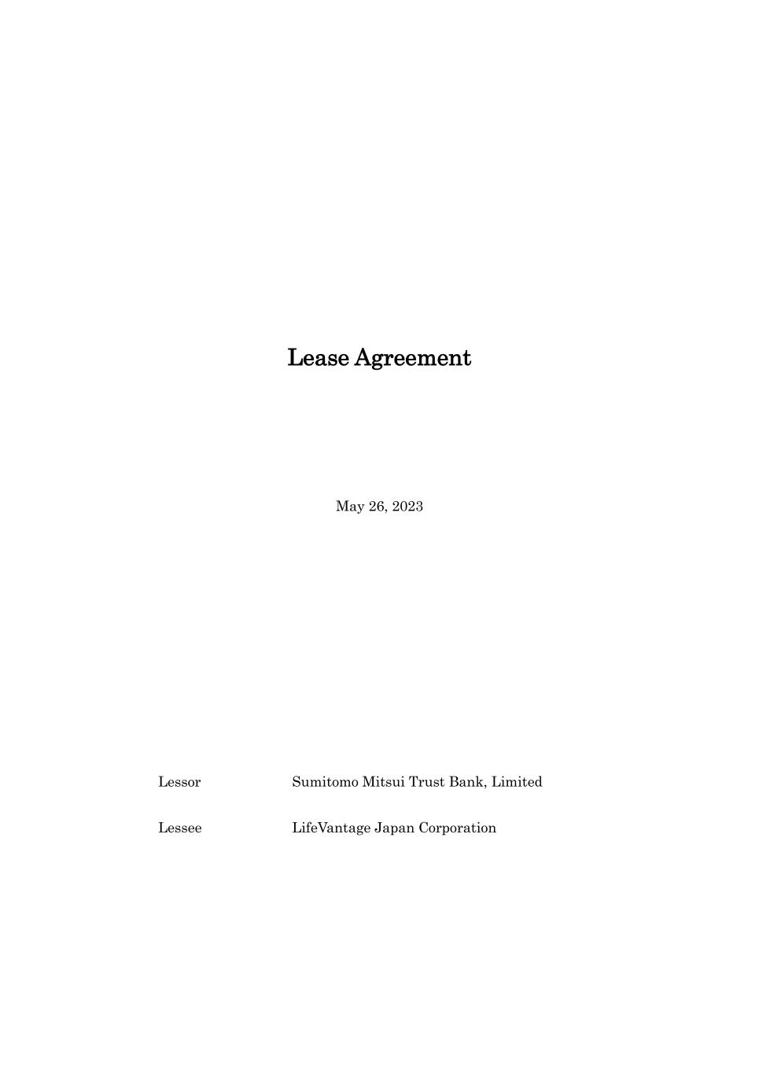
28
Lease Agreement May 26, 2023 Lessor Sumitomo Mitsui Trust Bank, Limited Lessee LifeVantage Japan Corporation

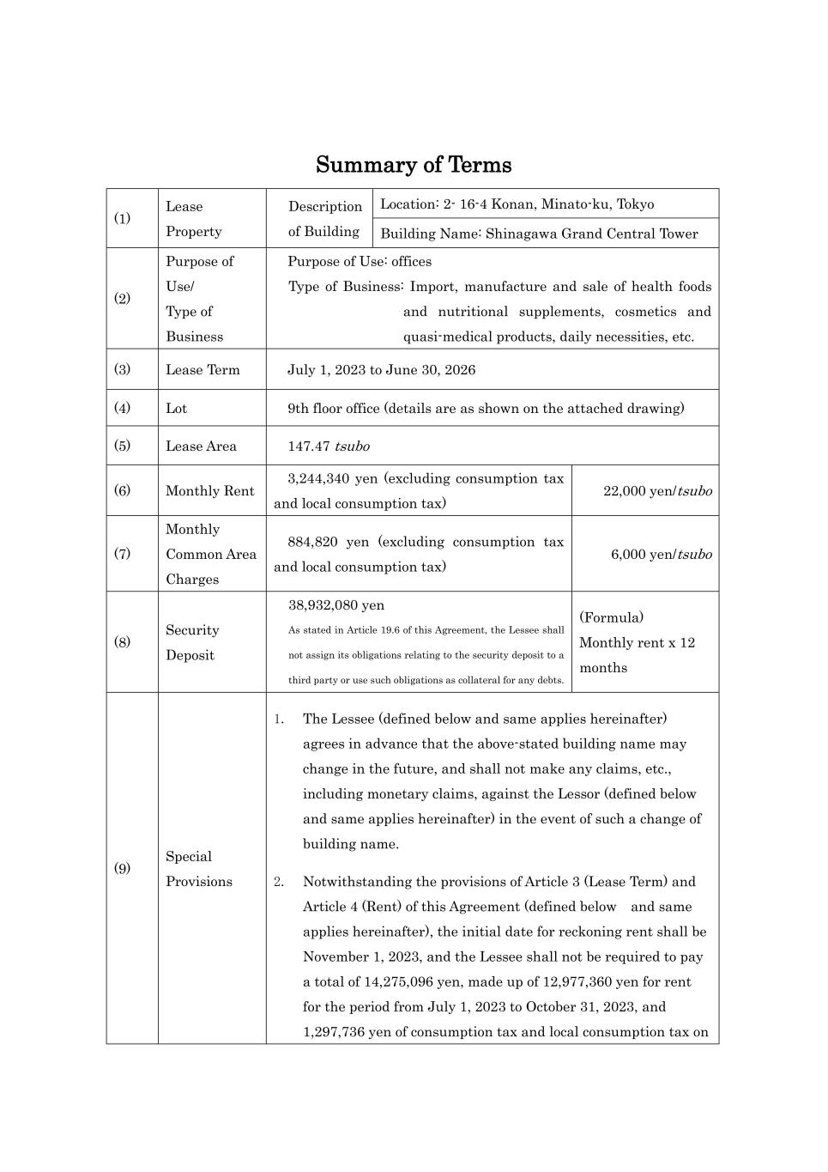
Summary of Terms (1) Lease Property Description of Building Location: 2- 16-4 Konan, Minato-ku, Tokyo Building Name: Shinagawa Grand Central Tower (2) Purpose of Use/ Type of Business Purpose of Use: offices Type of Business: Import, manufacture and sale of health foods and nutritional supplements, cosmetics and quasi-medical products, daily necessities, etc. (3) Lease Term July 1, 2023 to June 30, 2026 (4) Lot 9th floor office (details are as shown on the attached drawing) (5) Lease Area 147.47 tsubo (6) Monthly Rent 3,244,340 yen (excluding consumption tax and local consumption tax) 22,000 yen/tsubo (7) Monthly Common Area Charges 884,820 yen (excluding consumption tax and local consumption tax) 6,000 yen/tsubo (8) Security Deposit 38,932,080 yen As stated in Article 19.6 of this Agreement, the Lessee shall not assign its obligations relating to the security deposit to a third party or use such obligations as collateral for any debts. (Formula) Monthly rent x 12 months (9) Special Provisions 1. The Lessee (defined below and same applies hereinafter) agrees in advance that the above-stated building name may change in the future, and shall not make any claims, etc., including monetary claims, against the Lessor (defined below and same applies hereinafter) in the event of such a change of building name. 2. Notwithstanding the provisions of Article 3 (Lease Term) and Article 4 (Rent) of this Agreement (defined below and same applies hereinafter), the initial date for reckoning rent shall be November 1, 2023, and the Lessee shall not be required to pay a total of 14,275,096 yen, made up of 12,977,360 yen for rent for the period from July 1, 2023 to October 31, 2023, and 1,297,736 yen of consumption tax and local consumption tax on

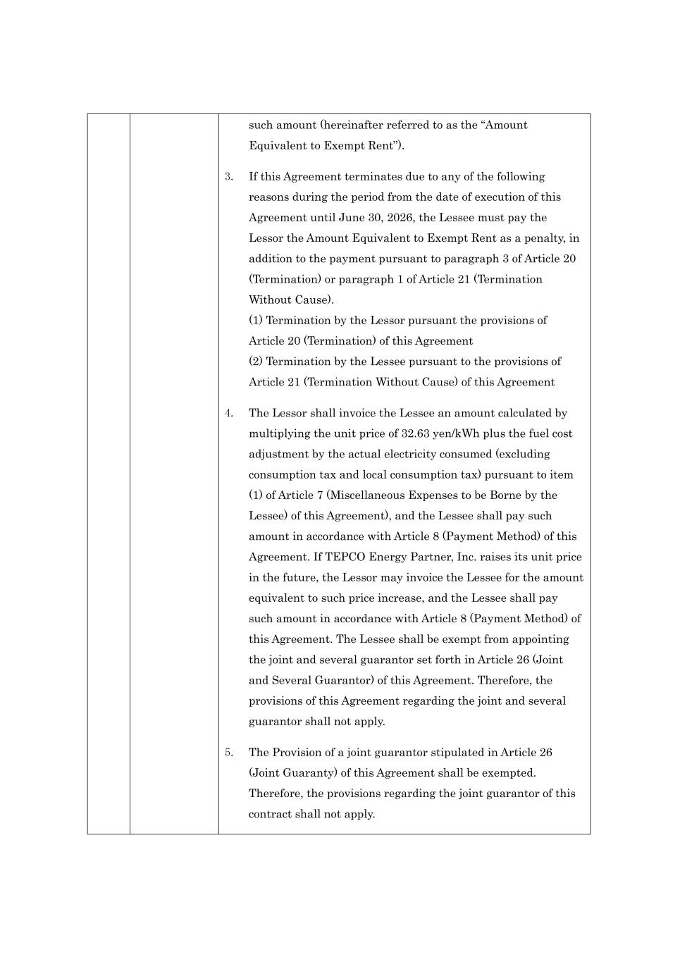
such amount (hereinafter referred to as the “Amount Equivalent to Exempt Rent”). 3. If this Agreement terminates due to any of the following reasons during the period from the date of execution of this Agreement until June 30, 2026, the Lessee must pay the Lessor the Amount Equivalent to Exempt Rent as a penalty, in addition to the payment pursuant to paragraph 3 of Article 20 (Termination) or paragraph 1 of Article 21 (Termination Without Cause). (1) Termination by the Lessor pursuant the provisions of Article 20 (Termination) of this Agreement (2) Termination by the Lessee pursuant to the provisions of Article 21 (Termination Without Cause) of this Agreement 4. The Lessor shall invoice the Lessee an amount calculated by multiplying the unit price of 32.63 yen/kWh plus the fuel cost adjustment by the actual electricity consumed (excluding consumption tax and local consumption tax) pursuant to item (1) of Article 7 (Miscellaneous Expenses to be Borne by the Lessee) of this Agreement), and the Lessee shall pay such amount in accordance with Article 8 (Payment Method) of this Agreement. If TEPCO Energy Partner, Inc. raises its unit price in the future, the Lessor may invoice the Lessee for the amount equivalent to such price increase, and the Lessee shall pay such amount in accordance with Article 8 (Payment Method) of this Agreement. The Lessee shall be exempt from appointing the joint and several guarantor set forth in Article 26 (Joint and Several Guarantor) of this Agreement. Therefore, the provisions of this Agreement regarding the joint and several guarantor shall not apply. 5. The Provision of a joint guarantor stipulated in Article 26 (Joint Guaranty) of this Agreement shall be exempted. Therefore, the provisions regarding the joint guarantor of this contract shall not apply.



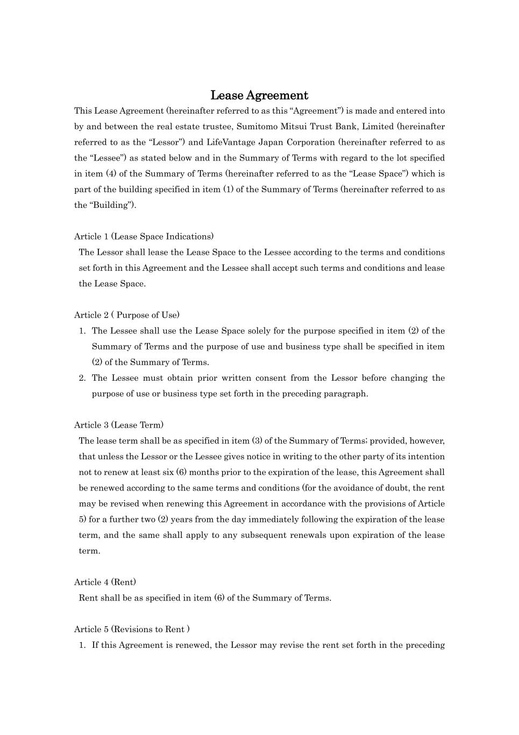
Lease Agreement This Lease Agreement (hereinafter referred to as this “Agreement”) is made and entered into by and between the real estate trustee, Sumitomo Mitsui Trust Bank, Limited (hereinafter referred to as the “Lessor”) and LifeVantage Japan Corporation (hereinafter referred to as the “Lessee”) as stated below and in the Summary of Terms with regard to the lot specified in item (4) of the Summary of Terms (hereinafter referred to as the “Lease Space”) which is part of the building specified in item (1) of the Summary of Terms (hereinafter referred to as the “Building”). Article 1 (Lease Space Indications) The Lessor shall lease the Lease Space to the Lessee according to the terms and conditions set forth in this Agreement and the Lessee shall accept such terms and conditions and lease the Lease Space. Article 2 ( Purpose of Use) 1. The Lessee shall use the Lease Space solely for the purpose specified in item (2) of the Summary of Terms and the purpose of use and business type shall be specified in item (2) of the Summary of Terms. 2. The Lessee must obtain prior written consent from the Lessor before changing the purpose of use or business type set forth in the preceding paragraph. Article 3 (Lease Term) The lease term shall be as specified in item (3) of the Summary of Terms; provided, however, that unless the Lessor or the Lessee gives notice in writing to the other party of its intention not to renew at least six (6) months prior to the expiration of the lease, this Agreement shall be renewed according to the same terms and conditions (for the avoidance of doubt, the rent may be revised when renewing this Agreement in accordance with the provisions of Article 5) for a further two (2) years from the day immediately following the expiration of the lease term, and the same shall apply to any subsequent renewals upon expiration of the lease term. Article 4 (Rent) Rent shall be as specified in item (6) of the Summary of Terms. Article 5 (Revisions to Rent ) 1. If this Agreement is renewed, the Lessor may revise the rent set forth in the preceding

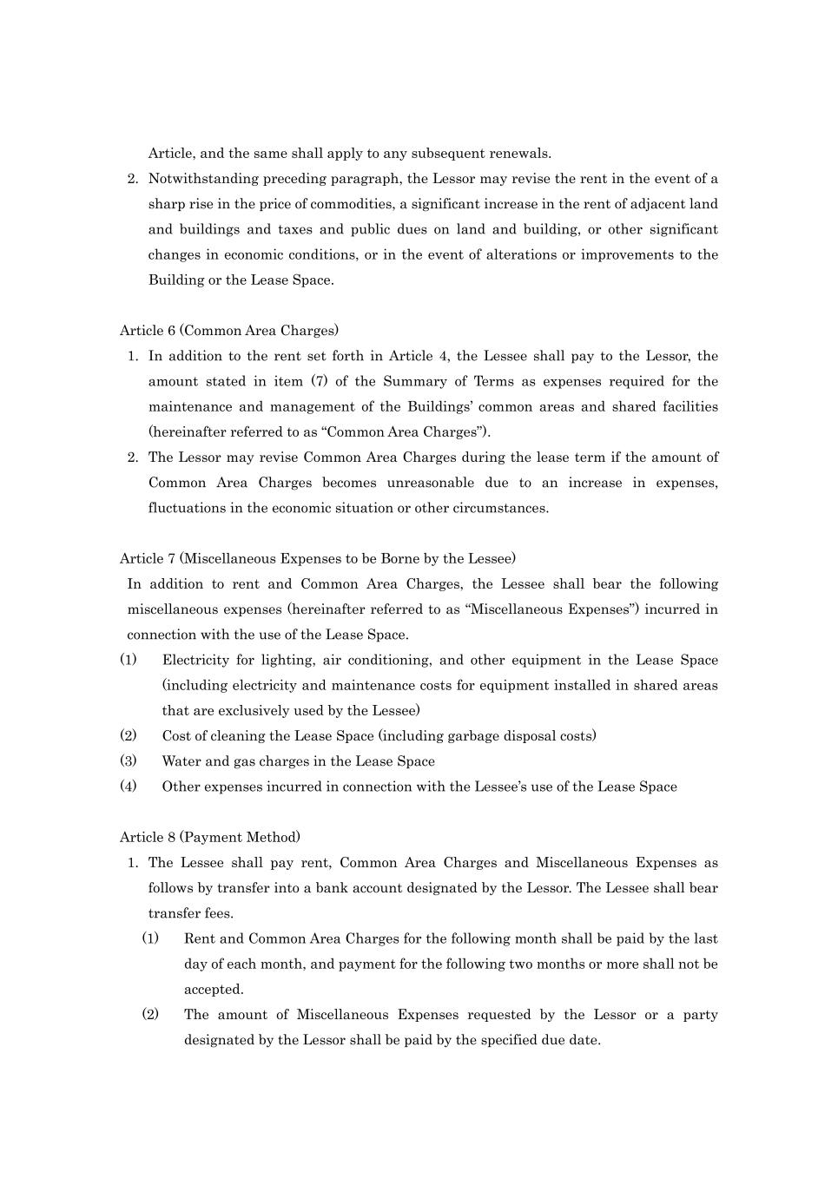
Article, and the same shall apply to any subsequent renewals. 2. Notwithstanding preceding paragraph, the Lessor may revise the rent in the event of a sharp rise in the price of commodities, a significant increase in the rent of adjacent land and buildings and taxes and public dues on land and building, or other significant changes in economic conditions, or in the event of alterations or improvements to the Building or the Lease Space. Article 6 (Common Area Charges) 1. In addition to the rent set forth in Article 4, the Lessee shall pay to the Lessor, the amount stated in item (7) of the Summary of Terms as expenses required for the maintenance and management of the Buildings’ common areas and shared facilities (hereinafter referred to as “Common Area Charges”). 2. The Lessor may revise Common Area Charges during the lease term if the amount of Common Area Charges becomes unreasonable due to an increase in expenses, fluctuations in the economic situation or other circumstances. Article 7 (Miscellaneous Expenses to be Borne by the Lessee) In addition to rent and Common Area Charges, the Lessee shall bear the following miscellaneous expenses (hereinafter referred to as “Miscellaneous Expenses”) incurred in connection with the use of the Lease Space. (1) Electricity for lighting, air conditioning, and other equipment in the Lease Space (including electricity and maintenance costs for equipment installed in shared areas that are exclusively used by the Lessee) (2) Cost of cleaning the Lease Space (including garbage disposal costs) (3) Water and gas charges in the Lease Space (4) Other expenses incurred in connection with the Lessee’s use of the Lease Space Article 8 (Payment Method) 1. The Lessee shall pay rent, Common Area Charges and Miscellaneous Expenses as follows by transfer into a bank account designated by the Lessor. The Lessee shall bear transfer fees. (1) Rent and Common Area Charges for the following month shall be paid by the last day of each month, and payment for the following two months or more shall not be accepted. (2) The amount of Miscellaneous Expenses requested by the Lessor or a party designated by the Lessor shall be paid by the specified due date.

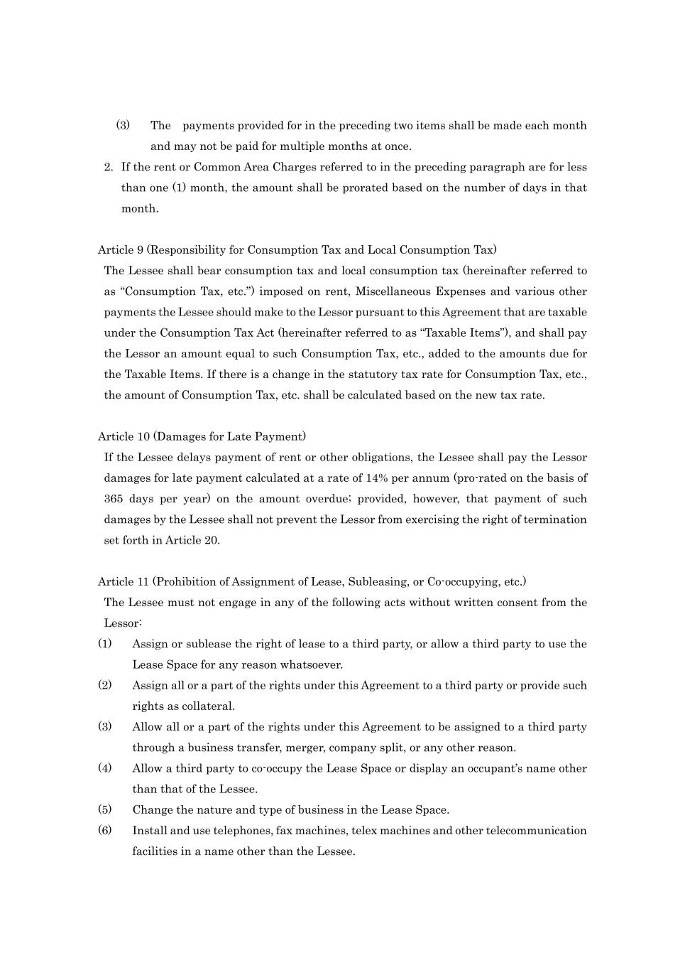
(3) The payments provided for in the preceding two items shall be made each month and may not be paid for multiple months at once. 2. If the rent or Common Area Charges referred to in the preceding paragraph are for less than one (1) month, the amount shall be prorated based on the number of days in that month. Article 9 (Responsibility for Consumption Tax and Local Consumption Tax) The Lessee shall bear consumption tax and local consumption tax (hereinafter referred to as “Consumption Tax, etc.”) imposed on rent, Miscellaneous Expenses and various other payments the Lessee should make to the Lessor pursuant to this Agreement that are taxable under the Consumption Tax Act (hereinafter referred to as “Taxable Items”), and shall pay the Lessor an amount equal to such Consumption Tax, etc., added to the amounts due for the Taxable Items. If there is a change in the statutory tax rate for Consumption Tax, etc., the amount of Consumption Tax, etc. shall be calculated based on the new tax rate. Article 10 (Damages for Late Payment) If the Lessee delays payment of rent or other obligations, the Lessee shall pay the Lessor damages for late payment calculated at a rate of 14% per annum (pro-rated on the basis of 365 days per year) on the amount overdue; provided, however, that payment of such damages by the Lessee shall not prevent the Lessor from exercising the right of termination set forth in Article 20. Article 11 (Prohibition of Assignment of Lease, Subleasing, or Co-occupying, etc.) The Lessee must not engage in any of the following acts without written consent from the Lessor: (1) Assign or sublease the right of lease to a third party, or allow a third party to use the Lease Space for any reason whatsoever. (2) Assign all or a part of the rights under this Agreement to a third party or provide such rights as collateral. (3) Allow all or a part of the rights under this Agreement to be assigned to a third party through a business transfer, merger, company split, or any other reason. (4) Allow a third party to co-occupy the Lease Space or display an occupant’s name other than that of the Lessee. (5) Change the nature and type of business in the Lease Space. (6) Install and use telephones, fax machines, telex machines and other telecommunication facilities in a name other than the Lessee.

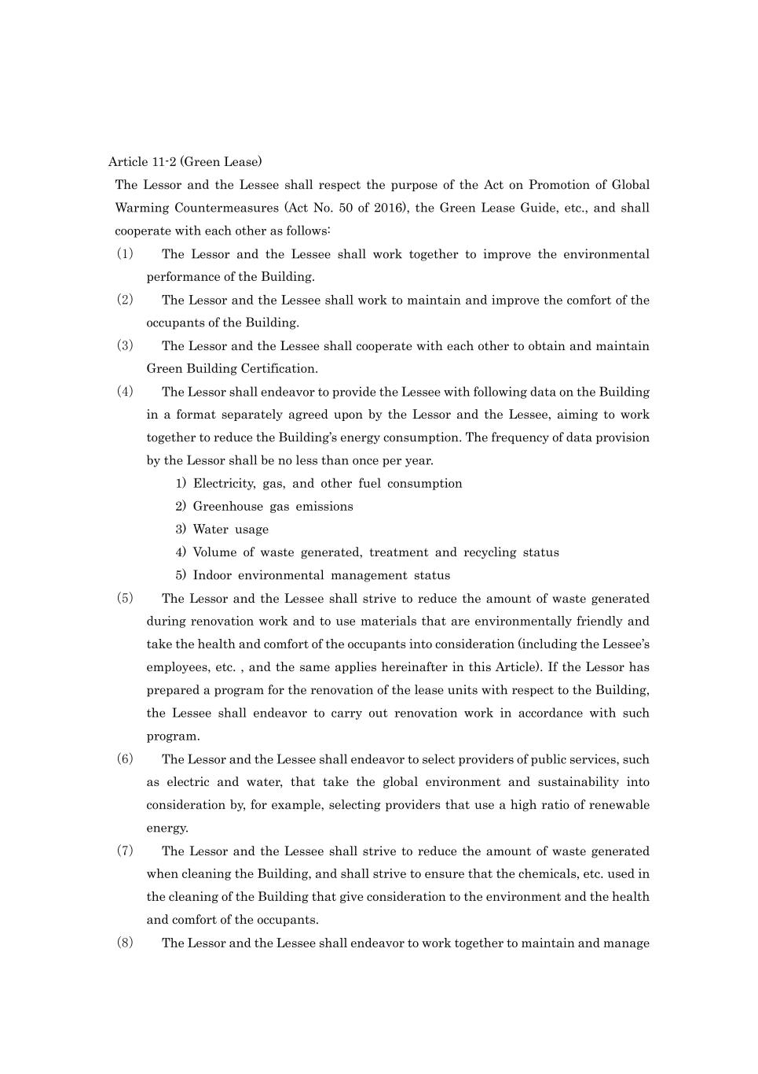
Article 11-2 (Green Lease) The Lessor and the Lessee shall respect the purpose of the Act on Promotion of Global Warming Countermeasures (Act No. 50 of 2016), the Green Lease Guide, etc., and shall cooperate with each other as follows: （1） The Lessor and the Lessee shall work together to improve the environmental performance of the Building. （2） The Lessor and the Lessee shall work to maintain and improve the comfort of the occupants of the Building. （3） The Lessor and the Lessee shall cooperate with each other to obtain and maintain Green Building Certification. （4） The Lessor shall endeavor to provide the Lessee with following data on the Building in a format separately agreed upon by the Lessor and the Lessee, aiming to work together to reduce the Building’s energy consumption. The frequency of data provision by the Lessor shall be no less than once per year. 1) Electricity, gas, and other fuel consumption 2) Greenhouse gas emissions 3) Water usage 4) Volume of waste generated, treatment and recycling status 5) Indoor environmental management status （5） The Lessor and the Lessee shall strive to reduce the amount of waste generated during renovation work and to use materials that are environmentally friendly and take the health and comfort of the occupants into consideration (including the Lessee’s employees, etc. , and the same applies hereinafter in this Article). If the Lessor has prepared a program for the renovation of the lease units with respect to the Building, the Lessee shall endeavor to carry out renovation work in accordance with such program. （6） The Lessor and the Lessee shall endeavor to select providers of public services, such as electric and water, that take the global environment and sustainability into consideration by, for example, selecting providers that use a high ratio of renewable energy. （7） The Lessor and the Lessee shall strive to reduce the amount of waste generated when cleaning the Building, and shall strive to ensure that the chemicals, etc. used in the cleaning of the Building that give consideration to the environment and the health and comfort of the occupants. （8） The Lessor and the Lessee shall endeavor to work together to maintain and manage

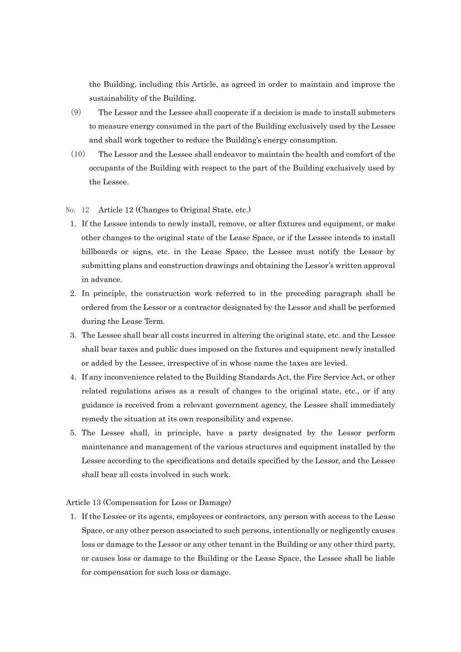
the Building, including this Article, as agreed in order to maintain and improve the sustainability of the Building. （9） The Lessor and the Lessee shall cooperate if a decision is made to install submeters to measure energy consumed in the part of the Building exclusively used by the Lessee and shall work together to reduce the Building’s energy consumption. （10） The Lessor and the Lessee shall endeavor to maintain the health and comfort of the occupants of the Building with respect to the part of the Building exclusively used by the Lessee. No. 12 Article 12 (Changes to Original State, etc.) 1. If the Lessee intends to newly install, remove, or alter fixtures and equipment, or make other changes to the original state of the Lease Space, or if the Lessee intends to install billboards or signs, etc. in the Lease Space, the Lessee must notify the Lessor by submitting plans and construction drawings and obtaining the Lessor’s written approval in advance. 2. In principle, the construction work referred to in the preceding paragraph shall be ordered from the Lessor or a contractor designated by the Lessor and shall be performed during the Lease Term. 3. The Lessee shall bear all costs incurred in altering the original state, etc. and the Lessee shall bear taxes and public dues imposed on the fixtures and equipment newly installed or added by the Lessee, irrespective of in whose name the taxes are levied. 4. If any inconvenience related to the Building Standards Act, the Fire Service Act, or other related regulations arises as a result of changes to the original state, etc., or if any guidance is received from a relevant government agency, the Lessee shall immediately remedy the situation at its own responsibility and expense. 5. The Lessee shall, in principle, have a party designated by the Lessor perform maintenance and management of the various structures and equipment installed by the Lessee according to the specifications and details specified by the Lessor, and the Lessee shall bear all costs involved in such work. Article 13 (Compensation for Loss or Damage) 1. If the Lessee or its agents, employees or contractors, any person with access to the Lease Space, or any other person associated to such persons, intentionally or negligently causes loss or damage to the Lessor or any other tenant in the Building or any other third party, or causes loss or damage to the Building or the Lease Space, the Lessee shall be liable for compensation for such loss or damage.

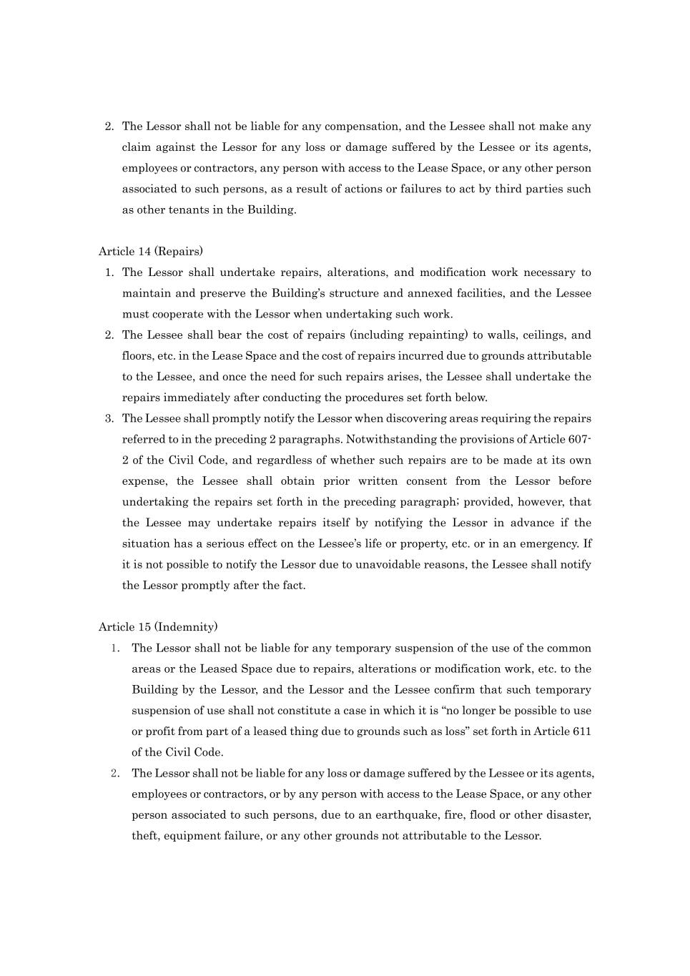
2. The Lessor shall not be liable for any compensation, and the Lessee shall not make any claim against the Lessor for any loss or damage suffered by the Lessee or its agents, employees or contractors, any person with access to the Lease Space, or any other person associated to such persons, as a result of actions or failures to act by third parties such as other tenants in the Building. Article 14 (Repairs) 1. The Lessor shall undertake repairs, alterations, and modification work necessary to maintain and preserve the Building’s structure and annexed facilities, and the Lessee must cooperate with the Lessor when undertaking such work. 2. The Lessee shall bear the cost of repairs (including repainting) to walls, ceilings, and floors, etc. in the Lease Space and the cost of repairs incurred due to grounds attributable to the Lessee, and once the need for such repairs arises, the Lessee shall undertake the repairs immediately after conducting the procedures set forth below. 3. The Lessee shall promptly notify the Lessor when discovering areas requiring the repairs referred to in the preceding 2 paragraphs. Notwithstanding the provisions of Article 607- 2 of the Civil Code, and regardless of whether such repairs are to be made at its own expense, the Lessee shall obtain prior written consent from the Lessor before undertaking the repairs set forth in the preceding paragraph; provided, however, that the Lessee may undertake repairs itself by notifying the Lessor in advance if the situation has a serious effect on the Lessee’s life or property, etc. or in an emergency. If it is not possible to notify the Lessor due to unavoidable reasons, the Lessee shall notify the Lessor promptly after the fact. Article 15 (Indemnity) 1． The Lessor shall not be liable for any temporary suspension of the use of the common areas or the Leased Space due to repairs, alterations or modification work, etc. to the Building by the Lessor, and the Lessor and the Lessee confirm that such temporary suspension of use shall not constitute a case in which it is “no longer be possible to use or profit from part of a leased thing due to grounds such as loss” set forth in Article 611 of the Civil Code. 2． The Lessor shall not be liable for any loss or damage suffered by the Lessee or its agents, employees or contractors, or by any person with access to the Lease Space, or any other person associated to such persons, due to an earthquake, fire, flood or other disaster, theft, equipment failure, or any other grounds not attributable to the Lessor.

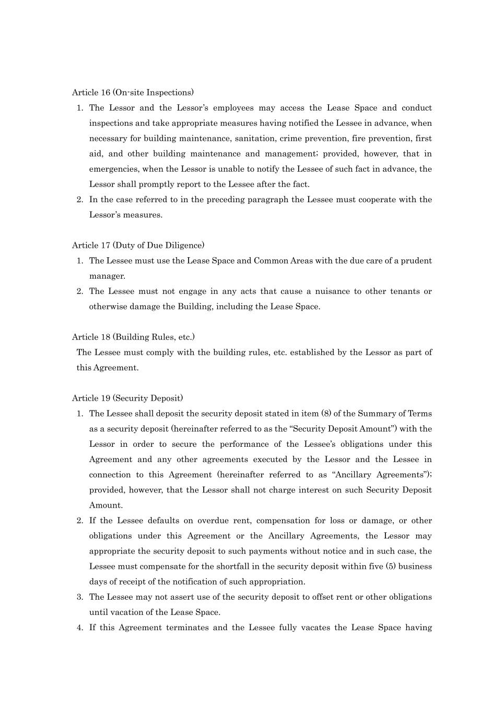
Article 16 (On-site Inspections) 1. The Lessor and the Lessor’s employees may access the Lease Space and conduct inspections and take appropriate measures having notified the Lessee in advance, when necessary for building maintenance, sanitation, crime prevention, fire prevention, first aid, and other building maintenance and management; provided, however, that in emergencies, when the Lessor is unable to notify the Lessee of such fact in advance, the Lessor shall promptly report to the Lessee after the fact. 2. In the case referred to in the preceding paragraph the Lessee must cooperate with the Lessor’s measures. Article 17 (Duty of Due Diligence) 1. The Lessee must use the Lease Space and Common Areas with the due care of a prudent manager. 2. The Lessee must not engage in any acts that cause a nuisance to other tenants or otherwise damage the Building, including the Lease Space. Article 18 (Building Rules, etc.) The Lessee must comply with the building rules, etc. established by the Lessor as part of this Agreement. Article 19 (Security Deposit) 1. The Lessee shall deposit the security deposit stated in item (8) of the Summary of Terms as a security deposit (hereinafter referred to as the “Security Deposit Amount”) with the Lessor in order to secure the performance of the Lessee’s obligations under this Agreement and any other agreements executed by the Lessor and the Lessee in connection to this Agreement (hereinafter referred to as “Ancillary Agreements”); provided, however, that the Lessor shall not charge interest on such Security Deposit Amount. 2. If the Lessee defaults on overdue rent, compensation for loss or damage, or other obligations under this Agreement or the Ancillary Agreements, the Lessor may appropriate the security deposit to such payments without notice and in such case, the Lessee must compensate for the shortfall in the security deposit within five (5) business days of receipt of the notification of such appropriation. 3. The Lessee may not assert use of the security deposit to offset rent or other obligations until vacation of the Lease Space. 4. If this Agreement terminates and the Lessee fully vacates the Lease Space having

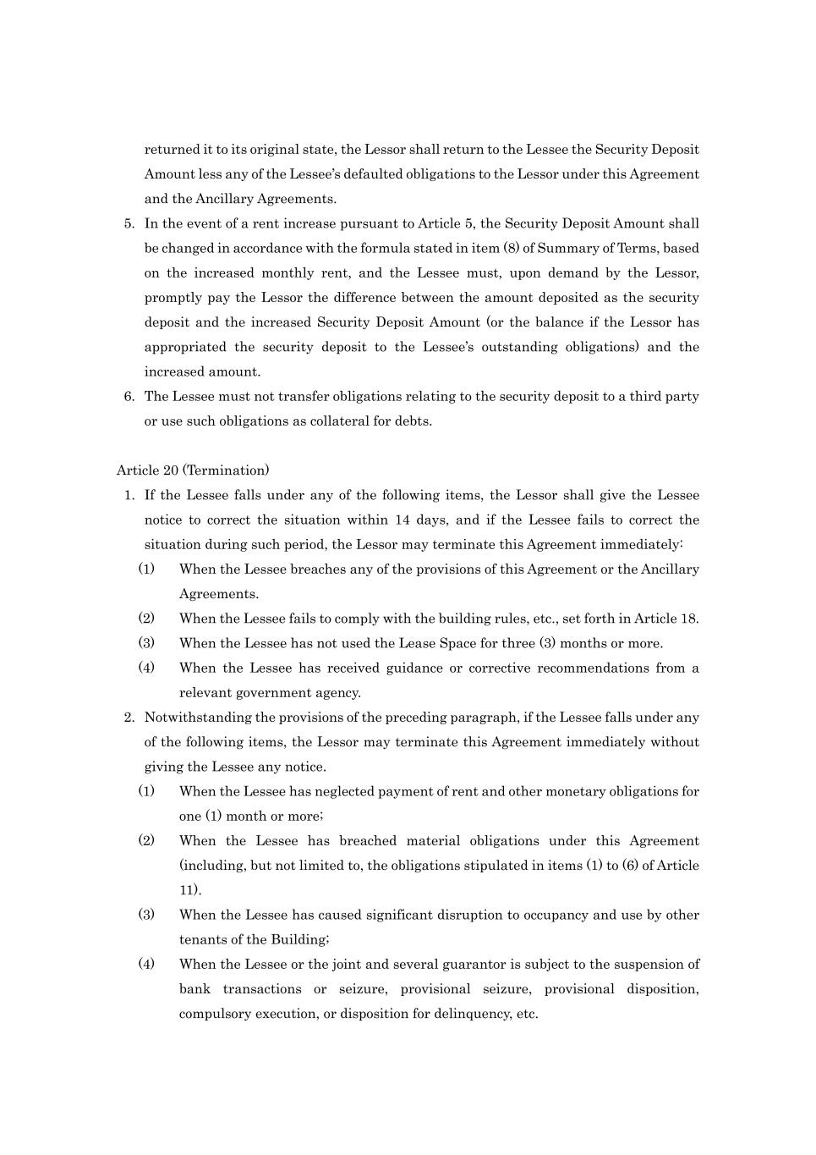
returned it to its original state, the Lessor shall return to the Lessee the Security Deposit Amount less any of the Lessee’s defaulted obligations to the Lessor under this Agreement and the Ancillary Agreements. 5. In the event of a rent increase pursuant to Article 5, the Security Deposit Amount shall be changed in accordance with the formula stated in item (8) of Summary of Terms, based on the increased monthly rent, and the Lessee must, upon demand by the Lessor, promptly pay the Lessor the difference between the amount deposited as the security deposit and the increased Security Deposit Amount (or the balance if the Lessor has appropriated the security deposit to the Lessee’s outstanding obligations) and the increased amount. 6. The Lessee must not transfer obligations relating to the security deposit to a third party or use such obligations as collateral for debts. Article 20 (Termination) 1. If the Lessee falls under any of the following items, the Lessor shall give the Lessee notice to correct the situation within 14 days, and if the Lessee fails to correct the situation during such period, the Lessor may terminate this Agreement immediately: (1) When the Lessee breaches any of the provisions of this Agreement or the Ancillary Agreements. (2) When the Lessee fails to comply with the building rules, etc., set forth in Article 18. (3) When the Lessee has not used the Lease Space for three (3) months or more. (4) When the Lessee has received guidance or corrective recommendations from a relevant government agency. 2. Notwithstanding the provisions of the preceding paragraph, if the Lessee falls under any of the following items, the Lessor may terminate this Agreement immediately without giving the Lessee any notice. (1) When the Lessee has neglected payment of rent and other monetary obligations for one (1) month or more; (2) When the Lessee has breached material obligations under this Agreement (including, but not limited to, the obligations stipulated in items (1) to (6) of Article 11). (3) When the Lessee has caused significant disruption to occupancy and use by other tenants of the Building; (4) When the Lessee or the joint and several guarantor is subject to the suspension of bank transactions or seizure, provisional seizure, provisional disposition, compulsory execution, or disposition for delinquency, etc.

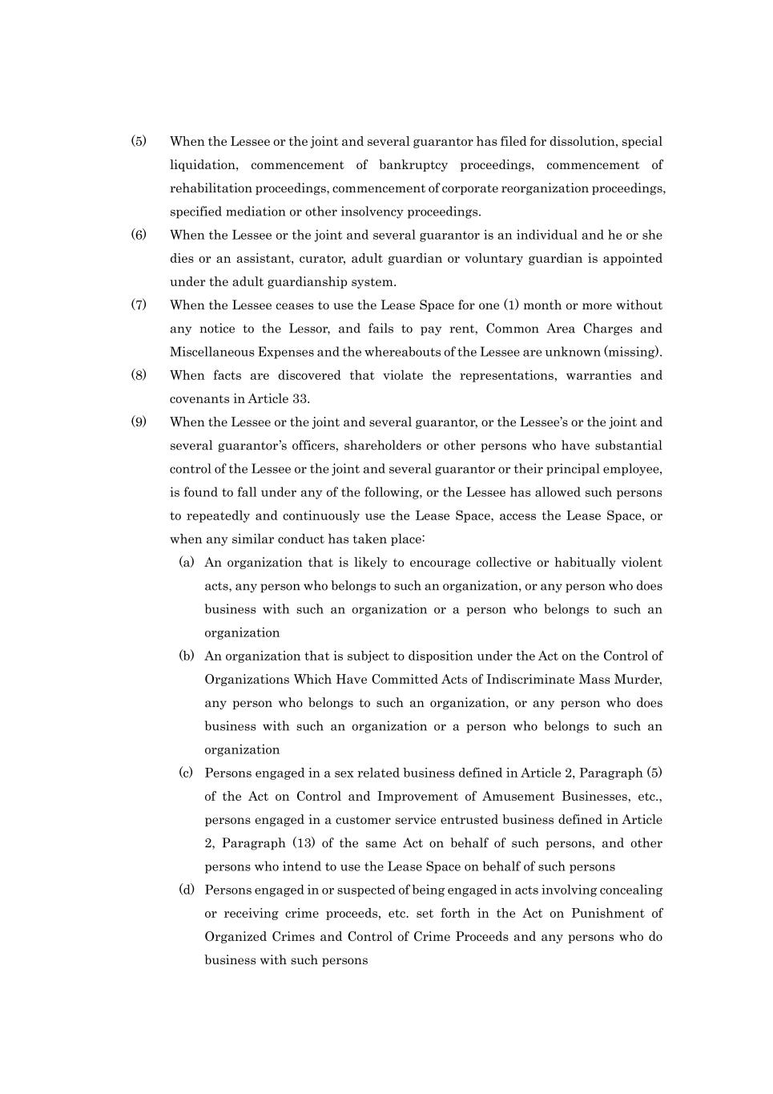
(5) When the Lessee or the joint and several guarantor has filed for dissolution, special liquidation, commencement of bankruptcy proceedings, commencement of rehabilitation proceedings, commencement of corporate reorganization proceedings, specified mediation or other insolvency proceedings. (6) When the Lessee or the joint and several guarantor is an individual and he or she dies or an assistant, curator, adult guardian or voluntary guardian is appointed under the adult guardianship system. (7) When the Lessee ceases to use the Lease Space for one (1) month or more without any notice to the Lessor, and fails to pay rent, Common Area Charges and Miscellaneous Expenses and the whereabouts of the Lessee are unknown (missing). (8) When facts are discovered that violate the representations, warranties and covenants in Article 33. (9) When the Lessee or the joint and several guarantor, or the Lessee’s or the joint and several guarantor’s officers, shareholders or other persons who have substantial control of the Lessee or the joint and several guarantor or their principal employee, is found to fall under any of the following, or the Lessee has allowed such persons to repeatedly and continuously use the Lease Space, access the Lease Space, or when any similar conduct has taken place: (a) An organization that is likely to encourage collective or habitually violent acts, any person who belongs to such an organization, or any person who does business with such an organization or a person who belongs to such an organization (b) An organization that is subject to disposition under the Act on the Control of Organizations Which Have Committed Acts of Indiscriminate Mass Murder, any person who belongs to such an organization, or any person who does business with such an organization or a person who belongs to such an organization (c) Persons engaged in a sex related business defined in Article 2, Paragraph (5) of the Act on Control and Improvement of Amusement Businesses, etc., persons engaged in a customer service entrusted business defined in Article 2, Paragraph (13) of the same Act on behalf of such persons, and other persons who intend to use the Lease Space on behalf of such persons (d) Persons engaged in or suspected of being engaged in acts involving concealing or receiving crime proceeds, etc. set forth in the Act on Punishment of Organized Crimes and Control of Crime Proceeds and any persons who do business with such persons

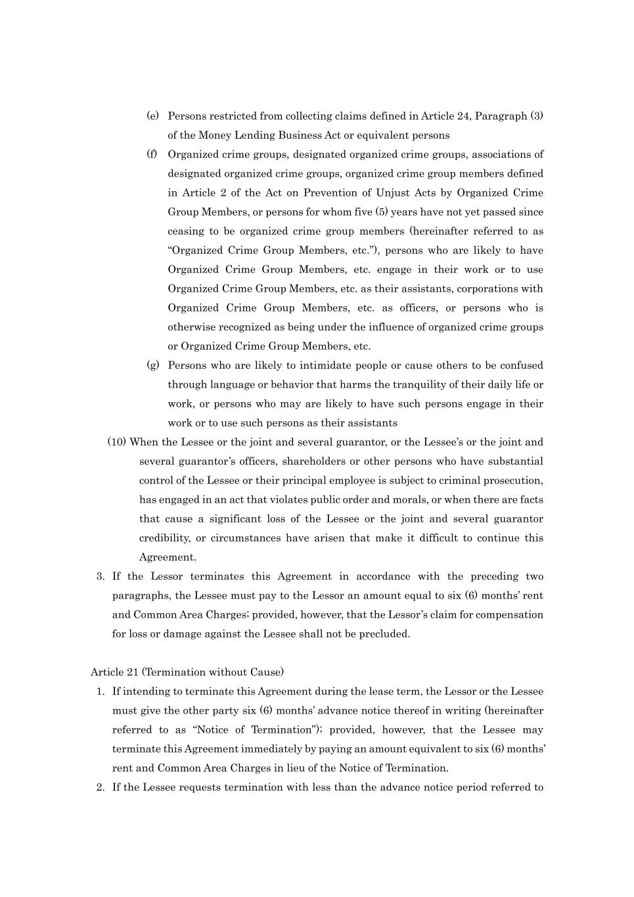
(e) Persons restricted from collecting claims defined in Article 24, Paragraph (3) of the Money Lending Business Act or equivalent persons (f) Organized crime groups, designated organized crime groups, associations of designated organized crime groups, organized crime group members defined in Article 2 of the Act on Prevention of Unjust Acts by Organized Crime Group Members, or persons for whom five (5) years have not yet passed since ceasing to be organized crime group members (hereinafter referred to as “Organized Crime Group Members, etc.”), persons who are likely to have Organized Crime Group Members, etc. engage in their work or to use Organized Crime Group Members, etc. as their assistants, corporations with Organized Crime Group Members, etc. as officers, or persons who is otherwise recognized as being under the influence of organized crime groups or Organized Crime Group Members, etc. (g) Persons who are likely to intimidate people or cause others to be confused through language or behavior that harms the tranquility of their daily life or work, or persons who may are likely to have such persons engage in their work or to use such persons as their assistants (10) When the Lessee or the joint and several guarantor, or the Lessee’s or the joint and several guarantor’s officers, shareholders or other persons who have substantial control of the Lessee or their principal employee is subject to criminal prosecution, has engaged in an act that violates public order and morals, or when there are facts that cause a significant loss of the Lessee or the joint and several guarantor credibility, or circumstances have arisen that make it difficult to continue this Agreement. 3. If the Lessor terminates this Agreement in accordance with the preceding two paragraphs, the Lessee must pay to the Lessor an amount equal to six (6) months’ rent and Common Area Charges; provided, however, that the Lessor’s claim for compensation for loss or damage against the Lessee shall not be precluded. Article 21 (Termination without Cause) 1. If intending to terminate this Agreement during the lease term, the Lessor or the Lessee must give the other party six (6) months’ advance notice thereof in writing (hereinafter referred to as “Notice of Termination”); provided, however, that the Lessee may terminate this Agreement immediately by paying an amount equivalent to six (6) months’ rent and Common Area Charges in lieu of the Notice of Termination. 2. If the Lessee requests termination with less than the advance notice period referred to

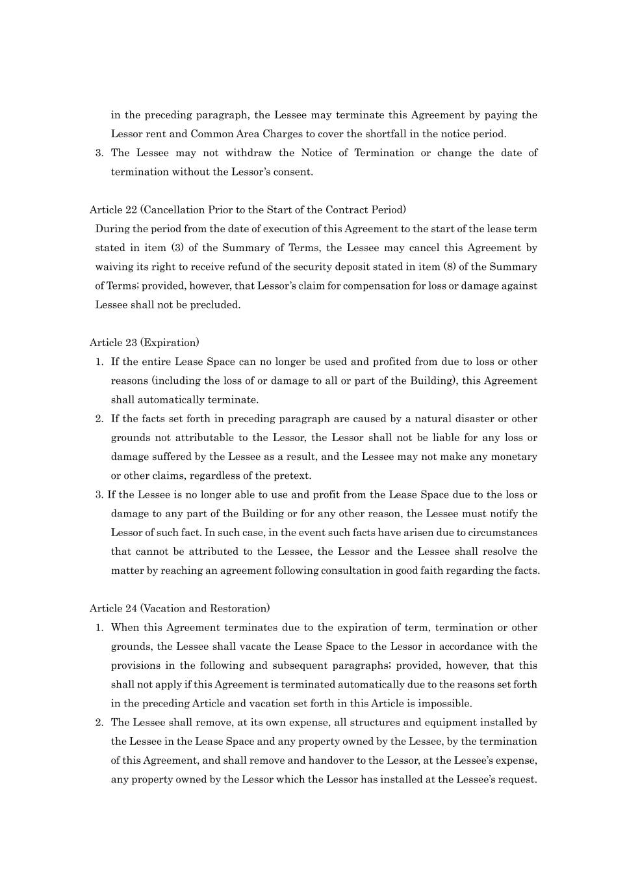
in the preceding paragraph, the Lessee may terminate this Agreement by paying the Lessor rent and Common Area Charges to cover the shortfall in the notice period. 3. The Lessee may not withdraw the Notice of Termination or change the date of termination without the Lessor’s consent. Article 22 (Cancellation Prior to the Start of the Contract Period) During the period from the date of execution of this Agreement to the start of the lease term stated in item (3) of the Summary of Terms, the Lessee may cancel this Agreement by waiving its right to receive refund of the security deposit stated in item (8) of the Summary of Terms; provided, however, that Lessor’s claim for compensation for loss or damage against Lessee shall not be precluded. Article 23 (Expiration) 1. If the entire Lease Space can no longer be used and profited from due to loss or other reasons (including the loss of or damage to all or part of the Building), this Agreement shall automatically terminate. 2. If the facts set forth in preceding paragraph are caused by a natural disaster or other grounds not attributable to the Lessor, the Lessor shall not be liable for any loss or damage suffered by the Lessee as a result, and the Lessee may not make any monetary or other claims, regardless of the pretext. 3. If the Lessee is no longer able to use and profit from the Lease Space due to the loss or damage to any part of the Building or for any other reason, the Lessee must notify the Lessor of such fact. In such case, in the event such facts have arisen due to circumstances that cannot be attributed to the Lessee, the Lessor and the Lessee shall resolve the matter by reaching an agreement following consultation in good faith regarding the facts. Article 24 (Vacation and Restoration) 1. When this Agreement terminates due to the expiration of term, termination or other grounds, the Lessee shall vacate the Lease Space to the Lessor in accordance with the provisions in the following and subsequent paragraphs; provided, however, that this shall not apply if this Agreement is terminated automatically due to the reasons set forth in the preceding Article and vacation set forth in this Article is impossible. 2. The Lessee shall remove, at its own expense, all structures and equipment installed by the Lessee in the Lease Space and any property owned by the Lessee, by the termination of this Agreement, and shall remove and handover to the Lessor, at the Lessee’s expense, any property owned by the Lessor which the Lessor has installed at the Lessee’s request.

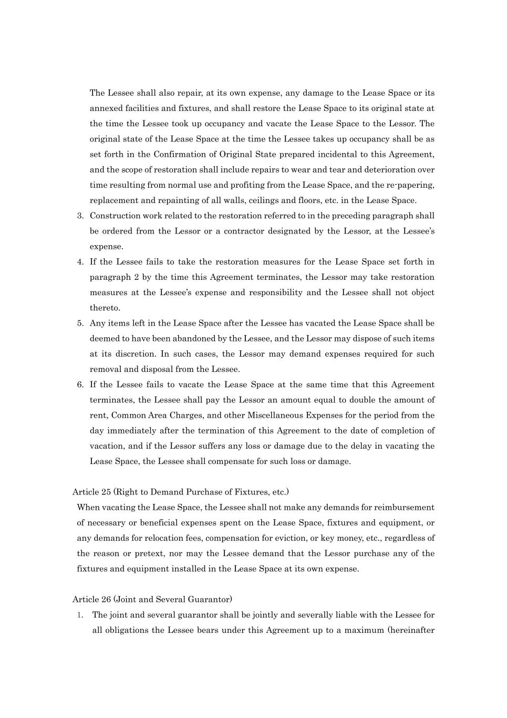
The Lessee shall also repair, at its own expense, any damage to the Lease Space or its annexed facilities and fixtures, and shall restore the Lease Space to its original state at the time the Lessee took up occupancy and vacate the Lease Space to the Lessor. The original state of the Lease Space at the time the Lessee takes up occupancy shall be as set forth in the Confirmation of Original State prepared incidental to this Agreement, and the scope of restoration shall include repairs to wear and tear and deterioration over time resulting from normal use and profiting from the Lease Space, and the re-papering, replacement and repainting of all walls, ceilings and floors, etc. in the Lease Space. 3. Construction work related to the restoration referred to in the preceding paragraph shall be ordered from the Lessor or a contractor designated by the Lessor, at the Lessee’s expense. 4. If the Lessee fails to take the restoration measures for the Lease Space set forth in paragraph 2 by the time this Agreement terminates, the Lessor may take restoration measures at the Lessee’s expense and responsibility and the Lessee shall not object thereto. 5. Any items left in the Lease Space after the Lessee has vacated the Lease Space shall be deemed to have been abandoned by the Lessee, and the Lessor may dispose of such items at its discretion. In such cases, the Lessor may demand expenses required for such removal and disposal from the Lessee. 6. If the Lessee fails to vacate the Lease Space at the same time that this Agreement terminates, the Lessee shall pay the Lessor an amount equal to double the amount of rent, Common Area Charges, and other Miscellaneous Expenses for the period from the day immediately after the termination of this Agreement to the date of completion of vacation, and if the Lessor suffers any loss or damage due to the delay in vacating the Lease Space, the Lessee shall compensate for such loss or damage. Article 25 (Right to Demand Purchase of Fixtures, etc.) When vacating the Lease Space, the Lessee shall not make any demands for reimbursement of necessary or beneficial expenses spent on the Lease Space, fixtures and equipment, or any demands for relocation fees, compensation for eviction, or key money, etc., regardless of the reason or pretext, nor may the Lessee demand that the Lessor purchase any of the fixtures and equipment installed in the Lease Space at its own expense. Article 26 (Joint and Several Guarantor) 1. The joint and several guarantor shall be jointly and severally liable with the Lessee for all obligations the Lessee bears under this Agreement up to a maximum (hereinafter

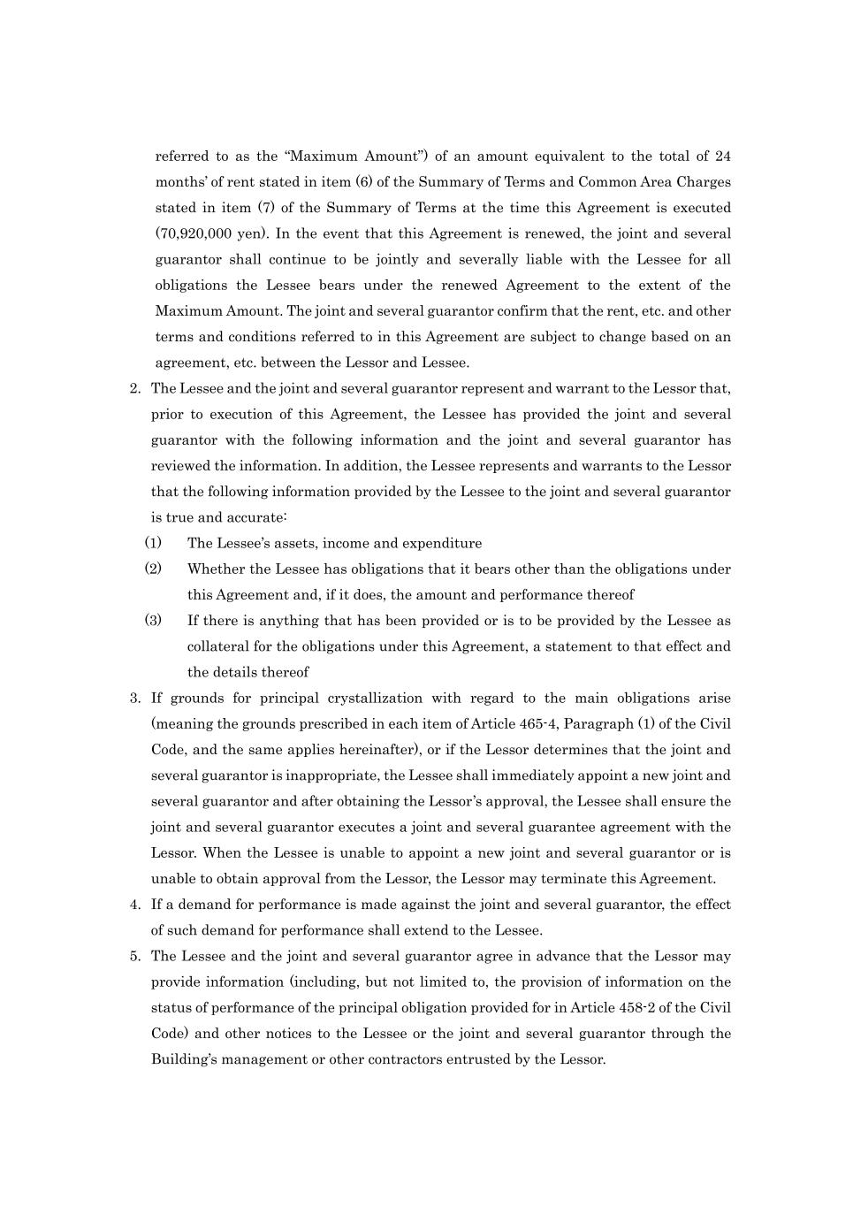
referred to as the “Maximum Amount”) of an amount equivalent to the total of 24 months’ of rent stated in item (6) of the Summary of Terms and Common Area Charges stated in item (7) of the Summary of Terms at the time this Agreement is executed (70,920,000 yen). In the event that this Agreement is renewed, the joint and several guarantor shall continue to be jointly and severally liable with the Lessee for all obligations the Lessee bears under the renewed Agreement to the extent of the Maximum Amount. The joint and several guarantor confirm that the rent, etc. and other terms and conditions referred to in this Agreement are subject to change based on an agreement, etc. between the Lessor and Lessee. 2. The Lessee and the joint and several guarantor represent and warrant to the Lessor that, prior to execution of this Agreement, the Lessee has provided the joint and several guarantor with the following information and the joint and several guarantor has reviewed the information. In addition, the Lessee represents and warrants to the Lessor that the following information provided by the Lessee to the joint and several guarantor is true and accurate: (1) The Lessee’s assets, income and expenditure (2) Whether the Lessee has obligations that it bears other than the obligations under this Agreement and, if it does, the amount and performance thereof (3) If there is anything that has been provided or is to be provided by the Lessee as collateral for the obligations under this Agreement, a statement to that effect and the details thereof 3. If grounds for principal crystallization with regard to the main obligations arise (meaning the grounds prescribed in each item of Article 465-4, Paragraph (1) of the Civil Code, and the same applies hereinafter), or if the Lessor determines that the joint and several guarantor is inappropriate, the Lessee shall immediately appoint a new joint and several guarantor and after obtaining the Lessor’s approval, the Lessee shall ensure the joint and several guarantor executes a joint and several guarantee agreement with the Lessor. When the Lessee is unable to appoint a new joint and several guarantor or is unable to obtain approval from the Lessor, the Lessor may terminate this Agreement. 4. If a demand for performance is made against the joint and several guarantor, the effect of such demand for performance shall extend to the Lessee. 5. The Lessee and the joint and several guarantor agree in advance that the Lessor may provide information (including, but not limited to, the provision of information on the status of performance of the principal obligation provided for in Article 458-2 of the Civil Code) and other notices to the Lessee or the joint and several guarantor through the Building’s management or other contractors entrusted by the Lessor.

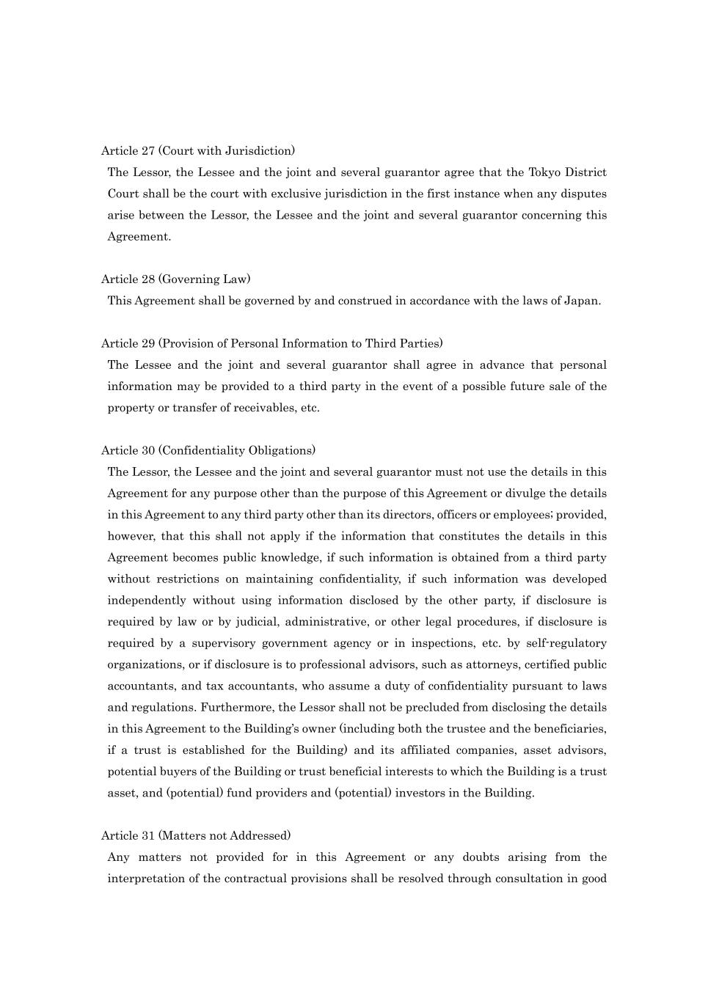
Article 27 (Court with Jurisdiction) The Lessor, the Lessee and the joint and several guarantor agree that the Tokyo District Court shall be the court with exclusive jurisdiction in the first instance when any disputes arise between the Lessor, the Lessee and the joint and several guarantor concerning this Agreement. Article 28 (Governing Law) This Agreement shall be governed by and construed in accordance with the laws of Japan. Article 29 (Provision of Personal Information to Third Parties) The Lessee and the joint and several guarantor shall agree in advance that personal information may be provided to a third party in the event of a possible future sale of the property or transfer of receivables, etc. Article 30 (Confidentiality Obligations) The Lessor, the Lessee and the joint and several guarantor must not use the details in this Agreement for any purpose other than the purpose of this Agreement or divulge the details in this Agreement to any third party other than its directors, officers or employees; provided, however, that this shall not apply if the information that constitutes the details in this Agreement becomes public knowledge, if such information is obtained from a third party without restrictions on maintaining confidentiality, if such information was developed independently without using information disclosed by the other party, if disclosure is required by law or by judicial, administrative, or other legal procedures, if disclosure is required by a supervisory government agency or in inspections, etc. by self-regulatory organizations, or if disclosure is to professional advisors, such as attorneys, certified public accountants, and tax accountants, who assume a duty of confidentiality pursuant to laws and regulations. Furthermore, the Lessor shall not be precluded from disclosing the details in this Agreement to the Building’s owner (including both the trustee and the beneficiaries, if a trust is established for the Building) and its affiliated companies, asset advisors, potential buyers of the Building or trust beneficial interests to which the Building is a trust asset, and (potential) fund providers and (potential) investors in the Building. Article 31 (Matters not Addressed) Any matters not provided for in this Agreement or any doubts arising from the interpretation of the contractual provisions shall be resolved through consultation in good

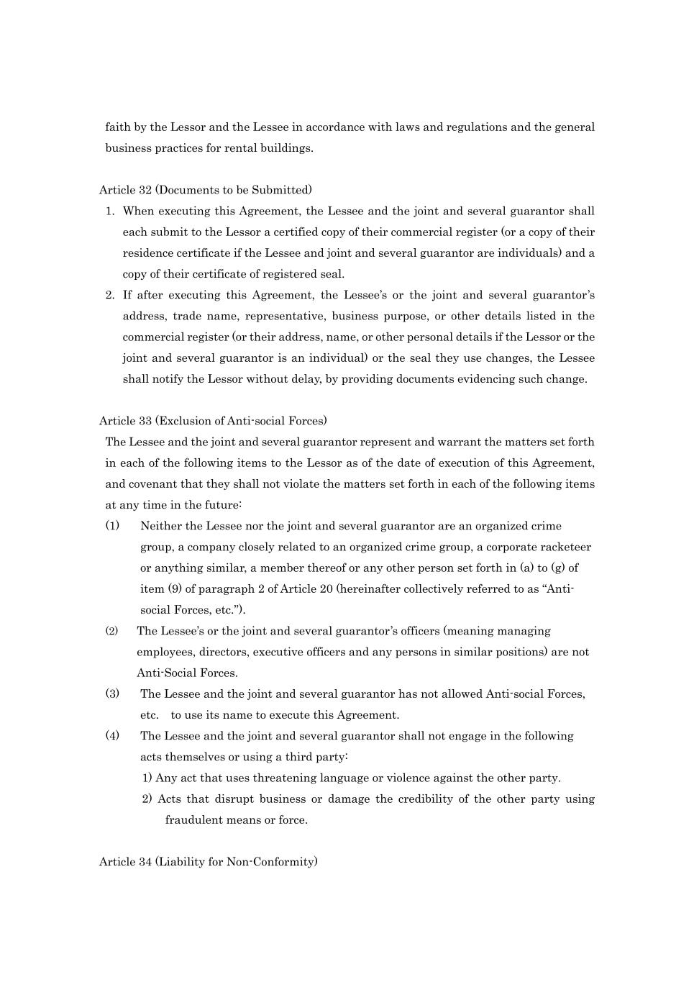
faith by the Lessor and the Lessee in accordance with laws and regulations and the general business practices for rental buildings. Article 32 (Documents to be Submitted) 1. When executing this Agreement, the Lessee and the joint and several guarantor shall each submit to the Lessor a certified copy of their commercial register (or a copy of their residence certificate if the Lessee and joint and several guarantor are individuals) and a copy of their certificate of registered seal. 2. If after executing this Agreement, the Lessee’s or the joint and several guarantor’s address, trade name, representative, business purpose, or other details listed in the commercial register (or their address, name, or other personal details if the Lessor or the joint and several guarantor is an individual) or the seal they use changes, the Lessee shall notify the Lessor without delay, by providing documents evidencing such change. Article 33 (Exclusion of Anti-social Forces) The Lessee and the joint and several guarantor represent and warrant the matters set forth in each of the following items to the Lessor as of the date of execution of this Agreement, and covenant that they shall not violate the matters set forth in each of the following items at any time in the future: (1) Neither the Lessee nor the joint and several guarantor are an organized crime group, a company closely related to an organized crime group, a corporate racketeer or anything similar, a member thereof or any other person set forth in (a) to (g) of item (9) of paragraph 2 of Article 20 (hereinafter collectively referred to as “Anti- social Forces, etc.”). (2) The Lessee’s or the joint and several guarantor’s officers (meaning managing employees, directors, executive officers and any persons in similar positions) are not Anti-Social Forces. (3) The Lessee and the joint and several guarantor has not allowed Anti-social Forces, etc. to use its name to execute this Agreement. (4) The Lessee and the joint and several guarantor shall not engage in the following acts themselves or using a third party: 1) Any act that uses threatening language or violence against the other party. 2) Acts that disrupt business or damage the credibility of the other party using fraudulent means or force. Article 34 (Liability for Non-Conformity)


Repairs to the Lease Space shall comply with the provisions of Article 14 of this Agreement, and the Lessor shall not assume any liabilities defined in Articles 560 to 565 of the Civil Code that apply mutatis mutandis in accordance with Article 559 of the Civil Code, except for the repair obligations set forth in said Article. END

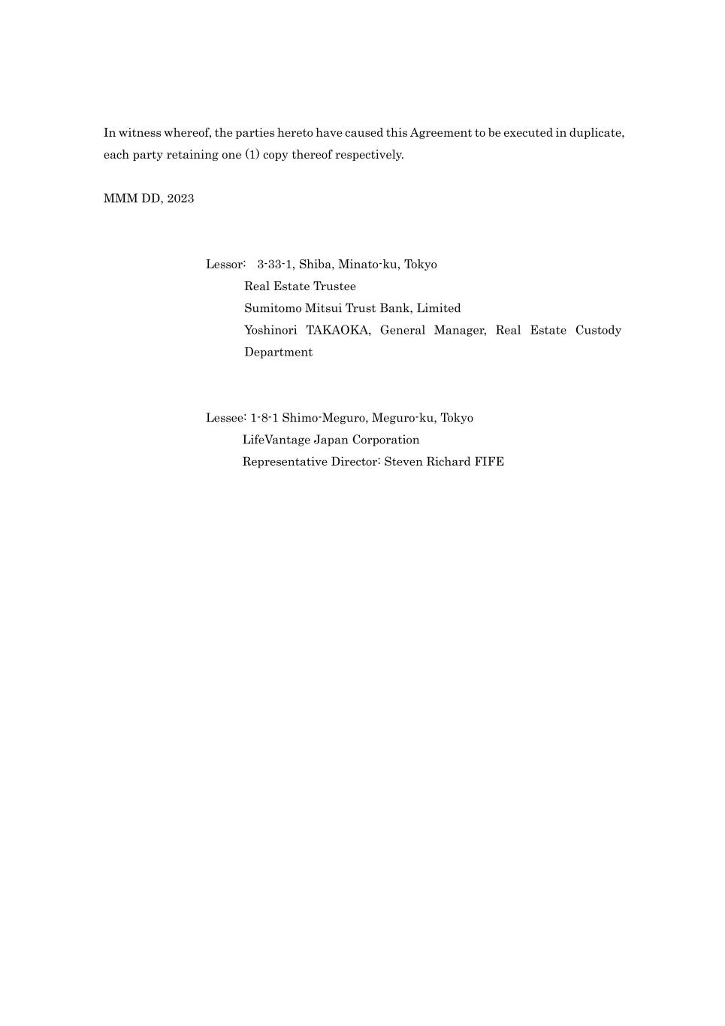
In witness whereof, the parties hereto have caused this Agreement to be executed in duplicate, each party retaining one (1) copy thereof respectively. MMM DD, 2023 Lessor: 3-33-1, Shiba, Minato-ku, Tokyo Real Estate Trustee Sumitomo Mitsui Trust Bank, Limited Yoshinori TAKAOKA, General Manager, Real Estate Custody Department Lessee: 1-8-1 Shimo-Meguro, Meguro-ku, Tokyo LifeVantage Japan Corporation Representative Director: Steven Richard FIFE

Exhibit 31.1
CERTIFICATION OF PRINCIPAL EXECUTIVE OFFICER
I, Steven R. Fife, certify that:
1.I have reviewed this quarterly report on Form 10-Q of LifeVantage Corporation;
2.Based on my knowledge, this report does not contain any untrue statement of a material fact or omit to state a material fact necessary to make the statements made, in light of the circumstances under which such statements were made, not misleading with respect to the period covered by this report;
3.Based on my knowledge, the financial statements, and other financial information included in this report, fairly present in all material respects the financial condition, results of operations and cash flows of the registrant as of, and for, the periods presented in this report;
4.The registrant’s other certifying officer and I are responsible for establishing and maintaining disclosure controls and procedures (as defined in Exchange Act Rules 13a-15(e) and 15d-15(e)) and internal control over financial reporting (as defined in Exchange Act Rules 13a-15(f) and 15d-15(f)) for the registrant and have:
a.Designed such disclosure controls and procedures, or caused such disclosure controls and procedures to be designed under our supervision, to ensure that material information relating to the registrant, including its consolidated subsidiaries, is made known to us by others within those entities, particularly during the period in which this report is being prepared;
b.Designed such internal control over financial reporting, or caused such internal control over financial reporting to be designed under our supervision, to provide reasonable assurance regarding the reliability of financial reporting and the preparation of financial statements for external purposes in accordance with generally accepted accounting principles;
c.Evaluated the effectiveness of the registrant’s disclosure controls and procedures and presented in this report our conclusions about the effectiveness of the disclosure controls and procedures, as of the end of the period covered by this report based on such evaluation; and
d.Disclosed in this report any change in the registrant’s internal control over financial reporting that occurred during the registrant’s most recent fiscal quarter (the registrant’s fourth fiscal quarter in the case of an annual report) that has materially affected, or is reasonably likely to materially affect, the registrant’s internal control over financial reporting; and
5.The registrant’s other certifying officer and I have disclosed, based on our most recent evaluation of internal control over financial reporting, to the registrant’s auditors and the audit committee of the registrant’s board of directors (or persons performing the equivalent functions):
a.All significant deficiencies and material weaknesses in the design or operation of internal control over financial reporting which are reasonably likely to adversely affect the registrant’s ability to record, process, summarize and report financial information; and
b.Any fraud, whether or not material, that involves management or other employees who have a significant role in the registrant’s internal control over financial reporting.
Date: November 9, 2023
/s/ Steven R. Fife
Steven R. Fife
President and Chief Executive Officer
(Principal Executive Officer)

Exhibit 31.2
CERTIFICATION OF PRINCIPAL FINANCIAL OFFICER
I, Carl A. Aure, certify that:
1.I have reviewed this quarterly report on Form 10-Q of LifeVantage Corporation;
2.Based on my knowledge, this report does not contain any untrue statement of a material fact or omit to state a material fact necessary to make the statements made, in light of the circumstances under which such statements were made, not misleading with respect to the period covered by this report;
3.Based on my knowledge, the financial statements, and other financial information included in this report, fairly present in all material respects the financial condition, results of operations and cash flows of the registrant as of, and for, the periods presented in this report;
4.The registrant’s other certifying officer and I are responsible for establishing and maintaining disclosure controls and procedures (as defined in Exchange Act Rules 13a-15(e) and 15d-15(e)) and internal control over financial reporting (as defined in Exchange Act Rules 13a-15(f) and 15d-15(f)) for the registrant and have:
a.Designed such disclosure controls and procedures, or caused such disclosure controls and procedures to be designed under our supervision, to ensure that material information relating to the registrant, including its consolidated subsidiaries, is made known to us by others within those entities, particularly during the period in which this report is being prepared;
b.Designed such internal control over financial reporting, or caused such internal control over financial reporting to be designed under our supervision, to provide reasonable assurance regarding the reliability of financial reporting and the preparation of financial statements for external purposes in accordance with generally accepted accounting principles;
c.Evaluated the effectiveness of the registrant’s disclosure controls and procedures and presented in this report our conclusions about the effectiveness of the disclosure controls and procedures, as of the end of the period covered by this report based on such evaluation; and
d.Disclosed in this report any change in the registrant’s internal control over financial reporting that occurred during the registrant’s most recent fiscal quarter (the registrant’s fourth fiscal quarter in the case of an annual report) that has materially affected, or is reasonably likely to materially affect, the registrant’s internal control over financial reporting; and
5.The registrant’s other certifying officer and I have disclosed, based on our most recent evaluation of internal control over financial reporting, to the registrant’s auditors and the audit committee of the registrant’s board of directors (or persons performing the equivalent functions):
a.All significant deficiencies and material weaknesses in the design or operation of internal control over financial reporting which are reasonably likely to adversely affect the registrant’s ability to record, process, summarize and report financial information; and
b.Any fraud, whether or not material, that involves management or other employees who have a significant role in the registrant’s internal control over financial reporting.
Date: November 9, 2023
/s/ Carl A. Aure
Carl A. Aure
Chief Financial Officer
(Principal Financial Officer)

Exhibit 32.1
CERTIFICATION PURSUANT TO 18 U.S.C. SECTION 1350, AS ADOPTED
PURSUANT TO SECTION 906 OF THE SARBANES-OXLEY ACT OF 2002
In connection with the filing of this quarterly report on Form 10-Q of LifeVantage Corporation (the “Company”) for the period ended September 30, 2023, with the Securities and Exchange Commission on the date hereof (the “report”), I, Steven R. Fife, Principal Executive Officer of the Company, certify, pursuant to 18 U.S.C. Section 1350, as adopted pursuant to Section 906 of the Sarbanes-Oxley Act of 2002, that:
1)The report fully complies with the requirements of section 13(a) or 15(d) of the Securities Exchange Act of 1934; and
2)The information contained in the report fairly presents, in all material respects, the financial condition and results of operations of the Company.
The foregoing certification is being furnished solely pursuant to 18 U.S.C. § 1350 and is not being filed as part of the report or as a separate disclosure document.
Date: November 9, 2023
/s/ Steven R. Fife
Steven R. Fife
President and Chief Executive Officer
(Principal Executive Officer)
A signed original of this written statement required by Section 906 has been provided to the Company and will be retained by the Company and furnished to the Securities and Exchange Commission or its staff upon request.

Exhibit 32.2
CERTIFICATION PURSUANT TO 18 U.S.C. SECTION 1350, AS ADOPTED
PURSUANT TO SECTION 906 OF THE SARBANES-OXLEY ACT OF 2002
In connection with the filing of this quarterly report on Form 10-Q of LifeVantage Corporation (the “Company”) for the period ended September 30, 2023, with the Securities and Exchange Commission on the date hereof (the “report”), I, Carl A. Aure, Principal Financial Officer of the Company, certify, pursuant to 18 U.S.C. Section 1350, as adopted pursuant to Section 906 of the Sarbanes-Oxley Act of 2002, that:
1)The report fully complies with the requirements of section 13(a) or 15(d) of the Securities Exchange Act of 1934; and
2)The information contained in the report fairly presents, in all material respects, the financial condition and results of operations of the Company.
The foregoing certification is being furnished solely pursuant to 18 U.S.C. § 1350 and is not being filed as part of the report or as a separate disclosure document.
Date: November 9, 2023
/s/ Carl A. Aure
Carl A. Aure
Chief Financial Officer
(Principal Financial Officer)
A signed original of this written statement required by Section 906 has been provided to the Company and will be retained by the Company and furnished to the Securities and Exchange Commission or its staff upon request.

