UNITED STATES

SECURITIES AND EXCHANGE COMMISSION

WASHINGTON, D.C. 20549

________________________________________________________________________________

FORM 10-K

(Mark One)

- ANNUAL REPORT UNDER SECTION 13 OR 15(d) OF THE SECURITIES EXCHANGE ACT OF 1934. For the fiscal year ended June 30, 2021

- TRANSITION REPORT UNDER SECTION 13 OR 15(d) OF THE SECURITIES EXCHANGE ACT OF 1934.

 |  |  | For the transition period from __________ to __________
 |  |  | Commission file number: 001-35647
 | ________________________________________________________________________________
 | LIFEVANTAGE CORPORATION
 |  |  | (Exact name of registrant as specified in its charter)
Delaware |  |  |  |  |  | 90-0224471
(State or other jurisdiction of |  |  |  |  |  | (IRS Employer
incorporation or organization) |  |  |  |  |  | Identification No.)
 |  |  | 3300 N. Triumph Blvd, Suite 700
 |  |  | Lehi, Utah 84043
 |  |  | (Address of principal executive offices, including zip code)
 | (801) 432-9000
 |  |  | Registrant's telephone number
 |  |  | Securities registered pursuant to Section 12(b) of the Act:
Common Stock, par value $0.0001 |  |  | LFVN |  |  | The Nasdaq Stock Market LLC
Title of each class |  |  | Trading Symbol(s) |  |  | Name of each exchange on which registered
 |  | Securities registered pursuant to Section 12(g) of the Act: None
 | ________________________________________________________________________________

Indicate by check mark if the registrant is a well-known seasoned issuer, as defined in Rule 405 of the Securities Act. Yes

☐

No

☒

Indicate by check mark if the registrant is not required to file reports pursuant to Section 13 or Section 15(d) of the Act. Yes

☐

No

☒

Indicate by check mark whether the registrant (1) has filed all reports required to be filed by Section 13 or 15(d) of the Securities Exchange Act of 1934 during the preceding 12 months (or for such shorter period that the registrant was required to file such reports), and (2) has been subject to such filing requirements for the past 90 days. Yes ☒ No ☐

Indicate by check mark whether the registrant has submitted electronically every Interactive Data File required to be submitted pursuant to Rule 405 of Regulation S-T during the preceding 12 months (or for such shorter period that the registrant was required to submit such files). Yes ☒ No ☐

Indicate by check mark whether the registrant is a large accelerated filer, an accelerated filer, a non-accelerated filer, a smaller reporting company, or an emerging growth company. See the definitions of “large accelerated filer,” “accelerated filer,” “smaller reporting company,” and "emerging growth company" in Rule 12b-2 of the Exchange Act.

Large accelerated filer | ☐ | Accelerated filer | ☒
Non-accelerated filer | ☐ | Smaller reporting company | ☒
Emerging growth company | ☐

If an emerging growth company, indicate by check mark if the registrant has elected not to use the extended transition period for complying with any new or revised financial accounting standards provided pursuant to Section 13(a) of the Exchange Act. ☐

Indicate by check mark whether the registrant has filed a report on and attestation to its management’s assessment of the effectiveness of its internal control over financial reporting under Section 404(b) of the Sarbanes-Oxley Act (15 U.S.C. 7262(b)) by the registered public accounting firm that prepared or issued its audit report. ☒

Indicate by check mark whether the registrant is a shell company (as defined in Rule 12b-2 of the Act). Yes ☐ No ☒

The aggregate market value of the registrant's common stock held by non-affiliates as of December 31, 2020, the end of the registrant's second fiscal quarter, was approximately $131.9 million, based on a closing market price of $9.32 per share.

The number of shares of common stock (par value $0.0001) outstanding as of August 13, 2021 was 13,647,499 shares.

________________________________________________________________________________

DOCUMENTS INCORPORATED BY REFERENCE

Portions of the registrant’s definitive proxy statement to be filed subsequent to the date hereof with the Securities and Exchange Commission pursuant to Regulation 14A in connection with the registrant’s fiscal year 2022 annual meeting of stockholders are incorporated by reference into Part III of this report. Such definitive proxy statement will be filed with the Commission not later than 120 days after the end of the registrant’s fiscal year ended June 30, 2021.

CAUTIONARY NOTE REGARDING FORWARD-LOOKING STATEMENTS

Certain statements contained in this report and the information incorporated by reference herein may contain “forward-looking statements” (as such term is defined in Section 27A of the Securities Act of 1933, as amended, and Section 21E of the Securities Exchange Act of 1934, as amended (the "Exchange Act")). These statements, which involve risks and uncertainties, reflect our current expectations, intentions, or strategies regarding our possible future results of operations, performance, and achievements. Forward-looking statements include, without limitation: statements regarding future products or product development; statements regarding future selling, general and administrative costs and research and development spending; statements regarding the future performance of our network marketing efforts; statements regarding our expectations regarding ongoing litigation; statements regarding international growth; and statements regarding future financial performance, results of operations, capital expenditures and sufficiency of capital resources to fund our operating requirements. These forward-looking statements are made pursuant to the safe harbor provisions of the Private Securities Litigation Reform Act of 1995 and applicable rules of the Securities and Exchange Commission and common law.

These forward-looking statements may be identified in this report and the information incorporated by reference by words such as “anticipate,” “believe,” “could,” “estimate,” “expect,” “intend,” “plan,” “predict,” “project,” “should” and similar terms and expressions, including references to assumptions and strategies. These statements reflect our current beliefs and are based on information currently available to us. Accordingly, these statements are subject to certain risks, uncertainties, and contingencies, which could cause our actual results, performance, or achievements to differ materially from those expressed in, or implied by, such statements.

The following factors are among those that may cause actual results to differ materially from our forward-looking statements:

- Inability to properly manage, motivate and retain our independent distributors or to attract new customers and independent distributors on an ongoing basis;

- The COVID-19 pandemic or the widespread outbreak of any other illness or communicable disease or any other public health crisis, could adversely affect our business, results of operations and financial condition;

- Inability to protect against cyber security risks and to maintain the integrity of data;

- Inability to manage existing markets, open new international markets or expand our operations;

- Non-compliance by our independent distributors with applicable legal requirements or our policies and procedures, including making improper and/or illegal claims about our products or earnings opportunity;

- Inability of new products and technological innovations to gain customer or independent distributor or market acceptance;

- Inability to execute our product launch process due to increased pressure on our supply chain, information systems and management;

- Inability to appropriately manage our inventory;

- Potential adverse effects on our business and stock price due to ineffective internal controls;

- Disruptions in our information technology systems;

- Inability to comply with financial covenants imposed by our credit facility and the impact of debt service obligations and restrictive debt covenants;

- International trade or foreign exchange restrictions, increased tariffs, foreign currency exchange fluctuations;

- Inability to raise additional capital or complete desired acquisitions;

- Dependence upon a few products for revenue;

- High quality materials for our products may become difficult to obtain or expensive;

- Dependence on third parties to manufacture our products;

- Disruptions to the transportation channels used to distribute our products;

- We may be subject to a product recall;

2

- Unfavorable publicity on our business or products;

- Our direct selling program could be found to not be in compliance with current or newly adopted laws or regulations in various markets;

- Legal proceedings may be expensive and time consuming;

- Strict government regulations on our business;

- Regulations governing the production or marketing of our products;

- Risk of investigatory and enforcement action;

- Government authorities may question our tax positions or transfer pricing policies or change their laws in a manner that could increase our effective tax rate or otherwise harm our business;

- Failure to comply with anti-corruption laws;

- Loss of, or inability to attract, key personnel;

- We may be held responsible for certain taxes or assessments and other obligations relating to the activity of our independent distributors;

- Competition in the dietary supplement and personal care markets;

- Our inability to protect our intellectual property rights;

- Third party claims that we infringe on their intellectual property;

- Product liability claims against us;

- Economic, political, foreign exchange and other risks associated with international operations;

- Potential delisting of our common stock due to non-compliance with Nasdaq's continued listing requirements;

- Volatility of the market price of our common stock;

- Substantial sales of shares may negatively impact the market price of our common stock; and

- Dilution of outstanding common shares may occur if holders of our existing options exercise their securities or upon future vesting of restricted stock units.

When considering these forward-looking statements, you should keep in mind the cautionary statements in this report and the documents incorporated by reference. Except as required by law, we have no obligation and do not undertake to update or revise any such forward-looking statements to reflect events or circumstances after the date of this report.

3

 |  |  |  |  |  |  |  |  |  |  |  |  |  |  | TABLE OF CONTENTS
 |  |  |  |  |  |  |  |  |  |  |  |  |  |  |  |  |  |  |  |  |  |  |  |  |  | Page
 |  |  |  |  |  |  |  |  |  |  |  |  |  |  |  |  |  | PART I
 | Item 1. Business |  |  |  |  |  |  |  |  |  |  |  |  |  |  |  |  |  |  |  |  |  |  |  |  | 5
 | Item 1A. Risk Factors |  |  |  |  |  |  |  |  |  |  |  |  |  |  |  |  |  |  |  |  |  |  |  |  | 21
 | Item 1B. Unresolved Staff Comments |  |  |  |  |  |  |  |  |  |  |  |  |  |  |  |  |  |  |  |  |  |  |  |  |  |  |  | 35
 | Item 2. Properties |  |  |  |  |  |  |  |  |  |  |  |  |  |  |  |  |  |  |  |  |  |  |  |  |  |  |  | 35
 | Item 3. Legal Proceedings |  |  |  |  |  |  |  |  |  |  |  |  |  |  |  |  |  |  |  |  |  |  |  |  | 36
 | Item 4. Mine Safety Disclosures |  |  |  |  |  |  |  |  |  |  |  |  |  |  |  |  |  |  |  |  |  |  |  |  | 36
 |  |  |  |  |  |  |  |  |  |  |  |  |  |  |  |  | PART II
 | Item 5. Market for Registrant’s Common Equity, Related Stockholder Matters and Issuer Purchases of Equity Securities |  |  |  |  |  |  |  |  |  |  |  |  |  |  |  |  |  |  |  |  |  |  |  |  |  |  |  | 36
 | Item 6. Selected Financial Data |  |  |  |  |  |  |  |  |  |  |  |  |  |  |  |  |  |  |  |  |  |  |  |  |  |  |  | 38
 | Item 7. Management’s Discussion and Analysis of Financial Condition and Results of Operations |  |  |  |  |  |  |  |  |  |  |  |  |  |  |  |  |  |  |  |  |  |  |  |  | 39
 | Item 7A. Quantitative and Qualitative Disclosures About Market Risk |  |  |  |  |  |  |  |  |  |  |  |  |  |  |  |  |  |  |  |  |  |  |  |  |  |  |  | 50
 | Item 8. Financial Statements and Supplementary Data |  |  |  |  |  |  |  |  |  |  |  |  |  |  |  |  |  |  |  |  |  |  |  |  |  |  |  | 50
 | Item 9. Changes in and Disagreements with Accountants on Accounting and Financial Disclosure |  |  |  |  |  |  |  |  |  |  |  |  |  |  |  |  |  |  |  |  |  |  |  |  | 50
 | Item 9A. Controls and Procedures |  |  |  |  |  |  |  |  |  |  |  |  |  |  |  |  |  |  |  |  |  |  |  |  |  |  |  | 51
 | Item 9B. Other Information |  |  |  |  |  |  |  |  |  |  |  |  |  |  |  |  |  |  |  |  |  |  |  |  |  |  |  | 51
 |  |  |  |  |  |  |  |  |  |  |  |  |  |  |  | PART III
 | Item 10. Directors, Executive Officers and Corporate Governance |  |  |  |  |  |  |  |  |  |  |  |  |  |  |  |  |  |  |  |  |  |  |  |  | 52
 | Item 11. Executive Compensation |  |  |  |  |  |  |  |  |  |  |  |  |  |  |  |  |  |  |  |  |  |  |  |  |  |  |  | 52
 | Item 12. Security Ownership of Certain Beneficial Owners and Management and Related Stockholder Matters |  |  |  |  |  |  |  |  |  |  |  |  |  |  |  |  |  |  |  |  |  |  |  |  |  |  |  | 52
 | Item 13. Certain Relationships and Related Transactions, and Director Independence |  |  |  |  |  |  |  |  |  |  |  |  |  |  |  |  |  |  |  |  |  |  |  |  |  |  |  | 52
 | Item 14. Principal Accountant Fees and Services |  |  |  |  |  |  |  |  |  |  |  |  |  |  |  |  |  |  |  |  |  |  |  |  |  |  |  | 52
 |  |  |  |  |  |  |  |  |  |  |  |  |  |  |  | PART IV
 | Item 15. Exhibits, Financial Statement Schedules |  |  |  |  |  |  |  |  |  |  |  |  |  |  |  |  |  |  |  |  |  |  |  |  | 52
 | Signatures |  |  |  |  |  |  |  |  |  |  |  |  |  |  |  |  |  |  |  |  |  |  |  |  |  |  |  | 54
 |  | 4

PART I

ITEM 1 — BUSINESS

Overview

LifeVantage Corporation (sometimes used herein, the “Company,” “we,” “us,” “our,” and similar terms) is a company focused on nutrigenomics, the study of how nutrition and naturally occurring compounds affect human genes to support good health. LifeVantage is dedicated to helping people achieve their health, wellness and financial goals. We provide quality, scientifically-validated products to customers and independent distributors as well as a financially rewarding commission-based direct sales opportunity to our independent distributors. We sell our products in the United States, Mexico, Japan, Australia, Hong Kong, Canada, Thailand, the United Kingdom, the Netherlands, Germany, Taiwan, Austria, Spain, Ireland, Belgium, New Zealand, and Singapore. In addition, we sell our products in a number of countries to customers for personal consumption only and in China through a China approved cross-border e-commerce business model.

We engage in the identification, research, development, formulation and sale of advanced nutrigenomic activators, dietary supplements, nootropics, pre- and pro-biotics, weight management, skin and hair care, bath & body, and targeted relief products. Our line of scientifically-validated dietary supplements include our flagship Protandim® family of products, LifeVantage® Omega+, ProBio and Daily Wellness dietary supplements. TrueScience® is our line of skin, hair, bath & body, and targeted relief products. We also market and sell Petandim®, our companion pet supplement formulated to combat oxidative stress in dogs, Axio®, our nootropic energy drink mixes, and PhysIQ™, our smart weight management system.

We were incorporated in Colorado in June 1988 under the name Andraplex Corporation. We changed our corporate name to Yaak River Resources, Inc. in January 1992, and subsequently changed it again in October 2004 to Lifeline Therapeutics, Inc. In October 2004 and March 2005, we acquired all of the outstanding common stock of Lifeline Nutraceuticals Corporation. In November 2006, we changed our name to LifeVantage Corporation. From our fiscal year 2005 until our fiscal year 2009, we marketed and sold a single product, Protandim®, through traditional retail stores. In October 2008, we announced that we were transitioning our business model from a traditional retail model to a direct sales model in which Protandim® would be sold primarily through a network of independent distributors. Since entering direct sales, we have increased our geographic reach by entering new international markets and increased our product offering by introducing additional scientifically-validated products.

On March 9, 2018, following approval by our stockholders at our 2018 Annual Meeting of Stockholders, we changed our state of incorporation from the State of Colorado to the State of Delaware pursuant to a plan of conversion. All outstanding shares of common stock, options and share units of the Colorado corporation were converted into an equivalent share, option or share unit of the Delaware corporation and the par value of our common stock was adjusted to $0.0001. All directors and officers of the Colorado corporation held the same position within the Delaware corporation on the date of reincorporation.

Fiscal Year 2021 Highlights

COVID-19 Response

Beginning in fiscal year 2020 and continuing throughout fiscal year 2021, we pivoted our business operations to overcome a variety of challenges related to the COVID-19 pandemic. During fiscal year 2021, we continued to provide successful virtual events and trainings, including twice-weekly online training events, and have seen a high level of engagement and attendance from our independent distributors, with hundreds of attendees on average and over 2,000 attendees at some meetings. We invested in incentives and promotions designed to build and maintain engagement with our independent distributors in lieu of in-person events. In addition, we successfully adapted in other ways, including shifting all our employees to work from home and accelerating our adoption of technology. We are focused on being digital first and committed to increasing our investments into digital technologies and tools for independent distributors and employees to function effectively in the current environment. We were able to pivot and modify our priorities mid-year with minimal disruption to our business and the businesses of our independent distributor base. Further, we completed a full evaluation of our supply chain and identified and mitigated risks resulting from the pandemic and, to date, have experienced only minimal impact across our supply chain.

New Product Offerings

In fiscal year 2021, we launched several new products. In October 2021 we launched six new Axio® flavors as limited time offerings. LifeVantage Daily Wellness™, which debuted in March 2021, is a product that has been formulated specifically to support and strengthen immune health. In June 2021 we introduced our new CBD-enhanced Nrf2 bath & body line which includes four new products: Body Lotion, Body Butter, Body Wash and a natural Deodorant. Along with this product line, we also launched at the same time a Body Rub and Soothing Balm in what we are calling our targeted relief line and our new Beauty Serum which is an extension to our TrueScience® skin care. Each of these products has been formulated to elevate a

5

consumer's everyday routines with Nrf2 active ingredients and to combat the visible signs of aging caused by oxidative stress. Also in June 2021, we launched two new permanent Axio® flavors, and one limited time seasonal flavor.

Global Expansion

To further support our global expansion initiative, we expanded our business operations to Singapore in September 2020 which includes a not-for-resale purchasing program for Malaysia customers.

Compensation Plan Enhancements

In fiscal year 2021, our independent distributors realized the benefits of the Daily Bonus program which was launched in late fiscal 2020 and allows them to receive commission and bonus payments sooner due to certain commissions being calculated each business day and paid either daily or weekly to qualified distributors in eligible markets. The sales compensation plan enhancements further encourage independent distributors to focus upon recurring sales and excellent customer service to their customers.

Technology Innovation

We continued to develop, enhance and improve the LifeVantage app, which is available for download on the Apple App Store and Google Play store. This custom-developed platform is pioneering new ways for us to interact with our independent distributors and gives us and our distributor leadership valuable insight into the activities of our independent distributor base. The app provides independent distributors with tools and communications that help simplify business activities, provide new distributors with step-by-step instruction for starting their business and improve the prospecting of potential distributors and customers.

Nutrigenomic Culture

We have continued to simplify our nutrigenomic story and the culture we have been building with independent distributors and customers. Nutrigenomics and cellular activation is a key underlying message for our independent distributors, leverages our core competencies and existing products and is supporting our unique position in the market. We are focused on capitalizing on this trend by highlighting it across our communications with our independent distributors and in our marketing materials, and have additional marketing and media assets in development to promote this culture.

Red Carpet Program

We continued to grow through our red carpet program, which is designed to attract and incentivize experienced direct selling sales leaders who are in transition to join LifeVantage. We remain optimistic that this program will help drive long term growth for our business. We have increased red carpet leadership enrollments and hope to see improved retention and active independent distributor and customer counts as a result of this program.

Our Competitive Advantages

We believe we have a competitive advantage in several key areas:

- Our Sales Compensation: We believe our sales compensation plan engineered for our independent distributors is one of the more financially rewarding plans in the direct selling industry. Our percentage of sales paid to independent distributors as compensation and incentives is one of the highest percentages reported in the direct selling industry. Our sales compensation plan also enables independent distributors to earn compensation early and often as they sell our products. Some elements of our sales compensation plan are calculated and paid daily to eligible independent distributors and others are calculated and paid weekly or monthly, allowing new independent distributors to receive their sales commissions quicker. We believe the ease of more frequent payments of sales commissions helps us attract and then retain new distributors by allowing them to receive their commission payments as soon as possible after making qualified product sales. We also offer a variety of incentives to our independent distributors for achieving specified product sales goals. We believe our sales compensation plan provides motivation for our independent distributors to sell our products to customers and share the business opportunity with those entrepreneurs’ seeking to begin their own sales business.

- Our Products: Our focus is on nutrigenomics, the study of how properly formulated and applied nutrition and naturally occurring compounds affect human genes to support good health. We have developed proprietary and exclusive scientifically-validated nutrigenomics products focused on helping individuals look, feel and perform better. Our products are the Protandim® line of scientifically-validated dietary supplements, LifeVantage® Omega+, ProBio and Daily Wellness dietary supplements, TrueScience®, our line of skin, bath & body, target relief, and hair care products, Petandim®, our companion pet supplement formulated to combat oxidative stress in dogs, Axio®, our nootropic energy

6

drink mixes, and PhysIQ™, our smart weight management system. The Protandim® product line includes Protandim® NRF1 Synergizer®, Protandim® Nrf2 Synergizer®, and Protandim® NAD Synergizer® The Protandim® NRF1 Synergizer® is formulated to increase cellular energy and performance by boosting mitochondria production to improve cellular repair and slow cellular aging. The Protandim® Nrf2 Synergizer® contains a proprietary blend of ingredients and has been shown to combat oxidative stress and enhance energy production by increasing the body’s natural antioxidant protection at the genetic level, inducing the production of naturally-occurring protective antioxidant enzymes, including superoxide dismutase, catalase, and glutathione synthase. The Protandim® NAD Synergizer® was specifically formulated to target cell signaling pathways involved in the synthesis and recycling of a specific molecule called NAD (nicotinamide adenine dinucleotide), and has been shown to double sirtuin activity, supporting increased health, focus, energy, mental clarity and mood. Use of the three Protandim® products together has been shown to produce synergistic benefits greater than using the individual products on their own. LifeVantage® Omega+ is a dietary supplement that combines DHA and EPA Omega-3 fatty acids, Omega-7 fatty acids, and Vitamin D3 to support cognitive health, cardiovascular health, skin health, and the immune system. LifeVantage® ProBio is a dietary supplement designed to support optimal digestion and immune system function. LifeVantage® Daily Wellness is a dietary supplement designed to support and strengthen the immune health. Our TrueScience® line of Nrf2 and CBD enhanced anti-aging skin care, hair care, bath & body, and targeted relief products includes TrueScience® Facial Cleanser, TrueScience® Perfecting Lotion, TrueScience® Eye Serum, TrueScience® Anti-Aging Cream, TrueScience® Beauty Serum, TrueScience® Hand Cream, TrueScience® Invigorating Shampoo, TrueScience® Nourishing Conditioner, TrueScience® Scalp Serum, TrueScience® Body Lotion, TrueScience® Body Wash, TrueScience® Body Butter, TrueScience® Deodorant, TrueScience® Soothing Balm, and TrueScience® Body Rub. Petandim® is a supplement specially formulated to combat oxidative stress in dogs through Nrf2 activation. Axio® is our line of our nootropic energy drink mixes formulated to promote alertness and support mental performance. PhysIQ™ is our smart weight management system, which includes PhysIQ™ Fat Burn, PhysIQ™ Prebiotic and PhysIQ™ Whey Protein, all formulated to aid in weight management. We believe our significant number of customers who regularly and repeatedly purchase our products is a strong indicator of the health benefits of our products.

- Technology-Enabled Distributor Training and Resources: We are committed to providing our independent distributors with resources and training designed to promote productivity and their opportunity for successful sales and resulting commissions. We are dedicated to using technology to facilitate a streamlined approach for independent distributors to manage their businesses and sell our products. The LifeVantage app, which is available for download on the Apple App Store and Google Play store, is a custom-developed platform that provides new ways for us to interact with our independent distributors and gives us and our distributor leadership valuable insight into the sales activities of our distributor base. The LifeVantage app was designed to allow independent distributors to conduct any aspect of their business on a single platform from anywhere in the world. Ultimately, through artificial intelligence and machine learning, we expect that the app will be able to guide independent distributors on what to share, when to share it, and with whom to sell LifeVantage products. In addition, we provide other business and product training materials and we encourage our independent distributors to participate in company-sponsored events, including conventions and sales promotions and incentives.

- Our Culture: We are committed to creating a culture for our independent distributors, their customers and our employees that focuses on ethical, legal and transparent business practices. At enrollment, our independent distributors agree to abide by their contract which includes the our policies and procedures. These policies and procedures, when followed, are designed to ensure that our independent distributors comply with applicable laws and regulations. Our distributor compliance department monitors the activities of our independent distributors as part of our effort to enforce our policies and procedures. Similarly, our code of business conduct and ethics sets forth guidelines and expectations for our employees. We believe our ethical, legal and transparent culture attracts highly qualified employees and independent distributors who share our commitment to these principles.

- Global Customer Acquisition: We introduced our global customer acquisition program in April 2018 to expand the number of countries where customers can purchase and use our products for personal consumption only. This program allows us to enter additional markets at low incremental cost and enables independent distributors to leverage customer sales through their international relationships outside of their home countries. The program initially launched in eight markets, many of which subsequently became fully open for business on-the-ground through a growing network of resident independent distributors. We expanded our global customer base in fiscal 2021 by entering into key strategic agreements with third parties based in the United States that will help customers ship LifeVantage products purchased in the U.S. throughout the world via their customer personal purchase and importation programs. We have also expanded our Auto-Assigned Customer Program, which allows new customers to order directly through www.lifevantage.com without being required to go through an independent distributor on their initial order. After the initial order, these new customers are then assigned to independent distributors, who benefit from the initial sale

7

commission and are then incentivized to provide future product support and sales to the assigned customer. This program provides consumers easier access to our innovative products while providing referrals to our distributor force.

- Our Employees: We believe that our employees are an essential asset. We have a dedicated team of professionals that support our independent distributors, work to generate long-term value for our shareholders and contribute to the broader society through charitable programs, including the 501(c)(3) LifeVantage Legacy, LLC. In turn, we offer competitive compensation and direct employee focus on the short and long-term goals of our shareholders and independent distributors. LifeVantage has been named one of the Best Places to Work by the Direct Selling News for five years in a row, which reflects our commitment to create a great work environment for our employees.

Scientific Background

The Normal Aging Process

Aging in humans is a complex process driven by diverse changes in genetic, molecular, biochemical, and cellular events. This multifactorial process is ultimately characterized by a gradual decline in physiological functions and in the effectiveness of the intricate network of internal cellular communication referred to as cellular signaling. Theories as to why humans' age include the oxidative stress theory, the mitochondrial theory, and the sirtuin theory.

Oxidative Stress Theory of Aging and the Nrf2 Pathway

The oxidative stress theory of aging states that as humans age, we accumulate free radicals and other oxidants. If left unchecked, this oxidative stress can lead to serious consequences to the cell.

Oxidative stress can ultimately lead to oxidative damage from attacks and damage to essential biological structures of the cell which results in compromised cellular function.

Antioxidants are the cell’s primary defense against free radicals and other oxidants. There are two major classes of antioxidants: 1) dietary antioxidants obtained through food and nutritional supplements and 2) endogenous antioxidants produced by the body. A 2013 review of the scientific literature led by the United States National Institutes of Health’s National Center for Complementary and Integrative Health concluded that “rigorous trials of antioxidant supplements in large numbers of people have not found that high doses of antioxidant supplements prevent disease.” Thus, much attention has shifted to the body’s endogenous antioxidant and detoxification systems. Endogenous antioxidants are antioxidants made by the body and are the primary line of defense against oxidative stress. In general, endogenous antioxidants either prevent oxidants from being formed, or remove them from the body. Endogenous antioxidants form a complex network of antioxidant metabolites and enzymes. These networks work together, throughout the cell, to neutralize oxidants and protect important biological structures from oxidative damage.

Endogenous antioxidants can also be upregulated in times of increasing oxidative stress. The Nrf2 cellular signaling pathway is the primary pathway for upregulating endogenous antioxidant and other detoxification pathways. With age, the activity of this Nrf2 cellular signaling pathway has been shown to decrease – both in its ability to sense oxidative threats and ultimately upregulate its target genes.

Mitochondrial Theory of Aging and the NRF1 Pathway

Mitochondria are membrane-bound cellular organelles that generate most of the chemical energy needed to power the cell's biochemical reactions. The mitochondria produce energy by breaking down food that has been ingested and capturing high-energy electrons in the process. When mitochondria are functioning properly, they harness the energy of these electrons to produce energy for the cell. At the end of this process, the mitochondria attach these electrons to molecular oxygen that ultimately get detoxified to water. However, this process is not perfectly efficient and, even in young, healthy mitochondria, electrons can escape, potentially forming free radicals and other oxidants.

The mitochondrial theory of aging states that as humans age, mitochondria function less efficiently, producing less energy and more free radicals and other oxidants. The reduction in energy production compromises cellular function. The increase in free radicals and other oxidants in turn damage structures of the cell, including the mitochondria. This mitochondrial damage goes on to further compromise mitochondrial function leading to a downward spiral of decreased mitochondrial efficiency and increased production of free radicals and other oxidants. This process ultimately contributes to an increase in the overall cellular burden of oxidative stress and otherwise compromises cellular function through decreased energy production.

A major cellular signaling pathway believed to be involved in mitochondrial health is NRF1 (nuclear factor erythroid 2-related factor 1). The NRF1 cellular signaling pathway, directly or indirectly, regulates a number of genes involved in mitochondrial health, turnover, and biogenesis. Nrf1 (Nuclear Respiratory Factor-1) is a protein believed to activate the expression of key genes involved in metabolism, cellular growth, energy production, and mitochondrial DNA transcription and replication. Together with Nrf2, Nrf1 also provides the essential function of coordinating gene expression between nuclear and mitochondrial genomes. An additional protein shown to support mitochondrial health is PGC1-alpha (peroxisome proliferator-

8

activated receptor gamma coactivator-1-alpha). PGC1-alpha has been shown to regulate energy metabolism and is the master regulator of mitochondrial biogenesis and turnover. Sirtuin Theory of Aging and the NAD Pathway
The sirtuin theory of aging developed from studies examining the health benefits of caloric restriction. Caloric restriction is the process whereby caloric intake is restricted by as much as 40 to 60 percent. In numerous experimental models, animals put on calorically restricted diets experienced significant increases in maximum lifespan. Numerous studies have concluded that a family of proteins called the “sirtuins” are required for the increase in lifespan brought on by caloric restriction.

When the physiology of humans undergoing caloric restriction was examined, a number of health benefits were discovered. As researchers began to understand the molecular biology of these sirtuins, they found that the enzymatic activity for most of them required the molecule NAD⁺ (nicotinamide adenine dinucleotide). NAD⁺ is an essential molecule for many biochemical reactions, most notably metabolism of food for energy in the mitochondria.

Taken together, these findings are intriguing because now there is a direct link between metabolism and healthy longevity. When energy intake is normal, the primary role of NAD⁺ is for energy production. However, when NAD⁺ levels increase, either due to restricting calories or increasing the cellular production of NAD⁺, it becomes a signaling molecule to activate sirtuins and other health promoting mechanisms within the cell.

Research and Development

Historically, we have focused our research and development efforts on creating and supporting scientifically-validated products under the LifeVantage®, Protandim®, TrueScience®, Petandim®, Axio®, and PhysIQ™ federation of brands. We anticipate that our future research and development efforts will be focused on creating, developing and evaluating new products that are consistent with our commitment to provide quality, scientifically-validated products. We intend to build on our foundation of combating oxidative stress and targeting specific benefit areas that help individuals feel, look and perform better.

Product Overview

Protandim® Nrf2 Synergizer®

Protandim® Nrf2 Synergizer® is a patented dietary supplement that has been shown in clinical trials to reduce the age-dependent increase in markers of oxidative stress, and has also been shown to provide substantial benefits to combat the variety of negative health effects linked to oxidative stress.

Protandim® Nrf2 Synergizer® combats oxidative stress by increasing the body’s natural antioxidant protection at the gene level. The unique blend of phytonutrients in Protandim® Nrf2 Synergizer® signals the activation of Nrf2 to increase production of antioxidant enzymes, specifically superoxide dismutase and catalase, and other cell-protective gene products. The body's internally produced antioxidant enzymes provide a better defense against oxidative stress than externally derived sources of antioxidants such as Vitamin C and Vitamin E. Unlike externally derived sources of antioxidants, these enzymes are “catalytic,” which means these enzymes are not used up upon neutralizing free radicals.

We hold multiple U.S. patents related to Protandim® Nrf2 Synergizer®. We believe these patents set Protandim® apart from other dietary supplements and protect the original formula as well as certain formula modifications we could create to extend our Protandim® product line. We sell Protandim® Nrf2 Synergizer® in three formulas around the world.

Protandim® Nrf2 Synergizer® has been, and is expected to continue to be, the subject of numerous independent scientific studies at various universities and research facilities including Ohio State University, Louisiana State University, University of Colorado Denver, Virginia Commonwealth University, Colorado State University, Texas Tech University and the National Institute on Aging. The results of these studies have been published in a variety of peer-reviewed scientific journals, including Free Radical Biology & Medicine, Enzyme Research, Circulation-the scientific journal of the American Heart Association, American Journal of Physiology-Lung Cellular and Molecular Physiology, PLoS One, Journal of Dietary Supplements, Molecular Aspects of Medicine, Oxidative Medicine and Cell Longevity, Exercise & Sports Science Reviews, Clinical Pharmacology, the FASEB Journal, and the Journal of Applied Physiology.

Protandim® NRF1 Synergizer®

Protandim® NRF1 Synergizer® is a dietary supplement which was formulated to strengthen the mitochondria, the powerhouse of all cells, for better cellular health. It is designed to work in tandem with our flagship Protandim® Nrf2 Synergizer® and further enhance the body's internal ability to naturally produce antioxidants and reduce the effects of cellular stress. Protandim® NRF1 Synergizer® activates NRF1, a protein that regulates the expression of genes involved in

9

mitochondrial DNA transcription, translation and repair. The unique blend of ingredients in Protandim® NRF1 Synergizer® supports the mitochondria to slow cellular aging and increase cellular energy.

Protandim® NAD Synergizer®

Sirtuin activity naturally declines by as much as 60 percent as humans age. Research has long shown that sirtuin activity can be increased by as much as 94 percent through drastic caloric restriction. Protandim® NAD Synergizer® is a dietary supplement which was specifically formulated to target the biochemical pathways involved in the synthesis and recycling of a specific molecule called NAD (nicotinamide adenine dinucleotide) and has been shown to double sirtuin activity in just 24 hours. Sirtuin activity has been linked to multiple health benefits. In addition to being responsible for cellular autophagy (cellular cleanup and renewal process), sirtuins help improve mental focus and concentration, support positive mood and motivation, boost mental and physical energy, support the body’s healthy inflammation response, aid in maintaining cholesterol levels already in a healthy range, support a healthy vascular system, and promote healthy longevity.

The Protandim® Family of Products and Nutrigenomics

Nutrigenomics is the study of how foods and individual nutrients can affect gene expression and how genes can also affect how humans metabolize food. Specific combinations of nutrients that engage cellular signaling and biochemical pathways are believed to unlock specific health mechanisms in human cells, tissues, and organs. Specifically, by looking at the cellular signaling and biochemical pathways known to be implicated in the aging process, we have formulated products to address various effects of aging utilizing nutrigenomics. This is the rationale behind the Protandim® family of products, which were formulated from specific combinations of nutrients with US Patents Pending to support natural cellular functions by targeting specific cellular signaling and biochemical pathways related to oxidative stress, optimal mitochondrial function, and activation of the sirtuin family of proteins.

LifeVantage® Omega+

LifeVantage® Omega+ is a dietary supplement that combines DHA and EPA Omega-3 fatty acids, Omega-7 fatty acids, and Vitamin D3 to support cognitive health, cardiovascular health, skin health, and the immune system.

LifeVantage® ProBio

LifeVantage® ProBio is a dietary supplement designed to support long-term gut health by restoring healthy gut bacteria to support digestive system health.

LifeVantage® Daily Wellness

LifeVantage® Daily Wellness is a dietary supplement designed to strengthen immune health by supporting and balancing the three essential roles of the immune system.

PhysIQ™

We sell a full line of weight management products under our PhysIQ™ brand, which consists of:

- PhysIQ™ Fat Burn: a supplement containing naturally derived active ingredients to stimulate the breakdown of abdominal fat, increase energy and support long-term weight management.

- PhysIQ™ Prebiotic: a supplement designed to support the “good” bacteria in the gut and a healthy microbiome, resulting in a healthier digestive tract and a healthier metabolism.

- PhysIQ™ Whey Protein: a combination of fast and slow release proteins designed to satisfy hunger and deliver amino acids to support quick recovery and improved muscle synthesis.

TrueScience® Skin Care

We sell a full line of anti-aging skin care products under our LifeVantage TrueScience® brand, which consists of:

- TrueScience® Facial Cleanser: a concentrated, ultra-rich cleanser used to remove impurities and light make-up without drying or stripping natural oils in the skin.

- TrueScience® Perfecting Lotion: a hybrid lotion formulated for smoother, radiant and brighter looking skin.

- TrueScience® Eye Serum: a serum that noticeably improves the visible signs of fine lines, creases and wrinkles around the entire eye area, diminishes puffiness above and below the eye, firms and tightens the upper eyelid area and evens skin tone and dark circles that are visible signs of aging.

10

- TrueScience® Anti-Aging Cream: a cream that deeply moisturizes and helps to combat the appearance of fine lines and wrinkles.

- TrueScience® Hand Cream: a cream formulated with Nrf2 ingredients to moisturize skin and decrease the visible signs of premature aging on the hands.

- TrueScience® Beauty Serum: a CBD-enhanced facial serum designed to renew radiance and bring balance to the skin.

Our TrueScience® Beauty System includes the following products in a TSA-compliant set: TrueScience® Facial Cleanser, TrueScience® Perfecting Lotion, TrueScience® Eye Serum, and TrueScience® Anti-Aging Cream.

We received two composition patents related to our LifeVantage TrueScience® skin care products, which were tested in an independent third-party clinical study and shown to reduce the visible signs of aging by utilizing Nrf2 technology to mitigate the visible effects of skin damage caused by oxidative stress. Our LifeVantage TrueScience® skin care products leverage our research on Nrf2 activation and oxidative stress.

TrueScience® Hair Care

We sell a full line of hair care products under our TrueScience® brand, which consists of:

- TrueScience® Invigorating Shampoo: Mild surfactant and added amino acid blend cleans hair without drying out the scalp.

- TrueScience® Nourishing Conditioner: Deeply nourishing weightless conditioner helps hair feel soft and smooth and look fuller and thicker.

- TrueScience® Scalp Serum: Nourishes scalp to support normal hair growth while soothing all scalp types.

TrueScience® Personal Care

We sell a full line of bath & body and targeted relief products under our TrueScience® brand, which consists of:

- TrueScience® Body Lotion: A lightweight formula that delivers nourishing hydration from rich emollients like mango seed butter and chia seed, prevents visible signs of aging with a postbiotic blend, and shields the skin from environmental assaults with Dragon’s Blood resin.

- TrueScience® Body Wash: Hydrates and protects the skin with luxurious manuka honey, cleanses with a fruit acid exfoliant, and supports the skin’s natural resilience with a unique adaptogen complex that includes Siberian ginseng, chaga mushroom and spikemoss.

- TrueScience® Body Butter: Loaded with rich, deep penetrating emollients like mistletoe and cloudberry that provide immediate and lasting relief for dry, distressed skin, it also combines nourishing oils from oat, olive, chia and amaranth seeds that leave the skin looking and feeling healthy and soft. Enhanced with broad-spectrum CBD-enhanced Nrf2 ingredients to protect the skin against the visible effects of free radical damage.

- TrueScience® Deodorant: Live fermented enzymes break down sweat molecules and effectively fight both odor and wetness to address the issue at the source. Hyaluronic acid aids in lowering the skin’s pH under the arm, which helps create an environment where odor-causing bacteria are less prone to flourish. Enriched with passionflower fruit extract, aloe, and CBD-enhanced Nrf2 ingredients, the gentle formula soothes and nourishes underarm skin.

- TrueScience® Soothing Balm: Lipid-rich emollients from a blend of four nourishing seed oils, beeswax, and shea and mango butters create a do-it-all, ultra-intensive balm that leaves skin soft, soothes away stress, and cools with invigorating camphor, eucalyptus, and spearmint.

- TrueScience® Body Rub: Offers a soothing cool-down for post workout—and post workday—muscles. CBD-enhanced Nrf2 ingredients give the body a boost of tranquility with a cooling sensation.

Petandim®

Petandim® is a supplement specially formulated to combat oxidative stress in dogs through Nrf2 activation. Petandim® builds upon the active ingredients in Protandim® Nrf2 Synergizer® to reduce oxidative stress and support joint function, mobility and flexibility in dogs. Petandim® received the Quality Seal from the National Animal Supplement Council.

11

Axio®

Axio® is our line of energy drink mixes, formulated as a nootropic to promote alertness and support mental performance. These energy drink powders deliver sustained energy, as well as improved mental focus and promote a positive mood. Axio® is derived from a unique combination of scientifically-validated ingredients.

Product Stacking

A stack consists of multiple products bundled together that are designed to achieve a specific result. By studying the effects of nutrients and natural compounds, we have developed scientifically-backed nutrigenomics products that promote healthy aging on the cellular level. By stacking these products together, we have created a foundation for synergy from nutrigenomic products to promote a healthier life.

The Vitality Stack™ includes four of our nutrigenomics products — Protandim® NRF1 Synergizer®, Protandim® Nrf2 Synergizer®, LifeVantage® Omega+ and LifeVantage® ProBio. This product stack was designed to provide a foundation for wellness, supporting healthy organs, including the brain, heart, eyes, and other vitals. With the Ultimate Stack™, we added Protandim® NAD Synergizer® and PhysIQ™ Prebiotic to our Vitality Stack™ to support gut health and increase sirtuin activity, supporting increased health, focus, energy, mental clarity and mood. The Protandim® Tri-Synergizer™ consists of our Protandim® NRF1 Synergizer®, Protandim® Nrf2 Synergizer® and Protandim® NAD Synergizer®, and was designed to effectively and synergistically reduce oxidative stress, support mitochondria function, increase sirtuin activity, and target cell signaling pathways to fight the effects of aging. We also offer stacks for our PhysIQ™ and TrueScience® product lines.

Distribution of Products

We believe our products are well suited for distributor to customer sales through our direct selling model. This model allows our independent distributors to educate our customers regarding the benefits of our unique products more thoroughly than other business models. Our direct selling model also allows our independent distributors to offer personalized customer service to our customers and encourage regular use of our products.

Product Return Policy

All products purchased directly from us include a product guarantee. Subject to some exceptions based on local regulations, we will accept returns of opened and unopened product within 30 days of purchase for a full refund of the purchase price. In addition, our product return program allows independent distributors to return certain unopened, unexpired product for a refund of the purchase price less a 10% restocking fee and any paid commissions. The amount of inventory we will repurchase from an independent distributor is subject to specified policies and procedures.

Accounts

We generally categorize accounts as either independent distributors or customers, both of which may be consumers of our products.

Independent Distributors

An independent distributor in our company is an independent contractor who participates in our direct sales opportunity by enrolling through the independent distributor contract process and selling our products. Independent distributors may purchase our products and sell them to others either directly or through our company. We believe our independent distributors are typically entrepreneurs, who believe in our products and desire to earn income through sales commissions and by building their own distributorship business. Many of our independent distributors are attracted by the opportunity to sell unique, scientifically-validated products without incurring significant start-up costs. Independent distributors sign a contract with us that includes a requirement that they adhere to strict policies and procedures. Independent distributors may purchase product from us for individual and family consumption, but may also purchase product from us to use for demonstrations, samples and retailing opportunities.

While we provide support, product samples, brochures, magazines, the LifeVantage App and other sales and marketing materials, independent distributors are primarily responsible for their sales to customers and for attracting, enrolling and educating new independent distributors about the benefits of our products and sales compensation plan. An independent distributor creates multiple levels of compensation by selling our products and enrolling new independent distributors who sell our products. These newly enrolled independent distributors form a “downline” for the independent distributor who enrolled them. If downline independent distributors enroll new independent distributors or customers who purchase our products, they create additional levels of compensation and their downline independent distributors remain in the same downline network as the original enrolling independent distributor. We pay commissions only upon the sale of our products. We do not pay commissions for enrolling independent distributors.

12

We define “active independent distributors” as those independent distributors who have purchased product from us for retail sales or personal consumption during the prior three months. As of June 30, 2021 and 2020, we had approximately 63,000 and 73,000 active independent distributors, respectively.

Independent Distributor Compensation

We believe our sales compensation plan is one of the more financially rewarding in the direct selling industry. Our percentage of sales paid to independent distributors as sales compensation and incentives is one of the highest percentages reported in the direct selling industry. Some elements of our sales compensation plan are paid daily, to eligible distributors, and others are paid weekly or monthly. We believe this gives us a competitive advantage and helps retain new distributors by allowing them to receive some sales commissions more timely from their sales efforts. Our sales compensation plan is intended to appeal to a broad cross-section of people, including those seeking to supplement family income, start a home-based business or pursue entrepreneurial opportunities full- or part-time. Our independent distributors earn sales commissions on product sales to their personally enrolled customers and independent distributors and the product sales to customers and independent distributors within their sales organization, or "downline." Our independent distributors can also earn money by purchasing product from us and selling that product to others at their chosen retail price. We pay sales commissions in the local currency of the independent distributor’s home country.

Independent Distributor Motivation and Training

Our revenue depends in part on the sales success and productivity of our independent distributors. We provide tools, training and technology designed to increase our independent distributors' sales productivity and increase their potential for sales success. We offer training and business development opportunities to our independent distributors, including the following:

- Playbook: Professionally-designed training materials independent distributors can utilize in their sales efforts;

- Digital Training: Our digital audio series presented by our independent distributor leaders provides training and tips on becoming more sales productive distributors;

- Elite Academy, Global Convention, and Other Company-Sponsored Training: We hold regularly occurring live and virtual company-sponsored events intended to provide sales training and motivation to our independent distributors, in addition to twice-weekly virtual distributor trainings;

- Promotions and Incentive Trips: We hold special sales promotions and incentive trips from time to time in order to motivate our independent distributors to accomplish specific sales goals; and

- Mobile Application: The LifeVantage app was designed to allow users to conduct any aspect of their business on a single platform from anywhere in the world. Ultimately, through artificial intelligence and machine learning, we expect that the app will be able to guide users on what to share, when to share it, and with whom to maximize their sales potential.

We are continuing to evaluate new ways in which to incorporate new technology and sales training opportunities to improve distributor sales success and commissions. Distributor Compliance Activities
Given that our independent distributors are independent contractors, we do not control or direct their promotional efforts. We do, however, require that our distributors abide by policies and procedures that require them to act in an ethical manner and in compliance with applicable laws and regulations. As a member of the United States Direct Selling Association and similar organizations in many of the markets where we do business, we are also subject to the ethical business practices and consumer service standards required by the industry's code of ethics.

Independent distributors represent to us that their receipt of sales commissions is based on retail sales and substantial personal sales efforts. We must produce or pre-approve all sales aids used by distributors, such as brochures and online materials. Products may be promoted only through sales materials produced or approved by us. Independent distributors may not use our trademarks or other intellectual property without our written consent.

We monitor and systematically review alleged distributor misbehavior through our internal distributor compliance department. If we determine one of our independent distributors has violated any of our policies and procedures, we first attempt to educate, but may discipline or terminate the distributor’s rights to sell or distribute our products when appropriate. When necessary, we have brought legal action against distributors, or former distributors, to enforce our policies and procedures. Short of termination or legal action, and in addition to educating, we may impose sanctions against distributors

13

whose actions are in violation of our policies and procedures. Such sanctions may include warnings, probation, withdrawal or denial of an award, suspension of privileges of a distributorship, fines and/or withholding of commissions until specified conditions are satisfied, or other appropriate injunctive relief.

Customers

Customers purchase products directly from us at either our non-subscription (list) pricing for one-time purchases or our subscription price on a monthly subscription basis for personal consumption, without the ability to resell or earn commissions from the purchase or sale of such products. A customer may decide to enroll as an independent distributor at any time if they become interested in selling the product. We believe our customers are a great source of word-of-mouth advertising for our products. We also believe our large base of customers validates the health benefits of our products.

We define an “active customer” as a customer who has purchased product from us within the prior three months. As of June 30, 2021 and 2020, we had approximately 107,000 and 106,000 active customers, respectively.

Sales of Our Products

We accept orders for our products through our own website at www.lifevantage.com and through personalized websites we provide to our independent distributors, which we refer to as “Virtual Offices”. Orders placed through Virtual Offices and through our website are processed daily at our fulfillment centers, where orders are shipped directly to the consumer.

We offer toll-free numbers for our independent distributors and our customers to order product or ask questions. Our customer service representatives assist customers in placing orders through our web order processing system, answering questions, tracking packages, and initiating refunds. The customer service representatives receive extensive training about our products and our direct selling business model. LifeVantage customers and independent distributors generally pay for products by credit card, prior to shipment, and as a result, we carry minimal accounts receivable.

Seasonality

In addition to general economic factors, we are impacted by seasonal factors and trends such as major cultural events and vacation patterns. We believe that direct selling in the United States and Japan is also generally negatively impacted during our first fiscal quarter, from July 1 through September 30, when many individuals, including our independent distributors, traditionally take vacations. The timing and size of our training events and incentive trips can also cause revenue and expense to fluctuate in the periods that they are held.

Although our product launch process may vary by market, we may introduce new products to our customers and independent distributors through limited-time offers and promotions. The limited-time offers and promotions typically generate significant activity and a high level of sales and purchasing, which may result in a higher than normal increase in revenue during the quarter of the limited-time offer and skew year-over-year and sequential comparisons. Similarly, company events for independent distributors typically generate a higher than normal increase in revenue. The timing of these events can also skew year-over-year and sequential comparisons.

Geographic Information

We sell our products in the United States, Mexico, Japan, Australia, Hong Kong, Canada, Thailand, the United Kingdom, the Netherlands, Germany, Taiwan, Austria, Spain, Ireland, Belgium, New Zealand, and Singapore. We also sell our products in a number of countries to customers for personal consumption only. In addition, we sell our products in China through our approved e-commerce business model. In fiscal year 2021, revenue generated in the United States accounted for approximately 66% of our total revenue and revenue generated from Japan accounted for approximately 19% of our total revenue. For reporting purposes, we generally divide our markets into two geographic regions: the Americas region and the Asia/Pacific & Europe region. The following table sets forth net revenue information by region for the periods indicated (in thousands):

 |  |  |  |  |  |  |  | For the fiscal years ended June 30,
 |  | 2021 |  |  |  |  |  |  | 2020 |  |  |  |  |  | 2019
Americas | $ | 154,655 |  |  | 70.2 % |  | $ | 166,336 | 71.4 % |  |  |  | $ | 163,236 | 72.2 %
Asia/Pacific & Europe |  | 65,526 |  |  | 29.8 % |  |  | 66,579 | 28.6 % |  |  |  |  | 62,722 | 27.8 %
Total | $ | 220,181 |  |  | 100.0 % |  | $ | 232,915 |  |  | 100.0 % |  | $ | 225,958 |  |  | 100.0 %

Additional comparative revenue and related financial information is presented in the section captioned "Segment Information" in Note 2 to our consolidated financial statements.

14

Marketing

We have a sales, marketing, public relations and customer service group consisting of 160 full-time employees as of June 30, 2021. We utilize our network of independent distributors located throughout the United States, Mexico, Japan, Australia, Hong Kong, Canada, Thailand, the United Kingdom, the Netherlands, Germany, Taiwan, Austria, Spain, Ireland, Belgium, New Zealand and Singapore to market and sell our products. In addition, we utilize our network of in-country social marketers to market and sell our US products in China through our cross-border e-commerce business model.

Raw Materials and Manufacturing

We outsource the primary manufacturing, fulfillment, and shipping components of our business to third-party companies we believe possess a high degree of expertise. We believe outsourcing provides us access to advanced manufacturing process capabilities and expertise without incurring fixed costs associated with manufacturing our own products in house.

We currently outsource the manufacture of our products to multiple third-party contract manufacturers. Our contract manufacturers have a legal obligation to comply with the current Good Manufacturing Practices regulations that are applicable to those who manufacture, package, label and hold dietary supplements and personal care products. Additionally, we are subject to regulations that, among other things, obligate us to know what and how manufacturing activities are performed so that we can make decisions related to whether the packaged and labeled product conforms to our established specifications and whether to approve and release product for distribution to consumers. We maintain and qualify alternative manufacturing options in order to keep our costs low, maintain the quality of our products, and prepare for unanticipated spikes in demand or manufacturing failure. Our contract manufacturers deliver products to our fulfillment centers based on our purchase orders.

We acquire raw materials for our products from third-party suppliers. Although we generally have good relationships with our suppliers, we believe we could replace any of our current suppliers without great difficulty or significant increase to our cost of goods sold. We also have ongoing relationships with secondary and tertiary suppliers. Please refer to "Risk Factors - High quality material for our products may be difficult to obtain or expensive" for a discussion of the risks and uncertainties associated with our sourcing of raw materials.

Product Liability and Other Insurance

We have product liability insurance coverage for our products that we believe is adequate for our needs. We also maintain commercial property and liability coverage and directors’ and officers’ liability insurance. We also maintain a cyber information security risk insurance policy.

Intellectual Property

We use commercially reasonable efforts to protect our intellectual property through patent protection, trademarks and trade secrets, licensed rights and contractual protections, and intend to continue to develop a strong brand identity for our company and our products.

Protandim® Nrf2 Synergizer® is a proprietary, patented dietary supplement formulation for enhancing antioxidant enzymes including superoxide dismutase and catalase. The patents and patent applications protecting its formulations are held by LifeVantage Corporation or our wholly-owned subsidiary, Lifeline Nutraceuticals Corporation. Our intellectual property is covered, in part, by many issued U.S. patents. Our patents and patent applications claim the benefit of priority of multiple U.S. provisional patent applications, the earliest of which was filed on March 23, 2004, and relate to compositions, methods of use, and methods of manufacture of various compositions, including those embodied by the Protandim® Nrf2 Synergizer® formulation. The expected duration of our patent protection via some granted patents for Protandim® Nrf2 Synergizer® is at least through approximately March 2025 and we continue to research and file new composition and method patents in the U.S. for enhanced and improved product formulations that will extend our patent protection for a variety of product formulations and methods. During fiscal 2018, we received other patents for personal care or skin care products. These patents expire approximately February 2036. In fiscal 2021, we filed additional U.S. patents that, if granted, will protect the combined effects and synergistic benefits of the Protandim® Nrf1 Synergizer®; Protandim® Nrf2 Synergizer® and Protandim® NAD Synergizer® products when these three products (also called the Tri-Synergizer™ pack) are used together.

We continue to protect our products and brands using trademarks. We have filed and successfully procured registered trademarks for our key brands consisting of Protandim®, LifeVantage®, and TrueScience® in many countries around the world, and we have pending trademark applications for these and other marks in many other countries. We anticipate seeking protection in other countries, as we deem appropriate.

In order to protect the confidentiality of our intellectual property, including trade secrets, know-how and other proprietary technical and business information, it is our policy to limit access to such information to those who require access in order to

15

perform their functions and to enter into agreements with employees, consultants and vendors to contractually protect such information.

Competition

Direct Selling Companies

We compete with other direct selling companies, many of which have longer operating histories and greater visibility, name recognition and financial resources than we do. We also compete with newer direct selling companies that may attempt to solicit our distributors by offering the possibility of a more financially rewarding opportunity or by being among the Company's early distributor base. We compete for new distributors with these companies on the basis of our business opportunity, product offerings, sales compensation plan, management and our operations. In order to successfully compete in the direct selling industry and attract and retain quality distributors, we must maintain the attractiveness of our business opportunity, product offerings and sales compensation plan.

Dietary Supplement Market

We compete with other companies that sell dietary supplements. We believe the dietary supplement market is highly fragmented and competitive. We believe competition in the dietary supplement market is based primarily on quality, price, efficacy of products, brand name and recognition of product benefits. In the dietary supplement industry, our competition includes numerous nutritional supplement companies, pharmaceutical companies and packaged food and beverage companies. Many of these companies have broader product lines, larger sales volumes and greater financial resources than we do. Additionally, some of these companies are able to compete more effectively due to greater vertical integration. Increased competition in the dietary supplement market could have a material adverse effect on our results of operations and financial condition.

Nrf2 Activators

In the last few years we have seen the number of products marketed as Nrf2 activators increase. We anticipate the number of products that claim to activate Nrf2 will continue to increase as the technology becomes more popular and more broadly accepted.

Direct Antioxidants

Vitamin C, Vitamin E, other vitamin/mineral antioxidants, and other sources of externally derived antioxidants may be considered competitors of Protandim® Nrf2 Synergizer® but they are mechanistically distinct from Protandim® Nrf2 Synergizer®. These other sources of antioxidants do not increase the body’s elimination of oxidants using internal antioxidant enzymes. Our research indicates that Protandim® Nrf2 Synergizer® increases production of hundreds of stress-related anti-inflammatory, and anti-fibrotic gene products including antioxidant enzymes, such as superoxide dismutase and catalase, within the cells of the body. We believe that the body’s internally produced antioxidant enzymes provide a better defense against oxidative stress than externally derived sources of antioxidants.

Oral Superoxide Dismutase and Catalase

There are many companies performing research into antioxidants. Several companies sell oral forms of superoxide dismutase and catalase. Although we believe Protandim® Nrf2 Synergizer® is a superior alternative to oral forms of superoxide dismutase and catalase, these products do compete with Protandim® Nrf2 Synergizer® in the marketplace. We anticipate additional companies will likely develop, purchase or in-license products that are competitive with Protandim® Nrf2 Synergizer®.

Omega Fatty Acid Products

There are many companies that market Omega supplements, including Omega-3. Although LifeVantage® Omega+ contains a unique combination of DHA and EPA Omega-3 fatty acids, Omega-7 fatty acids, and Vitamin D3, we anticipate additional companies will likely develop products that are competitive with LifeVantage® Omega+.

Probiotic Products

There are many companies that market probiotic supplements and we anticipate additional companies will likely continue to develop products that are competitive with our LifeVantage® ProBio supplement.

16

Personal Skin Care Market

In the personal skin care market, we compete principally with large, well-known cosmetics companies that manufacture and sell broad product lines through retail establishments. Many of these competitors have greater financial resources and brand recognition than we do. We believe, however, we can compete with these larger companies by leveraging our direct selling model and emphasizing our unique, science-based, Nrf2 and CBD enhanced skin and personal care products.

Personal Hair Care Market

In the personal hair care market, we compete principally with large, well-known hair care companies that manufacture and sell broad product lines through retail establishments. Many of these competitors have greater financial resources and brand recognition than we do. We believe, however, we can compete with these larger companies by leveraging our direct selling model and emphasizing our unique, science-based hair care products.

Animal Supplement Market

We compete principally with large, well-known companies in the animal supplement market. Most of the companies we compete with in the animal supplement market have broad distribution channels that include retail establishments. Many of these competitors have greater financial resources and brand recognition than we do. We believe, however, we can compete with these larger companies by leveraging our direct selling model and emphasizing our unique, science-based animal supplement product.

Energy Drink Market

We compete with large, well-known companies in the energy drink market. Most of the companies we compete with in the energy drink market have broad distribution channels that include big box retail establishments. Many of these competitors have greater financial resources and brand recognition than we do. We intend to compete with these larger companies by leveraging our direct selling model and emphasizing our unique, science-based energy drink product. Axio® is a no sugar, low-carbohydrate and low-calorie energy drink that is also non-GMO, gluten-free and vegan.

Weight Management Market

We compete with large, well-known companies in the weight management market. Most of the companies we compete with in the weight management market have broad distribution channels that include big box retail establishments. Many of these competitors have greater financial resources and brand recognition than we do. We intend to compete with these larger companies by leveraging our direct selling model and emphasizing our unique, science-based weight management products.

Regulatory Environment

The formulation, manufacturing, packaging, labeling, and advertising of our products in the United States are subject to regulation by the Food and Drug Administration, or FDA, and the Federal Trade Commission, or FTC, as well as comparable state laws.

FDA Regulations and DSHEA

We market our Protandim® products as “dietary supplements” as defined in the Dietary Supplement Health and Education Act of 1994, or DSHEA. DSHEA is intended to promote access to safe, quality dietary supplements, and information about dietary supplements. DSHEA established a new framework governing the composition and labeling of dietary supplements. DSHEA does not apply to animal supplements like Petandim®. We are not required to obtain FDA pre-market approval to sell our products in the United States under current laws.

DSHEA permits statements of nutritional support, called “structure-function” statements, to be included in labeling for dietary supplements without FDA marketing approval. Such statements may claim a benefit related to a classical nutrient deficiency disease and disclose the prevalence of such disease in the United States, describe the role of a nutrient or dietary ingredient intended to affect the structure or function in humans, characterize the documented mechanism by which a nutrient or dietary ingredient acts to maintain such structure or function, or describe general well-being from consumption of a nutrient or dietary ingredient. Such statements may not expressly or impliedly claim that a dietary supplement is intended to diagnose, cure, mitigate, treat, or prevent a disease. A company that uses a structure-function statement in labeling must possess evidence substantiating that the statement is truthful and not misleading and is supported by competent and reliable scientific evidence.

The FDA may assert that a particular structure-function statement that a company is using is an illegal claim; that assertion, normally, is in the form of a warning letter to that company. We have a duty to send to the FDA a notice that lists each new structure-function statement made by us; we are obligated to send that notice within 30 days after the first marketing of a supplement with such a statement.

17

DSHEA also permits certain scientific literature, for example a reprint of a peer-reviewed scientific publication, to be used in connection with the sale of a dietary supplement to consumers without the literature being subject to regulation as labeling. However, such literature must not be false or misleading, the literature may not promote a particular manufacturer or brand of dietary supplement and it must include a balanced view of the available scientific information on the subject matter, among other requirements.

The FDA's Center for Veterinary Medicine, or CVM, is responsible for enforcing the portion of the Federal Food, Drug, and Cosmetic Act, or the Act, that relates to animal supplements, like our Petandim® product. CVM's primary responsibility in enforcing the Act is to ensure that animal supplements are safe, effective, and can be manufactured to a consistent standard. CVM has taken the position that DSHEA does not apply to products intended for animals, but it is clear that products like Petandim® are under FDA jurisdiction.

Our Petandim® product follows the labeling rules of the National Animal Supplement Council (NASC) of which LifeVantage is a member. Under the NASC rules, Petandim® is classified as a dosage form animal health product.

While we exercise care in our formulation, manufacturing, packaging, labeling, and advertising of our products, we cannot guarantee the FDA will never inform us that the FDA believes some violation of law has occurred either by us or by our independent distributors. Any allegations of our non-compliance may result in time-consuming and expensive defense of our activities. The FDA’s normal course of action is to issue a warning letter if it believes that a product is misbranded or adulterated. The responsive action requested by the FDA differs depending upon the nature of the product and claims in question. Typically, the FDA expects a written response within 15 working days of the receipt of a warning letter. The warning letter is public information posted on the FDA’s web site. That information could affect our relationships with our customers/consumers, investors, independent distributors, vendors, and employees. Warning letters also often spark private class action litigation under state consumer protection statutes. The FDA could also order compliance activities, such as an inspection of our facilities and products, and could file a civil lawsuit in which an arrest warrant (seizure) could be issued as to some or all of our products. In extraordinary cases, we could be named a defendant and sued for declaratory and injunctive relief.

FTC Regulations

Advertising and marketing of our products in the United States are also subject to regulation by the FTC under the Federal Trade Commission Act, or FTC Act. Among other things, the FTC Act prohibits unfair methods of competition and unfair false or deceptive acts or practices in or affecting commerce. The FTC Act also makes it illegal to disseminate or cause to be disseminated any false advertisement for “food, drugs, devices, services, or cosmetics." The FTC Act provides that disseminating any false advertisement pertaining to foods, which would include dietary supplements, is an unfair or deceptive act or practice. An advertiser is required to have competent and reliable scientific evidence for all express and implied health-related product claims at the time the claims are first made. We are required to have adequate scientific substantiation for all material advertising claims made for our products in the United States. The FTC routinely reviews websites to identify questionable advertising claims and practices. Competitors sometimes inform the FTC when they believe other competitors are violating the FTC Act and consumers may also notify the FTC of what they believe may be wrongful advertising. The FTC may initiate a non-public investigation that focuses on our advertising claims, which usually involves non-public pre-lawsuit extensive formal discovery. Such an investigation may be very expensive to defend, be lengthy, and result in a publicly disclosed Consent Decree, which is a settlement agreement. If no settlement can be reached, the FTC may start an administrative proceeding or a federal court lawsuit against us and/or our principal officers. The FTC often seeks to recover from the defendants, whether in a Consent Decree or a proceeding, any or all of the following: (i) consumer redress in the form of monetary relief or disgorgement of profits; (ii) significant reporting requirements for several years; and (iii) injunctive relief. In addition, most, if not all, states have statutes prohibiting deceptive and unfair acts and practices. The requirements under these state statutes are similar to those of the FTC Act.

The National Advertising Division, or NAD, of the national Better Business Bureau, a non-governmental not-for-profit organization through its Advertising Self-Regulatory Council, or ASRC, is also actively engaged in conducting investigations, called inquiries, which are focused on determining whether the requisite claim substantiation standard exists for advertising claims, including specific structure-function claims. Although the results of each inquiry or proceeding are not binding on the recipient, they are posted on NAD’s website, and the NAD often refers cases to the FTC, if the advertisers do not agree to modify their advertising in conformance with the NAD decision. We have been the subject of a NAD proceeding in 2008 and 2009, which was concluded in 2009.

In January 2019, the Direct Selling Self-regulatory Council (DSSRC) was introduced. This program monitors the entire direct selling channel — including Direct Selling Association member companies and non-members. The DSSRC provides impartial monitoring, enforcement, and dispute resolution regarding product claims or income representations (including lifestyle claims) disseminated by direct selling companies and their sales force members (distributors). The failure of a

18

company to resolve DSSRC complaints will ultimately result in the DSSRC reporting the matter to the FTC, which may or may not pursue enforcement action in any given case. Regulation of Direct Selling Activities
Direct selling activities are regulated by the FTC, as well as various federal, state and local governmental agencies in the United States and foreign countries. These laws and regulations are generally intended to prevent fraudulent or deceptive schemes, often referred to as “pyramid” schemes, which compensate participants primarily for recruiting additional participants without sufficient emphasis on product sales. The laws and regulations may often:

- require us or our independent distributors to register with governmental agencies;

- impose caps on the amount or type of sales commission we can pay;

- impose reporting requirements; and

- require that we ensure, among other things, that our independent distributors maintain levels of product sales to qualify to receive sales commissions and that our independent distributors are being compensated primarily for sales of products and not primarily for recruiting additional participants.

The laws and regulations governing direct selling are modified from time to time, and, like other direct selling companies, we may be subject from time to time to government investigations related to our direct selling activities. This may require us to make changes to our business model and our sales compensation plan.

State Regulations

In addition to United States federal regulation, each state has enacted its own food and drug laws. We may receive requests to supply information regarding our sales or advertising to state regulatory agencies. We remain subject to the risk that, in one or more of our present or future markets, our products, sales, and advertising could be found non-compliant with state laws and regulations. If we fail to comply with these laws and regulations, it could have a material adverse effect on our business in a particular market or in general. In addition, these laws and regulations could affect our ability to enter new markets.

The FDA Food Safety Modernization Act

The FDA Food Safety Modernization Act, or FSMA, was enacted in 2011 and is now part of the Federal Food, Drug and Cosmetic Act, or FFDCA. The FSMA is a comprehensive set of laws that gives the FDA considerable authority with respect to the prevention of food contamination and the serious problems associated with such contamination. Among other things, it does the following:

- gives the FDA explicit authority to compel a recall if the FDA believes there is a reasonable probability of serious adverse health consequences or death;

- places strict obligations on food and dietary supplement importers to verify that food from foreign suppliers is not adulterated or misbranded; and

- provides whistle blower protection for employees of conventional food or dietary supplement companies who provide information to governmental authorities about violations of the

FFDCA.

International Regulations

In addition to the regulations applicable to our activities in the United States, all other markets in which we operate our business regulate our products under a variety of statutory and regulatory schemes. We typically market our Protandim® line of products in international markets as foods, health foods or dietary supplements under applicable regulatory regimes. However, because of varied regulations, some products or ingredients that are recognized as a “food” in certain markets may be treated as a “pharmaceutical” or equivalent in other markets. In the event a product, or an ingredient in a product, is classified as a drug or pharmaceutical product in any market, we will generally not be able to distribute that product through our independent distributors channel because of pre-marketing approval requirements and strict regulations applicable to drug and pharmaceutical products. In Japan, for example, ashwagandha was determined to be inappropriate for inclusion in food products. Ashwagandha is one of the ingredients in Protandim® Nrf2 Synergizer®. While we disagree with the assessment of ashwagandha by Japanese regulatory authorities, we are restricted from selling a formulation of Protandim® Nrf2 Synergizer® that contains ashwagandha in Japan. As such, we reformulated Protandim® Nrf2 Synergizer® for the Japan market to exclude ashwagandha and include black pepper extract. This reformulated Protandim® Nrf2 Synergizer® was introduced in Japan in fiscal year 2013.

19

Similarly, our other markets outside the United States regulate advertising and product claims regarding the efficacy of our products and require adequate substantiation of claims. As such, we are unable to claim that any of our products will diagnose, cure, mitigate, treat or prevent diseases. For example, in Japan, Protandim® Nrf2 Synergizer® is considered a food product, which significantly limits our ability to make claims regarding the product. If marketing materials make claims that exceed the scope of allowed claims for dietary supplements, regulatory authorities could deem our products to be unapproved drugs and we could experience substantial harm.

Our business model is also subject to regulatory frameworks that may limit or significantly alter the way business is done in foreign markets vis-à-vis the United States. For example, our marketing of products or business opportunity as a distributor in the United Kingdom differs significantly from marketing to United States customers and distributors. Consequently, we may experience additional costs and delays in entering or continuing to do business in foreign markets in order to comply with local regulations.

Potential FDA and Other Regulation

We could become subject to additional laws or regulations administered by the FDA, FTC, or other federal, state, local or international regulatory authorities, to the repeal of laws or regulations that we consider favorable, such as DSHEA, or to more stringent interpretations of current laws or regulations. Because of negative publicity associated with some adulterated or misbranded supplements, including pharmaceutical drugs marketed as dietary supplements, there has been an increased movement in the United States and other markets to expand the regulation of dietary supplements, which could impose additional restrictions or requirements in the future. In recent years, there also has been increased pressure in the United States to further regulate cosmetics. In general, the regulatory environment is becoming more complex with increasingly strict regulations.

The Dietary Supplement and Nonprescription Drug Consumer Protection Act requires us to report to the FDA all serious adverse events and to maintain for six years, records of all adverse events, whether or not serious. An adverse event is defined as any health-related event associated with the use of a dietary supplement that is adverse. In addition, this law requires the label of each dietary supplement, including our Protandim® products, to include a domestic address or telephone number by which the company selling the product may receive a report of a serious adverse event associated with such product. The labels of our Protandim® products comply with that statutory provision.

Employees

As of June 30, 2021 and 2020, we had 263 and 247 full-time employees, respectively. As of June 30, 2021, 198 of our full-time employees were based in the United States, 31 were based in Japan and a total of 34 were based in Singapore, Netherlands, Philippines, Thailand, Taiwan, Hong Kong, China, Mexico and Australia. We do not include our independent distributors in our number of employees because our independent distributors are independent contractors and not employees. We outsource our manufacturing, warehousing and shipping operations

Corporate Responsibility and Sustainability

We understand that long-term value creation for shareholders is our core responsibility. We are investing in a number of sustainability initiatives, including reducing the environmental impact of our business activities and products, improving the global human condition, and providing a positive working environment.

Employees: We believe that our employees are an essential asset. We have a dedicated team of professionals that support our customers and independent distributors, work to generate long-term value for our shareholders and contribute to the broader public through charitable programs, including our 501(c)3 organization, LifeVantage Legacy LLC. In turn, we offer competitive compensation and direct their focus on the long-term goals of our shareholders and independent distributors. We have been named one of the Best Places to Work by the Direct Selling News for five years in a row, which reflects our commitment to create a great work environment for our employees.

Environment: LifeVantage is committed to reducing its impact on the environment and creating awareness about sustainability. We will strive to improve our environmental performance over time and to initiate additional projects and activities that will further reduce our impacts on the environment. Our commitment to the environment extends to our customers, our independent distributors, our employees, and the global communities in which we operate. We comply with applicable environmental regulations and strive to prevent pollution whenever possible. We are increasing our efforts to train our employees and independent distributors on our environmental program and empower them to contribute and participate. We are committed to continually improve over time by striving to measure our environmental impacts and by setting goals to reduce these impacts each year. Some examples of our efforts include:

20

- Created a digital starter kit to replace the prior hard copy version in an effort to reduce the use of materials like paper and plastic;

- Designed our corporate office with furniture sourced from U.S. Green Building Council and LEED Platinum certified vendor;

- Designated sustainability as one of our corporate core values, and committed to continually look for ways to minimize our impact on the environment;

- Established a more flexible work from home structure for corporate employees, including positions that are now permanently work from home, reducing our impact on the environment with fewer vehicles on the road.

Social/Community: Our legacy isn’t the past, it’s the future we create. The LifeVantage Legacy, LLC 501(c)(3) charitable organization helps the leaders of tomorrow by touching a million lives across the world today. From simply helping a child in need to supporting initiatives that uplift entire communities, our goal is simple - give future generations the support and resources they need to live happier, healthier lives. ONE child at a time. One of the best parts of LifeVantage is our commitment to leaving places better than we find them.

- For six years prior to the COVID-19 pandemic, during the holidays, we traveled to Puerto Penasco, Mexico, and built over 25 homes for families in need;

- At our company-sponsored incentive trips, we make sure to take time and give back to the local communities. Some examples include:

  - Donated school supplies, food and personalized shirts to a local orphanage in the Bahamas;

  - Made improvements to local schools in Puerto Vallarta and Cancun, including cleaning, painting, and repairs;

  - Created Disney-inspired wigs from yarn to give to children fighting cancer in Ireland.

- In response to the COVID-19 pandemic, we worked with our manufactures to produce hand sanitizer which we donated to the Utah Food bank and distributed throughout Utah as well as provided to our employees.

Governance: We endeavor to continue to strengthen and improve our corporate governance and executive compensation practices. We adopted an equity ownership policy to reinforce our belief that executives and directors who believe in the future of the Company should have meaningful equity holdings in LifeVantage. In addition, we adopted a majority standard for the election of directors on our board.

Available Information

Our principal offices are located at 3300 N. Triumph Blvd, Suite 700, Lehi, UT 84043. Our telephone number is (801) 432-9000 and our fax number is (801) 880-0699. Our website address is www.lifevantage.com; however, information found on our website is not incorporated by reference into this report. Our website address is included in this annual report as an inactive textual reference only.

The reports filed with the Securities and Exchange Commission, or SEC, by us and by our officers, directors, and significant shareholders are available for review on the SEC’s website at www.sec.gov. Such reports are also available free of charge through the investor relations section of our website at www.lifevantage.com and are accessible as soon as reasonably practicable after being electronically filed with or furnished to the SEC.

ITEM 1A — RISK FACTORS

Because of the following risks, as well as other risks affecting our financial condition and operating results, past financial performance should not be considered to be a reliable indicator of future performance, and investors should not use historical trends to anticipate results or trends in future periods. The risks described below are those we currently believe could materially affect us. The following risks are not necessarily all of the important factors that could cause our actual results of operations to differ materially from those expressed in the forward-looking statements in this report.

Risks Relating to Our Company

An inability to properly motivate and incentivize sales from our independent distributors could harm our business.

Motivating our independent distributors and providing them with appropriate sales resources, including technology, tools and training, are important to the growth and success of our business. From time to time, we face challenges in motivating and

21

incentivizing sales from our independent distributors. For example, as we previously disclosed in Item 9A of our Annual Report on Form 10-K for the year ended June 30, 2016, the audit committee of our board of directors conducted an independent review related to the distribution of our products into countries outside the U.S. in which those products were not registered or that otherwise imposed stringent restrictions on our direct selling model, and the associated revenue and tax and other accruals associated with such sales. This independent review was initiated following internal reviews conducted by Company personnel and was further informed by the content of employee complaints. Actions we take from time to time to enforce our policies and procedures, may cause discord among some of our independent distributors. The loss of key independent distributors due to various factors including, but not limited to, voluntary termination or involuntary termination or suspension resulting from non-compliance with our policies and procedures, could distract our independent distributors and disrupt our business. For example, in the past, we have experienced discord among our leading independent distributors in Japan, which is a significant part of our business. If we fail to properly respond to any discord among our leading independent distributors in Japan and other markets, we could lose additional leaders, including to competing direct selling companies, which could have a significant negative impact on our revenue. Further, from time to time, we are involved in legal proceedings with former independent distributors. Such legal proceedings can be a distraction to our active independent distributors and can be expensive, time-consuming and cause a disruption to our business. Our inability to properly respond to these and other distractions may have a negative impact on our business.

The COVID-19 pandemic or the widespread outbreak of any other illness or communicable disease, or any other public health crisis, could adversely affect our business, results of operations and financial condition.

We could be negatively impacted by the widespread outbreak of an illness or any other communicable disease, or any other public health crisis that results in economic and trade disruptions, including the disruption of global supply chains. In December 2019, an outbreak of COVID-19 began in China and in March 2020, the World Health Organization declared COVID-19 a pandemic. The COVID-19 pandemic has negatively impacted the global economy, disrupted global supply chains and created significant volatility and disruption of financial markets. This pandemic has resulted, and is likely to continue to result, in significant national and global economic disruption and may adversely affect our business. Uncertainty exists concerning the magnitude of the impact and duration of the COVID-19 pandemic.

During the COVID-19 pandemic, and through the date of this filing, we have experienced multiple disruptions at the corporate level as we transitioned our corporate workforce to a remote working environment, closed some of our showrooms and will call locations in international markets and cancelled multiple planned events in order to comply with governmental group meeting restrictions. Our independent distributors have also experienced disruptions. Specifically, in Japan, independent distributors are required to provide a hard-copy introductory packet (gaiyoshomen) in person to each person they approach to possibly enroll as an independent distributor before presenting our products and business opportunity. This requirement inhibits independent distributors from connecting with potential new independent distributors virtually or through social media. Accordingly, quarantines, avoidance of public places and general concerns about physical distancing related to COVID-19 or otherwise can significantly reduce the ability for our independent distributors to meet people in person and commence the enrollment process. Elsewhere, our independent distributors have begun to adapt their approach for customer outreach and sales, including transitioning to a stronger social media presence, in an effort to sustain their sales volume. Our business may, in the future, experience additional disruptions and be negatively impacted by the COVID-19 pandemic, including as a result of limitations on the ability of our suppliers to manufacture, or procure from manufacturers, the products we sell or any of the raw materials or components required in the production process, or to meet delivery requirements and commitments; limitations on the ability of our employees to perform their work due to illness caused by the pandemic or local, state, or federal orders requiring employees to remain at home; limitations on the ability of carriers to deliver our products to customers; limitations on the ability of our independent distributors to conduct their businesses and purchase our products; and limitations on the ability of our customers or independent distributors to continue to purchase our products due to decreased disposable income.

The extent of the impact of the COVID-19 pandemic on our operational and financial performance, including our ability to execute our business strategies and initiatives in the expected time frame, will depend on future developments, including the duration of the pandemic and related restrictions on travel and transports, all of which are uncertain and cannot be predicted. An extended period of global supply chain and economic disruption could have a material adverse effect on our business, results of operations, access to sources of liquidity and financial condition.

Cyber security risks and the failure to maintain the integrity of data belonging to our company, employees, customers, and independent distributors could expose us to data loss, litigation and liability, and our reputation could be significantly harmed.

We collect and retain large volumes of data relating to our business and from our customers, independent distributors and employees for business purposes, including for transactional and promotional purposes, and our various information technology systems enter, process, summarize and report such data. The integrity and protection of this data is critical to our business. We are subject to significant security and privacy regulations, as well as requirements imposed by the payment card industry.

22

Maintaining compliance with these evolving regulations and requirements could be difficult and may increase our expenses. In addition, a penetrated or compromised data system or the intentional, inadvertent or negligent release or disclosure of data could result in theft, loss or fraudulent or unlawful use of data relating to our company or our customers, independent distributors and/or employees, which could harm our brand and reputation, disrupt our operations, or result in remedial and other costs, fines or lawsuits, all of which would substantially harm our business and operating results.

Further, we are subject to changes in the regulatory environment regarding privacy and data protection. Our growth and expansion into a variety of new markets may potentially involve new regulatory issues and requirements. For example, many countries, such as European Union member countries as a result of the General Data Protection Regulation (GDPR) have introduced into local law some form of traffic and user data retention requirements. Compliance with these retention requirements can be difficult and costly from a legal, operational and technical perspective and could harm our business and operational results.

We may not be successful in expanding our operations.

We may not be successful in expanding our operations. Although we began to sell our products through our direct selling network in fiscal year 2009, we still have limited experience in selling our products through direct selling compared to other companies in our industry. As such, we may have limited insight into trends, disruptions and other factors that may emerge and affect our business. For example, from time to time, we are compelled to terminate one or more of our independent distributors for actions contrary to their contractual obligations with us. In the past, some of these terminations have caused disruption among our independent distributors, and such terminations or resulting disruption in the future may slow our growth. Additionally, we may not be successful in keeping our leading independent distributors focused and motivated or in aligning their goals with the goals of our company. We also have limited experience expanding into new geographic markets. This limited experience was a contributing factor to the conduct that led to the independent review conducted by our audit committee in 2016. Although we are seeking to continue our expansion, if we fail to effectively expand our operations into additional markets, we may be unable to generate consistent operating profit growth in future periods.

If we are able to expand our operations, we may be unable to successfully manage our future growth.

Our business has grown significantly since we initiated our direct selling model in fiscal 2009. This growth placed substantial strain on our management, operational, financial and other resources. If we are able to continue expanding our operations in the United States and in other countries where we believe our products will be successful, such expansion could place increased strain on our management, operational, financial and other resources. In addition, an inability to leverage our current resources in an efficient manner could have a material adverse effect on our business, operating margins and results of operations.

We may not succeed in growing existing markets or opening new markets.

We sell our products in the United States, Mexico, Japan, Australia, Hong Kong, Canada, Thailand, the United Kingdom, the Netherlands, Germany, Taiwan, Austria, Spain, Ireland, Belgium, New Zealand, and Singapore. We also sell our products in a number of countries to customers for personal consumption only. In addition, we sell our products in China through our China approved cross-border e-commerce business model. In fiscal 2021, we generated approximately 34% of our revenue from our international operations, a majority of which was generated in Japan. We believe that our ability to achieve future growth is dependent in part on our ability to effectively expand into new international markets. In some of our international markets, we have experienced unexpected difficulties which have resulted in adverse consequences to our business and financial results, including slower than anticipated growth, limitations on in person meetings as a result of the COVID-19 pandemic, the closure of one of our markets (the Philippines) and disruption to our business as we implemented changes to our systems and independent distributor enrollment requirements as a result of the independent review conducted by our audit committee in 2016. In addition, the COVID-19 pandemic delayed our plans to also expand into Singapore and Malaysia has and may adversely impact our plans to expand into new markets in the near future. Our business and financial results may also be negatively impacted if a particular market or new business model, such as our China cross border e-commerce business model, is not widely accepted and adopted. We must overcome significant regulatory and legal barriers before we can begin marketing in any international market. Also, before marketing commences in a new country or market, it is difficult to assess the extent to which our products and sales techniques will be accepted or successful. In addition to significant regulatory barriers, we may also encounter problems conducting operations in new markets with different cultures and legal systems from those encountered elsewhere. We may be required to reformulate one or more of our products before commencing sales of that product in a given country. Once we have entered a market, we must adhere to the regulatory and legal requirements of that market. We may not be able to obtain and retain necessary permits and approvals in new markets, or we may have insufficient capital to finance our expansion efforts in a timely manner.

23

Our independent distributors could fail to comply with applicable legal requirements or our policies and procedures, which could result in claims against us that could harm our business.

Our independent distributors are independent contractors and, accordingly, we are not in a position to directly provide the same oversight, direction and motivation as we would if they were our employees. As a result, there can be no assurance that our independent distributors will comply with applicable laws or regulations or our independent distributor policies and procedures, participate in our marketing strategies or plans, or accept our introduction of new products.

Extensive federal, state, local and international laws regulate our business, products and direct selling activities. Because we have expanded into foreign countries, our policies and procedures for our independent distributors differ slightly in some countries due to the different legal requirements of each country in which we do business. In addition, as we have expanded internationally, some of our independent distributors have carried or shipped our products into countries in which such products are not registered or that otherwise impose stringent restrictions on our direct selling model. While we have taken steps to stop or restrict these sales from occurring, including through our independent distributor policies and procedures, it can be difficult to enforce these policies and procedures because of the large number of independent distributors and their independent status. If relevant regulatory authorities determined that any such independent distributor activities are not compliant with all regulatory requirements, we could be subject to related fines, penalties and other assessments. Activities by our independent distributors that violate applicable laws or regulations could result in government or third-party actions against us, which could harm our business. In addition, violations by our independent distributors of our policies and procedures could reflect negatively on our products and operations and harm our business reputation. Further, it is possible that a court could hold us civilly or criminally accountable based on vicarious liability because of the actions of our independent distributors. In the past, some of our independent distributors have been investigated by government agencies for conduct alleged to have violated the law and our policies. This type of investigation can have an adverse effect on us even if we are not involved in the independent distributor's activities.

Inability of new products and technological innovations to gain market acceptance by customers and/or independent distributors could harm our business.

We believe our ability to introduce new products that gain acceptance among our customers and independent distributors is an important part of our ability to grow our revenue in future periods. However, any new products we introduce may not gain market acceptance by customers and/or independent distributors to the extent we anticipate or project. Factors that could affect our ability to introduce new products include, among others, government regulations, the inability to attract and retain qualified research and development staff, the termination of third-party research and collaborative arrangements, proprietary protections of competitors that may limit our ability to offer comparable products and the difficulties in anticipating changes in consumer tastes and buying preferences. In addition, new products we introduce may not be successful or generate substantial sales revenue. The introduction of a new product could also negatively impact other product lines to the extent our independent distributor leaders focus their sales efforts on the new product instead of an existing product. If any of our products fails to gain customer and/or independent distributor acceptance, we could see an increase in product returns.

In addition, we believe our ability to introduce new technologies that gain acceptance among our customers and independent distributors is an important part of our ability to grow our sales revenue in future periods. However, these or other new technologies that we introduce may not gain customer and/or independent distributor acceptance to the extent we anticipate or project.

Our business and stock price may be adversely affected if our internal control over financial reporting is not effective.

As a public company, we are required to maintain internal controls over financial reporting and to report any material weaknesses in such internal controls. Section 404 of the Sarbanes-Oxley Act of 2002 (the Sarbanes-Oxley Act) requires that we evaluate and determine the effectiveness of our internal controls over financial reporting and provide a management report on the internal controls over financial reporting, which must be attested to by our independent registered public accounting firm.

In September 2016, our audit committee, with the assistance of outside legal counsel, commenced an independent review related to the distribution of our products into countries outside the U.S. in which such products are not registered or that otherwise impose stringent restrictions on our direct selling model, and the associated revenue and tax and other accruals associated with such sales. Based on its review, the audit committee determined that we had sold our products to independent distributors who carried or shipped such products primarily into four countries outside the U.S. in which those products are not registered or that otherwise impose stringent restrictions on our direct selling model and that we had allowed individuals who were resident in countries that impose stringent restrictions on our direct selling model to enroll as our independent distributors. Accordingly, we concluded that we had a material weakness in our internal control over financial reporting related to our business policies, practices, monitoring and training governing our international business operations, including the sale and distribution of our products in international markets. A “material weakness” is a deficiency, or a combination of deficiencies, in

24

internal control over financial reporting such that there is a reasonable possibility that a material misstatement of our annual or interim financial statements will not be prevented or detected on a timely basis. We also evaluated the effectiveness of the design and operation of our disclosure controls and procedures as of June 30, 2016 and concluded that our disclosure controls and procedures were not effective as of that date, because of the material weakness in our internal control over financial reporting.

We adopted various measures that were designed to remediate the material weakness in our internal control over financial reporting, including the development and implementation of new control policies and procedures regarding the international business policies, practices, monitoring and training for each country outside the U.S. in which we do business. However, we cannot be assured that significant deficiencies or material weaknesses in our internal control over financial reporting will not exist in the future. Any failure to maintain or implement required new or improved controls, or any difficulties we encounter in their implementation, could result in significant deficiencies or material weaknesses, cause us to fail to timely meet our periodic reporting obligations, or result in material misstatements in our financial statements. Any such failure could also adversely affect the results of periodic management evaluations and annual auditor attestation reports regarding disclosure controls and the effectiveness of our internal control over financial reporting required under Section 404 of the Sarbanes-Oxley Act of 2002 and the rules promulgated thereunder. The existence of a material weakness could result in errors in our financial statements that could result in a restatement of financial statements, cause us to fail to timely meet our reporting obligations and cause investors to lose confidence in our reported financial information, leading to a decline in our stock price.

Our business could be negatively impacted if we fail to execute our product launch process due to increased pressure on our supply chain, information systems and management.

Although our product launch process may vary by market, we generally introduce new products to our customers and independent distributors through live events or cyber launches, limited-time offers and promotions. The limited-time offers typically generate significant activity and a high level of purchasing, which may result in a higher than normal increase in sales revenue during the quarter of the limited-time offer and skew year-over-year and sequential comparisons. We may experience difficulty effectively managing growth associated with these limited-time offers. In addition, the size and condensed schedule of these product launches increases pressure on our supply chain. If we are unable to accurately forecast sales levels in each market, obtain sufficient ingredients or produce a sufficient supply to meet demand, we may incur higher expedited shipping costs and we may temporarily run out of stock of certain products, which could negatively impact the enthusiasm of our independent distributors and their customers. Conversely, if demand does not meet our expectations for a product launch, we could incur increased inventory write-offs. Any inventory write-off would negatively impact our gross margins. In addition, our order processing systems could have difficulties handling the high volume of orders generated by limited-time offers. Although our previous limited-time offers have not materially affected our product return rate, these events may increase our product return rate in the future.

Our business may be harmed if we are unable to appropriately manage our inventory.

In the past, we have experienced difficulties in appropriately managing our inventory. For example, when we launched our PhysIQ™ product line in December 2015, we experienced higher than expected demand and did not have sufficient inventory to meet demand. Subsequently, our inventory balances increased significantly, causing us to engage in a deliberate effort to manage our inventory balances down to levels we viewed as appropriate. We review all inventory items quarterly for obsolescence, and when items become obsolete or are expired we write down our inventory accordingly. If we are unable to sell our inventory in a timely manner, we may experience additional inventory obsolescence charges, including for finished products in inventory that have expired. If we are unable to appropriately manage our inventory balances, our business may be harmed.

We rely on our information technology systems to manage numerous aspects of our business, and a disruption in these systems could adversely affect our business.

We depend on our information technology, or IT, systems to manage numerous aspects of our business, including our finance and accounting transactions, to manage our independent distributor sales compensation plan and to provide analytical information to management. Our IT systems are an essential component of our business and growth strategies, and a serious disruption to our IT systems could significantly limit our ability to manage and operate our business efficiently. These systems are vulnerable to, among other things, damage and interruption from power loss or natural disasters, computer system and network failures, loss of telecommunications services, physical and electronic loss of data, security breaches and computer viruses. Any disruption could cause our business and competitive position to suffer and adversely affect our business and operating results. In addition, if we experience future growth, we will need to scale or change some of our systems to accommodate the increasing number of independent distributors and their customers.

25

Inability to comply with financial covenants imposed by our credit facility and the impact of debt service obligations and restrictive covenants could impede our operations and flexibility.

We entered into a Financing Agreement in March 2016, which was subsequently amended in May 2018 and February 2019, that provides for a credit facility consisting of a term loan in an aggregate principal amount of $10 million and a revolving loan facility in an aggregate principal amount not to exceed $5 million. During the fiscal year ended June 30, 2020, we repaid, in full, the remaining balance of the 2016 Term Loan. The revolving loan facility was again amended in April 2021 to extend the maturity date to March 2024. As of June 30, 2021 and 2020, there is no outstanding balance on the revolving loan facility. The principal amount of any borrowings under the credit facility is repayable in consecutive quarterly installments. We expect to generate the cash necessary to pay any future principal and interest on the credit facility from our cash flows provided by operating activities. However, our ability to meet our debt service obligations will depend on our future performance, which may be affected by financial, business, economic, demographic and other factors. If we do not have enough money to pay our debt service obligations, we may be required to refinance all or part of our debt, sell assets, borrow more money or raise cash through the sale of equity. In such an event, we may not be able to refinance our debt, sell assets, borrow more money or raise cash through the sale of equity on terms acceptable to us or at all. Also, our ability to carry out any of these activities on favorable terms, if at all, may be further impacted by any financial or credit crisis which may limit access to the credit markets and increase the cost of capital.

The credit facility is secured by a lien on substantially all of our assets, and the assets of our subsidiaries, and contains customary covenants, including affirmative and negative covenants, that restrict our ability to incur or guarantee additional indebtedness, declare or pay dividends on or redeem capital stock, make other payments to holders of our equity interests, make certain investments, purchase or otherwise acquire all or substantially all the assets or equity interests of other companies, sell our assets and enter into consolidations, mergers or transfers of all or substantially all of our assets. The credit facility requires that we maintain specified financial ratios and satisfy certain financial condition tests and meet certain informational requirements in order to draw on the revolving loan facility, if needed. Our ability to meet these financial ratios and tests and informational requirements can be affected by events beyond our control and we may be unable to meet these ratios and tests and informational requirements. A breach of any of the covenants, ratios, tests or restrictions imposed by the credit facility would result in an event of default and the lender could declare any and all amounts outstanding under the credit facility to be immediately due and payable or limit our ability to draw on the revolving loan facility. Our assets may not be sufficient to repay the indebtedness if the lenders accelerate our repayment of the indebtedness under the credit facility.

A substantial portion of our business is conducted in foreign markets, exposing us to the risks of trade or foreign exchange restrictions, increased tariffs, foreign currency fluctuations, disruptions or conflicts with our third-party importers and similar risks associated with foreign operations.

Global economic conditions continue to be challenging and unpredictable. A substantial portion of our sales are generated outside the United States. If we are successful in entering additional foreign markets, we anticipate that the percentage of our sales generated outside the United States will increase. There are substantial risks associated with foreign operations. For example, a foreign government may impose trade or foreign exchange restrictions, increased tariffs or other legal, tax, customs or other financial burdens on us or our independent distributors, due, for example, to the structure of our operations in various markets. Any such actions could negatively impact our operations and financial results. We are also exposed to risks associated with foreign currency fluctuations. For instance, in preparing our financial statements, we translate revenue and expenses in our markets outside the United States from their local currencies into U.S. Dollars using weighted average exchange rates. If the U.S. Dollar strengthens relative to local currencies, our reported revenue, gross profit and net income will likely be reduced. Foreign currency fluctuations can also result in losses and gains resulting from translation of foreign currency denominated balances on our balance sheet. Additionally, purchases from suppliers are generally made in U.S. Dollars while sales to customers and independent distributors are generally made in local currencies. Accordingly, strengthening of the U.S. Dollar versus a foreign currency could have a negative impact on us. Specifically, because a significant percentage of our revenue is generated in Japan, strengthening of the U.S. Dollar versus the Japanese yen has had and, in the future, could have an adverse impact on our financial results. Although we may engage in transactions intended to reduce our exposure to foreign currency fluctuations, there can be no assurance that these transactions will be effective. Given the complex global political and economic dynamics that affect exchange rate fluctuations, it is difficult to predict future fluctuations and the effect these fluctuations may have upon future reported results or our overall financial condition.

Additionally, we may be negatively impacted by conflicts with or disruptions caused or faced by third party importers, as well as conflicts between such importers and local governments or regulatory agencies. Our operations in some markets also may be adversely affected by political, economic and social instability in foreign countries.

26

If we are to expand our product offerings, we may need to raise additional capital.

We intend to continue our efforts to expand our product portfolio and may seek to do so by acquiring products by license or through product or company acquisitions. If cash generated from operations is insufficient to satisfy our requirements in this regard, we may need to raise additional capital, which may be dilutive to our existing shareholders. If we are unable to raise additional required capital in a timely manner, we could be forced to reduce our growth plans.

Risks Relating to Our Business and Industry

We primarily depend on a few products for our revenue.

Although we generate revenue through the sale of other products, we primarily rely on our Protandim® and TrueScience® product lines for our revenue, which collectively represent approximately 78.5% of our total revenue. We do not currently have a diversified portfolio of other products that we could rely on to support our operations if we were to experience any difficulty with the manufacture, marketing, sale or distribution of these product lines. If we are unable to sustain or increase the price or sales levels for the Protandim® and TrueScience® product lines, our business could be harmed.

If we are unable to retain our existing customers and independent distributors or attract additional customers and independent distributors, our revenue will not increase and may even decline.

Our customers may cease purchasing product at any time and for any reason. Our independent distributors may terminate their services at any time, and we can and have in the past terminated distributors for conduct violative of our policies and procedures. As such, like most direct selling companies, we have experienced and are likely to continue to experience turnover among both customers and independent distributors. The departure for any reason of one of our leading independent distributors can be a major disruption to other independent distributors and can have a significant negative impact on our sales and operating results. Independent distributors who join our company to purchase our products for personal consumption or for short-term income goals may only stay with us for a short time. While we take steps to help train, motivate, and retain independent distributors, we cannot accurately predict the number or sales productivity of our independent distributors.

Our operating results will be harmed if we and our independent distributor leaders do not generate sufficient interest in our business to retain existing customers and independent distributors and attract new customers and independent distributors. The number and sales productivity of our independent distributors could be harmed by several factors, including:

- any adverse publicity regarding us, our products, our distribution channel, or our competitors;

- non-compliance by our independent distributors with applicable legal requirements or our policies and procedures;

- lack of interest in existing or new products or their failure to achieve desired sales results;

- lack of a compelling business opportunity sufficient to generate the interest and commitment of new independent distributors;

- any changes we might make to our independent distributor sales compensation plan;

- any negative public perception of our company or our products or their ingredients;

- any negative public perception of our independent distributors and direct selling business in general;

- our actions to enforce our policies and procedures;

- any efforts to sell our products through competitive channels;

- any regulatory actions or charges against us or others in our industry;

- challenges resulting from the COVID-19 pandemic, including illness among our distributor base and their families; and

- general economic and business conditions.

High quality materials for our products may be difficult to obtain or expensive.

Raw materials account for a significant portion of our manufacturing costs and we rely on third-party suppliers to provide raw materials. Suppliers may be unable or unwilling to provide the raw materials our manufacturers need in the quantities requested, at a price we are willing to pay, or that meet our quality standards. We are also subject to potential delays in the delivery of raw materials caused by events beyond our control, including the COVID-19 pandemic, labor disputes,

27

transportation interruptions and changes in government regulations. Our business could be adversely affected if we are unable to obtain a reliable source of any of the raw materials used in the manufacturing of our products that meets our quality standards. Additionally, if demand for our products exceeds our forecasts, we may have difficulties in obtaining additional raw materials in time to meet the excess demand. Any significant delay in or disruption of the supply of raw materials could, among other things, substantially increase the cost of such materials, require reformulation or repackaging of products, require the qualification of new suppliers, or result in our inability to meet customer demands.

Although our independent distributors are independent contractors, improper actions by independent distributors that violate laws or regulations could harm our business.

Our independent distributors are not employees and act independent of us. However, activities by our independent distributors that allegedly violate applicable laws or regulations could result in government or third-party actions against us, which could harm our business. Our independent distributors agree to abide by our policies and procedures which are designed to ensure our independent distributors will comply with legal requirements. We have a distributor compliance department that addresses violations of our independent distributors when they become known to us. However, given the size of our independent distributor network, we experience problems with independent distributors violating our policies and procedures from time to time and are not always able to discover or remedy such violations.

One of our most significant areas of risk with respect to independent distributor activities relates to improper product claims and claims regarding the distributor business opportunity of being an independent distributor. Any determination by the Federal Trade Commission, any state agency or other similar governmental agency outside the United States that we or our independent distributors are not in compliance with applicable laws could materially harm our business. Even if governmental actions do not result in rulings or orders against us, they could create negative publicity that could detrimentally affect our efforts to recruit or motivate independent distributors and attract customers or lead to consumer lawsuits against us. As we experience growth in the number of our independent distributors, we have seen an increase in sales aids and promotional material being produced by independent distributors and distributor groups in some markets. This places an increased burden on us to monitor compliance of such materials and increases the risk that such materials could contain problematic product or marketing claims in violation of our policies and applicable regulations. As we expand internationally, our independent distributors sometimes attempt to anticipate additional new markets that we may enter in the future and begin marketing and sponsoring activities in markets where we are not qualified to conduct business. For example, some of our independent distributors have carried or shipped our products into countries in which such products are not registered or that otherwise impose stringent restrictions on our direct selling model. These or other activities by our independent distributors that violate applicable laws or regulations could subject us to legal or regulatory claims or actions, which could result in fines, penalties or negative publicity, any of which could have an adverse impact on our business.

We are dependent upon third parties to manufacture our products.

We currently rely on third parties to manufacture the products we sell. We are dependent on the uninterrupted and efficient operation of third-party manufacturers’ facilities. We currently use multiple third-party manufacturers for our products. If any of our current manufacturers are unable or unwilling, including as a result of the COVID-19 pandemic, to fulfill our manufacturing requirements or seek to impose unfavorable terms, we will likely have to seek out other manufacturers, which could disrupt our operations and we may not be successful in finding alternative manufacturing resources. In addition, competitors who perform their own manufacturing may have an advantage over us with respect to pricing, availability of product, and in other areas through their control of the manufacturing process.

Disruptions to transportation and other distribution channels for our products may adversely affect our margins and profitability.

We generally rely on the uninterrupted and efficient operation of third-party logistics companies to transport and deliver our products. These third-party logistics companies may experience disruptions to the transportation channels used to distribute our products, including disruptions caused by the COVID-19 pandemic, increased airport and shipping port congestion, a lack of transportation capacity, increased fuel expenses, and a shortage of manpower. Disruptions to the transportation channels experienced by our third-party logistics companies may result in increased costs, including the additional use of airfreight to meet demand. In addition, for our China cross-border e-commerce business model, we rely on a third party to process transactions, fulfill orders, and manage logistic and money flows. Disruptions to this business model or our relationship with the third party if, for example, performance fails to meet our expectations, could harm our business.

We are subject to risks related to product recalls.

We have implemented measures in our manufacturing process that are designed to prevent and detect defects in our products, including contaminants. However, such measures may not prevent or reveal defects or detect contaminants in our products and such defects and contaminants may not become apparent until after our products have been sold into the market.

28

Accordingly, there is a risk that product defects will occur, or that our products will contain foreign contaminants, and that such defects and contaminants will require a product recall. We do not maintain product recall insurance. In December 2012, we commenced a voluntary recall of certain lots of Protandim® Nrf2 Synergizer® to alleviate concerns that some tablets may have included small metal fragments. We discovered these small metal fragments in certain batches of turmeric extract, an ingredient in Protandim® Nrf2 Synergizer® we purchase from third-party suppliers.
Product recalls and subsequent remedial actions can be expensive to implement and could have a material adverse effect on our business, results of operations and financial condition. In addition, product recalls could result in negative publicity and public concerns regarding the safety of our products, either of which could harm the reputation of our products and our business and could cause the market value of our common stock to decline.

The events that lead to and followed our voluntary product recall in December 2012 strained our relationships with some of our third-party manufacturers. Additionally, following the voluntary recall we implemented more stringent measures, including several redundant measures, in our manufacturing process to detect contaminants. Third-party manufacturers may be reluctant to implement these redundant measures, may refuse to manufacture our products, and additional safety measures such as these may increase our cost of goods sold and strain our relationships with manufacturers.

Laws and regulations may prohibit or severely restrict direct selling and cause our revenue and profitability to decline, and regulators could adopt new regulations that negatively impact our business.

Various government agencies throughout the world regulate direct selling practices. The laws and regulations applicable to us and our independent distributors in Japan are particularly stringent. These laws and regulations are generally intended to prevent fraudulent or deceptive schemes, often referred to as “pyramid” schemes, which compensate participants primarily for recruiting additional participants without significant emphasis on the sale of product to end consumers. The laws and regulations in some of our markets impose cancellations, product returns, inventory buy-backs and cooling-off rights for our independent distributors and/or customers. Excessive refunds and/or product returns pursuant to local laws and regulations could have a negative impact on our operating results. Complying with these rules and regulations can be difficult and requires the devotion of significant resources on our part. We may not be able to continue business in existing markets or commence operations in new markets if we are unable to comply with these laws or adjust to changes in these laws.

Unfavorable publicity could materially harm our business.

We are highly dependent upon consumers' perceptions of the safety, quality, and efficacy of our products, as well as competitive products distributed by other companies. In the past, we have experienced negative publicity that has harmed our business. Critics of our industry and other individuals whose interests are not aligned with our interests, have in the past and may in the future utilize the Internet, the press and other means to publish criticism of the industry, our company, our products and our competitors, or make allegations regarding our business and operations, or the business and operations of our competitors. For instance, several prominent companies in our industry have been targeted by short sellers who profit if a company's stock price decreases. One such company was targeted by a short seller who, after taking a significant short position, publicly made allegations regarding the legality of the company's direct selling model. Short sellers have an incentive to publicly criticize our industry and business model and any such criticism may adversely affect our stock price.

Future scientific research or publicity may not be favorable to our industry or any particular product. Because of our dependence upon consumer perceptions, adverse publicity associated with illness or other adverse effects resulting or claimed to have resulted from the consumption or use of our products or any similar products distributed by other companies could have a material adverse impact on us. Such adverse publicity could arise even if the claims are unsubstantiated or if the adverse effects associated with such products resulted from failure to consume or use such products as directed. Adverse publicity could also increase our product liability exposure, result in increased regulatory scrutiny and lead to the initiation of private lawsuits.

We are subject to risks related to a Global Not For Resale Program

We are in the process of opening a Global Not For Resale program, which allows customers from around the world to purchase limited amounts of our products for their individual consumption. Under this program, customers from other countries will be able to set up a U.S. customer account and associated U.S. address and payment method to drop-ship their order to a third-party vendor in the US, who will then ship the products to the customer’s global location with any customs and/or duties being the sole responsibility of the ordering customer.

This program may raise questions from tax regulators about the appropriate sales tax jurisdiction due to the varied and complex tax regulations in the U.S. and around the world. Further, any regulatory review of our facilitation to ship U.S. product to existing LifeVantage markets, where such product has not been registered, may raise issues against the local subsidiary from the foreign jurisdiction equivalents of the FDA or FTC or the relevant trade associations, should any agency or association

29

perceive that we or our independent distributors are advertising and/or facilitating the sale of unregistered product in their country.

Our direct selling program could be found to be not in compliance with current or newly adopted laws or regulations in one or more markets, which could prevent us from conducting our business in these markets and harm our financial condition and operating results.

Some of the legal and regulatory requirements concerning the direct selling business model are ambiguous and subject to interpretation. As a result, regulators and courts have discretion in their application of these laws and regulations, and the enforcement or interpretation of these laws and regulations by governmental agencies or courts can change. Recent allegations by short sellers regarding the legality of multi-level marketing companies generally have also created intense public scrutiny of our industry and could cause governmental agencies to change their enforcement and interpretation of applicable laws and regulations. The failure of our business to comply with current or newly adopted regulations or interpretations could negatively impact our business in a particular market or in general and may adversely affect our stock price.

We may become involved in legal proceedings that are expensive, time consuming and, if adversely adjudicated or settled, could adversely affect our financial results.

Litigation claims can be expensive and time consuming to bring or defend against and could result in settlements or damages that could significantly affect our financial results. It is not possible to predict the final resolution of litigation to which we may become a party, and the impact of litigation proceedings on our business, results of operations and financial condition could be material.

We are currently involved in various legal matters, both as a plaintiff and as defendant. While we believe the suits against us are without merit, they are costly to defend and we cannot be assured that we will ultimately prevail. If we do not prevail and are required to pay damages, it could harm our business.

Our business is subject to strict government regulations.

The manufacturing, packaging, labeling, advertising, sale and distribution of our products are subject to federal laws and regulations by one or more federal agencies, including, in the United States, the Food and Drug Administration, or FDA, the Federal Trade Commission, or FTC, the Consumer Product Safety Commission, and the United States Department of Agriculture. These activities are also regulated by various state, local, and international laws and agencies of the states, localities and countries in which our products are sold. For instance, the FDA regulates, among other things, the composition, safety, labeling, and marketing of dietary supplements (including vitamins, minerals, herbs and other dietary ingredients for human use). Government regulations may prevent or delay the introduction of our products, or require us to reformulate our products or change the claims we make about them, which could result in lost revenue, increased costs and delay our expansion into new international markets.

The FDA may determine that a particular dietary supplement or ingredient is adulterated or misbranded or both, and may determine that a particular claim or statement of nutritional support that we make to support the marketing of a dietary supplement is an impermissible drug claim, or is an unauthorized version of a “health claim.” The FDA, the FTC, or state attorneys general may also determine that a particular claim we make for our products is not substantiated. Determining whether a claim is improper frequently involves a degree of subjectivity by the regulatory agency or individual regulator. Any of these determinations by the FDA or other regulators could prevent us from marketing that particular dietary supplement product, or making certain claims for that product. The FDA could also require us to remove a particular product from the market. Any future recall or removal would result in additional costs to us, including lost revenue from any product that we are required to remove from the market, which could be material. Any product recalls or removals could also lead to liability, substantial costs, and reduced growth prospects.

In April 2017, we received a warning letter from the FDA alleging that information on our website contained impermissible drug claims relating to our Protandim® Nrf2 Synergizer® product. We believe the letter from the FDA contained factual inaccuracies and we responded promptly to the FDA. The FDA subsequently concluded that the issues set forth in the warning letter have been fully resolved. We believe we do not claim that any of our products prevent, diagnose, treat or cure any disease in any of our marketing materials or labeling and we proactively and consistently engage distinguished experts in FDA law and regulation to ensure our promotional materials and websites adhere to applicable requirements and restrictions. Nevertheless, in the future, we may receive similar warning letters from the FDA if it believes some violation of law has occurred either by us or by our independent distributors. Any allegations of our non-compliance may result in time-consuming and expensive defense of our activities. FDA warning letters are available to the public on the FDA’s website. That information could negatively affect our relationships with our customers, investors, independent distributors, vendors, employees and consumers. Warning letters may also spark private class action litigation under state consumer protection statutes. The FDA could also order compliance activities, such as an inspection of our facilities and products, and could file a civil lawsuit in

30

which an arrest warrant (seizure) could be issued as to some or all of our products. In extraordinary cases, we could be named a defendant and sued for declaratory and injunctive relief.

Additional or more stringent regulations of dietary supplements and other products have been considered from time to time. In recent years, there has been increased pressure in the United States and other markets to increase regulation of dietary supplements. New regulations, or new interpretations of those regulations, could impose additional restrictions, including requiring reformulation of some products to meet new standards, recalls or discontinuance of some products not able to be reformulated, additional record-keeping requirements, increased documentation of the properties of some products, additional or different labeling, additional scientific substantiation, additional adverse event reporting, or other new requirements. Any of these developments could increase our costs significantly.

In the United States, for example, some legislators and industry critics continue to push for increased regulatory authority by the FDA over dietary supplements, and in early 2019 FDA announced its plan to strengthen the regulation of dietary supplements by modernizing its oversight of supplements, though concrete action has not yet been taken. Our business could be harmed if more restrictive legislation or regulation is successfully introduced and adopted in the future. In the United States, the FTC’s Guides Concerning the Use of Endorsements and Testimonials in Advertising, or Guides, require disclosure of material connections between an endorser and the company they are endorsing and generally do not allow marketing using atypical results. Our independent distributors have historically used testimonials to market and sell our products. Producing marketing materials that conform to the requirements and restrictions of the Guides may diminish the impact of our marketing efforts and negatively impact our sales results. If we or our independent distributors fail to comply with these Guides, the FTC could bring an enforcement action against us and we could be forced to alter our marketing materials and/or refund or disgorge funds. Our operations also could be harmed if new laws or regulations are enacted that restrict our ability to market or distribute dietary supplements or impose additional burdens or requirements on dietary supplement companies or require us to reformulate our products.

In addition, the Dietary Supplement and Nonprescription Drug Consumer Protection Act imposes significant regulatory requirements on dietary supplement manufacturers, packers and distributors including the reporting of “serious adverse events” to the FDA and record keeping requirements. Complying with this legislation could raise our costs and negatively impact our business. We and our suppliers are also required to comply with FDA regulations with respect to current Good Manufacturing Practices in manufacturing, packaging, or holding dietary ingredients and dietary supplements. These regulations require dietary supplements to be prepared, packaged, and held in compliance with procedures that we and our third-party subcontractors must develop and make available for inspection by the FDA. These regulations could raise our costs and negatively impact our business. Additionally, our third-party suppliers or vendors may not be able to comply with these rules without incurring substantial expenses. If our third-party suppliers or vendors are not able to comply with these rules, we may experience increased cost or delays in obtaining certain raw materials and third-party products.

In 2016, the FDA published an updated draft guidance which is intended, among other things, to help manufacturers and distributors of dietary supplement products determine when they are required to file with the FDA a New Dietary Ingredient, or NDI, notification with respect to a dietary supplement product. In this draft guidance, the FDA highlighted the necessity for marketers of dietary supplements to submit NDI notifications as an important preventive control to ensure that consumers are not exposed to potential unnecessary public health risks in the form of new ingredients with unknown safety profiles. Although we do not believe that any of our products contain an NDI, if the FDA were to conclude that we should have filed an NDI notification for any of our products, then we could be subject to enforcement actions by the FDA. Such enforcement actions could include product seizures and injunctive relief being granted against us, any of which would harm our business.

In May 2016, the FDA released a final rule updating the Nutrition Facts label for packaged foods and the Supplement Facts label for dietary supplements, with the objective to help consumers make better informed decisions. While the original compliance deadline for manufacturers of food and dietary supplements to use the new label was July 26, 2018, FDA subsequently extended the compliance deadline to January 1, 2020, and later announced it would exercise enforcement discretion (i.e., not enforce the new label requirements) until January 1, 2021. Further, in December 2018, the U.S. Department of Agriculture promulgated regulations requiring that, by January 1, 2022, the labels of certain bioengineered foods, including dietary supplements, must include a disclosure that the food is bioengineered. Implementation of the new label requirements may result in additional costs to our business.

Our Cannabidiol (“CBD”) products are subject to varying, rapidly changing federal, state and local laws, regulations, and rules, which could adversely affect our results of operations and financial condition.

We launched new hemp-derived CBD personal care products during fiscal year 2021. The CBD industry is evolving and subject to varying, and rapidly changing, laws, regulations and administrative practices. For example, the Agricultural Improvement Act of 2018 (the “2018 Farm Bill”) formally defined “hemp” as the Cannabis sativa plant and its derivatives, extracts and cannabinoids with a delta-9 tetrahydrocannabinol (“THC”) concentration of not more than 0.3%, and removed

31

hemp from the federal definition of marijuana, making it no longer a Schedule I illegal drug under the Controlled Substances Act. The 2018 Farm Bill thus opened a pathway for the production and marketing of hemp and hemp derivatives, subject to compliance with certain federal requirements and state and local law. Our CBD products are derived from hemp as defined in the 2018 Farm Bill. Continued development of CBD-related industries is dependent upon continued legalization of CBD-related products at the federal and state levels, and a number of factors could slow or halt progress in this area.

In addition, the manufacture, labeling, and distribution of our CBD products are regulated by various federal, state and local agencies. These governmental authorities or litigators, such as class action lawyers or attorneys general, may commence regulatory or legal proceedings, which could restrict the permissible scope of our product claims or our ability to sell products in the future. Violations of applicable laws, or allegations of such violations, could disrupt our business and result in material adverse effects on our operations and financial condition. We cannot predict the nature of any future laws, regulations, interpretations or applications, and it is possible that regulations may be enacted in the future that will have a material adverse effect on our business, including our ability to develop, sell, and expand our CBD-infused products. Further, in the event of either repeal of federal, state or local laws and regulations, or amendments thereto that are adverse to our intended products, we may be restricted or limited with respect to those products that we may sell or distribute, which could adversely impact our intended business plan with respect to such products.

Regulations governing the production and marketing of our products could harm our business.

We are subject to various domestic and foreign laws and regulations that regulate the production and marketing of our products. If, for example, a determination that our dietary supplement products are used to diagnose, treat, cure, or prevent any disease or illness, including due to improper marketing claims by our independent distributors, it may lead to a determination that the LifeVantage® supplements require pre-market approval as a drug. Such regulations in any given market can limit our ability to import products and can delay product launches as we go through the registration and approval process for those products. Furthermore, if we fail to comply with these regulations, we could face enforcement action against us and we could be fined, forced to alter or stop selling our products and/or be required to adjust our operations. Our operations also could be harmed if new laws or regulations are enacted that restrict our ability to market or distribute our products or impose additional burdens or requirements on the contents of our products or require us to reformulate our products.

We are subject to the risk of investigatory and enforcement action.

We are subject to the risk of investigatory and enforcement action by various government agencies, both domestic and international. For instance, the FTC and state attorneys general may open an investigation or bring an enforcement action against us based on our advertising claims and marketing practices. The FTC routinely reviews product advertising, including websites, to identify significant questionable advertising claims and practices. The FTC has brought many actions against dietary supplement companies, including some actions that were brought jointly with state attorneys general, based upon allegations that applicable advertising claims or practices were deceptive or not substantiated. If the FTC initiates an investigation, the FTC can initiate pre-complaint discovery that may be nonpublic in nature. In addition, we are subject to the risk of investigatory and enforcement action by other agencies including, but not limited to, the FDA, including warning letters and other sanctions, enforcement actions by the SEC and by other international regulatory agencies. Any investigation may be very expensive to defend and may result in an adverse ruling or in a consent decree.

Government authorities may question our tax positions or transfer pricing policies or change their laws in a manner that could increase our effective tax rate or otherwise harm our business.

As a U.S. company doing business in international markets through subsidiaries, we are subject to various tax and intercompany pricing laws, including those relating to the flow of funds between our company and our subsidiaries. From time to time, we are audited by tax regulators in the United States and in our foreign markets. If regulators challenge our tax positions, corporate structure, transfer pricing mechanisms or intercompany transfers, we may be subject to fines and payment of back taxes, our effective tax rate may increase and our operations may be harmed. Tax rates vary from country to country, and, if tax authorities determine that our profits in one jurisdiction may need to be increased, we may not be able to fully utilize all foreign tax credits that are generated, which will increase our effective tax rate. The various customs, exchange control and transfer pricing laws are continually changing and are subject to the interpretation of government agencies. We may experience increased efforts by customs authorities in foreign countries to reclassify our products or otherwise increase the level of duties we pay on our products. Despite our efforts to be aware of and comply with such laws, and changes to and interpretations thereof, there is a risk that we may not continue to operate in compliance with such laws. We may need to adjust our operating procedures in response to such changes and, as a result, our business may suffer. In addition, due to the international nature of our business, from time to time, we are subject to reviews and audits by taxing authorities of other jurisdictions in which we conduct business throughout the world.

Non-compliance with anti-corruption laws could harm our business.

32

Our international operations are subject to anti-corruption laws, including the Foreign Corrupt Practices Act, also known as the FCPA. Any allegations that we are not in compliance with anti-corruption laws may require us to dedicate time and resources to an internal investigation of the allegations or may result in a government investigation. Any determination that our operations or activities are not in compliance with existing anti-corruption laws or regulations could result in the imposition of substantial fines, and other penalties. Although we have implemented anti-corruption policies and controls to protect against violation of these laws, we cannot be certain that these efforts will be effective.

The loss of or inability to attract key personnel could negatively impact our business.

Our future performance will depend, in part, upon our ability to attract, retain, and motivate our executive and senior management team and scientific staff. Our success depends to a significant extent both upon the continued services of our current executive and senior management team and scientific staff, as well as our ability to attract, hire, motivate, and retain additional qualified management and scientific staff in the future. Specifically, competition for executive and senior staff in the direct selling and dietary supplement markets is intense, and our operations could be adversely affected if we cannot attract and retain qualified personnel. Additionally, former members of our executive and senior management team have in the past, and could in the future join or form companies that compete against us in the direct selling industry.

All of our employees are “at will” employees, which means any employee may quit at any time and we may terminate any employee at any time. We do not carry “key person” insurance covering members of senior management or our employees.

We may be held responsible for certain taxes or assessments and other obligations relating to the activities of our independent distributors, which could harm our financial condition and operating results.

Our independent distributors are subject to taxation, and in some instances, legislation or governmental agencies impose an obligation on us to collect or withhold taxes, such as value added taxes or income taxes, and to maintain appropriate records. In the event that local laws and regulations or the interpretation of local laws and regulations change to require us to treat our independent distributors as employees, or that our independent distributors are deemed by local regulatory authorities in one or more of the jurisdictions in which we operate to be our employees rather than independent contractors under existing laws and interpretations, or our independent distributors are deemed to be conducting business in countries outside of the country in which they are authorized to do business, we may be held responsible for social security, income, and other related taxes in those jurisdictions, plus any related assessments and penalties, which could harm our financial condition and operating results. If our independent distributors were deemed to be employees rather than independent contractors, we may be obligated to pay certain employee benefits, such as workers compensation and unemployment insurance. Further, if our independent distributors are misclassified as employees, we would also face the threat of increased vicarious liability for their actions.

The dietary supplement market is highly competitive.

Our flagship product line, Protandim®, competes in the dietary supplements market, which is large, highly competitive and fragmented. Participants include specialty retailers, supermarkets, drugstores, mass merchants, multi-level marketing organizations, on-line merchants, mail-order companies, and a variety of other smaller participants. Many of our competitors have greater financial and other resources available to them and possess better manufacturing, independent distribution and marketing capabilities than we do. We believe some of these competitors with greater resources are currently working on developing and releasing products that will compete directly with the Protandim® product line and be marketed as NRF1 and Nrf2 activators. One or more of these products could significantly reduce the demand for the Protandim® product line and have a material adverse effect on our revenue. We believe that the market is also highly sensitive to the introduction of new products, including various prescription drugs, which may rapidly capture a significant share of the market. Moreover, because of regulatory restrictions concerning claims about the efficacy of dietary supplements, we may have difficulty differentiating our products from our competitors’ products, and competing products entering the dietary supplements market could harm our revenue. In the United States and Japan, we also compete for sales with heavily advertised national brands manufactured by large pharmaceutical and food companies, as well as other retailers. In addition, as some products become more mainstream, we experience increased competition for those products as more participants enter the market. Our international competitors include large international pharmacy chains, major international supermarket chains, and other large U.S.-based companies with international operations. We may not be able to compete effectively and our attempt to do so may result in increased pricing pressure, which may result in lower margins and have a material adverse effect on our results of operations and financial condition.

Our intellectual property rights are valuable, and any inability to protect them could reduce the value of our products and brand.

The loss of our intellectual property rights in our products could permit our competitors to manufacture their own version of our products. We have attempted to protect our intellectual property rights in our products through a combination of patents, patent applications, trademarks, trade secrets, confidentiality agreements, non-compete agreements and other contractual

33

protection mechanisms, and we will continue to do so. While we intend to defend against any threats to our intellectual property, our patents or various contractual protections may not adequately protect our intellectual property. In addition, we could be required to expend significant resources to defend our rights to proprietary information, and may not be successful in such defense.

Moreover, our intellectual property rights are more limited outside of the United States than they are in the United States. As such, we may not be successful in preventing third parties from copying or misappropriating our intellectual property. There can also be no assurance that pending patent applications owned by us will result in patents being issued to us, that patents issued to or licensed by us in the past or in the future will not be challenged or circumvented by competitors or that such patents will be found to be valid or sufficiently broad to protect our products or to provide us with any competitive advantage. Third-parties could also obtain patents that may require us to negotiate to obtain licenses to conduct our business, and any required licenses may not be available on reasonable terms or at all. We also rely on confidentiality and non-compete agreements with certain employees, independent distributors, consultants and other parties to protect, in part, trade secrets and other proprietary rights. There can be no assurance that these agreements will not be breached, that we will have adequate remedies for any breach, that others will not independently develop substantially equivalent proprietary information or that third-parties will not otherwise gain access to our trade secrets or proprietary knowledge.

Third parties might claim that we infringe on their intellectual property rights.

Although the dietary supplement industry has historically been characterized by products with naturally occurring ingredients, recently it is becoming more common for suppliers and competitors to apply for patents or develop proprietary technologies and processes. Third-parties may assert intellectual property infringement claims against us despite our efforts to avoid such infringement. Such claims could prevent us from offering competitive products or result in litigation or threatened litigation.

Our business is susceptible to product liability claims.

The manufacture and sale of any product for human consumption raises the risk of product liability claims. These claims may derive from the product itself or a contaminant found in the product from the manufacturing, packaging, sales process or even due to tampering by unauthorized third parties. Our products consist of vitamins, minerals, herbs, and other ingredients that are classified as foods or dietary supplements and are not subject to pre-market regulatory approval in the United States. Our products could contain contaminated substances, and some of our products contain ingredients that do not have long histories of human consumption. Previously unknown adverse reactions resulting from human consumption of these ingredients could occur. In addition, third-party manufacturers produce all of the products we sell. As a distributor of products manufactured by third parties, we may also be liable for various product liability claims for these products despite not manufacturing them. We may be subject to various product liability claims, including, among others, that our products include inadequate instructions for use or inadequate warnings concerning possible side effects and interactions with other substances. Any product liability claim against us could result in increased costs and could adversely affect our reputation with our customers, which in turn could adversely affect our revenue and operating income. Although we maintain insurance coverage, there is a risk that our insurance will not cover our potential exposure completely or would fail to cover a particular claim, in which case we may not have the financial resources to satisfy such claim. In addition, certain types of damages, such as punitive damages, are not covered by our insurance policy.

Economic, political, and other risks associated with our international operations could adversely affect our revenue and international growth prospects.

As part of our business strategy, we intend to continue to expand our international presence. Our international operations are subject to a number of risks inherent to operating in foreign countries, and any expansion of our international operations will increase the effects of these risks. These risks include, among others:

- political and economic instability of foreign markets;

- foreign governments’ restrictive trade policies;

- lack of well-established or reliable legal systems in certain areas in which we operate;

- inconsistent product regulation or sudden policy changes by foreign agencies or governments;

- the imposition of, or increase in, duties, taxes, government royalties, or non-tariff trade barriers;

- difficulty in collecting international accounts receivable and potentially longer payment cycles;

- the possibility that a foreign government may limit our ability to repatriate cash;

34

- increased costs in maintaining international marketing efforts;

- problems entering international markets with different cultural bases and consumer preferences; and

- fluctuations in foreign currency exchange rates.

Any of these risks could have a material adverse effect on our international operations and our growth strategy.

Risks Related to Ownership of Our Common Stock

If we are unable to maintain compliance with Nasdaq requirements for continued listing, our common stock could be delisted from trading.

As previously disclosed, in fiscal 2016, we were delinquent in the filing of our periodic reports with the SEC and, as a result, were not in compliance with the continued listing requirements of the Nasdaq Stock Market. Accordingly, we were subject to having our stock delisted from trading on Nasdaq though we later were successful in regaining compliance with the Nasdaq continued listing requirements. However, there can be no assurance that our common stock will not be subject to delisting by Nasdaq in the future. If our common stock were to be delisted, there can be no assurance whether or when it would again be listed for trading on Nasdaq or any other exchange. In addition, if our common stock were to be delisted, the market price of our shares will likely decline and become more volatile, and our shareholders may find that their ability to trade in our stock will be adversely affected. Furthermore, institutions whose charters do not allow them to hold securities in unlisted companies might sell our shares, which could have a further adverse effect on the price of our stock.

Our stock price may experience future volatility.

The trading price of our common stock has historically been subject to wide fluctuations. The price of our common stock may fluctuate in the future in response to quarter-to-quarter variations in operating results, material announcements by us or competitors, governmental regulatory action, conditions in the dietary supplement industry, or other events or factors, many of which are beyond our control, and some of which do not have a strong correlation to our operating performance.

Substantial sales of shares may impact the market price of our common stock.

If our shareholders sell substantial amounts of our common stock, the market price of our common stock may decline. These sales also might make it more difficult for us to sell equity or equity-related securities in the future at a time and price that we consider appropriate.

Additional shares that may be issued upon the exercise of currently outstanding options or upon future vesting of performance restricted stock units, would dilute the voting power of our currently outstanding common stock and could cause our stock price to decline.

As of June 30, 2021, we had 13.6 million shares of common stock outstanding. As of June 30, 2021, we also had stock options outstanding for an aggregate of 0.2 million shares of common stock. Additionally, the future vesting of time-based and performance restricted stock units will further increase our outstanding shares of common stock. The issuance of these shares will dilute the voting power of our currently outstanding common stock and could cause our stock price to decline.

We have never paid dividends on our capital stock, and we do not currently anticipate paying any cash dividends in the foreseeable future.

We have paid no cash dividends on any of our classes of capital stock to date. We currently intend to retain our future earnings, if any, to fund the development and growth of our business. Additionally, the Credit Facility we entered into in March 2016, as amended, contains a customary covenant that restricts our ability to pay dividends. As a result, capital appreciation, if any, of our common stock is likely to be the sole source of gain for the foreseeable future.

ITEM 1B — UNRESOLVED STAFF COMMENTS

None.

ITEM 2 — PROPERTIES

Corporate Offices

On November 14, 2019, we entered into a lease agreement with Traverse Ridge Center III LLC, a Utah limited liability company, for our new corporate headquarters located at 3300 N. Triumph Blvd., Suite 700, Lehi, Utah 84043. The lease is for approximately 51,674 square feet with a right of first refusal to lease certain additional space in the building when such space becomes available. The term of the lease began on January 1, 2021 and will continue for a period of eleven years.

35

Our subsidiary, LifeVantage Japan K.K., leases approximately 10,400 square feet of office space in Tokyo, Japan. The lease for the Tokyo, Japan property expires in July 2023. Warehouse Facilities
Since fiscal year 2010, Visible Supply Chain Management (formerly IntegraCore, LLC) has provided fulfillment services to us, including services relating to procurement, warehousing, ordering, processing and shipping. We have also entered into arrangements to receive similar services in each of our international markets.

ITEM 3 — LEGAL PROCEEDINGS

See Note 14 of the Notes to the Consolidated Financial Statements contained within this Annual Report on Form 10-K for a discussion of the Company's legal proceedings.

ITEM 4 — MINE SAFETY DISCLOSURES

Not applicable.

PART II

ITEM 5 — MARKET FOR REGISTRANT’S COMMON EQUITY, RELATED STOCKHOLDER MATTERS AND ISSUER PURCHASES OF EQUITY SECURITIES Market Information and Holders
Our common stock began trading on the Nasdaq Capital Market under the symbol "LFVN" in September 2012. Our common stock was previously quoted on the OTC Bulletin Board under the symbol “LFVN.” On October 19, 2015, the Company effected a one-for-seven reverse stock split.

Our common stock is issued in registered form and the following information is taken from the records of our current transfer agent, Computershare Trust Company, Inc. As of June 30, 2021, we had 83 shareholders of record and 13.6 million shares of common stock outstanding. This does not include an unknown number of persons who hold shares in street name through brokers and dealers and who are not listed on our shareholder records.

Stock Performance Graph

The following line graph and table compares the cumulative total shareholder return on our common stock with the cumulative total return of (i) the Nasdaq Composite Index and (ii) a market-weighted index of publicly-traded peer companies (the "Peer Group") for the period from June 30, 2016 through June 30, 2021. The data shown assumes an investment on June 30, 2016 of $100 and reinvestment of all dividends into additional shares of the same class of equity, if applicable, to the stock or index. There is no expectation that the rate of return achieved in the prior 5 years will be achievable in the upcoming years.

36

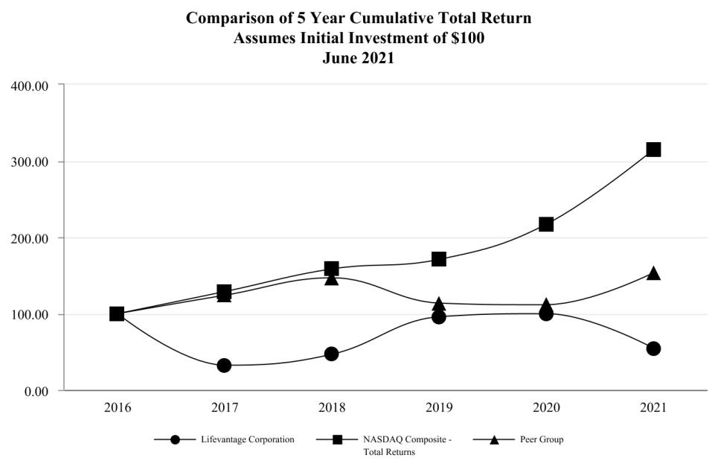

The Peer Group consists of the following companies, which compete in our industry and product categories: Nature's Sunshine Products, Inc.; Nu Skin Enterprises, Inc.; Mannatech, Incorporated; Herbalife LTD.; Reliv International, Inc.; Avon Products, Inc.; USANA Health Sciences, Inc. and Tupperware Brands Corporation.

Measured Period |  | LFVN |  |  |  | Nasdaq Composite |  |  | Peer Group
June 30, 2016 |  | $ | 100.00 |  | $ | 100.00 |  | $ | 100.00
June 30, 2017 |  | $ | 31.84 |  | $ | 128.30 |  | $ | 123.86
June 30, 2018 |  | $ | 46.84 |  | $ | 158.57 |  | $ | 146.62
June 30, 2019 |  | $ | 95.44 |  | $ | 170.91 |  | $ | 113.61
June 30, 2020 |  | $ | 99.41 |  | $ | 216.96 |  | $ | 111.26
June 30, 2021 |  | $ | 54.04 |  | $ | 315.10 |  | $ | 153.56

Dividends

We have not declared any dividends on any class of our equity securities since incorporation, and we do not currently anticipate declaring any dividends. Additionally, the 2016 Credit Facility, as amended, contains customary covenants that, among other things, restrict our ability to pay dividends.

Purchases of Equity Securities

On November 27, 2017, our board of directors approved a stock repurchase plan, which was subsequently amended on February 1, 2019. Under the plan, the we are authorized to repurchase up to $15.0 million of its outstanding shares through November 27, 2020. On August 27, 2020, our board of directors approved an amendment to the share repurchase program to increase the authorized share repurchase amount from $15 million to $35 million and to extend the duration of the program through November 30, 2023.The repurchase program permits us to purchase shares from time to time through a variety of methods, including in the open market, through privately negotiated transactions or other means as determined by our management, in accordance with applicable securities laws. As part of the repurchase program, the we may enter into a pre-arranged stock repurchase plan which operates in accordance with guidelines specified under Rule 10b5-1 of the Securities

37

Exchange Act of 1934, as amended. Accordingly, any transactions under such stock repurchase plan would be completed in accordance with the terms of the plan, including specified price, volume and timing conditions. The authorization may be suspended or discontinued at any time. During the three months ended June 30, 2021, we repurchase 0.5 million shares of our common stock under this repurchase plan.

The following table provides information with respect to all purchases made by the Company during the three months ended June 30, 2021. All purchases listed below were made at prevailing market prices.
 |  | Total Number of Shares |  |  |  |  | Total Number of Shares |  |  | Maximum Dollar Value of
Period |  | Total Number of Shares |  | Average Price Paid Per Share |  |  | Purchased as Part of the |  | Shares that May Yet Be Purchased
 |  | Purchased |  |  |  |  | Announced Plans or Programs |  | Under the Plans or Programs
April 1 - April 30 |  | 87,546 |  | $ | 8.89 |  | 87,546 |  | $ | 14,662,520
May 1 - May 31 |  | 251,251 | $ |  | 7.91 |  | 251,251 | $ |  | 12,674,487
June 1 - June 30 |  | 141,810 | $ |  | 8.23 |  | 141,810 | $ |  | 11,507,268
Total |  | 480,607 |  |  |  |  | 480,607

Recent Sale of Unregistered Securities

None.

Equity Compensation Plan Information

This information is incorporated by reference to Part III, Item 12 of this report.

ITEM 6 — SELECTED FINANCIAL DATA

The following table summarizes certain historical financial information at the dates and for the periods indicated prepared in accordance with GAAP.

The consolidated statement of operations data for each of the fiscal years ended June 30, 2021, 2020 and 2019, and the consolidated balance sheet data as of June 30, 2021 and 2020, have been derived from our consolidated financial statements audited by WSRP, LLC, an independent registered public accounting firm, included elsewhere in this annual report on Form 10-K. The consolidated statement of operations data for each of the fiscal years ended June 30, 2018 and 2017, and the consolidated balance sheet data as of June 30, 2019, 2018 and 2017, have been derived from our financial statements not included herein. The selected consolidated financial data should be read in conjunction with “Management's Discussion and Analysis of Financial Condition and Results of Operations” and the consolidated financial statements and notes thereto, which are included elsewhere in this annual report on Form 10-K. Our historical results are not necessarily indicative of operating results to be expected in the future.

38

 |  |  |  |  |  |  |  |  |  |  |  |  | Years Ended June 30,
 |  |  |  | 2021 |  |  |  |  | 2020 |  |  |  |  | 2019 |  |  |  |  | 2018 |  |  |  | 2017
 | (In thousands, except per share data)
 | Statement of Operations Data:
 | Revenue, net | $ |  | 220,181 |  |  | $ |  | 232,915 |  |  | $ |  | 225,958 |  |  | $ |  | 203,204 |  |  | $ | 199,489
 | Cost of sales |  |  | 38,187 |  |  |  |  | 37,964 |  |  |  |  | 37,973 |  |  |  |  | 34,848 |  |  |  | 33,456
 | Gross profit |  |  | 181,994 |  |  |  |  | 194,951 |  |  |  |  | 187,985 |  |  |  |  | 168,356 |  |  |  | 166,033
 | Operating expenses:
 | Commissions and incentives |  |  | 103,541 |  |  |  |  | 111,571 |  |  |  |  | 108,620 |  |  |  |  | 98,193 |  |  |  | 96,662
 | Selling, general and administrative |  |  | 60,838 |  |  |  |  | 67,914 |  |  |  |  | 69,551 |  |  |  |  | 59,840 |  |  |  | 64,922
 | Total operating expenses |  |  | 164,379 |  |  |  |  | 179,485 |  |  |  |  | 178,171 |  |  |  |  | 158,033 |  |  |  | 161,584
 | Operating income |  |  | 17,615 |  |  |  |  | 15,466 |  |  |  |  | 9,814 |  |  |  |  | 10,323 |  |  |  | 4,449
 | Other expense:
 | Interest expense |  |  | (17) |  |  |  |  | (120) |  |  |  |  | (323) |  |  |  |  | (456) |  |  |  | (570)
 | Other expense, net |  |  | (366) |  |  |  |  | (685) |  |  |  |  | (261) |  |  |  |  | (319) |  |  |  | (969)
 | Total other expense |  |  | (383) |  |  |  |  | (805) |  |  |  |  | (584) |  |  |  |  | (775) |  |  |  | (1,539)
 | Income before income taxes |  |  | 17,232 |  |  |  |  | 14,661 |  |  |  |  | 9,230 |  |  |  |  | 9,548 |  |  |  | 2,910
 | Income tax expense |  |  | (4,338) |  |  |  |  | (3,112) |  |  |  |  | (1,801) |  |  |  |  | (3,787) |  |  |  | (1,302)
 | Net income | $ |  | 12,894 |  |  | $ |  | 11,549 |  |  | $ |  | 7,429 |  |  | $ |  | 5,761 |  |  | $ | 1,608
 | Net income per share:
 | Basic | $ |  | 0.92 |  |  | $ |  | 0.82 |  |  | $ |  | 0.53 |  |  | $ |  | 0.41 |  |  | $ | 0.12
 | Diluted | $ |  | 0.90 |  |  | $ |  | 0.79 |  |  | $ |  | 0.50 |  |  | $ |  | 0.41 |  |  | $ | 0.11
 | Weighted-average shares outstanding:
 | Basic |  |  | 14,070 |  |  |  |  | 14,105 |  |  |  |  | 14,055 |  |  |  |  | 13,992 |  |  |  | 13,881
 | Diluted |  |  | 14,268 |  |  |  |  | 14,599 |  |  |  |  | 14,980 |  |  |  |  | 14,136 |  |  |  | 14,118
 |  |  |  |  |  |  |  |  |  |  |  |  |  | As of June 30,
 |  |  |  | 2021 |  |  |  |  | 2020 |  |  |  |  | 2019 |  |  |  |  | 2018 |  |  |  | 2017
 | (In thousands)
 | Balance Sheet Data:
 | Cash and cash equivalents | $ |  | 23,174 |  |  | $ |  | 22,138 |  |  | $ |  | 18,824 |  |  | $ |  | 16,652 |  |  | $ | 11,458
 | Working capital |  |  | 22,855 |  |  |  |  | 18,849 |  |  |  |  | 16,993 |  |  |  |  | 15,133 |  |  |  | 12,191
 | Total assets |  |  | 78,732 |  |  |  |  | 58,877 |  |  |  |  | 55,273 |  |  |  |  | 51,142 |  |  |  | 45,249
 | Current liabilities |  |  | 25,199 |  |  |  |  | 25,019 |  |  |  |  | 26,195 |  |  |  |  | 23,805 |  |  |  | 23,355
 | Long-term debt, net of unamortized discount |  |  | — |  |  |  |  | — |  |  |  |  | — |  |  |  |  | 3,412 |  |  |  | 5,440
 | Total liabilities |  |  | 41,925 |  |  |  |  | 25,623 |  |  |  |  | 28,074 |  |  |  |  | 29,195 |  |  |  | 30,722
 | Total stockholders' equity |  |  | 36,807 |  |  |  |  | 33,254 |  |  |  |  | 27,199 |  |  |  |  | 21,947 |  |  |  | 14,527

ITEM 7 — MANAGEMENT’S DISCUSSION AND ANALYSIS OF FINANCIAL CONDITION AND RESULTS OF OPERATIONS

The following discussion and analysis of our financial condition and results of operations should be read in conjunction with the consolidated financial statements and related notes, which are included in this Annual Report on Form 10-K.

Overview

We are a company focused on nutrigenomics, the study of how nutrition and naturally occurring compounds affect human genes to support good health. We are dedicated to helping people achieve their health, wellness and financial goals. We provide quality, scientifically-validated products to customers and independent distributors as well as a financially rewarding commission-based direct sales opportunity to our independent distributors. We engage in the identification, research, development, formulation and sale of advanced nutrigenomic activators, dietary supplements, nootropics, pre- and pro-biotics, weight management, skin and hair care, bath & body, and targeted relief products. We currently sell our products to customers and independent distributors in two geographic regions that we have classified as the Americas region and the Asia/Pacific & Europe region.

39

The success and growth of our business is primarily based on the effectiveness of our independent distributors to attract and retain customers in order to sell our products and our ability to attract and retain independent distributors. When we are successful in attracting and retaining independent distributors and customers, it is largely because of:

- Our products, including our flagship Protandim® family of scientifically-validated dietary supplements, LifeVantage® Omega+, ProBio and Daily Wellness dietary supplements, our line of Nrf2 enhanced TrueScience® skin, hair, bath & body, and targeted relief products, Petandim®, our companion pet supplement formulated to combat oxidative stress in dogs, Axio®, our nootropic energy drink mixes, and PhysIQ™, our smart weight management system.;

- Our sales compensation plan and other sales initiatives and incentives; and

- Our delivery of superior customer service.

As a result, it is vital to our success that we leverage our product development resources to develop and introduce compelling and innovative products and provide opportunities for our independent distributors to sell these products in a variety of markets. We sell our products in the United States, Mexico, Japan, Australia, Hong Kong, Canada, Thailand, the United Kingdom, the Netherlands, Germany, Taiwan, Austria, Spain, Ireland, Belgium, New Zealand, and Singapore. In addition, we sell our products in a number of countries to customers for personal consumption only and in China through a China approved cross-border e-commerce business model. Entering a new market requires a considerable amount of time, resources and continued support. If we are unable to properly support an existing or new market, our revenue growth may be negatively impacted.

Impact of COVID-19 on Our Business

The pandemic caused by an outbreak of a new strain of coronavirus (“COVID-19”) has resulted, and is likely to continue to result, in significant national and global economic disruption and may adversely affect our business. Uncertainty exists concerning the magnitude of the impact and duration of the COVID-19 pandemic. As of the date of this filing, we have experienced multiple disruptions at the corporate level as we transitioned our corporate workforce to a remote working environment, temporarily closed some of our showrooms and will call locations in international markets and cancelled multiple planned events in order to comply with group meeting restrictions. Our independent distributors have also experienced disruptions. Specifically, in Japan, independent distributors are required to provide a hard-copy introductory packet (gaiyoshomen) in person to each person they approach to sponsor as an independent distributor before presenting our products and business opportunity. This requirement inhibits independent distributors from connecting with potential new independent distributors virtually or through social media. Accordingly, quarantines, avoidance of public places and general concerns about physical distancing related to COVID-19 or otherwise can significantly reduce the ability for independent distributors to meet people in person and commence the enrollment process. Elsewhere, our independent distributors have begun to adapt their approach for customer outreach and enrollment, including transitioning to a stronger social media presence, in an effort to sustain their sales volume. Our business may, in the future, experience additional disruptions and be negatively impacted by the COVID-19 pandemic, including as a result of limitations on the ability of our suppliers to manufacture, or procure from manufacturers, the products we sell or any of the raw materials or components required in the production process, or to meet delivery requirements and commitments; limitations on the ability of our employees to perform their work due to illness caused by the pandemic or local, state, or federal orders requiring employees to remain at home; limitations on the ability of carriers to deliver our products to customers; limitations on the ability of our independent distributors to conduct their businesses and purchase our products; and limitations on the ability of our independent distributors or customers to continue to purchase our products due to decreased disposable income.

We have made modifications, and are evaluating additional potential modifications that may be needed, to protect our supply chain and preserve adequate liquidity to ensure that our business can continue to operate during this uncertain time. Some states have issued executive orders requiring all workers to remain at home, unless their work is critical, essential, or life-sustaining. Near the end of fiscal 2020 we transitioned all of our corporate employees to a work from home model and during July 2021 we began to implement a hybrid schedule with opportunities for employees to return back to the office. To date, our employees are performing and adapting well with the evolving environment. With respect to liquidity, we are evaluating and taking actions to ensure that we continue to responsibly manage expenses across our organization.

While we are unable to determine or predict the nature, duration or scope of the overall impact that the COVID-19 pandemic will have on our business, results of operations, liquidity or capital resources, we will continue to actively monitor the situation and may take further actions that alter our business operations as may be required by federal, state or local authorities or that we determine are in the best interests of our employees, independent distributors, customers, and stockholders.

40

Our Products

Our products are the Protandim® line of scientifically-validated dietary supplements, LifeVantage® Omega+, ProBio and Daily Wellness dietary supplements, TrueScience®, our line of skin, bath

- body, target relief, and hair care products, Petandim®, our companion pet supplement formulated to combat oxidative stress in dogs, Axio®, our nootropic energy drink mixes, and PhysIQ™, our smart weight management system. The Protandim® product line includes Protandim® NRF1 Synergizer®, Protandim® Nrf2 Synergizer®, and Protandim® NAD Synergizer®. The Protandim® NRF1 Synergizer® is formulated to increase cellular energy and performance by boosting mitochondria production to improve cellular repair and slow cellular aging. The Protandim® Nrf2 Synergizer® contains a proprietary blend of ingredients and has been shown to combat oxidative stress and enhance energy production by increasing the body’s natural antioxidant protection at the genetic level, inducing the production of naturally-occurring protective antioxidant enzymes, including superoxide dismutase, catalase, and glutathione synthase. The Protandim® NAD Synergizer® was specifically formulated to target cell signaling pathways involved in the synthesis and recycling of a specific molecule called NAD (nicotinamide adenine dinucleotide), and has been shown to double sirtuin activity, supporting increased health, focus, energy, mental clarity and mood. Use of the three Protandim® products together has been shown to produce synergistic benefits greater than using the single products on their own. LifeVantage® Omega+ is a dietary supplement that combines DHA and EPA Omega-3 fatty acids, Omega-7 fatty acids, and Vitamin D3 to support cognitive health, cardiovascular health, skin health, and the immune system. LifeVantage® ProBio is a dietary supplement designed to support optimal digestion and immune system function. LifeVantage® Daily Wellness is a dietary supplement designed to support and strengthen immune health. Our TrueScience® line of anti-aging skin and hair care, and CBD Nrf2 enhanced, bath & body, targeted relief products includes TrueScience® Facial Cleanser, TrueScience® Perfecting Lotion, TrueScience® Eye Serum, TrueScience® Anti-Aging Cream, TrueScience® Beauty Serum, TrueScience® Hand Cream, TrueScience® Invigorating Shampoo, TrueScience® Nourishing Conditioner, TrueScience® Scalp Serum, TrueScience® Body Lotion, TrueScience® Body Wash, TrueScience® Body Butter, TrueScience® Deodorant, TrueScience® Soothing Balm, and TrueScience® Body Rub. Petandim® is a supplement specially formulated to combat oxidative stress in dogs through Nrf2 activation. Axio® is our line of our nootropic energy drink mixes formulated to promote alertness and support mental performance. PhysIQ™ is our smart weight management system, which includes PhysIQ™ Fat Burn, PhysIQ™ Prebiotic and PhysIQ™ Whey Protein, all formulated to aid in weight management. We believe our significant number of customers who regularly and repeatedly purchase our products is a strong indicator of the health benefits of our products. The following table shows revenues by major product line for the fiscal years ended June 30, 2021, 2020 and 2019:

 |  |  |  |  |  |  |  | Years ended June 30,
 |  | 2021 |  |  |  |  |  | 2020 |  |  |  |  |  |  | 2019
Protandim® product line | $ | 150,272 |  |  | 68.2 % |  | $ | 156,335 |  |  | 67.1 % |  | $ | 144,100 | 63.8 %
TrueScience® product line |  | 22,617 |  |  | 10.3 % |  |  | 23,739 |  |  | 10.2 % |  |  | 24,853 | 11.0 %
Other |  | 47,292 |  |  | 21.5 % |  |  | 52,841 |  |  | 22.7 % |  |  | 57,005 | 25.2 %
Total | $ | 220,181 |  |  | 100.0 % |  | $ | 232,915 |  |  | 100.0 % |  | $ | 225,958 |  |  | 100.0 %

Our revenue is largely attributed to two product lines, Protandim® and TrueScience®, which each accounted for more than 10% of total revenue for each of the fiscal years ended June 30, 2021, 2020 and 2019. On a combined basis, these product lines represent approximately 78.5%, 77.3% and 74.8% of our total net revenue for the fiscal years ended June 30, 2021, 2020 and 2019, respectively.

We currently have additional products in development. Any delays or difficulties in introducing compelling products or attractive initiatives or tools into our markets may have a negative impact on our revenue and our ability to attract new independent distributors and customers.

Accounts

Because we primarily utilize a direct selling model for the distribution of a majority of our products, the success and growth of our business depends in large part on the effectiveness of our independent distributors to attract and retain customers to sell our products to, and our ability to attract new and retain existing independent distributors. Changes in our product sales are typically the result of variations in product sales volume relating to fluctuations in the number of active independent distributors and customers purchasing our products. The number of active independent distributors and customers is, therefore, used by management as a key non-financial measure.

The following tables summarize the changes in our active accounts by geographic region. These numbers have been rounded to the nearest thousand as of the dates indicated. For purposes of this report, we define "Active Accounts" as only those

41

independent distributors and customers who have purchased from us at any time during the most recent three-month period, either for personal use or for resale.

 |  |  |  | As of June 30,
 | 2021 |  |  |  |  |  | 2020 |  |  |  |  | Change from Prior |  | Percent Change
 |  |  |  |  |  |  |  |  |  |  |  | Year |  | Percent Change
Active Independent Distributors
Americas | 41,000 |  |  | 65.1 % |  |  | 49,000 |  |  | 67.1 % |  | (8,000) | (16.3)%
Asia/Pacific & Europe | 22,000 |  |  | 34.9 % |  |  | 24,000 |  |  | 32.9 % |  | (2,000) | (8.3)%
Total Active Independent Distributors | 63,000 |  |  | 100.0 % |  |  | 73,000 |  |  | 100.0 % |  | (10,000) | (13.7)%
Active Customers
Americas | 78,000 |  |  | 72.9 % |  |  | 83,000 |  |  | 78.3 % |  | (5,000) | (6.0)%
Asia/Pacific & Europe | 29,000 |  |  | 27.1 % |  |  | 23,000 |  |  | 21.7 % |  | 6,000 | 26.1 %
Total Active Customers | 107,000 |  |  | 100.0 % |  |  | 106,000 |  |  | 100.0 % |  | 1,000 | 0.9 %
Active Accounts
Americas | 119,000 |  |  | 70.0 % |  |  | 132,000 |  |  | 73.7 % |  | (13,000) | (9.8)%
Asia/Pacific & Europe | 51,000 |  |  | 30.0 % |  |  | 47,000 |  |  | 26.3 % |  | 4,000 | 8.5 %
Total Active Accounts | 170,000 |  |  | 100.0 % |  |  | 179,000 |  |  | 100.0 % |  | (9,000) | (5.0)%

Income Statement Presentation

We report revenue in two geographic regions and we translate revenue from each market's local currency into U.S. Dollars using weighted-average exchange rates. Revenue consists primarily of product sales, fee revenue, and shipping and handling fees, net of applicable sales discounts. Revenue is recognized at the time of shipment, which is when the passage of title and risk of loss to customers occurs. Also reflected in revenue is a provision for product returns and allowances, which is estimated based on our historical experience. The following table sets forth net revenue information by region for the years indicated. The following table should be reviewed in connection with the tables presented under "Results of Operations" (in thousands):

 |  |  |  |  |  |  |  | For the fiscal years ended June 30,
 |  | 2021 |  |  |  |  |  |  | 2020 |  |  |  |  |  | 2019
Americas | $ | 154,655 |  |  | 70.2 % |  | $ | 166,336 | 71.4 % |  |  |  | $ | 163,236 | 72.2 %
Asia/Pacific & Europe |  | 65,526 |  |  | 29.8 % |  |  | 66,579 | 28.6 % |  |  |  |  | 62,722 | 27.8 %
Total | $ | 220,181 |  |  | 100.0 % |  | $ | 232,915 |  |  | 100.0 % |  | $ | 225,958 |  |  | 100.0 %

Cost of sales primarily consists of costs of products purchased from and manufactured by third-party vendors, shipping and order fulfillment costs, costs of adjustments to inventory carrying value, and costs of marketing materials which we sell to our independent distributor sales force, as well as freight, duties and taxes associated with the import and export of our products. As our international revenue increases as a percentage of total revenue, cost of sales as a percentage of revenue likely will increase as a result of additional duties, freight, and other factors, such as changes in currency exchange rates.

Commissions and incentives expenses are our most significant expenses and are classified as operating expenses. Commissions and incentives expenses include sales commissions paid to our independent distributors, special incentives and costs for incentive trips and other rewards. Commissions and incentives expenses do not include any amounts we pay to our independent distributors related to their personal purchases. Commissions paid to independent distributors on personal purchases are considered a sales discount and are reported as a reduction to net revenue. Our global sales compensation plan is an important factor in our ability to attract and retain our independent distributors. Under our global sales compensation plan, independent distributors can earn commissions for product sales to their customers as well as the product sales made through the sales networks they have developed and trained. We do not pay commissions on marketing materials that are sold to our independent distributors. Commissions and incentives expenses, as a percentage of net revenue, may be impacted by the timing and magnitude of non-commissionable revenue derived from the sales of marketing materials, event tickets, and promotional items, investment in our red carpet program, limited-time offers and the timing, magnitude and number of incentive trips and

42

other promotional activities. From time to time, we make modifications and enhancements to our global sales compensation plan in an effort to help motivate our sales force and develop leadership characteristics, which can have an impact on commissions and incentives expenses.

Selling, general and administrative expenses include wages and benefits, stock compensation expenses, marketing and event costs, professional fees, rents and utilities, depreciation and amortization, research and development, travel costs and other operating expenses. Wages and benefits and stock compensation expenses represent the largest component of selling, general and administrative expenses. Marketing and event costs include costs of distributor conventions and events held in various markets worldwide, which we expense in the period in which they are incurred. Marketing and event costs also include expenses associated with our sponsorship of the Major League Soccer team, Real Salt Lake.

Sales to customers outside the United States are transacted in the respective local currencies and are translated to U.S. Dollars at weighted-average currency exchange rates for each monthly accounting period to which they relate. Consequently, our net sales and earnings are affected by changes in currency exchange rates. In general, sales and gross profit are affected positively by a weakening U.S. Dollar and negatively by a strengthening U.S. Dollar. Currency fluctuations, however, have the opposite effect on our commissions paid to independent distributors and selling, and general and administrative expenses. In our revenue discussions that follow, we approximate the impact of currency fluctuations on revenue by translating current year revenue at the average exchange rates in effect during the comparable prior year periods.

Results of Operations

For the fiscal years ended June 30, 2021, 2020 and 2019, we generated net revenue of $220.2 million, $232.9 million and $226.0 million, respectively, recognized operating profit of $17.6 million, $15.5 million and $9.8 million, respectively, and recognized net income of $12.9 million, $11.5 million and $7.4 million, respectively.

The following table presents certain consolidated earnings data as a percentage of net revenue for the years indicated⁽¹⁾:

For the fiscal years ended June 30,

 | 2021 |  |  | 2020 |  | 2019
Revenue, net |  | 100.0 % |  | 100.0 % |  | 100.0 %
Cost of sales |  | 17.3 |  | 16.3 |  | 16.8
Gross profit |  | 82.7 |  | 83.7 |  | 83.2
Operating expenses:
Commissions and incentives |  | 47.0 |  | 47.9 |  | 48.1
Selling, general and administrative |  | 27.6 |  | 29.2 |  | 30.8
Total operating expenses |  | 74.6 |  | 77.1 |  | 78.9
Operating income |  | 8.1 |  | 6.6 |  | 4.3
Other expense:
Interest expense |  | — |  | (0.1) |  | (0.1)
Other expense, net |  | (0.2) |  | (0.3) |  | (0.1)
Total other expense |  | (0.2) |  | (0.3) |  | (0.3)
Income before income taxes |  | 7.9 |  | 6.3 |  | 4.0
Income tax expense |  | (2.0) |  | (1.3) |  | (0.8)
Net income |  | 5.9 % |  | 5.0 % |  | 3.2 %
(1) Certain percentages may not add due to rounding.

Comparison of Fiscal Years Ended June 30, 2021 and 2020

Revenue, net. We generated net revenue of $220.2 million and $232.9 million during the fiscal years ended June 30, 2021 and 2020, respectively. The overall decrease in revenue is attributed mainly to a reduction of 5.0% in total active accounts during fiscal year 2021. Revenue in the United States, Japan, Canada and Taiwan declined on a year over year basis, partially offset by increases of 22.4% in our Australia and New Zealand market. During the prior year, at our October 2019 global convention, we launched our Protandim® NAD Synergizer® product which generated significant revenue during the prior fiscal year. During the current year, we launched several limited time and permanent flavors of Axio®, our energy drink mixes, launched our new LifeVantage® Daily Wellness product, and rolled out six new products in our TrueScience® Body & Bath and Targeted Relief product lines and a line extension to our TrueScience® skin care line. Foreign currency fluctuations positively impacted our net revenue $2.6 million or 1.1%.

43

Americas. The following table sets forth revenue for the fiscal years ended June 30, 2021 and 2020 for the Americas region (in thousands):

 | For the fiscal years ended June 30,
 | 2021 |  |  | 2020 |  |  | % change
United States | $ | 144,897 |  | $ | 155,480 |  | (6.8)%
Other |  | 9,758 |  |  | 10,856 | (10.1)%
Americas Total | $ | 154,655 |  | $ | 166,336 | (7.0)%

Revenue in the Americas region for the fiscal year ended June 30, 2021 decreased $11.7 million, or 7.0%, compared to the prior year. Total active accounts decreased 9.8% in the region compared to the prior fiscal year which drove the decrease in revenue. We believe that our total active accounts number was negatively impacted by the COVID-19 global pandemic as we were unable to hold our in-person training events and our independent distributors were not able to conduct in person opportunity and training meetings. Although we launched several new products during fiscal 2021, during our prior year October 2019 global convention, we launched our Protandim® NAD Synergizer® product which generated significant revenue during the prior fiscal year.

Asia/Pacific & Europe. The following table sets forth revenue for the fiscal years ended June 30, 2021 and 2020 for the Asia/Pacific & Europe region and its principal markets (in thousands):

 | For the fiscal years ended June 30,
 | 2021 |  |  | 2020 |  |  | % change
Japan | $ | 41,173 |  | $ | 42,343 |  | (2.8)%
Australia & New Zealand |  | 11,095 |  |  | 9,065 | 22.4 %
Greater China |  | 4,771 |  |  | 6,682 | (28.6)%
Other |  | 8,487 |  |  | 8,489 |  | — %
Asia/Pacific & Europe Total | $ | 65,526 |  | $ | 66,579 | (1.6)%

Revenue in the Asia/Pacific and Europe region for the fiscal year ended June 30, 2021 decreased $1.1 million, or 1.6%, compared to the prior year. Revenue in the region was positively impacted approximately $2.4 million, or 3.6%, by foreign currency exchange rate fluctuations.

Revenue in our Japan market decreased 2.8% year over year on a U.S. Dollar basis and 4.1% on a constant currency basis. Offsetting this decline in revenue during the fiscal year ended June 30, 2021, the Japanese yen, on average, strengthened against the U.S. Dollar, positively impacting our revenue in this market by $0.6 million or 1.3%. Revenues in this region, specifically Japan and Taiwan, were impacted by the COVID-19 global pandemic during the year, due, in part, to restrictions on in person meetings, requirements to close down, at times, our showrooms and will call pick up locations and overall difficulties for our independent distributors to conduct business.

Revenue in our Australia and New Zealand markets increased $2.0 million, or 22.4%, during fiscal 2021. We continue to see synergies between our Australian and New Zealand independent distributor organizations and customer bases, increasing our ability to attract experienced direct selling leaders and further driving the growth within the region.

Revenue in our Greater China region decreased by 28.6% year over year as we experienced continued weakening in our Taiwan market, due, in part, to the global pandemic. Other geopolitical events occurring in the region during the current year also contributed to the decline in revenue. We continue to work on refining our mainland China cross-border e-commerce business model and to date have not recognized significant revenues through this channel. Revenue in Thailand and Europe remained stable during the fiscal 2021 relative to the prior year.

Overall, we are encouraged with our increase in total active accounts in our Asia/Pacific and Europe region, which grew by 8.5% on a year over year basis, primarily from Thailand and Australia.

Globally, our sales and marketing efforts continue to be directed toward strengthening our core business through our fiscal year initiatives and building our worldwide sales. During fiscal 2021,we successfully launched several new products, completed a full on the ground launch of Singapore, and we have plans for future market expansion during the first half of fiscal 2022. In October 2021, we anticipate holding our first major event with in person attendance since the start of the COVID-19 global pandemic and look to a full return to in person meetings throughout the year where we are able. Throughout fiscal 2021, we

44

continued the refinement and expansion of our product offerings internationally during fiscal 2021 and have plans for continued product expansion in fiscal 2022 and beyond. We expect this expansion will continue to drive revenue growth globally through increased average order size and increased ability to attract and retain new independent distributors and customers with a compelling product lineup.

During fiscal year 2022, our main focus will be to increase our average account base through concentrating our efforts on the enrollment of new independent distributors, who will in turn help grow the business through incremental product sales, and on increasing the number of accounts that place an order in the month following their initial enrollment. We will continue investing in our red carpet program, which we believe has increased our ability to attract and retain strong distributor leadership and is a significant opportunity to drive revenue growth throughout our markets. We remain committed to further expanding the functionality and availability of our mobile application, which we believe will aid independent distributors in initiating and expanding their businesses.

Gross Margin. Cost of sales were $38.2 million for the fiscal year ended June 30, 2021, and $38.0 million for the fiscal year ended June 30, 2020, resulting in a gross margin of $182.0 million, or 82.7%, and $195.0 million, or 83.7%, respectively. The decrease in gross margin as a percentage of revenue is primarily due to increased shipping to customer expenses during the current fiscal year.

Commissions and Incentives. Commissions and incentives expenses for the fiscal year ended June 30, 2021 were $103.5 million or 47.0% of revenue compared to $111.6 million or 47.9% of revenue for the fiscal year ended June 30, 2020. The decrease of $8.0 million in fiscal 2021 was due to the decrease in revenue. Commissions and incentives expenses as a percentage of revenue decreased slightly during the comparable periods due, in part, to decreases in incentive expenses as a result of the cancellation of incentive events during the year due to the COVID 19 pandemic and associated travel and meeting restrictions as well as the continued refinement and the timing and magnitude of our various promotional and incentive programs during the year.

Commissions and incentives expenses, as a percentage of revenue, may fluctuate in future periods based on ability to hold incentive trips and events and the timing and magnitude of compensation, incentive and promotional programs.

Selling, General and Administrative. Selling, general and administrative expenses for the fiscal year ended June 30, 2021 were $60.8 million or 27.6% of revenue compared to $67.9 million or 29.2% of revenue for the fiscal year ended June 30, 2020. The decrease of $7.1 million during the current period primarily was due to decreased events and travel expenses as a result of changes to our event schedule related to the COVID-19 pandemic and associated group meeting restrictions, as well as decreased incentive and stock compensation expenses due to the reversal of unvested stock awards resulting from the departure of executives during the current fiscal year and a decrease in incentive compensation due to performance relative to target during the year. Legal expenses also decreased as compared to the prior fiscal year as well as expenses associated with our sponsorship of Real Salt Lake due to schedule limitations associated with COVID-19 restrictions and precautions. These decreases were partially offset by increased executive severance and transition expenses, depreciation expenses associated with our investment in new technology assets that have been placed in service and increased rent and depreciation expenses associated with our new corporate office and our old Sandy, Utah corporate office lease.

Primary factors that may cause our selling, general and administrative expenses to fluctuate in the future include changes in the number of employees, the timing and number of events we hold, marketing and branding initiatives and costs related to legal matters, if and as they arise. A fluctuation in our stock price may also impact our share-based compensation expense recorded for equity awards made in future years.

Other Expense. We recognized other expense for the fiscal year ended June 30, 2021 of $0.4 million as compared to $0.8 million for the fiscal year ended June 30, 2020. The decrease of $0.4 million was due to a decrease in net losses in currency hedges during fiscal 2021.

45

The following table sets forth interest expense for the fiscal years ended June 30, 2021 and 2020 (in thousands):

 | For the fiscal years ended June 30,
 | 2021 |  |  | 2020
Contractual interest expense:
2016 Term Loan | $ | — |  | $ | 44
Amortization of deferred financing fees:
2016 Term Loan |  | — |  |  | 7
Amortization of debt discount:
2016 Term Loan |  | — |  |  | 39
Other |  | 17 |  |  | 30
Total interest expense | $ | 17 |  | $ | 120

Income Tax Expense. Our income tax expense for the fiscal year ended June 30, 2021 was $4.3 million as compared to income tax expense of $3.1 million for the fiscal year ended June 30, 2020.

The effective tax rate was 25.2% of pre-tax income for the fiscal year ended June 30, 2021, compared to 21.2% for the fiscal year ended June 30, 2020. The increase in the effective tax rate for fiscal 2021 compared to the prior year is due mainly to a decrease in favorable book to tax differences associated with the vesting of stock awards.

Our provision for income taxes for the fiscal year ended June 30, 2021 consisted primarily of federal, state, and foreign tax on anticipated fiscal 2021 income which was partially offset by tax benefits. We expect our effective rate to fluctuate in future periods based on the impact of permanent items in relation to pre-tax income.

Net Income. As a result of the foregoing factors, net income for the fiscal year ended June 30, 2021 increased to $12.9 million compared to $11.5 million for the fiscal year ended June 30, 2020. Comparison of Fiscal Years Ended June 30, 2020 and 2019
For a discussion of our results of operations for the fiscal 2020 compared with fiscal 2019, refer to “Part II. Item 7. Management's Discussion and Analysis of Financial Condition and Results of Operations" in our annual report on Form 10-K for the fiscal year ended June 30, 2020, as filed with the SEC on August 18, 2020.

Liquidity and Capital Resources

Liquidity

Our primary liquidity and capital resource requirements are to service our debt, which includes any outstanding balances under the 2016 Credit Facility, and finance the cost of our planned operating expenses and working capital (principally inventory purchases), as well as capital expenditures. We have generally relied on cash flow from operations to fund operating activities and we have, at times, incurred long-term debt in order to fund stock repurchases and strategic transactions.

At June 30, 2021, our cash and cash equivalents were $23.2 million. This represented an increase of $1.1 million from the $22.1 million in cash and cash equivalents as of June 30, 2020.

During the fiscal year ended June 30, 2021, our net cash provided by operating activities was $16.3 million as compared to net cash provided by operating activities of $18.3 million during the fiscal year ended June 30, 2020. The decrease in cash provided by operating activities during the fiscal year ended June 30, 2021 primarily was due to increased cash used for inventory, cash used to pay for accrued expenses, and cash used to pay down lease liabilities. These decreases were partially offset by increases in net income and accounts payable.

During the fiscal year ended June 30, 2021, our net cash used in investing activities was $3.7 million, as a result of the purchase of fixed assets. During the fiscal year ended June 30, 2020, our net cash used in investing activities was $2.7 million, as a result of the purchase of fixed assets.

Cash used in financing activities during the fiscal year ended June 30, 2021 was $11.5 million, as a result of the repurchase of company stock and shares purchased as payment of tax withholding upon vesting of employee equity awards, partially offset by proceeds from stock option exercises and proceeds from purchases of company stock under our employee stock purchase plan. Cash used in financing activities during the fiscal year ended June 30, 2020 was $12.4 million, as a result of the repurchase of company stock, shares purchased as payment of tax withholding upon vesting of employee equity awards and our

46

quarterly principal payments on the 2016 Term Loan, which was repaid in full during fiscal 2020, partially offset by proceeds from stock option exercises and proceeds from purchases of company stock under our employee stock purchase plan.

At June 30, 2021 and 2020, the total amount of our foreign subsidiary cash was $9.2 million and $6.8 million, respectively. Under current U.S. tax law, in the future, if needed, we expect to be able to repatriate cash from foreign subsidiaries without paying additional U.S. taxes.

At June 30, 2021, we had working capital (current assets minus current liabilities) of $22.9 million compared to working capital of $18.8 million at June 30, 2020. The increase in working capital primarily was due to increases in cash and inventory and decreases in other accrued expenses and commissions payable, partially offset by an increase in accounts payable. We believe that our cash and cash equivalents balances and our ongoing cash flow from operations will be sufficient to satisfy our cash requirements for at least the next 12 months. The majority of our historical expenses have been variable in nature and as such, a potential reduction in the level of revenue would reduce our cash flow needs. In the event that our current cash balances and future cash flow from operations are not sufficient to meet our obligations or strategic needs, we would consider raising additional funds, which may not be available on terms that are acceptable to us, or at all. Our credit facility, however, contains covenants that restrict our ability to raise additional funds in the debt markets and repurchase our equity securities without prior approval from the lender. Additionally, our credit facility provides for a revolving loan facility in an aggregate principal amount up to $5.0 million. We would also consider realigning our strategic plans including a reduction in capital spending and expenses.

Capital Resources

Shelf Registration Statement

On March 24, 2020, we filed a shelf registration statement (the "Shelf Registration") on Form S-3 with the SEC that was declared effective April 3, 2020, which permits us to offer up to $75 million of common stock, preferred stock, debt securities and warrants in one or more offerings and in any combination, including in units from time to time. Our Shelf Registration is intended to provide us with additional flexibility to access capital markets for general corporate purposes, which may include, among other purposes, working capital, capital expenditures, other corporate expenses and acquisitions of assets, licenses, products, technologies or businesses.

2016 Credit Facility

On March 30, 2016, we entered into a loan agreement (the "2016 Loan Agreement") to refinance our outstanding debt. In connection with the 2016 Loan Agreement and on the same date, we entered into a security agreement (the "Security Agreement"). The 2016 Loan Agreement provides for a term loan in an aggregate principal amount of $10.0 million (the "2016 Term Loan") and a revolving loan facility in an aggregate principal amount not to exceed $2.0 million (the "2016 Revolving Loan," and collectively with the 2016 Term Loan, the 2016 Loan Agreement and the Security Agreement, the "2016 Credit Facility").

The principal amount of the 2016 Term Loan was payable in consecutive quarterly installments in the amount of $0.5 million plus accrued interest beginning with the fiscal quarter ended June 30, 2016. If we borrow under the 2016 Revolving Loan, interest will be payable quarterly in arrears on the last day of each fiscal quarter.

On May 4, 2018, we entered into a loan modification agreement, which amended the 2016 Credit Facility (“Amendment No. 1”). Amendment No. 1 revised the maturity date from March 30, 2019 to March 31, 2021 and increased the fixed interest rate for the term loan from 4.93% to 5.68%. Amendment No. 1 also revised certain financial covenants. The minimum fixed charge coverage ratio (as defined in Amendment No. 1) was revised from a minimum of 1.50 to 1.00 to 1.25 to 1.00, measured on a trailing twelve-month basis, at the end of each fiscal quarter. The minimum working capital was increased from $5.0 million to $8.0 million. The funded debt to EBITDA ratio was replaced with the total liabilities to tangible net worth ratio (as defined in Amendment No. 1) of not greater than 3.00 to 1.00 at the end of each quarter. The minimum tangible net worth measure was removed from the financial covenants.

Loans outstanding under the 2016 Credit Facility, as amended, may be prepaid in whole or in part at any time without premium or penalty. In addition, if, at any time, the aggregate principal amount outstanding under the 2016 Revolving Loan, as amended, exceeds $2.0 million, we must prepay an amount equal to such excess. Any principal amount of the 2016 Term Loan, as amended, which is prepaid or repaid may not be re-borrowed.

On February 1, 2019, we entered into a loan modification agreement, which amended the 2016 Credit Facility, as amended ("Amendment No. 2"). Under Amendment No. 2, we made a principal payment of $2.0 million and increased the revolving loan facility from $2.0 million to $5.0 million. Amendment No. 2 also revised certain financial covenants. The minimum fixed charge coverage ratio (as defined in Amendment No. 2) was revised from a minimum of 1.25 to 1.00 to 1.10 to 1.00, measured

47

on a trailing twelve-month basis, at the end of each fiscal quarter. The minimum working capital was decreased from $8.0 million to $6.0 million.

On April 1, 2021, we entered into a loan modification agreement ("Amendment No. 3"), which amended the 2016 Credit Facility, as previously amended. Amendment No. 3 revised the maturity date from March 31, 2021 to March 31, 2024 and modified the variable interest rate based on the one-month United States Treasury Rate, plus a margin of 3.00%, with an interest rate floor of 4.00%. As of June 30, 2021, the effective interest rate is 4.00%. Amendment No. 3 also revised the debt (total liabilities) to tangible net worth ratio (as defined in Amendment No. 3) covenant to require that we maintain this ratio not in excess of 2.00 to 1.00, measured as of the end of each fiscal quarter, and revised the definition and calculation of the minimum fixed charge coverage ratio (as defined in Amendment No. 3). There were no other changes to the covenants or revolving loan facility as set forth in Amendment No. 2.

The 2016 Credit Facility, as amended, contains customary covenants, including affirmative and negative covenants that, among other things, restrict our ability to create certain types of liens, incur additional indebtedness, declare or pay dividends on or redeem capital stock, make other payments to holders of our equity interests, make certain investments, purchase or otherwise acquire all or substantially all the assets or equity interests of other companies, sell assets or enter into consolidations, mergers or transfers of all or any substantial part of our assets. As of June 30, 2021, we were in compliance with all applicable non-financial and restrictive covenants under the 2016 Credit Facility, as amended.

The 2016 Credit Facility, as amended, also contains various financial covenants that require us to maintain certain consolidated working capital amounts, total liabilities to tangible net worth ratios and fixed charge coverage ratios. Specifically, we must:

- Maintain a minimum fixed charge coverage ratio (as defined in the 2016 Loan Agreement, as amended) of at least 1.10 to 1.00 at the end of each fiscal quarter, measured on a trailing twelve month basis;

- Maintain minimum consolidated working capital (as defined in the 2016 Loan Agreement, as amended) at the end of each fiscal quarter of at least $6.0 million; and

- Maintain a ratio of debt (total liabilities) to tangible net worth (as defined in the 2016 Loan Agreement, as amended) of not greater than 2.00 to 1.00 at the end of each quarter, measured on a trailing twelve month basis.

During the fiscal year ended June 30, 2020, we repaid, in full, the remaining balance of the 2016 Term Loan in accordance with the terms of the 2016 Credit Facility, as amended.

Commitments and Obligations

The following table summarizes our contractual payment obligations and commitments as of June 30, 2021 (in thousands):

 |  |  |  |  |  |  | Payments due by period
Contractual Obligations |  | Total |  |  | Less than |  |  | 1-3 years |  |  | 3-5 years |  |  | Thereafter
Contractual Obligations |  |  |  |  | 1 year |  |  |  |  |  |  |  |  | Thereafter
Operating lease obligations ⁽¹⁾ | $ | 21,345 |  | $ | 2,815 |  | $ | 5,468 |  | $ | 3,252 |  | $ | 9,810
Other operating obligations ⁽²⁾ |  | 14,519 |  |  | 11,428 |  |  | 3,091 |  |  | — |  |  | —
Total | $ | 35,864 |  | $ | 14,243 |  | $ | 8,559 |  | $ | 3,252 |  | $ | 9,810

- Operating lease obligations include current and future obligations associated with corporate office leases.

- Other operating obligations represent contractual obligations primarily related to marketing and sponsorship commitments and purchases of inventory.

Off-Balance Sheet Arrangements

At June 30, 2021 and 2020, we had no off-balance sheet arrangements.

Critical Accounting Policies

We prepare our financial statements in conformity with accounting principles generally accepted in the United States of America. As such, we are required to make certain estimates, judgments, and assumptions that we believe are reasonable based upon the information available. These estimates and assumptions affect the reported amounts of assets and liabilities at the date of the financial statements and the reported amounts of revenue and expenses during the periods presented. Actual results could differ from these estimates. Our significant accounting policies are described in Note 2 to our consolidated financial statements. Certain of these significant accounting policies require us to make difficult, subjective, or complex judgments or estimates. We

48

consider an accounting estimate to be critical if (1) the accounting estimate requires us to make assumptions about matters that were highly uncertain at the time the accounting estimate was made and

- changes in the estimate that are reasonably likely to occur from period to period, or use of different estimates that we reasonably could have used in the current period, would have a material impact on our financial condition or results of operations.

There are other items within our financial statements that require estimation, but are not deemed critical as defined above. Changes in estimates used in these and other items could have a material impact on our financial statements. Management has discussed the development and selection of these critical accounting estimates with our board of directors, and the audit committee has reviewed the disclosures noted below.

Allowances for Product Returns

We record allowances for product returns at the time we ship the product based on estimated return rates. Subject to some exceptions based on local regulations, our return policy is to provide a full refund for product returned within 30 days. After 30 days of purchase, only unopened product that is in a resalable and restockable condition may be returned within twelve months of purchase and shall receive a 100% refund, less a 10% handling and restocking fee and any shipping and handling costs. As of June 30, 2021, our shipments of products sold totaling approximately $19.0 million were subject to our return policy.

We monitor our product returns estimate on an ongoing basis and revise the allowances to reflect our experience. Our allowance for product returns was $0.2 million at June 30, 2021, compared with $0.3 million at June 30, 2020. To date, product expiration dates have not played any role in product returns, and we do not expect they will in the future as it is unlikely that we will ship product with an expiration date earlier than the latest allowable product return date.

Inventory Valuation

We value our inventory at the lower of cost or net realizable value on a first-in, first-out basis. Accordingly, we reduce our inventories for the diminution of value resulting from product obsolescence, damage or other issues affecting marketability equal to the difference between the cost of the inventory and its estimated net realizable value. Factors utilized in the determination of estimated net realizable value include (i) current sales data and historical return rates, (ii) estimates of future demand, (iii) competitive pricing pressures, (iv) new production introductions, (v) product expiration dates, and (vi) component and packaging obsolescence.

During the fiscal years ended June 30, 2021 and 2020, we recognized expenses of $0.4 million and $0.4 million, respectively, related to obsolete and slow-moving inventory. Revenue Recognition
Revenue is recognized when control of the promised goods or services are transferred to the customer, in an amount that reflects the consideration we expect to be entitled to in exchange for those goods or services. Sales, value add, and other taxes that we collect concurrent with revenue-producing activities are excluded from revenue.

Stock-Based Compensation

We use the fair value approach to account for stock-based compensation in accordance with current accounting guidance. We recognize compensation costs for awards with performance conditions when we conclude it is probable that the performance conditions will be achieved. We reassess the probability of vesting at each balance sheet date and adjust compensation costs based on our probability assessment. For awards with market-based performance conditions, the cost of the awards is recognized as the requisite service is rendered by the employees, regardless of when, if ever, the market-based performance conditions are satisfied.

Research and Development Costs

We expense all of our costs related to research and development activities as incurred.

Legal Accruals

We are occasionally involved in lawsuits and disputes arising in the normal course of business. Management regularly reviews all pending litigation matters in which we are involved and establishes accruals as we deem appropriate for these litigation matters when a probable loss estimate can be made. Estimated accruals require management judgment about future events. The results of lawsuits are inherently unpredictable and unfavorable resolutions could occur. As such, the amount of loss may differ from management estimates.

49

Recently Issued Accounting Standards

Refer to “Item 8. Financial Statements and Supplementary Data” and Note 2 to our consolidated financial statements included in Part IV, Item 15 of this report for discussion regarding the impact of accounting standards that were recently issued but not yet effective, on our consolidated financial statements.

ITEM 7A — QUANTITATIVE AND QUALITATIVE DISCLOSURES ABOUT MARKET RISK

We conduct business in several countries and intend to continue to grow our international operations. Net revenue, operating income, and net income are affected by fluctuations in currency exchange rates and other uncertainties in doing business and selling products in more than one currency. In addition, our operations are exposed to risks associated with changes in social, political and economic conditions inherent in international operations, including changes in the laws and policies that govern international investment in countries where we have operations, as well as, to a lesser extent, changes in U.S. laws and regulations relating to international trade and investment.

Foreign Currency Risk

During the fiscal year ended June 30, 2021, approximately 34% of our net revenue was realized outside of the United States. The local currency of each international subsidiary is generally the functional currency. All revenue and expenses are translated at weighted average exchange rates for the periods reported. Therefore, our reported revenue and earnings will be positively impacted by a weakening of the U.S. Dollar and will be negatively impacted by a strengthening of the U.S. Dollar. Currency fluctuations, however, have the opposite effect on our expenses incurred outside the United States. Given the large portion of our business derived from Japan, any weakening of the Japanese Yen will negatively impact our reported revenue and profits, whereas a strengthening of the Japanese Yen will positively impact our reported revenue and profits. Because of the uncertainty of exchange rate fluctuations, it is difficult to predict the effect of these fluctuations on our future business, product pricing and results of operations or financial condition. Changes in various currency exchange rates affect the relative prices at which we sell our products. We regularly monitor our foreign currency risks and periodically take measures to reduce the risk of foreign exchange rate fluctuations on our operating results. Additionally, we may seek to reduce our exposure to fluctuations in foreign currency exchange rates through the use of foreign currency exchange contracts. We do not use derivative financial instruments for trading or speculative purposes. At June 30, 2021, we did not have any derivative instruments. A 10% strengthening of the U.S. Dollar compared to all of the foreign currencies in which we transact business would have resulted in a 3.1% decrease of our 2021 fiscal year revenue, in the amount of $6.8 million.

Following are the average currency exchange rates of U.S. $1 into local currency for each of our international or foreign markets:

 |  |  | Year ended June 30, 2021 |  |  |  |  |  |  |  | Year ended June 30, 2020
 | 1st Quarter |  | 2nd Quarter |  | 3rd Quarter |  | 4th Quarter |  | 1st Quarter |  | 2nd Quarter |  | 3rd Quarter |  | 4th Quarter
Japan | 106.14 |  | 104.45 |  | 106.00 |  | 109.48 |  | 107.31 |  | 108.73 |  | 108.97 |  | 107.58
Australia | 1.40 |  | 1.37 |  | 1.29 |  | 1.30 |  | 1.46 |  | 1.46 |  | 1.52 |  | 1.53
Hong Kong | 7.75 |  | 7.75 |  | 7.76 |  | 7.77 |  | 7.83 |  | 7.83 |  | 7.77 |  | 7.75
Mexico | 22.08 |  | 20.55 |  | 20.36 |  | 20.04 |  | 19.44 |  | 19.24 |  | 19.98 |  | 23.36
Canada | 1.33 |  | 1.30 |  | 1.27 |  | 1.23 |  | 1.32 |  | 1.32 |  | 1.34 |  | 1.39
Thailand | 31.38 |  | 30.64 |  | 30.33 |  | 31.40 |  | 30.79 |  | 30.33 |  | 31.33 |  | 32.02
Europe | 0.86 |  | 0.84 |  | 0.83 |  | 0.83 |  | 0.90 |  | 0.90 |  | 0.91 |  | 0.91
Taiwan | 29.36 |  | 28.49 |  | 28.09 |  | 27.98 |  | 31.20 |  | 30.48 |  | 30.13 |  | 29.90
Singapore | 1.37 |  | 1.35 |  | 1.33 |  | 1.33 |  | 1.38 |  | 1.36 |  | 1.39 |  | 1.41
China | 6.92 |  | 6.63 |  | 6.49 |  | 6.46 |  | 7.02 |  | 7.04 |  | 6.98 |  | 7.09

ITEM 8 — FINANCIAL STATEMENTS AND SUPPLEMENTARY DATA

The information required by this Item 8 is set forth in the consolidated financial statements included in Part IV, Item 15 of this report and is incorporated into this Item 8 by reference.

ITEM 9 — CHANGES IN AND DISAGREEMENTS WITH ACCOUNTANTS ON ACCOUNTING AND FINANCIAL DISCLOSURE

None.

50

ITEM 9A — CONTROLS AND PROCEDURES

Disclosure Controls and Procedures

We maintain disclosure controls and procedures (as defined in Rules 13a-15(e) and 15d-15(e) of the Exchange Act) that are designed to ensure that the information required to be disclosed in the reports we file or submit under the Exchange Act is (a) recorded, processed, summarized and reported within the time periods specified in the rules and forms of the SEC and (b) accumulated and communicated to management, including our Chief Executive Officer and Chief Financial Officer, as appropriate, to allow timely decisions regarding required disclosure. As of June 30, 2021, we carried out an evaluation, under the supervision and with the participation of our management, including our Chief Executive Officer and Chief Financial Officer, of the effectiveness and design and operation of such disclosure controls and procedures, as defined in Rules 13a-15(e) and 15d-15(e) under the Exchange. Based on that evaluation, our Chief Executive Officer and Chief Financial Officer concluded that our disclosure controls and procedures were designed and operating effectively as of June 30, 2021.

Management’s Report on Internal Control Over Financial Reporting

Our management is responsible for establishing and maintaining adequate internal control over financial reporting, as defined in Exchange Act Rules 13a-15(f) and 15d-15(f). Our system of internal control over financial reporting is designed to provide reasonable assurance to our management and board of directors regarding the preparation and fair presentation of our consolidated and combined financial statements for external purposes in accordance with GAAP.

Our management, under the supervision of our Chief Executive Officer and Chief Financial Officer, assessed the effectiveness of our internal control over financial reporting as of June 30, 2021. In making this assessment, we used the framework included in Internal Control - Integrated Framework published by the Committee of Sponsoring Organizations of the Treadway Commission 2013 (COSO). Based on that evaluation, our management has concluded that internal control over financing reporting was effective as of June 30, 2021.

Auditor’s Attestation Report on Internal Control Over Financial Reporting

WSRP, LLC, our independent registered public accounting firm, has audited our consolidated financial statements included in this annual report on Form 10-K and has issued an attestation report, included herein, on the effectiveness of our internal control over financial reporting as of June 30, 2021.

Changes in Internal Control over Financial Reporting

There were no changes in our internal control over financial reporting during the quarter ended June 30, 2021 that have materially affected or are reasonably likely to materially affect our internal control over financial reporting.

Inherent Limitations on Effectiveness of Controls

Our management, including our Chief Executive Officer and Chief Financial Officer, cannot provide absolute assurance that our disclosure controls or our internal control over financial reporting will prevent or detect all error and all fraud. A control system, no matter how well designed and operated, can provide only reasonable, not absolute, assurance that the control system’s objectives will be met. The design of a control system must reflect the fact that there are resource constraints, and the benefits of controls must be considered relative to their costs. Further, because of the inherent limitations in all control systems, no evaluation of controls can provide absolute assurance that misstatements due to error or fraud will not occur or that all control issues and instances of fraud, if any, have been detected. These inherent limitations include the realities that judgments in decision-making can be faulty and that breakdowns can occur because of simple error or mistake. Controls can also be circumvented by the individual acts of some persons, by collusion of two or more people, or by management override of the controls. The design of any system of controls is based in part on certain assumptions about the likelihood of future events, and there can be no assurance that any design will succeed in achieving its stated goals under all potential future conditions. Projections of any evaluation of controls effectiveness to future periods are subject to risks. Over time, controls may become inadequate because of changes in conditions or deterioration in the degree of compliance with policies or procedures.

ITEM 9B — OTHER INFORMATION

None.

PART III

Certain information required by Part III of this report is omitted from this report pursuant to General Instruction G(3) of Form 10-K because we will file a definitive proxy statement pursuant to Regulation 14A for our fiscal 2022 annual meeting of stockholders (the “Proxy Statement”) not later than 120 days after the end of the fiscal year covered by this report, and the information included in the Proxy Statement that is required by Part III of this report is incorporated herein by reference.

51

ITEM 10 — DIRECTORS, EXECUTIVE OFFICERS AND CORPORATE GOVERNANCE

Incorporated herein by reference to the information to be set forth in the Proxy Statement.

ITEM 11 — EXECUTIVE COMPENSATION

Incorporated herein by reference to the information to be set forth in the Proxy Statement.

ITEM 12 — SECURITY OWNERSHIP OF CERTAIN BENEFICIAL OWNERS AND MANAGEMENT AND RELATED STOCKHOLDER MATTERS.

Incorporated herein by reference to the information to be set forth in the Proxy Statement.

ITEM 13 — CERTAIN RELATIONSHIP AND RELATED TRANSACTIONS, AND DIRECTORS INDEPENDENCE

Incorporated herein by reference to the information to be set forth in the Proxy Statement.

ITEM 14 — PRINCIPAL ACCOUNTING FEES AND SERVICES

Incorporated herein by reference to the information to be set forth in the Proxy Statement.

PART IV

ITEM 15 — EXHIBITS, FINANCIAL STATEMENT SCHEDULES

The following documents are being filed as part of this report:

Financial Statements

(a)(1) Financial Statements. The following consolidated financial statements of LifeVantage Corporation and Report of Independent Registered Public Accounting Firm are included in a separate section of this Annual Report on Form 10-K.

(a)(2) All schedules for which provision is made in the applicable accounting regulations of the SEC are not required under the related instructions or are inapplicable and therefore have been omitted.

Exhibits

(a)(3) The following exhibits are filed as part of, or incorporated by reference into, the Annual Report on Form 10-K.

Exhibit |  |  |  |  | Document Description |  |  |  |  |  |  |  | Filed Herewith or Incorporated by Reference From
No.
3.1 |  |  | Certificate of Incorporation |  |  |  |  |  |  |  |  |  | Exhibit to 3.1 to Form 8-K filed on March 13, 2018.
3.2 |  |  | Amended and Restated Bylaws |  |  |  |  |  |  |  |  |  | Exhibit 3.1 to the Current Report on Form 8-K filed on August 15, 2019
4.1 |  |  | Form of Common Stock Certificate |  |  |  |  |  |  |  |  |  | Exhibit to 4.1 to Form 8-K filed on March 13, 2018.
4.2 |  |  | Description of Capital Stock |  |  |  |  |  |  |  |  |  | Filed herewith.
10.1# |  |  | LifeVantage Sales Compensation Plan |  |  |  |  |  |  |  |  |  | Filed herewith.
10.2# |  |  | LifeVantage Corporation 2007 Long-Term Incentive Plan |  |  |  |  |  |  |  |  |  | Appendix B to Proxy Statement on Schedule 14A filed on October 20, 2006.
10.3(a)# |  |  | LifeVantage Corporation 2010 Long-Term Incentive Plan effective as of September 27, |  |  |  |  |  |  |  |  |  | Annex A to Proxy Statement on Schedule A filed on October 6, 2014.
 |  |  | 2010 and as amended as of August 21, 2014
10.3(b)# |  |  | Form of Nonstatutory Stock Option Agreement for the LifeVantage Corporation 2010 |  |  |  |  |  |  |  |  |  | Exhibit 4.4 to Registration Statement on Form S-8 (File No. 333-175104) filed on
 |  |  | Long-Term Incentive Plan |  |  |  |  |  |  |  |  |  | June 23, 2011.
 |  |  |  | 52

Exhibit |  |  |  |  |  |  |  | Document Description
No.
10.3(c)# |  |  | Form of Incentive Stock Option Agreement for the LifeVantage Corporation 2010
 |  |  | Long-Term Incentive Plan
10.3(d)# |  |  | Form of Amended and Restated Stock Unit Agreement for the LifeVantage Corporation
 |  |  | 2010 Long-Term Incentive Plan
10.4* |  |  | Commercial Supply Agreement dated January 31, 2014 between LifeVantage
 |  |  | Corporation and Deseret Laboratories, Inc.
10.5* |  |  | Service Agreement entered into as of June 1, 2014 between IntegraCore, LLC and
 |  |  | LifeVantage
10.6* |  |  | Commercial Supply Agreement entered into as of May 30, 2014 between LifeVantage
 |  |  | Corporation and Wasatch Product Development
10.7 |  |  | Form of Director and Officer Indemnification Agreement
10.8 |  |  | Loan Agreement, dated March 30, 2016, by and between Z.B., N.A., LifeVantage
 |  |  | Corporation and Lifeline Nutraceuticals Corporation
10.9 |  |  | Security Agreement, dated March 30, 2016, by and between Z.B., N.A., LifeVantage
 |  |  | Corporation and Lifeline Nutraceuticals Corporation
10.10# |  |  | CEO Offer Letter between the Company and Steven R. Fife dated January 31, 2021
10.11# |  |  | Amended and Restated Key Executive Benefit Package between the Company and
 |  |  | Steven R. Fife dated January 31, 2021
10.12# |  |  | Form of Key Executive Benefits Package
10.13# |  |  | Amended and Restated LifeVantage Corporation 2017 Long-Term Incentive Plan
10.14# |  |  | Form of Restricted Stock Grant Agreement for the 2017 Long-Term Incentive Plan
10.15# |  |  | Form of Stock Unit Agreement for the 2017 Long-Term Incentive Plan
10.16 |  |  | Amended No.1 to Loan Agreement, dated May 4, 2018, by and between Z.B., N.A.,
 |  |  | LifeVantage Corporation and Lifeline Nutraceuticals Corporation
10.17 |  |  | Change in Terms Agreement dated April 1, 2021 by and between Zions Bank and the
 |  |  | Company
10.18 |  |  | Second Loan Modification Agreement dated February 1, 2019 by and between Zions
 |  |  | Bank and the Company
 |  |  |  |  |  | 53

Filed Herewith or Incorporated by Reference From

Exhibit 4.5 to Registration Statement on Form S-8 (File No. 333-175104) filed on June 23, 2011.

Exhibit 10.3 to Form 10-Q for the fiscal quarter ended March 31, 2016 filed on May 4, 2016.

Exhibit 10.1 to Form 10-Q for the fiscal quarter ended March 31, 2014 filed on May 6, 2014.

Exhibit 10.29 to Form 10-K for the fiscal year ended June 30, 2014 filed on September 10, 2014.

Exhibit 10.30 to Form 10-K for the fiscal year ended June 30, 2014 filed on September 10, 2014.

Exhibit to 99.1 to Form 8-K filed on March 13, 2018.

Exhibit 10.1 to Form 8-K filed on April 4, 2016.

Exhibit 10.2 to Form 8-K filed on April 4, 2016.

Exhibit 10.1# to Form 10-Q filed for the fiscal quarter ended March 31, 2021 filed on April 29, 2021.

Exhibit 10.2# to Form 10-Q filed for the fiscal quarter ended March 31, 2021 filed on April 29, 2021.

Filed herewith.

Filed herewith.

Exhibit 99.2 to the Registration Statement on Form S-8 filed on March 27, 2017

Exhibit 99.3 to the Registration Statement on Form S-8 filed on March 27, 2017

Exhibit 10.1 to Form 10-Q filed for the fiscal quarter ended March 31, 2018 filed on May 9, 2018.

Exhibit 10.3 to Form 10-Q filed for the fiscal quarter ended March 31, 2021 filed on April 29, 2021.

Exhibit 10.1 to the Form 8-K filed on February 4, 2019

Exhibit |  |  |  |  |  |  | Document Description |  |  |  |  |  |  | Filed Herewith or Incorporated by Reference From
No. |  |  |  |  |  |  |  |  |  |  |  |  |  | Filed Herewith or Incorporated by Reference From
10.19# |  |  | LifeVantage Corporation 2019 Employee Stock Purchase Plan |  |  |  |  |  |  |  |  |  |  | Exhibit 10.2 to the Form 8-K filed on November 19, 2018
10.20 |  |  | Lease Agreement between Traverse Ridge Center III and LifeVantage Corporation |  |  |  |  |  |  |  |  |  |  | Exhibit 10.1 to Form 10-Q on January 28, 2020
 |  |  | dated November 14, 2019
14.1 |  |  | Code of Business Conduct and Ethics |  |  |  |  |  |  |  |  |  |  | Filed herewith.
21.1 |  |  | List of Subsidiaries |  |  |  |  |  |  |  |  |  |  | Filed herewith.
23.1 |  |  | Consent of WSRP, LLC |  |  |  |  |  |  |  |  |  |  | Filed herewith.
24.1 |  |  | Power of Attorney |  |  |  |  |  |  |  |  |  |  | Signature page to this report.
31.1 |  |  | Certification of Chief Executive Officer pursuant to Section 302 of the Sarbanes-Oxley |  |  |  |  |  |  |  |  |  |  | Filed herewith.
 |  |  | Act of 2002.
31.2 |  |  | Certification of Chief Financial Officer pursuant to Section 302 of the Sarbanes-Oxley |  |  |  |  |  |  |  |  |  |  | Filed herewith.
 |  |  | Act of 2002.
32.1 |  |  | Certification of Chief Executive Officer pursuant to Section 906 of the Sarbanes-Oxley |  |  |  |  |  |  |  |  |  |  | Furnished herewith.
 |  |  | Act of 2002.
32.2 |  |  | Certification of Chief Financial Officer pursuant to Section 906 of the Sarbanes-Oxley |  |  |  |  |  |  |  |  |  |  | Furnished herewith.
 |  |  | Act of 2002.
101 |  |  | The following financial information from the registrant’s Annual Report on Form 10-K |  |  |  |  |  |  |  |  |  |  | Filed herewith.
 |  |  | for the year ended June 30, 2021 formatted in Inline XBRL (eXtensible Business
 |  |  | Reporting Language): (i) Consolidated Balance Sheets; (ii) Consolidated Statements of
 |  |  | Operations and Other Comprehensive Income; (iii) Consolidated Statement of
 |  |  | Stockholders’ Deficit; (iv) Consolidated Statements of Cash Flows; and (v) Notes to
 |  |  | Consolidated Financial Statements, tagged as blocks of text.
104 |  |  | Cover Page Interactive Data File (formatted as Inline XBRL and contained in Exhibit |  |  |  |  |  |  |  |  |  |  | Filed herewith.
 |  | 101)

- Management contract or compensatory plan.

- The Company has been granted confidential treatment for portions of this agreement. Accordingly, certain portions of this agreement have been omitted in the version filed with this report and such confidential portions have been filed with the SEC.

SIGNATURES

Pursuant to the requirements of Section 13 or 15(d) of the Securities Exchange Act of 1934, the registrant duly caused this report to be signed on its behalf by the undersigned, thereunto duly authorized.

54

 | LIFEVANTAGE CORPORATION
By: | /s/ | Steven R. Fife
 | Steven R. Fife
 | President and Chief Executive Officer
Date: | August 19, 2021
By: | /s/ | Steven R. Fife
 | Steven R. Fife
 | Chief Financial Officer
Date: | August 19, 2021

Each person whose individual signature appears below hereby constitutes and appoints Steven R. Fife with full power of substitution and resubstitution and full power to act without the other, as his or her true and lawful attorney-in-fact and agent to act in his or her name, place and stead and to execute in the name and on behalf of each person, individually and in each capacity stated below, and to file any and all amendments to this report, and to file the same, with all exhibits thereto, and other documents in connection therewith, with the Securities and Exchange Commission, granting unto said attorneys-in-fact and agents, and each of them, full power and authority to do and perform each and every act and thing, ratifying and confirming all that said attorneys-in-fact and agents or any of them or their or his substitute or substitutes may lawfully do or cause to be done by virtue thereof.

Pursuant to the requirements of the Securities Exchange Act of 1934, this report has been signed below by the following persons on behalf of the registrant and in the capacities and on the dates indicated.

 |  | Signature | Date | Title
 |  |  |  | President, Chief Executive Officer
 |  |  |  | (Principal Executive Officer) and Chief Financial Officer (Principal
/s/ |  | Steven R. Fife | August 19, 2021 | Financial Officer and Principal Accounting Officer)
 | Steven R. Fife
/s/ |  | Garry Mauro | August 19, 2021 | Chairman of the Board
 |  | Garry Mauro
/s/ | Michael A. Beindorff |  | August 19, 2021 | Director
Michael A. Beindorff
/s/ |  | Erin Brockovich | August 19, 2021 | Director
 | Erin Brockovich
/s/ | Raymond B. Greer |  | August 19, 2021 | Director
Raymond B. Greer
/s/ | Vinayak R. Hegde |  | August 19, 2021 | Director
Vinayak R. Hegde
/s/ |  | Darwin K. Lewis | August 19, 2021 | Director
Darwin K. Lewis

55

 |  |  |  |  |  |  |  |  | LIFEVANTAGE CORPORATION
 |  |  |  |  |  |  |  |  | Index to Consolidated Financial Statements
 | Reports of Independent Registered Public Accounting Firm |  |  |  |  |  |  |  | 57
 | Consolidated Financial Statements:
 | Consolidated Balance Sheets |  |  |  |  |  |  |  | 60
 | Consolidated Statements of Operations and Comprehensive Income |  |  |  |  |  |  |  | 61
 | Consolidated Statements of Stockholders’ Equity |  |  |  |  |  |  |  | 62
 | Consolidated Statements of Cash Flows |  |  |  |  |  |  |  | 63
 | Notes to Consolidated Financial Statements |  |  |  |  |  |  |  | 64
 |  |  |  |  |  |  |  |  | 56

REPORT OF INDEPENDENT REGISTERED PUBLIC ACCOUNTING FIRM

The Board of Directors and Stockholders

of LifeVantage Corporation

Lehi, Utah

Opinion on the Consolidated Financial Statements

We have audited the accompanying consolidated balance sheets of LifeVantage Corporation and subsidiaries (the Company) as of June 30, 2021 and 2020, and the related consolidated statements of operations and comprehensive income, stockholders’ equity, and cash flows for each of the years in the three-year period ended June 30, 2021, and the related notes (collectively referred to as the financial statements). In our opinion, the consolidated financial statements present fairly, in all material respects, the financial position of the Company as of June 30, 2021 and 2020, and the results of its operations and its cash flows for each of the years in the three-year period ended June 30, 2021, in conformity with accounting principles generally accepted in the United States of America.

We also have audited, in accordance with the standards of the Public Company Accounting Oversight Board (United States) (PCAOB), the Company’s internal control over financial reporting as of June 30, 2021, based on criteria established in Internal Control—Integrated Framework (2013) issued by the Committee of Sponsoring Organizations of the Treadway Commission (COSO), and our report dated August 18, 2021, expressed an unqualified opinion.

Basis for Opinion

These consolidated financial statements are the responsibility of the Company’s management. Our responsibility is to express an opinion on the Company’s consolidated financial statements based on our audits. We are a public accounting firm registered with the PCAOB and are required to be independent with respect to the Company in accordance with the U.S. federal securities laws and the applicable rules and regulations of the Securities and Exchange Commission and the PCAOB.

We conducted our audits in accordance with the standards of the PCAOB. Those standards require that we plan and perform the audit to obtain reasonable assurance about whether the financial statements are free of material misstatement, whether due to error or fraud.

Our audits included performing procedures to assess the risks of material misstatement of the financial statements, whether due to error or fraud, and performing procedures that respond to those risks. Such procedures included examining, on a test basis, evidence regarding the amounts and disclosures in the financial statements. Our audits also included evaluating the accounting principles used and significant estimates made by management, as well as evaluating the overall presentation of the financial statements. We believe that our audits provide a reasonable basis for our opinion.

Critical Audit Matters

The critical audit matters communicated below are matters arising from the current period audit of the consolidated financial statements that were communicated or required to be communicated to the audit committee and that: (1) relates to accounts or disclosures that are material to the consolidated financial statements and (2) involved our especially challenging, subjective, or complex judgments. The communication of critical audit matters does not alter in any way our opinion on the consolidated financial statements, taken as a whole, and we are not, by communicating the critical audit matters below, providing separate opinions on the critical audit matters or on the accounts or disclosures to which they relate.

Income Tax Provision

As discussed in Note 12 to the consolidated financial statements, The Company’s income tax expense includes U.S., state, local and international income taxes. Deferred tax assets and liabilities are recognized for the consequences of temporary differences between the financial reporting basis and the tax basis of existing assets and liabilities. The tax rate used to determine the deferred tax assets and liabilities is based on the enacted tax rate for the year and the manner in which the differences are expected to reverse. Valuation allowances are recorded to reduce deferred tax assets to the amount that will more likely than not be realized.

We identified management’s calculation of income tax expense and deferred tax assets and liabilities (net of valuation allowance) as a critical audit matter because of the significant judgments and estimates management makes to determine these amounts as well as the complex nature of having multiple foreign jurisdiction’s roll into the consolidated global tax provision. Performing audit procedures to evaluate the reasonableness of management’s interpretation of tax law in various foreign

57

jurisdictions, and its estimate of the associated provisions and tax charges required a high degree of auditor judgment and increased effort.

The primary procedures we performed to address this critical audit matter include:

- Obtained an understanding, evaluated the design and tested the operating effectiveness of internal controls over the income tax provision for income taxes and deferred tax assets and liabilities (including valuation allowances).

- Assessed the Company’s income tax expense and deferred tax liabilities by evaluating the income tax provision calculation, including testing the appropriateness of the income tax rates applied and of income allocations among the various taxing jurisdictions, and reperforming the mathematical accuracy of the calculations; evaluating the Company’s analyses supporting its conclusions as to the recognition and measurement of deferred tax assets and liabilities, including the calculation of the deferred tax asset resulting from the carryover of net operating losses; evaluating management’s assessment of the Company’s ability to utilize the deferred tax assets in future years; and evaluating the Company’s disclosures related to the provision for income taxes and deferred tax assets and liabilities (including valuation allowances).

Cost Method Investment Impairment Analysis

Description of the Matter

As discussed in Note 6 to the consolidated financial statements, The Company has an equity investment without a readily determinable fair value. The Company has elected the measurement alternative for this investment and valued the investment at cost, less any impairment, plus or minus changes resulting from observable price changes in orderly transactions for an identical or similar investment of the same issuer. The Company performs an impairment indicator analysis each year. The impairment test is performed using a qualitative evaluation.

We have identified the valuation of cost method investment as a critical audit matter primarily due to significant assumptions management makes to reach a determination as whether the investment is impaired.

The primary procedures we performed to address this critical audit matter include:

- Obtained and tested management assumptions and analysis.

- Assessed management’s key indicators regarding impairment considerations compared to tests of underlying data.

- Interviewed the audit committee chairman, management of the Company and owners of the equity investment regarding the nature and status of the investment.

/s/ WSRP, LLC

We have served as the Company's auditor since 2016.

Salt Lake City, Utah

August 19, 2021

58

REPORT OF INDEPENDENT REGISTERED PUBLIC ACCOUNTING FIRM

The Board of Directors and Stockholders

of LifeVantage Corporation

Lehi, Utah

Opinion on Internal Control over Financial Reporting

We have audited LifeVantage Corporation and subsidiaries’ (the Company’s) internal control over financial reporting as of June 30, 2021, based on criteria established in Internal Control-Integrated Framework (2013) issued by the Committee of Sponsoring Organizations of the Treadway Commission (COSO). In our opinion, the Company maintained, in all material respects, effective internal control over financial reporting as of June 30, 2021, based on criteria established in Internal Control-Integrated Framework (2013) issued by COSO.

We also have audited, in accordance with the standards of the Public Company Accounting Oversight Board (United States) (PCAOB), the consolidated balance sheets and the related consolidated statements of operations and comprehensive income, stockholders’ equity, and cash flows of the Company, and our report dated August 19, 2021, expressed an unqualified opinion.

Basis for Opinion

The Company’s management is responsible for maintaining effective internal control over financial reporting, and for its assessment of the effectiveness of internal control over financial reporting, included in the accompanying Item 9A. Our responsibility is to express an opinion on the Company’s internal control over financial reporting based on our audit. We are a public accounting firm registered with the PCAOB and are required to be independent with respect to the Company in accordance with the U.S. federal securities laws and the applicable rules and regulations of the Securities and Exchange Commission and the PCAOB.

We conducted our audit in accordance with the standards of the PCAOB. Those standards require that we plan and perform the audit to obtain reasonable assurance about whether effective internal control over financial reporting was maintained in all material respects. Our audit of internal control over financial reporting included obtaining an understanding of internal control over financial reporting, assessing the risk that a material weakness exists, and testing and evaluating the design and operating effectiveness of internal control based on the assessed risk. Our audit also included performing such other procedures as we considered necessary in the circumstances. We believe that our audit provides a reasonable basis for our opinion.

Definition and Limitations of Internal Control over Financial Reporting

A company’s internal control over financial reporting is a process designed to provide reasonable assurance regarding the reliability of financial reporting and the preparation of financial statements for external purposes in accordance with generally accepted accounting principles. A company’s internal control over financial reporting includes those policies and procedures that (1) pertain to the maintenance of records that, in reasonable detail, accurately and fairly reflect the transactions and dispositions of the assets of the company; (2) provide reasonable assurance that transactions are recorded as necessary to permit preparation of financial statements in accordance with generally accepted accounting principles, and that receipts and expenditures of the company are being made only in accordance with authorizations of management and directors of the company; and (3) provide reasonable assurance regarding prevention or timely detection of unauthorized acquisition, use, or disposition of the company’s assets that could have a material effect on the financial statements.

Because of its inherent limitations, internal control over financial reporting may not prevent or detect misstatements. Also, projections of any evaluation of effectiveness to future periods are subject to the risk that controls may become inadequate because of changes in conditions, or that the degree of compliance with the policies or procedures may deteriorate.

/s/ WSRP, LLC

Salt Lake City, Utah

August 19, 2021

59

LIFEVANTAGE CORPORATION AND SUBSIDIARIES

CONSOLIDATED BALANCE SHEETS

 |  | June 30,
 | 2021 |  |  |  | 2020
(In thousands, except per share data)
ASSETS
Current assets
Cash and cash equivalents | $ | 23,174 |  | $ | 22,138
Accounts receivable |  | 2,925 |  |  | 2,610
Income tax receivable |  | 1,038 |  |  | —
Inventory, net |  | 16,145 |  |  | 13,888
Prepaid expenses and other |  | 4,772 |  |  | 5,232
Total current assets |  | 48,054 |  |  | 43,868
Property and equipment, net |  | 11,123 |  |  | 7,170
Right-of-use assets |  | 13,700 |  |  | 956
Intangible assets, net |  | 719 |  |  | 851
Deferred income tax asset |  | 1,208 |  |  | 2,164
Equity securities |  | 2,205 |  |  | 2,205
Other long-term assets |  | 1,723 |  |  | 1,663
TOTAL ASSETS | $ | 78,732 |  | $ | 58,877
LIABILITIES AND STOCKHOLDERS’ EQUITY
Current liabilities
Accounts payable | $ | 6,744 |  | $ | 3,521
Commissions payable |  | 8,138 |  |  | 9,219
Income tax payable |  | 830 |  |  | 784
Lease liabilities |  | 2,151 |  |  | 1,184
Other accrued expenses |  | 7,336 |  |  | 10,311
Total current liabilities |  | 25,199 |  |  | 25,019
Long-term lease liabilities |  | 16,032 |  |  | —
Other long-term liabilities |  | 694 |  |  | 604
Total liabilities |  | 41,925 |  |  | 25,623
Commitments and contingencies — Note 14
Stockholders’ equity
Preferred stock — par value $0.0001 per share, 5,000 shares authorized, no shares issued or outstanding |  | — |  |  | —
Common stock — par value $0.0001 per share, 40,000 shares authorized and 13,609 and 14,313 issued and outstanding |  | 1 |  |  | 1
as of June 30, 2021 and 2020, respectively |  | 1 |  |  | 1
Additional paid-in capital |  | 129,048 |  |  | 126,416
Accumulated deficit |  | (92,346) |  |  | (93,307)
Accumulated other comprehensive income |  | 104 |  |  | 144
Total stockholders’ equity |  | 36,807 |  |  | 33,254
TOTAL LIABILITIES AND STOCKHOLDERS’ EQUITY | $ | 78,732 |  | $ | 58,877

The accompanying notes are an integral part of these consolidated financial statements.

60

LIFEVANTAGE CORPORATION AND SUBSIDIARIES

CONSOLIDATED STATEMENTS OF OPERATIONS AND COMPREHENSIVE INCOME

 |  |  |  | For the years ended June 30,
 | 2021 |  |  |  | 2020 |  |  | 2019
(In thousands, except per share data)
Revenue, net | $ | 220,181 |  | $ | 232,915 |  | $ | 225,958
Cost of sales |  | 38,187 |  |  | 37,964 |  |  | 37,973
Gross profit |  | 181,994 |  |  | 194,951 |  |  | 187,985
Operating expenses:
Commissions and incentives |  | 103,541 |  |  | 111,571 |  |  | 108,620
Selling, general and administrative |  | 60,838 |  |  | 67,914 |  |  | 69,551
Total operating expenses |  | 164,379 |  |  | 179,485 |  |  | 178,171
Operating income |  | 17,615 |  |  | 15,466 |  |  | 9,814
Other expense:
Interest expense |  | (17) |  |  | (120) |  |  | (323)
Other expense, net |  | (366) |  |  | (685) |  |  | (261)
Total other expense |  | (383) |  |  | (805) |  |  | (584)
Income before income taxes |  | 17,232 |  |  | 14,661 |  |  | 9,230
Income tax expense |  | (4,338) |  |  | (3,112) |  |  | (1,801)
Net income | $ | 12,894 |  | $ | 11,549 |  | $ | 7,429
Net income per share:
Basic | $ | 0.92 |  | $ | 0.82 |  | $ | 0.53
Diluted | $ | 0.90 |  | $ | 0.79 |  | $ | 0.50
Weighted-average shares outstanding:
Basic |  | 14,070 |  |  | 14,105 |  |  | 14,055
Diluted |  | 14,268 |  |  | 14,599 |  |  | 14,980
Other comprehensive income, net of tax:
Foreign currency translation adjustment |  | (40) |  |  | 82 |  |  | 48
Other comprehensive income, net of tax: |  | (40) |  |  | 82 |  |  | 48
Comprehensive income | $ | 12,854 |  | $ | 11,631 |  | $ | 7,477

The accompanying notes are an integral part of these consolidated financial statements.

61

LIFEVANTAGE CORPORATION AND SUBSIDIARIES

CONSOLIDATED STATEMENTS OF STOCKHOLDERS’ EQUITY

For the years ended June 30, 2021, 2020 and 2019

 |  | Common Stock |  |  |  |  |  |  |  |  |  |  |  | Accumulated
 |  |  |  |  |  |  |  | Additional |  |  | Accumulated |  |  | Other
 | Shares |  |  | Amount |  |  |  |  |  |  |  |  |  | Comprehensive |  |  | Total
 | Shares |  |  | Amount |  |  |  | Paid-In Capital |  |  | Deficit |  |  | Income (Loss) |  |  | Total
(In thousands)
Balances, June 30, 2018 |  | 14,073 |  | $ | 1 |  | $ | 124,663 |  | $ | (102,731) |  | $ | 14 |  | $ | 21,947
Cumulative effect of adoption of accounting principle |  | — |  |  | — |  |  | — |  |  | (3) |  |  | — |  |  | (3)
Balances, July 1, 2018 |  | 14,073 |  | $ | 1 |  | $ | 124,663 |  | $ | (102,734) |  | $ | 14 |  | $ | 21,944
Stock-based compensation |  | — |  |  | — |  |  | 4,899 |  |  | — |  |  | — |  |  | 4,899
Exercise of options |  | 155 |  |  | — |  |  | 701 |  |  | — |  |  | — |  |  | 701
Common stock issued under equity award plans |  | 515 |  |  | — |  |  | — |  |  | — |  |  | — |  |  | —
Shares canceled or surrendered as payment of tax withholding and other |  | (240) |  |  | — |  |  | (3,167) |  |  | — |  |  | — |  |  | (3,167)
Repurchase of company stock |  | (389) |  |  | — |  |  | — |  |  | (4,655) |  |  | — |  |  | (4,655)
Currency translation adjustment |  | — |  |  | — |  |  | — |  |  | — |  |  | 48 |  |  | 48
Net income |  | — |  |  | — |  |  | — |  |  | 7,429 |  |  | — |  |  | 7,429
Balances, June 30, 2019 |  | 14,114 |  | $ | 1 |  | $ | 127,096 |  | $ | (99,960) |  | $ | 62 |  | $ | 27,199
Cumulative effect of adoption of accounting principle |  | — |  |  | — |  |  | — |  |  | 508 |  |  | — |  |  | 508
Balances, July 1, 2019 |  | 14,114 |  | $ | 1 |  | $ | 127,096 |  | $ | (99,452) |  | $ | 62 |  | $ | 27,707
Stock-based compensation |  | — |  |  | — |  |  | 4,837 |  |  | — |  |  | — |  |  | 4,837
Exercise of options |  | 25 |  |  | — |  |  | 76 |  |  | — |  |  | — |  |  | 76
Common stock issued under employee stock purchase plan |  | 64 |  |  |  |  |  | 653 |  |  |  |  |  |  |  |  | 653
Common stock issued under equity award plans |  | 910 |  |  | — |  |  | — |  |  | — |  |  | — |  |  | —
Shares canceled or surrendered as payment of tax withholding and other |  | (413) |  |  | — |  |  | (6,246) |  |  | — |  |  | — |  |  | (6,246)
Repurchase of company stock |  | (387) |  |  | — |  |  | — |  |  | (5,404) |  |  | — |  |  | (5,404)
Currency translation adjustment |  | — |  |  | — |  |  | — |  |  | — |  |  | 82 |  |  | 82
Net income |  | — |  |  | — |  |  | — |  |  | 11,549 |  |  | — |  |  | 11,549
Balances, June 30, 2020 |  | 14,313 |  | $ | 1 |  | $ | 126,416 |  | $ | (93,307) |  | $ | 144 |  | $ | 33,254
Stock-based compensation |  | — |  |  | — |  |  | 2,152 |  |  | — |  |  | — |  |  | 2,152
Exercise of options |  | 289 |  |  | — |  |  | 1,379 |  |  | — |  |  | — |  |  | 1,379
Common stock issued under employee stock purchase plan |  | 59 |  |  |  |  |  | 517 |  |  |  |  |  |  |  |  | 517
Common stock issued under equity award plans |  | 230 |  |  | — |  |  | — |  |  | — |  |  | — |  |  | —
Shares canceled or surrendered as payment of tax withholding and other |  | (86) |  |  | — |  |  | (1,416) |  |  | — |  |  | — |  |  | (1,416)
Repurchase of company stock |  | (1,196) |  |  | — |  |  | — |  |  | (11,933) |  |  | — |  |  | (11,933)
Currency translation adjustment |  | — |  |  | — |  |  | — |  |  | — |  |  | (40) |  |  | (40)
Net income |  | — |  |  | — |  |  | — |  |  | 12,894 |  |  | — |  |  | 12,894
Balances, June 30, 2021 |  | 13,609 |  | $ | 1 |  | $ | 129,048 |  | $ | (92,346) |  | $ | 104 |  | $ | 36,807

The accompanying notes are an integral part of these consolidated financial statements.

62

LIFEVANTAGE CORPORATION AND SUBSIDIARIES

CONSOLIDATED STATEMENTS OF CASH FLOWS

 |  |  |  | For the years ended June 30,
 | 2021 |  |  |  | 2020 |  |  | 2019
(In thousands)
Cash Flows from Operating Activities:
Net income | $ | 12,894 |  | $ | 11,549 |  | $ | 7,429
Adjustments to reconcile net income to net cash provided by operating activities:
Depreciation and amortization |  | 3,460 |  |  | 2,777 |  |  | 1,895
Stock-based compensation |  | 2,036 |  |  | 4,919 |  |  | 5,525
Amortization of right-of-use assets |  | 2,365 |  |  | 2,323 |  |  | —
Gain on sale of fixed assets |  | (7) |  |  | — |  |  | —
Amortization of deferred financing fees |  | — |  |  | 7 |  |  | 6
Amortization of debt discount |  | — |  |  | 39 |  |  | 36
Deferred income tax |  | 955 |  |  | 364 |  |  | 563
Changes in operating assets and liabilities:
Accounts receivable |  | (265) |  |  | (539) |  |  | 14
Income tax receivable |  | (1,036) |  |  | 1,237 |  |  | (785)
Inventory, net |  | (2,069) |  |  | (152) |  |  | (64)
Prepaid expenses and other |  | 486 |  |  | (29) |  |  | 1,029
Other long-term assets |  | 59 |  |  | (483) |  |  | 7
Accounts payable |  | 3,214 |  |  | (1,648) |  |  | 1,369
Income tax payable |  | 46 |  |  | 193 |  |  | 552
Other accrued expenses |  | (3,659) |  |  | 432 |  |  | 545
Lease liabilities |  | (1,913) |  |  | (2,698) |  |  | —
Other long-term liabilities |  | (293) |  |  | 35 |  |  | (332)
Net Cash Provided by Operating Activities |  | 16,273 |  |  | 18,326 |  |  | 17,789
Cash Flows from Investing Activities:
Investments in convertible note receivable |  | — |  |  | — |  |  | (2,000)
Purchase of equipment |  | (3,741) |  |  | (2,681) |  |  | (2,506)
Proceeds from sale of fixed assets |  | 7 |  |  | — |  |  | —
Net Cash Used in Investing Activities |  | (3,734) |  |  | (2,681) |  |  | (4,506)
Cash Flows from Financing Activities:
Repurchase of company stock |  | (11,933) |  |  | (5,405) |  |  | (4,655)
Payment on term loan |  | — |  |  | (1,500) |  |  | (4,000)
Shares purchased as payment of tax withholding and other |  | (1,416) |  |  | (6,246) |  |  | (3,167)
Proceeds from common stock issued under employee stock purchase plan |  | 517 |  |  | 653 |  |  | —
Exercise of options and warrants |  | 1,379 |  |  | 76 |  |  | 701
Net Cash Used in Financing Activities |  | (11,453) |  |  | (12,422) |  |  | (11,121)
Foreign Currency Effect on Cash |  | (50) |  |  | 91 |  |  | 10
Increase in Cash and Cash Equivalents |  | 1,036 |  |  | 3,314 |  |  | 2,172
Cash and Cash Equivalents — beginning of period |  | 22,138 |  |  | 18,824 |  |  | 16,652
Cash and Cash Equivalents — end of period | $ | 23,174 |  | $ | 22,138 |  | $ | 18,824
Non Cash Investing and Financing Activities
Increase in property and equipment and lease liabilities from lease incentives | $ | 3,543 |  | $ | — |  | $ | —
Conversion of convertible notes receivable to equity securities | $ | — |  | $ | 2,205 |  | $ | —
SUPPLEMENTAL DISCLOSURE OF CASH FLOW INFORMATION
Cash paid for interest | $ | 17 |  | $ | 44 |  | $ | 227
Cash paid for income taxes | $ | 4,017 |  | $ | 1,623 |  | $ | 1,286

The accompanying notes are an integral part of these consolidated financial statements.

63

LIFEVANTAGE CORPORATION AND SUBSIDIARIES

NOTES TO CONSOLIDATED FINANCIAL STATEMENTS

Note 1 — The Company

LifeVantage Corporation (the "Company") is a company focused on nutrigenomics, the study of how nutrition and naturally occurring compounds affect human genes to support good health. The Company is dedicated to helping people achieve their health, wellness and financial goals. The Company provides quality, scientifically-validated products and a financially rewarding direct sales opportunity to customers and independent distributors as well as a financially rewarding commission-based direct sales opportunity to its independent distributors. LifeVantage sells its products in the United States, Mexico, Japan, Australia, Hong Kong, Canada, Thailand, the United Kingdom, the Netherlands, Germany, Taiwan, Austria, Spain, Ireland, Belgium, New Zealand, and Singapore. The Company also sells its products in a number of countries to customers for personal consumption only. In addition, the Company sells its products in China through a China approved cross border e-commerce business model.

The Company engages in the identification, research, development, formulation and sale of advanced nutrigenomic activators, dietary supplements, nootropics, pre- and pro-biotics, weight management, skin and hair care, bath & body, and targeted relief products. The Company’s line of scientifically-validated dietary supplements includes its flagship Protandim® family of products, LifeVantage® Omega+, ProBio, and Daily Wellness dietary supplements, TrueScience® is the Company's line of skin, hair, bath & body, and targeted relief products. The Company also markets and sells Petandim®, its companion pet supplement formulated to combat oxidative stress in dogs, Axio® its nootropic energy drink mixes, and PhysIQ™, its smart weight management system.

The Company was incorporated in Colorado in June 1988 under the name Andraplex Corporation. The Company changed its corporate name to Yaak River Resources, Inc. in January 1992, and subsequently changed it again in October 2004 to Lifeline Therapeutics, Inc. In October 2004 and March 2005, the Company acquired all of the outstanding common stock of Lifeline Nutraceuticals Corporation. In November 2006, the Company changed its name to LifeVantage Corporation.

In March 2018, following approval by the Company's stockholders at its fiscal 2018 Annual Meeting of Stockholders, the Company changed its state of incorporation from Colorado to Delaware pursuant to a plan of conversion. All outstanding shares of common stock, options and share units of the Colorado corporation were converted into an equivalent share, option or share unit of the Delaware corporation and the par value of the Company's common stock was adjusted to $0.0001. All directors and officers of the Colorado corporation held the same position within the Delaware corporation on the date of reincorporation.

Note 2 — Summary of Significant Accounting Policies

Consolidation

The consolidated financial statements include the accounts of the Company and its wholly-owned subsidiaries. All significant intercompany accounts and transactions are eliminated in consolidation. Certain other prior period balances have also been reclassified to conform to the current period presentation.

Use of Estimates

The Company prepares the consolidated financial statements and related disclosures in conformity with accounting principles generally accepted in the United States of America (GAAP). In preparing these statements, the Company is required to use estimates and assumptions that affect the reported amounts of assets and liabilities, the disclosure of contingent assets and liabilities at the date of the financial statements and the reported amounts of revenue and expenses during the reporting period. Actual results could differ materially from those estimates and assumptions. On an ongoing basis, the Company reviews its estimates, including, but not limited to, those related to inventory valuation and obsolescence, sales returns, income taxes and tax valuation reserves, transfer pricing methodology and positions, impairment of assets, share-based compensation, and loss contingencies.

Foreign Currency Translation

A portion of the Company’s business operations occurs outside the United States. The local currency of each of the Company’s subsidiaries generally is its functional currency. All assets and liabilities are translated into U.S. Dollars at exchange rates existing at the balance sheet dates, revenue and expenses are translated at weighted-average exchange rates and stockholders’ equity is recorded at historical exchange rates. The resulting foreign currency translation adjustments are recorded as a separate component of stockholders’ equity in the consolidated balance sheets and as a component of comprehensive

64

income. Transaction gains and losses are included in other expense, net in the consolidated statements of operations and comprehensive income.

Fair Value of Financial Instruments

The Company accounts for assets and liabilities using a hierarchy of valuation techniques based on whether the inputs to those valuation techniques are observable or unobservable. Observable inputs reflect market data obtained from independent sources, while unobservable inputs reflect the Company's market assumptions. These two types of inputs have created the fair-value hierarchy below. This hierarchy requires the Company to minimize the use of unobservable inputs and to use observable market data, if available, when determining fair value.

- Level 1—Quoted prices for identical instruments in active markets;

- Level 2—Quoted prices for similar instruments in active markets, quoted prices for identical or similar instruments in markets that are not active, and model-derived valuations in which all significant inputs and significant value drivers are observable in active markets; and

- Level 3—Valuations derived from valuation techniques in which one or more significant inputs or significant value drivers are unobservable.

Equity securities held by the Company are measured at fair value on a nonrecurring basis; that is, the assets are not measured at fair value on an ongoing basis, but are subject to fair value adjustments using fair value measurements with unobservable inputs (level 3), in certain circumstances (e.g., when there is evidence of impairment).

Cash and Cash Equivalents

The Company considers only its monetary liquid assets with original maturities of three months or less to be cash and cash equivalents.

Accounts Receivable

The Company’s accounts receivable for the fiscal years ended June 30, 2021 and 2020 consist primarily of credit card receivables. Based on the Company’s verification process for customer credit cards and historical information available, management has determined that an allowance for doubtful accounts on credit card sales related to its customer sales as of June 30, 2021 or 2020 is not necessary. No bad debt expense was recorded for the fiscal years ended June 30, 2021, 2020 and 2019.

Inventory

As of June 30, 2021 and 2020, inventory consisted of (in thousands):

 |  |  |  |  | As of June 30,
 |  | 2021 |  |  |  |  |  |  | 2020
Finished goods | $ | 12,225 |  |  | 75.7 % |  | $ | 10,164 | 73.2 %
Raw materials |  | 3,920 |  |  | 24.3 % |  |  | 3,724 | 26.8 %
Total inventory | $ | 16,145 |  |  | 100.0 % |  | $ | 13,888 |  |  | 100.0 %

Inventories are carried at the lower of cost or net realizable value, using the first-in, first-out method, which includes a reduction in inventory values of $0.5 million and $0.2 million at June 30, 2021 and 2020, respectively, related to obsolete and slow-moving inventory.

Property and Equipment

Property and equipment are recorded at cost and depreciated using the straight-line method over the following useful lives:
 | Years
Equipment (includes computer hardware and software) | 3 - 5
Furniture and fixtures | 5
Vehicles | 5

Leasehold improvements are depreciated over the shorter of estimated useful life of the related asset or the lease term.

65

The cost of normal maintenance and repairs is charged to expense as incurred. When an asset is sold or otherwise disposed of, the cost and associated accumulated depreciation are removed from the accounts and the resulting gain or loss is recognized in the consolidated statements of operations and comprehensive income in other expense, net. Significant expenditures that increase the useful life of an asset are capitalized and depreciated over the estimated useful life of the asset. Property and equipment are reviewed for impairment whenever events or changes in circumstances indicate that the carrying amount of such assets may not be recoverable.

Intangible Assets

Intangible assets are stated at cost less accumulated amortization. Definite-lived intangible assets are amortized over their related useful lives, using a straight-line method, consistent with the underlying expected future cash flows related to the specific intangible asset. Definite-lived intangible assets are reviewed for impairment whenever events or changes in circumstances exist that indicate the carrying amount of an asset may not be recoverable. When indicators of impairment exist, an estimate of undiscounted net cash flows is used in measuring whether the carrying amount of the asset or related asset group is recoverable. Measurement of the amount of impairment, if any, is based upon the difference between the asset’s carrying value and estimated fair value.

Indefinite-lived intangible assets are not amortized; however, they are tested at least annually for impairment or more frequently if events or changes in circumstances exist that may indicate impairment. An impairment loss is recognized if the carrying amount of the asset exceeds its fair value. Annual impairment tests on intangible assets were completed for the fiscal years ended June 30, 2021 and 2020, resulting in no impairment charges.

Impairment of Long-Lived Assets

Pursuant to guidance established for impairment or disposal of assets, the Company assesses impairment whenever events or changes in circumstances indicate that the carrying amount of a long-lived asset may not be recoverable. When an assessment for impairment of long-lived assets, long-lived assets to be disposed of, and certain identifiable intangibles related to those assets is performed, the Company is required to compare the net carrying value of long-lived assets on the lowest level at which cash flows can be determined on a consistent basis to the related estimates of future undiscounted net cash flows for such assets. If the net carrying value exceeds the net cash flows, then an impairment is recognized to reduce the carrying value to the estimated fair value, generally equal to the future discounted net cash flow. For the fiscal years ended June 30, 2021 and 2020, management has concluded that there are no indications of impairment.

Concentration of Credit Risk

Accounting guidance for financial instruments requires disclosure of significant concentrations of credit risk regardless of the degree of such risk. Financial instruments with significant credit risk include cash and cash equivalents. At June 30, 2021, the Company had $17.2 million in cash accounts at one financial institution and $6.0 million in other financial institutions. As of June 30, 2021 and 2020, and during the years then ended, the Company’s cash balances exceeded federally insured limits.

Commissions and Incentives

Commissions and incentives expenses are the Company’s most significant expenses and are classified as operating expenses. Commissions and incentives expenses include sales commissions paid to the Company's independent distributors, special incentives, costs for incentive trips and other rewards. Commissions and incentives expenses do not include any amounts the Company pays to its independent distributors for personal purchases. Commissions paid to independent distributors on personal purchases are considered a sales discount and are reported as a reduction to net revenue.

Shipping and Handling

Shipping and handling costs associated with inbound freight and freight out to customers, including independent distributors, are included in cost of sales. Shipping and handling fees charged to all customers are included in sales.

Research and Development Costs

The Company expenses all costs related to research and development activities as incurred. Research and development expenses for the fiscal years ended June 30, 2021, 2020 and 2019 were $0.7 million, $0.9 million and $1.1 million, respectively.

Leases

The Company accounts for leases in accordance with Accounting Standards Codification ("ASC") 842. The Company reviews all contracts and determines if the arrangement is or contains a lease, at inception. Operating leases are included in right-of-use (“ROU”) assets, current lease liabilities and long-term lease liabilities on the condensed consolidated balance sheets. The Company does not have any finance leases.

66

Operating lease ROU assets represent the Company’s right to use an underlying asset for the lease term and lease liabilities represent the Company’s obligation to make lease payments arising from the lease. ROU assets and lease liabilities are recognized at the lease commencement date based on the estimated present value of lease payments over the lease term. The Company uses its estimated incremental borrowing rate based on the information available at the commencement date in determining the present value of future payments. The operating lease ROU asset also includes any upfront lease payments made and excludes lease incentives and initial direct costs incurred. The Company’s lease terms may include options to extend or terminate the lease when it is reasonably certain that the Company will exercise that option. Lease expense for minimum lease payments is recognized on a straight-line basis over the lease term. Leases with a term of 12 months or less are not recorded on the balance sheet. The Company’s lease agreements do not contain any residual value guarantees.

Stock-Based Compensation

The Company recognizes stock-based compensation by measuring the cost of services to be rendered based on the grant date fair value of the equity award. The Company recognizes stock-based compensation, net of any estimated forfeitures, over the period an employee is required to provide service in exchange for the award, generally referred to as the requisite service period. The Company estimates forfeitures based on historical information and other management assumptions. For awards with market-based performance conditions, the cost of the awards is recognized as the requisite service is rendered by employees, regardless of when, if ever, the market-based performance conditions are satisfied.

The Black-Scholes option pricing model is used to estimate the fair value of stock options and options under the Company's 2019 Employee Stock Purchase Plan. The determination of the fair value of options is affected by the Company's stock price and a number of assumptions, including expected volatility, expected life, risk-free interest rate and expected dividends. The Company uses historical data for estimating the expected volatility and expected life of stock options required in the Black-Scholes model. The risk-free interest rate assumption is based on observed interest rates appropriate for the expected terms of the stock options.

The fair value of restricted stock grants, including performance restricted stock units that include non-market based performance conditions, is based on the closing market price of the Company's stock on the date of grant less the Company's expected dividend yield. The fair value of cash-settled performance-based awards, accounted for as liabilities, is remeasured at the end of each reporting period and is based on the closing market price of the Company’s stock on the last day of the reporting period. The Company recognizes compensation costs for awards with performance conditions when it concludes it is probable that the performance conditions will be achieved. The Company reassesses the probability of vesting at each balance sheet date and adjusts compensation costs accordingly.

Income Taxes

Income taxes are accounted for under the asset and liability method. Deferred tax assets and liabilities are recognized for the future tax consequences attributable to differences between the financial statement carrying amounts of existing assets and liabilities and their respective tax bases and operating loss and tax credit carry-forwards. Deferred tax assets and liabilities are measured using statutory tax rates expected to apply to taxable income in the years in which those temporary differences are expected to be recovered or settled, updated as needed for changes in corporate tax rates. The effect on deferred tax assets and liabilities from a change in tax rates is recognized in income in the period that includes the effective date of the change. The Company recognizes tax liabilities or benefits from an uncertain position only if it is more likely than not that the position will be sustained upon examination by taxing authorities based on the technical merits of the issue. The amount recognized would be the largest liability or benefit that the Company believes has greater than a 50% likelihood of being realized upon settlement.

Income Per Share

Basic income per common share is computed by dividing net income by the weighted-average number of common shares outstanding during the period, less unvested restricted stock awards.

Diluted income per common share is computed by dividing net income by the weighted-average common shares and potentially dilutive common share equivalents using the treasury stock method.

For the fiscal years ended June 30, 2021, 2020 and 2019, the effects of approximately 0.1 million, 0.1 million and 0.2 million common shares, respectively, issuable upon exercise of options and non-vested shares of restricted stock, are not included in the computations as their effect was anti-dilutive.

67

The following is a reconciliation of net income per share and the weighted-average common shares outstanding for purposes of computing basic and diluted net income per share (in thousands, except per share amounts):

 |  |  |  |  | Years ended June 30,
 | 2021 |  |  |  | 2020 |  |  | 2019
Numerator:
Net income | $ | 12,894 |  | $ | 11,549 |  | $ | 7,429
Denominator:
Basic weighted-average common shares outstanding |  | 14,070 |  |  | 14,105 |  |  | 14,055
Effect of dilutive securities:
Stock awards and options |  | 198 |  |  | 494 |  |  | 925
Diluted weighted-average common shares outstanding |  | 14,268 |  |  | 14,599 |  |  | 14,980
Net income per share, basic
Net income per share, basic | $ | 0.92 |  | $ | 0.82 |  | $ | 0.53
Net income per share, diluted | $ | 0.90 |  | $ | 0.79 |  | $ | 0.50

Segment Information

The Company operates in a single operating segment by selling products directly to customers through an international network of independent distributors that operates in an integrated manner from market to market. Commissions and incentives expenses are the Company’s largest expense comprised of the commissions paid to its independent distributors. The Company manages its business primarily by managing its international network of independent distributors. The Company disaggregates revenue in two geographic regions: the Americas region and the Asia/Pacific & Europe region. See disaggregated revenue in Note 3.

The following table presents the Company's long-lived assets for its most significant geographic markets (in thousands):

 |  | June 30,
 |  | 2021 |  |  | 2020
United States | $ | 22,696 |  | $ | 10,126
Japan | $ | 3,363 |  | $ | 1,070

New Accounting Pronouncements

In February 2016, the Financial Accounting Standards Board (“FASB”) issued Accounting Standards Update (“ASU”) 2016-02, Leases (Topic 842), which requires all lessees to recognize both a right-of-use asset and lease liability on its balance sheet, representing the obligation to make payments and the right to use or control the use of a specified asset for the lease term. The Company adopted Topic 842 on July 1, 2019, using the modified retrospective transition method. The Company elected the practical expedients available under the provisions of the new standard, including: not reassessing whether expired or existing contracts are or contain leases; not reassessing the classification of expired or existing leases; not reassessing the initial direct cost for any existing leases; and using hindsight in determining the lease term. Upon adoption, the Company recognized cumulative operating lease liabilities of $3.9 million and operating right-of-use assets of $3.3 million. Additionally, a one-time beginning balance adjustment of $0.5 million was recognized in the condensed consolidated statement of stockholders’ equity due to an update to the expected term of an operating lease.

Note 3 — Revenue

Revenue is recognized when control of the promised goods or services are transferred to the customer, in an amount that reflects the consideration the Company expects to be entitled to in exchange for those goods or services. Sales, value add, and other taxes the Company collects concurrent with revenue-producing activities are excluded from revenue.

The Company generates the majority of its revenue through product sales to customers. These products include the Protandim® line of dietary supplements, LifeVantage® Omega+, ProBio, and Daily Wellness dietary supplements, TrueScience® skin, hair, bath & body and targeted relief, Petandim®, Axio® nootropic energy drink mixes, and the PhysIQ™ smart weight management system. The Company ships most of its product directly to the consumer and receives substantially all payment for product sales in the form of credit card receipts. Revenue from direct product sales to customers is recognized upon shipment, which is when passage of title and risk of loss occurs. For items sold in packs and bundles, the Company determines the standalone selling price at contract inception for each distinct good, and then allocates the transaction price on a relative

68

standalone selling price basis. Any discounts are accounted for as a direct reduction to the transaction price. Shipping and handling revenue is recognized upon shipment when the performance obligation is completed.

The Company also charges amounts to independent distributors to attend events that it holds. Tickets to events are sold as standalone items or included within packs. For event tickets sold in packs, the Company allocates a portion of the transaction price to the ticket on a relative standalone selling price basis, adjusted for the probability of the tickets being redeemed for attendance at a future event. Any discounts are accounted for as a direct reduction to the transaction price. Fee revenue associated with ticket sales is recorded in the month that the event is held, which is when the Company has performed its obligations under the contract.

Deferred Revenue

The Company records deferred revenue when cash payments are received or due in advance of performance, including amounts which are refundable. Deferred revenue is included in accrued expenses in the condensed consolidated balance sheets. The Company pre-sells tickets to its events. When cash payments are received in advance of events, the cash received is recorded to deferred revenue until the event is held, at which time the Company has performed its obligations under the contract and the revenue is recognized.

Sales Returns and Allowances

Estimated returns are recorded when product is shipped. Subject to some exceptions based on local regulations, the Company’s return policy is to provide a full refund for product returned within 30 days. After 30 days of purchase, only unopened product that is in a resalable and restockable condition may be returned within twelve months of purchase and shall receive a 100% refund, less a 10% handling and restocking fee and any shipping and handling costs. The Company establishes a refund liability reserve, and an asset reserve for its right to recover products, based on historical experience. The returns asset reserve and returns liability reserve are evaluated on a quarterly basis. As of June 30, 2021 and 2020, the Company’s return liability reserve, net was $0.2 million and $0.3 million, respectively.

Geographic Information

The Company reports revenue in two geographic regions: the Americas region and the Asia/Pacific & Europe region. The following table presents the Company's revenue disaggregated by these two geographic regions (in thousands):

 |  |  |  |  | Years ended June 30,
 | 2021 |  |  |  | 2020 |  |  | 2019
Americas | $ | 154,655 |  | $ | 166,336 |  | $ | 163,236
Asia/Pacific & Europe |  | 65,526 |  |  | 66,579 |  |  | 62,722
Total revenue | $ | 220,181 |  | $ | 232,915 |  | $ | 225,958
Additional information as to the Company’s revenue from operations in the most significant geographical areas is set forth below (in thousands):
 |  |  |  |  | Years ended June 30,
 | 2021 |  |  |  | 2020 |  |  | 2019
United States | $ | 144,897 |  | $ | 155,480 |  | $ | 151,966
Japan | $ | 41,173 |  | $ | 42,343 |  | $ | 40,796

Major Products

The Company's revenue is largely attributed to two product lines, Protandim® and TrueScience®, which each accounted for more than 10% of total revenue for each of the fiscal years ended June 30, 2021, 2020, and 2019. On a combined basis, the Protandim® and TrueScience® product lines represent approximately 78.5%, 77.3% and 74.8% of the Company's total revenue for the fiscal years ended June 30, 2021, 2020 and 2019, respectively. The following table shows revenue by major product line for the fiscal years ended June 30, 2021, 2020 and 2019:

69

 |  |  |  |  |  |  |  |  |  | Years ended June 30,
 |  |  | 2021 |  |  |  |  |  | 2020 |  |  |  |  |  |  |  |  | 2019
 | Protandim® product line | $ | 150,272 |  |  | 68.2 % |  | $ | 156,335 |  |  |  | 67.1 % |  | $ |  | 144,100 | 63.8 %
 | TrueScience® product line |  | 22,617 |  |  | 10.3 % |  |  | 23,739 |  |  |  | 10.2 % |  |  |  | 24,853 | 11.0 %
 | Other |  | 47,292 |  |  | 21.5 % |  |  | 52,841 |  |  |  | 22.7 % |  |  |  | 57,005 | 25.2 %
 | Total | $ | 220,181 |  |  | 100.0 % |  | $ | 232,915 |  |  |  | 100.0 % |  | $ |  | 225,958 |  |  | 100.0 %
Note 4 — Property and Equipment, Net
 | Property and equipment, net consist of (in thousands):
 |  |  |  |  |  |  |  |  |  |  |  |  |  |  | June 30,
 |  |  |  |  |  |  |  |  |  | 2021 |  |  |  |  |  |  |  | 2020
Equipment (includes computer hardware and software) |  |  |  |  |  |  |  |  |  | $ |  |  | 16,850 |  |  |  | $ | 15,297
Furniture and fixtures |  |  |  |  |  |  |  |  |  |  |  |  |  | 1,211 |  |  |  | 1,622
Leasehold improvements |  |  |  |  |  |  |  |  |  |  |  |  | 6,037 |  |  |  |  | 3,981
Vehicles |  |  |  |  |  |  |  |  |  |  |  |  |  | 51 |  |  |  | 51
Accumulated depreciation |  |  |  |  |  |  |  |  |  |  |  |  | (13,026) |  |  |  |  | (13,781)
 | Total property and equipment, net |  |  |  |  |  |  |  |  | $ |  |  | 11,123 |  |  |  | $ | 7,170

Depreciation expense totaled $3.3 million, $2.6 million and $1.8 million for the fiscal years ended June 30, 2021, 2020 and 2019, respectively.

Note 5 — Intangible Assets, Net

Intangible assets, net consist of (in thousands):

 |  | June 30,
 | 2021 |  |  |  | 2020
Patent costs | $ | 2,330 |  | $ | 2,330
Accumulated amortization |  | (1,856) |  |  | (1,724)
Total definite-lived intangible assets, net |  | 474 |  |  | 606
Trademarks and other indefinite-lived intangible assets |  | 245 |  |  | 245
Total intangible assets, net | $ | 719 |  | $ | 851

Amortization expense totaled $0.1 million, $0.1 million and $0.1 million for the fiscal years ended June 30, 2021, 2020 and 2019, respectively. As of June 30, 2021, the remaining weighted-average amortization period for definite-lived intangible assets was 3.75 years. Annual estimated amortization expense is expected to approximate $0.1 million for each of the four succeeding fiscal years.

Note 6 — Gig Economy Group Investment

Convertible Note Receivable

The Company entered into a convertible promissory note agreement with Gig Economy Group, Inc. ("GEG") pursuant to which the Company agreed to loan to GEG up to an aggregate of

$2.0 million in a series of loan installments, evidenced by a convertible promissory note having a maturity date of May 31, 2019 ("Convertible Note"). The Convertible Note accrued interest at a rate

of 8% per annum, compounded annually. On May 17, 2019, the Company and GEG entered into an amendment agreement to extend the maturity date of the Convertible Note to December 31, 2019.

In all other aspects, the Convertible Note remained unchanged from the original agreement. Pursuant to a Common Stock Purchase Agreement between the Company and GEG dated December 16,

2019, GEG issued to the Company 1,000,000 shares of GEG’s common stock, par value $0.0001 per share, in consideration for conversion and cancellation of all principal, interest and other amounts

due under the Convertible Note (representing $2.2 million in aggregate consideration).

70

Equity Securities under ASC 321

At December 31, 2019, the Company held a minority interest (less than 20%) in GEG, accounted for under ASC 321, Investments - Equity Securities ("ASC 321"), which is included in equity securities in the condensed consolidated balance sheets. Dividends received are reported in earnings if and when received. The Company reviews securities individually for impairment by evaluating if events or circumstances have occurred that may indicate the fair value of the investment is less than its carrying value. If such events or circumstances have occurred, the Company estimates the fair value of the investment and recognizes an impairment loss in other expense, net on the condensed consolidated statements of operations and comprehensive income equal to the difference between the fair value of the investment and its carrying value. The estimated fair value of the investment is determined using unobservable inputs including assumptions by GEG's management and quantitative information such as lower valuations in recently completed or proposed financings. These inputs are classified as Level 3. Because GEG is in the early startup stage, GEG is subject to potential changes in cash flows and valuation, and may be unable to raise additional capital necessary to support its ongoing operations, which may result in future impairment.

Equity securities held by the Company lack readily determinable fair values and therefore the securities are measured at cost minus impairment, if any, plus or minus changes resulting from observable price changes in orderly transactions for the identical or similar equity securities of the same issuer. The carrying amount of equity securities held by the Company without readily determinable fair values was $2.2 million at June 30, 2021 and 2020. During the fiscal years ended June 30, 2021 and 2020, there were no price changes or impairments recognized.

Note 7 — Other Accrued Expenses

Other accrued expenses consist of (in thousands):

 |  | June 30,
 | 2021 |  |  |  | 2020
Accrued incentive compensation | $ | 1,497 |  | $ | 4,552
Other taxes payable |  | 1,959 |  |  | 2,041
Accrued other expenses |  | 1,657 |  |  | 1,108
Accrued payable to vendors |  | 847 |  |  | 1,090
Deferred revenue |  | 319 |  |  | 792
Accrued incentives and promotions to distributors |  | 1,057 |  |  | 728
Total other accrued expenses | $ | 7,336 |  | $ | 10,311

Note 8 — Long-Term Debt

On March 30, 2016, the Company entered into a loan agreement (the "2016 Loan Agreement") to refinance its outstanding debt. In connection with the 2016 Loan Agreement and on the same date, the Company entered into a security agreement (the "Security Agreement"). The 2016 Loan Agreement provides for a term loan in an aggregate principal amount of $10.0 million (the "2016 Term Loan") and a revolving loan facility in an aggregate principal amount not to exceed $2.0 million (the "2016 Revolving Loan," and collectively with the 2016 Term Loan, the 2016 Loan Agreement and the Security Agreement, the "2016 Credit Facility").

The principal amount of the 2016 Term Loan is payable in consecutive quarterly installments in the amount of $0.5 million plus accrued interest beginning with the fiscal quarter ended June 30, 2016. If the Company borrows under the 2016 Revolving Loan, interest will be payable quarterly in arrears on the last day of each fiscal quarter.

On May 4, 2018, the Company entered into a loan modification agreement, which amended the 2016 Credit Facility (“Amendment No. 1”). Amendment No. 1 revised the maturity date

from March 30, 2019 to March 31, 2021 and increased the fixed interest rate for the term loan from 4.93% to 5.68%. Amendment No. 1 also revised certain financial covenants. The minimum fixed charge coverage ratio (as defined in Amendment No. 1) was revised from a minimum of 1.50 to 1.00 to 1.25 to 1.00, measured on a trailing twelve-month basis, at the end of each fiscal quarter. The minimum working capital was increased from $5.0 million to $8.0 million. The funded debt to EBITDA ratio was replaced with the total liabilities to tangible net worth ratio (as defined in Amendment No. 1) of not greater than 3.00 to 1.00 at the end of each quarter. The minimum tangible net worth measure was removed from the financial covenants.

The Company’s obligations under the 2016 Credit Facility, as amended, are secured by a security interest in substantially all of the Company’s assets. Loans outstanding under the 2016 Credit Facility, as amended, may be prepaid in whole or in part at any time without premium or penalty. In addition, if, at any time, the aggregate principal amount outstanding under the 2016

71

Revolving Loan, as amended, exceeds $2.0 million, the Company must prepay an amount equal to such excess. Any principal amount of the 2016 Term Loan, as amended, which is prepaid or repaid may not be re-borrowed.

On February 1, 2019, the Company entered into a loan modification agreement, which amended the 2016 Credit Facility, as amended ("Amendment No. 2"). Under Amendment No. 2, the Company made a principal payment of $2.0 million and increased the revolving loan facility from $2.0 million to $5.0 million. Amendment No. 2 also revised certain financial covenants. The minimum fixed charge coverage ratio (as defined in Amendment No. 2) was revised from a minimum of 1.25 to 1.00 to 1.10 to 1.00, measured on a trailing twelve-month basis, at the end of each fiscal quarter. The minimum working capital was decreased from $8.0 million to $6.0 million.

On April 1, 2021, the Company entered into a loan modification agreement ("Amendment No. 3"), which amended the 2016 Credit Facility, as previously amended. Amendment No. 3 revised the maturity date from March 31, 2021 to March 31, 2024 and modified the variable interest rate based on the one-month United States Treasury Rate, plus a margin of 3.00%, with an interest rate floor of 4.00%. As of June 30, 2021, the effective interest rate is 4.00%. Amendment No. 3 also revised the debt (total liabilities) to tangible net worth ratio (as defined in Amendment No. 3) covenant to require that the Company maintain this ratio not in excess of 2.00 to 1.00, measured as of the end of each fiscal quarter, and revised the definition and calculation of the minimum fixed charge coverage ratio (as defined in Amendment No. 3). There were no other changes to the covenants or revolving loan facility as set forth in Amendment No. 2.

The 2016 Credit Facility, as amended, contains customary covenants, including affirmative and negative covenants that, among other things, restrict the Company's ability to create certain types of liens, incur additional indebtedness, declare or pay dividends on or redeem capital stock, make other payments to holders of equity interests in the Company, make certain investments, purchase or otherwise acquire all or substantially all the assets or equity interests of other companies, sell assets or enter into consolidations, mergers or transfers of all or any substantial part of the Company's assets. The 2016 Credit Facility, as amended, also contains various financial covenants that require the Company to maintain a certain consolidated working capital amounts, total liabilities to tangible net worth ratios and fixed charge coverage ratios. Additionally, the 2016 Credit Facility, as amended, contains cross-default provisions, whereby a default under the terms of certain indebtedness or an uncured default of a payment or other material obligation of the Company under a material contract of the Company will cause a default on the remaining indebtedness under the 2016 Credit Facility, as amended. As of June 30, 2021, the Company was in compliance with all applicable covenants under the 2016 Credit Facility, as amended.

The Company’s book value for the 2016 Credit Facility, as amended, approximates the fair value. During the fiscal year ended June 30, 2020, the Company repaid, in full, the remaining balance of the 2016 Term Loan in accordance with the terms of the 2016 Credit Facility, as amended.

Note 9 — Stockholders’ Equity

During the fiscal years ended June 30, 2021, 2020 and 2019, the Company issued 0.3 million, 25,000 and 0.2 million shares, respectively, of common stock as a result of the exercise of options and warrants. During the fiscal years ended June 30, 2021, 2020 and 2019, the Company issued 0.2 million, 0.9 million and 0.5 million shares, respectively, under the Company's equity incentive plans. During the fiscal years ended June 30, 2021, 2020 and 2019, 0.1 million, 0.4 million and 0.2 million shares, respectively, of restricted stock were canceled or surrendered as payment of tax withholding upon vesting. During the fiscal years ended June 30, 2021 and 2020, the Company sold 0.1 million and 0.1 million shares under its 2019 Employee Stock Purchase Plan, respectively. No shares were sold under this plan during the fiscal year ended June 30, 2019.

On November 27, 2017, the Company's board of directors approved a stock repurchase plan, which was subsequently amended on February 1, 2019. Under the plan, the Company was authorized to repurchase up to $15.0 million of its outstanding shares through November 27, 2020. On August 27, 2020, the Board of Directors approved an amendment to the share repurchase program to increase the authorized share repurchase amount from $15 million to $35 million and to extend the duration of the program through November 30, 2023.The repurchase program permits the Company to purchase shares from time to time through a variety of methods, including in the open market, through privately negotiated transactions or other means as determined by the Company's management, in accordance with applicable securities laws. As part of the repurchase program, the Company may enter into a pre-arranged stock repurchase plan which operates in accordance with guidelines specified under Rule 10b5-1 of the Securities Exchange Act of 1934, as amended. Accordingly, any transactions under such stock repurchase plan would be completed in accordance with the terms of the plan, including specified price, volume and timing conditions. The authorization may be suspended or discontinued at any time. During year ended June 30, 2021, the Company purchased 1.2 million shares of its common stock at an aggregate purchase price of $11.9 million under this repurchase program. During year ended June 30, 2020, the Company purchased 0.4 million shares of its common stock at an aggregate purchase price of $5.4 million under this repurchase program. At June 30, 2021, there is $11.5 million remaining under this repurchase program.

72

The Company’s Certificate of Incorporation authorizes the designation and issuance shares of preferred stock. However, as of June 30, 2021, none have been issued nor have any rights or preferences been assigned to the preferred stock by the Company’s board of directors.

Note 10 — Share-Based Compensation

Long-Term Incentive Plans

Equity-Settled Plans

The Company adopted, and the shareholders approved, the 2007 Long-Term Incentive Plan (the “2007 Plan”), effective November 21, 2006, to provide incentives to certain eligible employees,

directors and consultants. A maximum of 1.4 million shares of the Company’s common stock can be issued under the 2007 Plan in connection with the grant of awards. Awards to purchase common

stock have been granted pursuant to the 2007 Plan and are outstanding to various employees, officers, directors, Scientific Advisory Board members and independent distributors at prices between

$9.31 and $10.50 per share, with initial vesting periods of one to three years. Awards expire in accordance with the terms of each award and the shares subject to the award are added back to the 2007

Plan upon expiration of the award. The contractual term of stock options granted is generally ten years. No new awards can be granted under the 2007 Plan. As of June 30, 2021, under the 2007 Plan,

there were stock option awards outstanding, net of awards expired, for the purchase in aggregate of 9,700 shares of the Company’s common stock.

The Company adopted, and the shareholders approved, the 2010 Long-Term Incentive Plan (the “2010 Plan”), effective September 27, 2010, as amended on August 21, 2014, to provide incentives to certain eligible employees, directors and consultants. A maximum of 1.0 million shares of the Company’s common stock can be issued under the 2010 Plan in connection with the grant of awards. Awards to purchase common stock have been granted pursuant to the 2010 Plan and are outstanding to various employees, officers and directors. Outstanding stock options awarded under the 2010 Plan have exercise prices between $9.31 and $20.09 per share, and vest over one to four year vesting periods. Awards expire in accordance with the terms of each award. The contractual term of stock options granted is generally ten years. No new awards will be granted under the 2010 Plan and forfeited or terminated shares may be added to the 2017 Plan pool as described below. As of June 30, 2021, under the 2010 Plan, there were stock option awards outstanding, net of awards expired, for an aggregate of 27,000 shares of the Company’s common stock.

The Company adopted, and the shareholders approved, the 2017 Long-Term Incentive Plan (the “2017 Plan”), effective February 16, 2017, to provide incentives to eligible employees, directors and consultants. On February 2, 2018, November 15, 2018, and November 12, 2020, the shareholders approved amendments to the 2017 Plan to increase by 425,000 shares, 715,000 shares, and 650,000 shares respectively, the number of shares of the Company's common stock that are available for issuance under the 2017 Plan. As of June 30, 2021, a maximum of 2.9 million shares of the Company's common stock can be issued under the 2017 Plan in connection with the grant of awards which is calculated as the sum of (i) 2,440,000 shares and (ii) up to 475,000 shares previously reserved for issuance under the 2010 Plan, including shares returned upon cancellation, termination or forfeiture of awards that were previously granted under that plan. Outstanding stock options awarded under the 2017 Plan have exercise prices of $4.44 per share, and vest over a three year vesting period. Awards expire in accordance with the terms of each award and, upon expiration of the award, the shares subject to the award are added back to the 2017 Plan. The contractual term of stock options granted are substantially the same as described above for the 2007 Plan and 2010 Plan. As of June 30, 2021, under the 2017 Plan, there were stock option awards outstanding, net of awards expired, for an aggregate of 0.1 million shares of the Company’s common stock.

Cash-Settled Plans

Performance Units

The Company adopted a performance incentive plan effective July 1, 2017 (the "Fiscal 2018 Performance Plan"). The Fiscal 2018 Performance Plan is intended to provide selected employees an opportunity to earn performance-based cash bonuses whose value is based upon the Company’s stock value and to encourage such employees to provide services to the Company and to attract new individuals with outstanding qualifications. The Fiscal 2018 Performance Plan seeks to achieve this purpose by providing for awards in the form of performance share units (the “Units”). No shares will be issued under the Fiscal 2018 Performance Plan. Awards may be settled only with cash and will be paid subsequent to award vesting. The fair value of share-based compensation awards, that include performance shares, are accounted for as liabilities. Vesting for the Units is subject to achievement of both service-based and performance-based vesting requirements. Performance-based vesting occurs in three installments if the Company meets certain performance criteria generally set for each year of a three-year performance period. The service-based vesting criteria occurs in a single installment at the end of the third fiscal year after the awards are granted if the participant has continuously remained in service from the date of award through the end of the third

73

fiscal year. The fair value of these awards is based on the trading price of the Company's common stock and is remeasured at each reporting period date until settlement.

Phantom Units

During the fiscal year ended June 30, 2018, the Company awarded phantom units to its executive officers and senior management. The vesting date for the phantom units was December 31, 2018, at which time the units would be settled in cash equal to (i) the number of vested units multiplied by (ii) the positive difference (if any) between the value at December 31, 2018 and $4.76, the closing price of the Company's common stock on the start date. The start date is December 29, 2017, the last business day of calendar year 2017. The fair value of these awards is based on the Black-Scholes valuation model and is remeasured at each reporting period date until settlement.

Upon vesting of the phantom units, the awards were partially settled in cash and partially settled with the issuance of restricted stock units. The restricted stock units were issued on January 8, 2019 and vest in a single installment after a one-year vesting period, subject to continued service through the vesting date. On January 8, 2020, the restricted stock units were fully vested. As of June 30, 2021 and 2020, there were no restricted stock units outstanding related to the phantom units.

Employee Stock Purchase Plan

General. The Company’s 2019 Employee Stock Purchase Plan ("ESPP") was adopted by its board of directors in September 2018 and its stockholders approved it in November 2018. The ESPP is intended to qualify under Section 423 of the Internal Revenue Code.

Share Reserve. The Company has reserved 0.4 million shares of its common stock for issuance under the ESPP. As of June 30, 2021, 0.3 million shares were available for issuance. The number of shares reserved under the ESPP will automatically be adjusted in the event of a stock split, stock dividend or a reverse stock split (including an adjustment to the per-purchase period share limit).

Purchase Price. Employees may purchase each share of common stock under the ESPP at a price equal to 85% of the lower of the fair market values of the stock as of the beginning or the end of the six-month offering periods. An employee’s contributions to the ESPP are limited to 15% of the compensation, and up to a maximum of 3,000 shares may be purchased by an employee during any offering period. A participant shall not be granted an option under the ESPP if such option would permit the participant’s rights to purchase stock to accrue at a rate exceeding $25,000 fair market value of stock for each calendar year in which such option is outstanding at any time.

Offering Periods. Unless otherwise determined by the compensation committee, the ESPP will be operated through a series of successive six-month offering periods, which will begin each year on March 1 and September 1.

During the fiscal years ended June 30, 2021 and 2020, 0.1 million and 0.1 million shares of common stock were purchased under the ESPP, respectively. During the fiscal year ended June 30, 2019, no shares of common stock were purchased under the ESPP.

Stock-Based Compensation

In accordance with accounting guidance for stock-based compensation, payments in equity instruments for goods or services are accounted for by the fair value method. For the fiscal years ended June 30, 2021, 2020 and 2019, stock-based compensation of $2.2 million, $4.8 million and $4.9 million, respectively, was reflected as an increase to additional paid in capital and a reduction of $0.1 million, and increase of $0.1 million and $0.6 million, respectively, was reflected in other accrued expenses, all of which was employee related.

At June 30, 2021, there was $1.8 million of unrecognized compensation cost related to nonvested share-based compensation arrangements under the 2010 and 2017 Plans, based on management's estimate of the shares that will ultimately vest. The Company expects to recognize such costs over a weighted-average period of 1.94 years.

Stock Options

During the fiscal year ended June 30, 2018, the Company awarded stock options ("FY 2018 Stock Options") to its executive officers and senior management. The vesting period for the FY 2018 Stock Options is three years and occurs as follows, subject to continued service through the applicable vesting dates: one-third of the total number of shares awarded vests on January 1, 2019; and one-twelfth of the total number of shares awarded vests on the last day of each fiscal quarter following January 1, 2019. The fair value of the stock options will be recognized on a straight-line basis over the requisite service period of the awards.

There were no stock option grants during the fiscal years ended June 30, 2021, 2020 and 2019.

74

The following is a summary of stock option activity for the fiscal years ended June 30, 2021, 2020 and 2019:

 |  |  | Weighted |  |  | Weighted |  |  | Aggregate Intrinsic Value (in
 | Options (in thousands) |  | Average |  |  | Average Remaining |  |  | Aggregate Intrinsic Value (in
 | Options (in thousands) |  | Exercise Price |  |  | Contractual Term (in years) |  |  | thousands)
Outstanding at June 30, 2018 | 730 |  | $ | 4.96
Granted | — | $ |  | —
Exercised | (155) |  |  | 4.52 |  |  |  | $ | 1,328
Forfeited | (19) |  |  | 4.58
Expired or Canceled | (29) |  |  | 4.64
Outstanding at June 30, 2019 | 527 |  |  | 5.12
Granted | — | $ |  | —
Exercised | (25) |  |  | 3.00 |  |  |  | $ | 283
Forfeited | (1) |  |  | 20.09
Expired or Canceled | (5) |  |  | 4.11
Outstanding at June 30, 2020 | 496 |  |  | 5.23
Granted | — | $ |  | —
Exercised | (289) |  |  | 4.77 |  |  |  | $ | 1,590
Forfeited | (20) |  |  | 4.82
Expired or Canceled | (9) |  |  | 6.19
Outstanding at June 30, 2021 | 178 |  |  | 5.96 |  | 5.40 |  | $ | 410
Exercisable at June 30, 2021 | 178 | $ |  | 5.96 |  | 5.40 |  | $ | 410

Restricted Stock Awards

The following is a summary of restricted stock award activity during the fiscal years ended June 30, 2021, 2020 and 2019:

 | Shares |  |  | Weighted Average Grant Date Fair Value
 | (in thousands)
Nonvested at June 30, 2018 |  | 109 |  | $ | 5.43
Granted |  | 37 | $ |  | 11.59
Vested |  | (56) |  |  | 5.55
Forfeited |  | — |  |  | —
Nonvested at June 30, 2019 |  | 90 |  |  | 7.87
Granted |  | 30 | $ |  | 15.2
Vested |  | (80) |  |  | 8.19
Forfeited |  | — |  |  | —
Nonvested at June 30, 2020 |  | 40 |  |  | 12.74
Granted |  | 41 | $ |  | 11.14
Vested |  | (40) |  |  | 12.74
Forfeited |  | — |  |  | —
Nonvested at June 30, 2021 |  | 41 |  |  | 11.14

The total vesting date fair value of restricted shares that vested during the fiscal years ended June 30, 2021, 2020 and 2019 was $0.5 million, $1.0 million and $0.7 million, respectively.

75

Restricted Stock Units

The following is a summary of restricted stock units activity during the fiscal years ended June 30, 2021, 2020 and 2019:

 | Number of Units (in thousands) |  | Weighted Average Grant Date Fair Value
Nonvested at June 30, 2018 | — |  | $ | —
Granted | 347 | $ |  | 13.81
Vested | — |  |  | —
Forfeited | (7) |  |  | 13.51
Nonvested at June 30, 2019 | 340 |  |  | 13.81
Granted | 122 | $ |  | 13.64
Vested | (221) |  |  | 13.87
Forfeited | (2) |  |  | 12.92
Nonvested at June 30, 2020 | 239 |  |  | 13.68
Granted | 202 | $ |  | 12.77
Vested | (135) |  |  | 13.07
Forfeited | (121) |  |  | 14.60
Nonvested at June 30, 2021 | 185 |  |  | 12.54

The total vesting date fair value of restricted stock units that vested during the fiscal years ended June 30, 2021 and 2020 was $1.6 million and $3.3 million, respectively. No restricted stock units vested during the fiscal year ended June 30, 2019.

Performance Restricted Stock Units

During the fiscal year ended June 30, 2019, the Company awarded performance restricted stock units ("FY 2019 Performance Restricted Stock Units") to certain employees (the "FY 2019 Recipients"). Each FY 2019 Performance Restricted Stock Unit represents a contingent right for the FY 2019 Recipients to receive a distribution of shares of common stock of the Company equal to 0% to 200% of the target number of performance restricted stock units subject to the award. The actual number of shares distributed will be based on the Company's achievement of specified financial performance metrics. The performance period for the FY 2019 Performance Restricted Stock Units ended June 30, 2019. The FY 2019 Performance Restricted Stock Units will vest only to the extent the specified financial performance criteria are achieved and subject to the FY 2019 Recipient’s continued service with the Company, as follows: (i) a portion of the earned award will vest on the first anniversary of the grant date and (ii) an additional portion of the earned award will vest thereafter in a series of quarterly installments. The fair values of the FY 2019 Performance Restricted Stock Units were based on the grant date fair value which is the closing price of the Company's common stock on the date of grant. During the fiscal years ended June 30, 2021 and 2020, the Company awarded performance restricted stock units ("FY 2021 Performance Restricted Stock Units" and "FY 2020 Performance Restricted Stock Units") to certain employees. The FY 2021 Performance Restricted Stock Units and FY 2020 Performance Restricted Stock Units include terms that are substantially the same as described above for the FY 2019 Performance Restricted Stock Units.

The following is a summary of performance restricted stock units activity during the fiscal years ended June 30, 2021, 2020 and 2019:

76

 | Number of Units (in thousands) |  | Weighted Average Grant Date Fair Value
Nonvested at June 30, 2018 | 630 |  | $ | 8.82
Granted | 348 | $ |  | 12.98
Vested | (479) |  |  | 13.28
Forfeited | (49) |  |  | 4.99
Nonvested at June 30, 2019 | 450 |  |  | 7.71
Granted⁽¹⁾ | 357 | $ |  | 6.96
Vested⁽¹⁾ | (658) |  |  | 5.88
Forfeited | (40) |  |  | 15.02
Nonvested at June 30, 2020 | 109 |  |  | 13.61
Granted | 49 | $ |  | 14.50
Vested⁽¹⁾ | (55) |  |  | 13.08
Forfeited | (91) |  |  | 14.39
Nonvested at June 30, 2021 | 12 |  |  | 13.85

Includes shares added based on achievement of performance goals in excess of target.
(1)

The total vesting date fair value of performance restricted stock units that vested during the fiscal years ended June 30, 2021, 2020, and 2019 was $0.6 million, $10.1 million, and $6.3 million, respectively.

Cash-Settled Performance Units

The following is a summary of cash-settled performance units activity during the fiscal years ended June 30, 2020 and 2019:

 | Number of Units (in thousands) |  | Weighted Average Grant Date Fair Value
Outstanding at June 30, 2018, nonvested | 58
Granted | 42 | $ |  | 11.27
Vested | (32) |  |  | —
Forfeited | (18) |  |  | 9.07
Outstanding at June 30, 2019, nonvested | 50
Granted | — | $ |  | —
Vested | (42) |  |  | —
Forfeited | (8) |  |  | 7.68
Outstanding at June 30, 2020, nonvested | —

The fair value of vested awards under the cash-settled performance plan for the fiscal years ended June 30, 2020 and 2019 was $0.4 million and $0.4 million, respectively. All vested awards under the cash-settle performance plan were cash-settled as of June 30, 2021. Payments of $0.4 million, $0.3 million and $0.3 million were made to settle vested cash-settled performance units during the fiscal years ended June 30, 2021, 2020 and 2019, respectively.

Cash-Settled Phantom Units

The following is a summary of cash-settled phantom units activity during the fiscal year ended June 30, 2019:

77

 |  | Number of Units (in thousands) |  |  | Weighted Average Remaining |  | Aggregate Intrinsic Value (in thousands)
 |  | Number of Units (in thousands) |  |  | Contractual Term (in years)
Outstanding at June 30, 2018, nonvested |  | 170 |  |  |  |  | $ | 273
Granted |  | — |  |  | — |  |  | —
Vested |  | (170) |  |  | — |  |  | 1,619
Forfeited |  | — |  |  | — |  |  | —
Outstanding at June 30, 2019, nonvested |  | — |  |  | — |  | $ | —
No phantom units were outstanding as of June 30, 2021, 2020 and 2019.
Note 11 — Other Expense, Net
Other expense, net consists of the following (in thousands):
 |  |  |  |  | Year ended June 30,
 |  | 2021 |  |  | 2020 |  |  | 2019
Foreign currency transaction gain (loss), net | $ | 201 |  | $ | (434) |  | $ | (121)
Loss on settlement of forward contract |  | (571) |  |  | (368) |  |  | (287)
Gain on disposal of fixed assets |  | 7 |  |  | 3 |  |  | —
Other (expense) income, net |  | (3) |  |  | 114 |  |  | 147
Total other expense, net | $ | (366) |  | $ | (685) |  | $ | (261)

Note 12 — Income Taxes

The income tax expense for the fiscal years ended June 30, 2021, 2020 and 2019 consists of the following (in thousands):

 |  |  |  |  | Year ended June 30,
 | 2021 |  |  |  | 2020 |  |  | 2019
Income Before Income Taxes:
Domestic | $ | 15,233 |  | $ | 12,817 |  | $ | 6,596
International |  | 1,999 |  |  | 1,844 |  |  | 2,634
 | $ | 17,232 |  | $ | 14,661 |  | $ | 9,230
Current Taxes:
Federal | $ | 2,146 |  | $ | 1,297 |  | $ | 222
State |  | 510 |  |  | 332 |  |  | 176
Foreign |  | 730 |  |  | 1,113 |  |  | 833
Total Current Income Tax Provision | $ | 3,386 |  | $ | 2,742 |  | $ | 1,231
Deferred Taxes:
Federal | $ | 897 |  | $ | 316 |  | $ | 502
State |  | 197 |  |  | 71 |  |  | 109
Foreign |  | (142) |  |  | (17) |  |  | (41)
Total Deferred Income Tax Provision | $ | 952 |  | $ | 370 |  | $ | 570
Net Income Tax Provision | $ | 4,338 |  | $ | 3,112 |  | $ | 1,801
 | 78

The effective income tax rate for the fiscal years ended June 30, 2021, 2020 and 2019 differs from the U.S. Federal statutory income tax rate due to the following:

Year ended June 30,

 | 2021 | 2020 |  |  |  |  |  |  |  |  | 2019
Federal statutory income tax rate |  | 21.0 % |  |  |  | 21.0 % |  |  |  |  | 21.0 %
State income taxes, net of federal benefit |  | 3.6 % |  |  |  | 3.8 % |  |  |  |  | 3.1 %
Foreign tax rate difference |  | 2.1 % |  |  |  | 1.4 % |  |  |  |  | 4.5 %
Tax return to provision true-up |  | (0.7)% |  |  |  | 0.0 % |  |  |  |  | (1.1)%
Limit on future stock compensation due to 162(m) |  | 1.7 % |  |  |  | 2.3 % |  |  |  |  | 2.6 %
Foreign withholding tax |  | 0.4 % |  |  |  | 3.3 % |  |  |  |  | 0.0 %
Other differences |  | 1.5 % |  |  |  | 1.9 % |  |  |  |  | (0.1)%
Revalue of deferred for change in federal tax rate |  | 0.1 % |  |  |  | (0.1)% |  |  |  |  | (0.6)%
Permanent differences:
— stock based compensation |  | (2.3)% |  |  |  | (13.6)% |  |  |  |  | (7.7)%
— current year section 162(m) limitation |  | 0.0 % |  |  |  | 1.6 % |  |  |  |  | 0.0 %
— foreign derived intangible income deduction |  | (0.6)% |  |  |  | (0.5)% |  |  |  |  | (0.1)%
— tax credits |  | (1.4)% |  |  |  | (2.3)% |  |  |  |  | (3.7)%
— meals and entertainment |  | 0.1 % |  |  |  | 0.4 % |  |  |  |  | 0.7 %
— other permanent differences |  | 0.9 % |  |  |  | 1.8 % |  |  |  |  | 1.7 %
Change in valuation allowance |  | (1.2)% |  |  |  | 0.2 % |  |  |  |  | (0.8)%
Net income tax provision |  | 25.2 % |  |  |  | 21.2 % |  |  |  |  | 19.5 %
The components of the deferred tax assets and liabilities as of June 30, 2021 and 2020 are as follows (in thousands):
 |  |  |  |  |  | June 30,
 |  |  |  |  | 2021 |  |  |  |  |  | 2020
Deferred tax assets:
Federal, state, and foreign net operating loss carryovers |  | $ |  |  |  | 271 |  |  | $ |  | 501
Stock option compensation |  |  |  |  |  | 444 |  |  |  |  | 824
Accrued vacation, allowance for returns, bonuses & other |  |  |  |  |  | 2,104 |  |  |  |  | 2,067
Gross deferred tax asset |  |  |  |  | $ | 2,819 |  |  |  | $ | 3,392
Deferred tax liabilities:
Patents and trademarks |  | $ |  |  |  | (99) |  |  | $ |  | (117)
Property & equipment |  |  |  |  |  | (1,250) |  |  |  |  | (801)
Other |  |  |  |  |  | (189) |  |  |  |  | (59)
Gross deferred tax liabilities |  |  |  |  |  | (1,538) |  |  |  |  | (977)
Less: valuation allowance |  |  |  |  |  | (73) |  |  |  |  | (251)
Deferred tax assets, net |  |  |  |  | $ | 1,208 |  |  |  | $ | 2,164

The Company has adopted accounting guidance for uncertain tax positions which provides that in order to recognize an uncertain tax benefit, the taxpayer must be more likely than not of sustaining the position. The measurement of the benefit is calculated as the largest amount that is more than 50% likely to be realized upon recognition of the benefit. Currently, the Company has no material uncertain tax positions and does not expect significant changes within the next twelve months. Accordingly, the Company has not reserved for any corresponding interest or penalties.

In fiscal 2020, the Company recorded an uncertain tax position related to withholding taxes in Taiwan. During fiscal 2021, the Company applied for and received approval for a reduced withholding rate. The Company has not yet made the withholding payments but has accrued for the liability as of the balance sheet date. The Company will make the required payments in the beginning of fiscal 2022.

79

The beginning balance, ending balance, and changes to the liability for uncertain tax positions for the fiscal years ending June 30, 2021 and 2020 are as follows (in thousands):

 |  | June 30,
 | 2021 |  |  |  | 2020
Unrecognized tax benefits, beginning of period | $ | 480 |  | $ | —
Gross increases - tax positions in prior period |  | — |  |  | —
Gross decreases - tax positions in prior period |  | (480) |  |  | —
Gross increases - tax positions in current period |  | — |  |  | 480
Settlement |  | — |  |  | —
Lapse of statute of limitations |  | — |  |  | —
Currency adjustment |  | — |  |  | —
Unrecognized tax benefits, end of period | $ | — |  | $ | 480

The tax years open for examination by the Internal Revenue Service (“IRS”) include returns for fiscal years June 30, 2018 through present and the open tax years by state tax authorities include returns for fiscal years June 30, 2017 through present. In addition, the IRS and state tax authorities may examine NOLs for any previous years if utilized by the Company.

As of June 30, 2021, the Company had utilized all of its Federal net operating loss (“NOL”) carry-forwards. The net operating losses were to expire by June 30, 2024 and are subject to review by the Internal Revenue Service, and are subject to U.S. Internal Revenue Code Section 382 limitations. As of June 30, 2021, state NOLs were $6.7 million and foreign NOLs were $0.1 million.

The total recognized tax benefit from settlement of stock based awards for the fiscal years ending June 30, 2021 and 2020, was $8,000 and $2.0 million, respectively.

The Company conducts its business globally. As a result, the Company and its subsidiaries file income tax returns in the U.S. federal jurisdiction and various state and foreign jurisdictions, and are subject to examination for the open tax years of June 30, 2017 through June 30, 2021.

Note 13 — Leases

The Company has operating leases for current corporate offices and certain equipment. These leases have remaining terms of approximately two to eleven years. As of June 30, 2021, the weighted average remaining lease term and weighted average discount rate for operating leases was 8.93 years and 3.28%, respectively.

For the fiscal years ended June 30, 2021 and 2020, operating lease expense was $3.6 million and $2.7 million, respectively.

Supplemental cash flow information related to operating leases was as follows (in thousands):

 |  | June 30, 2021 |  |  | June 30, 2020
Operating cash outflows from operating leases | $ | 2,536 |  | $ | 2,886
Right-of-use assets obtained in exchange for lease obligations | $ | 15,725 |  | $ | —

Maturity of lease liabilities at June 30, 2021 are as follows (in thousands):

80

Year ended June 30, |  |  | Amount
2022 |  | $ | 2,550
2023 |  |  | 3,167
2024 |  |  | 1,876
2025 |  |  | 1,606
2026 |  |  | 1,646
Thereafter |  |  | 9,810
Total |  |  | 20,655
Less: imputed interest |  |  | (2,472)
Present value of lease liabilities |  | $ | 18,183

Rent expense under ASC 840 totaled $2.7 million for the fiscal year ended June 30, 2019.

Note 14 — Commitments and Contingencies

Contingencies

The Company accounts for contingent liabilities in accordance with ASC 450, Contingencies. This guidance requires management to assess potential contingent liabilities that may exist as of the date of the financial statements to determine the probability and amount of loss that may have occurred, which inherently involves an exercise of judgment. If the assessment of a contingency indicates that it is probable that a material loss has been incurred and the amount of the liability can be estimated, then the estimated liability would be accrued in the Company’s financial statements. If the assessment indicates that a potential material loss contingency is not probable but is reasonably possible, or is probable but cannot be estimated, then the nature of the contingent liability, and an estimate of the range of possible losses, if determinable and material, would be disclosed. For loss contingencies considered remote, no accrual or disclosures are generally made. Management has assessed potential contingent liabilities as of June 30, 2021, and based on the assessment there are no probable loss contingencies requiring accrual or disclosures within its financial statements.

Legal Accruals

In addition to commitments and obligations in the ordinary course of business, from time to time, the Company is subject to various claims, pending and potential legal actions, investigations relating to governmental laws and regulations and other matters arising out of the normal conduct of its business. Management assesses contingencies to determine the degree of probability and range of possible loss for potential accrual in the consolidated financial statements. An estimated loss contingency is accrued in the consolidated financial statements if it is probable that a liability has been incurred and the amount of the loss can be reasonably estimated. Because evaluating legal claims and litigation results are inherently unpredictable and unfavorable results could occur, assessing contingencies is highly subjective and requires judgments about future events. When evaluating contingencies, management may be unable to provide a meaningful estimate due to a number of factors, including the procedural status of the matter in question, the presence of complex or novel legal theories, and/or the ongoing discovery and development of information important to the matters. In addition, damage amounts claimed or asserted against the Company may be unsupported, exaggerated or unrelated to possible outcomes, and as such are not meaningful indicators of a potential liability. Management regularly reviews contingencies to determine the adequacy of financial statement accruals and related disclosures. The amount of ultimate loss may differ from these estimates. It is possible that cash flows or results of operations could be materially affected in any particular period by the unfavorable publicity or resolution of one or more of these contingencies. Whether any losses finally determined in any claim, action, investigation or proceeding or publicity related to such could reasonably have a material effect on the Company's business, financial condition, results of operations or cash flows will depend on a number of variables, including: the timing and amount of such losses; the structure and type of any remedies; the significance of the impact of any such losses, damages or remedies may have on the consolidated financial statements; and the unique facts and circumstances of the particular matter that may give rise to additional factors.

Class Action Lawsuit (Smith v. LifeVantage Corp.): On January 24, 2018, a purported class action was filed in the United States District Court for the District of Connecticut, entitled Smith v. LifeVantage Corp., Case No. 3:18-cv-a35 (D. Connecticut filed Jan. 24, 2018). In this action, Plaintiffs alleged that the Company, its Chief Executive Officer, Chief Sales Officer and Chief Marketing Officer operated a pyramid scheme in violation of a variety of federal and state statutes, including RICO and the Connecticut Unfair Trade Practices Act. On April 16, 2018, the Company filed motions with the court to dismiss the complaint against LifeVantage, dismiss the complaint against the Company's executives, transfer the venue of the case from the State of Connecticut to the State of Utah, and contest class certification. On July 23, 2018, the parties filed a stipulation with

81

the Court agreeing to transfer the case to the Federal District Court for Utah. On September 20, 2018, Plaintiffs filed an amended complaint in Utah. As per the parties stipulated agreement, Plaintiffs' amended complaint dropped the RICO and Connecticut state law claims and removed the Company's Chief Sales Officer and Chief Marketing Officer as individual defendants (the former Chief Executive Officer remains a defendant in the case). The Plaintiffs' amended complaint added an antitrust claim, alleging that the Company fraudulently obtained patents for its products and is attempting to use those patents in an anti-competitive manner. The Company filed a Motion to Dismiss the amended complaint on November 5, 2018, Plaintiffs filed a response to the Company’s Motion to Dismiss on December 17, 2018, and the Company filed a reply brief on January 10, 2019. The Court ruled on the motion on December 5, 2019, dismissing three of the Plaintiff's four claims, including the antitrust claim, unjust enrichment claim, and the securities claim for the sale of unregistered securities. On December 19, 2019, Plaintiffs filed a second amended complaint which included three causes of action, including a 10(b)(5) securities fraud claim, and renewed claims relating to the sale of unregistered securities and unjust enrichment. LifeVantage filed a Motion to Dismiss the Second Amended Complaint on January 28, 2020, and with the Motion fully briefed by the parties as of March 17, 2020, the Court decided the matter on the parties’ briefs only on November 25, 2020. In its decision, the Court dismissed with prejudice the Plaintiffs’ Section 12(1) claim (sale of an unregistered security), because the Court concluded the claim is time barred. The Court also dismissed the Plaintiffs’ claim for unjust enrichment against LifeVantage without prejudice, and the Plaintiffs did not amend their complaint following the Court’s order to re-plead unjust enrichment. The court found that the Plaintiffs had sufficiently pled their claim under Section 12(2) (offer to sell a security that misstates or omits a material fact by means of a prospectus or oral communication). LifeVantage filed its Answer to the Second Amended Complaint on December 23, 2020, responding to the Plaintiffs’ remaining securities claims. On February 2, 2021, the Court issued an amended scheduling order that reflects the parties’ agreement on a schedule for discovery and other litigation matters. Initial discovery has begun and will continue per the amended scheduling order. On June 15, 2021, the plaintiffs filed their motion for class certification, and on July 13, 2021, the defendants, including LifeVantage Corporation, filed their opposition brief that opposed class certification. The court has not set a hearing for the motion for class certification and it is unknown when the court may rule. The Company has not established a loss contingency accrual for this lawsuit as it believes liability is not probable or estimable, and the Company plans to vigorously defend against this lawsuit. Nonetheless, an unfavorable resolution of this matter could have a material adverse effect on the Company's business, results of operations or financial condition.

Other Matters. In addition to the matters described above, the Company also may become involved in other litigation and regulatory matters incidental to its business and the matters disclosed in this annual report on Form 10-K, including, but not limited to, product liability claims, regulatory actions, employment matters and commercial disputes. The Company intends to defend itself in any such matters and does not currently believe that the outcome of any such matters will have a material adverse effect on the Company's business, financial condition, results of operations and cash flows.

Note 15 — Related Party Transactions

The Company has entered into a series of agreements with GEG for outsourced software application development services. The Company and GEG have also entered into a common stock purchase agreement. For discussion related to the common stock purchase agreement, see Note 6. Two members of the Company's board of directors serve on the GEG board of directors. During the fiscal year ended June 30, 2020, the Company paid $1.2 million to GEG for software application development services. No payments were made to GEG for software and application development services during the fiscal year ended June 30, 2021.

Note 16 — Interim Financial Results (Unaudited)

The following summarizes selected quarterly financial information for quarterly periods during the fiscal years ended June 30, 2021 and 2020:

LIFEVANTAGE CORPORATION AND SUBSIDIARIES

CONDENSED CONSOLIDATED QUARTERLY RESULTS

(in thousands except per share data)

82

 |  |  |  |  |  |  |  |  | Fiscal Quarter
 |  |  | First |  |  |  |  |  | Second |  |  |  |  | Third |  |  |  |  | Fourth |  |  | Year ended June 30, 2021
 | Revenue, net |  | $ | 54,827 |  |  |  | $ | 59,007 |  |  |  | $ | 51,570 |  |  |  | $ | 54,777 |  |  | $ | 220,181
 | Gross profit |  |  | 45,429 |  |  |  |  | 48,818 |  |  |  |  | 42,752 |  |  |  |  | 44,995 |  |  |  | 181,994
 | Net income |  | $ | 2,451 |  |  |  | $ | 3,812 |  |  |  | $ | 1,724 |  |  |  | $ | 4,907 | $ |  |  | 12,894
 | Per common share:
 | Income per share, basic |  | $ | 0.17 |  |  |  | $ | 0.27 |  |  |  | $ | 0.12 |  |  |  | $ | 0.36 | $ |  |  | 0.92
 | Income per share, diluted |  | $ | 0.17 |  |  |  | $ | 0.26 |  |  |  | $ | 0.12 |  |  |  | $ | 0.35 | $ |  |  | 0.90
 |  |  |  |  |  |  |  |  | Fiscal Quarter
 |  |  | First |  |  |  |  |  | Second |  |  |  |  | Third |  |  |  |  | Fourth |  |  | Year ended June 30, 2020
 | Revenue, net |  | $ | 56,228 |  |  |  | $ | 61,242 |  |  |  | $ | 56,077 |  |  |  | $ | 59,368 |  | $ |  | 232,915
 | Gross profit |  |  | 47,038 |  |  |  |  | 51,012 |  |  |  |  | 46,982 |  |  |  |  | 49,919 |  |  |  | 194,951
 | Net income |  | $ | 1,761 |  |  |  | $ | 4,303 |  |  |  | $ | 1,661 |  |  |  | $ | 3,824 | $ |  |  | 11,549
 | Per common share:
 | Income per share, basic |  | $ | 0.13 |  |  |  | $ | 0.31 |  |  |  | $ | 0.12 |  |  |  | $ | 0.27 | $ |  |  | 0.82
 | Income per share, diluted |  | $ | 0.12 |  |  |  | $ | 0.30 |  |  |  | $ | 0.11 |  |  |  | $ | 0.26 | $ |  |  | 0.79
 |  |  |  |  |  |  |  | 83

Exhibit 4.2

DESCRIPTION OF CAPITAL STOCK

General

LifeVantage Corporation (“we,” “us,” and “our”) has one class of securities registered under Section 12 of the Securities Exchange Act of 1934, as amended - our common stock, $0.0001 par value per share.

The following information describes our capital stock, as well as certain provisions of our certificate of incorporation and amended and restated bylaws. The summary does not purport to be complete and is qualified in its entirety by reference to our certificate of incorporation and amended and restated bylaws, copies of which have been filed as exhibits to our public filings with the Securities and Exchange Commission.

Our authorized capital stock consists of 40,000,000 shares of common stock and 5,000,000 shares of preferred stock with a $0.0001 par value per share, all of which shares of preferred stock are undesignated. Our board of directors may establish the rights and preferences of the preferred stock from time to time. As of August 13, 2021, there were 13,647,499 shares of common stock issued and outstanding, held of record by 82 stockholders, although we believe that there may be a significantly larger number of beneficial owners of our common stock. We derived the number of stockholders by reviewing the listing of outstanding common stock recorded by our transfer agent as of August 13, 2021.

Common Stock

The holders of common stock are entitled to one vote per share on all matters to be voted upon by the stockholders. The holders of common stock are entitled to receive ratably such dividends, if any, as may be declared from time to time by the board of directors out of funds legally available, subject to preferences that may be applicable to preferred stock, if any, then outstanding. In the event of a liquidation, dissolution or winding up of our company, the holders of common stock are entitled to share ratably in all assets remaining after payment of liabilities, subject to prior distribution rights of preferred stock, if any, then outstanding. The common stock has no preemptive or conversion rights or other subscription rights. There are no redemption or sinking fund provisions applicable to the common stock. All outstanding shares of common stock are fully paid and non-assessable.

The rights, preferences and privileges of the holders of our common stock are subject to, and may be adversely affected by, the rights of the holders of shares of any series of preferred stock that we may designate and issue in the future.

Our common stock is listed on the Nasdaq Capital Market under the symbol “LFVN.” The transfer agent and registrar for the common stock is Computershare Trust Company, Inc. Its address is P.O. Box 505000, Louisville, KY 40233, and its telephone number is 1-800-962-4284.

Preferred Stock

Our board of directors is authorized, subject to limitations prescribed by Delaware law, to issue preferred stock in one or more series, to establish from time to time the number of shares to be included in each series, and to fix the designation, powers, preferences, and rights of the shares of each series and any of its qualifications, limitations, or restrictions, in each case without further vote or action by our stockholders. Our board of directors may authorize the issuance of preferred stock with voting or conversion rights that could adversely affect the voting power or other rights of the holders of our common stock. The issuance of preferred stock, while providing flexibility in connection with possible acquisitions and other corporate purposes, could, among other things, have the effect of delaying, deferring, or preventing a change in our control and might adversely affect the market price of our common stock and the voting and other rights of the holders of our common stock. We have no current plan to issue any shares of preferred stock.

Effect of Certain Provisions of our Certificate of Incorporation and Amended and Restated Bylaws

Provisions of our certificate of incorporation and our amended and restated bylaws could have the effect of delaying, deferring or discouraging another party from acquiring control of us. These provisions, which are summarized below, may have the effect of discouraging takeover bids. These provisions are also designed, in part, to encourage persons seeking to acquire control of us to first negotiate with our board of directors. We believe that the benefits of increased protection of our potential ability to negotiate with an unfriendly or unsolicited acquirer outweigh the disadvantages of discouraging a proposal to acquire us because negotiation of these proposals could result in an improvement of their terms.

Undesignated preferred stock. Our board of directors has the ability to issue preferred stock with voting or other rights or preferences that could impede the success of any attempt to change control of us. These and other provisions may have the effect of deferring hostile takeovers or delaying changes in control or management of our company.

Limits on ability of stockholders to act by written consent or call a special meeting. Except in the case of holders of our preferred stock, if any, which are entitled to take action by written consent as provided in an applicable certificate of designation, our stockholders may not act by written consent, which may lengthen the amount of time required to take stockholder actions. As a result, a holder controlling a majority of our capital stock would not be able to amend our amended and restated bylaws or remove directors without holding a meeting of our stockholders called in accordance with our amended and restated bylaws.

In addition, our amended and restated bylaws provide that special meetings of the stockholders may be called only by the chairperson of our board of directors, our Chief Executive Officer, our board of directors or by stockholders holding at least ten percent (10%) of the outstanding shares entitled to vote as such special meeting. Other than as set forth in the preceding sentence, our amended and restated bylaws prohibit a stockholder from calling a special meeting, which may delay the ability of our stockholders to force consideration of a proposal.

Requirements for advance notification of stockholder nominations and proposals. Our amended and restated bylaws establish advance notice procedures with respect to stockholder proposals and the nomination of candidates for election as directors, other than nominations made by or at the direction of our board of directors or a committee of our board of directors. However, our amended and restated bylaws may have the effect of precluding the conduct of certain business at a meeting if the proper procedures are not followed. These provisions may also discourage or deter a potential acquirer from conducting a solicitation of proxies to elect the acquirer’s own slate of directors or otherwise attempting to obtain control of our company.

Board vacancies filled only by majority of directors then in office. Subject to the rights of the holders of any series of outstanding preferred stock, if any, vacancies and newly created seats on our board of directors may be filled only by our board of directors. Only our board of directors may determine the number of directors on our board of directors. The inability of stockholders to determine the number of directors or to fill vacancies or newly created seats on our board of directors makes it more difficult to change the composition of our board of directors, but these provisions promote a continuity of existing management.

No cumulative voting. The Delaware General Corporation Law provides that stockholders are not entitled to the right to cumulate votes in the election of directors unless our certificate of incorporation provides otherwise. Our certificate of incorporation and amended and restated bylaws do not expressly provide for cumulative voting.

Amendment of charter provisions. The amendment of the above provisions in our certificate of incorporation requires approval by holders of at least a majority of our outstanding common stock.

Delaware Anti-Takeover Statute

We are subject to the provisions of Section 203 of the Delaware General Corporation Law regulating corporate takeovers. In general, Section 203 generally prohibits a publicly-held Delaware corporation from engaging in a business combination with an interested stockholder for a period of three years following the date on which the person became an interested stockholder unless:

- prior to the date of the transaction, the board of directors of the corporation approved either the business combination or the transaction which resulted in the stockholder becoming an interested stockholder;

- upon completion of the transaction that resulted in the stockholder becoming an interested stockholder, the interested stockholder owned at least 85% of the voting stock of the corporation outstanding at the time the transaction commenced, excluding for purposes of determining the voting stock outstanding, but not the outstanding voting stock owned by the interested stockholder, (1) shares owned by persons who are directors and also officers and (2) shares owned by employee stock plans in which employee participants do not have the right to determine confidentially whether shares held subject to the plan will be tendered in a tender or exchange offer; or

- at or subsequent to the date of the transaction, the business combination is approved by the board of directors of the corporation and authorized at an annual or special meeting of stockholders, and not by written consent, by the affirmative vote of at least 66²/3% of the outstanding voting stock that is not owned by the interested stockholder.

In general, Section 203 defines business combination to include the following:

- any merger or consolidation involving the corporation and the interested stockholder;

- any sale, lease, exchange, mortgage, transfer, pledge or other disposition of 10% or more of either the assets or outstanding stock of the corporation involving the interested stockholder;

- subject to certain exceptions, any transaction that results in the issuance or transfer by the corporation of any stock of the corporation to the interested stockholder;

- any transaction involving the corporation that has the effect of increasing the proportionate share of the stock of any class or series of the corporation beneficially owned by the interested stockholder; or

- the receipt by the interested stockholder of the benefit of any loans, advances, guarantees, pledges or other financial benefits by or through the corporation.

In general, Section 203 defines interested stockholder as an entity or person who, together with affiliates and associates, beneficially owns, or within three years prior to the determination of interested stockholder status did own, 15% or more of the outstanding voting stock of the corporation.

The provisions of Delaware law and our certificate of incorporation and our amended and restated bylaws could have the effect of discouraging others from attempting hostile takeovers and, as a consequence, they may also inhibit temporary fluctuations in the market price of our common stock that often result from actual or rumored hostile takeover attempts. These provisions may also have the effect of preventing changes in our management. It is possible that these provisions may make it more difficult to accomplish transactions that stockholders may otherwise deem to be in their best interests.

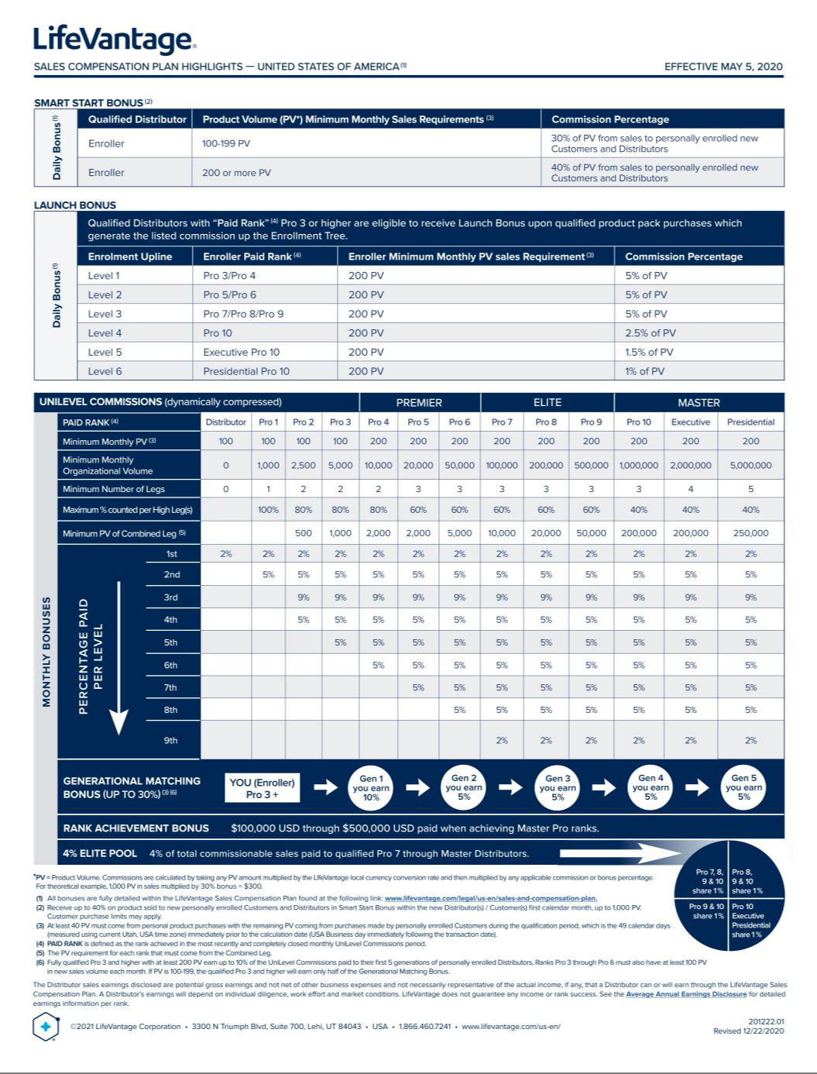

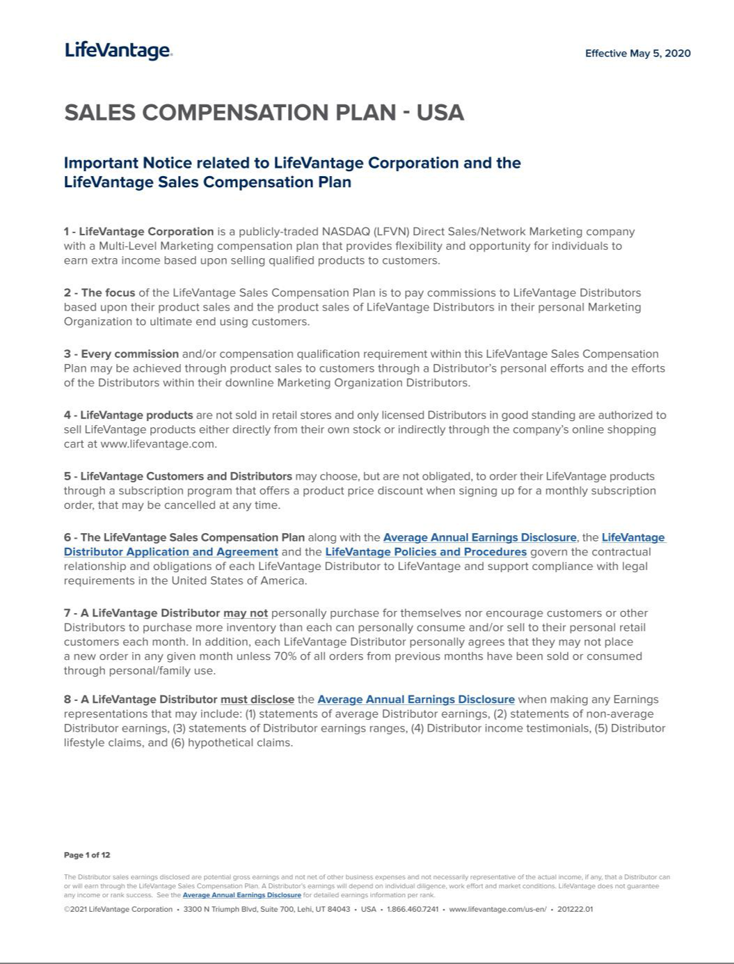

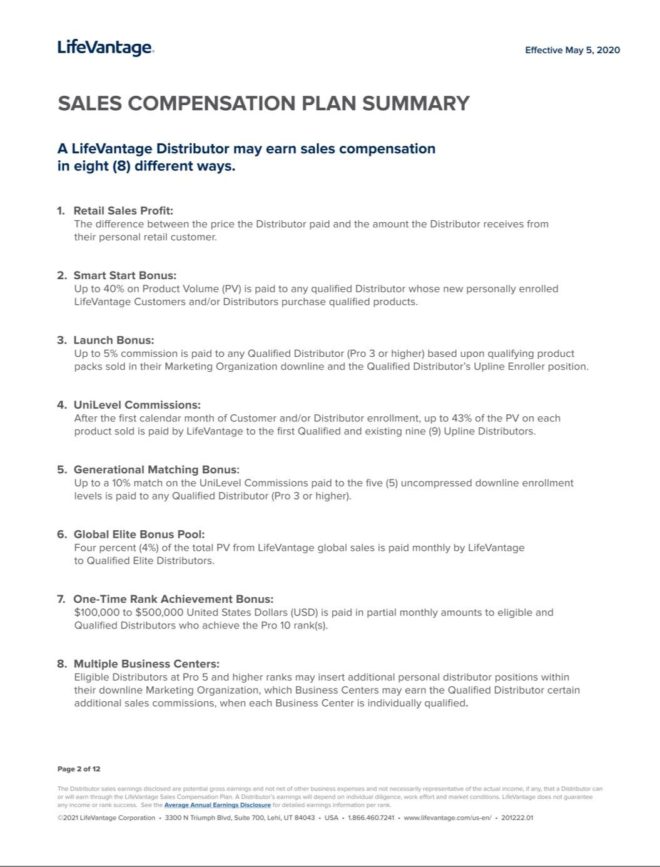

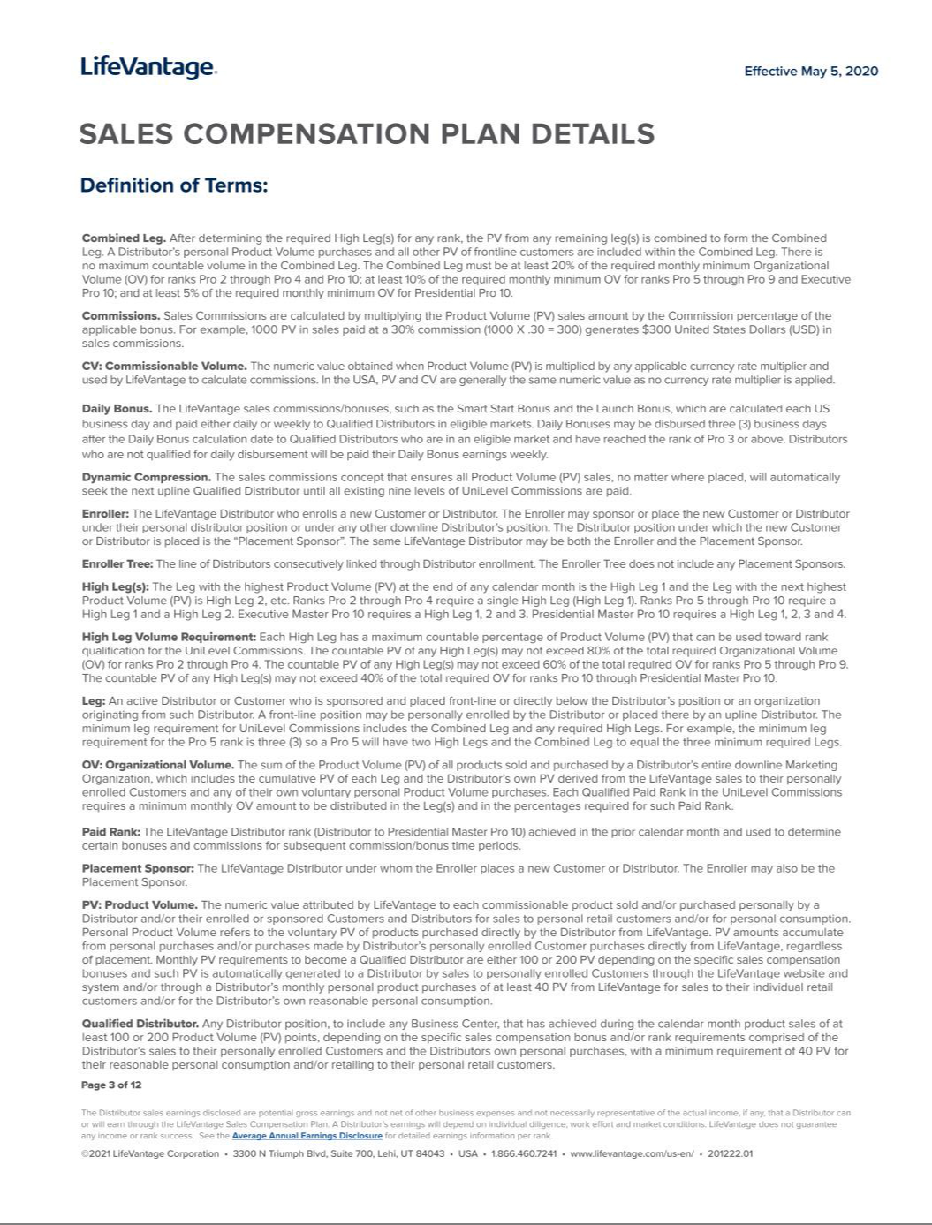

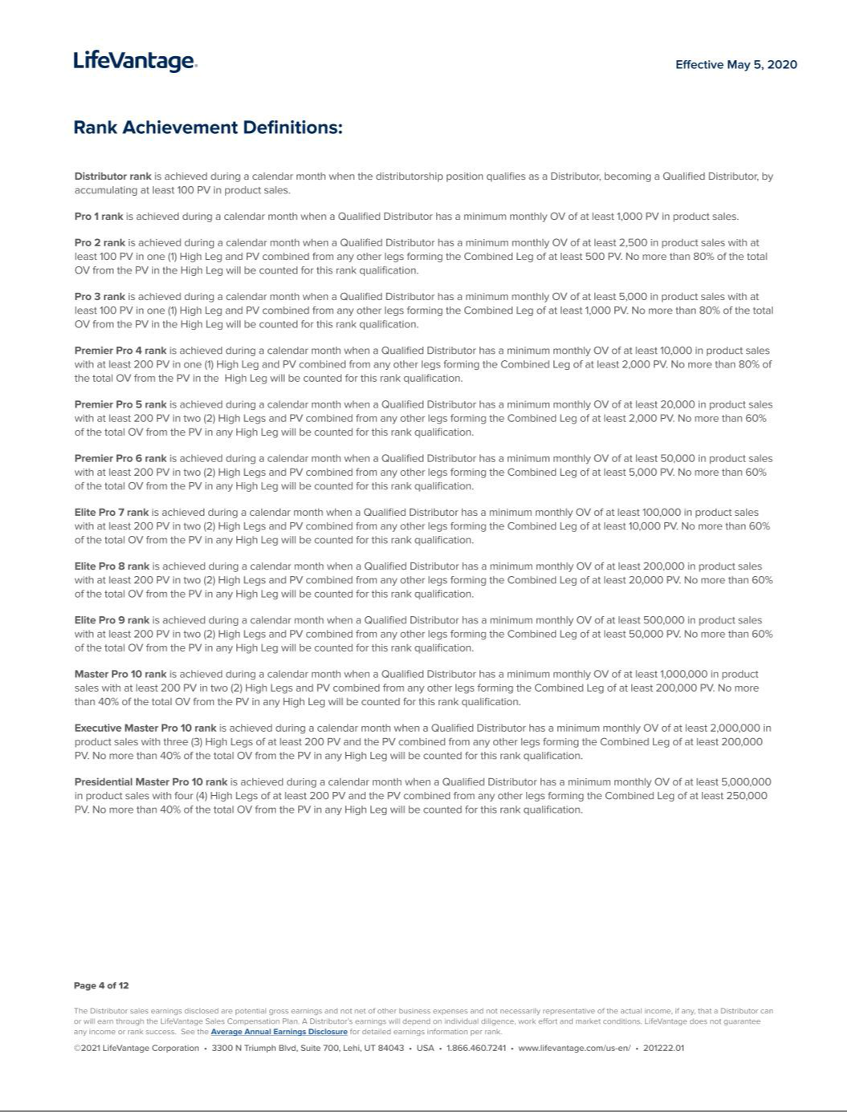

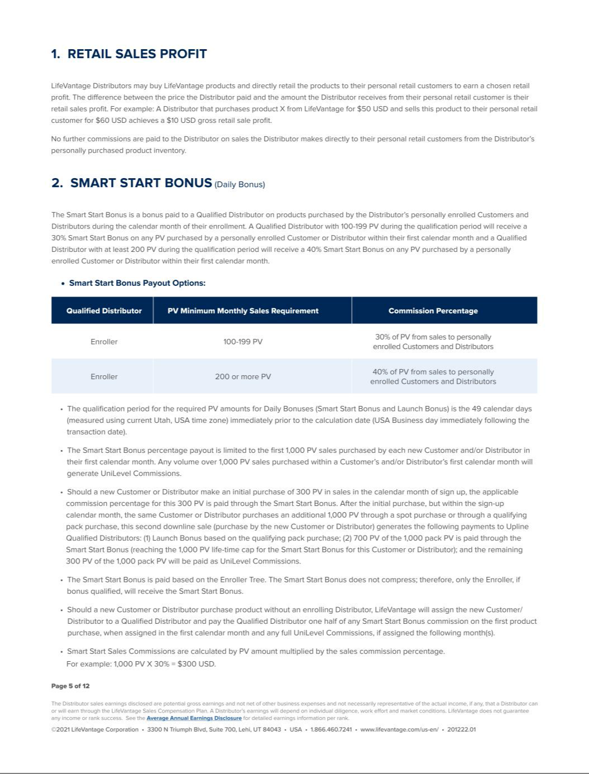

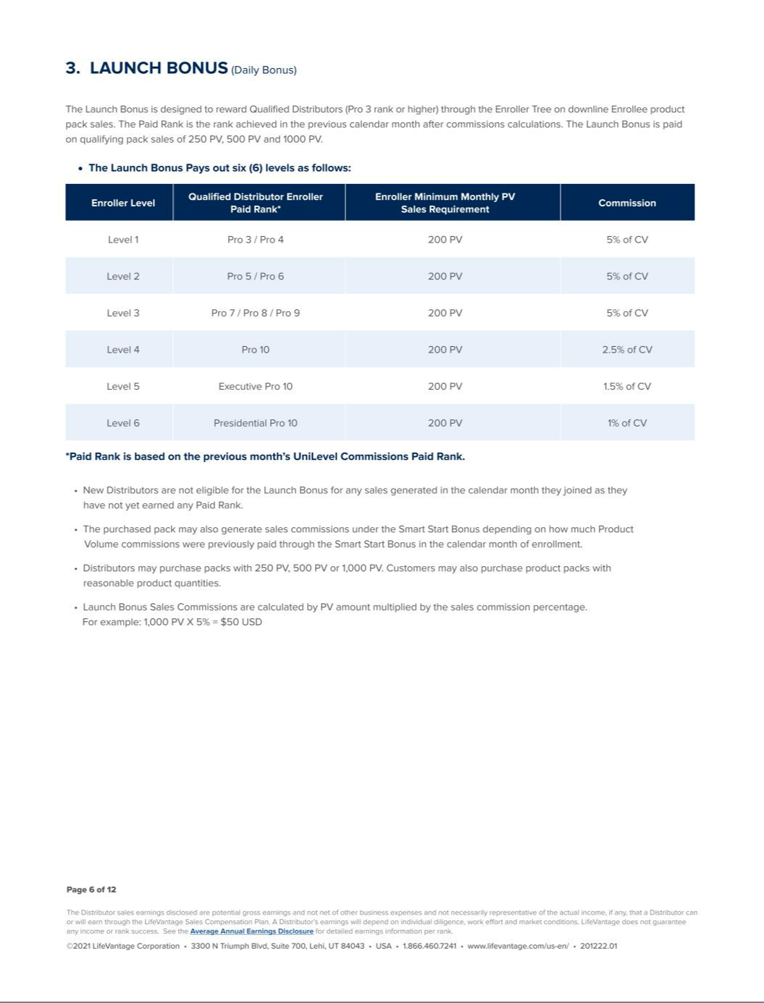

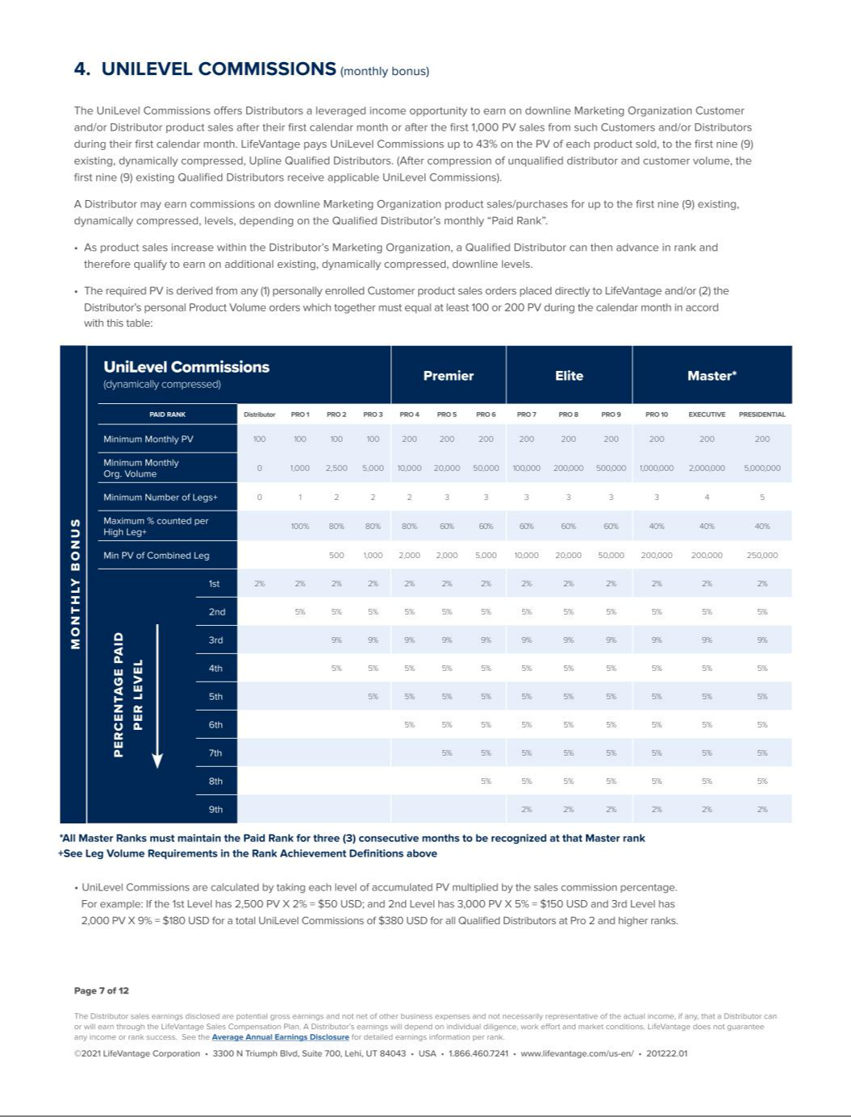

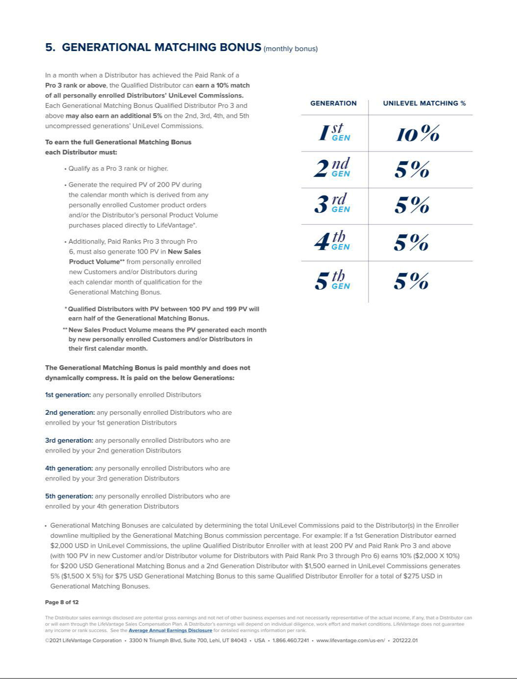

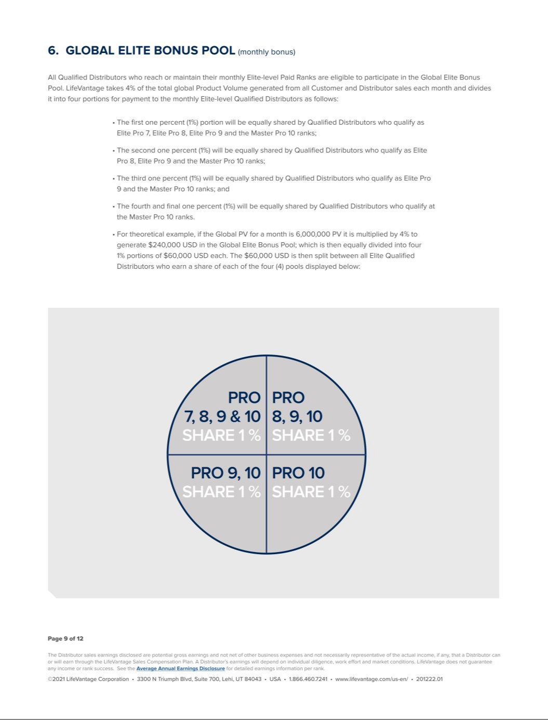

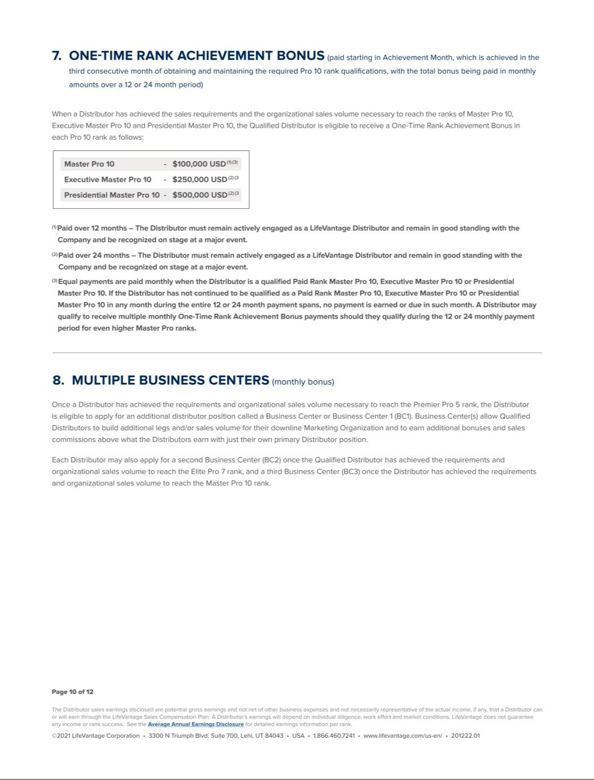

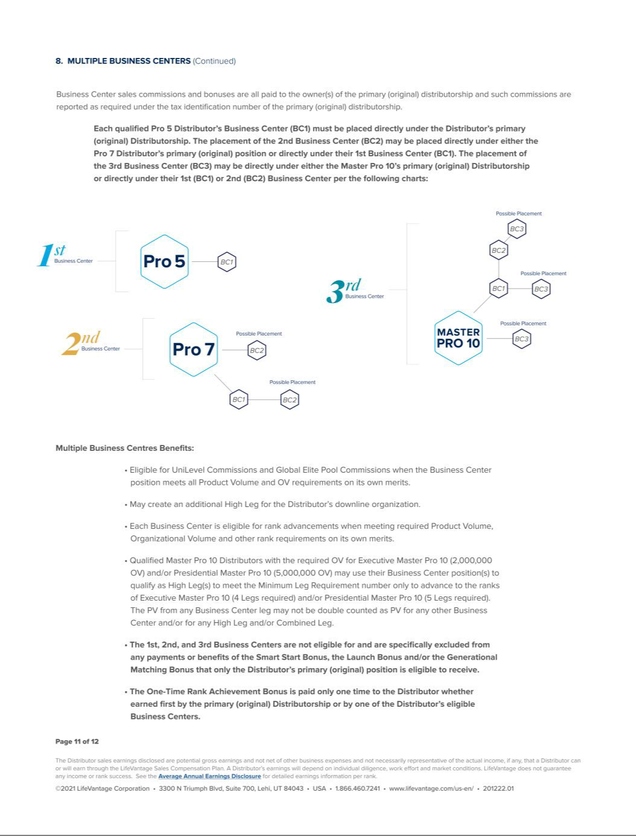

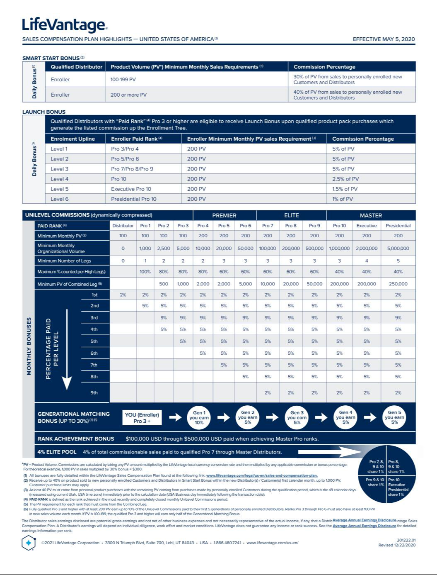

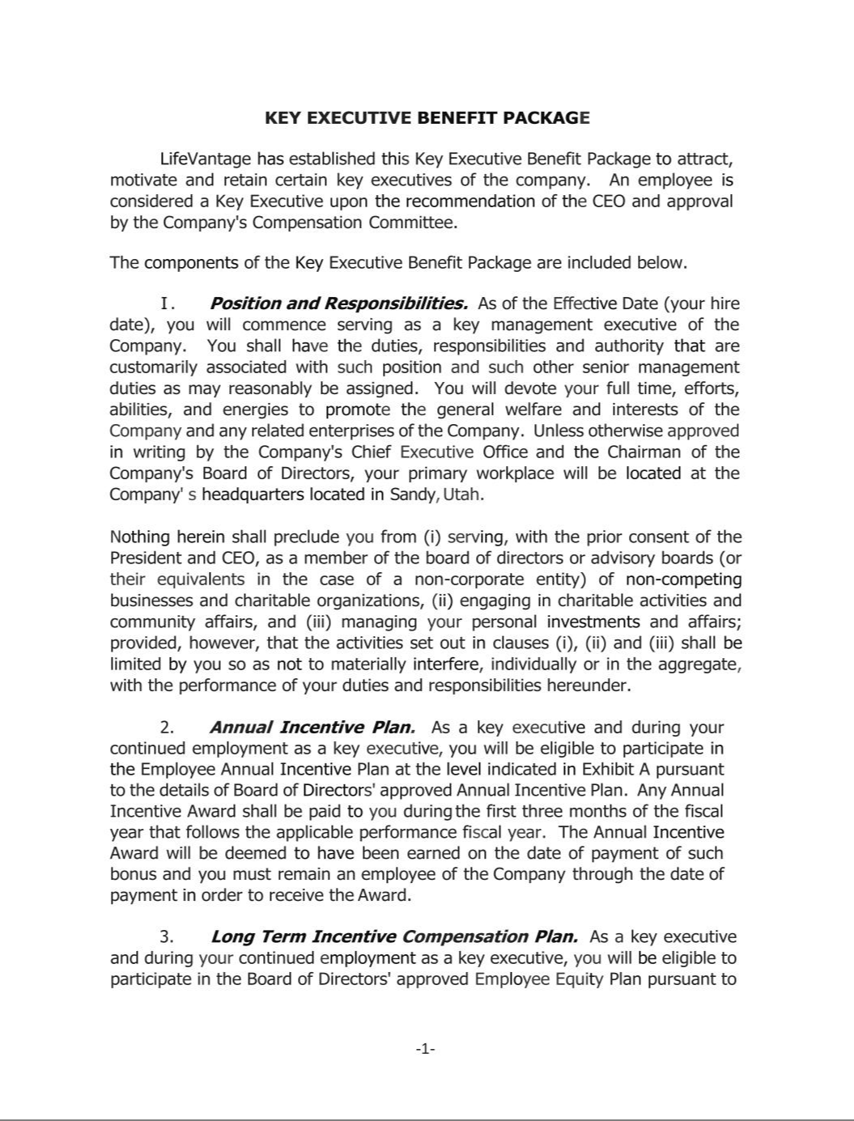

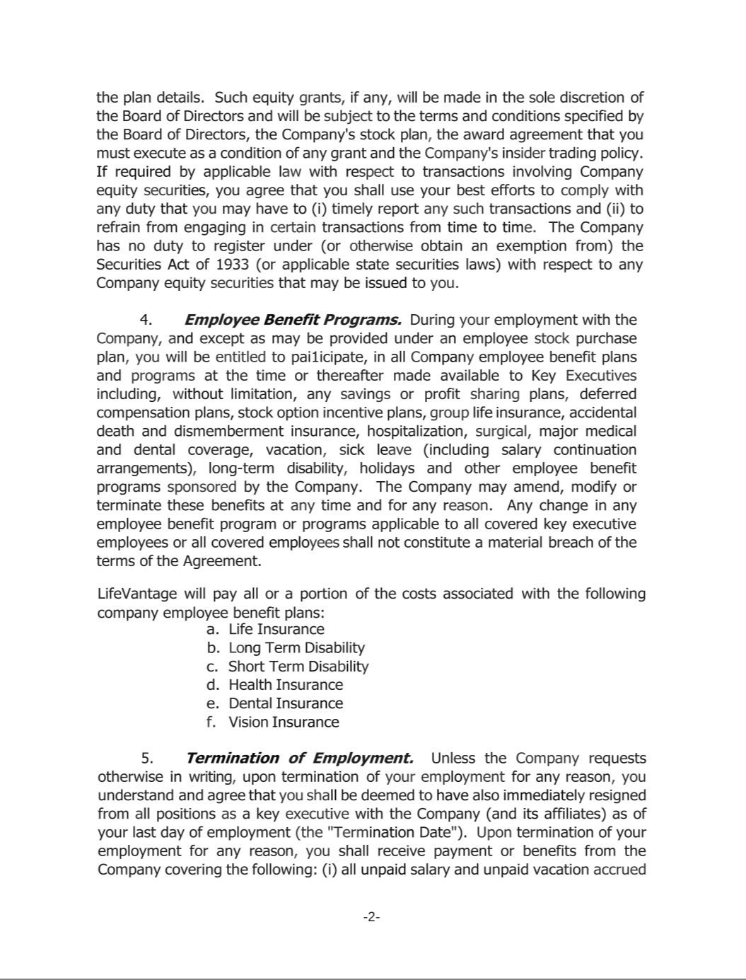

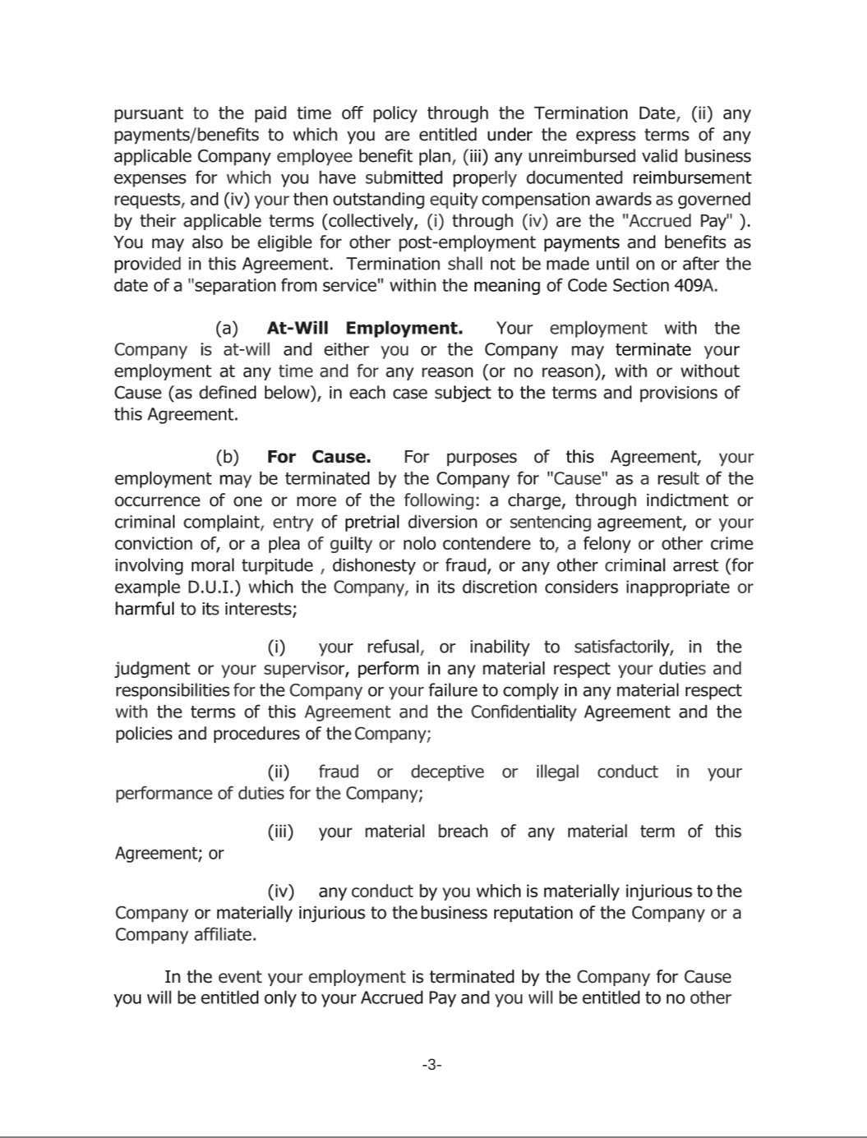

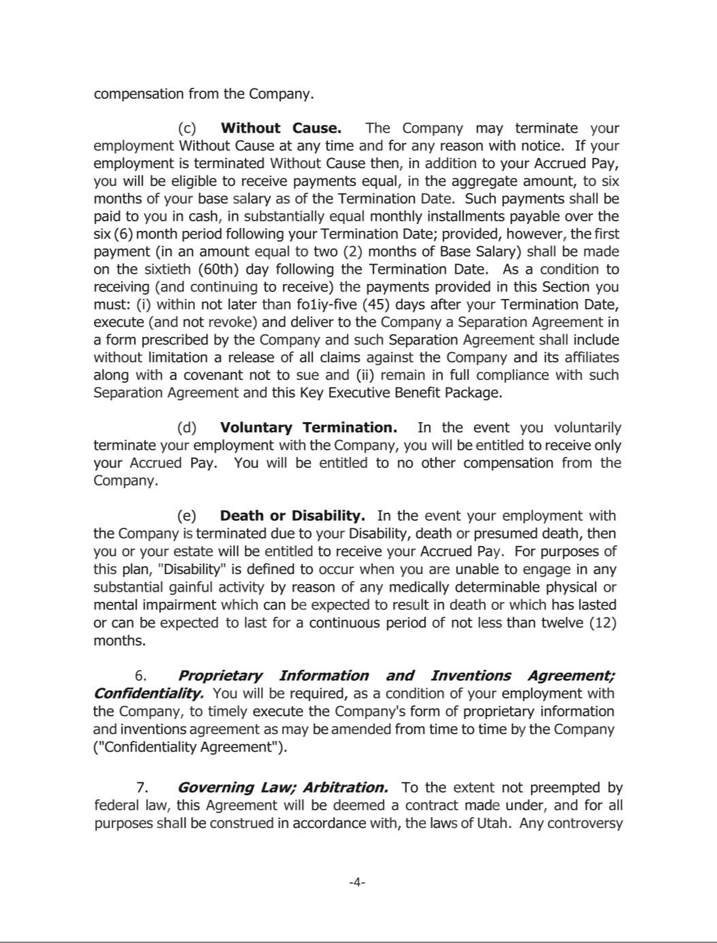

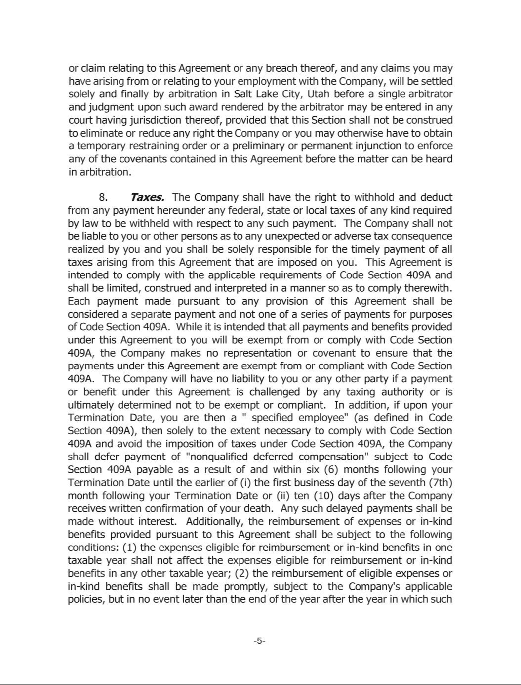

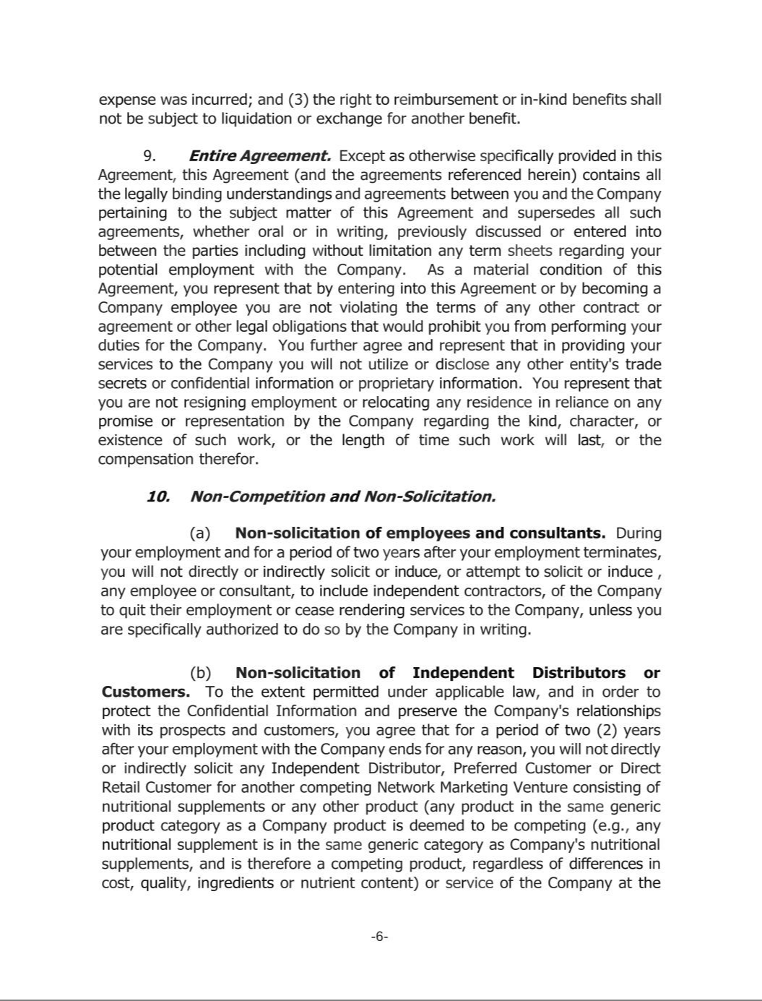

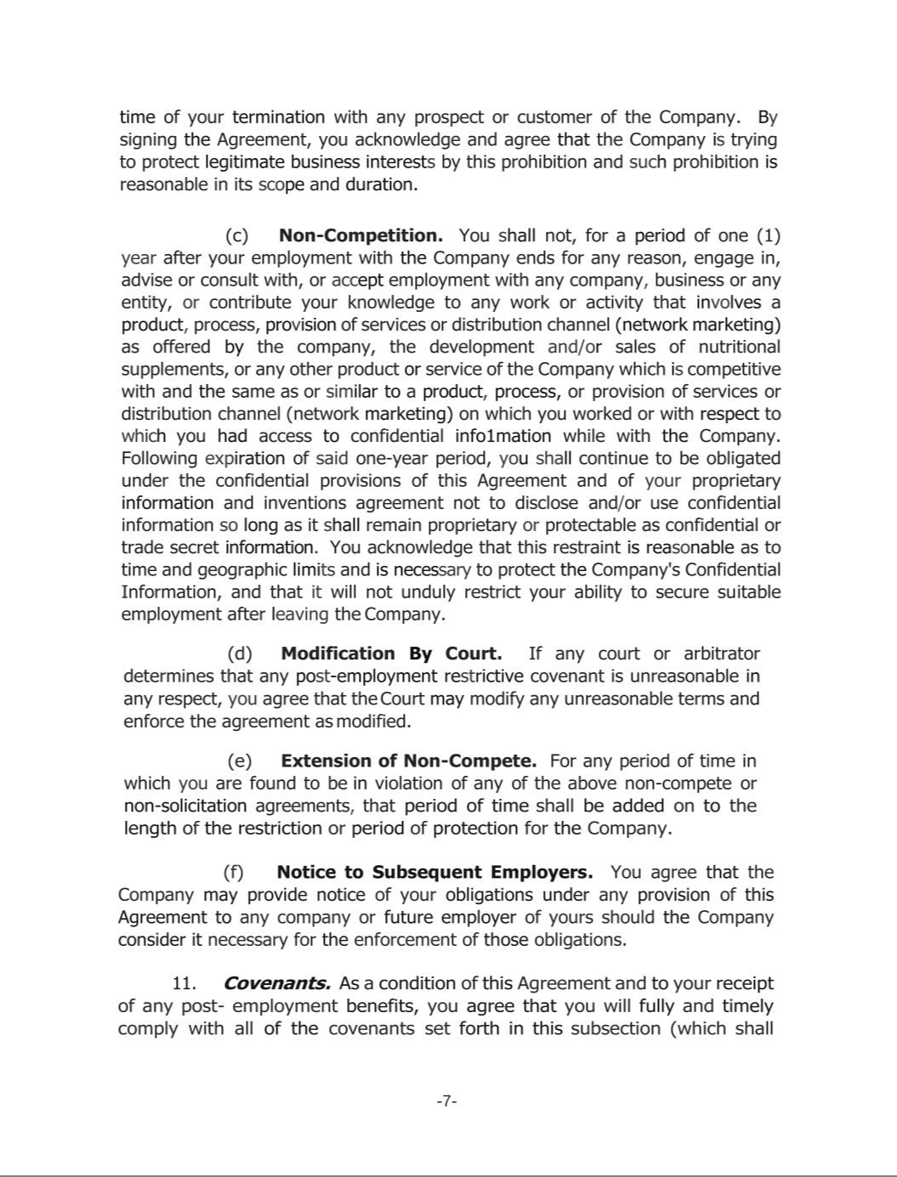

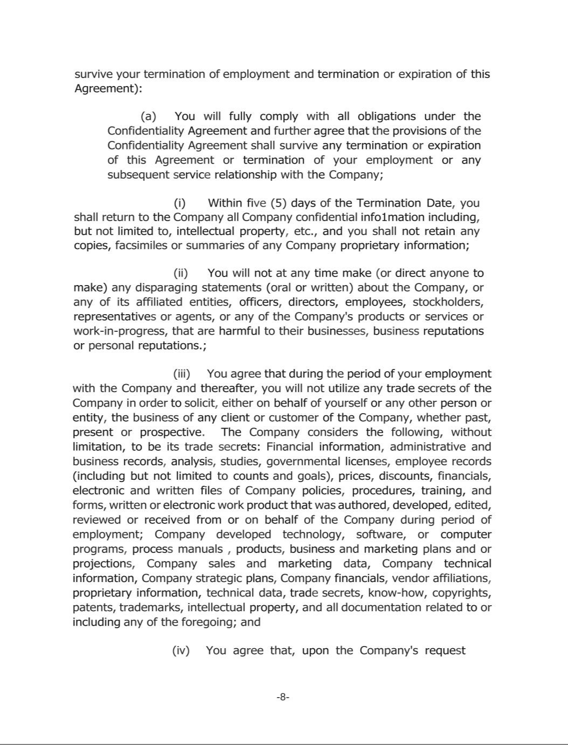

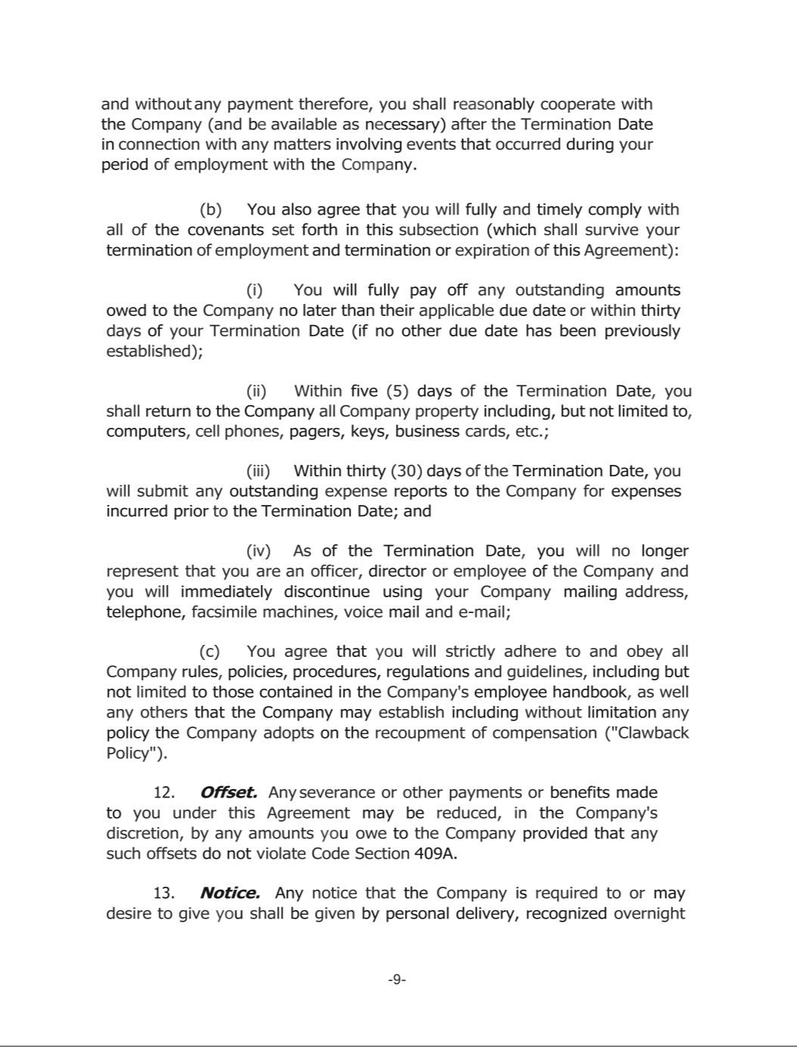

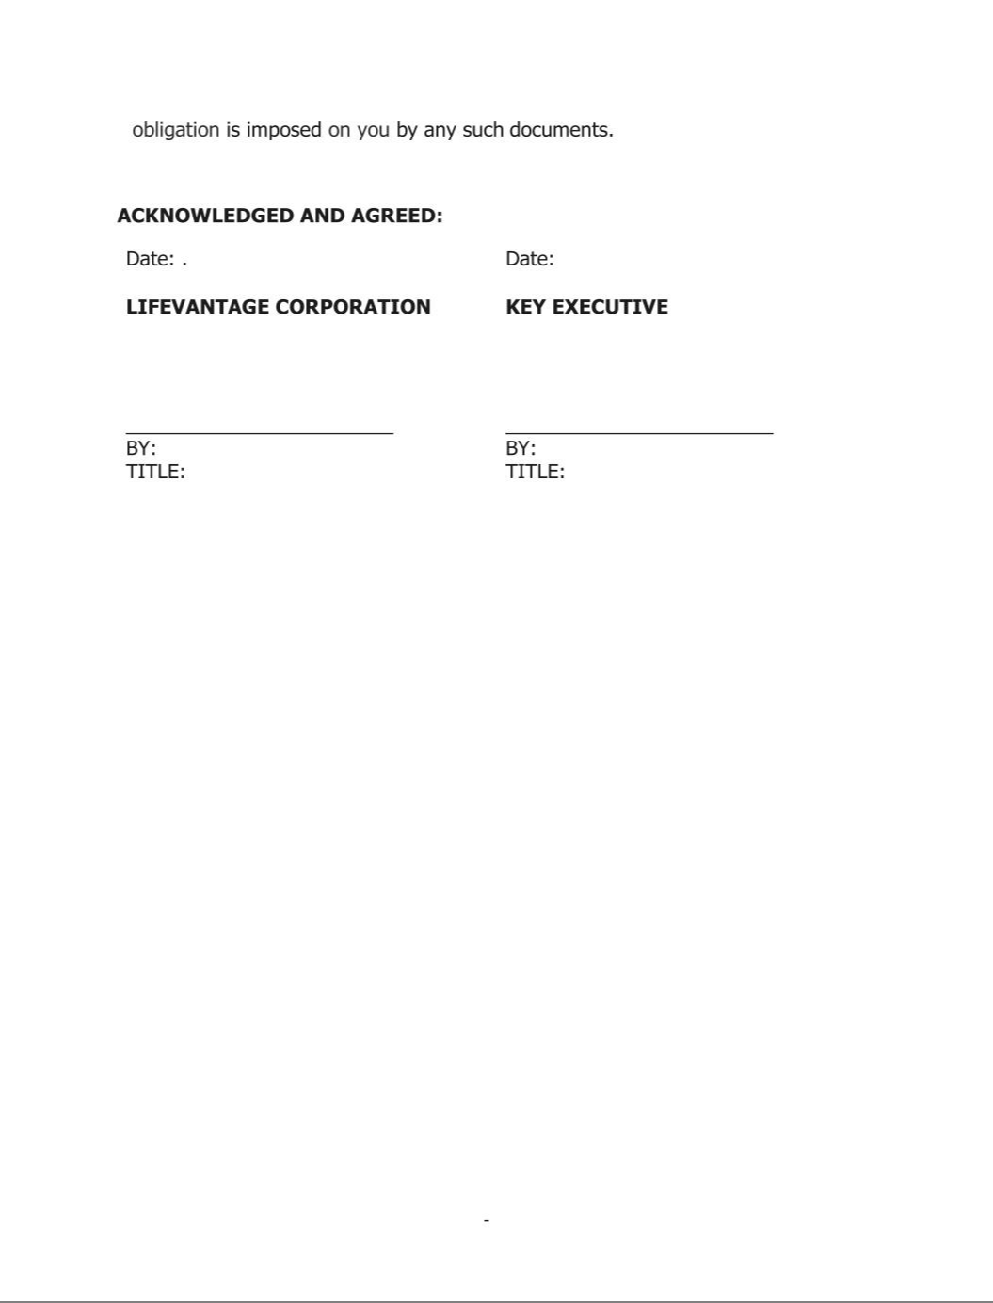



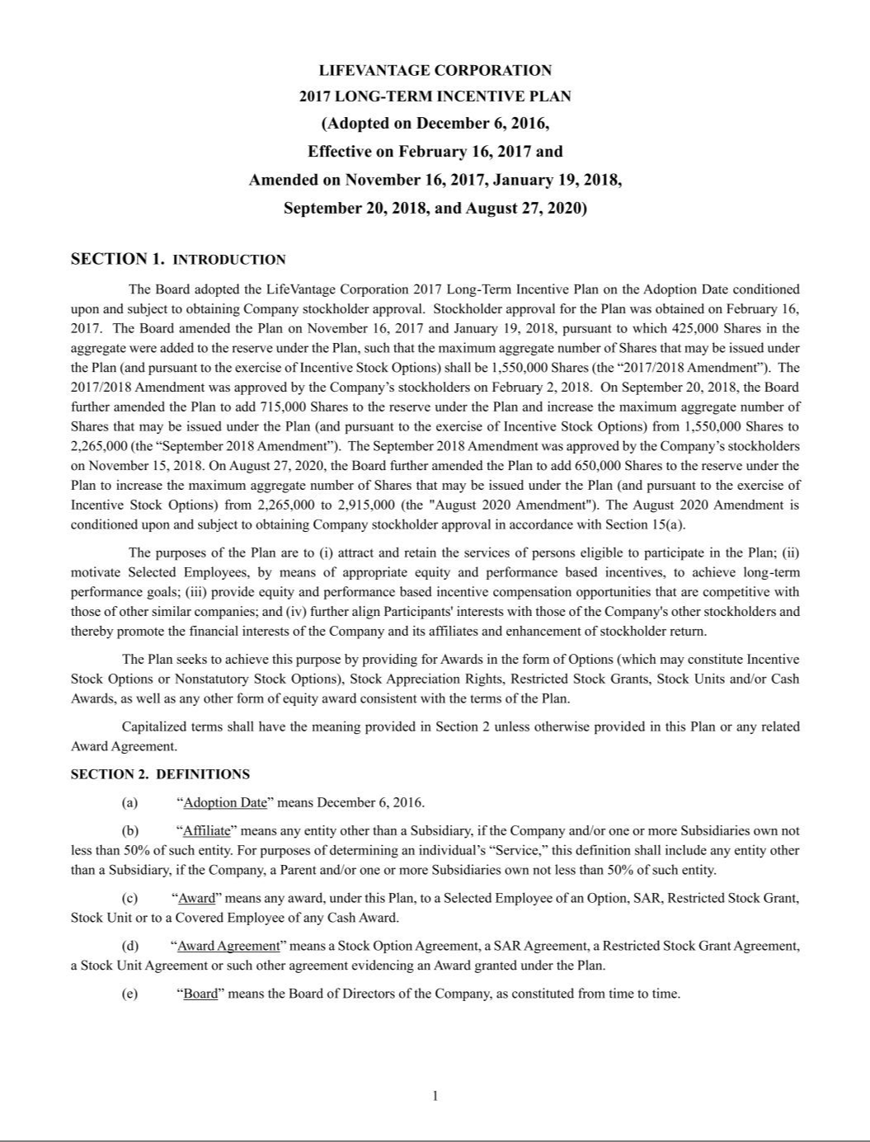

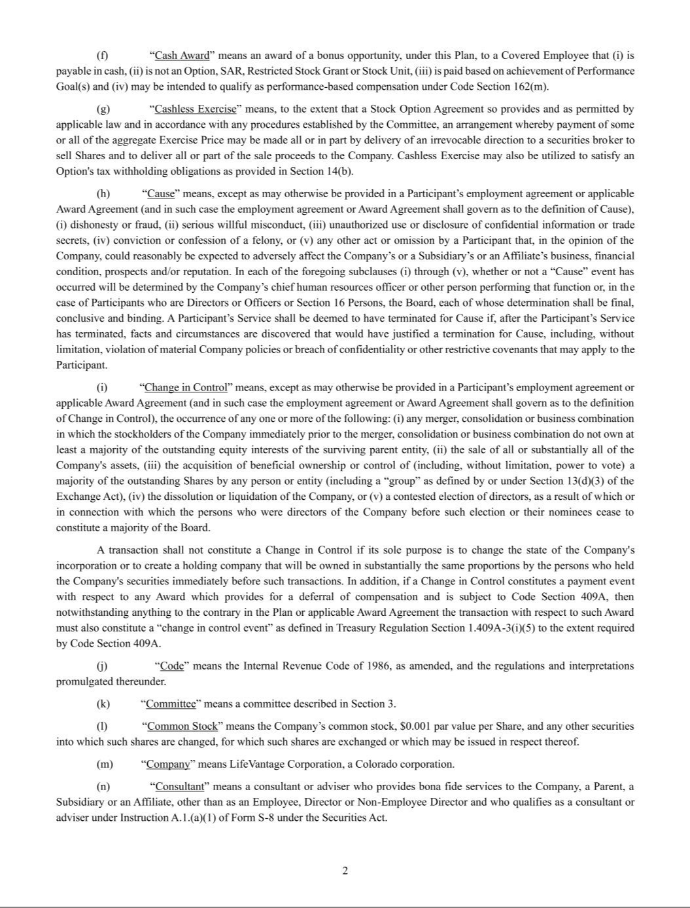

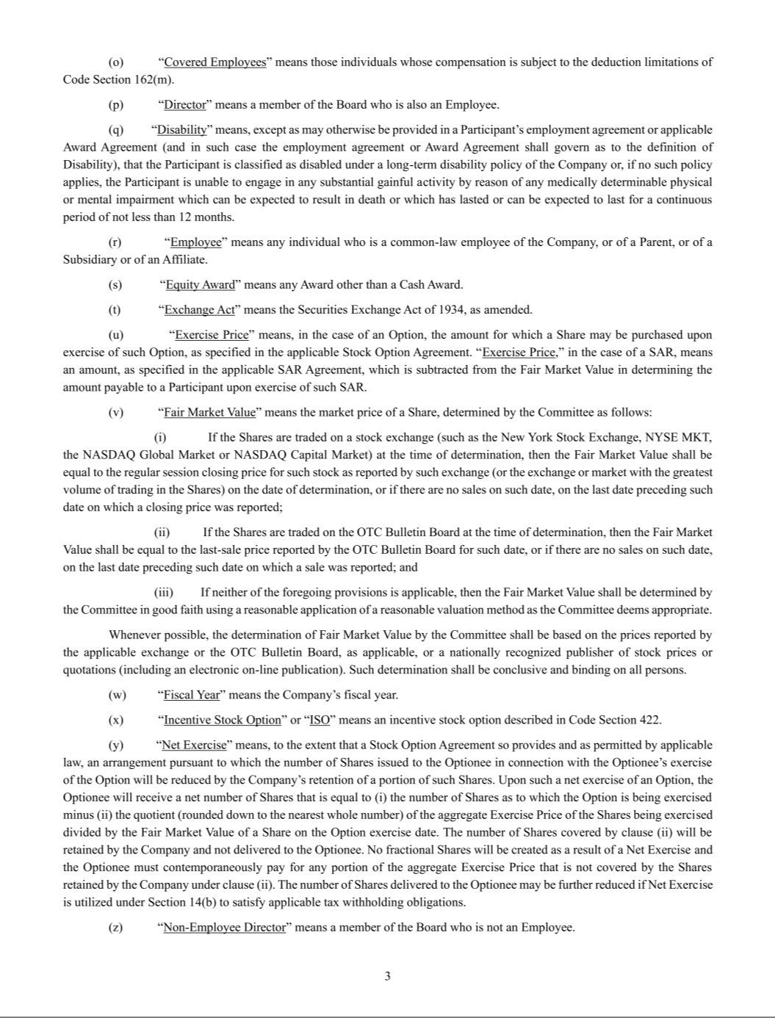

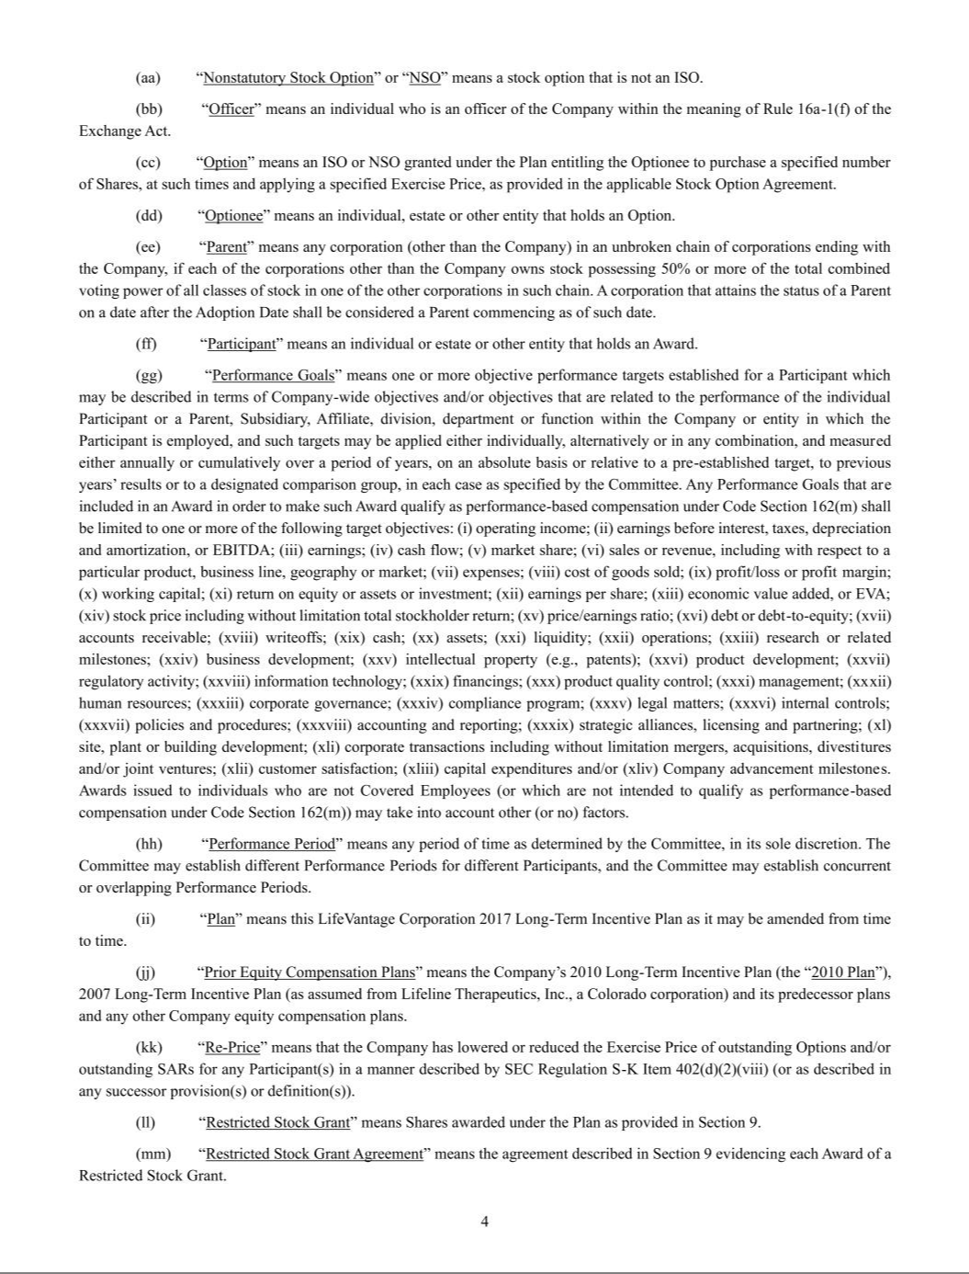

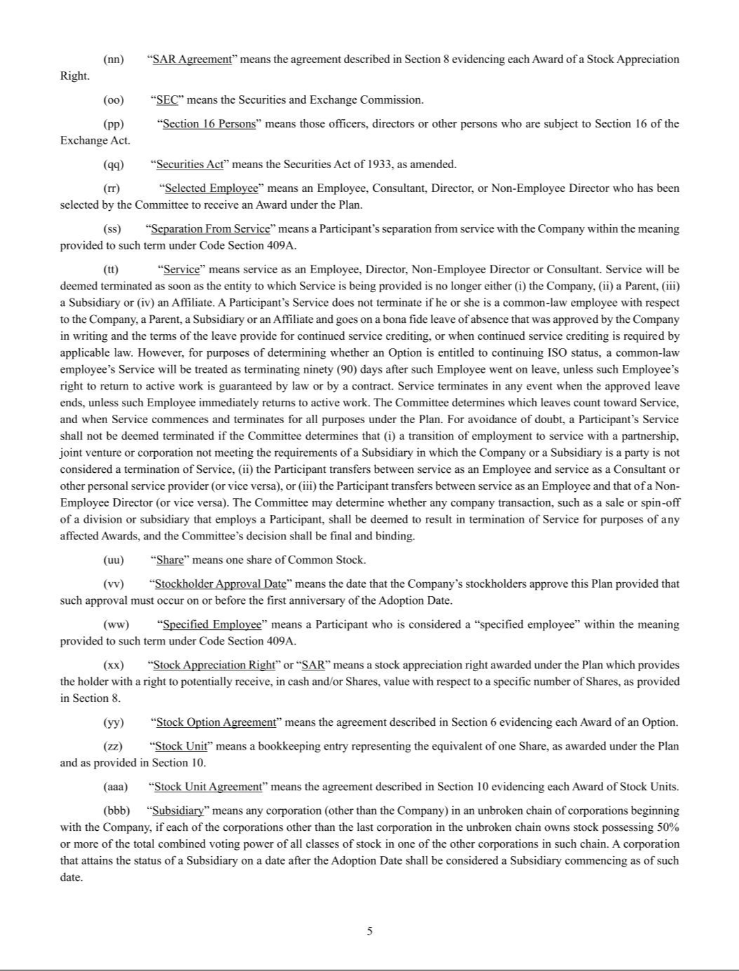

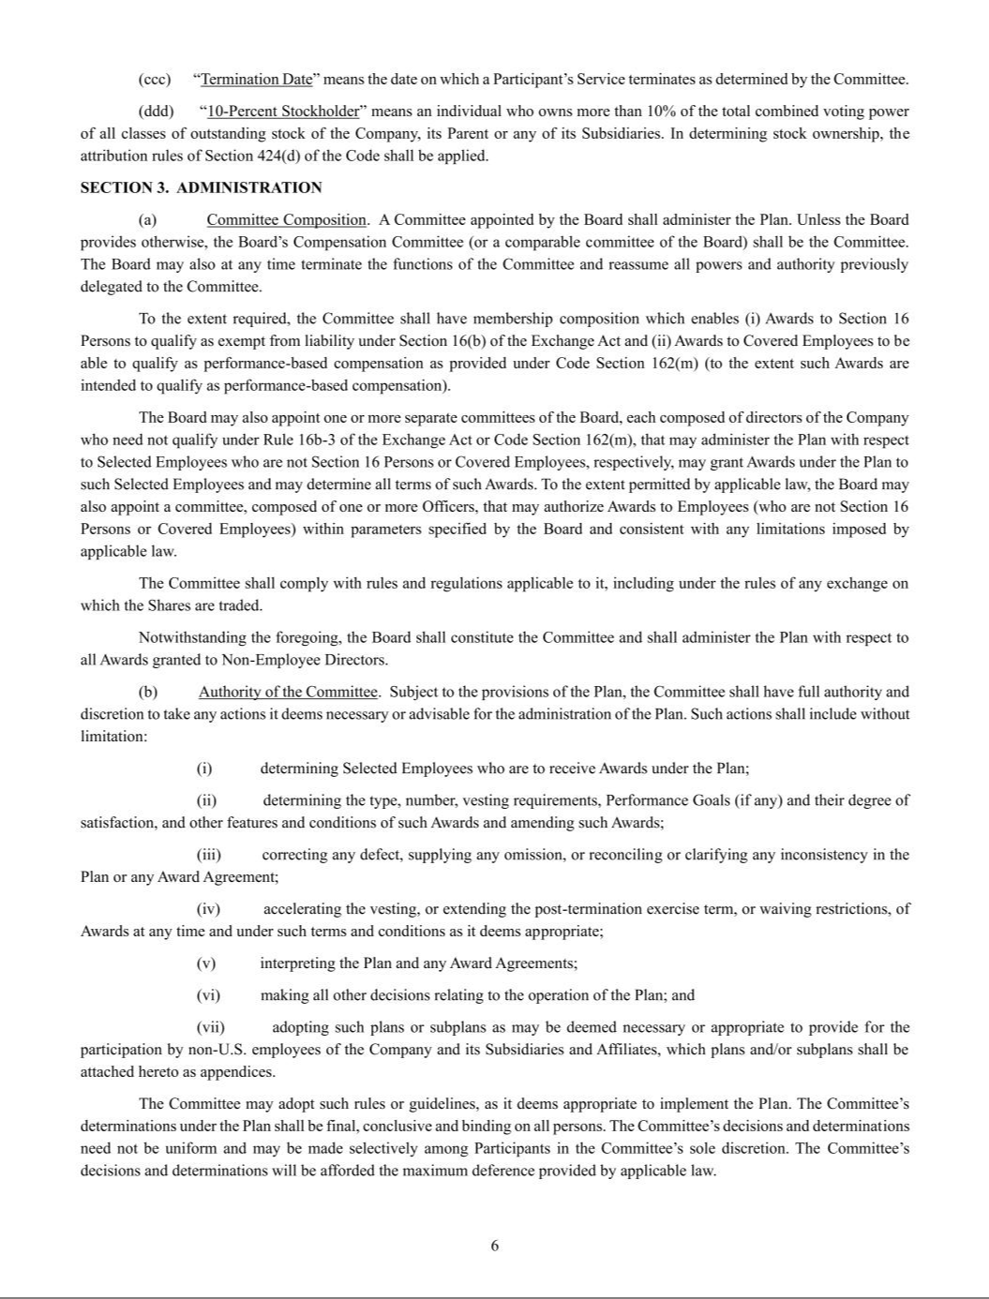

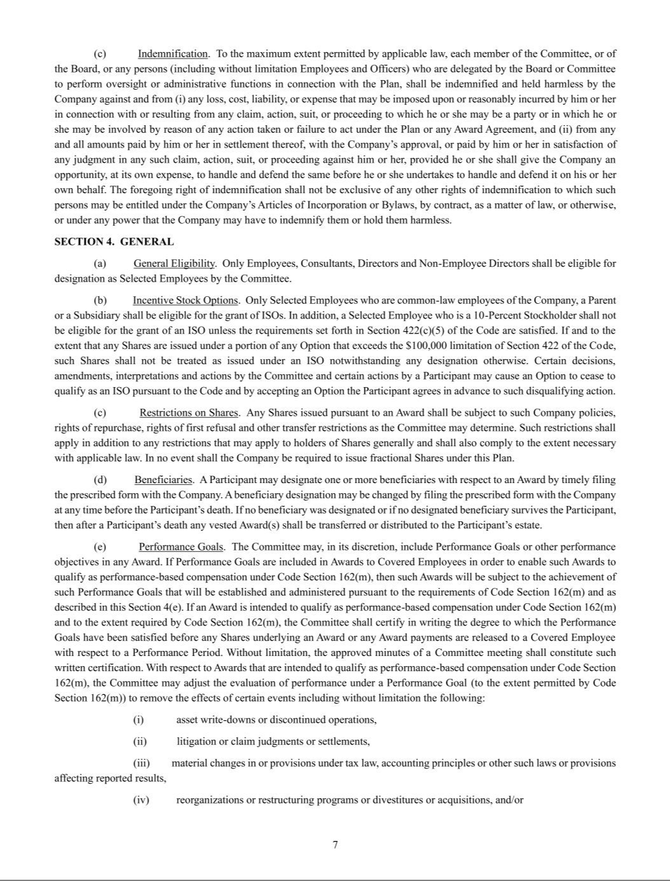

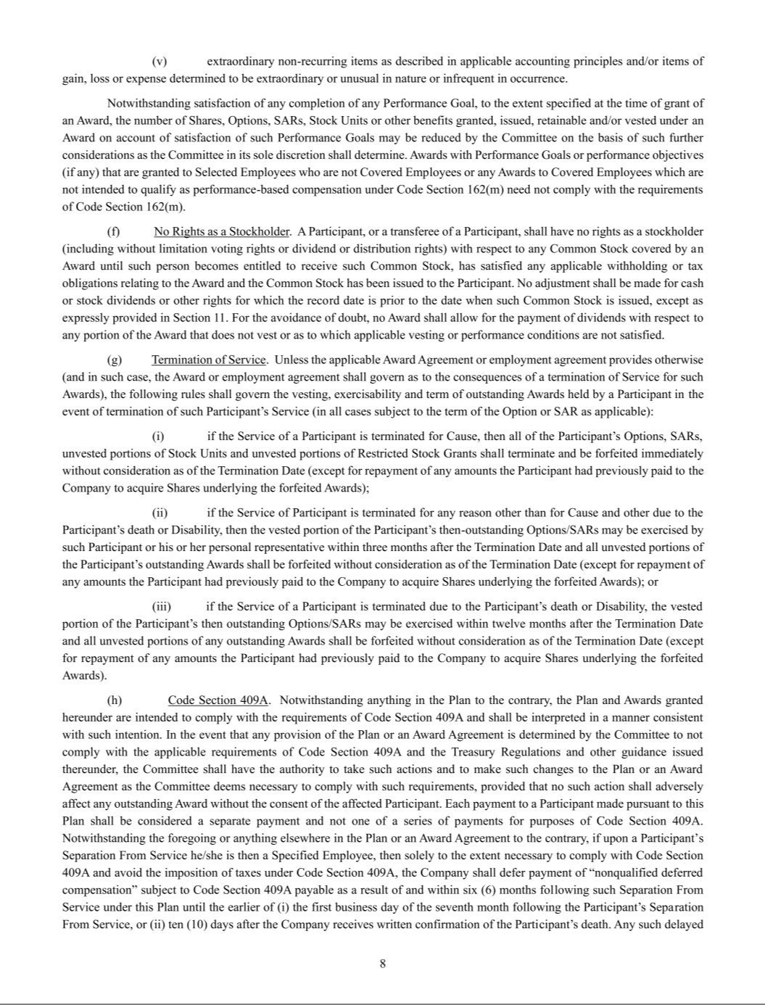

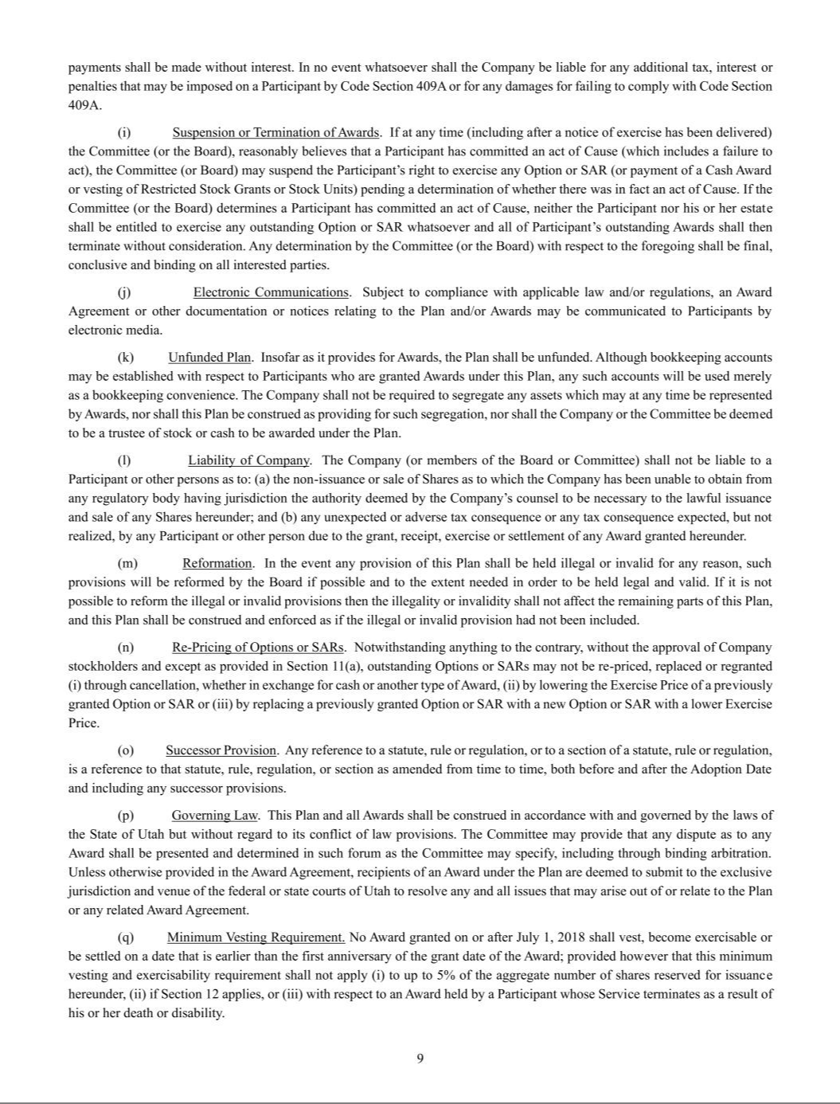

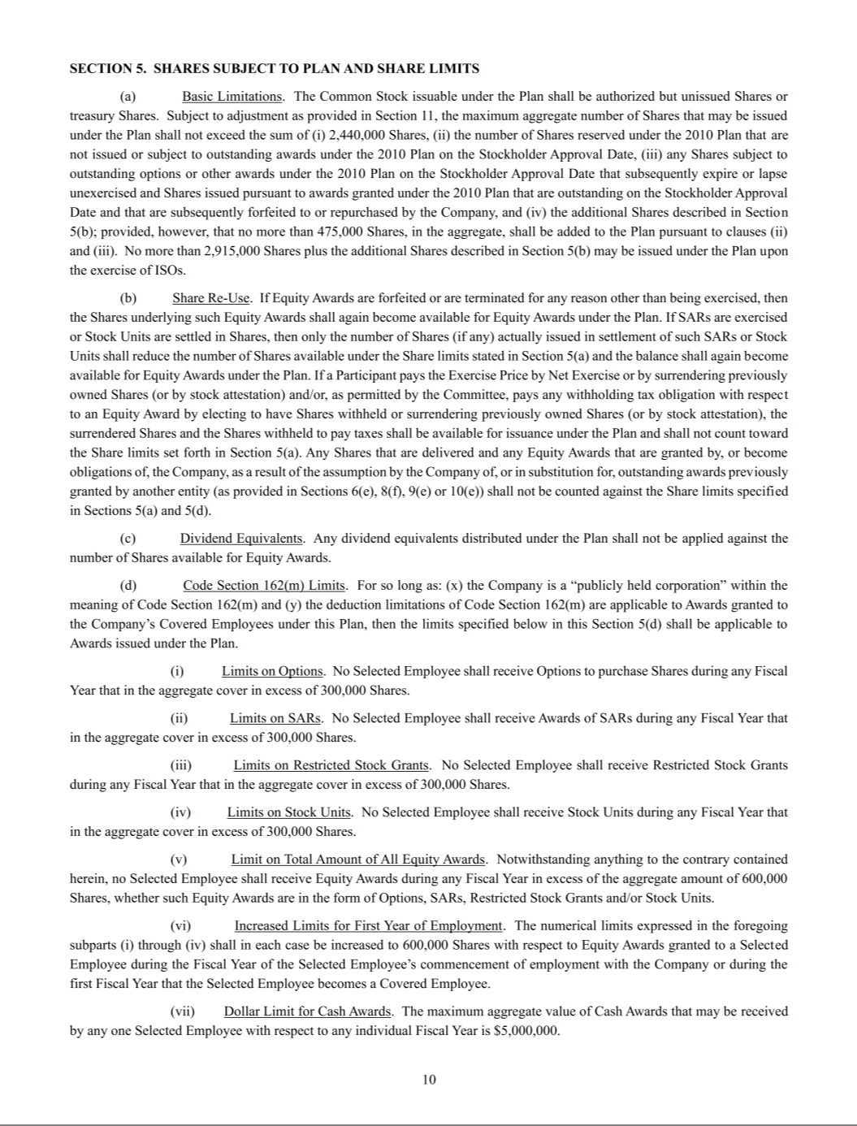

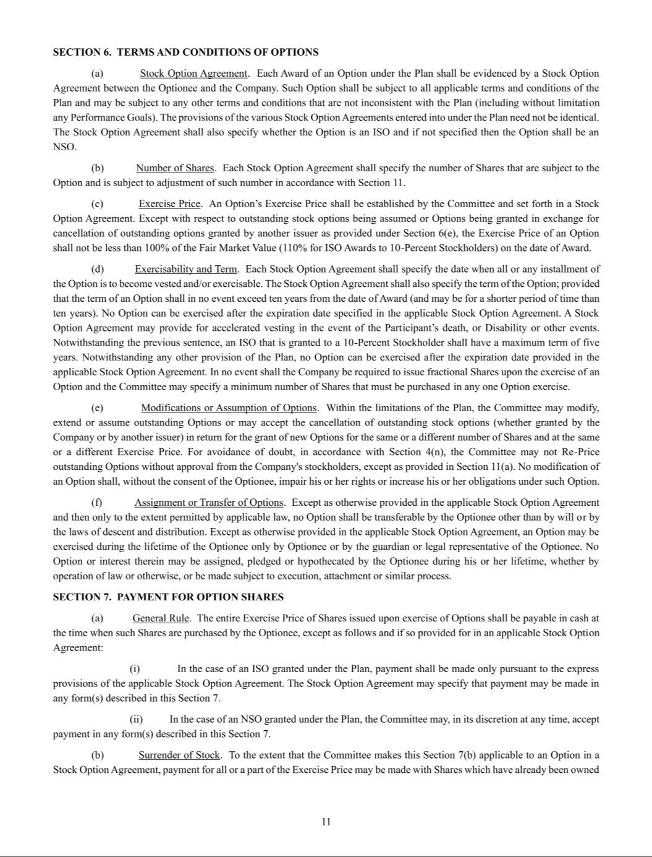

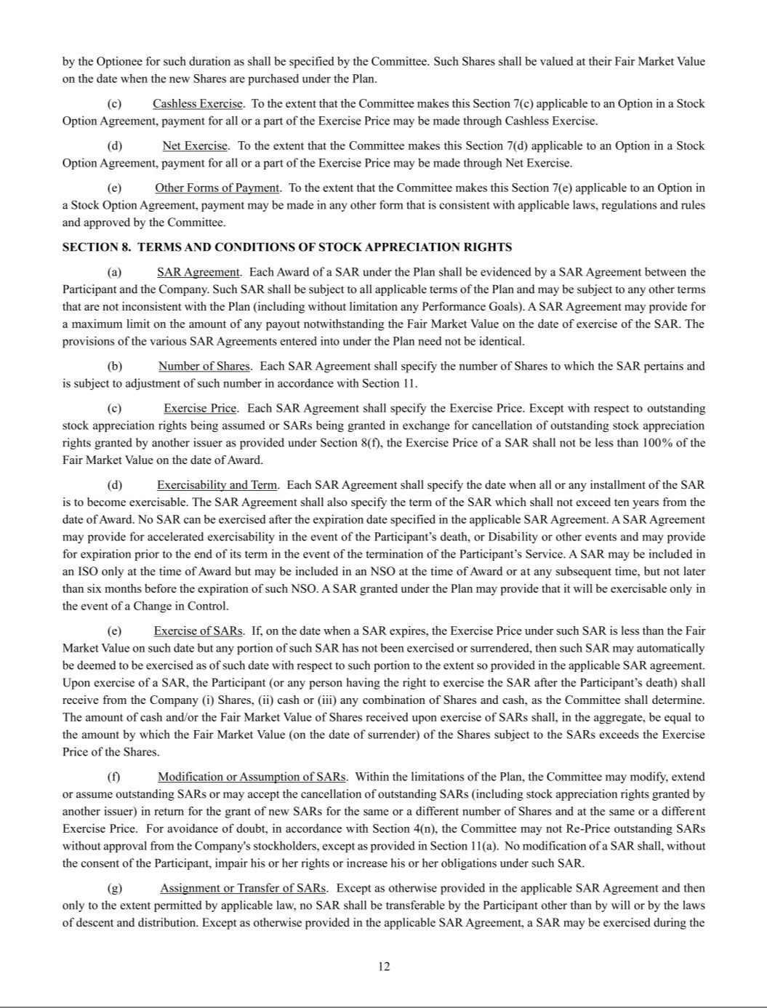

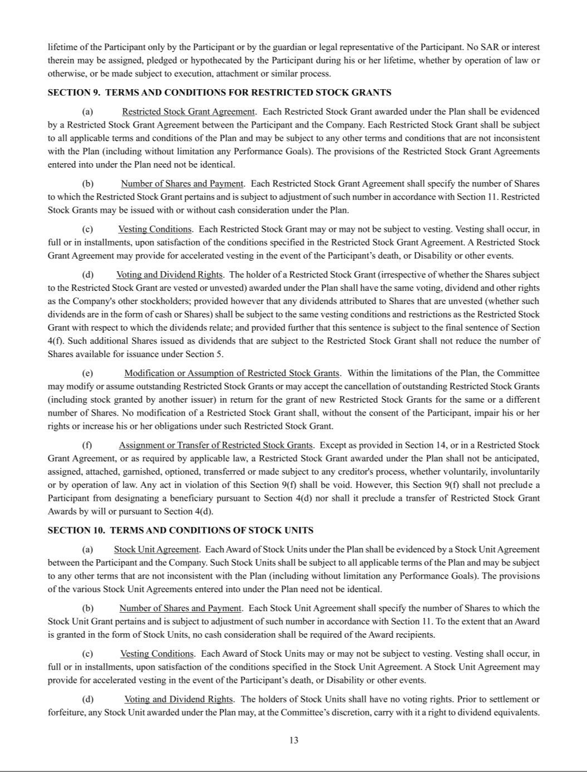

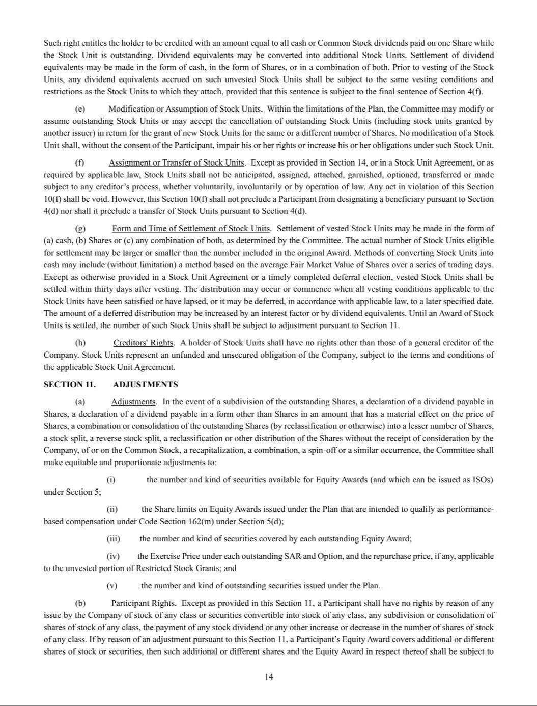

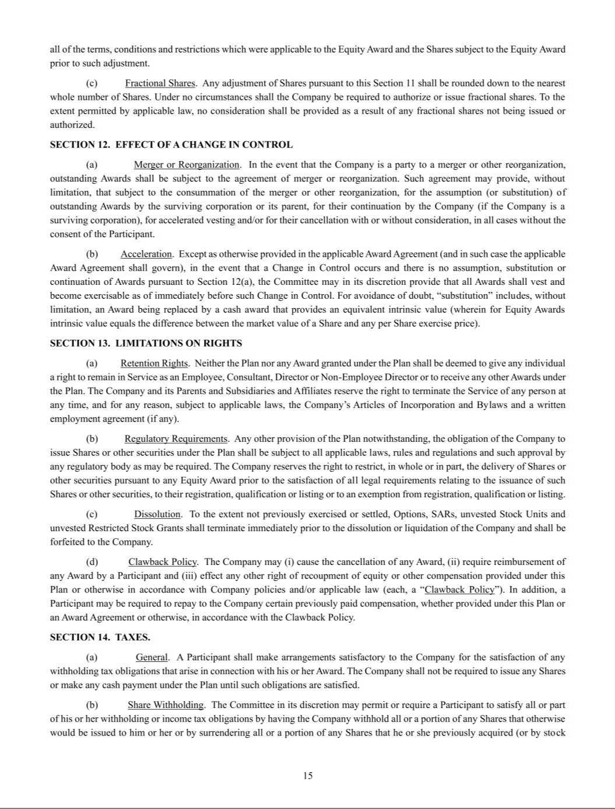

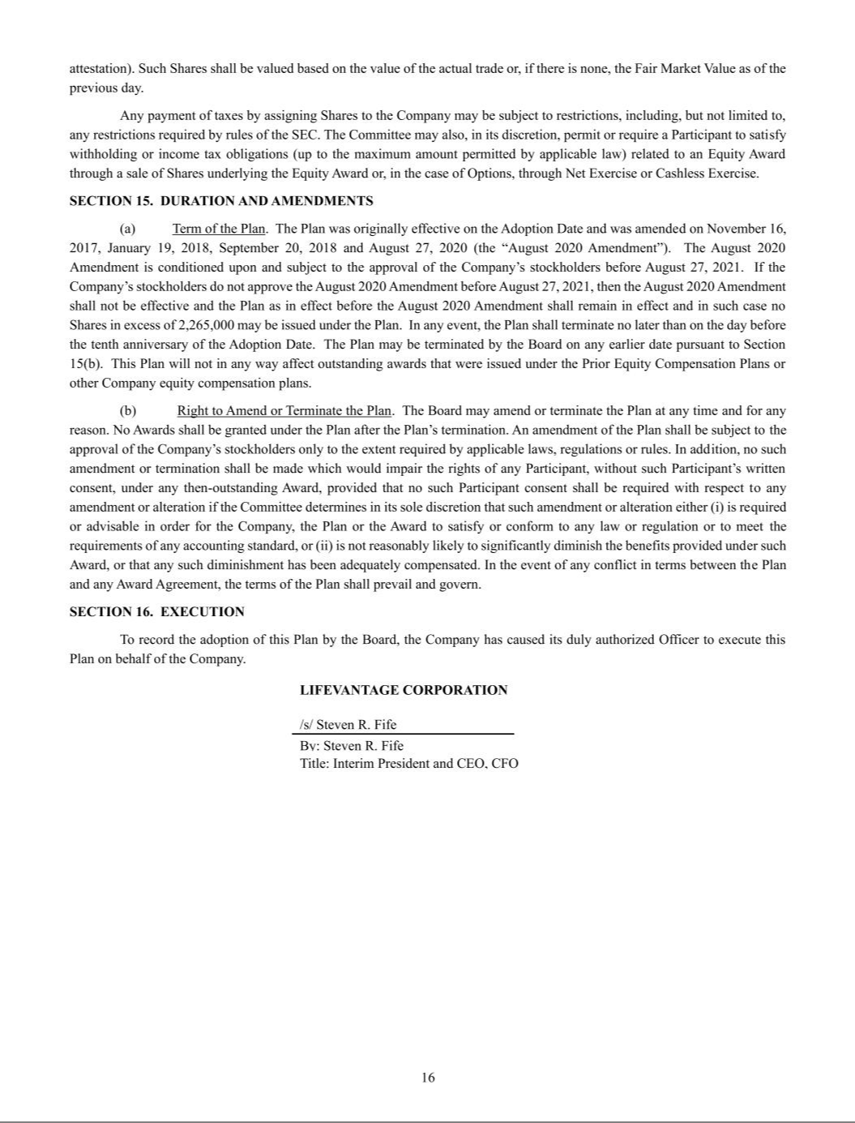

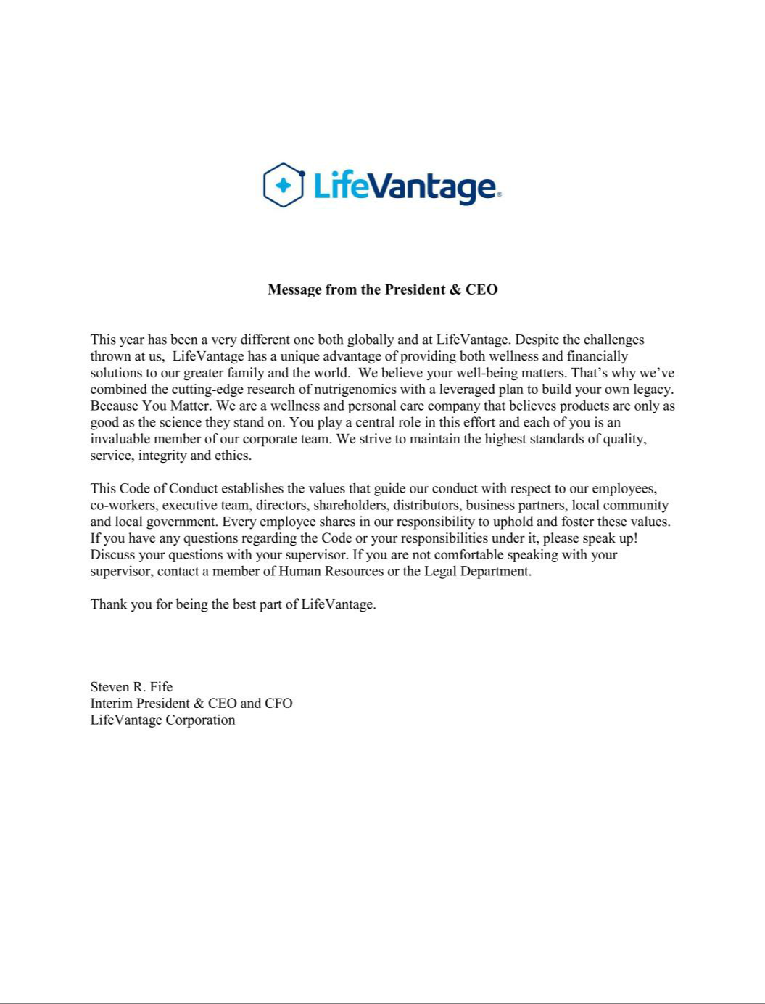

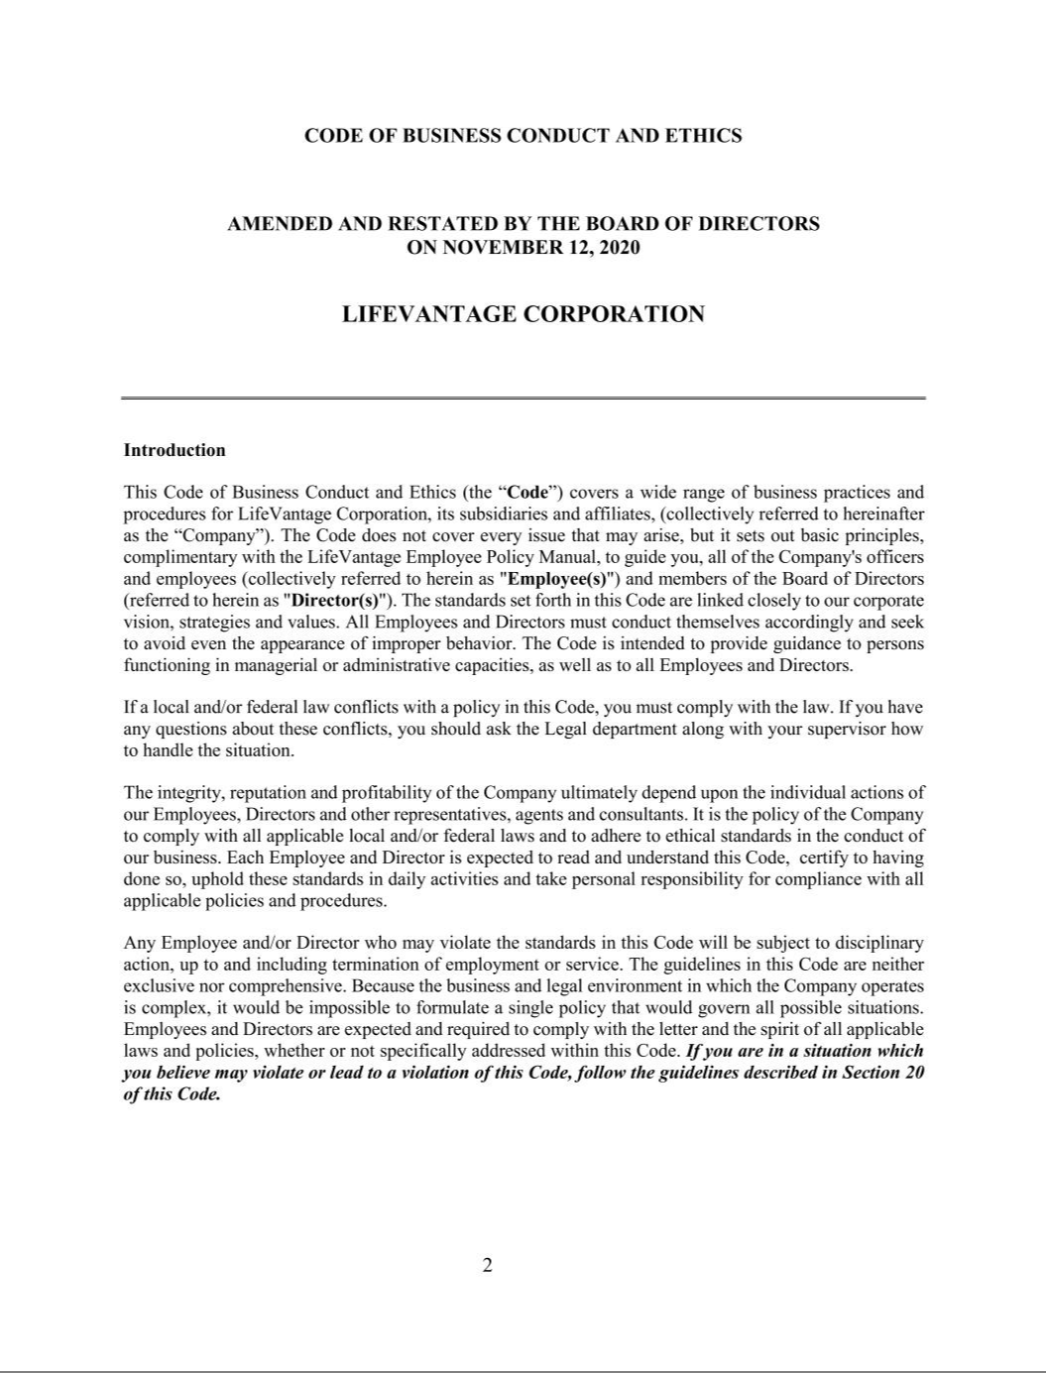

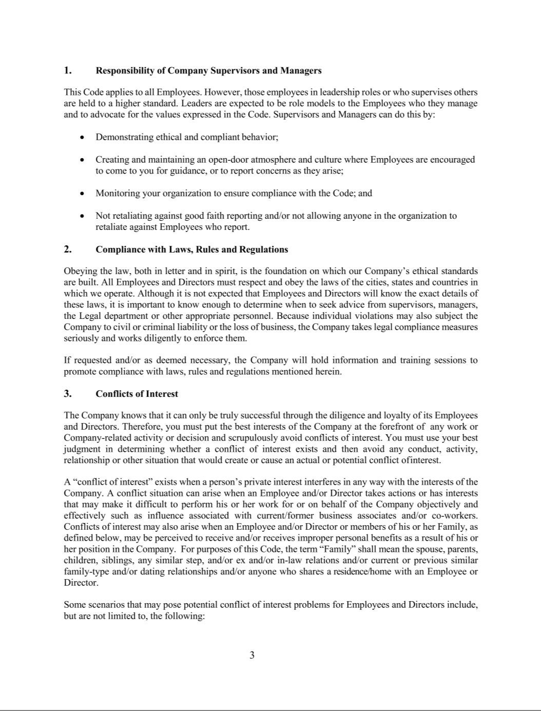

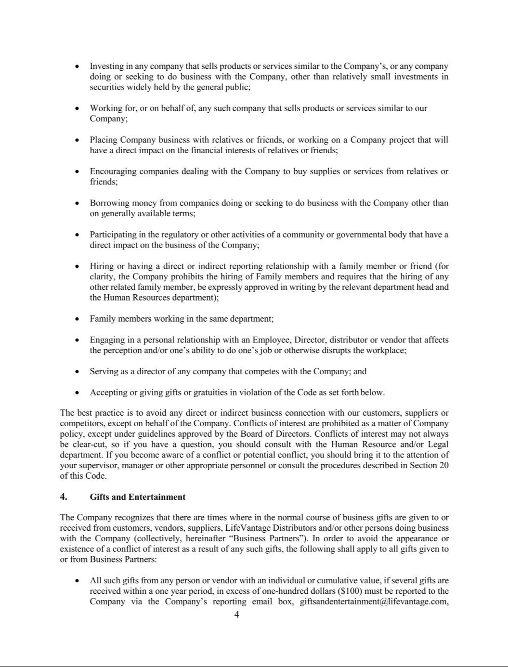

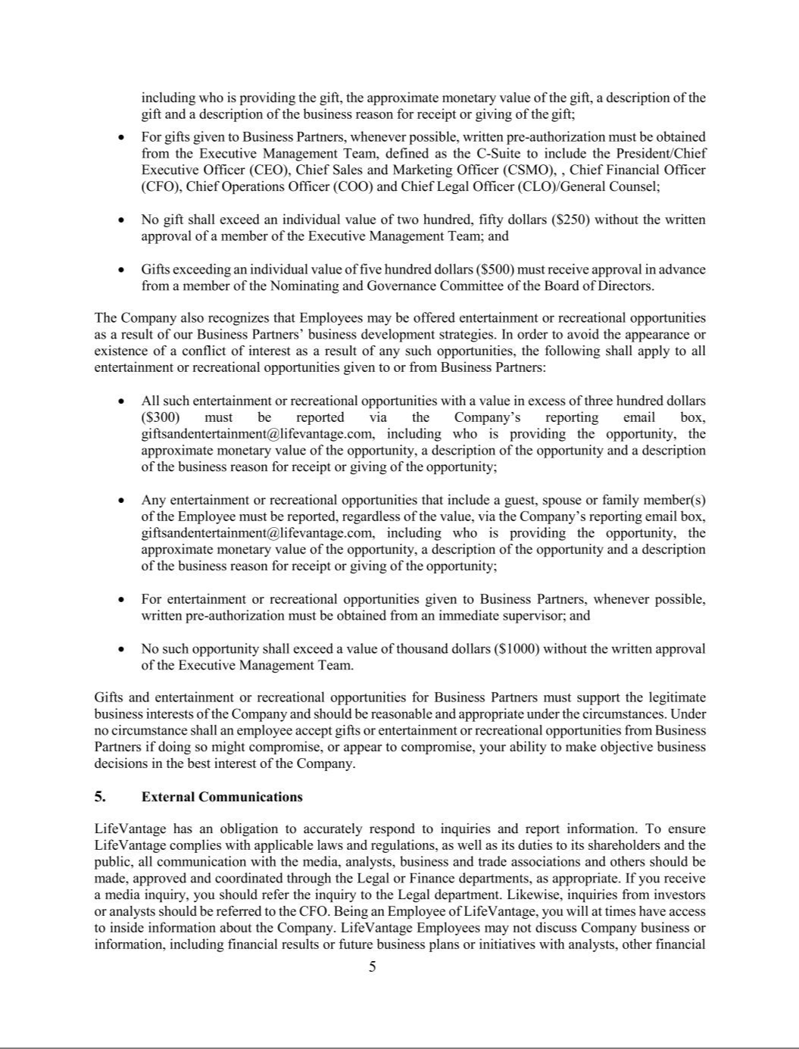

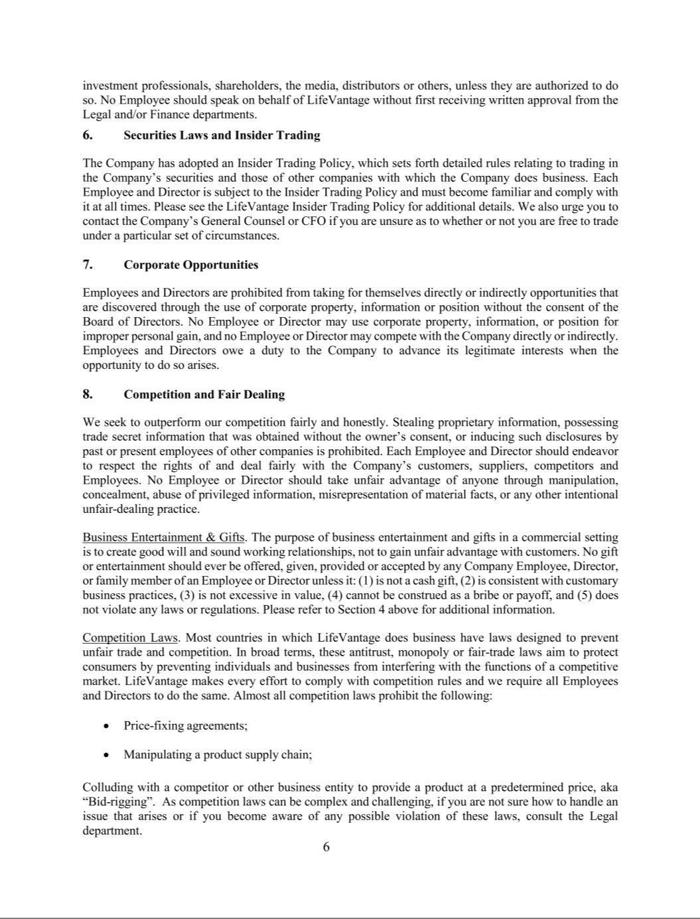

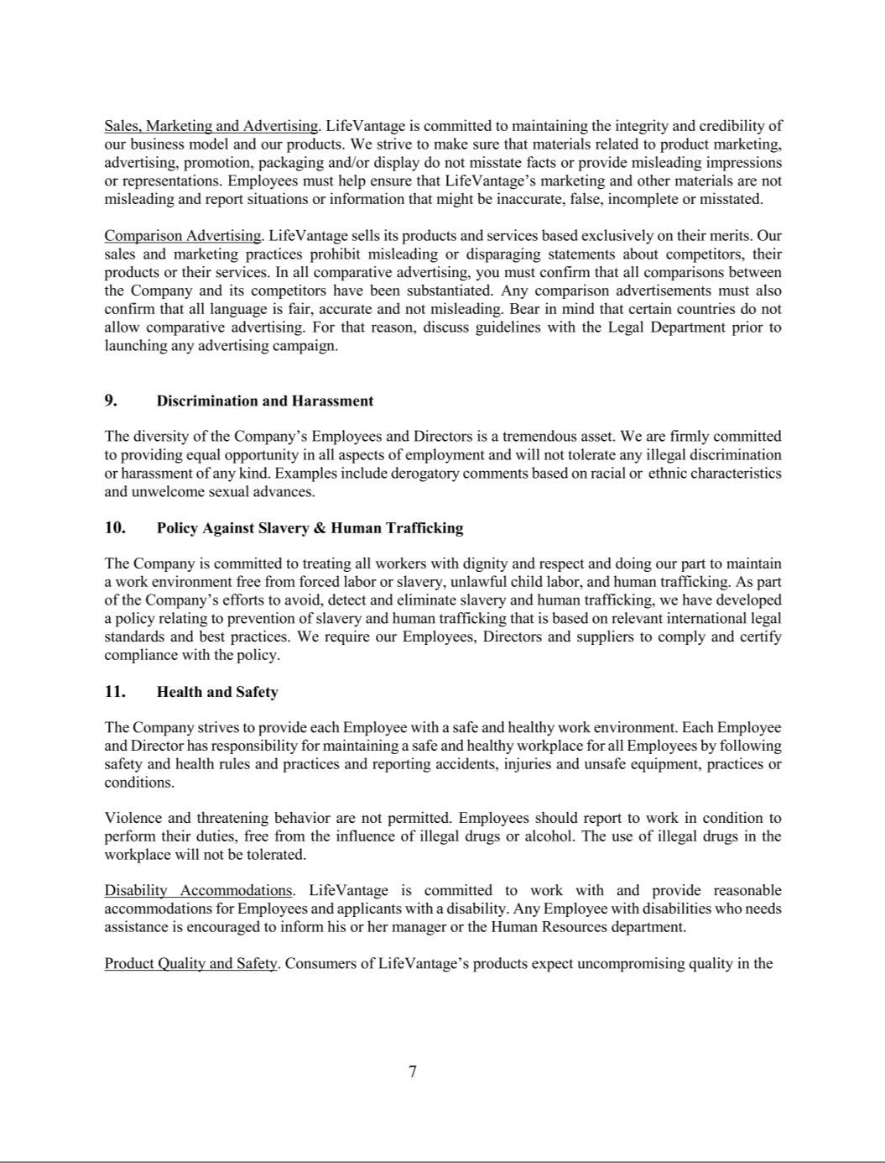

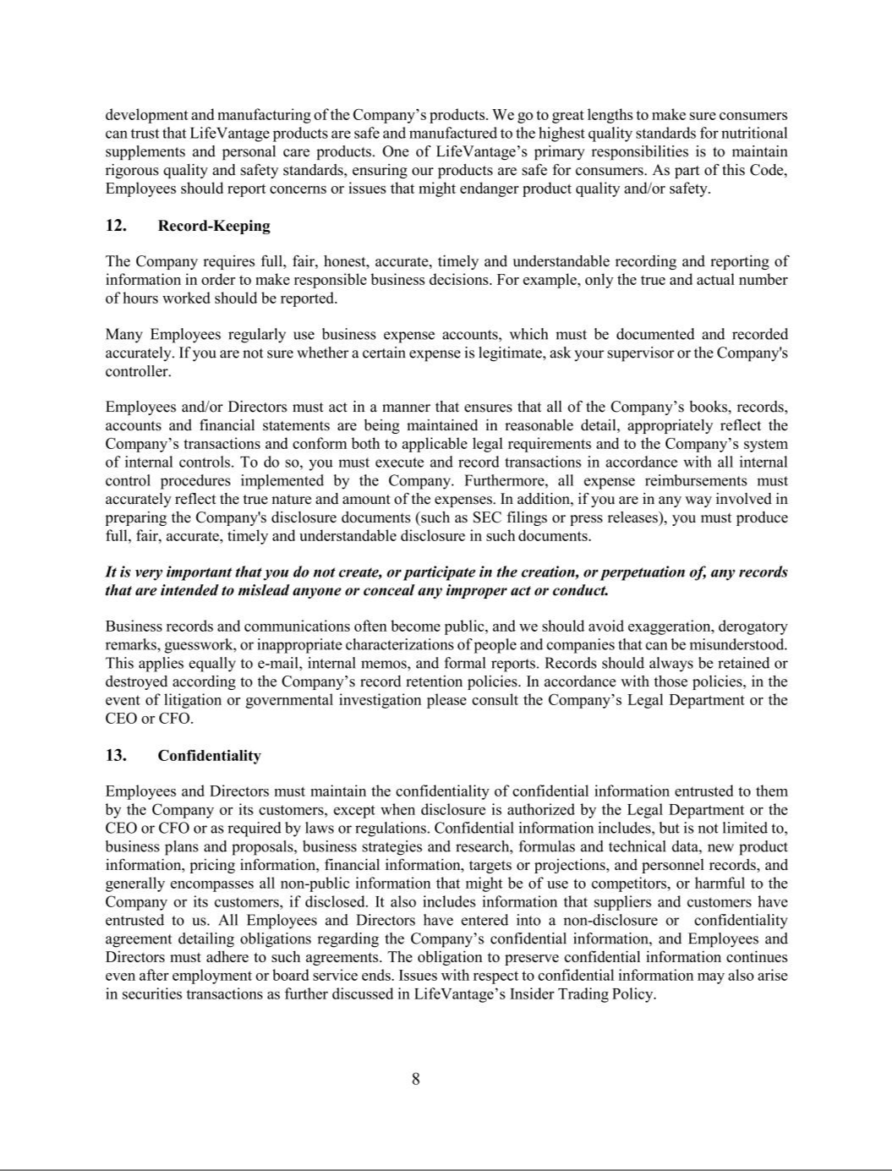

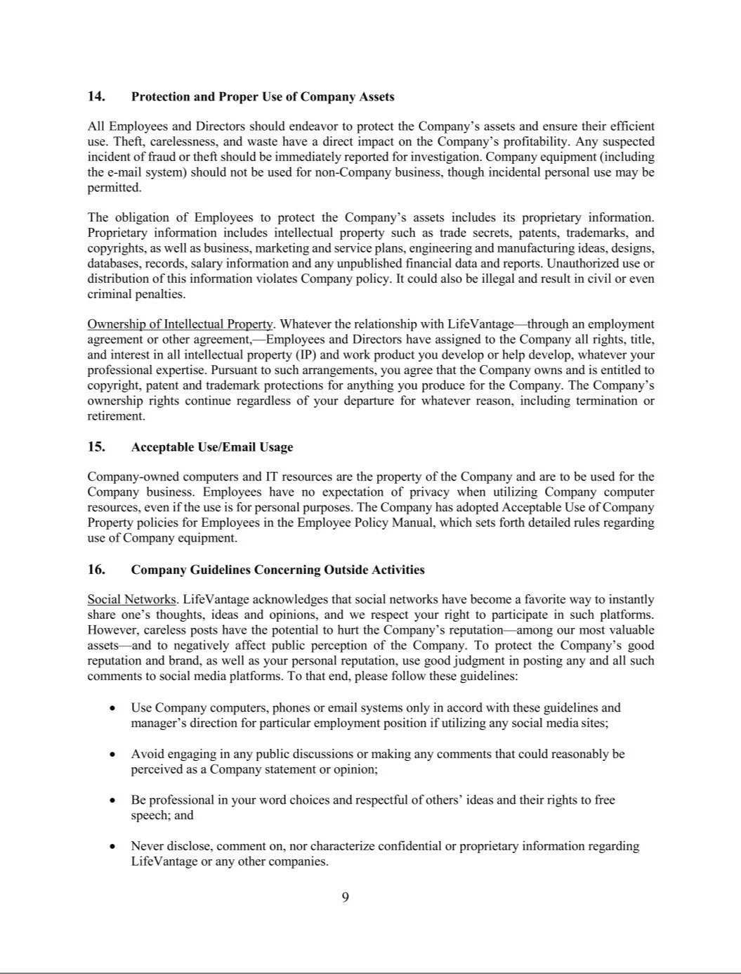

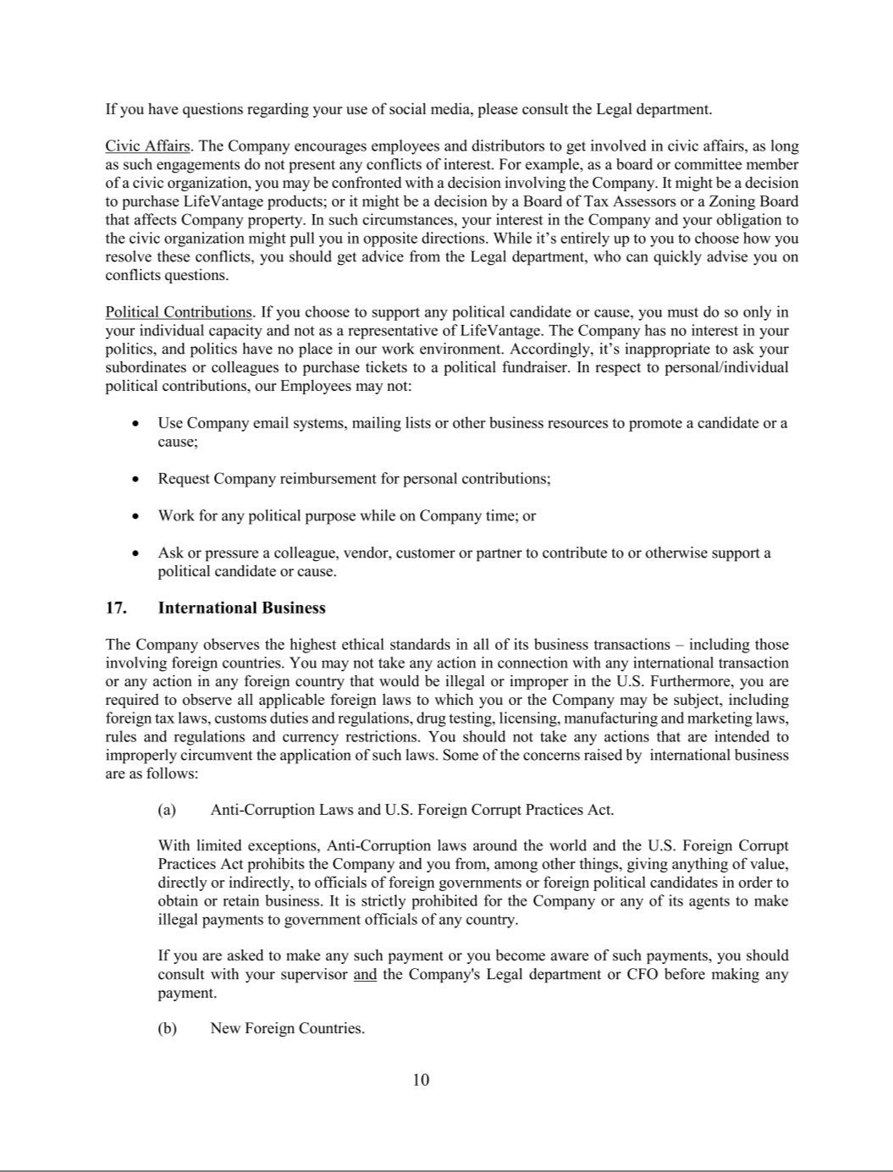

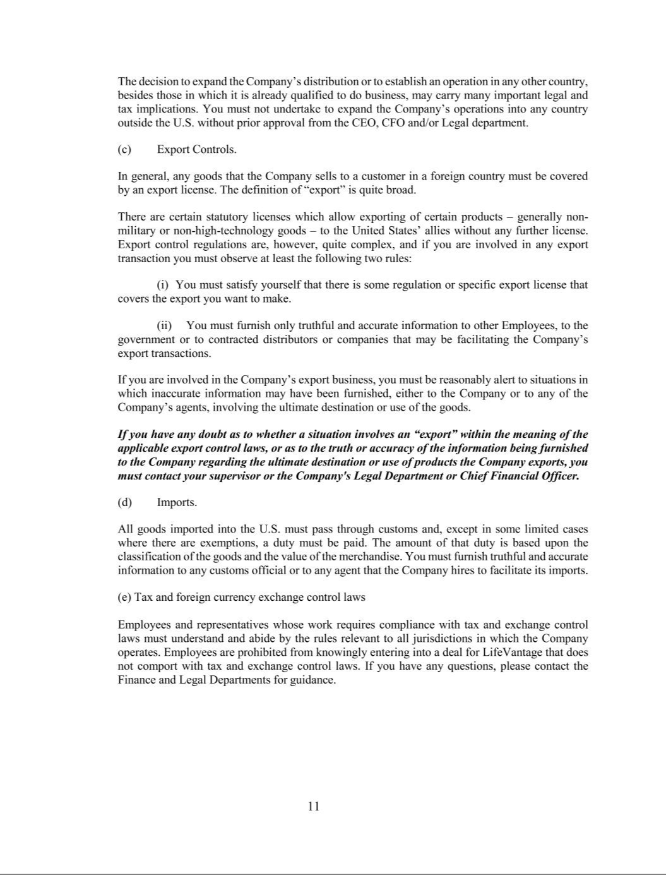

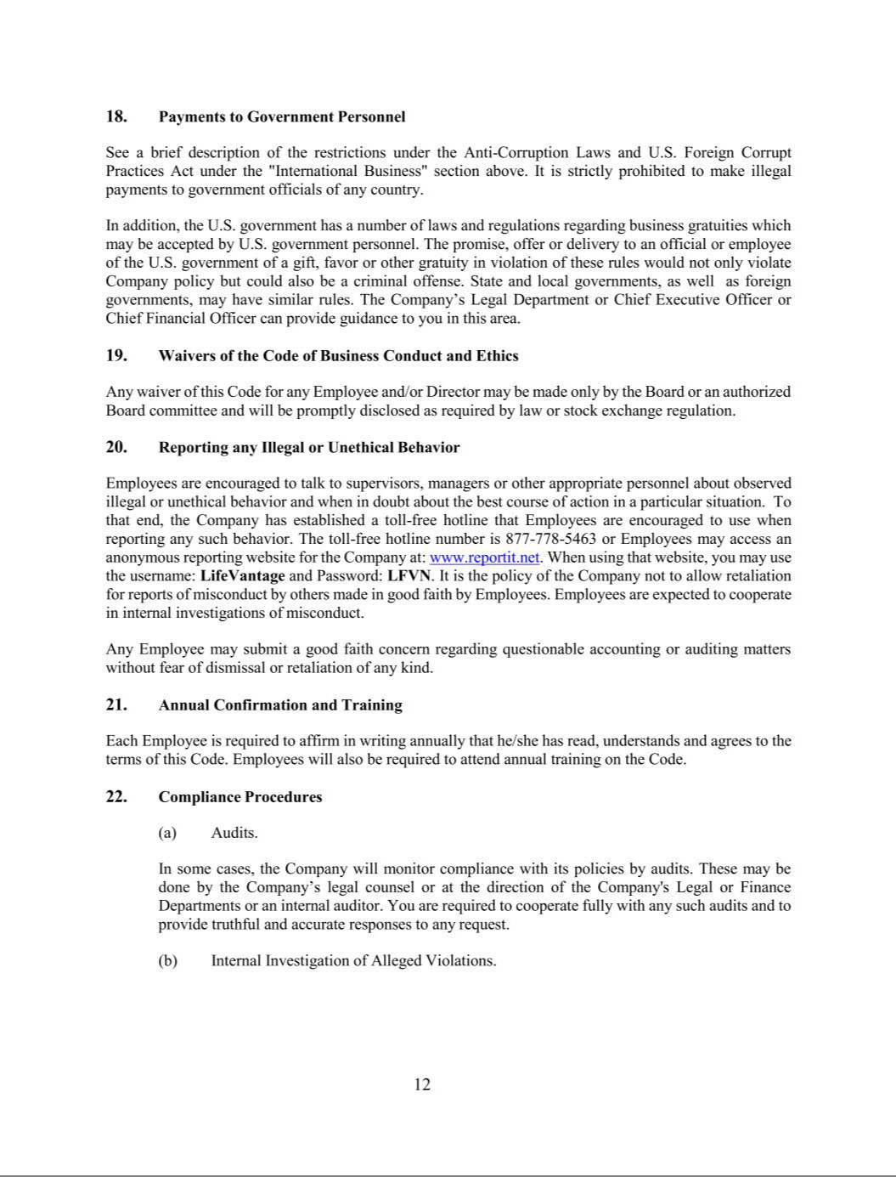

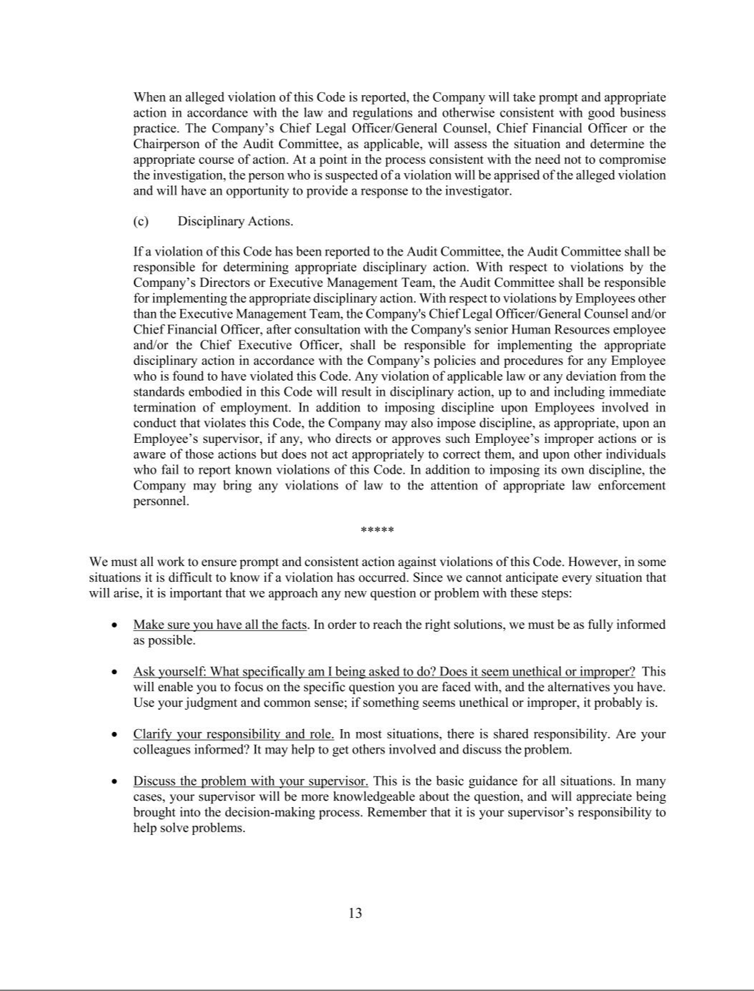

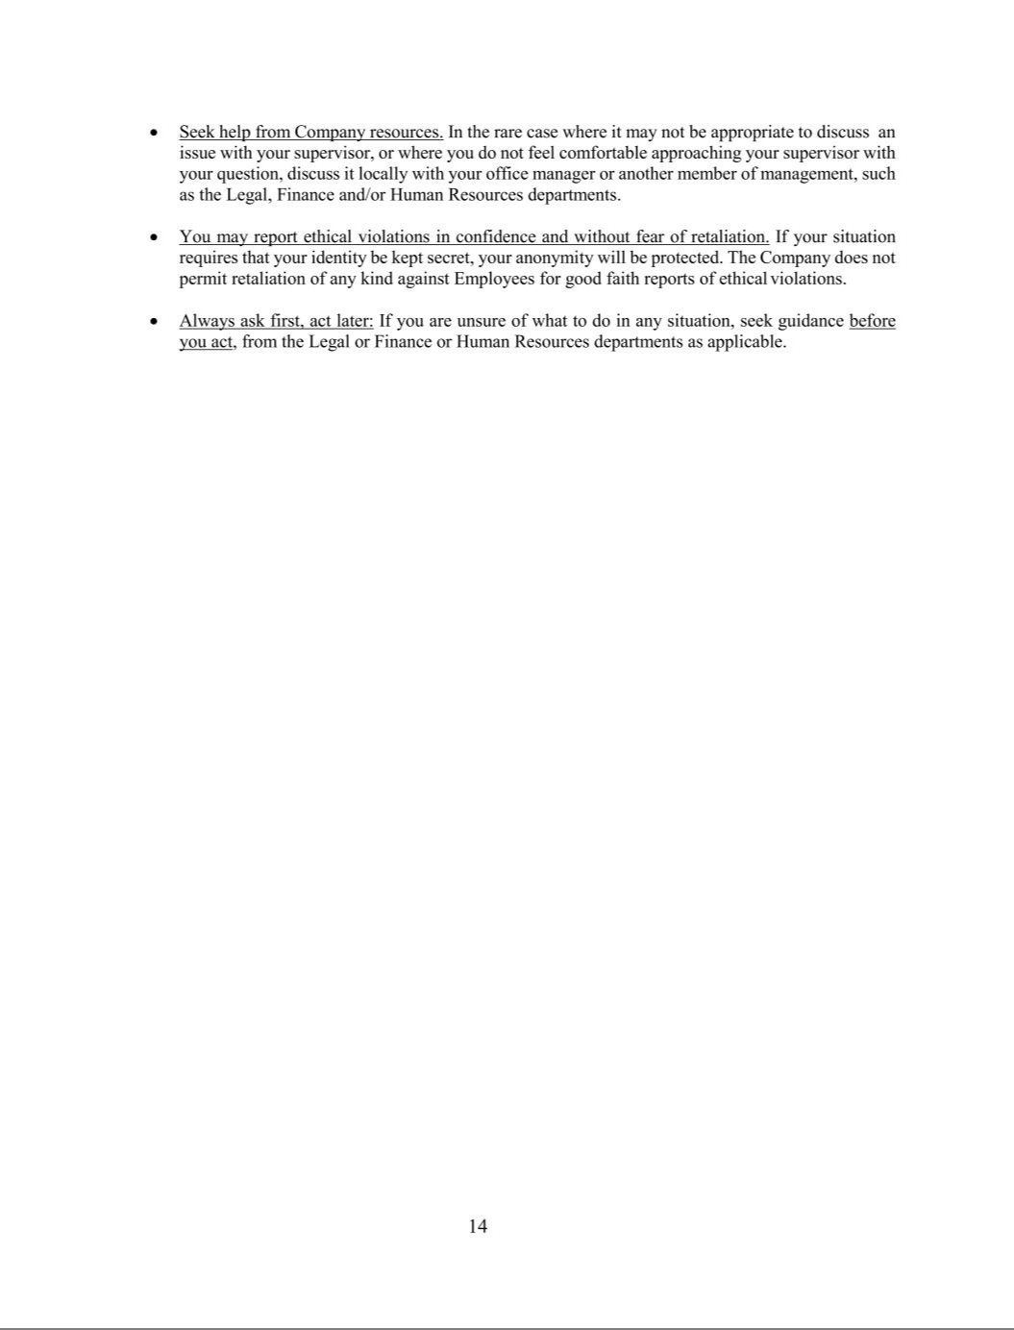

Exhibit 21.1

SUBSIDIARIES OF LIFEVANTAGE CORPORATION

Set forth below is a list of all subsidiaries of LifeVantage Corporation, a Delaware corporation, and the state or country of incorporation of each as of June 30, 2021.

Name |  | State or Country of Incorporation
Dinng Creative, Inc. |  | Utah
Importadora LifeVantage S. de R.L. de C.V. |  | Mexico
LFVN Malaysia SDN. BHD. |  | Malaysia
LifeLine Nutraceuticals Corporation |  | Colorado
LifeVantage Asia Pte. Ltd. |  | Singapore
LifeVantage Australia Pty. Ltd. |  | Australia
LifeVantage Canada Ltd. |  | Canada
LifeVantage de Mexico S. de R.L. de C.V. |  | Mexico
LifeVantage Hong Kong Limited |  | Hong Kong
LifeVantage Japan Kabushiki Kaisha (KK) |  | Japan
LifeVantage Netherlands B.V. |  | Netherlands
LifeVantage New Zealand Limited |  | New Zealand
LifeVantage (Shanghai) Trading Co. Ltd. |  | China
LifeVantage Singapore Pte. Ltd. |  | Singapore
LifeVantage Taiwan Pte. Ltd. |  | Taiwan
LifeVantage Thailand Company Limited |  | Thailand
LifeVantage UK Limited |  | United Kingdom
Protandum Philippines Corporation |  | Philippines
Puyoujian (Guangzhou) Technology Co., Ltd. |  | China

Exhibit 23.1

CONSENT OF INDEPENDENT REGISTERED PUBLIC ACCOUNTING FIRM

We consent to the incorporation by reference in this Registration Statement on Form S-8 (No. 333-200363) of LifeVantage Corporation and subsidiaries (the “Company”) of our report dated August 19, 2021 with respect to the consolidated balance sheets of the Company as of June 30, 2021 and 2020, and the related consolidated statements of operations and comprehensive income, changes in stockholders' equity, and cash flows for the three-year period ended June 30, 2021, which report appears in the Company's annual report on Form 10-K filed with the Securities and Exchange Commission on August 19, 2021, and the effectiveness of internal control over financial reporting as of June 30, 2021, which report appears in the June 30, 2021 annual report on Form 10-K of the Company.

WSRP, LLC

Salt Lake City, Utah

August 19, 2021

EXHIBIT 31.1

CERTIFICATION OF PRINCIPAL EXECUTIVE OFFICER PURSUANT TO SECURITIES EXCHANGE ACT RULES 13a-14(a) AND 15(d)-14(a) AS ADOPTED PURSUANT TO SECTION 302 OF THE SARBANES-OXLEY ACT OF 2002

I, Steven R. Fife, certify that:

- I have reviewed this Annual Report on Form 10-K of LifeVantage Corporation;

- Based on my knowledge, this report does not contain any untrue statement of a material fact or omit to state a material fact necessary to make the statements made, in light of the circumstances under which such statements were made, not misleading with respect to the period covered by this report;

- Based on my knowledge, the financial statements, and other financial information included in this report, fairly present in all material respects the financial condition, results of operations and cash flows of the registrant as of, and for, the periods presented in this report;

- The registrant’s other certifying officer(s) and I are responsible for establishing and maintaining disclosure controls and procedures (as defined in Exchange Act Rules 13a-15(e) and 15d-15(e)) and internal control over financial reporting (as defined in Exchange Act Rules 13a-15(f) and 15d-15(f)) for the registrant and have:

    - Designed such disclosure controls and procedures, or caused such disclosure controls and procedures to be designed under our supervision, to ensure that material information relating to the registrant, including its consolidated subsidiaries, is made known to us by others within those entities, particularly during the period in which this report is being prepared;

    - Designed such internal control over financial reporting, or caused such internal control over financial reporting to be designed under our supervision, to provide reasonable assurance regarding the reliability of financial reporting and the preparation of financial statements for external purposes in accordance with generally accepted accounting principles;

  - Evaluated the effectiveness of the registrant’s disclosure controls and procedures and presented in this report our conclusions about the effectiveness of the disclosure controls and procedures, as of the end of the period covered by this report based on such evaluation; and

  - Disclosed in this report any change in the registrant’s internal control over financial reporting that occurred during the registrant’s most recent fiscal quarter (the registrant’s fourth fiscal quarter in the case of an annual report) that has materially affected, or is reasonably likely to materially affect, the registrant’s internal control over financial reporting; and

- The registrant’s other certifying officer(s) and I have disclosed, based on our most recent evaluation of internal control over financial reporting, to the registrant’s auditors and the audit committee of the registrant’s board of directors (or persons performing the equivalent functions):

    - All significant deficiencies and material weaknesses in the design or operation of internal control over financial reporting which are reasonably likely to adversely affect the registrant’s ability to record, process, summarize and report financial information; and

    - Any fraud, whether or not material, that involves management or other employees who have a significant role in the registrant’s internal control over financial reporting.

August 19, 2021 | /s/ Steven R. Fife
 | Steven R. Fife
 | President & Chief Executive Officer
 | (Principal Executive Officer)

EXHIBIT 31.2

CERTIFICATION OF PRINCIPAL FINANCIAL OFFICER PURSUANT TO SECURITIES EXCHANGE ACT RULES 13a-14(a) AND 15(d)-14(a) AS ADOPTED PURSUANT TO SECTION 302 OF THE SARBANES-OXLEY ACT OF 2002

I, Steven R. Fife, certify that:

- I have reviewed this Annual Report on Form 10-K of LifeVantage Corporation;

- Based on my knowledge, this report does not contain any untrue statement of a material fact or omit to state a material fact necessary to make the statements made, in light of the circumstances under which such statements were made, not misleading with respect to the period covered by this report;

- Based on my knowledge, the financial statements, and other financial information included in this report, fairly present in all material respects the financial condition, results of operations and cash flows of the registrant as of, and for, the periods presented in this report;

- The registrant’s other certifying officer(s) and I are responsible for establishing and maintaining disclosure controls and procedures (as defined in Exchange Act Rules 13a-15(e) and 15d-15(e)) and internal control over financial reporting (as defined in Exchange Act Rules 13a-15(f) and 15d-15(f)) for the registrant and have:

  - Designed such disclosure controls and procedures, or caused such disclosure controls and procedures to be designed under our supervision, to ensure that material information relating to the registrant, including its consolidated subsidiaries, is made known to us by others within those entities, particularly during the period in which this report is being prepared;

  - Designed such internal control over financial reporting, or caused such internal control over financial reporting to be designed under our supervision, to provide reasonable assurance regarding the reliability of financial reporting and the preparation of financial statements for external purposes in accordance with generally accepted accounting principles;

  - Evaluated the effectiveness of the registrant’s disclosure controls and procedures and presented in this report our conclusions about the effectiveness of the disclosure controls and procedures, as of the end of the period covered by this report based on such evaluation; and

  - Disclosed in this report any change in the registrant’s internal control over financial reporting that occurred during the registrant’s most recent fiscal quarter (the registrant’s fourth fiscal quarter in the case of an annual report) that has materially affected, or is reasonably likely to materially affect, the registrant’s internal control over financial reporting; and

- The registrant’s other certifying officer(s) and I have disclosed, based on our most recent evaluation of internal control over financial reporting, to the registrant’s auditors and the audit committee of the registrant’s board of directors (or persons performing the equivalent functions):

    - All significant deficiencies and material weaknesses in the design or operation of internal control over financial reporting which are reasonably likely to adversely affect the registrant’s ability to record, process, summarize and report financial information; and

    - Any fraud, whether or not material, that involves management or other employees who have a significant role in the registrant’s internal control over financial reporting.

August 19, 2021 /s/ Steven R. Fife
Steven R. Fife
Chief Financial Officer
(Principal Financial Officer and Principal Accounting
Officer)

EXHIBIT 32.1

CERTIFICATION PURSUANT TO 18 U.S.C. SECTION 1350, AS ADOPTED

PURSUANT TO SECTION 906 OF THE SARBANES-OXLEY ACT OF 2002

In connection with the filing of this annual report on Form 10-K of LifeVantage Corporation (the “Company”) for the period ended June 30, 2021, with the Securities and Exchange Commission on the date hereof (the “Report”), I, Steven R. Fife, President and Chief Executive Officer of the Company, certify, pursuant to 18 U.S.C. Section 1350, as adopted pursuant to Section 906 of the Sarbanes-Oxley Act of 2002, that:

- The Report fully complies with the requirements of Section 13(a) or 15(d) of the Securities Exchange Act of 1934; and

- The information contained in the Report fairly presents, in all material respects, the financial condition and results of operations of the Company.

August 19, 2021 /s/ Steven R. Fife
Steven R. Fife
President & Chief Executive Officer
(Principal Executive Officer)

EXHIBIT 32.2

CERTIFICATION PURSUANT TO 18 U.S.C. SECTION 1350, AS ADOPTED

PURSUANT TO SECTION 906 OF THE SARBANES-OXLEY ACT OF 2002

In connection with the filing of this annual report on Form 10-K of LifeVantage Corporation (the “Company”) for the period ended June 30, 2021, with the Securities and Exchange Commission on the date hereof (the “Report”), I, Steven R. Fife, Chief Financial Officer of the Company, certify, pursuant to 18 U.S.C. Section 1350, as adopted pursuant to Section 906 of the Sarbanes-Oxley Act of 2002, that:

- The Report fully complies with the requirements of Section 13(a) or 15(d) of the Securities Exchange Act of 1934; and

- The information contained in the Report fairly presents, in all material respects, the financial condition and results of operations of the Company.

August 19, 2021 /s/ Steven R. Fife
Steven R. Fife
Chief Financial Officer
(Principal Financial Officer and Principal Accounting
Officer)

