UNITED STATES
SECURITIES AND EXCHANGE COMMISSION
Washington, D.C. 20549
________________________________________________________________________________
Form 10-Q
________________________________________________________________________________
☒ |  |  | QUARTERLY REPORT UNDER SECTION 13 OR 15 (d) OF THE SECURITIES EXCHANGE ACT OF 1934
FOR THE QUARTERLY PERIOD ENDED MARCH 31, 2024
☐ |  |  | TRANSITION REPORT PURSUANT TO SECTION 13 OR 15 (d) OF THE SECURITIES EXCHANGE ACT OF 1934
FOR THE TRANSITION PERIOD FROM TO
Commission file number 001-35647
________________________________________________________________________________

LIFEVANTAGE CORPORATION
(Exact name of Registrant as specified in its charter)
________________________________________________________________________________
Delaware |  |  |  |  |  | 90-0224471
(State or other jurisdiction of incorporation or organization) |  |  |  |  |  | (IRS Employer Identification No.)
3300 Triumph Blvd, Suite 700, Lehi, UT 84043
(Address of principal executive offices, including zip code)
(801) 432-9000
(Registrant’s telephone number)

Securities registered pursuant to Section 12(b) of the Act:
Common Stock, par value $0.0001 |  |  |  |  |  | LFVN |  |  |  |  |  | The Nasdaq Stock Market LLC
Title of each class |  |  |  |  |  | Trading Symbol(s) |  |  |  |  |  | Name of each exchange on which registered
________________________________________________________________________________
Indicate by check mark whether the registrant (1) has filed all reports required to be filed by Section 13 or 15 (d) of the Securities Exchange Act of 1934 during the preceding 12 months (or for such shorter period that the registrant was required to file such reports), and (2) has been subject to such filing requirements for the past 90 days. Yes ☒ No ☐
Indicate by check mark whether the registrant has submitted electronically every Interactive Data File required to be submitted pursuant to Rule 405 of Regulation S-T (§232.405 of this chapter) during the preceding 12 months (or for such shorter period that the registrant was required to submit such files). Yes ☒ No ☐
Indicate by check mark whether the registrant is a large accelerated filer, an accelerated filer, a non-accelerated filer, a smaller reporting company, or an emerging growth company. See the definitions of “large accelerated filer,” “accelerated filer,” “smaller reporting company” and “emerging growth company” in Rule 12b-2 of the Exchange Act.
Large accelerated filer |  |  | ☐ |  |  | Accelerated filer |  |  | ☐
Non-accelerated filer |  |  | ☒ |  |  | Smaller reporting company |  |  | ☒
Emerging Growth Company |  |  | ☐
If an emerging growth company, indicate by check mark if the registrant has elected not to use the extended transition period for complying with any new or revised financial accounting standards provided pursuant to Section 13(a) of the Exchange Act. ☐
Indicate by check mark whether the registrant is a shell company (as defined in Rule 12b-2 of the Exchange Act). Yes ☐ No ☒
The number of shares outstanding of the issuer’s common stock, par value $0.0001 per share, as of May 1, 2024 was 12,700,556.

CAUTIONARY NOTE REGARDING FORWARD-LOOKING STATEMENTS
This quarterly report on Form 10-Q, in particular “Item 2. Management’s Discussion and Analysis of Financial Condition and Results of Operations,” and the information incorporated by reference herein contains “forward-looking statements” (as such term is defined in Section 27A of the Securities Act of 1933, as amended and Section 21E of the Securities Exchange Act of 1934, as amended). These statements, which involve risks and uncertainties, reflect our current expectations, intentions, or strategies regarding our possible future results of operations, performance, and achievements. Forward-looking statements include, without limitation: statements regarding future products or product development; statements regarding future selling, general and administrative costs and research and development spending; statements regarding the future performance of our network marketing efforts; statements regarding our expectations regarding ongoing litigation; statements regarding international growth; and statements regarding future financial performance, results of operations, capital expenditures and sufficiency of capital resources to fund our operating requirements. These forward-looking statements are made pursuant to the safe harbor provisions of the Private Securities Litigation Reform Act of 1995 and applicable rules of the Securities and Exchange Commission and common law.
These forward-looking statements may be identified in this report and the information incorporated by reference by words such as “anticipate,” “believe,” “could,” “estimate,” “expect,” “intend,” “plan,” “predict,” “project,” “should” and similar terms and expressions, including references to assumptions and strategies. These statements reflect our current beliefs and are based on information currently available to us. Accordingly, these statements are subject to certain risks, uncertainties, and contingencies, which could cause our actual results, performance, or achievements to differ materially from those expressed in, or implied by, such statements.
The following factors are among those that may cause actual results to differ materially from our forward-looking statements:
•Inability to properly manage, motivate and retain our independent consultants (which we previously referred to as “distributors” in our prior filings) or to attract new customers and independent consultants on an ongoing basis;
•The widespread outbreak of an illness or communicable disease or any other public health crisis, similar to the recent COVID-19 pandemic, could adversely affect our business, results of operations and financial condition;
•Inability to protect against cyber security risks and to maintain the integrity of data;
•Inability to manage existing markets, open new international markets or expand our operations;
•Non-compliance by our independent consultants with applicable legal requirements or our policies and procedures, including making improper and/or illegal claims about our products or earnings opportunity;
•Inability of new products and technological innovations to gain customer or independent consultant or market acceptance;
•Our business and stock price may be adversely affected if our internal controls over financial reporting is not effective;
•Inability to execute our product launch process due to increased pressure on our supply chain, information systems and management;
•Inability to appropriately manage our inventory;
•Disruptions in our information technology systems;
•International trade or foreign exchange restrictions, increased tariffs, foreign currency exchange fluctuations;
•Inability to raise additional capital or complete desired acquisitions;
•Inability to comply with financial covenants imposed by our revolving line of credit and the impact of debt service obligations and restrictive debt covenants;
•Dependence upon a few products for revenue;
•We may be unable to retain our existing consultant force or customer base or attract additional customers and/or independent consultants;
•Changes to the Company’s independent consultant compensation plans;
•High quality materials for our products may become difficult to obtain or expensive;
2

•Improper actions by our independent consultants that violate laws or regulations could harm our business;
•Dependence on third parties to manufacture our products;
•Disruptions to the transportation channels used to distribute our products;
•We may be subject to a product recall;
•Unfavorable publicity on our business or products;
•Risks related to Global Not For Resale programs;
•Our direct selling program could be found to not be in compliance with current or newly adopted laws or regulations in various markets;
•The impact of actions by activist stockholders;
•Legal proceedings may be expensive and time consuming;
•Strict government regulations on our business;
•Regulations governing the production or marketing of our products;
•Risk of investigatory and enforcement action;
•Government authorities may question our tax positions or transfer pricing policies or change their laws in a manner that could increase our effective tax rate or otherwise harm our business;
•Failure to comply with anti-corruption laws;
•Loss of or inability to attract key personnel;
•We may be held responsible for certain taxes or assessments and other obligations relating to the activity of our independent consultants;
•Competition in the dietary supplement and personal care markets;
•Our inability to protect our intellectual property rights;
•Third party claims that we infringe on their intellectual property;
•Product liability claims against us;
•Consumer discretionary spending habits factor into our economic success;
•Economic, political, foreign exchange and other risks associated with international operations;
•Unfavorable global economic conditions, including high inflation, and other macroeconomic conditions;
•Potential delisting of our common stock due to non-compliance with Nasdaq's continued listing requirements;
•Volatility of the market price of our common stock; and
•Substantial sales of shares may negatively impact the market price of our common stock.
When considering these forward-looking statements, you should keep in mind the cautionary statements in this report and the documents incorporated by reference. Except as required by law, we have no obligation and do not undertake to update or revise any such forward-looking statements to reflect events or circumstances after the date of this report.

3

LIFEVANTAGE CORPORATION
INDEX

 |  |  |  |  |  | PAGE
PART I. Financial Information |  |  |  |  |  | 5
Item 1. |  |  | Financial Statements: |  |  | 5
 |  |  | Condensed Consolidated Balance Sheets (unaudited) |  |  | 5
 |  |  | Condensed Consolidated Statements of Operations and Comprehensive Income (Loss) (unaudited) |  |  | 6
 |  |  | Condensed Consolidated Statement of Stockholders’ Equity (unaudited) |  |  | 7
 |  |  | Condensed Consolidated Statements of Cash Flows (unaudited) |  |  | 9
 |  |  | Notes to Condensed Consolidated Financial Statements (unaudited) |  |  | 10
Item 2. |  |  | Management's Discussion and Analysis of Financial Condition and Results of Operations |  |  | 19
Item 3. |  |  | Quantitative and Qualitative Disclosures About Market Risk |  |  | 26
Item 4. |  |  | Controls and Procedures |  |  | 27
PART II. Other Information |  |  |  |  |  | 27
Item 1. |  |  | Legal Proceedings |  |  | 27
Item 1A. |  |  | Risk Factors |  |  | 27
Item 2. |  |  | Unregistered Sales of Equity Securities and Use of Proceeds |  |  | 27
Item 3. |  |  | Defaults Upon Senior Securities |  |  | 28
Item 4. |  |  | Mine Safety Disclosures |  |  | 28
Item 5. |  |  | Other Information |  |  | 28
Item 6. |  |  | Exhibits |  |  | 28
Signatures |  |  |  |  |  | 30

4

PART I. Financial Information

Item 1. Financial Statements

LIFEVANTAGE CORPORATION AND SUBSIDIARIES
CONDENSED CONSOLIDATED BALANCE SHEETS
(Unaudited)
 |  |  | March 31, 2024 |  |  |  |  |  | June 30, 2023
(In thousands, except per share data)
ASSETS
Current assets
Cash and cash equivalents |  |  | $ | 17,377 |  |  |  |  | $ | 21,605
Accounts receivable |  |  | 2,135 |  |  |  |  |  | 1,612
Income tax receivable |  |  | 360 |  |  |  |  |  | 241
Inventory, net |  |  | 15,162 |  |  |  |  |  | 16,073
Prepaid expenses and other |  |  | 2,763 |  |  |  |  |  | 4,753
Total current assets |  |  | 37,797 |  |  |  |  |  | 44,284
Property and equipment, net |  |  | 8,349 |  |  |  |  |  | 9,086
Right-of-use assets |  |  | 9,382 |  |  |  |  |  | 8,738
Intangible assets, net |  |  | 356 |  |  |  |  |  | 455
Deferred income tax asset |  |  | 4,927 |  |  |  |  |  | 2,991
Other long-term assets |  |  | 496 |  |  |  |  |  | 569
TOTAL ASSETS |  |  | $ | 61,307 |  |  |  |  | $ | 66,123
LIABILITIES AND STOCKHOLDERS’ EQUITY
Current liabilities
Accounts payable |  |  | $ | 6,954 |  |  |  |  | $ | 3,505
Commissions payable |  |  | 6,093 |  |  |  |  |  | 6,651
Income tax payable |  |  | 772 |  |  |  |  |  | —
Lease liabilities |  |  | 1,675 |  |  |  |  |  | 1,521
Other accrued expenses |  |  | 6,981 |  |  |  |  |  | 7,932
Total current liabilities |  |  | 22,475 |  |  |  |  |  | 19,609
Long-term lease liabilities |  |  | 11,852 |  |  |  |  |  | 11,566
Other long-term liabilities |  |  | 211 |  |  |  |  |  | 299
Total liabilities |  |  | 34,538 |  |  |  |  |  | 31,474
Commitments and contingencies - Note 7
Stockholders’ equity
Preferred stock — par value $0.0001 per share, 5,000 shares authorized, no shares issued or outstanding |  |  | — |  |  |  |  |  | —
Common stock — par value $0.0001 per share, 40,000 shares authorized and 12,688 and 12,622 issued and outstanding as of March 31, 2024 and June 30, 2023, respectively |  |  | 1 |  |  |  |  |  | 1
Additional paid-in capital |  |  | 136,198 |  |  |  |  |  | 134,314
Accumulated deficit |  |  | (107,709) |  |  |  |  |  | (98,305)
Accumulated other comprehensive loss |  |  | (1,721) |  |  |  |  |  | (1,361)
Total stockholders’ equity |  |  | 26,769 |  |  |  |  |  | 34,649
TOTAL LIABILITIES AND STOCKHOLDERS’ EQUITY |  |  | $ | 61,307 |  |  |  |  | $ | 66,123
The accompanying notes are an integral part of these condensed consolidated financial statements.
5

LIFEVANTAGE CORPORATION AND SUBSIDIARIES
CONDENSED CONSOLIDATED STATEMENTS OF OPERATIONS AND COMPREHENSIVE INCOME (LOSS)
(Unaudited)
 |  |  | Three Months Ended March 31, |  |  |  |  |  |  |  |  |  |  |  | Nine Months Ended March 31,
 |  |  | 2024 |  |  |  |  |  | 2023 |  |  |  |  |  | 2024 |  |  |  |  |  | 2023
(In thousands, except per share data)
Revenue, net |  |  | $ | 48,245 |  |  |  |  | $ | 53,741 |  |  |  |  | $ | 151,233 |  |  |  |  | $ | 159,177
Cost of sales |  |  | 10,172 |  |  |  |  |  | 10,618 |  |  |  |  |  | 31,418 |  |  |  |  |  | 32,318
Gross profit |  |  | 38,073 |  |  |  |  |  | 43,123 |  |  |  |  |  | 119,815 |  |  |  |  |  | 126,859
Operating expenses:
Commissions and incentives |  |  | 19,714 |  |  |  |  |  | 23,816 |  |  |  |  |  | 63,941 |  |  |  |  |  | 71,185
Selling, general and administrative |  |  | 16,425 |  |  |  |  |  | 17,708 |  |  |  |  |  | 54,452 |  |  |  |  |  | 54,018
Total operating expenses |  |  | 36,139 |  |  |  |  |  | 41,524 |  |  |  |  |  | 118,393 |  |  |  |  |  | 125,203
Operating income |  |  | 1,934 |  |  |  |  |  | 1,599 |  |  |  |  |  | 1,422 |  |  |  |  |  | 1,656
Other income (expense):
Interest income, net |  |  | 76 |  |  |  |  |  | 59 |  |  |  |  |  | 352 |  |  |  |  |  | 91
Other income (expense), net |  |  | (89) |  |  |  |  |  | 7 |  |  |  |  |  | (135) |  |  |  |  |  | (304)
Total other income (expense) |  |  | (13) |  |  |  |  |  | 66 |  |  |  |  |  | 217 |  |  |  |  |  | (213)
Income before income taxes |  |  | 1,921 |  |  |  |  |  | 1,665 |  |  |  |  |  | 1,639 |  |  |  |  |  | 1,443
Income tax expense |  |  | (262) |  |  |  |  |  | (643) |  |  |  |  |  | (7) |  |  |  |  |  | (869)
Net income |  |  | $ | 1,659 |  |  |  |  | $ | 1,022 |  |  |  |  | $ | 1,632 |  |  |  |  | $ | 574
Net income per share:
Basic |  |  | $ | 0.13 |  |  |  |  | $ | 0.08 |  |  |  |  | $ | 0.13 |  |  |  |  | $ | 0.05
Diluted |  |  | $ | 0.13 |  |  |  |  | $ | 0.08 |  |  |  |  | $ | 0.13 |  |  |  |  | $ | 0.05
Weighted-average shares outstanding:
Basic |  |  | 12,424 |  |  |  |  |  | 12,615 |  |  |  |  |  | 12,525 |  |  |  |  |  | 12,538
Diluted |  |  | 12,986 |  |  |  |  |  | 12,770 |  |  |  |  |  | 13,010 |  |  |  |  |  | 12,555
Other comprehensive (loss) income, net of tax:
Foreign currency translation adjustment |  |  | $ | (529) |  |  |  |  | $ | 14 |  |  |  |  | $ | (360) |  |  |  |  | $ | 144
Other comprehensive (loss) income, net of tax |  |  | (529) |  |  |  |  |  | 14 |  |  |  |  |  | (360) |  |  |  |  |  | 144
Comprehensive income |  |  | $ | 1,130 |  |  |  |  | $ | 1,036 |  |  |  |  | $ | 1,272 |  |  |  |  | $ | 718
The accompanying notes are an integral part of these condensed consolidated financial statements.

6

LIFEVANTAGE CORPORATION AND SUBSIDIARIES
CONDENSED CONSOLIDATED STATEMENT OF STOCKHOLDERS’ EQUITY
(Unaudited)
 |  |  | Common Stock |  |  |  |  |  |  |  |  |  |  |  | Additional  Paid-In  Capital |  |  |  |  |  | Accumulated  Deficit |  |  |  |  |  | Accumulated  Other  Comprehensive Loss |  |  |  |  |  | Total
 |  |  | Shares |  |  |  |  |  | Amount
(In thousands, except per share data)
Balances, June 30, 2023 |  |  | 12,622 |  |  |  |  |  | $ | 1 |  |  |  |  | $ | 134,314 |  |  |  |  | $ | (98,305) |  |  |  |  | $ | (1,361) |  |  |  |  | $ | 34,649
Stock-based compensation |  |  | — |  |  |  |  |  | — |  |  |  |  |  | 978 |  |  |  |  |  | — |  |  |  |  |  | — |  |  |  |  |  | 978
Common stock issued under equity award plans |  |  | 281 |  |  |  |  |  | — |  |  |  |  |  | — |  |  |  |  |  | — |  |  |  |  |  | — |  |  |  |  |  | —
Shares canceled or surrendered as payment of tax withholding and other |  |  | (90) |  |  |  |  |  | — |  |  |  |  |  | (465) |  |  |  |  |  | — |  |  |  |  |  | — |  |  |  |  |  | (465)
Repurchase of company stock |  |  | (145) |  |  |  |  |  | — |  |  |  |  |  | — |  |  |  |  |  | (795) |  |  |  |  |  | — |  |  |  |  |  | (795)
Common stock issued under employee stock purchase plan |  |  | 39 |  |  |  |  |  | — |  |  |  |  |  | 126 |  |  |  |  |  | — |  |  |  |  |  | — |  |  |  |  |  | 126
Cash dividends |  |  | — |  |  |  |  |  | — |  |  |  |  |  | — |  |  |  |  |  | (5,534) |  |  |  |  |  | — |  |  |  |  |  | (5,534)
Currency translation adjustment |  |  | — |  |  |  |  |  | — |  |  |  |  |  | — |  |  |  |  |  | — |  |  |  |  |  | (294) |  |  |  |  |  | (294)
Net income |  |  | — |  |  |  |  |  | — |  |  |  |  |  | — |  |  |  |  |  | 629 |  |  |  |  |  | — |  |  |  |  |  | 629
Balances, September 30, 2023 |  |  | 12,707 |  |  |  |  |  | $ | 1 |  |  |  |  | $ | 134,953 |  |  |  |  | $ | (104,005) |  |  |  |  | $ | (1,655) |  |  |  |  | $ | 29,294
Stock-based compensation |  |  | — |  |  |  |  |  | — |  |  |  |  |  | 750 |  |  |  |  |  | — |  |  |  |  |  | — |  |  |  |  |  | 750
Common stock issued under equity award plans |  |  | 495 |  |  |  |  |  | — |  |  |  |  |  | — |  |  |  |  |  | — |  |  |  |  |  | — |  |  |  |  |  | —
Shares canceled or surrendered as payment of tax withholding and other |  |  | (34) |  |  |  |  |  | — |  |  |  |  |  | (213) |  |  |  |  |  | — |  |  |  |  |  | — |  |  |  |  |  | (213)
Repurchase of company stock |  |  | (288) |  |  |  |  |  | — |  |  |  |  |  | — |  |  |  |  |  | (1,876) |  |  |  |  |  | — |  |  |  |  |  | (1,876)
Cash dividends |  |  | — |  |  |  |  |  | — |  |  |  |  |  | — |  |  |  |  |  | (455) |  |  |  |  |  | — |  |  |  |  |  | (455)
Currency translation adjustment |  |  | — |  |  |  |  |  | — |  |  |  |  |  | — |  |  |  |  |  | — |  |  |  |  |  | 463 |  |  |  |  |  | 463
Net loss |  |  | — |  |  |  |  |  | — |  |  |  |  |  | — |  |  |  |  |  | (656) |  |  |  |  |  | — |  |  |  |  |  | (656)
Balances, December 31, 2023 |  |  | 12,880 |  |  |  |  |  | $ | 1 |  |  |  |  | $ | 135,490 |  |  |  |  | $ | (106,992) |  |  |  |  | $ | (1,192) |  |  |  |  | $ | 27,307
Stock-based compensation |  |  | — |  |  |  |  |  | — |  |  |  |  |  | 796 |  |  |  |  |  | — |  |  |  |  |  | — |  |  |  |  |  | 796
Common stock issued under employee stock purchase plan |  |  | 25 |  |  |  |  |  | — |  |  |  |  |  | 145 |  |  |  |  |  | — |  |  |  |  |  | — |  |  |  |  |  | 145
Common stock issued under equity award plans |  |  | 113 |  |  |  |  |  | — |  |  |  |  |  | — |  |  |  |  |  | — |  |  |  |  |  | — |  |  |  |  |  | —
Shares canceled or surrendered as payment of tax withholding and other |  |  | (38) |  |  |  |  |  | — |  |  |  |  |  | (233) |  |  |  |  |  | — |  |  |  |  |  | — |  |  |  |  |  | (233)
Repurchase of company stock |  |  | (292) |  |  |  |  |  | — |  |  |  |  |  | — |  |  |  |  |  | (1,928) |  |  |  |  |  | — |  |  |  |  |  | (1,928)
Cash dividends |  |  | — |  |  |  |  |  | — |  |  |  |  |  | — |  |  |  |  |  | (448) |  |  |  |  |  | — |  |  |  |  |  | (448)
Currency translation adjustment |  |  | — |  |  |  |  |  | — |  |  |  |  |  | — |  |  |  |  |  | — |  |  |  |  |  | (529) |  |  |  |  |  | (529)
Net income |  |  | — |  |  |  |  |  | — |  |  |  |  |  | — |  |  |  |  |  | 1,659 |  |  |  |  |  | — |  |  |  |  |  | 1,659
Balances, March 31, 2024 |  |  | 12,688 |  |  |  |  |  | $ | 1 |  |  |  |  | $ | 136,198 |  |  |  |  | $ | (107,709) |  |  |  |  | $ | (1,721) |  |  |  |  | $ | 26,769
The accompanying notes are an integral part of these condensed consolidated financial statements.

7

LIFEVANTAGE CORPORATION AND SUBSIDIARIES
CONDENSED CONSOLIDATED STATEMENT OF STOCKHOLDERS’ EQUITY (CONTINUED)
(Unaudited)
 |  |  | Common Stock |  |  |  |  |  |  |  |  |  |  |  | Additional  Paid-In  Capital |  |  |  |  |  | Accumulated  Deficit |  |  |  |  |  | Accumulated  Other  Comprehensive Loss |  |  |  |  |  | Total
 |  |  | Shares |  |  |  |  |  | Amount
(In thousands, except per share data)
Balances, June 30, 2022 |  |  | 12,493 |  |  |  |  |  | $ | 1 |  |  |  |  | $ | 131,075 |  |  |  |  | $ | (98,437) |  |  |  |  | $ | (1,123) |  |  |  |  | $ | 31,516
Stock-based compensation |  |  | — |  |  |  |  |  | — |  |  |  |  |  | 602 |  |  |  |  |  | — |  |  |  |  |  | — |  |  |  |  |  | 602
Common stock issued under equity award plans |  |  | 48 |  |  |  |  |  | — |  |  |  |  |  | — |  |  |  |  |  | — |  |  |  |  |  | — |  |  |  |  |  | —
Shares canceled or surrendered as payment of tax withholding and other |  |  | (17) |  |  |  |  |  | — |  |  |  |  |  | (72) |  |  |  |  |  | — |  |  |  |  |  | — |  |  |  |  |  | (72)
Common stock issued under employee stock purchase plan |  |  | 36 |  |  |  |  |  | — |  |  |  |  |  | 121 |  |  |  |  |  | — |  |  |  |  |  | — |  |  |  |  |  | 121
Cash dividends |  |  | — |  |  |  |  |  | — |  |  |  |  |  | — |  |  |  |  |  | (377) |  |  |  |  |  | — |  |  |  |  |  | (377)
Currency translation adjustment |  |  | — |  |  |  |  |  | — |  |  |  |  |  | — |  |  |  |  |  | — |  |  |  |  |  | (510) |  |  |  |  |  | (510)
Net income |  |  | — |  |  |  |  |  | — |  |  |  |  |  | — |  |  |  |  |  | 610 |  |  |  |  |  | — |  |  |  |  |  | 610
Balances, September 30, 2022 |  |  | 12,560 |  |  |  |  |  | $ | 1 |  |  |  |  | $ | 131,726 |  |  |  |  | $ | (98,204) |  |  |  |  | $ | (1,633) |  |  |  |  | $ | 31,890
Stock-based compensation |  |  | — |  |  |  |  |  | — |  |  |  |  |  | 823 |  |  |  |  |  | — |  |  |  |  |  | — |  |  |  |  |  | 823
Common stock issued under equity award plans |  |  | 152 |  |  |  |  |  | — |  |  |  |  |  | — |  |  |  |  |  | — |  |  |  |  |  | — |  |  |  |  |  | —
Shares canceled or surrendered as payment of tax withholding and other |  |  | (5) |  |  |  |  |  | — |  |  |  |  |  | (19) |  |  |  |  |  | — |  |  |  |  |  | — |  |  |  |  |  | (19)
Cash dividends |  |  | — |  |  |  |  |  | — |  |  |  |  |  | — |  |  |  |  |  | (381) |  |  |  |  |  | — |  |  |  |  |  | (381)
Currency translation adjustment |  |  | — |  |  |  |  |  | — |  |  |  |  |  | — |  |  |  |  |  | — |  |  |  |  |  | 640 |  |  |  |  |  | 640
Net loss |  |  | — |  |  |  |  |  | — |  |  |  |  |  | — |  |  |  |  |  | (1,058) |  |  |  |  |  | — |  |  |  |  |  | (1,058)
Balances, December 31, 2022 |  |  | 12,707 |  |  |  |  |  | $ | 1 |  |  |  |  | $ | 132,530 |  |  |  |  | $ | (99,643) |  |  |  |  | $ | (993) |  |  |  |  | $ | 31,895
Stock-based compensation |  |  | — |  |  |  |  |  | — |  |  |  |  |  | 817 |  |  |  |  |  | — |  |  |  |  |  | — |  |  |  |  |  | 817
Common stock issued under employee stock purchase plan |  |  | 40 |  |  |  |  |  | — |  |  |  |  |  | 131 |  |  |  |  |  | — |  |  |  |  |  | — |  |  |  |  |  | 131
Common stock issued under equity award plans |  |  | 38 |  |  |  |  |  | — |  |  |  |  |  | — |  |  |  |  |  | — |  |  |  |  |  | — |  |  |  |  |  | —
Shares canceled or surrendered as payment of tax withholding and other |  |  | (14) |  |  |  |  |  | — |  |  |  |  |  | (54) |  |  |  |  |  | — |  |  |  |  |  | — |  |  |  |  |  | (54)
Cash dividends |  |  | — |  |  |  |  |  | — |  |  |  |  |  | — |  |  |  |  |  | (383) |  |  |  |  |  | — |  |  |  |  |  | (383)
Currency translation adjustment |  |  | — |  |  |  |  |  | — |  |  |  |  |  | — |  |  |  |  |  | — |  |  |  |  |  | 14 |  |  |  |  |  | 14
Net income |  |  | — |  |  |  |  |  | — |  |  |  |  |  | — |  |  |  |  |  | 1,022 |  |  |  |  |  | — |  |  |  |  |  | 1,022
Balances, March 31, 2023 |  |  | 12,771 |  |  |  |  |  | $ | 1 |  |  |  |  | $ | 133,424 |  |  |  |  | $ | (99,004) |  |  |  |  | $ | (979) |  |  |  |  | $ | 33,442
The accompanying notes are an integral part of these condensed consolidated financial statements.

8

LIFEVANTAGE CORPORATION AND SUBSIDIARIES
CONDENSED CONSOLIDATED STATEMENTS OF CASH FLOWS
(Unaudited)
 |  |  | Nine Months Ended March 31,
 |  |  | 2024 |  |  |  |  |  | 2023
(In thousands)
Cash Flows from Operating Activities:
Net income |  |  | $ | 1,632 |  |  |  |  | $ | 574
Adjustments to reconcile net income to net cash provided by (used in) operating activities:
Depreciation and amortization |  |  | 2,775 |  |  |  |  |  | 2,678
Stock-based compensation |  |  | 2,524 |  |  |  |  |  | 2,242
Non-cash operating lease expense |  |  | 920 |  |  |  |  |  | 1,257
Loss on disposal of assets |  |  | — |  |  |  |  |  | 24
Deferred income tax |  |  | (1,936) |  |  |  |  |  | (953)
Changes in operating assets and liabilities:
Accounts receivable |  |  | (552) |  |  |  |  |  | 975
Income tax receivable |  |  | (118) |  |  |  |  |  | 1,090
Inventory, net |  |  | 725 |  |  |  |  |  | (1,947)
Prepaid expenses and other |  |  | 1,983 |  |  |  |  |  | 1,859
Other long-term assets |  |  | 59 |  |  |  |  |  | 55
Accounts payable |  |  | 3,385 |  |  |  |  |  | (1,642)
Income tax payable |  |  | 772 |  |  |  |  |  | (453)
Other accrued expenses |  |  | (1,549) |  |  |  |  |  | (1,301)
Lease liabilities |  |  | (1,120) |  |  |  |  |  | (1,274)
Other long-term liabilities |  |  | 115 |  |  |  |  |  | (119)
Net Cash Provided by Operating Activities |  |  | 9,615 |  |  |  |  |  | 3,065
Cash Flows from Investing Activities:
Purchase of property and equipment |  |  | (1,967) |  |  |  |  |  | (2,554)
Net Cash Used in Investing Activities |  |  | (1,967) |  |  |  |  |  | (2,554)
Cash Flows from Financing Activities:
Repurchase of company stock |  |  | (4,599) |  |  |  |  |  | —
Payment of cash dividends |  |  | (6,437) |  |  |  |  |  | (1,141)
Shares canceled or surrendered as payment of tax withholding and other |  |  | (911) |  |  |  |  |  | (145)
Proceeds from common stock issued under employee stock purchase plan |  |  | 271 |  |  |  |  |  | 252
Net Cash Used in Financing Activities |  |  | (11,676) |  |  |  |  |  | (1,034)
Foreign Currency Effect on Cash |  |  | (200) |  |  |  |  |  | (138)
Decrease in Cash and Cash Equivalents: |  |  | (4,228) |  |  |  |  |  | (661)
Cash and Cash Equivalents — beginning of period |  |  | 21,605 |  |  |  |  |  | 20,190
Cash and Cash Equivalents — end of period |  |  | $ | 17,377 |  |  |  |  | $ | 19,529
SUPPLEMENTAL DISCLOSURE OF CASH FLOW INFORMATION
Cash paid for interest |  |  | $ | 5 |  |  |  |  | $ | 3
Cash paid for income taxes |  |  | $ | 1,381 |  |  |  |  | $ | 977
The accompanying notes are an integral part of these condensed consolidated financial statements.

9

LIFEVANTAGE CORPORATION AND SUBSIDIARIES
NOTES TO CONDENSED CONSOLIDATED FINANCIAL STATEMENTS
(Unaudited)
These unaudited condensed consolidated financial statements and notes should be read in conjunction with the audited financial statements and notes of LifeVantage Corporation (“LifeVantage" or the “Company”) as of and for the year ended June 30, 2023 included in the annual report on Form 10-K filed with the Securities and Exchange Commission (“SEC”) on August 28, 2023.

Note 1 — Organization and Basis of Presentation
LifeVantage is a company focused on nutrigenomics, the study of how nutrition and naturally occurring compounds affect human genes to support good health. The Company is dedicated to helping people achieve their health, wellness and financial goals. The Company provides quality, scientifically-validated products to customers and independent consultants as well as a financially rewarding commission-based direct sales opportunity to its independent consultants. LifeVantage sells its products in the United States, Mexico, Japan, Australia, Hong Kong, Canada, Thailand, the United Kingdom, the Netherlands, Germany, Taiwan, Austria, Spain, Ireland, Belgium, New Zealand, Singapore, and the Philippines. The Company sold its products in China through a China approved cross-border e-commerce business model until March 15, 2023, at which time the Company closed its e-commerce business in China.
The Company engages in the identification, research, development, formulation and sale of advanced nutrigenomic activators, dietary supplements, nootropics, pre- and pro-biotics, weight management, skin and hair care, bath & body, and targeted relief products. The Company’s line of scientifically validated dietary supplements includes its flagship Protandim® family of products, LifeVantage® Omega+, ProBio, IC Bright®, Daily Wellness, Rise AM, Reset PM and D3+ dietary supplements. TrueScience® is the Company's Nrf2 enhanced line of skin, hair, and bath & body products. The Company also markets and sells Petandim®, its companion pet supplement formulated to combat oxidative stress in dogs, AXIO® its nootropic energy drink mixes, and PhysIQ™, its smart weight management system.
The condensed consolidated financial statements included herein have been prepared by the Company’s management, without audit, pursuant to the rules and regulations of the SEC. In the opinion of the Company’s management, these interim financial statements include all adjustments that are considered necessary for a fair presentation of its financial position as of March 31, 2024, and the results of operations for the three and nine months ended March 31, 2024 and 2023, and the cash flows for the nine months ended March 31, 2024 and 2023. Interim results are not necessarily indicative of results for a full year or for any future period.
The condensed consolidated financial statements and notes included herein are presented as required by Form 10-Q, and do not contain certain information included in the Company’s audited financial statements and notes for the fiscal year ended June 30, 2023, pursuant to the rules and regulations of the SEC. For further information, refer to the financial statements and notes thereto as of and for the year ended June 30, 2023, and included in the annual report on Form 10-K on file with the SEC.

Note 2 — Summary of Significant Accounting Policies
Consolidation
The condensed consolidated financial statements include the accounts of the Company and its wholly-owned subsidiaries. All significant intercompany accounts and transactions are eliminated in consolidation.
Use of Estimates
The Company prepares the condensed consolidated financial statements and related disclosures in conformity with accounting principles generally accepted in the United States of America ("GAAP"). In preparing these statements, the Company is required to use estimates and assumptions that affect the reported amounts of assets and liabilities, the disclosure of contingent assets and liabilities at the date of the financial statements and the reported amounts of revenue and expenses during the reporting period. Actual results could differ materially from those estimates and assumptions. On an ongoing basis, the Company reviews its estimates, including, but not limited to, those related to inventory valuation and obsolescence, sales returns, income taxes and tax valuation reserves, transfer pricing methodology and positions, impairment of assets, share-based compensation, and loss contingencies.
Foreign Currency Translation
A portion of the Company’s business operations occurs outside the United States. The local currency of each of the Company’s subsidiaries is generally its functional currency. All assets and liabilities are translated into U.S. dollars at exchange rates existing at the balance sheet dates, revenue and expenses are translated at weighted-average exchange rates and
10

stockholders’ equity is recorded at historical exchange rates. The resulting foreign currency translation adjustments are recorded as a separate component of stockholders’ equity in the condensed consolidated balance sheets and as a component of comprehensive income. Transaction gains and losses are included in other expense, net in the condensed consolidated statements of operations and comprehensive income. For the three months ended March 31, 2024 and 2023, net foreign currency losses of $0.1 million and gains of $36,000, respectively, are recorded in other income (expense), net. For the nine months ended March 31, 2024 and 2023, net foreign currency losses of $0.2 million and $0.2 million, respectively, are recorded in other income (expense), net.
Cash and Cash Equivalents
The Company considers only its monetary liquid assets with original maturities of three months or less as cash and cash equivalents.
Concentration of Credit Risk
Accounting guidance for financial instruments requires disclosure of significant concentrations of credit risk regardless of the degree of such risk. Financial instruments with significant credit risk include cash and investments. At March 31, 2024, the Company had $13.1 million in cash accounts at one financial institution and $4.3 million in accounts at other financial institutions. At June 30, 2023, the Company had $17.0 million in cash accounts at one financial institution and $4.6 million in accounts at other financial institutions. As of March 31, 2024 and June 30, 2023, and during the periods then ended, the Company’s cash balances exceeded federally insured limits.
Accounts Receivable
The Company’s accounts receivable as of March 31, 2024 and June 30, 2023 consist primarily of credit card receivables. Based on the Company’s verification process for customer credit cards and historical information available, management has determined that an allowance for doubtful accounts on credit card sales related to its customer sales as of March 31, 2024 and June 30, 2023 is not necessary. No bad debt expense was recorded during the three and nine months ended March 31, 2024 and 2023.
Inventory
As of March 31, 2024 and June 30, 2023, inventory consisted of (in thousands):
 |  |  | March 31,  2024 |  |  |  |  |  |  |  |  |  |  |  | June 30,  2023
Finished goods |  |  | $ | 11,273 |  |  |  |  | 74.4 |  | % |  |  |  | $ | 12,153 |  |  |  |  | 75.6 |  | %
Raw materials |  |  | 3,889 |  |  |  |  |  | 25.6 |  | % |  |  |  | 3,920 |  |  |  |  |  | 24.4 |  | %
Total inventory |  |  | $ | 15,162 |  |  |  |  | 100.0 |  | % |  |  |  | $ | 16,073 |  |  |  |  | 100.0 |  | %
Inventories are carried at the lower of cost or net realizable value, using the first-in, first-out method, which includes a reduction in inventory values of $1.3 million and $1.3 million at March 31, 2024 and June 30, 2023, respectively, related to obsolete and slow-moving inventory.
Fair Value of Financial Instruments
The Company accounts for assets and liabilities using a hierarchy of valuation techniques based on whether the inputs to those valuation techniques are observable or unobservable. Observable inputs reflect market data obtained from independent sources, while unobservable inputs reflect the Company's market assumptions. These two types of inputs have created the fair-value hierarchy below. This hierarchy requires the Company to minimize the use of unobservable inputs and to use observable market data, if available, when determining fair value.
•Level 1—Quoted prices for identical instruments in active markets;
•Level 2—Quoted prices for similar instruments in active markets, quoted prices for identical or similar instruments in markets that are not active, and model-derived valuations in which all significant inputs and significant value drivers are observable in active markets; and
•Level 3—Valuations derived from valuation techniques in which one or more significant inputs or significant value drivers are unobservable.
Our financial instruments, consisting primarily of cash and cash equivalents, accounts receivable, and accounts payable, approximate fair value due to their short-term nature.
11

Revenue Recognition
Revenue is recognized when control of the promised goods or services are transferred to the customer, in an amount that reflects the consideration the Company expects to be entitled to in exchange for those goods or services. Sales, value-added, and other taxes the Company collects concurrent with revenue-producing activities are excluded from revenue.
The Company generates the majority of its revenue through product sales to customers. These products include the Protandim® line of dietary supplements, LifeVantage® Omega+, ProBio, IC Bright®, Daily Wellness, Rise AM, Reset PM, and D3+ dietary supplements, TrueScience® skin, hair, bath & body and targeted relief, Petandim®, Axio® nootropic energy drink mixes, and the PhysIQ™ smart weight management system. The Company ships most of its product directly to the consumer and receives substantially all payment for product sales in the form of credit card receipts. Revenue from direct product sales to customers is recognized upon shipment, which is when passage of title and risk of loss occurs. For items sold in packs and bundles, the Company determines the standalone selling price at contract inception for each distinct good, and then allocates the transaction price on a relative standalone selling price basis. Any discounts are accounted for as a direct reduction to the transaction price. Shipping and handling revenue is recognized upon shipment when the performance obligation is completed.
Contract liabilities, recorded as deferred revenue, include loyalty program credit deferrals with certain customers which are accounted for as a reduction in the transaction price and are generally recognized as credits which are redeemed for additional products at a later date. The Company also records deferred revenue when cash payments are received or due in advance of performance, including amounts which are refundable. In addition, the Company pre-sells tickets to its events. When cash payments are received in advance of events, the cash received is recorded to deferred revenue until the event is held, at which time the Company has performed its obligations under the contract and the revenue is recognized.
Deferred revenue is included in accrued expenses in the consolidated balance sheets. The balance of deferred revenue related to contract liabilities was $0.7 million and $0.8 million as of March 31, 2024 and June 30, 2023, respectively. The contract liabilities impact to revenue for the three months ended March 31, 2024 and 2023 was an increase of $0.2 million and a decrease of $0.1 million, respectively. The contract liabilities impact to revenue for the nine months ended March 31, 2024 and 2023 was an increase of $0.1 million and a decrease of $0.3 million, respectively.
Estimated returns are recorded when product is shipped. Subject to some exceptions based on local regulations, the Company’s return policy is to provide a full refund for product returned within 30 days. After 30 days of purchase, only unopened product that is in a resalable and restockable condition may be returned within twelve months of purchase and shall receive a 100% refund, less a 10% handling and restocking fee and any shipping and handling costs. The Company establishes a refund liability reserve, and an asset reserve for its right to recover products, based on historical experience. The returns asset reserve and returns liability reserve are evaluated on a quarterly basis. As of March 31, 2024 and June 30, 2023, the returns liability reserve, net was $0.1 million and $0.1 million, respectively.
Shipping and Handling
Shipping and handling costs associated with inbound freight and freight out to customers and independent consultants are included in cost of sales. Shipping and handling fees charged to customers and independent consultants are included in revenue.
Research and Development Costs
The Company expenses all costs related to research and development activities, as incurred. Research and development expenses for the three months ended March 31, 2024 and 2023 were $0.2 million and $0.2 million, respectively. Research and development expenses for the nine months ended March 31, 2024 and 2023 were $0.5 million and $0.4 million, respectively.
Leases
The Company accounts for leases in accordance with Accounting Standards Codification ("ASC") 842. The Company reviews all contracts and determines if the arrangement is or contains a lease, at inception. Operating leases are included in right-of-use (“ROU”) assets, current lease liabilities and long-term lease liabilities on the condensed consolidated balance sheets. The Company does not have any finance leases.
Operating lease ROU assets represent the Company’s right to use an underlying asset for the lease term and lease liabilities represent the Company’s obligation to make lease payments arising from the lease. ROU assets and lease liabilities are recognized at the lease commencement date based on the estimated present value of lease payments over the lease term. The Company uses its estimated incremental borrowing rate based on the information available at commencement date in determining the present value of future payments. The operating lease ROU asset also includes any upfront lease payments made and excludes lease incentives and initial direct costs incurred. The Company’s lease terms may include options to extend or terminate the lease when it is reasonably certain that the Company will exercise that option. Lease expense for minimum
12

lease payments is recognized on a straight-line basis over the lease term. Leases with a term of 12 months or less are not recorded on the balance sheet. The Company’s lease agreements do not contain any residual value guarantees.
Changes in the Company's strategies have resulted in operation modifications in certain Asia/Pacific markets resulting in the closure of showrooms and changes to selling models. As of December 31, 2022, the Company abandoned the ROU assets related to the Hong Kong and Singapore showroom leases. These leases were terminated in February 2023 and the Company has no remaining lease liability for these showrooms. Total expenses related to the abandonment of the ROU assets and costs associated with the change in operations in these markets for the nine months ended March 31, 2023 was $0.4 million and is included in selling, general, and administrative expenses.
Stock-Based Compensation
The Company recognizes stock-based compensation by measuring the cost of services to be rendered based on the grant date fair value of the equity award. The Company recognizes stock-based compensation, net of any estimated forfeitures, over the period an employee is required to provide service in exchange for the award, generally referred to as the requisite service period. The Company estimates forfeitures based on historical information and other management assumptions. For awards with market-based performance conditions, the cost of the awards is recognized as the requisite service is rendered by employees, regardless of when, if ever, the market-based performance conditions are satisfied.
The Black-Scholes option pricing model is used to estimate the fair value of stock options and options under the Company's 2019 Employee Stock Purchase Plan. The determination of the fair value of options is affected by the Company's stock price and a number of assumptions, including expected volatility, expected life, risk-free interest rate and expected dividends. The Company uses historical data for estimating the expected volatility and expected life of stock options required in the Black-Scholes model. The risk-free interest rate assumption is based on observed interest rates appropriate for the expected terms of the stock options.
The fair value of restricted stock grants, including performance restricted stock units that include non-market based performance conditions, is based on the closing market price of the Company's stock on the date of grant less the Company's expected dividend yield. The Company recognizes compensation costs for awards with performance conditions when it concludes it is probable that the performance conditions will be achieved. The Company reassesses the probability of vesting at each balance sheet date and adjusts compensation costs accordingly.
Income Taxes
Income taxes are accounted for under the asset and liability method. Deferred tax assets and liabilities are recognized for the future tax consequences attributable to differences between the financial statement carrying amounts of existing assets and liabilities and their respective tax bases and operating loss and tax credit carry-forwards. Deferred tax assets and liabilities are measured using statutory tax rates expected to apply to taxable income in the years in which those temporary differences are expected to be recovered or settled, updated as needed for changes in corporate tax rates. The effect on deferred tax assets and liabilities from a change in tax rates is recognized in income in the period that includes the effective date of the change. The Company recognizes tax liabilities or benefits from an uncertain position only if it is more likely than not that the position will be sustained upon examination by taxing authorities based on the technical merits of the issue. The amount recognized would be the largest liability or benefit that the Company believes has greater than a 50% likelihood of being realized upon settlement.
For the nine months ended March 31, 2024 and 2023, the Company recognized income tax expense of $7,000 and $0.9 million, respectively, which is reflective of the Company’s current estimated federal, state and foreign effective tax rate. Realization of deferred tax assets is dependent upon future earnings in specific tax jurisdictions, the timing and amount of which are uncertain.
Income Per Share
Basic income per common share is computed by dividing the net income by the weighted-average number of common shares outstanding during the period, less unvested restricted stock awards. Diluted income per common share is computed by dividing net income by the weighted-average common shares and potentially dilutive common share equivalents using the treasury stock method.
For the three months ended March 31, 2024 and 2023, the effects of approximately 8,000 and 0.1 million common shares, respectively, issuable upon exercise of options and non-vested shares of restricted stock are not included in computations as their effect was anti-dilutive. For the nine months ended March 31, 2024 and 2023, the effects of approximately 34,000 and 0.3 million common shares, respectively, issuable upon exercise of options and non-vested shares of restricted stock are not included in computations as their effect was anti-dilutive.
13

The following is a reconciliation of net income per share and the weighted-average common shares outstanding for purposes of computing basic and diluted net income per share (in thousands, except per share amounts):
 |  |  | Three Months Ended March 31, |  |  |  |  |  |  |  |  |  |  |  | Nine Months Ended March 31,
 |  |  | 2024 |  |  |  |  |  | 2023 |  |  |  |  |  | 2024 |  |  |  |  |  | 2023
Numerator:
Net income |  |  | $ | 1,659 |  |  |  |  | $ | 1,022 |  |  |  |  | $ | 1,632 |  |  |  |  | $ | 574
Denominator:
Basic weighted-average common shares outstanding |  |  | 12,424 |  |  |  |  |  | 12,615 |  |  |  |  |  | 12,525 |  |  |  |  |  | 12,538
Effect of dilutive securities:
Stock awards and options |  |  | 562 |  |  |  |  |  | 155 |  |  |  |  |  | 485 |  |  |  |  |  | 17
Diluted weighted-average common shares outstanding |  |  | 12,986 |  |  |  |  |  | 12,770 |  |  |  |  |  | 13,010 |  |  |  |  |  | 12,555
Net income per share, basic |  |  | $ | 0.13 |  |  |  |  | $ | 0.08 |  |  |  |  | $ | 0.13 |  |  |  |  | $ | 0.05
Net income per share, diluted |  |  | $ | 0.13 |  |  |  |  | $ | 0.08 |  |  |  |  | $ | 0.13 |  |  |  |  | $ | 0.05
Segment Information and Disaggregated Revenue
The Company operates in a single operating segment by selling products directly to customers and through an international network of independent consultants that operates in an integrated manner from market to market. Commissions and incentives expenses are the Company’s largest expense comprised of the commissions paid to its independent consultants. The Company manages its business primarily by managing its international network of independent consultants. The Company disaggregates revenue in two geographic regions: the Americas region and the Asia/Pacific & Europe region.
The following table presents the Company's revenue disaggregated by these two geographic regions (in thousands):
 |  |  | Three Months Ended March 31, |  |  |  |  |  |  |  |  |  |  |  | Nine Months Ended March 31,
 |  |  | 2024 |  |  |  |  |  | 2023 |  |  |  |  |  | 2024 |  |  |  |  |  | 2023
Americas |  |  | $ | 37,215 |  |  |  |  | $ | 39,532 |  |  |  |  | $ | 114,795 |  |  |  |  | $ | 115,606
Asia/Pacific & Europe |  |  | 11,030 |  |  |  |  |  | 14,209 |  |  |  |  |  | 36,438 |  |  |  |  |  | 43,571
Total revenue |  |  | $ | 48,245 |  |  |  |  | $ | 53,741 |  |  |  |  | $ | 151,233 |  |  |  |  | $ | 159,177
Additional information as to the Company’s revenue from operations in the most significant geographical areas is set forth below (in thousands):
 |  |  | Three Months Ended March 31, |  |  |  |  |  |  |  |  |  |  |  | Nine Months Ended March 31,
 |  |  | 2024 |  |  |  |  |  | 2023 |  |  |  |  |  | 2024 |  |  |  |  |  | 2023
United States |  |  | $ | 35,333 |  |  |  |  | $ | 37,855 |  |  |  |  | $ | 109,448 |  |  |  |  | $ | 110,485
Japan |  |  | $ | 6,223 |  |  |  |  | $ | 8,133 |  |  |  |  | $ | 21,051 |  |  |  |  | $ | 23,665
The following table presents the Company's long-lived assets for its most significant geographic markets (in thousands):
 |  |  | March 31,  2024 |  |  |  |  |  | June 30,  2023
United States |  |  | $ | 20,468 |  |  |  |  | $ | 20,504
Japan |  |  | $ | 2,156 |  |  |  |  | $ | 354

Note 3 — Leases
The Company has operating leases for current corporate offices and certain equipment. These leases have remaining terms of approximately one to eight years. As of March 31, 2024, the weighted average remaining lease term and weighted average discount rate for operating leases was 7.28 years and 3.26%, respectively. As of June 30, 2023, the weighted average remaining lease term and weighted average discount rate for operating leases was 8.27 years and 3.25%, respectively.
For the three months ended March 31, 2024 and 2023, operating lease expense was $0.5 million and $0.6 million, respectively. For the nine months ended March 31, 2024 and 2023, operating lease expense was $1.6 million and $2.2 million, respectively.
The components of lease expense for the three and nine months ended March 31, 2024 and 2023, were as follows:
14

 |  |  | Three Months Ended March 31, |  |  |  |  |  |  |  |  |  |  |  | Nine Months Ended March 31,
 |  |  | 2024 |  |  |  |  |  | 2023 |  |  |  |  |  | 2024 |  |  |  |  |  | 2023
Operating lease expense
Operating lease cost |  |  | $ | 459 |  |  |  |  | $ | 516 |  |  |  |  | $ | 1,451 |  |  |  |  | $ | 1,929
Variable lease cost |  |  | 42 |  |  |  |  |  | 103 |  |  |  |  |  | 136 |  |  |  |  |  | 189
Short-term lease costs |  |  | 12 |  |  |  |  |  | 18 |  |  |  |  |  | 35 |  |  |  |  |  | 63
Total lease expense |  |  | $ | 513 |  |  |  |  | $ | 637 |  |  |  |  | $ | 1,622 |  |  |  |  | $ | 2,181
Supplemental cash flow information related to operating leases was as follows (in thousands):
 |  |  | Three Months Ended March 31, |  |  |  |  |  |  |  |  |  |  |  | Nine Months Ended March 31,
 |  |  | 2024 |  |  |  |  |  | 2023 |  |  |  |  |  | 2024 |  |  |  |  |  | 2023
Operating cash outflows from operating leases |  |  | $ | 560 |  |  |  |  | $ | 782 |  |  |  |  | $ | 1,651 |  |  |  |  | $ | 2,288
Right-of-use assets obtained in exchange for lease obligations |  |  | $ | 265 |  |  |  |  | $ | — |  |  |  |  | $ | 1,767 |  |  |  |  | $ | —
Maturity of lease liabilities at March 31, 2024 are as follows (in thousands):
Year ended June 30, |  |  |  |  |  | Amount
2024 (remaining three months ending June 30, 2024) |  |  |  |  |  | $ | 550
2025 |  |  |  |  |  | 2,025
2026 |  |  |  |  |  | 2,068
2027 |  |  |  |  |  | 2,080
2028 |  |  |  |  |  | 2,057
Thereafter |  |  |  |  |  | 6,394
Total |  |  |  |  |  | 15,174
Less: imputed interest |  |  |  |  |  | (1,647)
Present value of lease liabilities |  |  |  |  |  | $ | 13,527

Note 4 — Long-Term Debt
On March 30, 2016, the Company entered into a loan agreement (the "2016 Loan Agreement") and a security agreement (the "Security Agreement"). The 2016 Loan Agreement provides for a term loan in an aggregate principal amount of $10.0 million (the "2016 Term Loan") and a revolving loan facility in an aggregate principal amount not to exceed $2.0 million (the "2016 Revolving Loan," and collectively with the 2016 Term Loan, the 2016 Loan Agreement and the Security Agreement, the "2016 Credit Facility" and together with the amendments described below, the "Credit Facility"). During the fiscal year ended June 30, 2020, the Company repaid, in full, the balance of the 2016 Term Loan.
On May 4, 2018 and February 1, 2019, the Company entered into loan modification agreements (“Amendment No. 1” and “Amendment No. 2”, respectively). These loan modification agreements amended certain financial covenants and the available borrowing amount under the 2016 Revolving Loan.
On April 1, 2021, the Company entered into a loan modification agreement ("Amendment No. 3"), which amended the Credit Facility. Amendment No. 3, with an available borrowing amount of $5.0 million, a revised maturity date from March 31, 2021 to March 31, 2024, and a modified variable interest rate based on the one-month United States Treasury Rate, plus a margin of 3.00%, with an interest rate floor of 4.00%. Amendment No. 3 also revised the debt (total liabilities) to tangible net worth ratio (as defined in Amendment No. 3) covenant to require that the Company maintain this ratio not in excess of 2.00 to 1.00, measured as of the end of each fiscal quarter, and revised the definition and calculation of the minimum fixed charge coverage ratio (as defined in Amendment No. 3). There were no other changes to the minimum fixed charge coverage ratio of 1.10 to 1.00 or the minimum working capital of $6.0 million as set forth in previous amendments.
The Company entered into a loan modification agreement ("Amendment No. 4"), effective September 30, 2022, which further amended the Credit Facility. Amendment No. 4 revised the calculation of the minimum fixed charge coverage ratio (as defined in Amendment No. 4) and allows the Company to declare and pay dividends, up to $500,000 per quarter, through September 30, 2023. There were no other changes to the covenants or revolving loan facility as set forth in Amendment No. 3.
15

If the Company borrows under the 2016 Revolving Loan, interest will be payable quarterly in arrears on the last day of each fiscal quarter.
On August 28, 2023, the Company received approval, without modifying Amendment No. 4, to declare and pay a one-time cash dividend of $0.40 per share of common stock, to be paid on September 22, 2023. The Company also received approval to declare and pay dividends, up to $750,000, per quarter, through September 30, 2024.
On March 31, 2024, the Credit Facility reached the maturity date and was terminated. As of March 31, 2024, there was no balance outstanding on this credit facility.
On April 12, 2024, the Company entered into a Loan Agreement (the “Loan Agreement”) with Bank of America, N.A., as Lender (the “Lender”). In connection with the Loan Agreement and on the same date, the Company, Lifeline Nutraceuticals Corporation, as Guarantor (the “Guarantor”), and the Lender also entered into a Continuing and Unconditional Guaranty (the “Continuing and Unconditional Guaranty”) and a Security and Pledge Agreement (the “Security and Pledge Agreement”). The Loan Agreement provides for a revolving line of credit in an aggregate principal amount not to exceed $5.0 million (the “Line of Credit” and collectively with the Loan Agreement, Continuing and Unconditional Guaranty and the Security and Pledge Agreement the “2024 Credit Facility”) (see Note 8 “Subsequent Events”) for more details).

Note 5 — Stockholders’ Equity
During the three months ended March 31, 2024 and 2023, the Company issued 0.1 million and 38,000 shares of common stock, respectively, under equity award plans. During the three months ended March 31, 2024 and 2023, the Company issued zero shares of common stock upon the exercise of stock options. During the three months ended March 31, 2024 and 2023, 38,000 and 14,000 shares of restricted stock, respectively, were canceled or surrendered as payment of tax withholding upon vesting.
During the nine months ended March 31, 2024 and 2023, the Company issued 0.9 million and 0.2 million shares of common stock, respectively, under equity award plans. During the nine months ended March 31, 2024 and 2023, the Company issued zero shares of common stock upon the exercise of stock options. During the nine months ended March 31, 2024 and 2023, 0.2 million and 36,000 shares of restricted stock, respectively, were canceled or surrendered as payment of tax withholding upon vesting.
On November 27, 2017, the Company announced a share repurchase program authorizing it to repurchase up to $5 million in shares of the Company's common stock. The repurchase program permits the Company to purchase shares through a variety of methods, including in the open market, through privately negotiated transactions or other means as determined by the Company's management. As part of the repurchase program, the Company has entered into a pre-arranged stock repurchase plan which operates in accordance with guidelines specified under Rule 10b5-1 of the Securities Exchange Act of 1934, as amended. Accordingly, any transactions under such stock repurchase plan will be completed in accordance with the terms of the plan, including specified price, volume and timing conditions. The authorization may be suspended or discontinued at any time. On February 1, 2019, the Company's board of directors (the "Board of Directors") approved an amendment to increase the authorized share repurchase amount from $5.0 million to $15.0 million. On August 27, 2020, the Board of Directors approved an amendment to increase the authorized share repurchase amount from $15.0 million to $35.0 million and to extend the duration of the program through November 30, 2023 and, on February 17, 2022, the Board of Directors approved an amendment to increase the authorized share repurchase amount from $35.0 million to $60.0 million. On June 12, 2023, the Board of Directors approved an amendment to extend the duration of the repurchase program period to December 31, 2026. During the three and nine months ended March 31, 2024, the Company purchased 0.3 million shares and 0.7 million shares of common stock at an aggregate price of $1.9 million and $4.6 million under this repurchase program, respectively. During the three and nine months ended March 31, 2023, the Company purchased no shares of common stock under this repurchase program, respectively. At March 31, 2024, there is $22.3 million remaining under this repurchase program.
On August 30, 2023, the Board of Directors approved a stockholder rights agreement (the “Rights Plan”) and declared a dividend of one right for each outstanding share of common stock to stockholders of record on September 11, 2023. Each right entitles holders to purchase one newly issued share of preferred stock at an exercise price of $20 per right, subject to adjustment. Initially, the rights are not exercisable and trade with shares of the Company’s common stock.
In general, the rights become exercisable following a public announcement that a person acquires 12% (or, in the case of passive investors, 20%) or more of the outstanding shares of the Company’s common stock. If a person becomes an acquiring person, each holder of rights (except the acquiring person) will have the right to purchase, for the purchase price, a number of shares of the Company’s common stock at a 50% discount to the then-current trading price. Rather than allowing the rights to be exercised in those circumstances, the Board of Directors may exchange each right, other than the rights owned by the acquiring person, for a share of the Company’s common stock. The agreement provides for exceptions and additional terms for other certain situations and circumstances.
16

The Rights Plan is intended to protect the interests of LifeVantage and its stockholders by reducing the likelihood that any entity, person or group gains control of the Company through open-market accumulation or other means without payment of an adequate control premium and expires August 24, 2024, unless it is earlier terminated or the rights are earlier redeemed or exchanged by the Board of Directors. There is currently no impact to the Company’s Consolidated Financial Statements.
The Company’s Certificate of Incorporation authorizes the issuance of preferred stock. However, as of March 31, 2024, none have been issued nor have any rights or preferences been assigned to the preferred stock by the Company’s Board of Directors.
Dividends
In August 2023, the Board of Directors declared a quarterly cash dividend of $0.035 per share of common stock and a one-time cash dividend of $0.40 per share of common stock to be paid on September 22, 2023 to stockholders of record on September 8, 2023. In November 2023, the Board of Directors declared a quarterly cash dividend of $0.035 per share of common stock to be paid on December 15, 2023 to stockholders of record on December 1, 2023. In January 2024, the Board of Directors declared a quarterly cash dividend of $0.035 per share of common stock to be paid on March 15, 2024 to stockholders of record on March 1, 2024. Cash dividends for the three and nine months ended March 31, 2024 totaled $0.4 million and $6.4 million, or $0.035 and $0.51 per share, respectively. Cash dividends for the three and nine months ended March 31, 2023 totaled $0.4 million and $1.1 million, or $0.03 and $0.09 per share, respectively.
The declaration of dividends is subject to the discretion of the Board of Directors and will depend upon various factors, including the Company's earnings, financial condition, restrictions imposed by any indebtedness that may be outstanding, cash requirements, future prospects and other factors deemed relevant by the Board of Directors.

Note 6 — Stock-Based Compensation
Long-Term Incentive Plans
Equity-Settled Plans
The Company adopted, and the stockholders approved, the 2017 Long-Term Incentive Plan (the “2017 Plan”), effective February 16, 2017, to provide incentives to eligible employees, directors and consultants. The initial share pool approved was 650,000 shares. On November 9, 2023, the stockholders approved amendments to the 2017 Plan to increase the number of shares of the Company's common stock that are available for issuance under the 2017 plan by 1,138,000 shares. As of March 31, 2024, a maximum of 5.1 million shares of the Company's common stock can be issued under the 2017 Plan in connection with the grant of awards which is calculated as the sum of (i) 4,630,000 shares and (ii) up to 475,000 shares previously reserved for issuance under the Company's 2010 Long Term Incentive Plan, including shares returned upon cancellation, termination or forfeiture of awards that were previously granted under that plan. Outstanding stock options awarded under the 2017 Plan have exercise prices of $4.44 per share, and vest over a three year vesting period. Awards expire in accordance with the terms of each award and, upon expiration of the award, the shares subject to the award are added back to the 2017 Plan. The contractual term of stock options granted is generally ten years. As of March 31, 2024, under the 2017 Plan, there were stock option awards outstanding, net of awards expired, for an aggregate of 0.1 million shares of the Company's common stock.
Employee Stock Purchase Plan
General. The Company's 2019 Employee Stock Purchase Plan ("ESPP") was adopted by the Board of Directors in September 2018 and the Company's stockholders approved it in November 2018. The ESPP is intended to qualify under Section 423 of the Internal Revenue Code.
Share Reserve. The Company has reserved 0.4 million shares of its common stock for issuance under the ESPP. As of March 31, 2024, 0.1 million shares were available for issuance. The number of shares reserved under the ESPP will automatically be adjusted in the event of a stock split, stock dividend or a reverse stock split (including an adjustment to the per-purchase period share limit).
Purchase Price. Employees may purchase each share of common stock under the ESPP at a price equal to 85% of the lower of the fair market values of the stock as of the beginning or the end of the six-month offering periods. An employee's contributions to the ESPP are limited to 15% of their regular hourly or salary compensation, and up to a maximum of 3,000 shares may be purchased during any offering period. A participant shall not be granted an option under the ESPP if such option would permit the participant's rights to purchase stock to accrue at a rate exceeding $25,000 grant date fair market value of stock for each calendar year in which such option is outstanding at any time.
17

Offering Periods. Unless otherwise determined by the compensation committee, the ESPP will be operated through a series of successive six-month offering periods, which will begin each year on March 1 and September 1.
During the three months ended March 31, 2024 and 2023, approximately 25,000 and 40,000 shares of common stock were issued under the ESPP, respectively. During the nine months ended March 31, 2024 and 2023, approximately 64,000 and 76,000 shares of common stock were issued under the ESPP, respectively.
Stock-Based Compensation
For the three months ended March 31, 2024 and 2023, compensation of $0.8 million and $0.8 million, respectively, was reflected as an increase to additional paid-in capital, all of which was employee related. For the nine months ended March 31, 2024 and 2023, compensation of $2.5 million and $2.2 million, respectively, was reflected as an increase to additional paid-in capital, all of which was employee related.

Note 7 — Commitments and Contingencies
Contingencies
The Company accounts for contingent liabilities in accordance with ASC 450, Contingencies. This guidance requires management to assess potential contingent liabilities that may exist as of the date of the financial statements to determine the probability and amount of loss that may have occurred, which inherently involves an exercise of judgment. If the assessment of a contingency indicates that it is probable that a material loss has been incurred and the amount of the liability can be estimated, then the estimated liability would be accrued in the Company’s financial statements. If the assessment indicates that a potential material loss contingency is not probable but is reasonably possible, or is probable but cannot be estimated, then the nature of the contingent liability, and an estimate of the range of possible losses, if determinable and material, would be disclosed. For loss contingencies considered remote, no accrual or disclosures are generally made. Management has assessed potential contingent liabilities as of March 31, 2024, and based on the assessment, there are no probable loss contingencies requiring accrual or disclosures within its financial statements.
Legal Accruals
In addition to commitments and obligations in the ordinary course of business, from time to time, the Company is subject to various claims, pending and potential legal actions, investigations relating to governmental laws and regulations and other matters arising out of the normal conduct of its business. Management assesses contingencies to determine the degree of probability and range of possible loss for potential accrual in the consolidated financial statements. An estimated loss contingency is accrued in the consolidated financial statements if it is probable that a liability has been incurred and the amount of the loss can be reasonably estimated. Because evaluating legal claims and litigation results are inherently unpredictable and unfavorable results could occur, assessing contingencies is highly subjective and requires judgments about future events. When evaluating contingencies, management may be unable to provide a meaningful estimate due to a number of factors, including the procedural status of the matter in question, the presence of complex or novel legal theories, and/or the ongoing discovery and development of information important to the matters. In addition, damage amounts claimed or asserted against the Company may be unsupported, exaggerated or unrelated to possible outcomes, and as such are not meaningful indicators of a potential liability. Management regularly reviews contingencies to determine the adequacy of financial statement accruals and related disclosures. The amount of ultimate loss may differ from these estimates. It is possible that cash flows or results of operations could be materially affected in any particular period by the unfavorable publicity or resolution of one or more of these contingencies. Whether any losses finally determined in any claim, action, investigation or proceeding or publicity related to such could reasonably have a material effect on the Company's business, financial condition, results of operations or cash flows will depend on a number of variables, including: the timing and amount of such losses; the structure and type of any remedies; the significance of the impact of any such losses, damages or remedies may have on the consolidated financial statements; and the unique facts and circumstances of the particular matter that may give rise to additional factors.
Other Matters. In addition to the matters described above, the Company also may become involved in other litigation and regulatory matters incidental to its business and the matters disclosed in this quarterly report on Form 10-Q, including, but not limited to, product liability claims, regulatory actions, employment matters and commercial disputes. The Company intends to defend itself in any such matters and does not currently believe that the outcome of any such matters will have a material adverse effect on the Company's business, financial condition, results of operations and cash flows.

Note 8 — Subsequent Events
On April 12, 2024, the Company entered into the 2024 Credit Facility.
In the event the Company borrows under the Line of Credit, interest will be payable commencing May 31, 2024, and then on the last day of each month thereafter until payment in full of all principal outstanding under the Line of Credit, with all
18

unpaid principal and interest due on April 12, 2027 (the “Expiration Date”). The Line of Credit will bear interest at a rate per year equal to the sum of (i) the greater of the Term SOFR Daily Floating Rate (as defined in the Loan Agreement) or 0.00%, plus (ii) 2.00%. Amounts under the Line of Credit may be repaid and re-borrowed from time to time until the Expiration Date.
The Company’s obligations under the Loan Agreement are secured by a security interest in substantially all of the assets of the Company and the Guarantor, as further provided for in the Security and Pledge Agreement. Pursuant to the Continuing and Unconditional Guaranty, the Guarantor guarantees and promises to pay promptly to the Lender all indebtedness of the Company when due.
The Loan Agreement contains customary covenants, including affirmative and negative covenants that in certain circumstances restrict the Company’s ability to incur additional indebtedness, make certain investments, purchase or otherwise acquire all or substantially all the assets or equity interests of other companies, or transfer any part of the business or any assets of the Company or the Guarantor. The Loan Agreement requires that the Company maintain specified financial ratios and satisfy certain financial condition tests.
The Loan Agreement contains certain customary events of default, including, among other things, failure of the Company to make required payments under the Loan Agreement, certain breaches of representations made by the Company or the Guarantor, insolvency or bankruptcy of the Company or the Guarantor, failure to have an enforceable first lien or security interest in any property given as security for the Loan Agreement, or failure of the Company to comply with covenants set forth in the Loan Agreement. If an event of default occurs under the Loan Agreement, the obligation of the Lender to make any additional credit available to the Company may be terminated and the amounts outstanding may become immediately due and payable in the discretion of the Lender, provided that in the event of insolvency or bankruptcy of the Company or the Guarantor, all debts outstanding under the Loan Agreement will automatically become due and payable. Upon the occurrence of any default or after maturity, all amounts outstanding under the Loan Agreement will at the option of the Lender bear interest at a rate which is 2.00% higher than the rate of interest otherwise provided under the Loan Agreement.
As of the date of this report, the Company has not borrowed under the 2024 Credit Facility.

Item 2. Management’s Discussion and Analysis of Financial Condition and Results of Operations

Overview
LifeVantage Corporation (the “Company,”, “we,” “us,” or “our”) is a company focused on nutrigenomics, the study of how nutrition and naturally occurring compounds affect human genes to support good health. We are dedicated to helping people achieve their health, wellness and financial goals. We provide quality, scientifically validated products to customers and independent consultants as well as a financially rewarding commission-based direct sales opportunity to our independent consultants. We engage in the identification, research, development, formulation and sale of advanced nutrigenomic activators, dietary supplements, nootropics, pre- and pro-biotics, weight management, skin and hair care, bath & body, and targeted relief products. We currently sell our products to customers and independent consultants in two geographic regions that we have classified as the Americas region and the Asia/Pacific & Europe region.
The success and growth of our business is primarily based on the effectiveness of our independent consultants to attract and retain customers in order to sell our products and our ability to attract and retain independent consultants. When we are successful in attracting and retaining independent consultants and customers, it is largely because of:
•Our products, including our flagship Protandim® family of scientifically validated dietary supplements, LifeVantage® Omega+, ProBio, IC Bright®, Daily Wellness, Rise AM, Reset PM, and D3+ dietary supplements, our line of Nrf2 enhanced TrueScience® skin, hair, bath & body, and targeted relief products, Petandim®, our companion pet supplement formulated to combat oxidative stress in dogs, Axio®, our nootropic energy drink mixes, and PhysIQ™, our smart weight management system;
•Our sales compensation plan and other sales initiatives and incentives; and
•Our delivery of superior customer service.
As a result, it is vital to our success that we leverage our product development resources to develop and introduce compelling and innovative products and provide opportunities for our independent consultants to sell these products in a variety of markets. We sell our products in the United States, Mexico, Japan, Australia, Hong Kong, Canada, Thailand, the United Kingdom, the Netherlands, Germany, Taiwan, Austria, Spain, Ireland, Belgium, New Zealand, Singapore, and the Philippines. We sold our products in China through a China approved cross-border e-commerce business model until March 15, 2023, at which time we closed our e-commerce business in China. In addition, we sell our products in a number of countries for personal consumption only. Entering a new market requires a considerable amount of time, resources and continued support. If we are unable to properly support an existing or new market, our revenue growth may be negatively impacted.
19

COVID-19 Influence on Business Operations and Work Environment
We maintain both virtual and in person business operations in hybrid form, which started in 2020 as a result of the COVID-19 pandemic. We have continued to provide successful virtual events and trainings for our independent consultants and have been successful in conducting day to day business operations both in person, and over virtual platforms. During the COVID-19 pandemic, we implemented and continue to operate, a hybrid model with our employees working from home a few days a week and in the office a few days a week. We believe that this has worked well for employee productivity. We remain focused on being digital first and committed to increasing our investments in digital technologies and tools for independent consultants and employees to function effectively in the current hybrid working environment.

Our Products
Our products are the Protandim® line of scientifically-validated dietary supplements, LifeVantage® Omega+, ProBio, IC Bright®, Rise AM, Reset PM, D3+ and Daily Wellness dietary supplements, TrueScience®, our line of skin, bath & body, targeted relief, and hair care products, Petandim®, our companion pet supplement formulated to combat oxidative stress in dogs, AXIO®, our nootropic energy drink mixes, and PhysIQ™ our smart weight management system. The Protandim® product line includes Protandim® NRF1 Synergizer®, Protandim® Nrf2 Synergizer®, and Protandim® NAD Synergizer®. The Protandim® NRF1 Synergizer® is formulated to increase cellular energy and performance by boosting mitochondria production to improve cellular repair and slow cellular aging. The Protandim® Nrf2 Synergizer® contains a proprietary blend of ingredients and has been shown to combat oxidative stress and enhance energy production by increasing the body’s natural antioxidant protection at the genetic level, inducing the production of naturally-occurring protective antioxidant enzymes, including superoxide dismutase, catalase, and glutathione synthase. The Protandim® NAD Synergizer® was specifically formulated to target cell signaling pathways involved in the synthesis and recycling of a specific molecule called NAD (nicotinamide adenine dinucleotide), and it has been shown to double sirtuin activity, supporting increased health, focus, energy, mental clarity and mood. Use of the three Protandim® products together, marketed as the Protandim® Tri-Synergizer®, has been shown to produce synergistic benefits greater than using the single products on their own. LifeVantage® Omega+ is a dietary supplement that combines DHA and EPA Omega-3 fatty acids, omega-7 fatty acids, and vitamin D3 to support cognitive health, cardiovascular health, skin health, and the immune system. LifeVantage® ProBio is a dietary supplement designed to support optimal digestion and immune system function. LifeVantage® Daily Wellness is a dietary supplement designed to support immune health. IC Bright® is a dietary supplement to help support eye and brain health, reduce eye fatigue and strain, support cognitive functions and may help support normal sleep patterns. Our Nrf2 enhanced TrueScience® line of anti-aging skin, hair, and bath & body products includes TrueScience® Perfecting Lotion, TrueScience® TrueRenew Daily Firming Complex, TrueScience® TruePout Advanced Lip Duo, TrueScience® TrueClean Refining Cleanser, TrueScience® TrueLift Illuminating Eye Cream, TrueScience® TrueHydrate Brightening Moisturizer, TrueScience® Hand Cream, TrueScience® TrueProtect Daily Mineral Sunstick, TrueScience® Invigorating Shampoo, TrueScience® Nourishing Conditioner, TrueScience® Scalp Serum, and TrueScience® Liquid Collagen. TrueScience® Liquid Collagen activates, replenishes, and maintains collagen to support firmness and elasticity from within. Petandim® is a supplement specially formulated to combat oxidative stress in dogs through Nrf2 activation. AXIO® is our line of our nootropic energy drink mixes formulated to promote alertness and support mental performance. PhysIQ™ is our smart weight management system, which includes PhysIQ™ Fat Burn, and PhysIQ™ Prebiotic, all formulated to aid in weight management. We believe our significant number of customers who regularly and repeatedly purchase our products is a strong indicator of the health benefits of our products.
We sell our products both individually and in stacks. A stack consists of multiple products bundled together that are designed to achieve a specific result. The Vitality Stack includes four of our nutrigenomics products — Protandim® NRF1 Synergizer®, Protandim® Nrf2 Synergizer®, LifeVantage® Omega+ and LifeVantage® ProBio. This product stack was designed to provide a foundation for wellness, supporting healthy organs, including the brain, heart, eyes, and other vitals. With the Ultimate Stack, we added Protandim® NAD Synergizer® and PhysIQ™ Prebiotic to our Vitality Stack to support gut health and increase sirtuin activity, supporting increased health, focus, energy, mental clarity and mood. The Protandim® Tri-Synergizer® consists of our Protandim® NRF1 Synergizer®, Protandim® Nrf2 Synergizer® and Protandim® NAD Synergizer®, and was designed to effectively and synergistically reduce oxidative stress, support mitochondria function, increase sirtuin activity, and target cell signaling pathways to fight the effects of aging. We also offer stacks that directly support the following consumer needs: immune support, heart health, energy, well-being, eye health, cognition and memory, metabolism, gut health, skin care, and hair care.
We currently have additional products in development. Any delays or difficulties in introducing compelling products or attractive initiatives or tools into our markets may have a negative impact on our revenue and our ability to attract new independent consultants and customers.
Compensation Plan for our Independent Consultants
20

On March 1, 2023, we launched a new compensation plan for our Independent Consultants in the United States, Japan, Australia, and New Zealand markets. We refer to this compensation plan as our Evolve Compensation Plan. On February 1, 2024, we launched the Evolve Compensation Plan in the Canada, Mexico, and Europe markets.

Accounts
Because we primarily utilize a direct selling model for the distribution of a majority of our products, the success and growth of our business depends in large part on the effectiveness of our independent consultants to attract and retain customers to purchase our products and our ability to attract new and retain existing independent consultants. Changes in our product sales typically are the result of variations in product sales volume relating to fluctuations in the number of active independent consultants and customers purchasing our products. The number of active independent consultants and customers is, therefore, used by management as a key non-financial measure.
The following tables summarize the changes in our active accounts base by geographic region. These numbers have been rounded to the nearest thousand as of the dates indicated. For purposes of this report, we define “Active Accounts” as only those independent consultants and customers who have purchased from us at any time during the most recent three-month period, either for personal use or for resale.
 |  |  | As of March 31,
 |  |  | 2024 |  |  |  |  |  |  |  |  |  |  |  | 2023 |  |  |  |  |  |  |  |  |  |  |  | Change from Prior Year |  |  |  |  |  | Percent Change
Active Independent Consultants
Americas |  |  | 31,000 |  |  |  |  |  | 63.3 |  | % |  |  |  | 36,000 |  |  |  |  |  | 62.1 |  | % |  |  |  | (5,000) |  |  |  |  |  | (13.9) |  | %
Asia/Pacific & Europe |  |  | 18,000 |  |  |  |  |  | 36.7 |  | % |  |  |  | 22,000 |  |  |  |  |  | 37.9 |  | % |  |  |  | (4,000) |  |  |  |  |  | (18.2) |  | %
Total Active Independent Consultants |  |  | 49,000 |  |  |  |  |  | 100.0 |  | % |  |  |  | 58,000 |  |  |  |  |  | 100.0 |  | % |  |  |  | (9,000) |  |  |  |  |  | (15.5) |  | %
Active Customers
Americas |  |  | 62,000 |  |  |  |  |  | 79.5 |  | % |  |  |  | 72,000 |  |  |  |  |  | 79.1 |  | % |  |  |  | (10,000) |  |  |  |  |  | (13.9) |  | %
Asia/Pacific & Europe |  |  | 16,000 |  |  |  |  |  | 20.5 |  | % |  |  |  | 19,000 |  |  |  |  |  | 20.9 |  | % |  |  |  | (3,000) |  |  |  |  |  | (15.8) |  | %
Total Active Customers |  |  | 78,000 |  |  |  |  |  | 100.0 |  | % |  |  |  | 91,000 |  |  |  |  |  | 100.0 |  | % |  |  |  | (13,000) |  |  |  |  |  | (14.3) |  | %
Active Accounts
Americas |  |  | 93,000 |  |  |  |  |  | 73.2 |  | % |  |  |  | 108,000 |  |  |  |  |  | 72.5 |  | % |  |  |  | (15,000) |  |  |  |  |  | (13.9) |  | %
Asia/Pacific & Europe |  |  | 34,000 |  |  |  |  |  | 26.8 |  | % |  |  |  | 41,000 |  |  |  |  |  | 27.5 |  | % |  |  |  | (7,000) |  |  |  |  |  | (17.1) |  | %
Total Active Accounts |  |  | 127,000 |  |  |  |  |  | 100.0 |  | % |  |  |  | 149,000 |  |  |  |  |  | 100.0 |  | % |  |  |  | (22,000) |  |  |  |  |  | (14.8) |  | %

Results of Operations
Three and Nine Months Ended March 31, 2024 and 2023
Revenue. We generated net revenue of $48.2 million and $53.7 million during the three months ended March 31, 2024 and 2023, respectively. We generated net revenue of $151.2 million and $159.2 million during the nine months ended March 31, 2024 and 2023, respectively. Foreign currency fluctuations negatively impacted our revenue $0.8 million, or 1.5% and $1.3 million, or 0.8%, during the three and nine months ended March 31, 2024, respectively.
Americas. The following table sets forth revenue for the three and nine months ended March 31, 2024 and 2023 for the Americas region (in thousands):
 |  |  | Three Months Ended March 31, |  |  |  |  |  |  |  |  |  |  |  |  |  |  |  |  |  | Nine Months Ended March 31,
 |  |  | 2024 |  |  |  |  |  | 2023 |  |  |  |  |  | % Change |  |  |  |  |  | 2024 |  |  |  |  |  | 2023 |  |  |  |  |  | % Change
United States |  |  | $ | 35,333 |  |  |  |  | $ | 37,855 |  |  |  |  | (6.7) |  | % |  |  |  | $ | 109,448 |  |  |  |  | $ | 110,485 |  |  |  |  | (0.9) |  | %
Other |  |  | 1,882 |  |  |  |  |  | 1,677 |  |  |  |  |  | 12.2 |  | % |  |  |  | 5,347 |  |  |  |  |  | 5,121 |  |  |  |  |  | 4.4 |  | %
Americas Total |  |  | $ | 37,215 |  |  |  |  | $ | 39,532 |  |  |  |  | (5.9) |  | % |  |  |  | $ | 114,795 |  |  |  |  | $ | 115,606 |  |  |  |  | (0.7) |  | %
Revenue in the Americas region for the three and nine months ended March 31, 2024 decreased $2.3 million, or 5.9%, and $0.8 million, or 0.7%, respectively, from the prior year periods. Total Active Accounts decreased 13.9% in the region compared
21

to the prior year period. The average revenue per account increased due to changes in our product sales mix, driven primarily by our new TrueScience® Liquid Collagen product. Total TrueScience® Liquid Collagen related revenue, including the product when sold as part of a bundle, was approximately $9.3 million and $29.7 million for the three and nine months ended March 31, 2024, respectively, compared to approximately $9.9 million and $26.3 million in the prior year periods, respectively.
Asia/Pacific & Europe. The following table sets forth revenue for the three and nine months ended March 31, 2024 and 2023 for the Asia/Pacific & Europe region and its principal markets (in thousands):
 |  |  | Three Months Ended March 31, |  |  |  |  |  |  |  |  |  |  |  |  |  |  |  |  |  | Nine Months Ended March 31,
 |  |  | 2024 |  |  |  |  |  | 2023 |  |  |  |  |  | % Change |  |  |  |  |  | 2024 |  |  |  |  |  | 2023 |  |  |  |  |  | % Change
Japan |  |  | $ | 6,223 |  |  |  |  | $ | 8,133 |  |  |  |  | (23.5) |  | % |  |  |  | $ | 21,051 |  |  |  |  | $ | 23,665 |  |  |  |  | (11.0) |  | %
Australia & New Zealand |  |  | 1,789 |  |  |  |  |  | 2,179 |  |  |  |  |  | (17.9) |  | % |  |  |  | 6,200 |  |  |  |  |  | 6,295 |  |  |  |  |  | (1.5) |  | %
Greater China |  |  | 966 |  |  |  |  |  | 811 |  |  |  |  |  | 19.1 |  | % |  |  |  | 2,163 |  |  |  |  |  | 2,810 |  |  |  |  |  | (23.0) |  | %
Other |  |  | 2,052 |  |  |  |  |  | 3,086 |  |  |  |  |  | (33.5) |  | % |  |  |  | 7,024 |  |  |  |  |  | 10,801 |  |  |  |  |  | (35.0) |  | %
Asia/Pacific & Europe Total |  |  | $ | 11,030 |  |  |  |  | $ | 14,209 |  |  |  |  | (22.4) |  | % |  |  |  | $ | 36,438 |  |  |  |  | $ | 43,571 |  |  |  |  | (16.4) |  | %
Revenue in the Asia/Pacific & Europe region decreased $3.2 million, or 22.4% and $7.1 million, or 16.4%, for the three and nine months ended March 31, 2024, respectively, as compared to the prior year periods. Total Active Accounts in the region decreased 17.1% compared to the prior year period. Decreases in total Active Accounts, the closure of our e-commerce business in China, along with negative impacts from foreign currency exchange rate fluctuations, have contributed to the overall decrease in revenue within the Asia/Pacific & Europe region.
Overall, revenue in the Asia/Pacific & Europe region was negatively impacted by foreign currency exchange rate fluctuations in the amount of approximately $0.9 million, or 6.3% and $1.5 million, or 3.5%, during the three and nine months ended March 31, 2024, respectively, as compared to the prior year periods, mainly due to currency fluctuations in Japan. Revenue in Japan was negatively impacted by foreign exchange rate fluctuations in the amount of approximately $0.8 million, or 9.3% and $1.4 million, or 6.0%, during the three and nine months ended March 31, 2024, respectively, as compared to the prior year periods. On a constant currency basis, revenue in Japan decreased 14.5% and 5.2% for the three and nine months ended March 31, 2024, respectively, as compared to the prior year periods. The decrease in revenue on a constant currency basis in Japan during nine months ended March 31, 2024 was due to our Active Accounts in that region increasing their purchases in September 2022, ahead of price increases that went into effect on October 1, 2022. The decrease was offset by increases in the average revenue per account, primarily from TrueScience® Liquid Collagen related revenue which started selling in Japan in March 2023. Revenue related to TrueScience® Liquid Collagen was approximately $0.8 million and $3.7 million for the three and nine months ended March 31, 2024, respectively.
Globally, our sales and marketing efforts continue to be directed toward strengthening our core business through our fiscal year initiatives and building our worldwide revenue. In March 2024, we launched our TrueScience® TrueClean Refining Cleanser, TrueLift Illuminating Eye Cream, and TrueHydrate Brightening Moisturizer, which, together with the launch of TrueRenew Daily Firming Complex in October 2023, resulted in the completion of the launch of our new TrueScience® Activated Skin Care Collection. We also launched TrueScience® TrueProtect Daily Mineral Sunstick. During fiscal year 2024, we launched our TrueScience® Liquid Collagen in our Philippines, Canada, Mexico, and Europe markets. Revenue related to these products has offset decreases in our Active Accounts in these regions by increasing our overall average revenue per account. We have seen and continue to expect that these product launches will help drive revenue growth globally through increased average order size and increased ability to attract and retain new independent consultants and customers with a compelling product lineup.
Cost of Sales. Cost of sales were $10.2 million and $10.6 million for the three months ended March 31, 2024 and 2023, respectively, resulting in gross profit percentages of 78.9% and 80.2%, respectively. Cost of sales were $31.4 million and $32.3 million for the nine months ended March 31, 2024 and 2023, respectively, resulting in gross profit percentages of 79.2% and 79.7%, respectively. The increase in cost of sales as a percentage of revenue is primarily due to a shift in product mix, changes in raw material and manufacturing related costs, shipping to customer expenses, and warehouse fulfillment expenses during three and nine months ended March 31, 2024.
Commissions and Incentives. Commissions and incentives expenses during the three months ended March 31, 2024 were $19.7 million or 40.9% of revenue as compared to $23.8 million or 44.3% of revenue for the three months ended March 31, 2023. Commissions and incentives expenses during the nine months ended March 31, 2024 were $63.9 million or 42.3% of revenue as compared to $71.2 million or 44.7% of revenue for the nine months ended March 31, 2023. The decrease in commissions and incentives expenses as a percentage of revenue compared to the prior year periods is due to changes in sales mix, timing and magnitude of our various promotional and incentive programs, and decreases in commission expenses as a
22

result of the change to our Evolve Compensation Plan in March 2023 in the United States, Australia, New Zealand, and Japan markets, as well as in Canada, Mexico, and Europe markets in February 2024.
Commissions and incentives expenses, as a percentage of revenue, may fluctuate in future periods based on ability to hold incentive trips and events and the timing and magnitude of compensation, incentive and promotional programs.
Selling, General and Administrative. Selling, general and administrative expenses during the three months ended March 31, 2024 were $16.4 million or 34.0% of revenue as compared to $17.7 million or 33.0% of revenue for the three months ended March 31, 2023. Selling, general and administrative expenses during the nine months ended March 31, 2024 were $54.5 million or 36.0% of revenue as compared to $54.0 million or 33.9% of revenue for the nine months ended March 31, 2023. The increase in selling, general and administrative expenses as a percentage of revenue during the three and nine months ended March 31, 2024 compared to the prior year periods is primarily due to increased proxy contest related expenses. These increases have been partially offset by decreases in event costs, endorsement agreements, employee compensation related expenses, office lease and professional services expenses.
Total Other Income (Expense). During the three months ended March 31, 2024 we recognized total net other expense of $13,000 as compared to income of $0.1 million for the three months ended March 31, 2023. During the nine months ended March 31, 2024 we recognized total net other income of $0.2 million as compared to expense of $0.2 million for the nine months ended March 31, 2023. Total net other income (expense) for the three and nine months ended March 31, 2024 and 2023 consisted primarily of interest income, offset by foreign currency gains and losses.
Income Tax Expense. We recognized income tax expense of $0.3 million and $7,000 for the three and nine months ended March 31, 2024, respectively, as compared to income tax expense of $0.6 million and $0.9 million for the three and nine months ended March 31, 2023, respectively.
The change in the effective tax rate for the nine months ended March 31, 2024 compared to the prior year period was primarily due to changes in taxable income and the impact of discrete items.
We expect that our effective tax rate will fluctuate slightly during the remainder of fiscal 2024 as the impact of discrete items and other permanent differences are recognized during the year; however, our tax rate can be impacted by various book to tax differences and fluctuations in our stock price that occur during the year which are difficult to forecast.

Liquidity and Capital Resources
Liquidity
Our primary liquidity and capital resource requirements are to finance the cost of our planned operating expenses and working capital (principally inventory purchases), fund capital expenditures, and service our debt, which includes any outstanding balances under a credit facility. We have generally relied on cash flow from operations to fund operating activities and we have, at times, incurred long-term debt in order to fund stock repurchases and strategic transactions.
As of March 31, 2024, our available liquidity was $17.4 million, which consisted of available cash and cash equivalents. This represents a decrease of $4.2 million from the $21.6 million in cash and cash equivalents as of June 30, 2023.
During the nine months ended March 31, 2024, our net cash provided by operating activities was $9.6 million as compared to $3.1 million during the nine months ended March 31, 2023.
During the nine months ended March 31, 2024, our net cash used in investing activities was $2.0 million, as a result of the purchase of fixed assets. During the nine months ended March 31, 2023, our net cash used in investing activities was $2.6 million, as a result of the purchase of fixed assets.
Cash used in financing activities during the nine months ended March 31, 2024 was $11.7 million as a result of our payment of cash dividends, repurchases of common stock, and shares purchased as payment of tax withholding upon vesting of equity awards, partially offset by proceeds from stock issued under our employee stock purchase plan. Cash used in financing activities during the nine months ended March 31, 2023 was $1.0 million as a result of our repurchase of common stock, and shares purchased as payment of tax withholding upon vesting of equity awards, partially offset by proceeds from stock issued under our employee stock purchase plan and stock option exercises.
At March 31, 2024 and June 30, 2023, the total amount of our foreign subsidiary cash was $7.6 million and $6.2 million, respectively. The federal tax reform legislation that was passed into law during December 2017 enacted a 100% dividend deduction for greater than 10% owned foreign corporations. Therefore, in the future, if needed, we expect to be able to repatriate cash from foreign subsidiaries without paying additional U.S. taxes.
23

At March 31, 2024, we had working capital (current assets minus current liabilities) of $15.3 million, compared to working capital of $24.7 million at June 30, 2023. We believe that our cash and cash equivalents balances and our ongoing cash flow from operations will be sufficient to satisfy our cash requirements for at least the next 12 months. The majority of our historical expenses have been variable in nature and as such, a potential reduction in the level of revenue would reduce our cash flow needs. In the event that our current cash balances and future cash flow from operations are not sufficient to meet our obligations or strategic needs, we would consider raising additional funds, which may not be available on terms that are acceptable to us, or at all. Our 2024 Credit Facility (as defined below), provides for a revolving line of credit in an aggregate principal amount not to exceed $5.0 million. We would also consider realigning our strategic plans including a reduction in capital spending and expenses.
Capital Resources
Shelf Registration Statement
On March 31, 2023, we filed a shelf registration statement on Form S-3 (the “2023 Shelf Registration”) with the SEC that was declared effective on April 6, 2023, which permits us to offer up to $75 million of common stock, preferred stock, debt securities and warrants in one or more offerings and in any combination, including in units from time to time. Our 2023 Shelf Registration is intended to provide us with additional flexibility to access capital markets for general corporate purposes, which may include, among other purposes, working capital, capital expenditures, other corporate expenses and acquisitions of assets, licenses, products, technologies or businesses.
Credit Facility
On March 30, 2016, we entered into a loan agreement (the "2016 Loan Agreement") and a security agreement (the "Security Agreement"). The 2016 Loan Agreement provides for a term loan in an aggregate principal amount of $10.0 million (the "2016 Term Loan") and a revolving loan facility in an aggregate principal amount not to exceed $2.0 million (the "2016 Revolving Loan," and collectively with the 2016 Term Loan, the 2016 Loan Agreement and the Security Agreement, the "2016 Credit Facility" and together with the amendments described below, the "Credit Facility"). During the fiscal year ended June 30, 2020, we repaid, in full, the balance of the 2016 Term Loan.
On May 4, 2018 and February 1, 2019, we entered into loan modification agreements (“Amendment No. 1” and “Amendment No. 2”, respectively). These loan modification agreements amended certain financial covenants and the available borrowing amount under the 2016 Revolving Loan.
On April 1, 2021, we entered into a loan modification agreement ("Amendment No. 3"), which further amended the Credit Facility, as previously amended, to provide for an available borrowing amount of $5.0 million, a revised maturity date from March 31, 2021 to March 31, 2024, and a modified variable interest rate based on the one-month United States Treasury Rate, plus a margin of 3.00%, with an interest rate floor of 4.00%. Amendment No. 3 also revised the debt (total liabilities) to tangible net worth ratio (as defined in Amendment No. 3) covenant to require that the company maintain this ratio not in excess of 2.00 to 1.00, measured as of the end of each fiscal quarter, and revised the definition and calculation of the minimum fixed charge coverage ratio (as defined in Amendment No. 3). There were no other changes to the minimum fixed charge coverage ratio of 1.10 to 1.00 or the minimum working capital of $6.0 million as set forth in previous amendments.
We entered into a loan modification agreement ("Amendment No. 4"), effective September 30, 2022, which further amended the Credit Facility. Amendment No. 4 revised the calculation of the minimum fixed charge coverage ratio (as defined in Amendment No. 4) and allowed us to declare and pay dividends, up to $500,000 per quarter, through September 30, 2023. There were no other changes to the covenants or revolving loan facility as set forth in Amendment No. 3.
On August 28, 2023, we received approval, without modifying Amendment No. 4, to declare and pay a one-time cash dividend of $0.40 per share of common stock, to be paid on September 22, 2023. We also received approval to declare and pay dividends, up to $750,000 per quarter, through September 30, 2024.
On March 31, 2024, the Credit Facility reached the maturity date and no further loan modifications were entered into. As of March 31, 2024, there was no balance outstanding on this Credit Facility.
2024 Credit Facility
On April 12, 2024, we entered into a Loan Agreement (the “Loan Agreement”) with Bank of America, N.A., as Lender (the “Lender”). In connection with the Loan Agreement and on the same date, we, Lifeline Nutraceuticals Corporation, as Guarantor (the “Guarantor”), and the Lender also entered into a Continuing and Unconditional Guaranty (the “Continuing and Unconditional Guaranty”) and a Security and Pledge Agreement (the “Security and Pledge Agreement”). The Loan Agreement provides for a revolving line of credit in an aggregate principal amount not to exceed $5.0 million (the “Line of Credit”) and
24

collectively with the Loan Agreement, the Continuing and Unconditional Guaranty and the Security and Pledge Agreement, the “2024 Credit Facility.”
In the event we borrow under the Line of Credit, interest will be payable commencing May 31, 2024, and then on the last day of each month thereafter until payment in full of all principal outstanding under the Line of Credit, with all unpaid principal and interest due on April 12, 2027 (the “Expiration Date”). The Line of Credit will bear interest at a rate per year equal to the sum of (i) the greater of the Term SOFR Daily Floating Rate (as defined in the Loan Agreement) or 0.00%, plus (ii) 2.00%. Amounts under the Line of Credit may be repaid and re-borrowed from time to time until the Expiration Date.
Our obligations under the Loan Agreement are secured by a security interest in substantially all of the assets of the Company and the Guarantor, as further provided for in the Security and Pledge Agreement. Pursuant to the Continuing and Unconditional Guaranty, the Guarantor guarantees and promises to pay promptly to the Lender all indebtedness of the Company when due.
The Loan Agreement contains customary covenants, including affirmative and negative covenants that in certain circumstances restrict our ability to incur additional indebtedness, make certain investments, purchase or otherwise acquire all or substantially all the assets or equity interests of other companies, or transfer any part of the business or any assets of the Company or the Guarantor. The Loan Agreement requires us to maintain specified financial ratios and satisfy certain financial condition tests.
The Loan Agreement contains certain customary events of default, including, among other things, our failure to make required payments under the Loan Agreement, certain breaches of representations made by us or the Guarantor, insolvency or bankruptcy of the Company or the Guarantor, failure to have an enforceable first lien or security interest in any property given as security for the Loan Agreement, or our failure to comply with covenants set forth in the Loan Agreement. If an event of default occurs under the Loan Agreement, the obligation of the Lender to make any additional credit available to us may be terminated and the amounts outstanding may become immediately due and payable in the discretion of the Lender, provided that in the event of insolvency or bankruptcy of the Company or the Guarantor, all debts outstanding under the Loan Agreement will automatically become due and payable. Upon the occurrence of any default or after maturity, all amounts outstanding under the Loan Agreement will at the option of the Lender bear interest at a rate which is 2.00% higher than the rate of interest otherwise provided under the Loan Agreement.
As of the date of this report, we have not borrowed under the 2024 Credit Facility.
Commitments and Obligations
Please refer to Note 7 to the condensed consolidated financial statements contained in this report for information regarding our contingent liabilities.

Critical Accounting Policies and Estimates
We prepare our financial statements in conformity with accounting principles generally accepted in the United States of America. As such, we are required to make certain estimates, judgments, and assumptions that we believe are reasonable based upon the information available. These estimates and assumptions affect the reported amounts of assets and liabilities at the date of the financial statements and the reported amounts of revenue and expenses during the periods presented. Actual results could differ from these estimates. Our significant accounting policies are described in Note 2 to our consolidated financial statements. Certain of these significant accounting policies require us to make difficult, subjective, or complex judgments or estimates. We consider an accounting estimate to be critical if (1) the accounting estimate requires us to make assumptions about matters that were highly uncertain at the time the accounting estimate was made and (2) changes in the estimate that are reasonably likely to occur from period to period, or use of different estimates that we reasonably could have used in the current period, would have a material impact on our financial condition or results of operations.
There are other items within our financial statements that require estimation but are not deemed critical as defined above. Changes in estimates used in these and other items could have a material impact on our financial statements. Management has discussed the development and selection of these critical accounting estimates with our Board of Directors, and our audit committee has reviewed the disclosures noted below.
Inventory Valuation
We value our inventory at the lower of cost or net realizable value on a first-in first-out basis. Accordingly, we reduce our inventories for the diminution of value resulting from product obsolescence, damage or other issues affecting marketability equal to the difference between the cost of the inventory and its net realizable value. Factors utilized in the determination of net realizable value include: (i) current sales data and historical return rates, (ii) estimates of future demand, (iii) competitive
25

pricing pressures, (iv) new production introductions, (v) product expiration dates, and (vi) component and packaging obsolescence.
During the three and nine months ended March 31, 2024 we recognized expenses of approximately $0.4 million and $0.7 million, respectively, related to obsolete and slow-moving inventory. During the three and nine months ended March 31, 2023 we recognized expenses of approximately $0.3 million and $0.7 million, respectively, related to obsolete and slow-moving inventory.
Stock-Based Compensation
We use the fair value approach to account for stock-based compensation in accordance with current accounting guidance. We recognize compensation costs for awards with performance conditions when we conclude it is probable that the performance conditions will be achieved. We reassess the probability of vesting at each balance sheet date and adjust compensation costs based on our probability assessment. For awards with market-based performance conditions, the cost of the awards is recognized as the requisite service is rendered by the employees, regardless of when, if ever, the market-based performance conditions are satisfied.
Historically, our estimates and underlying assumptions have not materially deviated from our actual reported results and rates. However, we base the assumptions we use on our best estimates, which involves inherent uncertainties based on market conditions that are outside of our control. If actual results are not consistent with the assumptions we use, the stock-based compensation expense reported in our consolidated financial statements may not be representative of the actual economic cost of stock-based compensation. For example, if actual employee forfeitures significantly differ from our estimated forfeitures, we may be required to adjust our consolidated financial statements in future periods.
Income Taxes
The provision for income taxes includes income from U.S. and foreign subsidiaries taxed at statutory rates, the accrual or release of amounts for tax uncertainties, and U.S. tax impacts of foreign income in the U.S.
Deferred tax assets and liabilities are recognized for the future tax consequences attributable to temporary differences between the carrying amounts of assets and liabilities on the financial statements and their respective tax bases. Deferred tax assets also are recognized for net operating losses and credit carryforwards. Deferred tax assets and liabilities are measured using the enacted rates applicable to taxable income in the years in which the temporary differences are expected to reverse and the credits are expected to be used. The effect on deferred tax assets and liabilities of a change in tax rates is recognized in income in the period that includes the enactment date. An assessment is made as to whether or not a valuation allowance is required to offset deferred tax assets. This assessment requires estimates as to future operating results, as well as an evaluation of the effectiveness of our tax planning strategies. These estimates are made on an ongoing basis based upon our business plans and growth strategies in each market and consequently, future material changes in the valuation allowance are possible. The valuation allowance reduces the deferred tax assets to an amount that management determined is more-likely-than-not to be realized.
We operate in and file income tax returns in the U.S. and numerous foreign jurisdictions with complex tax laws and regulations, which are subject to examination by tax authorities. The complexity of our global structure requires specialized knowledge and judgment in determining the application of tax laws in various jurisdictions. Years open to examination contain matters that could be subject to differing interpretations of applicable tax laws and regulations related to the amount and/or timing of income, deductions, and tax credits. We account for uncertain tax positions in accordance with Accounting Standards Codification ("ASC") 740, Income Taxes. This guidance prescribes a minimum probability threshold that a tax position must meet before a financial statement benefit is recognized. The minimum threshold is defined as a tax position that is more likely than not to be sustained upon examination by the applicable taxing authority, including resolution of any related appeals or litigation processes, based on the technical merits of the position. The tax benefit to be recognized is measured as the largest amount of benefit that is greater than 50 percent likely of being realized upon ultimate settlement.
Interest and penalties related to tax contingency or settlement items are recorded as a component of the provision for income taxes in our Consolidated Statements of Operations and Comprehensive Income. We record accruals for tax contingencies as a component of accrued liabilities or other long-term liabilities on our Consolidated Balance Sheet.

Item 3. Quantitative and Qualitative Disclosures About Market Risk
This item is not required for smaller reporting companies.

26

Item 4. Controls and Procedures
Disclosure Controls and Procedures
We maintain disclosure controls and procedures (as defined in Rules 13a-15(e) and 15d-15(e) of the Exchange Act of 1934, as amended) that are designed to ensure that the information required to be disclosed in the reports we file or submit under the Exchange Act of 1934, as amended, is (a) recorded, processed, summarized and reported within the time periods specified in the rules and forms of the SEC and (b) accumulated and communicated to management, including our Chief Executive Officer and Chief Financial Officer, as appropriate, to allow timely decisions regarding required disclosure. As of the end of the period covered by this quarterly report on Form 10-Q, we carried out an evaluation, under the supervision and with the participation of our management, including our Chief Executive Officer and Chief Financial Officer, of the effectiveness and design and operation of such disclosure controls and procedures, as defined in Rules 13a-15(e) and 15d-15(e) under the Exchange Act of 1934, as amended. Based on that evaluation, our Chief Executive Officer and Chief Financial Officer concluded that our disclosure controls and procedures were designed and operating effectively as of March 31, 2024.
Changes in Internal Control over Financial Reporting
An evaluation required by paragraph (d) of Rules 13a-15 and 15d-15 of the Exchange Act of 1934, as amended, was also performed under the supervision and with the participation of our management, including our Chief Executive Officer and Chief Financial Officer, of any change in our internal control over financial reporting that occurred during our last fiscal quarter. That evaluation did not identify any changes in our internal control over financial reporting during the three months ended March 31, 2024 that have materially affected, or are reasonably likely to materially affect, our internal control over financial reporting.
Inherent Limitations of Internal Control Over Financial Reporting
Because of the inherent limitations of internal control over financial reporting, including the possibility of collusion or improper management override of controls, material misstatements due to error or fraud may not be prevented or detected on a timely basis. Also, projections of any evaluation of the effectiveness of the internal control over financial reporting to future periods are subject to the risk that the controls may become inadequate because of changes in conditions, or that the degree of compliance with the policies or procedures may deteriorate.

PART II. Other Information

Item 1. Legal Proceedings
See Note 7 to our unaudited condensed consolidated financial statements contained within this quarterly report on Form 10-Q for a discussion of our legal proceedings.

Item 1A. Risk Factors
In addition to the other information set forth in this report, you should carefully consider the risk factors discussed in “Part I. Item 1A — Risk Factors” in our annual report on Form 10-K for the fiscal year ended June 30, 2023, filed on August 28, 2023. The risks and uncertainties described in such risk factors and elsewhere in this report have the potential to materially affect our business, financial condition, results of operations, cash flows, projected results and future prospects. We do not believe that there have been any material changes to the risk factors previously disclosed in our recent SEC filings, including our most recently filed Form 10-K, as referenced above, as updated by our Quarterly Report on Form 10-Q for the quarter ended December 31, 2023, filed on January 30, 2024.

Item 2. Unregistered Sales of Equity Securities and Use of Proceeds
The following table provides information with respect to all purchases of our common stock made by or on behalf of the Company or any “affiliated purchaser,” as defined in Rule 10b-18 under the Exchange Act, during the three months ended
27

March 31, 2024. All purchases listed below were made in the open market at prevailing market prices.
Period |  |  |  |  |  | Total Number of Shares Purchased |  |  |  |  |  | Average Price Paid Per Share |  |  |  |  |  | Total Number of Shares Purchased as Part of Publicly Announced Plans or Programs(1) |  |  |  |  |  | Maximum Dollar Value of Shares that May Yet Be Purchased Under the Plans or Programs(1)
January 1 - January 31 |  |  |  |  |  | 69,178 |  |  |  |  |  | $ | 5.84 |  |  |  |  | 69,178 |  |  |  |  |  | $ | 23,776,731
February 1 - February 29 |  |  |  |  |  | 125,763 |  |  |  |  |  | $ | 6.72 |  |  |  |  | 125,763 |  |  |  |  |  | $ | 22,931,443
March 1 - March 31 |  |  |  |  |  | 96,968 |  |  |  |  |  | $ | 6.99 |  |  |  |  | 96,968 |  |  |  |  |  | $ | 22,253,206
Total |  |  |  |  |  | 291,909 |  |  |  |  |  |  |  |  |  |  |  | 291,909
1.On November 27, 2017, our Board of Directors approved a stock repurchase program, as amended on February 1, 2019, August 27, 2020, February 17, 2022, and June 12, 2023. Under the program, we are authorized to repurchase up to $60.0 million of our outstanding shares through December 31, 2026. The repurchase program permits us to purchase shares from time to time through a variety of methods, including in the open market, through privately negotiated transactions or other means as determined by our management, in accordance with applicable securities laws. As part of the repurchase program, we have authorized a pre-arranged stock repurchase plan which operates in accordance with guidelines specified under Rule 10b5-1 of the Securities Exchange Act of 1934, as amended. Accordingly, any transactions under such stock repurchase plan will be completed in accordance with the terms of the plan, including specified price, volume and timing conditions. The authorization may be suspended or discontinued at any time.

Item 3. Defaults Upon Senior Securities
None.

Item 4. Mine Safety Disclosures
Not applicable.

Item 5. Other Information
During the three months ended March 31, 2024, none of the Company’s directors or officers (as defined in Rule 16a-1(f) of the Exchange Act) informed the Company of adoption, modification or termination of a “Rule 10b5-1 trading arrangement” or non-Rule 10b5-1 trading arrangement,” as defined in Item 408 of Regulation S-K.

Item 6. Exhibits
Exhibit No. |  |  |  |  |  | Document Description |  |  |  |  |  | Filed Herewith or Incorporate by Reference From
3.1 |  |  |  |  |  | Certificate of Incorporation, as filed with the Delaware Secretary of State on March 9, 2018 |  |  |  |  |  | Exhibit 3.1 to the Current Report on Form 8-K filed with the SEC on March 13, 2018.
3.2 |  |  |  |  |  | Amended and Restated Bylaws, August 9, 2019 |  |  |  |  |  | Exhibit 3.1 to the Current Report on Form 8-K filed with the SEC on August 15, 2019.
3.3 |  |  |  |  |  | Certificate of Designation of Series A Junior Participating Preferred Stock of Registrant |  |  |  |  |  | Exhibit 3.1 to the Current Report on Form 8-K filed with the SEC on August 31, 2023.
4.1 |  |  |  |  |  | Rights Agreement, dated as of August 30, 2023, between the Registrant and Computershare Trust Company, N.A., as Rights Agent |  |  |  |  |  | Exhibit 4.1 to the Current Report on Form 8-K filed with the SEC on August 31, 2023.
10.1 |  |  |  |  |  | Cooperation Agreement, by and among the Company, the entities and person listed on Exhibit A thereto, and the entities and person listed on Exhibit B thereto, dated February 14, 2023 |  |  |  |  |  | Exhibit 10.1 to the Current Report on Form 8-K filed with the SEC on February 15, 2024.
10.2 |  |  |  |  |  | Loan Agreement, dated as of April 12, 2024, between LifeVantage Corporation and Bank of America, N.A. |  |  |  |  |  | Exhibit 10.1 to the Current Report on Form 8-K filed with the SEC on April 16, 2024.
28

10.3 |  |  |  |  |  | Continuing and Unconditional Guaranty, dated as of April 12, 2024, among LifeVantage Corporation, as Borrower, Lifeline Nutraceuticals Corporation, as Guarantor, and Bank of America, N.A. |  |  |  |  |  | Exhibit 10.2 to the Current Report on Form 8-K filed with the SEC on April 16, 2024.
10.4 |  |  |  |  |  | Security and Pledge Agreement, dated as of April 12, 2024, among LifeVantage Corporation, as Borrower, Lifeline Nutraceuticals Corporation, as Guarantor, and Bank of America, N.A. |  |  |  |  |  | Exhibit 10.3 to the Current Report on Form 8-K filed with the SEC on April 16, 2024.
10.5 |  |  |  |  |  | Evolve Compensation Plan (Canada) |  |  |  |  |  | Filed herewith.
10.6 |  |  |  |  |  | Evolve Compensation Plan (Mexico) |  |  |  |  |  | Filed herewith.
10.7 |  |  |  |  |  | Evolve Compensation Plan (UK) |  |  |  |  |  | Filed herewith.
10.8 |  |  |  |  |  | Evolve Compensation Plan (EU) |  |  |  |  |  | Filed herewith.
31.1 |  |  |  |  |  | Certification of principal executive officer pursuant to Rule 13a-14(a)/15d-14(a) |  |  |  |  |  | Filed herewith.
31.2 |  |  |  |  |  | Certification of principal financial officer pursuant to Rule 13a-14(a)/15d-14(a) |  |  |  |  |  | Filed herewith.
32.1* |  |  |  |  |  | Certification of principal executive officer pursuant to 18 U.S.C. 1350, as adopted pursuant to Section 906 of the Sarbanes-Oxley Act of 2002 |  |  |  |  |  | Furnished herewith.
32.2* |  |  |  |  |  | Certification of principal financial officer pursuant to 18 U.S.C. 1350, as adopted pursuant to Section 906 of the Sarbanes-Oxley Act of 2002 |  |  |  |  |  | Furnished herewith.
101 |  |  |  |  |  | The following financial information from the Company’s quarterly report on Form 10-Q for the quarter ended March 31, 2024 formatted in Inline XBRL (extensible Business Reporting Language): (i) Unaudited Condensed Consolidated Balance Sheets at March 31, 2024 and June 30, 2023; (ii) Unaudited Condensed Consolidated Statements of Operations and Other Comprehensive Income for the three and nine months ended March 31, 2024 and 2023; (iii) Unaudited Condensed Consolidated Statement of Stockholders’ Equity for the three and nine months ended March 31, 2024 and 2023; (iv) Unaudited Condensed Consolidated Statements of Cash Flows for the nine months ended March 31, 2024 and 2023; and (v) Notes to Unaudited Condensed Consolidated Financial Statements, tagged as blocks of text. |  |  |  |  |  | Filed herewith.
104 |  |  |  |  |  | Cover Page Interactive Data File (formatted as Inline XBRL and contained in Exhibit 101 |  |  |  |  |  | Filed herewith
* |  |  |  |  |  | This certification is being furnished solely to accompany this report pursuant to 18 U.S.C. 1350, and is not being filed for purposes of Section 18 of the Exchange Act and is not to be incorporated by reference into any filing of the registrant, whether made before or after the date hereof, regardless of any general incorporation language in such filing

29

SIGNATURES
Pursuant to the requirements of the Securities Exchange Act of 1934, the Registrant has duly caused this report to be signed on its behalf by the undersigned thereunto duly authorized.
 |  |  |  |  |  | LIFEVANTAGE CORPORATION
Date: |  |  | May 2, 2024 |  |  | /s/ Steven R. Fife
Steven R. Fife
President and Chief Executive Officer
(Principal Executive Officer)
Date: |  |  | May 2, 2024 |  |  | /s/ Carl A. Aure
Carl A. Aure
Chief Financial Officer
(Principal Financial Officer and Principal Accounting Officer)


30
Evolve COMPENSATION PLAN GUIDE FOR INDEPENDENT LIFEVANTAGE CONSULTANTS CANADA Effective February 1, 2024


activatedLife. It’s complicated. Messy. Beautiful. It goes by fast, and you want to live life to the fullest. But everyday responsibilities, fears, or restrictions can hold you back. You deserve to break free. You deserve to be your best self and live a healthy, happy life on your terms. LifeVantage is here to help. Our products are purposefully designed to activate your body’s ability to create vibrant health, starting at the cellular level. And when you look and feel your best, you’ll want to help others do the same. LifeVantage activates financial wellness with the opportunity to grow a business that can change people’s lives for the better. That’s where Evolve creates possibilities. Evolve is a compensation plan that allows you to work part-time or full-time.* Whether you are looking to simply share life-changing products or wanting to work and grow as a professional mentor and leader, being an Independent LifeVantage® Consultant will positively challenge and reward you. Welcome to life IT’S TIME TO LIVE WITH PURPOSE. IT’S TIME TO INSPIRE REMARKABLE. IT’S TIME TO LIVE ACTIVATED. LifeVantage expects the typical participant to earn $0 to $15 in commissions and bonuses, excluding retail profits. 2 3

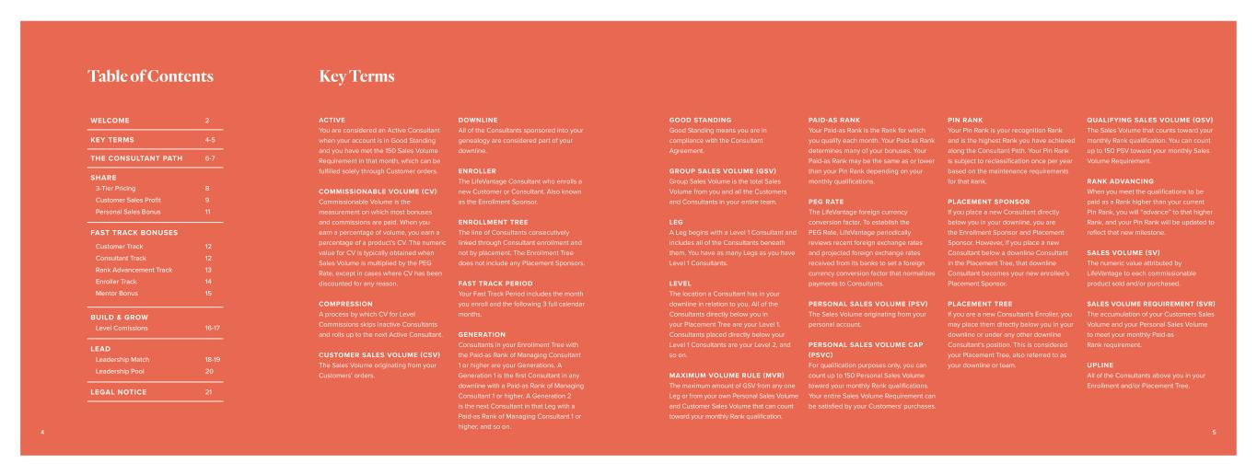
WELCOME 2 KEY TERMS 4-5 THE CONSULTANT PATH 6-7 SHARE 3-Tier Pricing Customer Sales Profit Personal Sales Bonus 8 9 11 FAST TRACK BONUSES Customer Track Consultant Track Rank Advancement Track Enroller Track Mentor Bonus 12 12 13 14 15 BUILD & GROW Level Comissions 16-17 LEAD Leadership Match Leadership Pool 18-19 20 LEGAL NOTICE 21 ACTIVE You are considered an Active Consultant when your account is in Good Standing and you have met the 150 Sales Volume Requirement in that month, which can be fulfilled solely through Customer orders. COMMISSIONABLE VOLUME (CV) Commissionable Volume is the measurement on which most bonuses and commissions are paid. When you earn a percentage of volume, you earn a percentage of a product’s CV. The numeric value for CV is typically obtained when Sales Volume is multiplied by the PEG Rate, except in cases where CV has been discounted for any reason. COMPRESSION A process by which CV for Level Commissions skips inactive Consultants and rolls up to the next Active Consultant. CUSTOMER SALES VOLUME (CSV) The Sales Volume originating from your Customers’ orders. DOWNLINE All of the Consultants sponsored into your genealogy are considered part of your downline. ENROLLER The LifeVantage Consultant who enrolls a new Customer or Consultant. Also known as the Enrollment Sponsor. ENROLLMENT TREE The line of Consultants consecutively linked through Consultant enrollment and not by placement. The Enrollment Tree does not include any Placement Sponsors. FAST TRACK PERIOD Your Fast Track Period includes the month you enroll and the following 3 full calendar months. GENERATION Consultants in your Enrollment Tree with the Paid-as Rank of Managing Consultant 1 or higher are your Generations. A Generation 1 is the first Consultant in any downline with a Paid-as Rank of Managing Consultant 1 or higher. A Generation 2 is the next Consultant in that Leg with a Paid-as Rank of Managing Consultant 1 or higher, and so on. Table of Contents Key Terms GOOD STANDING Good Standing means you are in compliance with the Consultant Agreement. GROUP SALES VOLUME (GSV) Group Sales Volume is the total Sales Volume from you and all the Customers and Consultants in your entire team. LEG A Leg begins with a Level 1 Consultant and includes all of the Consultants beneath them. You have as many Legs as you have Level 1 Consultants. LEVEL The location a Consultant has in your downline in relation to you. All of the Consultants directly below you in your Placement Tree are your Level 1. Consultants placed directly below your Level 1 Consultants are your Level 2, and so on. MAXIMUM VOLUME RULE (MVR) The maximum amount of GSV from any one Leg or from your own Personal Sales Volume and Customer Sales Volume that can count toward your monthly Rank qualification. PAID-AS RANK Your Paid-as Rank is the Rank for which you qualify each month. Your Paid-as Rank determines many of your bonuses. Your Paid-as Rank may be the same as or lower than your Pin Rank depending on your monthly qualifications. PEG RATE The LifeVantage foreign currency conversion factor. To establish the PEG Rate, LifeVantage periodically reviews recent foreign exchange rates and projected foreign exchange rates received from its banks to set a foreign currency conversion factor that normalizes payments to Consultants. PERSONAL SALES VOLUME (PSV) The Sales Volume originating from your personal account. PERSONAL SALES VOLUME CAP (PSVC) For qualification purposes only, you can count up to 150 Personal Sales Volume toward your monthly Rank qualifications. Your entire Sales Volume Requirement can be satisfied by your Customers' purchases. PIN RANK Your Pin Rank is your recognition Rank and is the highest Rank you have achieved along the Consultant Path. Your Pin Rank is subject to reclassification once per year based on the maintenance requirements for that Rank. PLACEMENT SPONSOR If you place a new Consultant directly below you in your downline, you are the Enrollment Sponsor and Placement Sponsor. However, if you place a new Consultant below a downline Consultant in the Placement Tree, that downline Consultant becomes your new enrollee’s Placement Sponsor. PLACEMENT TREE If you are a new Consultant's Enroller, you may place them directly below you in your downline or under any other downline Consultant’s position. This is considered your Placement Tree, also referred to as your downline or team. QUALIFYING SALES VOLUME (QSV) The Sales Volume that counts toward your monthly Rank qualification. You can count up to 150 PSV toward your monthly Sales Volume Requirement. RANK ADVANCING When you meet the qualifications to be paid as a Rank higher than your current Pin Rank, you will “advance” to that higher Rank, and your Pin Rank will be updated to reflect that new milestone. SALES VOLUME (SV) The numeric value attributed by LifeVantage to each commissionable product sold and/or purchased. SALES VOLUME REQUIREMENT (SVR) The accumulation of your Customers Sales Volume and your Personal Sales Volume to meet your monthly Paid-as Rank requirement. UPLINE All of the Consultants above you in your Enrollment and/or Placement Tree. 4 5

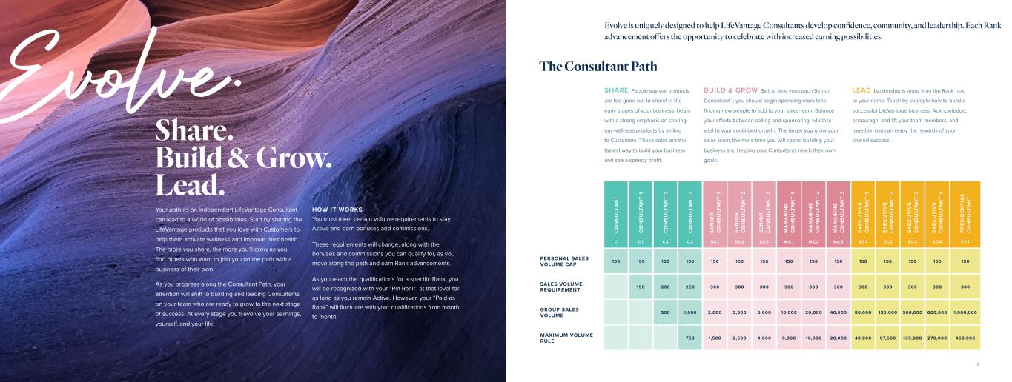
Evolve. Share. Build & Grow. Lead. Your path as an Independent LifeVantage Consultant can lead to a world of possibilities. Start by sharing the LifeVantage products that you love with Customers to help them activate wellness and improve their health. The more you share, the more you’ll grow as you find others who want to join you on the path with a business of their own. As you progress along the Consultant Path, your attention will shift to building and leading Consultants on your team who are ready to grow to the next stage of success. At every stage you’ll evolve your earnings, yourself, and your life. HOW IT WORKS You must meet certain volume requirements to stay Active and earn bonuses and commissions. These requirements will change, along with the bonuses and commissions you can qualify for, as you move along the path and earn Rank advancements. As you reach the qualifications for a specific Rank, you will be recognized with your “Pin Rank” at that level for as long as you remain Active. However, your “Paid-as Rank” will fluctuate with your qualifications from month to month. SHARE People say our products are too good not to share! In the early stages of your business, begin with a strong emphasis on sharing our wellness products by selling to Customers. These sales are the fastest way to build your business and see a speedy profit. BUILD & GROW By the time you reach Senior Consultant 1, you should begin spending more time finding new people to add to your sales team. Balance your efforts between selling and sponsoring, which is vital to your continued growth. The larger you grow your sales team, the more time you will spend building your business and helping your Consultants reach their own goals. C O N S U LT A N T C O N S U LT A N T 1 C O N S U LT A N T 2 C O N S U LT A N T 3 S EN IO R C O N S U LT A N T 1 S EN IO R C O N S U LT A N T 2 S EN IO R C O N S U LT A N T 3 M A N A G IN G C O N S U LT A N T 1 M A N A G IN G C O N S U LT A N T 2 M A N A G IN G C O N S U LT A N T 3 EX EC U TI V E C O N S U LT A N T 1 EX EC U TI V E C O N S U LT A N T 2 EX EC U TI V E C O N S U LT A N T 3 EX EC U TI V E C O N S U LT A N T 4 P R ES ID EN TI A L C O N S U LT A N T C C1 C2 C3 SC1 SC2 SC3 MC1 MC2 MC3 EC1 EC2 EC3 EC 4 PC1 PERSONAL SALES VOLUME CAP 150 150 150 150 150 150 150 150 150 150 150 150 150 150 150 SALES VOLUME REQUIREMENT 150 200 250 300 300 300 300 300 300 300 300 300 300 300 GROUP SALES VOLUME 500 1,000 2,000 3,500 6,000 10,000 20,000 40,000 80,000 150,000 300,000 600,000 1,000,000 MAXIMUM VOLUME RULE 750 1,500 2,500 4,000 6,000 10,000 20,000 40,000 67,500 135,000 270,000 450,000 LEAD Leadership is more than the Rank next to your name. Teach by example how to build a successful LifeVantage business. Acknowledge, encourage, and lift your team members, and together you can enjoy the rewards of your shared success! The Consultant Path Evolve is uniquely designed to help LifeVantage Consultants develop confidence, community, and leadership. Each Rank advancement offers the opportunity to celebrate with increased earning possibilities. 6 7

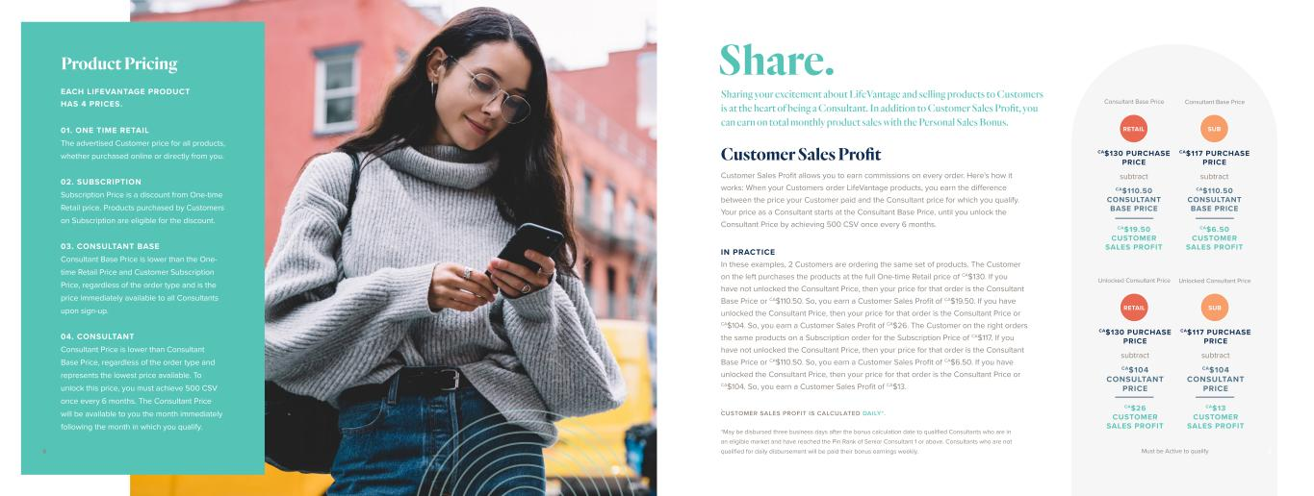
EACH LIFEVANTAGE PRODUCT HAS 4 PRICES. 03. CONSULTANT BASE Consultant Base Price is lower than the One- time Retail Price and Customer Subscription Price, regardless of the order type and is the price immediately available to all Consultants upon sign-up. 04. CONSULTANT Consultant Price is lower than Consultant Base Price, regardless of the order type and represents the lowest price available. To unlock this price, you must achieve 500 CSV once every 6 months. The Consultant Price will be available to you the month immediately following the month in which you qualify. 02. SUBSCRIPTION Subscription Price is a discount from One-time Retail price. Products purchased by Customers on Subscription are eligible for the discount. 01. ONE TIME RETAIL The advertised Customer price for all products, whether purchased online or directly from you. Product Pricing Customer Sales Profit allows you to earn commissions on every order. Here's how it works: When your Customers order LifeVantage products, you earn the difference between the price your Customer paid and the Consultant price for which you qualify. Your price as a Consultant starts at the Consultant Base Price, until you unlock the Consultant Price by achieving 500 CSV once every 6 months. IN PRACTICE In these examples, 2 Customers are ordering the same set of products. The Customer on the left purchases the products at the full One-time Retail price of CA$130. If you have not unlocked the Consultant Price, then your price for that order is the Consultant Base Price or CA$110.50. So, you earn a Customer Sales Profit of CA$19.50. If you have unlocked the Consultant Price, then your price for that order is the Consultant Price or CA$104. So, you earn a Customer Sales Profit of CA$26. The Customer on the right orders the same products on a Subscription order for the Subscription Price of CA$117. If you have not unlocked the Consultant Price, then your price for that order is the Consultant Base Price or CA$110.50. So, you earn a Customer Sales Profit of CA$6.50. If you have unlocked the Consultant Price, then your price for that order is the Consultant Price or CA$104. So, you earn a Customer Sales Profit of CA$13. . CUSTOMER SALES PROFIT IS CALCULATED DAILY*. *May be disbursed three business days after the bonus calculation date to qualified Consultants who are in an eligible market and have reached the Pin Rank of Senior Consultant 1 or above. Consultants who are not qualified for daily disbursement will be paid their bonus earnings weekly. Sharing your excitement about LifeVantage and selling products to Customers is at the heart of being a Consultant. In addition to Customer Sales Profit, you can earn on total monthly product sales with the Personal Sales Bonus. Customer Sales Profit Share. Must be Active to qualify RETAIL CA$130 PURCHASE PRICE CA$19.50 CUSTOMER SALES PROFIT subtract CA$110.50 CONSULTANT BASE PRICE Consultant Base Price RETAIL CA$130 PURCHASE PRICE CA$26 CUSTOMER SALES PROFIT subtract CA$104 CONSULTANT PRICE Unlocked Consultant Price SUB CA$117 PURCHASE PRICE CA$6.50 CUSTOMER SALES PROFIT subtract CA$110.50 CONSULTANT BASE PRICE Consultant Base Price SUB CA$117 PURCHASE PRICE CA$13 CUSTOMER SALES PROFIT subtract CA$104 CONSULTANT PRICE Unlocked Consultant Price 98

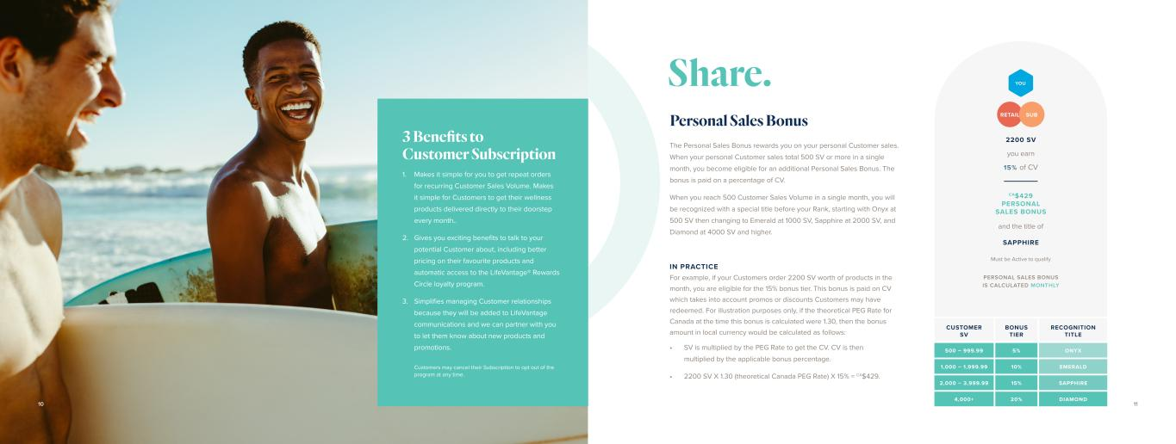
Must be Active to qualify Customers may cancel their Subscription to opt out of the program at any time. CUSTOMER SV BONUS TIER RECOGNITION TITLE 500 – 999.99 5% ONYX 1,000 – 1,999.99 10% EMERALD 2,000 – 3,999.99 15% SAPPHIRE 4,000+ 20% DIAMOND Personal Sales Bonus The Personal Sales Bonus rewards you on your personal Customer sales. When your personal Customer sales total 500 SV or more in a single month, you become eligible for an additional Personal Sales Bonus. The bonus is paid on a percentage of CV. When you reach 500 Customer Sales Volume in a single month, you will be recognized with a special title before your Rank, starting with Onyx at 500 SV then changing to Emerald at 1000 SV, Sapphire at 2000 SV, and Diamond at 4000 SV and higher. IN PRACTICE For example, if your Customers order 2200 SV worth of products in the month, you are eligible for the 15% bonus tier. This bonus is paid on CV which takes into account promos or discounts Customers may have redeemed. For illustration purposes only, if the theoretical PEG Rate for Canada at the time this bonus is calculated were 1.30, then the bonus amount in local currency would be calculated as follows: • SV is multiplied by the PEG Rate to get the CV. CV is then multiplied by the applicable bonus percentage. • 2200 SV X 1.30 (theoretical Canada PEG Rate) X 15% = CA$429. PERSONAL SALES BONUS IS CALCULATED MONTHLY Makes it simple for you to get repeat orders for recurring Customer Sales Volume. Makes it simple for Customers to get their wellness products delivered directly to their doorstep every month.. Gives you exciting benefits to talk to your potential Customer about, including better pricing on their favourite products and automatic access to the LifeVantage® Rewards Circle loyalty program. Simplifies managing Customer relationships because they will be added to LifeVantage communications and we can partner with you to let them know about new products and promotions. 1. 2. 3. 3 Benefits to Customer Subscription Share. 1110 2200 SV SAPPHIRE CA$429 PERSONAL SALES BONUS you earn 15% of CV and the title of RETAIL SUB YOU

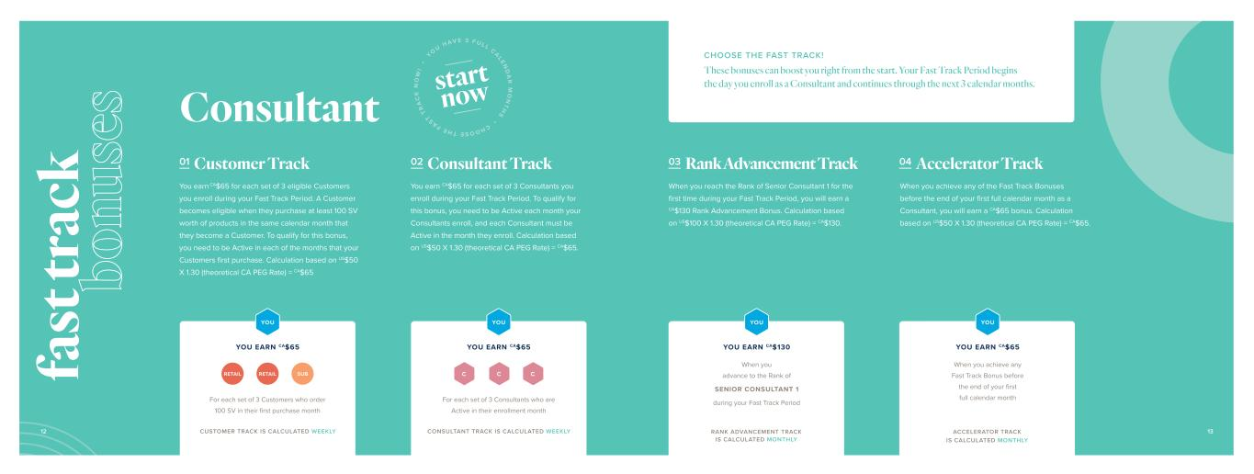
Consultant 01 Customer Track You earn CA$65 for each set of 3 eligible Customers you enroll during your Fast Track Period. A Customer becomes eligible when they purchase at least 100 SV worth of products in the same calendar month that they become a Customer. To qualify for this bonus, you need to be Active in each of the months that your Customers first purchase. Calculation based on US$50 X 1.30 (theoretical CA PEG Rate) = CA$65 02 Consultant Track You earn CA$65 for each set of 3 Consultants you enroll during your Fast Track Period. To qualify for this bonus, you need to be Active each month your Consultants enroll, and each Consultant must be Active in the month they enroll. Calculation based on US$50 X 1.30 (theoretical CA PEG Rate) = CA$65. C C C For each set of 3 Customers who order 100 SV in their first purchase month For each set of 3 Consultants who are Active in their enrollment month YOU EARN CA$65 YOU EARN CA$65 RETAIL RETAIL SUB CHOOSE THE FAST TRACK! These bonuses can boost you right from the start. Your Fast Track Period begins the day you enroll as a Consultant and continues through the next 3 calendar months. YOU YOU CUSTOMER TRACK IS CALCULATED WEEKLY CONSULTANT TRACK IS CALCULATED WEEKLY 03 Rank Advancement Track 04 Accelerator Track When you reach the Rank of Senior Consultant 1 for the first time during your Fast Track Period, you will earn a CA$130 Rank Advancement Bonus. Calculation based on US$100 X 1.30 (theoretical CA PEG Rate) = CA$130. When you achieve any of the Fast Track Bonuses before the end of your first full calendar month as a Consultant, you will earn a CA$65 bonus. Calculation based on US$50 X 1.30 (theoretical CA PEG Rate) = CA$65. YOU EARN CA$65 When you achieve any Fast Track Bonus before the end of your first full calendar month YOU YOU EARN CA$130 When you advance to the Rank of SENIOR CONSULTANT 1 during your Fast Track Period YOU RANK ADVANCEMENT TRACK IS CALCULATED MONTHLY ACCELERATOR TRACK IS CALCULATED MONTHLY 12 13 fa st tr ac k bo nu se s CHOOSE THE FAST T R A C K N O W ! • YO U H AV E 3 F U L L CALEN D A R M O N T H S • start now

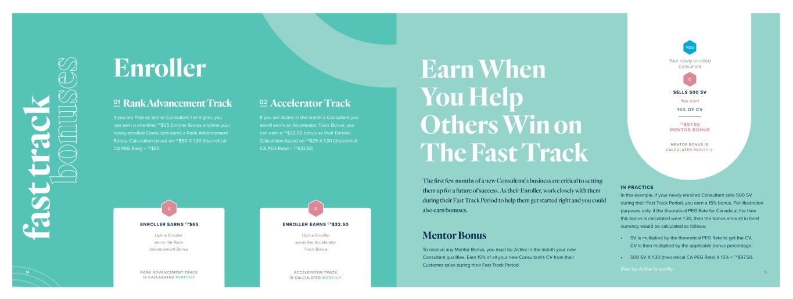
01 Rank Advancement Track 02 Accelerator Track Mentor Bonus If you are Paid-as Senior Consultant 1 or higher, you can earn a one-time CA$65 Enroller Bonus anytime your newly enrolled Consultant earns a Rank Advancement Bonus. Calculation based on US$50 X 1.30 (theoretical CA PEG Rate) = CA$65. If you are Active in the month a Consultant you enroll earns an Accelerator Track Bonus, you can earn a CA$32.50 bonus as their Enroller. Calculation based on US$25 X 1.30 (theoretical CA PEG Rate) = CA$32.50. IN PRACTICE In this example, if your newly enrolled Consultant sells 500 SV during their Fast Track Period, you earn a 15% bonus. For illustration purposes only, if the theoretical PEG Rate for Canada at the time this bonus is calculated were 1.30, then the bonus amount in local currency would be calculated as follows: • SV is multiplied by the theoretical PEG Rate to get the CV. CV is then multiplied by the applicable bonus percentage. • 500 SV X 1.30 (theoretical CA PEG Rate) X 15% = CA$97.50. To receive any Mentor Bonus, you must be Active in the month your new Consultant qualifies. Earn 15% of all your new Consultant’s CV from their Customer sales during their Fast Track Period. Must be Active to qualify. Enroller RANK ADVANCEMENT TRACK IS CALCULATED MONTHLY Upline Enroller earns the Rank Advancement Bonus C ACCELERATOR TRACK IS CALCULATED MONTHLY Upline Enroller earns the Accelerator Track Bonus C You earn 15% OF CV Your newly enrolled Consultant YOU C SELLS 500 SV CA$97.50 MENTOR BONUS MENTOR BONUS IS CALCULATED MONTHLY ENROLLER EARNS CA$65 ENROLLER EARNS CA$32.50 Earn When You Help Others Win on The Fast Track The first few months of a new Consultant’s business are critical to setting them up for a future of success. As their Enroller, work closely with them during their Fast Track Period to help them get started right and you could also earn bonuses. 14 15 fa st tr ac k bo nu se s

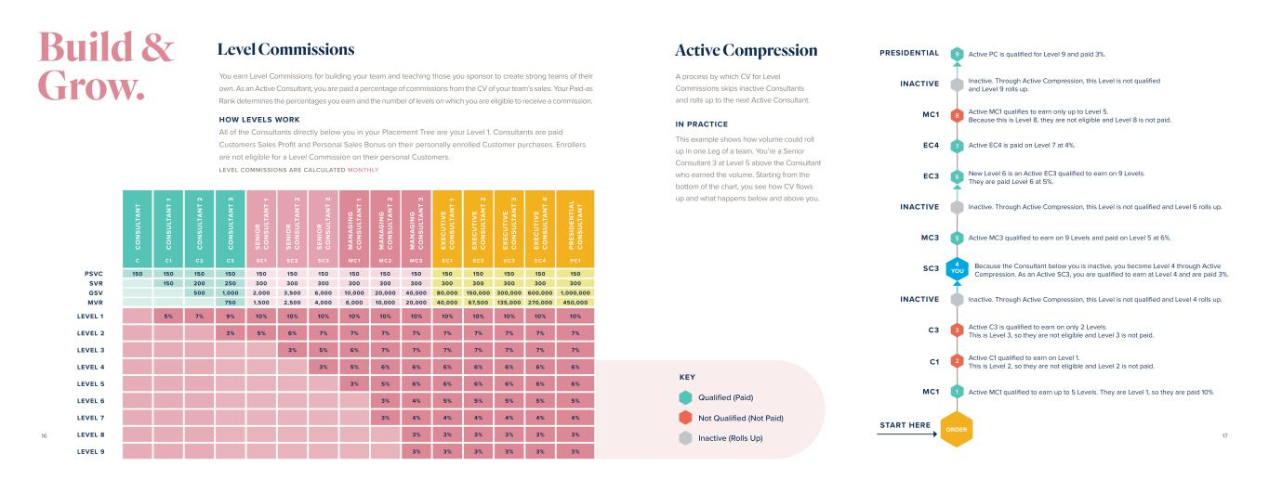
Level Commissions Active Compression C O N S U LT A N T C O N S U LT A N T 1 C O N S U LT A N T 2 C O N S U LT A N T 3 S EN IO R C O N S U LT A N T 1 S EN IO R C O N S U LT A N T 2 S EN IO R C O N S U LT A N T 3 M A N A G IN G C O N S U LT A N T 1 M A N A G IN G C O N S U LT A N T 2 M A N A G IN G C O N S U LT A N T 3 EX EC U TI V E C O N S U LT A N T 1 EX EC U TI V E C O N S U LT A N T 2 EX EC U TI V E C O N S U LT A N T 3 EX EC U TI V E C O N S U LT A N T 4 P R ES ID EN TI A L C O N S U LT A N T C C1 C2 C3 SC1 SC2 SC3 MC1 MC2 MC3 EC1 EC2 EC3 EC 4 PC1 150 150 150 150 150 150 150 150 150 150 150 150 150 150 150 150 200 250 300 300 300 300 300 300 300 300 300 300 300 500 1,000 2,000 3,500 6,000 10,000 20,000 40,000 80,000 150,000 300,000 600,000 1,000,000 750 1,500 2,500 4,000 6,000 10,000 20,000 40,000 67,500 135,000 270,000 450,000 LEVEL 1 5% 7% 9% 10% 10% 10% 10% 10% 10% 10% 10% 10% 10% 10% LEVEL 2 3% 5% 6% 7% 7% 7% 7% 7% 7% 7% 7% 7% LEVEL 3 3% 5% 6% 7% 7% 7% 7% 7% 7% 7% LEVEL 4 3% 5% 6% 6% 6% 6% 6% 6% 6% LEVEL 5 3% 5% 6% 6% 6% 6% 6% 6% LEVEL 6 3% 4% 5% 5% 5% 5% 5% LEVEL 7 3% 4% 4% 4% 4% 4% 4% LEVEL 8 3% 3% 3% 3% 3% 3% LEVEL 9 3% 3% 3% 3% 3% 3% 9 8 5 3 7 2 6 1 ORDER MC1 START HERE C1 C3 INACTIVE SC3 MC3 INACTIVE EC3 EC4 MC1 INACTIVE PRESIDENTIAL 4 YOU Active MC1 qualified to earn up to 5 Levels. They are Level 1, so they are paid 10% Active C1 qualified to earn on Level 1. This is Level 2, so they are not eligible and Level 2 is not paid. Active C3 is qualified to earn on only 2 Levels. This is Level 3, so they are not eligible and Level 3 is not paid. Inactive. Through Active Compression, this Level is not qualified and Level 4 rolls up. Because the Consultant below you is inactive, you become Level 4 through Active Compression. As an Active SC3, you are qualified to earn at Level 4 and are paid 3%. Active MC3 qualified to earn on 9 Levels and paid on Level 5 at 6%. Inactive. Through Active Compression, this Level is not qualified and Level 6 rolls up. New Level 6 is an Active EC3 qualified to earn on 9 Levels. They are paid Level 6 at 5%. Active EC4 is paid on Level 7 at 4%. Active MC1 qualifies to earn only up to Level 5. Because this is Level 8, they are not eligible and Level 8 is not paid. Inactive. Through Active Compression, this Level is not qualified and Level 9 rolls up. Active PC is qualified for Level 9 and paid 3%. A process by which CV for Level Commissions skips inactive Consultants and rolls up to the next Active Consultant. IN PRACTICE This example shows how volume could roll up in one Leg of a team. You’re a Senior Consultant 3 at Level 5 above the Consultant who earned the volume. Starting from the bottom of the chart, you see how CV flows up and what happens below and above you. KEY Qualified (Paid) Not Qualified (Not Paid) Inactive (Rolls Up) You earn Level Commissions for building your team and teaching those you sponsor to create strong teams of their own. As an Active Consultant, you are paid a percentage of commissions from the CV of your team’s sales. Your Paid-as Rank determines the percentages you earn and the number of levels on which you are eligible to receive a commission. HOW LEVELS WORK All of the Consultants directly below you in your Placement Tree are your Level 1. Consultants are paid Customers Sales Profit and Personal Sales Bonus on their personally enrolled Customer purchases. Enrollers are not eligible for a Level Commission on their personal Customers. LEVEL COMMISSIONS ARE CALCULATED MONTHLY 16 17 Build & Grow. PSVC SVR GSV MVR

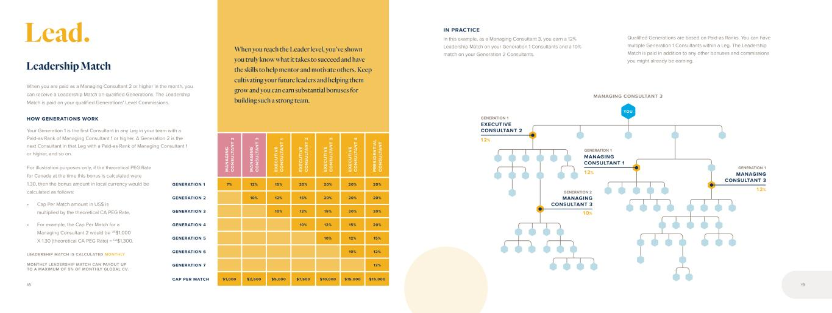
M A N A G IN G C O N S U LT A N T 2 M A N A G IN G C O N S U LT A N T 3 EX EC U TI V E C O N S U LT A N T 1 EX EC U TI V E C O N S U LT A N T 2 EX EC U TI V E C O N S U LT A N T 3 EX EC U TI V E C O N S U LT A N T 4 P R ES ID EN TI A L C O N S U LT A N T GENERATION 1 7% 12% 15% 20% 20% 20% 20% GENERATION 2 10% 12% 15% 20% 20% 20% GENERATION 3 10% 12% 15% 20% 20% GENERATION 4 10% 12% 15% 20% GENERATION 5 10% 12% 15% GENERATION 6 10% 12% GENERATION 7 12% CAP PER MATCH $1,000 $2,500 $5,000 $7,500 $10,000 $15,000 $15,000 When you are paid as a Managing Consultant 2 or higher in the month, you can receive a Leadership Match on qualified Generations. The Leadership Match is paid on your qualified Generations' Level Commissions. HOW GENERATIONS WORK Your Generation 1 is the first Consultant in any Leg in your team with a Paid-as Rank of Managing Consultant 1 or higher. A Generation 2 is the next Consultant in that Leg with a Paid-as Rank of Managing Consultant 1 or higher, and so on. LEADERSHIP MATCH IS CALCULATED MONTHLY MONTHLY LEADERSHIP MATCH CAN PAYOUT UP TO A MAXIMUM OF 9% OF MONTHLY GLOBAL CV. For illustration purposes only, if the theoretical PEG Rate for Canada at the time this bonus is calculated were 1.30, then the bonus amount in local currency would be calculated as follows: • Cap Per Match amount in US$ is multiplied by the theoretical CA PEG Rate. • For example, the Cap Per Match for a Managing Consultant 2 would be US$1,000 X 1.30 (theoretical CA PEG Rate) = CA$1,300. Leadership Match When you reach the Leader level, you’ve shown you truly know what it takes to succeed and have the skills to help mentor and motivate others. Keep cultivating your future leaders and helping them grow and you can earn substantial bonuses for building such a strong team. YOU MANAGING CONSULTANT 3 10% 12% EXECUTIVE CONSULTANT 2 12% MANAGING CONSULTANT 1 12% MANAGING CONSULTANT 3 MANAGING CONSULTANT 3 IN PRACTICE In this example, as a Managing Consultant 3, you earn a 12% Leadership Match on your Generation 1 Consultants and a 10% match on your Generation 2 Consultants. Qualified Generations are based on Paid-as Ranks. You can have multiple Generation 1 Consultants within a Leg. The Leadership Match is paid in addition to any other bonuses and commissions you might already be earning. GENERATION 1 GENERATION 1 GENERATION 2 GENERATION 1 18 19 Lead.

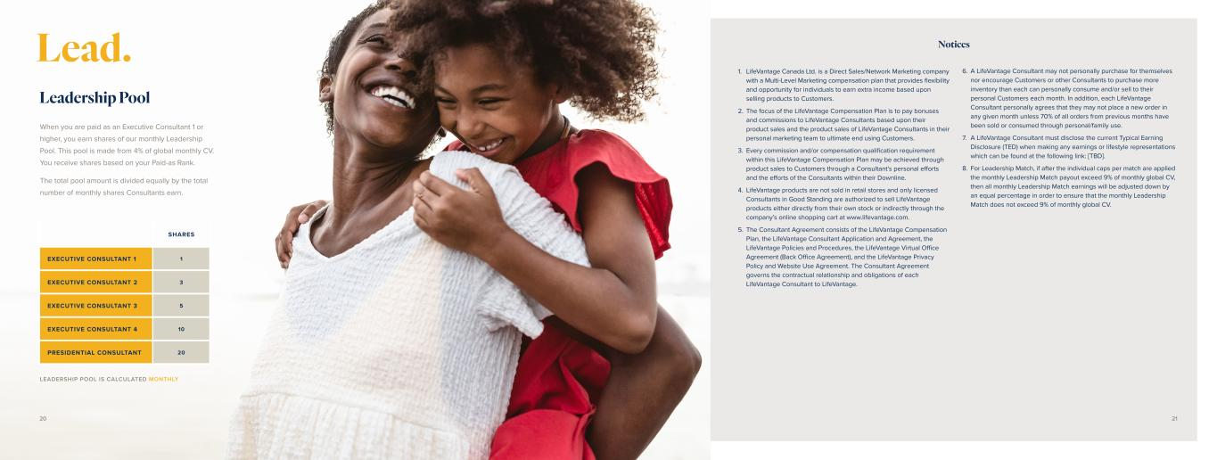
When you are paid as an Executive Consultant 1 or higher, you earn shares of our monthly Leadership Pool. This pool is made from 4% of global monthly CV. You receive shares based on your Paid-as Rank. The total pool amount is divided equally by the total number of monthly shares Consultants earn. Leadership Pool SHARES EXECUTIVE CONSULTANT 1 1 EXECUTIVE CONSULTANT 2 3 EXECUTIVE CONSULTANT 3 5 EXECUTIVE CONSULTANT 4 10 PRESIDENTIAL CONSULTANT 20 LEADERSHIP POOL IS CALCULATED MONTHLY Lead. Notices 1. LifeVantage Canada Ltd. is a Direct Sales/Network Marketing company with a Multi-Level Marketing compensation plan that provides flexibility and opportunity for individuals to earn extra income based upon selling products to Customers. 2. The focus of the LifeVantage Compensation Plan is to pay bonuses and commissions to LifeVantage Consultants based upon their product sales and the product sales of LifeVantage Consultants in their personal marketing team to ultimate end using Customers. 3. Every commission and/or compensation qualification requirement within this LifeVantage Compensation Plan may be achieved through product sales to Customers through a Consultant’s personal efforts and the efforts of the Consultants within their Downline. 4. LifeVantage products are not sold in retail stores and only licensed Consultants in Good Standing are authorized to sell LifeVantage products either directly from their own stock or indirectly through the company’s online shopping cart at www.lifevantage.com. 5. The Consultant Agreement consists of the LifeVantage Compensation Plan, the LifeVantage Consultant Application and Agreement, the LifeVantage Policies and Procedures, the LifeVantage Virtual Office Agreement (Back Office Agreement), and the LifeVantage Privacy Policy and Website Use Agreement. The Consultant Agreement governs the contractual relationship and obligations of each LifeVantage Consultant to LifeVantage. 6. A LifeVantage Consultant may not personally purchase for themselves nor encourage Customers or other Consultants to purchase more inventory than each can personally consume and/or sell to their personal Customers each month. In addition, each LifeVantage Consultant personally agrees that they may not place a new order in any given month unless 70% of all orders from previous months have been sold or consumed through personal/family use. 7. A LifeVantage Consultant must disclose the current Typical Earning Disclosure (TED) when making any earnings or lifestyle representations which can be found at the following link: [TBD]. 8. For Leadership Match, if after the individual caps per match are applied the monthly Leadership Match payout exceed 9% of monthly global CV, then all monthly Leadership Match earnings will be adjusted down by an equal percentage in order to ensure that the monthly Leadership Match does not exceed 9% of monthly global CV. 20 21


Notes 22 23


Evolve © 2 02 3 Li fe Va nt ag e C or po ra tio n. A ll rig ht s re se rv ed . 08 09 23 .0 6


Evolve GUÍA DEL PLAN DE COMPENSACIÓN PARA CONSULTORES INDEPENDIENTES DE LIFEVANTAGE MÉXICO Válido a partir del 1° de febrero de 2024


activadaLa vida. Es complicada. Caótica. Hermosa. La vida pasa rápido y quierevivirla al máximo,pero las responsabilidades cotidianas, los miedos o las restricciones pueden frenarlo. Merece ser libre. Merece ser su mejor yo y vivir una vida sana y feliz en sus propios términos. LifeVantage está aquí para ayudarlo. Nuestros productos están diseñados a conciencia para activar la capacidad de su cuerpo de crear una salud vibrante, empezando a nivel celular. Y cuando se vea y se sienta lo mejor posible, querrá ayudar a los demás a hacer lo mismo. LifeVantage activa el bienestar financiero con la oportunida de crecer en un negocio que puede mejorar la vida de las personas. Es ahí donde Evolve crea posibilidades. Evolve es un plan de Compensación que le permite trabajar a medio tiempo o a tiempo completo.* Si lo que busca es simplemente compartir productos que cambien vidas o quieres trabajar y crecer como mentor y líder profesional, ser Consultor Independiente de LifeVantage® lo desafiará y le recompensará positivamente. Bienvenido a una Vida YA ES HORA DE VIVIR CON PROPÓSITO. ES HORA DE INSPIRAR LO EXTRAORDINARIO. ES HORA DE UNA VIDA ACTIVADA. *LifeVantage no promete el éxito económico de ningún Consultor. Su éxito dependerá de sus habilidades, fortaleza, dedicación, además de su capacidad para llevar a otros a imitar esas cualidades. Nada en esta guía pretende ser una garantía de que tendrá éxito financiero. LifeVantage no garantiza ningún ingreso ni éxito relacionado a rangos. 2 3

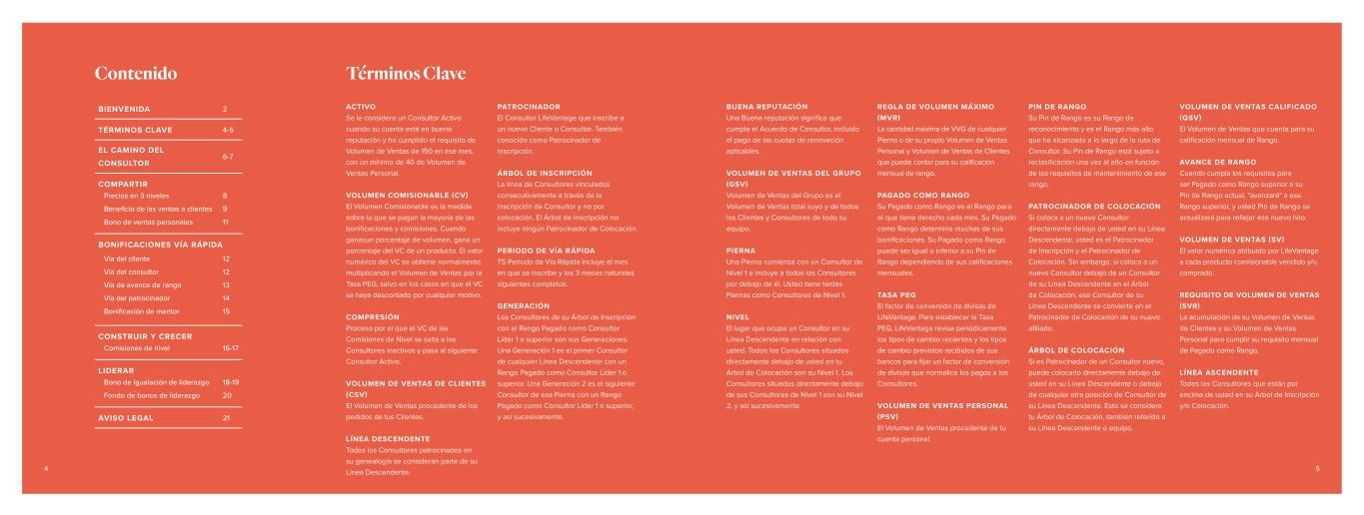
BIENVENIDA 2 TÉRMINOS CLAVE 4-5 EL CAMINO DEL CONSULTOR 6-7 COMPARTIR Precios en 3 niveles Beneficio de las ventas a clientes Bono de ventas personales 8 9 11 BONIFICACIONES VÍA RÁPIDA Vía del cliente Vía del consultor Vía de avance de rango Vía del patrocinador Bonificación de mentor 12 12 13 14 15 CONSTRUIR Y CRECER Comisiones de nivel 16-17 LIDERAR Bono de igualación de liderazgo Fondo de bonos de liderazgo 18-19 20 AVISO LEGAL 21 ACTIVO Se le considera un Consultor Activo cuando su cuenta está en buena reputación y ha cumplido el requisito de Volumen de Ventas de 150 en ese mes, con un mínimo de 40 de Volumen de Ventas Personal. VOLUMEN COMISIONABLE (CV) El Volumen Comisionable es la medida sobre la que se pagan la mayoría de las bonificaciones y comisiones. Cuando ganasun porcentaje de volumen, gana un porcentaje del VC de un producto. El valor numérico del VC se obtiene normalmente multiplicando el Volumen de Ventas por la Tasa PEG, salvo en los casos en que el VC se haya descontado por cualquier motivo. COMPRESIÓN Proceso por el que el VC de las Comisiones de Nivel se salta a los Consultores inactivos y pasa al siguiente Consultor Activo. VOLUMEN DE VENTAS DE CLIENTES (CSV) El Volumen de Ventas procedente de los pedidos de tus Clientes. LÍNEA DESCENDENTE Todos los Consultores patrocinados en su genealogía se consideran parte de su Línea Descendente. PATROCINADOR El Consultor LifeVantage que inscribe a un nuevo Cliente o Consultor. También conocido como Patrocinador de Inscripción. ÁRBOL DE INSCRIPCIÓN La línea de Consultores vinculados consecutivamente a través de la inscripción de Consultor y no por colocación. El Árbol de Inscripción no incluye ningún Patrocinador de Colocación. PERIODO DE VÍA RÁPIDA TS Periodo de Vía Rápida incluye el mes en que se inscribe y los 3 meses naturales siguientes completos. GENERACIÓN Los Consultores de su Árbol de Inscripción con el Rango Pagado como Consultor Líder 1 o superior son sus Generaciones. Una Generación 1 es el primer Consultor de cualquier Línea Descendente con un Rango Pagado como Consultor Líder 1 o superior. Una Generación 2 es el siguiente Consultor de esa Pierna con un Rango Pagado como Consultor Líder 1 o superior, y así sucesivamente. Contenido Términos Clave BUENA REPUTACIÓN Una Buena reputación significa que cumple el Acuerdo de Consultor, incluido el pago de las cuotas de renovación aplicables. VOLUMEN DE VENTAS DEL GRUPO (GSV) Volumen de Ventas del Grupo es el Volumen de Ventas total suyo y de todos los Clientes y Consultores de todo su equipo. PIERNA Una Pierna comienza con un Consultor de Nivel 1 e incluye a todos los Consultores por debajo de él. Usted tiene tantas Piernas como Consultores de Nivel 1. NIVEL El lugar que ocupa un Consultor en su Línea Descendente en relación con usted. Todos los Consultores situados directamente debajo de usted en tu Árbol de Colocación son su Nivel 1. Los Consultores situados directamente debajo de sus Consultores de Nivel 1 son su Nivel 2, y así sucesivamente. REGLA DE VOLUMEN MÁXIMO (MVR) La cantidad máxima de VVG de cualquier Pierna o de su propio Volumen de Ventas Personal y Volumen de Ventas de Clientes que puede contar para su calificación mensual de rango. PAGADO COMO RANGO Su Pagado como Rango es el Rango para el que tiene derecho cada mes. Su Pagado como Rango determina muchas de sus bonificaciones. Su Pagado como Rango puede ser igual o inferior a su Pin de Rango dependiendo de sus calificaciones mensuales. TASA PEG El factor de conversión de divisas de LifeVantage. Para establecer la Tasa PEG, LifeVantage revisa periódicamente los tipos de cambio recientes y los tipos de cambio previstos recibidos de sus bancos para fijar un factor de conversión de divisas que normalice los pagos a los Consultores. VOLUMEN DE VENTAS PERSONAL (PSV) El Volumen de Ventas procedente de tu cuenta personal. PIN DE RANGO Su Pin de Rango es su Rango de reconocimiento y es el Rango más alto que ha alcanzado a lo largo de la ruta de Consultor. Su Pin de Rango está sujeto a reclasificación una vez al año en función de los requisitos de mantenimiento de ese rango. PATROCINADOR DE COLOCACIÓN Si coloca a un nuevo Consultor directamente debajo de usted en su Línea Descendente, usted es el Patrocinador de Inscripción y el Patrocinador de Colocación. Sin embargo, si coloca a un nuevo Consultor debajo de un Consultor de su Línea Descendente en el Árbol de Colocación, ese Consultor de su Línea Descendente se convierte en el Patrocinador de Colocación de su nuevo afiliado. ÁRBOL DE COLOCACIÓN Si es Patrocinador de un Consultor nuevo, puede colocarlo directamente debajo de usted en su Línea Descendente o debajo de cualquier otra posición de Consultor de su Línea Descendente. Esto se considera tu Árbol de Colocación, también referido a su Línea Descendente o equipo. VOLUMEN DE VENTAS CALIFICADO (QSV) El Volumen de Ventas que cuenta para su calificación mensual de Rango. AVANCE DE RANGO Cuando cumpla los requisitos para ser Pagado como Rango superior a su Pin de Rango actual, "avanzará" a ese Rango superior, y usted Pin de Rango se actualizará para reflejar ese nuevo hito. VOLUMEN DE VENTAS (SV) El valor numérico atribuido por LifeVantage a cada producto comisionable vendido y/o comprado. REQUISITO DE VOLUMEN DE VENTAS (SVR) La acumulación de su Volumen de Ventas de Clientes y su Volumen de Ventas Personal para cumplir su requisito mensual de Pagado como Rango. LÍNEA ASCENDENTE Todos los Consultores que están por encima de usted en su Árbol de Inscripción y/o Colocación. 4 5

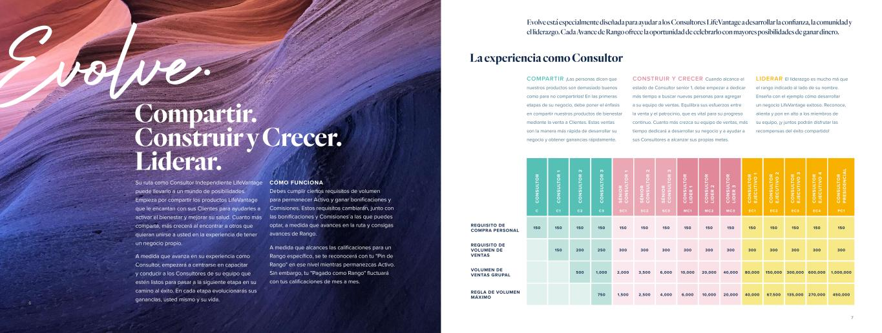
Evolve. Compartir. Construir y Crecer. Liderar. Su ruta como Consultor Independiente LifeVantage puede llevarlo a un mundo de posibilidades. Empieza por compartir los productos LifeVantage que le encantan con sus Clientes para ayudarles a activar el bienestar y mejorar su salud. Cuanto más comparta, más crecerá al encontrar a otros que quieran unirse a usted en la experiencia de tener un negocio propio. A medida que avanza en su experiencia como Consultor, empezará a centrarse en capacitar y conducir a los Consultores de su equipo que estén listos para pasar a la siguiente etapa en su camino al éxito. En cada etapa evolucionarás sus ganancias, usted mismo y su vida. CÓMO FUNCIONA Debes cumplir ciertos requisitos de volumen para permanecer Activo y ganar bonificaciones y Comisiones. Estos requisitos cambiarán, junto con las bonificaciones y Comisiones a las que puedes optar, a medida que avances en la ruta y consigas avances de Rango. A medida que alcances las calificaciones para un Rango específico, se te reconocerá con tu "Pin de Rango" en ese nivel mientras permanezcas Activo. Sin embargo, tu "Pagado como Rango" fluctuará con tus calificaciones de mes a mes. COMPARTIR ¡Las personas dicen que nuestros productos son demasiado buenos como para no compartirlos! En las primeras etapas de su negocio, debe poner el énfasis en compartir nuestros productos de bienestar mediante la venta a Clientes. Estas ventas son la manera más rápida de desarrollar su negocio y obtener ganancias rápidamente. CONSTRUIR Y CRECER Cuando alcance el estado de Consultor senior 1, debe empezar a dedicar más tiempo a buscar nuevas personas para agregar a su equipo de ventas. Equilibra sus esfuerzos entre la venta y el patrocinio, que es vital para su progreso continuo. Cuanto más crezca su equipo de ventas, más tiempo dedicará a desarrollar su negocio y a ayudar a sus Consultores a alcanzar sus propias metas. C O N S U LT O R C O N S U LT O R 1 C O N S U LT O R 2 C O N S U LT O R 3 S ÉN IO R C O N S U LT O R 1 S ÉN IO R C O N S U LT O R 2 S ÉN IO R C O N S U LT O R 3 C O N S U LT O R LI D ER 1 C O N S U LT O R LI D ER 2 C O N S U LT O R LI D ER 3 C O N S U LT O R EJ EC U TI V O 1 C O N S U LT O R EJ EC U TI V O 2 C O N S U LT O R EJ EC U TI V O 3 C O N S U LT O R EJ EC U TI V O 4 C O N S U LT O R P R ES ID EN C IA L C C1 C2 C3 SC1 SC2 SC3 MC1 MC2 MC3 EC1 EC2 EC3 EC 4 PC1 REQUISITO DE COMPRA PERSONAL 150 150 150 150 150 150 150 150 150 150 150 150 150 150 150 REQUISITO DE VOLUMEN DE VENTAS 150 200 250 300 300 300 300 300 300 300 300 300 300 300 VOLUMEN DE VENTAS GRUPAL 500 1,000 2,000 3,500 6,000 10,000 20,000 40,000 80,000 150,000 300,000 600,000 1,000,000 REGLA DE VOLUMEN MÁXIMO 750 1,500 2,500 4,000 6,000 10,000 20,000 40,000 67,500 135,000 270,000 450,000 LIDERAR El liderazgo es mucho má que el rango indicado al lado de su nombre. Enseña con el ejemplo cómo desarrollar un negocio LifeVantage exitoso. Reconoce, alienta y pon en alto a los miembros de su equipo, ¡y juntos podrán disfrutar las recompensas del éxito compartido! La experiencia como Consultor Evolve está especialmente diseñada para ayudar a los Consultores LifeVantage a desarrollar la confianza, la comunidad y el liderazgo. Cada Avance de Rango ofrece la oportunidad de celebrarlo con mayores posibilidades de ganar dinero. 6 7

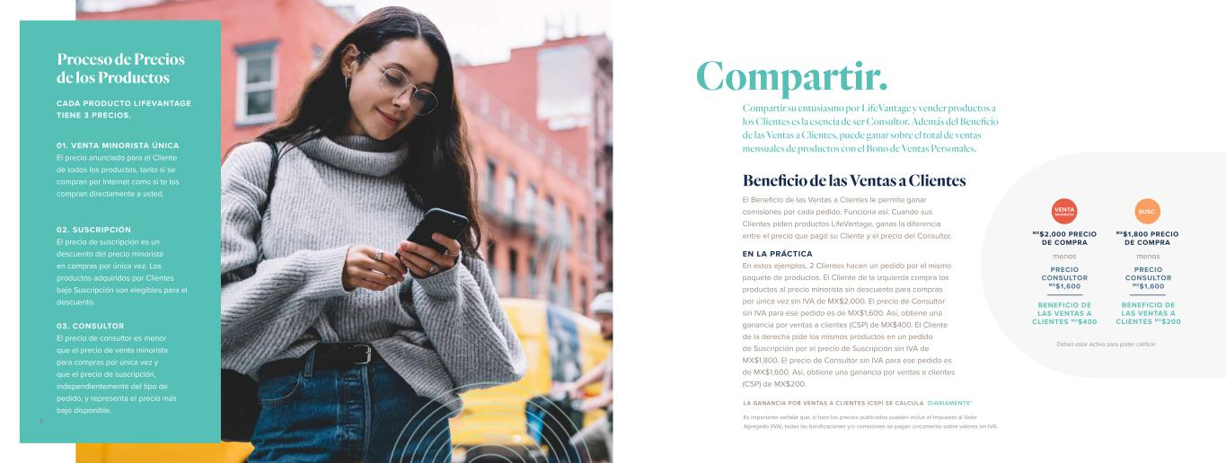
CADA PRODUCTO LIFEVANTAGE TIENE 3 PRECIOS. 03. CONSULTOR El precio de consultor es menor que el precio de venta minorista para compras por única vez y que el precio de suscripción, independientemente del tipo de pedido, y representa el precio más bajo disponible. 02. SUSCRIPCIÓN El precio de suscripción es un descuento del precio minorista en compras por única vez. Los productos adquiridos por Clientes bajo Suscripción son elegibles para el descuento. 01. VENTA MINORISTA ÚNICA El precio anunciado para el Cliente de todos los productos, tanto si se compran por Internet como si te los compran directamente a usted. Proceso de Precios de los Productos El Beneficio de las Ventas a Clientes le permite ganar comisiones por cada pedido. Funciona así: Cuando sus Clientes piden productos LifeVantage, ganas la diferencia entre el precio que pagó su Cliente y el precio del Consultor. EN LA PRÁCTICA En estos ejemplos, 2 Clientes hacen un pedido por el mismo paquete de productos. El Cliente de la izquierda compra los productos al precio minorista sin descuento para compras por única vez sin IVA de MX$2,000. El precio de Consultor sin IVA para ese pedido es de MX$1,600. Así, obtiene una ganancia por ventas a clientes (CSP) de MX$400. El Cliente de la derecha pide los mismos productos en un pedido de Suscripción por el precio de Suscripción sin IVA de MX$1,800. El precio de Consultor sin IVA para ese pedido es de MX$1,600. Así, obtiene una ganancia por ventas a clientes (CSP) de MX$200. VENTA MINORISTA SUSC. MX$2,000 PRECIO DE COMPRA BENEFICIO DE LAS VENTAS A CLIENTES MX$400 BENEFICIO DE LAS VENTAS A CLIENTES MX$200 menos PRECIO CONSULTOR MX$1,600 menos PRECIO CONSULTOR MX$1,600 Compartir su entusiasmo por LifeVantage y vender productos a los Clientes es la esencia de ser Consultor. Además del Beneficio de las Ventas a Clientes, puede ganar sobre el total de ventas mensuales de productos con el Bono de Ventas Personales. Beneficio de las Ventas a Clientes Compartir. LA GANANCIA POR VENTAS A CLIENTES (CSP) SE CALCULA DIARIAMENTE* Es importante señalar que, si bien los precios publicados pueden incluir el Impuesto al Valor Agregado (IVA), todas las bonificaciones y/o comisiones se pagan únicamente sobre valores sin IVA. Debes estar Activo para poder calificar MX$1,800 PRECIO DE COMPRA 98

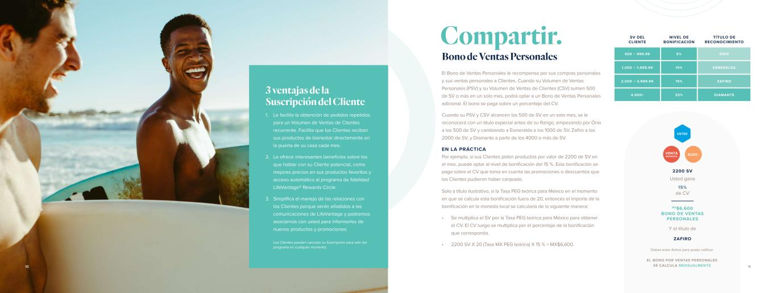
Debes estar Activo para poder calificar Los Clientes pueden cancelar su Suscripción para salir del programa en cualquier momento. SV DEL CLIENTE NIVEL DE BONIFICACIÓN TÍTULO DE RECONOCIMIENTO 500 – 999.99 5% ÓNIX 1,000 – 1,999.99 10% ESMERALDA 2,000 – 3,999.99 15% ZAFIRO 4,000+ 20% DIAMANTE Bono de Ventas Personales El Bono de Ventas Personales le recompensa por sus compras personales y sus ventas personales a Clientes. Cuando su Volumen de Ventas Personales (PSV) y su Volumen de Ventas de Clientes (CSV) sumen 500 de SV o más en un solo mes, podrá optar a un Bono de Ventas Personales adicional. El bono se paga sobre un porcentaje del CV. Cuando su PSV y CSV alcancen los 500 de SV en un solo mes, se le reconocerá con un título especial antes de su Rango, empezando por Ónix a los 500 de SV y cambiando a Esmeralda a los 1000 de SV, Zafiro a los 2000 de SV, y Diamante a partir de los 4000 o más de SV. EN LA PRÁCTICA Por ejemplo, si sus Clientes piden productos por valor de 2200 de SV en el mes, puede optar al nivel de bonificación del 15 %. Esta bonificación se paga sobre el CV que toma en cuenta las promociones o descuentos que los Clientes pudieron haber canjeado. Solo a título ilustrativo, si la Tasa PEG teórica para México en el momento en que se calcula esta bonificación fuera de 20, entonces el importe de la bonificación en la moneda local se calcularía de la siguiente manera: • Se multiplica el SV por la Tasa PEG teórica para México para obtener el CV. El CV luego se multiplica por el porcentaje de la bonificación que corresponda. • 2200 SV X 20 (Tasa MX PEG teórica) X 15 % = MX$6,600. EL BONO POR VENTAS PERSONALES SE CALCULA MENSUALMENTE Le facilita la obtención de pedidos repetidos para un Volumen de Ventas de Clientes recurrente. Facilita que los Clientes reciban sus productos de bienestar directamente en la puerta de su casa cada mes. Le ofrece interesantes beneficios sobre los que hablar con su Cliente potencial, como mejores precios en sus productos favoritos y acceso automático al programa de fidelidad LifeVantage® Rewards Circle. Simplifica el manejo de las relaciones con los Clientes porque serán añadidos a las comunicaciones de LifeVantage y podremos asociarnos con usted para informarles de nuevos productos y promociones. 1. 2. 3. 3 ventajas de la Suscripción del Cliente Compartir. 1110 2200 SV ZAFIRO MX$6,600 BONO DE VENTAS PERSONALES Usted gana 15% de CV Y el título de VENTA MINORISTA SUSC. USTED

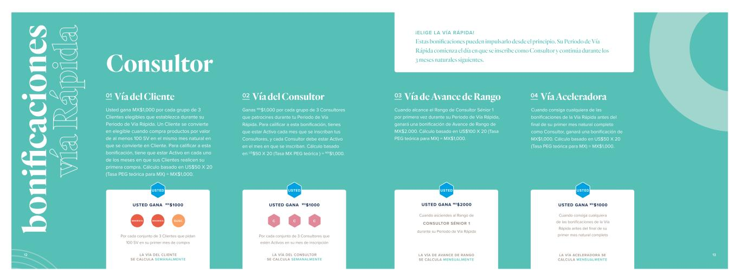
Consultor 01 Vía del Cliente Usted gana MX$1,000 por cada grupo de 3 Clientes elegibles que establezca durante su Periodo de Vía Rápida. Un Cliente se convierte en elegible cuando compra productos por valor de al menos 100 SV en el mismo mes natural en que se convierte en Cliente. Para calificar a esta bonificación, tiene que estar Activo en cada uno de los meses en que sus Clientes realicen su primera compra. Cálculo basado en US$50 X 20 (Tasa PEG teórica para MX) = MX$1,000. 02 Vía del Consultor Ganas MX$1,000 por cada grupo de 3 Consultores que patrocines durante tu Periodo de Vía Rápida. Para calificar a esta bonificación, tienes que estar Activo cada mes que se inscriban tus Consultores, y cada Consultor debe estar Activo en el mes en que se inscriban. Cálculo basado en US$50 X 20 (Tasa MX PEG teórica ) = MX$1,000. C C C Por cada conjunto de 3 Clientes que pidan 100 SV en su primer mes de compra Por cada conjunto de 3 Consultores que estén Activos en su mes de inscripción USTED GANA MX$1000 USTED GANA MX$1000 MINORISTA MINORISTA SUSC. ¡ELIGE LA VÍA RÁPIDA! Estas bonificaciones pueden impulsarlo desde el principio. Su Periodo de Vía Rápida comienza el día en que se inscribe como Consultor y continúa durante los 3 meses naturales siguientes. USTED USTED LA VÍA DEL CLIENTE SE CALCULA SEMANALMENTE LA VÍA DEL CONSULTOR SE CALCULA SEMANALMENTE 03 Vía de Avance de Rango 04 Vía Aceleradora Cuando alcance el Rango de Consultor Sénior 1 por primera vez durante su Periodo de Vía Rápida, ganará una bonificación de Avance de Rango de MX$2.000. Cálculo basado en US$100 X 20 (Tasa PEG teórica para MX) = MX$1,000. Cuando consiga cualquiera de las bonificaciones de la Vía Rápida antes del final de su primer mes natural completo como Consultor, ganará una bonificación de MX$1,000. Cálculo basado en US$50 X 20 (Tasa PEG teórica para MX) = MX$1,000. USTED GANA MX$1000 Cuando consiga cualquiera de las bonificaciones de la Vía Rápida antes del final de su primer mes natural completo USTED USTED GANA MX$2000 Cuando asciendes al Rango de CONSULTOR SÉNIOR 1 durante su Periodo de Vía Rápida USTED LA VÍA DE AVANCE DE RANGO SE CALCULA MENSUALMENTE LA VÍA ACELERADORA SE CALCULA MENSUALMENTE 12 13 bo ni fic ac io ne s ví a R áp id a


01 Vía de Avance de Rango 02 Vía Aceleradora Bonificación de Mentor Si es Patrocinador como Consultor Sénior 1 o superior, puede ganar una bonificación única de MX$1,000 cada vez que su Consultor recién inscrito gane una bonificación de Avance de Rango. Cálculo basado en US$50 X 20 (Tasa PEG teórica para MX) = MX$1,000. Si usted es Activo en el mes en que un Consultor que inscribe gana una Bonificación de la Vía Aceleradora, puedeganar una bonificación de MX$500 como su Patrocinador. Cálculo basado en US$25 X 20 (Tasa PEG teórica para MX) = MX$500. EN LA PRÁCTICA En este ejemplo, si su Consultor recién patrocinado vende 500 SV durante su Periodo de Vía Rápida, obtiene una bonificación del 15 %. Solo a título ilustrativo, si la Tasa PEG teórica para México en el momento en que se calcula esta bonificación fuera de 20, entonces el importe de la bonificación en moneda local se calcularía de la siguiente manera: • Se multiplica el SV por la Tasa PEG teórica para México para obtener el CV. El CV luego se multiplica por el porcentaje de la bonificación que corresponda. • 500 SV X 20 (Tasa PEG teórica para MX) X 15 % = MX$1,500. Para recibir cualquier Bonificación de Mentor, debe estar Activo en el mes en que su nuevo Consultor cumpla los requisitos. Gana un 15 % del CV de todos sus Consultores nuevos por sus ventas a Clientes durante su Periodo Fast Track. bo ni fic ac io ne s ví a R áp id a Patrocinador LA VÍA DE AVANCE DE RANGO SE CALCULA MENSUALMENTE El Patrocinador de inscripción de la Línea ascendente gana la Bonificación por Avance de Rango C LA VÍA ACELERADORA SE CALCULA MENSUALMENTE El Patrocinador de la Línea ascendente gana la Bonificación de la Vía Aceleradora C Usted gana 15% DE CV Su nuevo Consultor inscrito USTED C VENDE 500 SV BONIFICACIÓN DE MENTOR MX$1,500 LA BONIFICACIÓN DE MENTOR SE CALCULA MENSUALMENTE EL PATROCINADOR DE INSCRIPCIÓN GANA MX$1,000 EL PATROCINADOR DE INSCRIPCIÓN GANA MX$500 Gana cuando ayude a otros a ganar en la Vía Rápida Los primeros meses del Negocio del Consultor son cruciales para establecer un futuro de éxito. Como su Patrocinador, trabaja estrechamente con ellos durante su Periodo de Vía Rápida para ayudarles a empezar bien y, además, podrá ganar bonificaciones. Debe estar Activo para poder calificar14 15

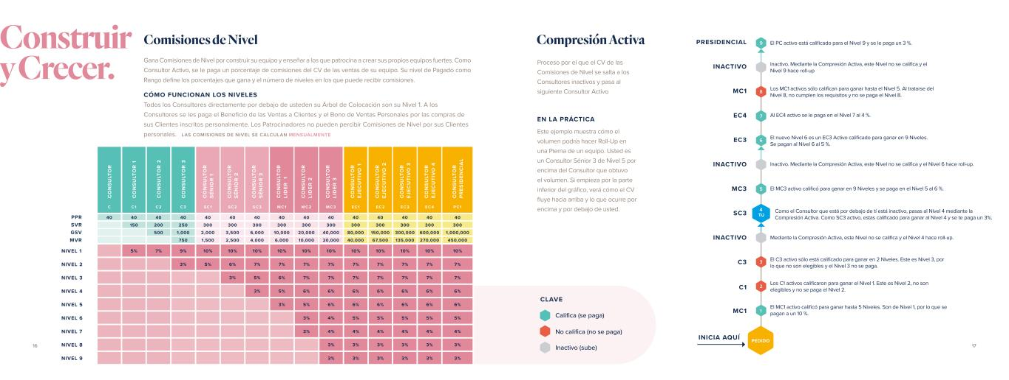
Gana Comisiones de Nivel por construir su equipo y enseñar a los que patrocina a crear sus propios equipos fuertes. Como Consultor Activo, se le paga un porcentaje de comisiones del CV de las ventas de su equipo. Su nivel de Pagado como Rango define los porcentajes que gana y el número de niveles en los que puede recibir comisiones. CÓMO FUNCIONAN LOS NIVELES Todos los Consultores directamente por debajo de usteden su Árbol de Colocación son su Nivel 1. A los Consultores se les paga el Beneficio de las Ventas a Clientes y el Bono de Ventas Personales por las compras de sus Clientes inscritos personalmente. Los Patrocinadores no pueden percibir Comisiones de Nivel por sus Clientes personales. Comisiones de Nivel Compresión Activa C O N S U LT O R C O N S U LT O R 1 C O N S U LT O R 2 C O N S U LT O R 3 C O N S U LT O R S ÉN IO R 1 C O N S U LT O R S ÉN IO R 2 C O N S U LT O R S ÉN IO R 3 C O N S U LT O R LI D ER 1 C O N S U LT O R LI D ER 2 C O N S U LT O R LI D ER 3 C O N S U LT O R EJ EC U TI V O 1 C O N S U LT O R EJ EC U TI V O 2 C O N S U LT O R EJ EC U TI V O 3 C O N S U LT O R EJ EC U TI V O 4 C O N S U LT O R P R ES ID EN C IA L C C1 C2 C3 SC1 SC2 SC3 MC1 MC2 MC3 EC1 EC2 EC3 EC 4 PC1 40 40 40 40 40 40 40 40 40 40 40 40 40 40 40 150 200 250 300 300 300 300 300 300 300 300 300 300 300 500 1,000 2,000 3,500 6,000 10,000 20,000 40,000 80,000 150,000 300,000 600,000 1,000,000 750 1,500 2,500 4,000 6,000 10,000 20,000 40,000 67,500 135,000 270,000 450,000 NIVEL 1 5% 7% 9% 10% 10% 10% 10% 10% 10% 10% 10% 10% 10% 10% NIVEL 2 3% 5% 6% 7% 7% 7% 7% 7% 7% 7% 7% 7% NIVEL 3 3% 5% 6% 7% 7% 7% 7% 7% 7% 7% NIVEL 4 3% 5% 6% 6% 6% 6% 6% 6% 6% NIVEL 5 3% 5% 6% 6% 6% 6% 6% 6% NIVEL 6 3% 4% 5% 5% 5% 5% 5% NIVEL 7 3% 4% 4% 4% 4% 4% 4% NIVEL 8 3% 3% 3% 3% 3% 3% NIVEL 9 3% 3% 3% 3% 3% 3% 9 8 5 3 7 2 6 1 PEDIDO MC1 INICIA AQUÍ C1 C3 INACTIVO SC3 MC3 INACTIVO EC3 EC4 MC1 INACTIVO PRESIDENCIAL 4 TÚ El MC1 activo calificó para ganar hasta 5 Niveles. Son de Nivel 1, por lo que se pagan a un 10 %. Los C1 activos calificaron para ganar el Nivel 1. Este es Nivel 2, no son elegibles y no se paga el Nivel 2. El C3 activo sólo está calificado para ganar en 2 Niveles. Este es Nivel 3, por lo que no son elegibles y el Nivel 3 no se paga. Mediante la Compresión Activa, este Nivel no se califica y el Nivel 4 hace roll-up. Como el Consultor que está por debajo de tí está inactivo, pasas al Nivel 4 mediante la Compresión Activa. Como SC3 activo, estas calificado para ganar al Nivel 4 y se te paga un 3%. El MC3 activo calificó para ganar en 9 Niveles y se paga en el Nivel 5 al 6 %. Inactivo. Mediante la Compresión Activa, este Nivel no se califica y el Nivel 6 hace roll-up. El nuevo Nivel 6 es un EC3 Activo calificado para ganar en 9 Niveles. Se pagan al Nivel 6 al 5 %. Al EC4 activo se le paga en el Nivel 7 al 4 %. Los MC1 activos sólo califican para ganar hasta el Nivel 5. Al tratarse del Nivel 8, no cumplen los requisitos y no se paga el Nivel 8. Inactivo. Mediante la Compresión Activa, este Nivel no se califica y el Nivel 9 hace roll-up El PC activo está calificado para el Nivel 9 y se le paga un 3 %. Proceso por el que el CV de las Comisiones de Nivel se salta a los Consultores inactivos y pasa al siguiente Consultor Activo EN LA PRÁCTICA Este ejemplo muestra cómo el volumen podría hacer Roll-Up en una Pierna de un equipo. Usted es un Consultor Sénior 3 de Nivel 5 por encima del Consultor que obtuvo el volumen. Si empieza por la parte inferior del gráfico, verá cómo el CV fluye hacia arriba y lo que ocurre por encima y por debajo de usted. CLAVE Califica (se paga) No califica (no se paga) Inactivo (sube) LAS COMISIONES DE NIVEL SE CALCULAN MENSUALMENTE 16 17 Construir y Crecer. PPR SVR GSV MVR

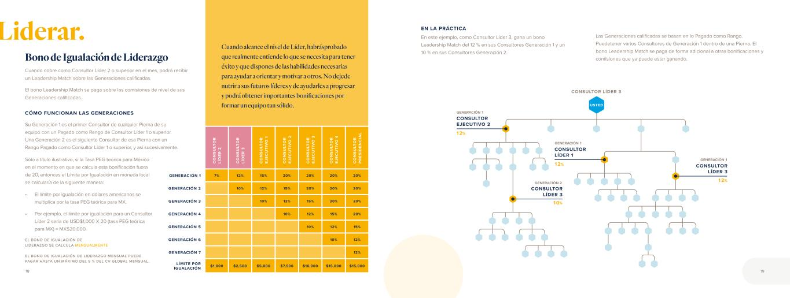
C O N S U LT O R LÍ D ER 2 C O N S U LT O R LÍ D ER 3 C O N S U LT O R EJ EC U TI V O 1 C O N S U LT O R EJ EC U TI V O 2 C O N S U LT O R EJ EC U TI V O 3 C O N S U LT O R EJ EC U TI V O 4 C O N S U LT O R P R ES ID EN C IA L GENERACIÓN 1 7% 12% 15% 20% 20% 20% 20% GENERACIÓN 2 10% 12% 15% 20% 20% 20% GENERACIÓN 3 10% 12% 15% 20% 20% GENERACIÓN 4 10% 12% 15% 20% GENERACIÓN 5 10% 12% 15% GENERACIÓN 6 10% 12% GENERACIÓN 7 12% LÍMITE POR IGUALACIÓN $1,000 $2,500 $5,000 $7,500 $10,000 $15,000 $15,000 Cuando cobre como Consultor Líder 2 o superior en el mes, podrá recibir un Leadership Match sobre las Generaciones calificadas. El bono Leadership Match se paga sobre las comisiones de nivel de sus Generaciones calificadas. CÓMO FUNCIONAN LAS GENERACIONES Su Generación 1 es el primer Consultor de cualquier Pierna de su equipo con un Pagado como Rango de Consultor Líder 1 o superior. Una Generación 2 es el siguiente Consultor de esa Pierna con un Rango Pagado como Consultor Líder 1 o superior, y así sucesivamente. Bono de Igualación de Liderazgo Cuando alcance el nivel de Líder, habrásprobado que realmente entiende lo que se necesita para tener éxito y que dispones de las habilidades necesarias para ayudar a orientar y motivar a otros. No dejede nutrir a sus futuros líderes y de ayudarles a progresar y podrá obtener importantes bonificaciones por formar un equipo tan sólido. USTED CONSULTOR LÍDER 3 10% 12% CONSULTOR EJECUTIVO 2 12% CONSULTOR LÍDER 1 12% CONSULTOR LÍDER 3 CONSULTOR LÍDER 3 EN LA PRÁCTICA En este ejemplo, como Consultor Líder 3, gana un bono Leadership Match del 12 % en sus Consultores Generación 1 y un 10 % en sus Consultores Generación 2. Las Generaciones calificadas se basan en lo Pagado como Rango. Puedetener varios Consultores de Generación 1 dentro de una Pierna. El bono Leadership Match se paga de forma adicional a otras bonificaciones y comisiones que ya puede estar ganando. GENERACIÓN 1 GENERACIÓN 1 GENERACIÓN 2 GENERACIÓN 1Sólo a título ilustrativo, si la Tasa PEG teórica para México en el momento en que se calcula esta bonificación fuera de 20, entonces el Límite por Igualación en moneda local se calcularía de la siguiente manera: • El límite por igualación en dólares americanos se multiplica por la tasa PEG teórica para MX. • Por ejemplo, el límite por igualación para un Consultor Líder 2 sería de USD$1,000 X 20 (tasa PEG teórica para MX) = MX$20,000. EL BONO DE IGUALACIÓN DE LIDERAZGO SE CALCULA MENSUALMENTE EL BONO DE IGUALACIÓN DE LIDERAZGO MENSUAL PUEDE PAGAR HASTA UN MÁXIMO DEL 9 % DEL CV GLOBAL MENSUAL. 18 19 Liderar.

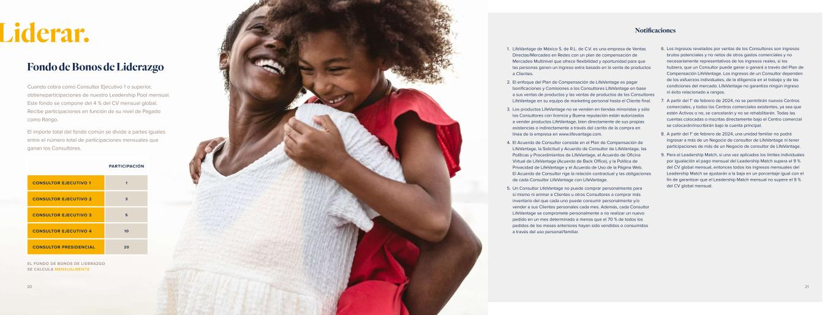
Cuando cobra como Consultor Ejecutivo 1 o superior, obtieneparticipaciones de nuestro Leadership Pool mensual. Este fondo se compone del 4 % del CV mensual global. Recibe participaciones en función de su nivel de Pagado como Rango. El importe total del fondo común se divide a partes iguales entre el número total de participaciones mensuales que ganan los Consultores. Fondo de Bonos de Liderazgo PARTICIPACIÓN CONSULTOR EJECUTIVO 1 1 CONSULTOR EJECUTIVO 2 3 CONSULTOR EJECUTIVO 3 5 CONSULTOR EJECUTIVO 4 10 CONSULTOR PRESIDENCIAL 20 EL FONDO DE BONOS DE LIDERAZGO SE CALCULA MENSUALMENTE Liderar. Notificaciones 1. LifeVantage de México S. de R.L. de C.V. es una empresa de Ventas Directas/Mercadeo en Redes con un plan de compensación de Mercadeo Multinivel que ofrece flexibilidad y oportunidad para que las personas ganen un ingreso extra basado en la venta de productos a Clientes. 2. El enfoque del Plan de Compensación de LifeVantage es pagar bonificaciones y Comisiones a los Consultores LifeVantage en base a sus ventas de productos y las ventas de productos de los Consultores LifeVantage en su equipo de marketing personal hasta el Cliente final. 3. Los productos LifeVantage no se venden en tiendas minoristas y sólo los Consultores con licencia y Buena reputación están autorizados a vender productos LifeVantage, bien directamente de sus propias existencias o indirectamente a través del carrito de la compra en línea de la empresa en www.lifevantage.com. 4. El Acuerdo de Consultor consiste en el Plan de Compensación de LifeVantage, la Solicitud y Acuerdo de Consultor de LifeVantage, las Políticas y Procedimientos de LifeVantage, el Acuerdo de Oficina Virtual de LifeVantage (Acuerdo de Back Office), y la Política de Privacidad de LifeVantage y el Acuerdo de Uso de la Página Web. El Acuerdo de Consultor rige la relación contractual y las obligaciones de cada Consultor LifeVantage con LifeVantage. 5. Un Consultor LifeVantage no puede comprar personalmente para sí mismo ni animar a Clientes u otros Consultores a comprar más inventario del que cada uno puede consumir personalmente y/o vender a sus Clientes personales cada mes. Además, cada Consultor LifeVantage se compromete personalmente a no realizar un nuevo pedido en un mes determinado a menos que el 70 % de todos los pedidos de los meses anteriores hayan sido vendidos o consumidos a través del uso personal/familiar. 6. Los ingresos revelados por ventas de los Consultores son ingresos brutos potenciales y no netos de otros gastos comerciales y no necesariamente representativos de los ingresos reales, si los hubiera, que un Consultor puede ganar o ganará a través del Plan de Compensación LifeVantage. Los ingresos de un Consultor dependen de los esfuerzos individuales, de la diligencia en el trabajo y de las condiciones del mercado. LifeVantage no garantiza ningún ingreso ni éxito relacionado a rangos. 7. A partir del 1° de febrero de 2024, no se permitirán nuevos Centros comerciales, y todos los Centros comerciales existentes, ya sea que estén Activos o no, se cancelarán y no se rehabilitarán. Todas las cuentas colocadas o inscritas directamente bajo el Centro comercial se colocarán/inscribirán bajo la cuenta principal. 8. A partir del 1° de febrero de 2024, una unidad familiar no podrá ingresar a más de un Negocio de consultor de LifeVantage ni tener participaciones de más de un Negocio de consultor de LifeVantage. 9. Para el Leadership Match, si una vez aplicados los límites individuales por igualación el pago mensual del Leadership Match supera el 9 % del CV global mensual, entonces todos los ingresos mensuales del Leadership Match se ajustarán a la baja en un porcentaje igual con el fin de garantizar que el Leadership Match mensual no supere el 9 % del CV global mensual. 20 21


Notas 22 23


Evolve © 2 02 3 Li fe Va nt ag e C or po ra tio n. A ll rig ht s re se rv ed . 02 10 23 .18


Evolve COMPENSATION PLAN GUIDE FOR INDEPENDENT LIFEVANTAGE CONSULTANTS UNITED KINGDOM Effective February 1, 2024


activatedLife. It’s complicated. Messy. Beautiful. It goes by fast, and you want to live life to the fullest. But everyday responsibilities, fears, or restrictions can hold you back. You deserve to break free. You deserve to be your best self and live a healthy, happy life on your terms. LifeVantage is here to help. Our products are purposefully designed to activate your body’s ability to create vibrant health, starting at the cellular level. And when you look and feel your best, you’ll want to help others do the same. LifeVantage activates financial wellness with the opportunity to grow a business that can change people’s lives for the better. That’s where Evolve creates possibilities. Evolve is a compensation plan that allows you to work part-time or full-time.* Whether you are looking to simply share life-changing products or wanting to work and grow as a professional mentor and leader, being an Independent LifeVantage® Consultant will positively challenge and reward you. Welcome to life IT’S TIME TO LIVE WITH PURPOSE. IT’S TIME TO INSPIRE REMARKABLE. IT’S TIME TO LIVE ACTIVATED. *LifeVantage does not promise the financial success of any Consultant. Your success depends on your skill, fortitude, dedication, and your ability to lead others to emulate these qualities. Nothing in this guide is a representation that you will be financially successful. LifeVantage does not guarantee any income or Rank success. 2 3

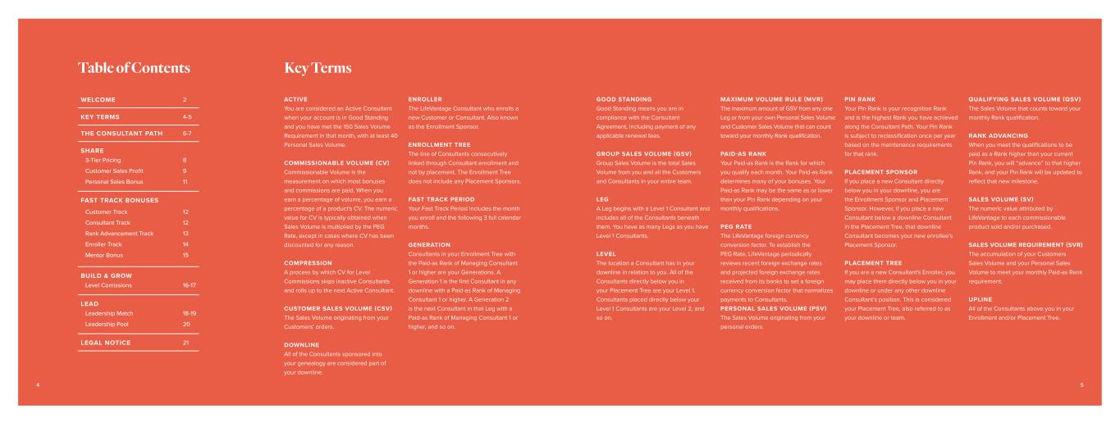
WELCOME 2 KEY TERMS 4-5 THE CONSULTANT PATH 6-7 SHARE 3-Tier Pricing Customer Sales Profit Personal Sales Bonus 8 9 11 FAST TRACK BONUSES Customer Track Consultant Track Rank Advancement Track Enroller Track Mentor Bonus 12 12 13 14 15 BUILD & GROW Level Comissions 16-17 LEAD Leadership Match Leadership Pool 18-19 20 LEGAL NOTICE 21 ACTIVE You are considered an Active Consultant when your account is in Good Standing and you have met the 150 Sales Volume Requirement in that month, with at least 40 Personal Sales Volume. COMMISSIONABLE VOLUME (CV) Commissionable Volume is the measurement on which most bonuses and commissions are paid. When you earn a percentage of volume, you earn a percentage of a product's CV. The numeric value for CV is typically obtained when Sales Volume is multiplied by the PEG Rate, except in cases where CV has been discounted for any reason. COMPRESSION A process by which CV for Level Commissions skips inactive Consultants and rolls up to the next Active Consultant. CUSTOMER SALES VOLUME (CSV) The Sales Volume originating from your Customers’ orders. DOWNLINE All of the Consultants sponsored into your genealogy are considered part of your downline. ENROLLER The LifeVantage Consultant who enrolls a new Customer or Consultant. Also known as the Enrollment Sponsor. ENROLLMENT TREE The line of Consultants consecutively linked through Consultant enrollment and not by placement. The Enrollment Tree does not include any Placement Sponsors. FAST TRACK PERIOD Your Fast Track Period includes the month you enroll and the following 3 full calendar months. GENERATION Consultants in your Enrollment Tree with the Paid-as Rank of Managing Consultant 1 or higher are your Generations. A Generation 1 is the first Consultant in any downline with a Paid-as Rank of Managing Consultant 1 or higher. A Generation 2 is the next Consultant in that Leg with a Paid-as Rank of Managing Consultant 1 or higher, and so on. Table of Contents Key Terms GOOD STANDING Good Standing means you are in compliance with the Consultant Agreement, including payment of any applicable renewal fees. GROUP SALES VOLUME (GSV) Group Sales Volume is the total Sales Volume from you and all the Customers and Consultants in your entire team. LEG A Leg begins with a Level 1 Consultant and includes all of the Consultants beneath them. You have as many Legs as you have Level 1 Consultants. LEVEL The location a Consultant has in your downline in relation to you. All of the Consultants directly below you in your Placement Tree are your Level 1. Consultants placed directly below your Level 1 Consultants are your Level 2, and so on. MAXIMUM VOLUME RULE (MVR) The maximum amount of GSV from any one Leg or from your own Personal Sales Volume and Customer Sales Volume that can count toward your monthly Rank qualification. PAID-AS RANK Your Paid-as Rank is the Rank for which you qualify each month. Your Paid-as Rank determines many of your bonuses. Your Paid-as Rank may be the same as or lower than your Pin Rank depending on your monthly qualifications. PEG RATE The LifeVantage foreign currency conversion factor. To establish the PEG Rate, LifeVantage periodically reviews recent foreign exchange rates and projected foreign exchange rates received from its banks to set a foreign currency conversion factor that normalizes payments to Consultants. PERSONAL SALES VOLUME (PSV) The Sales Volume originating from your personal orders. PIN RANK Your Pin Rank is your recognition Rank and is the highest Rank you have achieved along the Consultant Path. Your Pin Rank is subject to reclassification once per year based on the maintenance requirements for that rank. PLACEMENT SPONSOR If you place a new Consultant directly below you in your downline, you are the Enrollment Sponsor and Placement Sponsor. However, if you place a new Consultant below a downline Consultant in the Placement Tree, that downline Consultant becomes your new enrollee’s Placement Sponsor. PLACEMENT TREE If you are a new Consultant's Enroller, you may place them directly below you in your downline or under any other downline Consultant’s position. This is considered your Placement Tree, also referred to as your downline or team. QUALIFYING SALES VOLUME (QSV) The Sales Volume that counts toward your monthly Rank qualification. RANK ADVANCING When you meet the qualifications to be paid as a Rank higher than your current Pin Rank, you will “advance” to that higher Rank, and your Pin Rank will be updated to reflect that new milestone. SALES VOLUME (SV) The numeric value attributed by LifeVantage to each commissionable product sold and/or purchased. SALES VOLUME REQUIREMENT (SVR) The accumulation of your Customers Sales Volume and your Personal Sales Volume to meet your monthly Paid-as Rank requirement. UPLINE All of the Consultants above you in your Enrollment and/or Placement Tree. 4 5

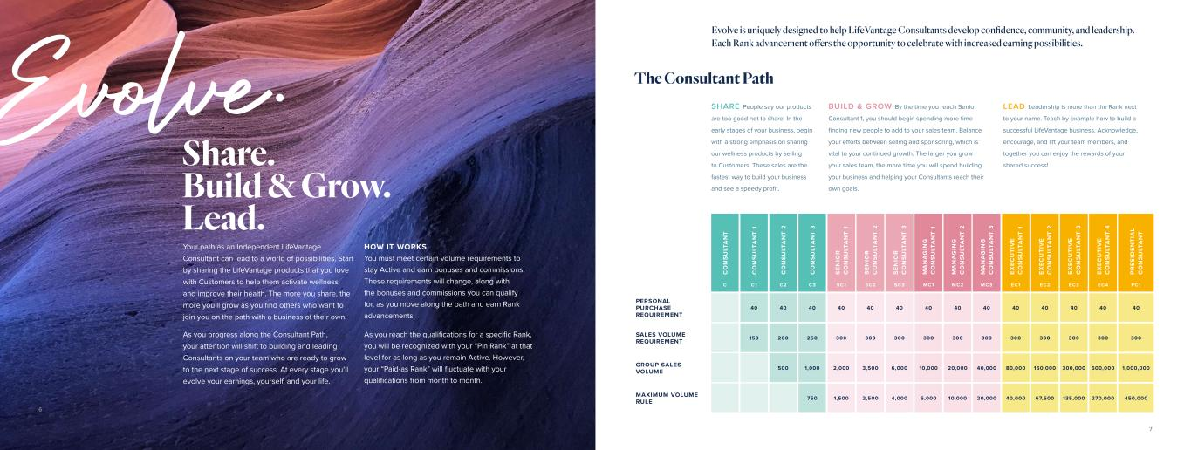
Evolve. Share. Build & Grow. Lead. Your path as an Independent LifeVantage Consultant can lead to a world of possibilities. Start by sharing the LifeVantage products that you love with Customers to help them activate wellness and improve their health. The more you share, the more you’ll grow as you find others who want to join you on the path with a business of their own. As you progress along the Consultant Path, your attention will shift to building and leading Consultants on your team who are ready to grow to the next stage of success. At every stage you’ll evolve your earnings, yourself, and your life. HOW IT WORKS You must meet certain volume requirements to stay Active and earn bonuses and commissions. These requirements will change, along with the bonuses and commissions you can qualify for, as you move along the path and earn Rank advancements. As you reach the qualifications for a specific Rank, you will be recognized with your “Pin Rank” at that level for as long as you remain Active. However, your “Paid-as Rank” will fluctuate with your qualifications from month to month. SHARE People say our products are too good not to share! In the early stages of your business, begin with a strong emphasis on sharing our wellness products by selling to Customers. These sales are the fastest way to build your business and see a speedy profit. BUILD & GROW By the time you reach Senior Consultant 1, you should begin spending more time finding new people to add to your sales team. Balance your efforts between selling and sponsoring, which is vital to your continued growth. The larger you grow your sales team, the more time you will spend building your business and helping your Consultants reach their own goals. C O N S U LT A N T C O N S U LT A N T 1 C O N S U LT A N T 2 C O N S U LT A N T 3 S EN IO R C O N S U LT A N T 1 S EN IO R C O N S U LT A N T 2 S EN IO R C O N S U LT A N T 3 M A N A G IN G C O N S U LT A N T 1 M A N A G IN G C O N S U LT A N T 2 M A N A G IN G C O N S U LT A N T 3 EX EC U TI V E C O N S U LT A N T 1 EX EC U TI V E C O N S U LT A N T 2 EX EC U TI V E C O N S U LT A N T 3 EX EC U TI V E C O N S U LT A N T 4 P R ES ID EN TI A L C O N S U LT A N T C C1 C2 C3 SC1 SC2 SC3 MC1 MC2 MC3 EC1 EC2 EC3 EC 4 PC1 PERSONAL PURCHASE REQUIREMENT 40 40 40 40 40 40 40 40 40 40 40 40 40 40 SALES VOLUME REQUIREMENT 150 200 250 300 300 300 300 300 300 300 300 300 300 300 GROUP SALES VOLUME 500 1,000 2,000 3,500 6,000 10,000 20,000 40,000 80,000 150,000 300,000 600,000 1,000,000 MAXIMUM VOLUME RULE 750 1,500 2,500 4,000 6,000 10,000 20,000 40,000 67,500 135,000 270,000 450,000 LEAD Leadership is more than the Rank next to your name. Teach by example how to build a successful LifeVantage business. Acknowledge, encourage, and lift your team members, and together you can enjoy the rewards of your shared success! The Consultant Path Evolve is uniquely designed to help LifeVantage Consultants develop confidence, community, and leadership. Each Rank advancement offers the opportunity to celebrate with increased earning possibilities. 6 7

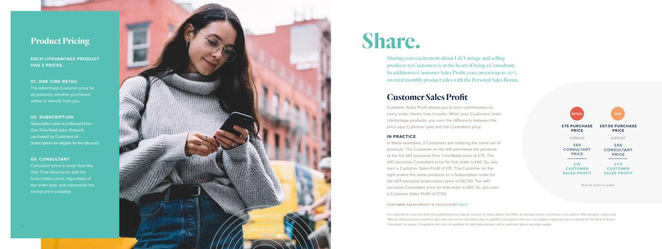
EACH LIFEVANTAGE PRODUCT HAS 3 PRICES. 03. CONSULTANT Consultant price is lower than the One Time Retail price and the Subscription price, regardless of the order type, and represents the lowest price available. 02. SUBSCRIPTION Subscription price is a discount from One Time Retail price. Products purchased by Customers on Subscription are eligible for the discount. 01. ONE TIME RETAIL The advertised Customer price for all products, whether purchased online or directly from you. Product Pricing Customer Sales Profit allows you to earn commissions on every order. Here's how it works: When your Customers order LifeVantage products, you earn the difference between the price your Customer paid and the Consultant price. IN PRACTICE In these examples, 2 Customers are ordering the same set of products. The Customer on the left purchases the products at the full VAT-exclusive One Time Retail price of £75. The VAT-exclusive Consultant price for that order is £60. So, you earn a Customer Sales Profit of £15. The Customer on the right orders the same products on a Subscription order for the VAT-exclusive Subscription price of £67.50. The VAT- exclusive Consultant price for that order is £60. So, you earn a Customer Sales Profit of £7.50. RETAIL SUB £75 PURCHASE PRICE £67.50 PURCHASE PRICE £15 CUSTOMER SALES PROFIT £7.5 CUSTOMER SALES PROFIT subtract £60 CONSULTANT PRICE subtract £60 CONSULTANT PRICE Sharing your excitement about LifeVantage and selling products to Customers is at the heart of being a Consultant. In addition to Customer Sales Profit, you can earn up to 20% on total monthly product sales with the Personal Sales Bonus. Customer Sales Profit Share. CUSTOMER SALES PROFIT IS CALCULATED DAILY* It is important to note that while the published prices may be inclusive of Value-Added Tax (VAT), all bonuses and/or commissions are paid on VAT-exclusive values only. *May be disbursed three business days after the bonus calculation date to qualified Consultants who are in an eligible market and have reached the Pin Rank of Senior Consultant 1 or above. Consultants who are not qualified for daily disbursement will be paid their bonus earnings weekly. Must be active to qualify 98

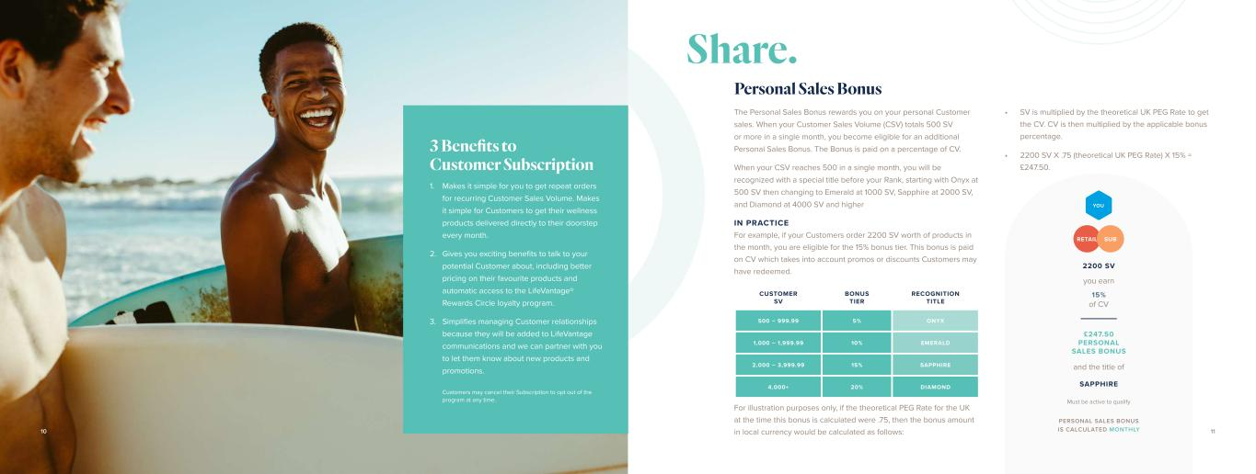
Must be active to qualify Customers may cancel their Subscription to opt out of the program at any time. CUSTOMER SV BONUS TIER RECOGNITION TITLE 500 – 999.99 5% ONYX 1,000 – 1,999.99 10% EMERALD 2,000 – 3,999.99 15% SAPPHIRE 4,000+ 20% DIAMOND Personal Sales Bonus The Personal Sales Bonus rewards you on your personal Customer sales. When your Customer Sales Volume (CSV) totals 500 SV or more in a single month, you become eligible for an additional Personal Sales Bonus. The Bonus is paid on a percentage of CV. When your CSV reaches 500 in a single month, you will be recognized with a special title before your Rank, starting with Onyx at 500 SV then changing to Emerald at 1000 SV, Sapphire at 2000 SV, and Diamond at 4000 SV and higher IN PRACTICE For example, if your Customers order 2200 SV worth of products in the month, you are eligible for the 15% bonus tier. This bonus is paid on CV which takes into account promos or discounts Customers may have redeemed. For illustration purposes only, if the theoretical PEG Rate for the UK at the time this bonus is calculated were .75, then the bonus amount in local currency would be calculated as follows: PERSONAL SALES BONUS IS CALCULATED MONTHLY Makes it simple for you to get repeat orders for recurring Customer Sales Volume. Makes it simple for Customers to get their wellness products delivered directly to their doorstep every month. Gives you exciting benefits to talk to your potential Customer about, including better pricing on their favourite products and automatic access to the LifeVantage® Rewards Circle loyalty program. Simplifies managing Customer relationships because they will be added to LifeVantage communications and we can partner with you to let them know about new products and promotions. 1. 2. 3. 3 Benefits to Customer Subscription Share. • SV is multiplied by the theoretical UK PEG Rate to get the CV. CV is then multiplied by the applicable bonus percentage. • 2200 SV X .75 (theoretical UK PEG Rate) X 15% = £247.50. 1110 2200 SV SAPPHIRE £247.50 PERSONAL SALES BONUS you earn 15% of CV and the title of RETAIL SUB YOU

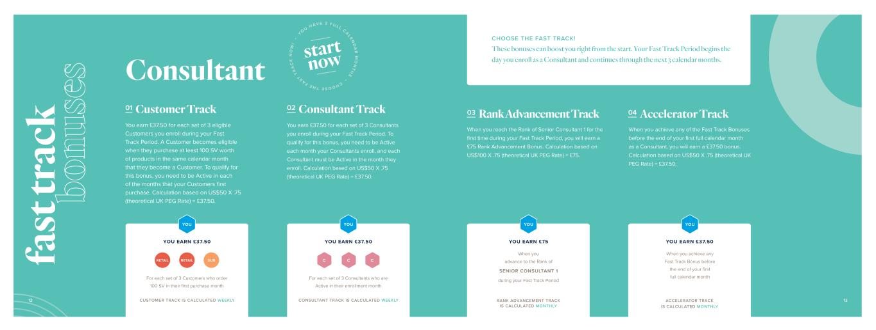
Consultant 01 Customer Track You earn £37.50 for each set of 3 eligible Customers you enroll during your Fast Track Period. A Customer becomes eligible when they purchase at least 100 SV worth of products in the same calendar month that they become a Customer. To qualify for this bonus, you need to be Active in each of the months that your Customers first purchase. Calculation based on US$50 X .75 (theoretical UK PEG Rate) = £37.50. 02 Consultant Track You earn £37.50 for each set of 3 Consultants you enroll during your Fast Track Period. To qualify for this bonus, you need to be Active each month your Consultants enroll, and each Consultant must be Active in the month they enroll. Calculation based on US$50 X .75 (theoretical UK PEG Rate) = £37.50. C C C For each set of 3 Customers who order 100 SV in their first purchase month For each set of 3 Consultants who are Active in their enrollment month YOU EARN £37.50 YOU EARN £37.50 RETAIL RETAIL SUB CHOOSE THE FAST TRACK! These bonuses can boost you right from the start. Your Fast Track Period begins the day you enroll as a Consultant and continues through the next 3 calendar months. YOU YOU CUSTOMER TRACK IS CALCULATED WEEKLY CONSULTANT TRACK IS CALCULATED WEEKLY 03 Rank Advancement Track 04 Accelerator Track When you reach the Rank of Senior Consultant 1 for the first time during your Fast Track Period, you will earn a £75 Rank Advancement Bonus. Calculation based on US$100 X .75 (theoretical UK PEG Rate) = £75. When you achieve any of the Fast Track Bonuses before the end of your first full calendar month as a Consultant, you will earn a £37.50 bonus. Calculation based on US$50 X .75 (theoretical UK PEG Rate) = £37.50. YOU EARN £37.50 When you achieve any Fast Track Bonus before the end of your first full calendar month YOU YOU EARN £75 When you advance to the Rank of SENIOR CONSULTANT 1 during your Fast Track Period YOU RANK ADVANCEMENT TRACK IS CALCULATED MONTHLY ACCELERATOR TRACK IS CALCULATED MONTHLY 12 13 fa st tr ac k bo nu se s CHOOSE THE FAST T R A C K N O W ! • YO U H AV E 3 F U L L CALEN D A R M O N T H S • start now

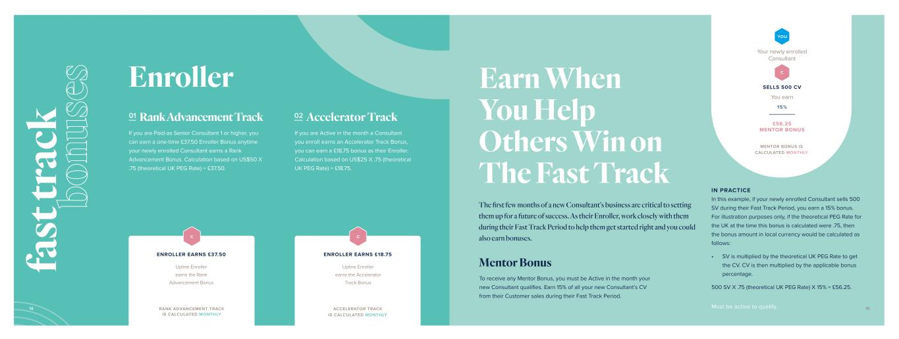
01 Rank Advancement Track 02 Accelerator Track Mentor Bonus If you are Paid-as Senior Consultant 1 or higher, you can earn a one-time £37.50 Enroller Bonus anytime your newly enrolled Consultant earns a Rank Advancement Bonus. Calculation based on US$50 X .75 (theoretical UK PEG Rate) = £37.50. If you are Active in the month a Consultant you enroll earns an Accelerator Track Bonus, you can earn a £18.75 bonus as their Enroller. Calculation based on US$25 X .75 (theoretical UK PEG Rate) = £18.75. IN PRACTICE In this example, if your newly enrolled Consultant sells 500 SV during their Fast Track Period, you earn a 15% bonus. For illustration purposes only, if the theoretical PEG Rate for the UK at the time this bonus is calculated were .75, then the bonus amount in local currency would be calculated as follows: • SV is multiplied by the theoretical UK PEG Rate to get the CV. CV is then multiplied by the applicable bonus percentage. 500 SV X .75 (theoretical UK PEG Rate) X 15% = £56.25. To receive any Mentor Bonus, you must be Active in the month your new Consultant qualifies. Earn 15% of all your new Consultant’s CV from their Customer sales during their Fast Track Period. Enroller RANK ADVANCEMENT TRACK IS CALCULATED MONTHLY Upline Enroller earns the Rank Advancement Bonus C ACCELERATOR TRACK IS CALCULATED MONTHLY Upline Enroller earns the Accelerator Track Bonus C You earn 15% Your newly enrolled Consultant YOU C SELLS 500 CV £56.25 MENTOR BONUS MENTOR BONUS IS CALCULATED MONTHLY ENROLLER EARNS £18.75 Earn When You Help Others Win on The Fast Track The first few months of a new Consultant’s business are critical to setting them up for a future of success. As their Enroller, work closely with them during their Fast Track Period to help them get started right and you could also earn bonuses. Must be active to qualify. ENROLLER EARNS £37.50 14 15 fa st tr ac k bo nu se s

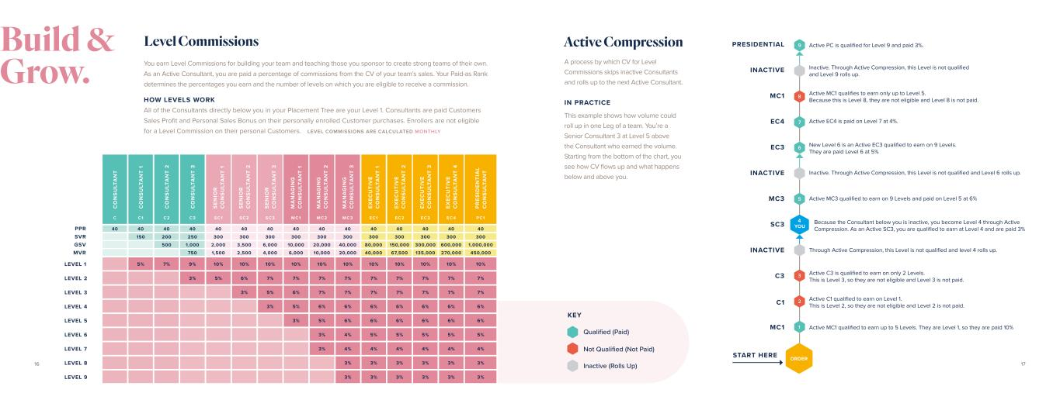
You earn Level Commissions for building your team and teaching those you sponsor to create strong teams of their own. As an Active Consultant, you are paid a percentage of commissions from the CV of your team’s sales. Your Paid-as Rank determines the percentages you earn and the number of levels on which you are eligible to receive a commission. HOW LEVELS WORK All of the Consultants directly below you in your Placement Tree are your Level 1. Consultants are paid Customers Sales Profit and Personal Sales Bonus on their personally enrolled Customer purchases. Enrollers are not eligible for a Level Commission on their personal Customers. Level Commissions Active Compression C O N S U LT A N T C O N S U LT A N T 1 C O N S U LT A N T 2 C O N S U LT A N T 3 S EN IO R C O N S U LT A N T 1 S EN IO R C O N S U LT A N T 2 S EN IO R C O N S U LT A N T 3 M A N A G IN G C O N S U LT A N T 1 M A N A G IN G C O N S U LT A N T 2 M A N A G IN G C O N S U LT A N T 3 EX EC U TI V E C O N S U LT A N T 1 EX EC U TI V E C O N S U LT A N T 2 EX EC U TI V E C O N S U LT A N T 3 EX EC U TI V E C O N S U LT A N T 4 P R ES ID EN TI A L C O N S U LT A N T C C1 C2 C3 SC1 SC2 SC3 MC1 MC2 MC3 EC1 EC2 EC3 EC 4 PC1 40 40 40 40 40 40 40 40 40 40 40 40 40 40 40 150 200 250 300 300 300 300 300 300 300 300 300 300 300 500 1,000 2,000 3,500 6,000 10,000 20,000 40,000 80,000 150,000 300,000 600,000 1,000,000 750 1,500 2,500 4,000 6,000 10,000 20,000 40,000 67,500 135,000 270,000 450,000 LEVEL 1 5% 7% 9% 10% 10% 10% 10% 10% 10% 10% 10% 10% 10% 10% LEVEL 2 3% 5% 6% 7% 7% 7% 7% 7% 7% 7% 7% 7% LEVEL 3 3% 5% 6% 7% 7% 7% 7% 7% 7% 7% LEVEL 4 3% 5% 6% 6% 6% 6% 6% 6% 6% LEVEL 5 3% 5% 6% 6% 6% 6% 6% 6% LEVEL 6 3% 4% 5% 5% 5% 5% 5% LEVEL 7 3% 4% 4% 4% 4% 4% 4% LEVEL 8 3% 3% 3% 3% 3% 3% LEVEL 9 3% 3% 3% 3% 3% 3% 9 8 5 3 7 2 6 1 ORDER MC1 START HERE C1 C3 INACTIVE SC3 MC3 INACTIVE EC3 EC4 MC1 INACTIVE PRESIDENTIAL 4 YOU Active MC1 qualified to earn up to 5 Levels. They are Level 1, so they are paid 10% Active C1 qualified to earn on Level 1. This is Level 2, so they are not eligible and Level 2 is not paid. Active C3 is qualified to earn on only 2 Levels. This is Level 3, so they are not eligible and Level 3 is not paid. Through Active Compression, this Level is not qualified and level 4 rolls up. Because the Consultant below you is inactive, you become Level 4 through Active Compression. As an Active SC3, you are qualified to earn at Level 4 and are paid 3% Active MC3 qualified to earn on 9 Levels and paid on Level 5 at 6% Inactive. Through Active Compression, this Level is not qualified and Level 6 rolls up. New Level 6 is an Active EC3 qualified to earn on 9 Levels. They are paid Level 6 at 5% Active EC4 is paid on Level 7 at 4%. Active MC1 qualifies to earn only up to Level 5. Because this is Level 8, they are not eligible and Level 8 is not paid. Inactive. Through Active Compression, this Level is not qualified and Level 9 rolls up. Active PC is qualified for Level 9 and paid 3%. IN PRACTICE This example shows how volume could roll up in one Leg of a team. You’re a Senior Consultant 3 at Level 5 above the Consultant who earned the volume. Starting from the bottom of the chart, you see how CV flows up and what happens below and above you. A process by which CV for Level Commissions skips inactive Consultants and rolls up to the next Active Consultant. KEY Qualified (Paid) Not Qualified (Not Paid) Inactive (Rolls Up) LEVEL COMMISSIONS ARE CALCULATED MONTHLY 16 17 Build & Grow. PPR SVR GSV MVR

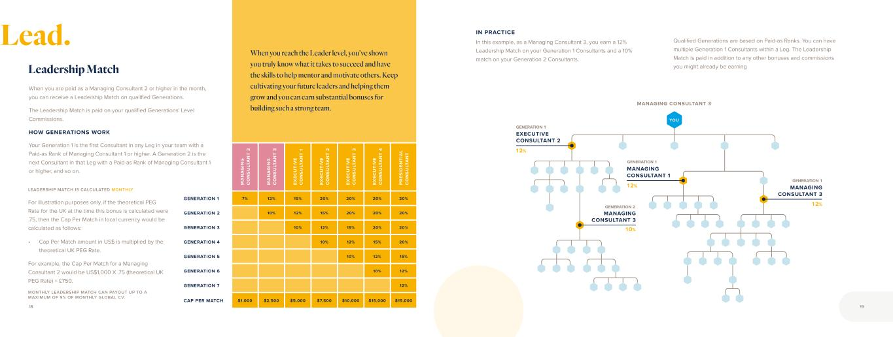
M A N A G IN G C O N S U LT A N T 2 M A N A G IN G C O N S U LT A N T 3 EX EC U TI V E C O N S U LT A N T 1 EX EC U TI V E C O N S U LT A N T 2 EX EC U TI V E C O N S U LT A N T 3 EX EC U TI V E C O N S U LT A N T 4 P R ES ID EN TI A L C O N S U LT A N T GENERATION 1 7% 12% 15% 20% 20% 20% 20% GENERATION 2 10% 12% 15% 20% 20% 20% GENERATION 3 10% 12% 15% 20% 20% GENERATION 4 10% 12% 15% 20% GENERATION 5 10% 12% 15% GENERATION 6 10% 12% GENERATION 7 12% CAP PER MATCH $1,000 $2,500 $5,000 $7,500 $10,000 $15,000 $15,000 When you are paid as a Managing Consultant 2 or higher in the month, you can receive a Leadership Match on qualified Generations. The Leadership Match is paid on your qualified Generations' Level Commissions. HOW GENERATIONS WORK Your Generation 1 is the first Consultant in any Leg in your team with a Paid-as Rank of Managing Consultant 1 or higher. A Generation 2 is the next Consultant in that Leg with a Paid-as Rank of Managing Consultant 1 or higher, and so on. Leadership Match When you reach the Leader level, you’ve shown you truly know what it takes to succeed and have the skills to help mentor and motivate others. Keep cultivating your future leaders and helping them grow and you can earn substantial bonuses for building such a strong team. YOU MANAGING CONSULTANT 3 10% 12% EXECUTIVE CONSULTANT 2 12% MANAGING CONSULTANT 1 12% MANAGING CONSULTANT 3 MANAGING CONSULTANT 3 IN PRACTICE In this example, as a Managing Consultant 3, you earn a 12% Leadership Match on your Generation 1 Consultants and a 10% match on your Generation 2 Consultants. Qualified Generations are based on Paid-as Ranks. You can have multiple Generation 1 Consultants within a Leg. The Leadership Match is paid in addition to any other bonuses and commissions you might already be earning GENERATION 1 GENERATION 1 GENERATION 2 GENERATION 1 LEADERSHIP MATCH IS CALCULATED MONTHLY For illustration purposes only, if the theoretical PEG Rate for the UK at the time this bonus is calculated were .75, then the Cap Per Match in local currency would be calculated as follows: • Cap Per Match amount in US$ is multiplied by the theoretical UK PEG Rate. For example, the Cap Per Match for a Managing Consultant 2 would be US$1,000 X .75 (theoretical UK PEG Rate) = £750. MONTHLY LEADERSHIP MATCH CAN PAYOUT UP TO A MAXIMUM OF 9% OF MONTHLY GLOBAL CV. 18 19 Lead.

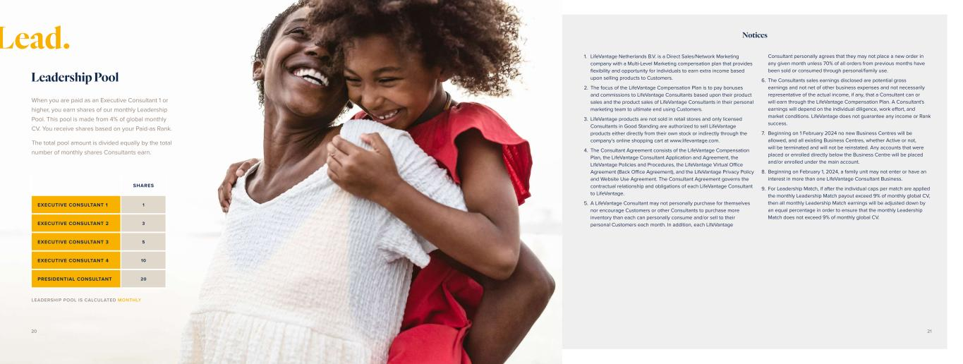
When you are paid as an Executive Consultant 1 or higher, you earn shares of our monthly Leadership Pool. This pool is made from 4% of global monthly CV. You receive shares based on your Paid-as Rank. The total pool amount is divided equally by the total number of monthly shares Consultants earn. Leadership Pool SHARES EXECUTIVE CONSULTANT 1 1 EXECUTIVE CONSULTANT 2 3 EXECUTIVE CONSULTANT 3 5 EXECUTIVE CONSULTANT 4 10 PRESIDENTIAL CONSULTANT 20 LEADERSHIP POOL IS CALCULATED MONTHLY Lead. Notices 1. LifeVantage Netherlands B.V. is a Direct Sales/Network Marketing company with a Multi-Level Marketing compensation plan that provides flexibility and opportunity for individuals to earn extra income based upon selling products to Customers. 2. The focus of the LifeVantage Compensation Plan is to pay bonuses and commissions to LifeVantage Consultants based upon their product sales and the product sales of LifeVantage Consultants in their personal marketing team to ultimate end using Customers. 3. LifeVantage products are not sold in retail stores and only licensed Consultants in Good Standing are authorized to sell LifeVantage products either directly from their own stock or indirectly through the company’s online shopping cart at www.lifevantage.com. 4. The Consultant Agreement consists of the LifeVantage Compensation Plan, the LifeVantage Consultant Application and Agreement, the LifeVantage Policies and Procedures, the LifeVantage Virtual Office Agreement (Back Office Agreement), and the LifeVantage Privacy Policy and Website Use Agreement. The Consultant Agreement governs the contractual relationship and obligations of each LifeVantage Consultant to LifeVantage. 5. A LifeVantage Consultant may not personally purchase for themselves nor encourage Customers or other Consultants to purchase more inventory than each can personally consume and/or sell to their personal Customers each month. In addition, each LifeVantage Consultant personally agrees that they may not place a new order in any given month unless 70% of all orders from previous months have been sold or consumed through personal/family use. 6. The Consultants sales earnings disclosed are potential gross earnings and not net of other business expenses and not necessarily representative of the actual income, if any, that a Consultant can or will earn through the LifeVantage Compensation Plan. A Consultant's earnings will depend on the individual diligence, work effort, and market conditions. LifeVantage does not guarantee any income or Rank success. 7. Beginning on 1 February 2024 no new Business Centres will be allowed, and all existing Business Centres, whether Active or not, will be terminated and will not be reinstated. Any accounts that were placed or enrolled directly below the Business Centre will be placed and/or enrolled under the main account. 8. Beginning on February 1, 2024, a family unit may not enter or have an interest in more than one LifeVantage Consultant Business. 9. For Leadership Match, if after the individual caps per match are applied the monthly Leadership Match payout exceed 9% of monthly global CV, then all monthly Leadership Match earnings will be adjusted down by an equal percentage in order to ensure that the monthly Leadership Match does not exceed 9% of monthly global CV. 20 21


Notes 22 23


Evolve © 2 02 3 Li fe Va nt ag e C or po ra tio n. A ll rig ht s re se rv ed . 10 12 23 .0 1


Evolve COMPENSATION PLAN GUIDE FOR INDEPENDENT LIFEVANTAGE CONSULTANTS EUROPE Effective February 1, 2024


activatedLife. It’s complicated. Messy. Beautiful. It goes by fast, and you want to live life to the fullest. But everyday responsibilities, fears, or restrictions can hold you back. You deserve to break free. You deserve to be your best self and live a healthy, happy life on your terms. LifeVantage is here to help. Our products are purposefully designed to activate your body’s ability to create vibrant health, starting at the cellular level. And when you look and feel your best, you’ll want to help others do the same. LifeVantage activates financial wellness with the opportunity to grow a business that can change people’s lives for the better. That’s where Evolve creates possibilities. Evolve is a compensation plan that allows you to work part-time or full-time.* Whether you are looking to simply share life-changing products or wanting to work and grow as a professional mentor and leader, being an Independent LifeVantage® Consultant will positively challenge and reward you. Welcome to life IT’S TIME TO LIVE WITH PURPOSE. IT’S TIME TO INSPIRE REMARKABLE. IT’S TIME TO LIVE ACTIVATED. *LifeVantage does not promise the financial success of any Consultant. Your success depends on your skill, fortitude, dedication, and your ability to lead others to emulate these qualities. Nothing in this guide is a representation that you will be financially successful. LifeVantage does not guarantee any income or Rank success. 2 3

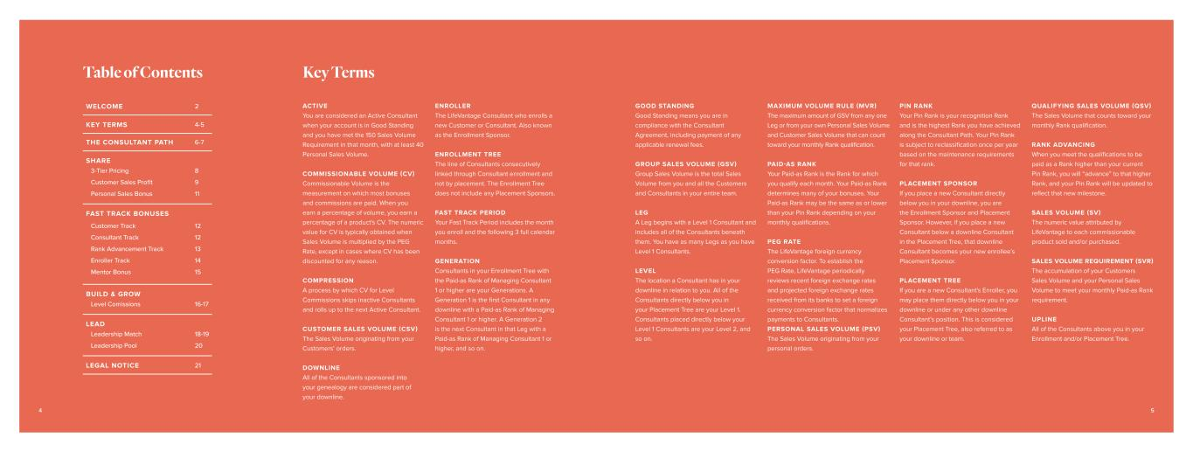
WELCOME 2 KEY TERMS 4-5 THE CONSULTANT PATH 6-7 SHARE 3-Tier Pricing Customer Sales Profit Personal Sales Bonus 8 9 11 FAST TRACK BONUSES Customer Track Consultant Track Rank Advancement Track Enroller Track Mentor Bonus 12 12 13 14 15 BUILD & GROW Level Comissions 16-17 LEAD Leadership Match Leadership Pool 18-19 20 LEGAL NOTICE 21 ACTIVE You are considered an Active Consultant when your account is in Good Standing and you have met the 150 Sales Volume Requirement in that month, with at least 40 Personal Sales Volume. COMMISSIONABLE VOLUME (CV) Commissionable Volume is the measurement on which most bonuses and commissions are paid. When you earn a percentage of volume, you earn a percentage of a product's CV. The numeric value for CV is typically obtained when Sales Volume is multiplied by the PEG Rate, except in cases where CV has been discounted for any reason. COMPRESSION A process by which CV for Level Commissions skips inactive Consultants and rolls up to the next Active Consultant. CUSTOMER SALES VOLUME (CSV) The Sales Volume originating from your Customers’ orders. DOWNLINE All of the Consultants sponsored into your genealogy are considered part of your downline. ENROLLER The LifeVantage Consultant who enrolls a new Customer or Consultant. Also known as the Enrollment Sponsor. ENROLLMENT TREE The line of Consultants consecutively linked through Consultant enrollment and not by placement. The Enrollment Tree does not include any Placement Sponsors. FAST TRACK PERIOD Your Fast Track Period includes the month you enroll and the following 3 full calendar months. GENERATION Consultants in your Enrollment Tree with the Paid-as Rank of Managing Consultant 1 or higher are your Generations. A Generation 1 is the first Consultant in any downline with a Paid-as Rank of Managing Consultant 1 or higher. A Generation 2 is the next Consultant in that Leg with a Paid-as Rank of Managing Consultant 1 or higher, and so on. Table of Contents Key Terms GOOD STANDING Good Standing means you are in compliance with the Consultant Agreement, including payment of any applicable renewal fees. GROUP SALES VOLUME (GSV) Group Sales Volume is the total Sales Volume from you and all the Customers and Consultants in your entire team. LEG A Leg begins with a Level 1 Consultant and includes all of the Consultants beneath them. You have as many Legs as you have Level 1 Consultants. LEVEL The location a Consultant has in your downline in relation to you. All of the Consultants directly below you in your Placement Tree are your Level 1. Consultants placed directly below your Level 1 Consultants are your Level 2, and so on. MAXIMUM VOLUME RULE (MVR) The maximum amount of GSV from any one Leg or from your own Personal Sales Volume and Customer Sales Volume that can count toward your monthly Rank qualification. PAID-AS RANK Your Paid-as Rank is the Rank for which you qualify each month. Your Paid-as Rank determines many of your bonuses. Your Paid-as Rank may be the same as or lower than your Pin Rank depending on your monthly qualifications. PEG RATE The LifeVantage foreign currency conversion factor. To establish the PEG Rate, LifeVantage periodically reviews recent foreign exchange rates and projected foreign exchange rates received from its banks to set a foreign currency conversion factor that normalizes payments to Consultants. PERSONAL SALES VOLUME (PSV) The Sales Volume originating from your personal orders. PIN RANK Your Pin Rank is your recognition Rank and is the highest Rank you have achieved along the Consultant Path. Your Pin Rank is subject to reclassification once per year based on the maintenance requirements for that rank. PLACEMENT SPONSOR If you place a new Consultant directly below you in your downline, you are the Enrollment Sponsor and Placement Sponsor. However, if you place a new Consultant below a downline Consultant in the Placement Tree, that downline Consultant becomes your new enrollee’s Placement Sponsor. PLACEMENT TREE If you are a new Consultant's Enroller, you may place them directly below you in your downline or under any other downline Consultant’s position. This is considered your Placement Tree, also referred to as your downline or team. QUALIFYING SALES VOLUME (QSV) The Sales Volume that counts toward your monthly Rank qualification. RANK ADVANCING When you meet the qualifications to be paid as a Rank higher than your current Pin Rank, you will “advance” to that higher Rank, and your Pin Rank will be updated to reflect that new milestone. SALES VOLUME (SV) The numeric value attributed by LifeVantage to each commissionable product sold and/or purchased. SALES VOLUME REQUIREMENT (SVR) The accumulation of your Customers Sales Volume and your Personal Sales Volume to meet your monthly Paid-as Rank requirement. UPLINE All of the Consultants above you in your Enrollment and/or Placement Tree. 4 5

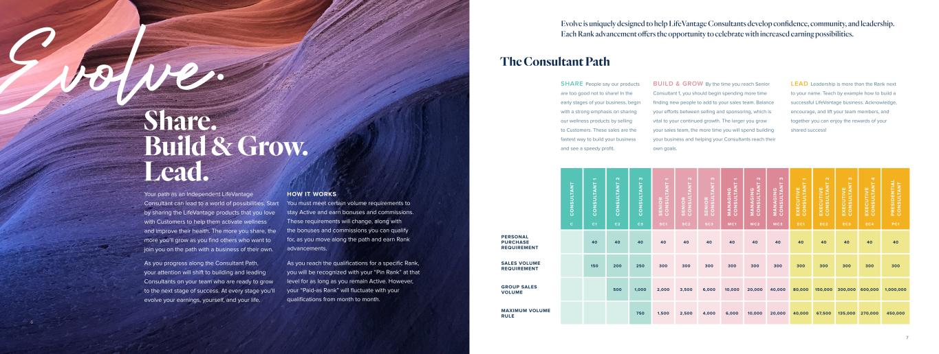
Evolve. Share. Build & Grow. Lead. Your path as an Independent LifeVantage Consultant can lead to a world of possibilities. Start by sharing the LifeVantage products that you love with Customers to help them activate wellness and improve their health. The more you share, the more you’ll grow as you find others who want to join you on the path with a business of their own. As you progress along the Consultant Path, your attention will shift to building and leading Consultants on your team who are ready to grow to the next stage of success. At every stage you’ll evolve your earnings, yourself, and your life. HOW IT WORKS You must meet certain volume requirements to stay Active and earn bonuses and commissions. These requirements will change, along with the bonuses and commissions you can qualify for, as you move along the path and earn Rank advancements. As you reach the qualifications for a specific Rank, you will be recognized with your “Pin Rank” at that level for as long as you remain Active. However, your “Paid-as Rank” will fluctuate with your qualifications from month to month. SHARE People say our products are too good not to share! In the early stages of your business, begin with a strong emphasis on sharing our wellness products by selling to Customers. These sales are the fastest way to build your business and see a speedy profit. BUILD & GROW By the time you reach Senior Consultant 1, you should begin spending more time finding new people to add to your sales team. Balance your efforts between selling and sponsoring, which is vital to your continued growth. The larger you grow your sales team, the more time you will spend building your business and helping your Consultants reach their own goals. C O N S U LT A N T C O N S U LT A N T 1 C O N S U LT A N T 2 C O N S U LT A N T 3 S E N IO R C O N S U LT A N T 1 S E N IO R C O N S U LT A N T 2 S E N IO R C O N S U LT A N T 3 M A N A G IN G C O N S U LT A N T 1 M A N A G IN G C O N S U LT A N T 2 M A N A G IN G C O N S U LT A N T 3 E X E C U T IV E C O N S U LT A N T 1 E X E C U T IV E C O N S U LT A N T 2 E X E C U T IV E C O N S U LT A N T 3 E X E C U T IV E C O N S U LT A N T 4 P R E S ID E N T IA L C O N S U LT A N T C C1 C2 C3 SC1 SC2 SC3 MC1 MC2 MC3 EC1 EC2 EC3 EC 4 PC1 PERSONAL PURCHASE REQUIREMENT 40 40 40 40 40 40 40 40 40 40 40 40 40 40 SALES VOLUME REQUIREMENT 150 200 250 300 300 300 300 300 300 300 300 300 300 300 GROUP SALES VOLUME 500 1,000 2,000 3,500 6,000 10,000 20,000 40,000 80,000 150,000 300,000 600,000 1,000,000 MAXIMUM VOLUME RULE 750 1,500 2,500 4,000 6,000 10,000 20,000 40,000 67,500 135,000 270,000 450,000 LEAD Leadership is more than the Rank next to your name. Teach by example how to build a successful LifeVantage business. Acknowledge, encourage, and lift your team members, and together you can enjoy the rewards of your shared success! The Consultant Path Evolve is uniquely designed to help LifeVantage Consultants develop confidence, community, and leadership. Each Rank advancement offers the opportunity to celebrate with increased earning possibilities. 6 7

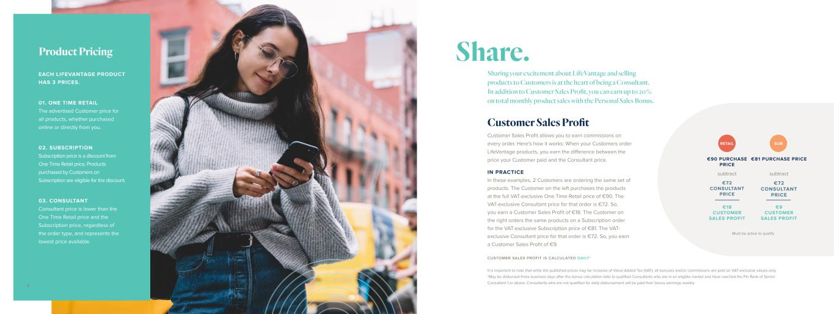
EACH LIFEVANTAGE PRODUCT HAS 3 PRICES. 03. CONSULTANT Consultant price is lower than the One Time Retail price and the Subscription price, regardless of the order type, and represents the lowest price available. 02. SUBSCRIPTION Subscription price is a discount from One Time Retail price. Products purchased by Customers on Subscription are eligible for the discount. 01. ONE TIME RETAIL The advertised Customer price for all products, whether purchased online or directly from you. Product Pricing Customer Sales Profit allows you to earn commissions on every order. Here's how it works: When your Customers order LifeVantage products, you earn the difference between the price your Customer paid and the Consultant price. IN PRACTICE In these examples, 2 Customers are ordering the same set of products. The Customer on the left purchases the products at the full VAT-exclusive One Time Retail price of €90. The VAT-exclusive Consultant price for that order is €72. So, you earn a Customer Sales Profit of €18. The Customer on the right orders the same products on a Subscription order for the VAT-exclusive Subscription price of €81. The VAT- exclusive Consultant price for that order is €72. So, you earn a Customer Sales Profit of €9. RETAIL SUB €90 PURCHASE PRICE €81 PURCHASE PRICE €18 CUSTOMER SALES PROFIT €9 CUSTOMER SALES PROFIT subtract €72 CONSULTANT PRICE subtract €72 CONSULTANT PRICE Sharing your excitement about LifeVantage and selling products to Customers is at the heart of being a Consultant. In addition to Customer Sales Profit, you can earn up to 20% on total monthly product sales with the Personal Sales Bonus. Customer Sales Profit Share. CUSTOMER SALES PROFIT IS CALCULATED DAILY* It is important to note that while the published prices may be inclusive of Value-Added Tax (VAT), all bonuses and/or commissions are paid on VAT-exclusive values only. *May be disbursed three business days after the bonus calculation date to qualified Consultants who are in an eligible market and have reached the Pin Rank of Senior Consultant 1 or above. Consultants who are not qualified for daily disbursement will be paid their bonus earnings weekly. Must be active to qualify 98

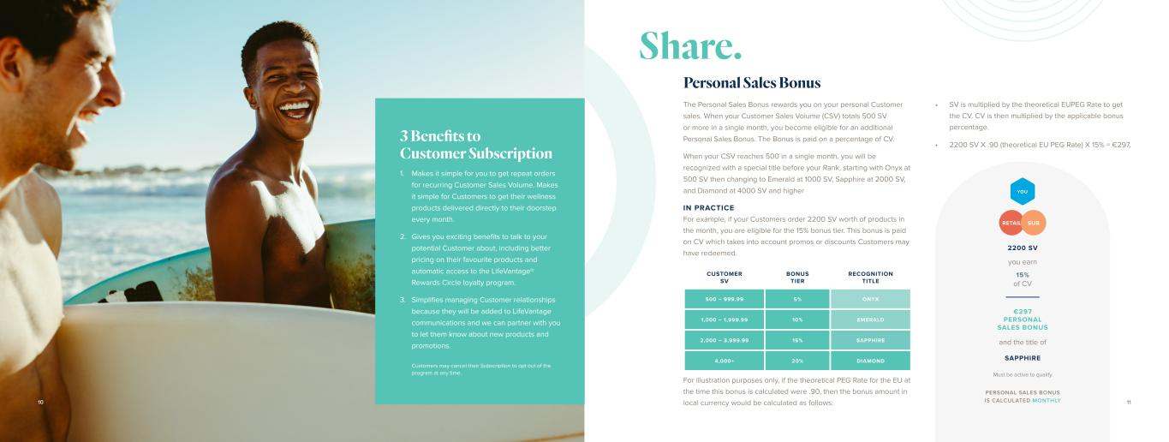
Must be active to qualify Customers may cancel their Subscription to opt out of the program at any time. CUSTOMER SV BONUS TIER RECOGNITION TITLE 500 – 999.99 5% ONYX 1,000 – 1,999.99 10% EMERALD 2,000 – 3,999.99 15% SAPPHIRE 4,000+ 20% DIAMOND Personal Sales Bonus The Personal Sales Bonus rewards you on your personal Customer sales. When your Customer Sales Volume (CSV) totals 500 SV or more in a single month, you become eligible for an additional Personal Sales Bonus. The Bonus is paid on a percentage of CV. When your CSV reaches 500 in a single month, you will be recognized with a special title before your Rank, starting with Onyx at 500 SV then changing to Emerald at 1000 SV, Sapphire at 2000 SV, and Diamond at 4000 SV and higher IN PRACTICE For example, if your Customers order 2200 SV worth of products in the month, you are eligible for the 15% bonus tier. This bonus is paid on CV which takes into account promos or discounts Customers may have redeemed. For illustration purposes only, if the theoretical PEG Rate for the EU at the time this bonus is calculated were .90, then the bonus amount in local currency would be calculated as follows: PERSONAL SALES BONUS IS CALCULATED MONTHLY Makes it simple for you to get repeat orders for recurring Customer Sales Volume. Makes it simple for Customers to get their wellness products delivered directly to their doorstep every month. Gives you exciting benefits to talk to your potential Customer about, including better pricing on their favourite products and automatic access to the LifeVantage® Rewards Circle loyalty program. Simplifies managing Customer relationships because they will be added to LifeVantage communications and we can partner with you to let them know about new products and promotions. 1. 2. 3. 3 Benefits to Customer Subscription Share. • SV is multiplied by the theoretical EUPEG Rate to get the CV. CV is then multiplied by the applicable bonus percentage. • 2200 SV X .90 (theoretical EU PEG Rate) X 15% = €297. 1110 2200 SV SAPPHIRE €297 PERSONAL SALES BONUS you earn 15% of CV and the title of RETAIL SUB YOU

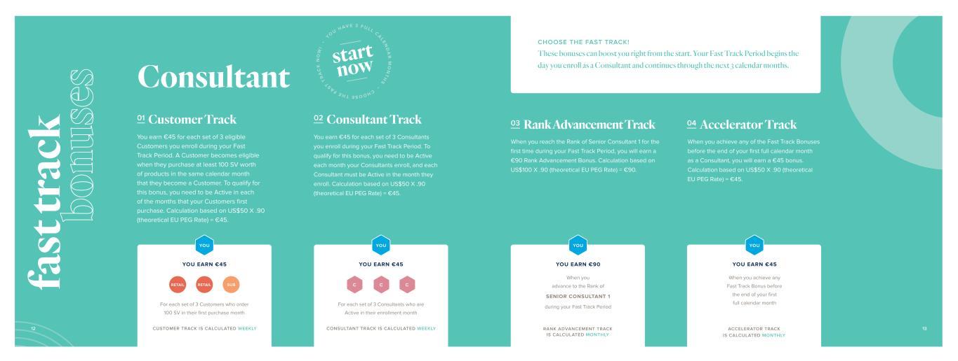
Consultant 01 Customer Track You earn €45 for each set of 3 eligible Customers you enroll during your Fast Track Period. A Customer becomes eligible when they purchase at least 100 SV worth of products in the same calendar month that they become a Customer. To qualify for this bonus, you need to be Active in each of the months that your Customers first purchase. Calculation based on US$50 X .90 (theoretical EU PEG Rate) = €45. 02 Consultant Track You earn €45 for each set of 3 Consultants you enroll during your Fast Track Period. To qualify for this bonus, you need to be Active each month your Consultants enroll, and each Consultant must be Active in the month they enroll. Calculation based on US$50 X .90 (theoretical EU PEG Rate) = €45. C C C For each set of 3 Customers who order 100 SV in their first purchase month For each set of 3 Consultants who are Active in their enrollment month YOU EARN €45 YOU EARN €45 RETAIL RETAIL SUB CHOOSE THE FAST TRACK! These bonuses can boost you right from the start. Your Fast Track Period begins the day you enroll as a Consultant and continues through the next 3 calendar months. YOU YOU CUSTOMER TRACK IS CALCULATED WEEKLY CONSULTANT TRACK IS CALCULATED WEEKLY 03 Rank Advancement Track 04 Accelerator Track When you reach the Rank of Senior Consultant 1 for the first time during your Fast Track Period, you will earn a €90 Rank Advancement Bonus. Calculation based on US$100 X .90 (theoretical EU PEG Rate) = €90. When you achieve any of the Fast Track Bonuses before the end of your first full calendar month as a Consultant, you will earn a €45 bonus. Calculation based on US$50 X .90 (theoretical EU PEG Rate) = €45. YOU EARN €45 When you achieve any Fast Track Bonus before the end of your first full calendar month YOU YOU EARN €90 When you advance to the Rank of SENIOR CONSULTANT 1 during your Fast Track Period YOU RANK ADVANCEMENT TRACK IS CALCULATED MONTHLY ACCELERATOR TRACK IS CALCULATED MONTHLY 12 13 fa st tr ac k bo nu se s CHOOSE THE F A S T T R A C K N O W ! • Y O U H AV E 3 F U L L C A L E N D A R M O N T H S • start now

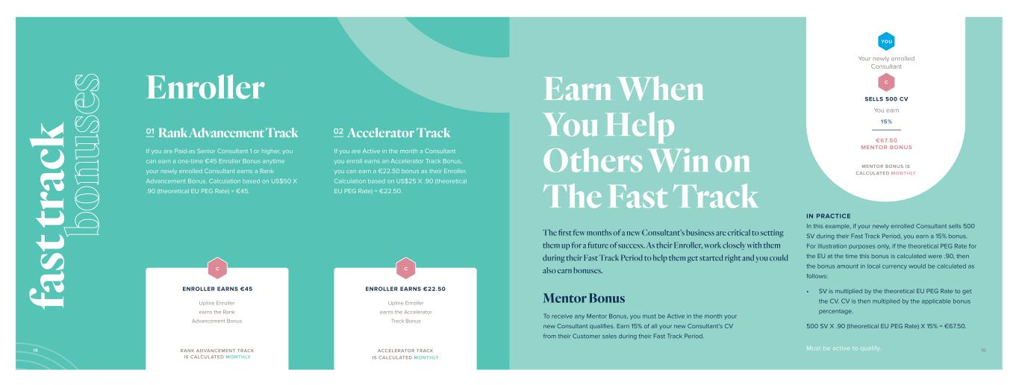
01 Rank Advancement Track 02 Accelerator Track Mentor Bonus If you are Paid-as Senior Consultant 1 or higher, you can earn a one-time €45 Enroller Bonus anytime your newly enrolled Consultant earns a Rank Advancement Bonus. Calculation based on US$50 X .90 (theoretical EU PEG Rate) = €45. If you are Active in the month a Consultant you enroll earns an Accelerator Track Bonus, you can earn a €22.50 bonus as their Enroller. Calculation based on US$25 X .90 (theoretical EU PEG Rate) = €22.50. IN PRACTICE In this example, if your newly enrolled Consultant sells 500 SV during their Fast Track Period, you earn a 15% bonus. For illustration purposes only, if the theoretical PEG Rate for the EU at the time this bonus is calculated were .90, then the bonus amount in local currency would be calculated as follows: • SV is multiplied by the theoretical EU PEG Rate to get the CV. CV is then multiplied by the applicable bonus percentage. 500 SV X .90 (theoretical EU PEG Rate) X 15% = €67.50. To receive any Mentor Bonus, you must be Active in the month your new Consultant qualifies. Earn 15% of all your new Consultant’s CV from their Customer sales during their Fast Track Period. Enroller RANK ADVANCEMENT TRACK IS CALCULATED MONTHLY Upline Enroller earns the Rank Advancement Bonus C ACCELERATOR TRACK IS CALCULATED MONTHLY Upline Enroller earns the Accelerator Track Bonus C You earn 15% Your newly enrolled Consultant YOU C SELLS 500 CV €67.50 MENTOR BONUS MENTOR BONUS IS CALCULATED MONTHLY ENROLLER EARNS €45 ENROLLER EARNS €22.50 Earn When You Help Others Win on The Fast Track The first few months of a new Consultant’s business are critical to setting them up for a future of success. As their Enroller, work closely with them during their Fast Track Period to help them get started right and you could also earn bonuses. Must be active to qualify.14 15 fa st tr ac k bo nu se s

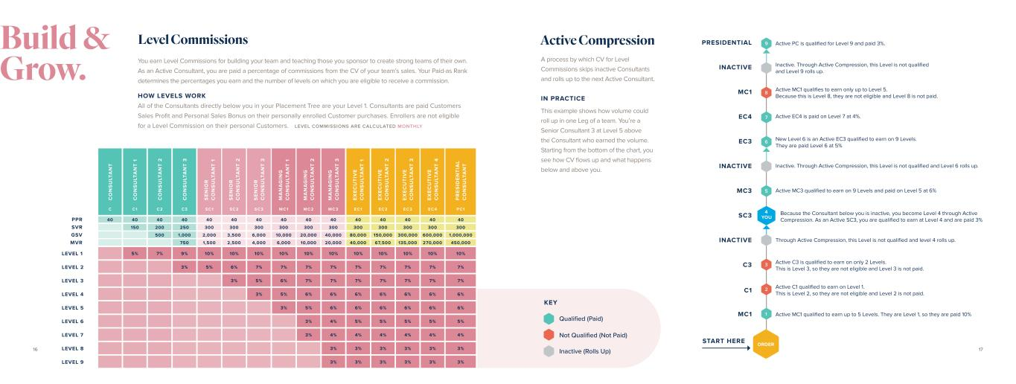
You earn Level Commissions for building your team and teaching those you sponsor to create strong teams of their own. As an Active Consultant, you are paid a percentage of commissions from the CV of your team’s sales. Your Paid-as Rank determines the percentages you earn and the number of levels on which you are eligible to receive a commission. HOW LEVELS WORK All of the Consultants directly below you in your Placement Tree are your Level 1. Consultants are paid Customers Sales Profit and Personal Sales Bonus on their personally enrolled Customer purchases. Enrollers are not eligible for a Level Commission on their personal Customers. Level Commissions Active Compression C O N S U LT A N T C O N S U LT A N T 1 C O N S U LT A N T 2 C O N S U LT A N T 3 S E N IO R C O N S U LT A N T 1 S E N IO R C O N S U LT A N T 2 S E N IO R C O N S U LT A N T 3 M A N A G IN G C O N S U LT A N T 1 M A N A G IN G C O N S U LT A N T 2 M A N A G IN G C O N S U LT A N T 3 E X E C U T IV E C O N S U LT A N T 1 E X E C U T IV E C O N S U LT A N T 2 E X E C U T IV E C O N S U LT A N T 3 E X E C U T IV E C O N S U LT A N T 4 P R E S ID E N T IA L C O N S U LT A N T C C1 C2 C3 SC1 SC2 SC3 MC1 MC2 MC3 EC1 EC2 EC3 EC 4 PC1 40 40 40 40 40 40 40 40 40 40 40 40 40 40 40 150 200 250 300 300 300 300 300 300 300 300 300 300 300 500 1,000 2,000 3,500 6,000 10,000 20,000 40,000 80,000 150,000 300,000 600,000 1,000,000 750 1,500 2,500 4,000 6,000 10,000 20,000 40,000 67,500 135,000 270,000 450,000 LEVEL 1 5% 7% 9% 10% 10% 10% 10% 10% 10% 10% 10% 10% 10% 10% LEVEL 2 3% 5% 6% 7% 7% 7% 7% 7% 7% 7% 7% 7% LEVEL 3 3% 5% 6% 7% 7% 7% 7% 7% 7% 7% LEVEL 4 3% 5% 6% 6% 6% 6% 6% 6% 6% LEVEL 5 3% 5% 6% 6% 6% 6% 6% 6% LEVEL 6 3% 4% 5% 5% 5% 5% 5% LEVEL 7 3% 4% 4% 4% 4% 4% 4% LEVEL 8 3% 3% 3% 3% 3% 3% LEVEL 9 3% 3% 3% 3% 3% 3% 9 8 5 3 7 2 6 1 ORDER MC1 START HERE C1 C3 INACTIVE SC3 MC3 INACTIVE EC3 EC4 MC1 INACTIVE PRESIDENTIAL 4 YOU Active MC1 qualified to earn up to 5 Levels. They are Level 1, so they are paid 10% Active C1 qualified to earn on Level 1. This is Level 2, so they are not eligible and Level 2 is not paid. Active C3 is qualified to earn on only 2 Levels. This is Level 3, so they are not eligible and Level 3 is not paid. Through Active Compression, this Level is not qualified and level 4 rolls up. Because the Consultant below you is inactive, you become Level 4 through Active Compression. As an Active SC3, you are qualified to earn at Level 4 and are paid 3% Active MC3 qualified to earn on 9 Levels and paid on Level 5 at 6% Inactive. Through Active Compression, this Level is not qualified and Level 6 rolls up. New Level 6 is an Active EC3 qualified to earn on 9 Levels. They are paid Level 6 at 5% Active EC4 is paid on Level 7 at 4%. Active MC1 qualifies to earn only up to Level 5. Because this is Level 8, they are not eligible and Level 8 is not paid. Inactive. Through Active Compression, this Level is not qualified and Level 9 rolls up. Active PC is qualified for Level 9 and paid 3%. IN PRACTICE This example shows how volume could roll up in one Leg of a team. You’re a Senior Consultant 3 at Level 5 above the Consultant who earned the volume. Starting from the bottom of the chart, you see how CV flows up and what happens below and above you. A process by which CV for Level Commissions skips inactive Consultants and rolls up to the next Active Consultant. KEY Qualified (Paid) Not Qualified (Not Paid) Inactive (Rolls Up) LEVEL COMMISSIONS ARE CALCULATED MONTHLY 16 17 Build & Grow. PPR SVR GSV MVR

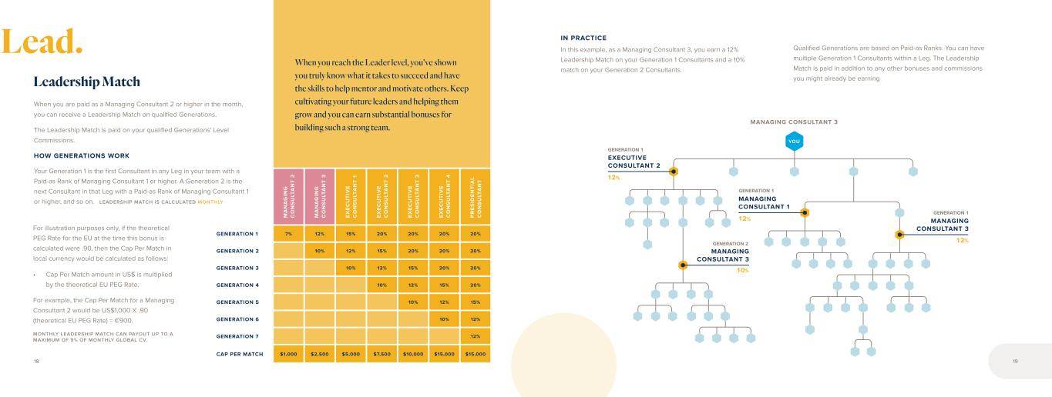
M A N A G IN G C O N S U LT A N T 2 M A N A G IN G C O N S U LT A N T 3 E X E C U T IV E C O N S U LT A N T 1 E X E C U T IV E C O N S U LT A N T 2 E X E C U T IV E C O N S U LT A N T 3 E X E C U T IV E C O N S U LT A N T 4 P R E S ID E N T IA L C O N S U LT A N T GENERATION 1 7% 12% 15% 20% 20% 20% 20% GENERATION 2 10% 12% 15% 20% 20% 20% GENERATION 3 10% 12% 15% 20% 20% GENERATION 4 10% 12% 15% 20% GENERATION 5 10% 12% 15% GENERATION 6 10% 12% GENERATION 7 12% CAP PER MATCH $1,000 $2,500 $5,000 $7,500 $10,000 $15,000 $15,000 When you are paid as a Managing Consultant 2 or higher in the month, you can receive a Leadership Match on qualified Generations. The Leadership Match is paid on your qualified Generations' Level Commissions. HOW GENERATIONS WORK Your Generation 1 is the first Consultant in any Leg in your team with a Paid-as Rank of Managing Consultant 1 or higher. A Generation 2 is the next Consultant in that Leg with a Paid-as Rank of Managing Consultant 1 or higher, and so on. LEADERSHIP MATCH IS CALCULATED MONTHLY Leadership Match When you reach the Leader level, you’ve shown you truly know what it takes to succeed and have the skills to help mentor and motivate others. Keep cultivating your future leaders and helping them grow and you can earn substantial bonuses for building such a strong team. YOU MANAGING CONSULTANT 3 10% 12% EXECUTIVE CONSULTANT 2 12% MANAGING CONSULTANT 1 12% MANAGING CONSULTANT 3 MANAGING CONSULTANT 3 IN PRACTICE In this example, as a Managing Consultant 3, you earn a 12% Leadership Match on your Generation 1 Consultants and a 10% match on your Generation 2 Consultants. Qualified Generations are based on Paid-as Ranks. You can have multiple Generation 1 Consultants within a Leg. The Leadership Match is paid in addition to any other bonuses and commissions you might already be earning GENERATION 1 GENERATION 1 GENERATION 2 GENERATION 1 For illustration purposes only, if the theoretical PEG Rate for the EU at the time this bonus is calculated were .90, then the Cap Per Match in local currency would be calculated as follows: • Cap Per Match amount in US$ is multiplied by the theoretical EU PEG Rate. For example, the Cap Per Match for a Managing Consultant 2 would be US$1,000 X .90 (theoretical EU PEG Rate) = €900. MONTHLY LEADERSHIP MATCH CAN PAYOUT UP TO A MAXIMUM OF 9% OF MONTHLY GLOBAL CV. 18 19 Lead.

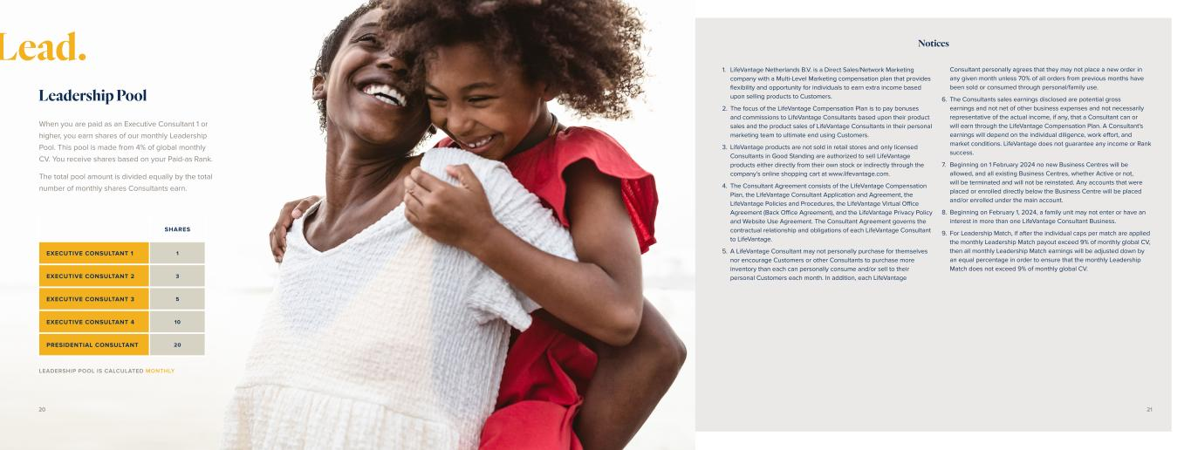
When you are paid as an Executive Consultant 1 or higher, you earn shares of our monthly Leadership Pool. This pool is made from 4% of global monthly CV. You receive shares based on your Paid-as Rank. The total pool amount is divided equally by the total number of monthly shares Consultants earn. Leadership Pool SHARES EXECUTIVE CONSULTANT 1 1 EXECUTIVE CONSULTANT 2 3 EXECUTIVE CONSULTANT 3 5 EXECUTIVE CONSULTANT 4 10 PRESIDENTIAL CONSULTANT 20 LEADERSHIP POOL IS CALCULATED MONTHLY Lead. Notices 1. LifeVantage Netherlands B.V. is a Direct Sales/Network Marketing company with a Multi-Level Marketing compensation plan that provides flexibility and opportunity for individuals to earn extra income based upon selling products to Customers. 2. The focus of the LifeVantage Compensation Plan is to pay bonuses and commissions to LifeVantage Consultants based upon their product sales and the product sales of LifeVantage Consultants in their personal marketing team to ultimate end using Customers. 3. LifeVantage products are not sold in retail stores and only licensed Consultants in Good Standing are authorized to sell LifeVantage products either directly from their own stock or indirectly through the company’s online shopping cart at www.lifevantage.com. 4. The Consultant Agreement consists of the LifeVantage Compensation Plan, the LifeVantage Consultant Application and Agreement, the LifeVantage Policies and Procedures, the LifeVantage Virtual Office Agreement (Back Office Agreement), and the LifeVantage Privacy Policy and Website Use Agreement. The Consultant Agreement governs the contractual relationship and obligations of each LifeVantage Consultant to LifeVantage. 5. A LifeVantage Consultant may not personally purchase for themselves nor encourage Customers or other Consultants to purchase more inventory than each can personally consume and/or sell to their personal Customers each month. In addition, each LifeVantage Consultant personally agrees that they may not place a new order in any given month unless 70% of all orders from previous months have been sold or consumed through personal/family use. 6. The Consultants sales earnings disclosed are potential gross earnings and not net of other business expenses and not necessarily representative of the actual income, if any, that a Consultant can or will earn through the LifeVantage Compensation Plan. A Consultant's earnings will depend on the individual diligence, work effort, and market conditions. LifeVantage does not guarantee any income or Rank success. 7. Beginning on 1 February 2024 no new Business Centres will be allowed, and all existing Business Centres, whether Active or not, will be terminated and will not be reinstated. Any accounts that were placed or enrolled directly below the Business Centre will be placed and/or enrolled under the main account. 8. Beginning on February 1, 2024, a family unit may not enter or have an interest in more than one LifeVantage Consultant Business. 9. For Leadership Match, if after the individual caps per match are applied the monthly Leadership Match payout exceed 9% of monthly global CV, then all monthly Leadership Match earnings will be adjusted down by an equal percentage in order to ensure that the monthly Leadership Match does not exceed 9% of monthly global CV. 20 21

Notes 22 23


Evolve © 2 0 23 L ife V an ta ge C or po ra tio n. A ll rig ht s re se rv ed . 10 12 23 .0 1

Exhibit 31.1
CERTIFICATION OF PRINCIPAL EXECUTIVE OFFICER
I, Steven R. Fife, certify that:
1.I have reviewed this quarterly report on Form 10-Q of LifeVantage Corporation;
2.Based on my knowledge, this report does not contain any untrue statement of a material fact or omit to state a material fact necessary to make the statements made, in light of the circumstances under which such statements were made, not misleading with respect to the period covered by this report;
3.Based on my knowledge, the financial statements, and other financial information included in this report, fairly present in all material respects the financial condition, results of operations and cash flows of the registrant as of, and for, the periods presented in this report;
4.The registrant’s other certifying officer and I are responsible for establishing and maintaining disclosure controls and procedures (as defined in Exchange Act Rules 13a-15(e) and 15d-15(e)) and internal control over financial reporting (as defined in Exchange Act Rules 13a-15(f) and 15d-15(f)) for the registrant and have:
a.Designed such disclosure controls and procedures, or caused such disclosure controls and procedures to be designed under our supervision, to ensure that material information relating to the registrant, including its consolidated subsidiaries, is made known to us by others within those entities, particularly during the period in which this report is being prepared;
b.Designed such internal control over financial reporting, or caused such internal control over financial reporting to be designed under our supervision, to provide reasonable assurance regarding the reliability of financial reporting and the preparation of financial statements for external purposes in accordance with generally accepted accounting principles;
c.Evaluated the effectiveness of the registrant’s disclosure controls and procedures and presented in this report our conclusions about the effectiveness of the disclosure controls and procedures, as of the end of the period covered by this report based on such evaluation; and
d.Disclosed in this report any change in the registrant’s internal control over financial reporting that occurred during the registrant’s most recent fiscal quarter (the registrant’s fourth fiscal quarter in the case of an annual report) that has materially affected, or is reasonably likely to materially affect, the registrant’s internal control over financial reporting; and
5.The registrant’s other certifying officer and I have disclosed, based on our most recent evaluation of internal control over financial reporting, to the registrant’s auditors and the audit committee of the registrant’s board of directors (or persons performing the equivalent functions):
a.All significant deficiencies and material weaknesses in the design or operation of internal control over financial reporting which are reasonably likely to adversely affect the registrant’s ability to record, process, summarize and report financial information; and
b.Any fraud, whether or not material, that involves management or other employees who have a significant role in the registrant’s internal control over financial reporting.
Date: May 2, 2024
/s/ Steven R. Fife
Steven R. Fife
President and Chief Executive Officer
(Principal Executive Officer)

Exhibit 31.2
CERTIFICATION OF PRINCIPAL FINANCIAL OFFICER
I, Carl A. Aure, certify that:
1.I have reviewed this quarterly report on Form 10-Q of LifeVantage Corporation;
2.Based on my knowledge, this report does not contain any untrue statement of a material fact or omit to state a material fact necessary to make the statements made, in light of the circumstances under which such statements were made, not misleading with respect to the period covered by this report;
3.Based on my knowledge, the financial statements, and other financial information included in this report, fairly present in all material respects the financial condition, results of operations and cash flows of the registrant as of, and for, the periods presented in this report;
4.The registrant’s other certifying officer and I are responsible for establishing and maintaining disclosure controls and procedures (as defined in Exchange Act Rules 13a-15(e) and 15d-15(e)) and internal control over financial reporting (as defined in Exchange Act Rules 13a-15(f) and 15d-15(f)) for the registrant and have:
a.Designed such disclosure controls and procedures, or caused such disclosure controls and procedures to be designed under our supervision, to ensure that material information relating to the registrant, including its consolidated subsidiaries, is made known to us by others within those entities, particularly during the period in which this report is being prepared;
b.Designed such internal control over financial reporting, or caused such internal control over financial reporting to be designed under our supervision, to provide reasonable assurance regarding the reliability of financial reporting and the preparation of financial statements for external purposes in accordance with generally accepted accounting principles;
c.Evaluated the effectiveness of the registrant’s disclosure controls and procedures and presented in this report our conclusions about the effectiveness of the disclosure controls and procedures, as of the end of the period covered by this report based on such evaluation; and
d.Disclosed in this report any change in the registrant’s internal control over financial reporting that occurred during the registrant’s most recent fiscal quarter (the registrant’s fourth fiscal quarter in the case of an annual report) that has materially affected, or is reasonably likely to materially affect, the registrant’s internal control over financial reporting; and
5.The registrant’s other certifying officer and I have disclosed, based on our most recent evaluation of internal control over financial reporting, to the registrant’s auditors and the audit committee of the registrant’s board of directors (or persons performing the equivalent functions):
a.All significant deficiencies and material weaknesses in the design or operation of internal control over financial reporting which are reasonably likely to adversely affect the registrant’s ability to record, process, summarize and report financial information; and
b.Any fraud, whether or not material, that involves management or other employees who have a significant role in the registrant’s internal control over financial reporting.
Date: May 2, 2024
/s/ Carl A. Aure
Carl A. Aure
Chief Financial Officer
(Principal Financial Officer)

Exhibit 32.1
CERTIFICATION PURSUANT TO 18 U.S.C. SECTION 1350, AS ADOPTED
PURSUANT TO SECTION 906 OF THE SARBANES-OXLEY ACT OF 2002
In connection with the filing of this quarterly report on Form 10-Q of LifeVantage Corporation (the “Company”) for the period ended March 31, 2024, with the Securities and Exchange Commission on the date hereof (the “report”), I, Steven R. Fife, Principal Executive Officer of the Company, certify, pursuant to 18 U.S.C. Section 1350, as adopted pursuant to Section 906 of the Sarbanes-Oxley Act of 2002, that:
1)The report fully complies with the requirements of section 13(a) or 15(d) of the Securities Exchange Act of 1934; and
2)The information contained in the report fairly presents, in all material respects, the financial condition and results of operations of the Company.
The foregoing certification is being furnished solely pursuant to 18 U.S.C. § 1350 and is not being filed as part of the report or as a separate disclosure document.
Date: May 2, 2024
/s/ Steven R. Fife
Steven R. Fife
President and Chief Executive Officer
(Principal Executive Officer)
A signed original of this written statement required by Section 906 has been provided to the Company and will be retained by the Company and furnished to the Securities and Exchange Commission or its staff upon request.

Exhibit 32.2
CERTIFICATION PURSUANT TO 18 U.S.C. SECTION 1350, AS ADOPTED
PURSUANT TO SECTION 906 OF THE SARBANES-OXLEY ACT OF 2002
In connection with the filing of this quarterly report on Form 10-Q of LifeVantage Corporation (the “Company”) for the period ended March 31, 2024, with the Securities and Exchange Commission on the date hereof (the “report”), I, Carl A. Aure, Principal Financial Officer of the Company, certify, pursuant to 18 U.S.C. Section 1350, as adopted pursuant to Section 906 of the Sarbanes-Oxley Act of 2002, that:
1)The report fully complies with the requirements of section 13(a) or 15(d) of the Securities Exchange Act of 1934; and
2)The information contained in the report fairly presents, in all material respects, the financial condition and results of operations of the Company.
The foregoing certification is being furnished solely pursuant to 18 U.S.C. § 1350 and is not being filed as part of the report or as a separate disclosure document.
Date: May 2, 2024
/s/ Carl A. Aure
Carl A. Aure
Chief Financial Officer
(Principal Financial Officer)
A signed original of this written statement required by Section 906 has been provided to the Company and will be retained by the Company and furnished to the Securities and Exchange Commission or its staff upon request.

