UNITED STATES

SECURITIES AND EXCHANGE COMMISSION
Washington, D.C. 20549
________________________________________________________________________________

Form 10-Q

________________________________________________________________________________

- QUARTERLY REPORT UNDER SECTION 13 OR 15 (d) OF THE SECURITIES EXCHANGE ACT OF 1934

FOR THE QUARTERLY PERIOD ENDED MARCH 31, 2021

- TRANSITION REPORT PURSUANT TO SECTION 13 OR 15 (d) OF THE SECURITIES EXCHANGE ACT OF 1934

 | FOR THE TRANSITION PERIOD FROM |  |  |  | TO
 |  |  | Commission file number 001-35647
 | ________________________________________________________________________________
 | LIFEVANTAGE CORPORATION
 |  |  | (Exact name of Registrant as specified in its charter)
 | ________________________________________________________________________________
Delaware |  |  |  |  | 90-0224471
(State or other jurisdiction of incorporation or organization) |  |  |  |  |  |  |  | (IRS Employer Identification No.)
 |  |  | 3300 Triumph Blvd, Suite 700, Lehi, UT 84043
 |  |  | (Address of principal executive offices, including zip code)
 | (801) 432-9000
 |  |  | (Registrant’s telephone number)
 |  |  | Securities registered pursuant to Section 12(b) of the Act:
Common Stock, par value $0.0001 |  |  | LFVN |  |  |  |  |  | The Nasdaq Stock Market LLC
Title of each class |  |  | Trading Symbol(s) |  |  |  |  |  | Name of each exchange on which registered

________________________________________________________________________________

Indicate by check mark whether the registrant (1) has filed all reports required to be filed by Section 13 or 15 (d) of the Securities Exchange Act of 1934 during the preceding 12 months (or for such shorter period that the registrant was required to file such reports), and (2) has been subject to such filing requirements for the past 90 days. Yes ☒ No ☐

Indicate by check mark whether the registrant has submitted electronically Interactive Data File required to be submitted pursuant to Rule 405 of Regulation S-T (§232.405 of this chapter) during the preceding 12 months (or for such shorter period that the registrant was required to submit such files). Yes ☒ No ☐

Indicate by check mark whether the registrant is a large accelerated filer, an accelerated filer, a non-accelerated filer, a smaller reporting company, or an emerging growth company. See the definitions of “large accelerated filer,” “accelerated filer,” “smaller reporting company” and “emerging growth company” in Rule 12b-2 of the Exchange Act.

Large accelerated filer | ☐ | Accelerated filer | ☒
Non-accelerated filer | ☐ | Smaller reporting company | ☒
Emerging Growth Company | ☐

If an emerging growth company, indicate by check mark if the registrant has elected not to use the extended transition period for complying with any new or revised financial accounting standards provided pursuant to Section 13(a) of the Exchange Act. ☐

Indicate by check mark whether the registrant is a shell company (as defined in Rule 12b-2 of the Exchange Act). Yes ☐ No ☒ The number of shares outstanding of the issuer’s common stock, par value $0.0001 per share, as of April 23, 2021 was 14,004,850.

CAUTIONARY NOTE REGARDING FORWARD-LOOKING STATEMENTS

This quarterly report on Form 10-Q, in particular “Item 2. Management’s Discussion and Analysis of Financial Condition and Results of Operations,” and the information incorporated by reference herein contains “forward-looking statements” (as such term is defined in Section 27A of the Securities Act of 1933, as amended and Section 21E of the Securities Exchange Act of 1934, as amended). These statements, which involve risks and uncertainties, reflect our current expectations, intentions, or strategies regarding our possible future results of operations, performance, and achievements. Forward-looking statements include, without limitation: statements regarding future products or product development; statements regarding future selling, general and administrative costs and research and development spending; statements regarding the future performance of our network marketing efforts; statements regarding our expectations regarding ongoing litigation; statements regarding international growth; and statements regarding future financial performance, results of operations, capital expenditures and sufficiency of capital resources to fund our operating requirements. These forward-looking statements are made pursuant to the safe harbor provisions of the Private Securities Litigation Reform Act of 1995 and applicable rules of the Securities and Exchange Commission and common law.

These forward-looking statements may be identified in this report and the information incorporated by reference by words such as “anticipate,” “believe,” “could,” “estimate,” “expect,” “intend,” “plan,” “predict,” “project,” “should” and similar terms and expressions, including references to assumptions and strategies. These statements reflect our current beliefs and are based on information currently available to us. Accordingly, these statements are subject to certain risks, uncertainties, and contingencies, which could cause our actual results, performance, or achievements to differ materially from those expressed in, or implied by, such statements.

The following factors are among those that may cause actual results to differ materially from our forward-looking statements:

- The COVID-19 pandemic or the widespread outbreak of any other illness or communicable disease or any other public health crisis, could adversely affect our business, results of operations and financial condition;

- Inability to properly manage, motivate and retain our independent distributors or to attract new customers and independent distributors on an ongoing basis;

- Inability to manage existing markets, open new international markets or expand our operations;

- Non-compliance by our independent distributors with applicable legal requirements or our policies and procedures, including making improper and/or illegal claims about our products or earnings opportunity;

- Inability of new products and technological innovations to gain customer or independent distributor or market acceptance;

- Inability to execute our product launch process due to increased pressure on our supply chain, information systems and management;

- Inability to appropriately manage our inventory;

- Potential adverse effects on our business and stock price due to ineffective internal controls;

- Disruptions in our information technology systems;

- Inability to protect against cyber security risks and to maintain the integrity of data;

- Inability to comply with financial covenants imposed by our credit facility and the impact of debt service obligations and restrictive debt covenants;

- International trade or foreign exchange restrictions, increased tariffs, foreign currency exchange fluctuations;

- Inability to raise additional capital or complete desired acquisitions;

- Dependence upon a few products for revenue;

- High quality materials for our products may become difficult to obtain or expensive;

- Dependence on third parties to manufacture our products;

- Disruptions to the transportation channels used to distribute our products;

- We may be subject to a product recall;

2

- Unfavorable publicity on our business or products;

- Our direct selling program could be found to not be in compliance with current or newly adopted laws or regulations in various markets;

- Legal proceedings may be expensive and time consuming;

- Strict government regulations on our business;

- Regulations governing the production or marketing of our products;

- Risk of investigatory and enforcement action;

- Government authorities may question our tax positions or transfer pricing policies or change their laws in a manner that could increase our effective tax rate or otherwise harm our business;

- Failure to comply with anti-corruption laws;

- Loss of, or inability to attract, key personnel;

- We may be held responsible for certain taxes or assessments and other obligations relating to the activity of our independent distributors;

- Competition in the dietary supplement and personal care markets;

- Our inability to protect our intellectual property rights;

- Third party claims that we infringe on their intellectual property;

- Product liability claims against us;

- Economic, political, foreign exchange and other risks associated with international operations;

- Potential delisting of our common stock due to non-compliance with Nasdaq's continued listing requirements;

- Volatility of the market price of our common stock;

- Substantial sales of shares may negatively impact the market price of our common stock; and

- Dilution of outstanding common shares may occur if holders of our existing options exercise their securities or upon future vesting of restricted stock units.

When considering these forward-looking statements, you should keep in mind the cautionary statements in this report and the documents incorporated by reference. Except as required by law, we have no obligation and do not undertake to update or revise any such forward-looking statements to reflect events or circumstances after the date of this report.

3

LIFEVANTAGE CORPORATION

INDEX

 |  |  |  |  |  |  |  |  |  |  |  |  |  |  |  |  |  |  |  |  | PAGE
 | PART I. Financial Information |  |  |  |  |  |  |  |  |  |  |  |  |  |  |  |  |  |  |  | 5
 | Item 1. |  | Financial Statements: |  |  |  |  |  |  |  |  |  |  |  |  |  |  |  |  |  | 5
 |  |  | Condensed Consolidated Balance Sheets (unaudited) |  |  |  |  |  |  |  |  |  |  |  |  |  |  |  |  |  | 5
 |  |  | Condensed Consolidated Statements of Operations and Comprehensive Income (unaudited) |  |  |  |  |  |  |  |  |  |  |  |  |  |  |  |  |  | 6
 |  |  | Condensed Consolidated Statement of Stockholders’ Equity (unaudited) |  |  |  |  |  |  |  |  |  |  |  |  |  |  |  |  |  | 7
 |  |  | Condensed Consolidated Statements of Cash Flows (unaudited) |  |  |  |  |  |  |  |  |  |  |  |  |  |  |  |  |  | 9
 |  |  | Notes to Condensed Consolidated Financial Statements (unaudited) |  |  |  |  |  |  |  |  |  |  |  |  |  |  |  |  |  |  | 10
 | Item 2. |  | Management's Discussion and Analysis of Financial Condition and Results of Operations |  |  |  |  |  |  |  |  |  |  |  |  |  |  |  |  |  | 20
 | Item 3. |  | Quantitative and Qualitative Disclosures About Market Risk |  |  |  |  |  |  |  |  |  |  |  |  |  |  |  |  |  |  | 29
 | Item 4. |  | Controls and Procedures |  |  |  |  |  |  |  |  |  |  |  |  |  |  |  |  |  |  | 30
 | PART II. Other Information |  |  |  |  |  |  |  |  |  |  |  |  |  |  |  |  |  |  |  |  | 30
 | Item 1. |  | Legal Proceedings |  |  |  |  |  |  |  |  |  |  |  |  |  |  |  |  |  |  | 30
 | Item 1A. |  | Risk Factors |  |  |  |  |  |  |  |  |  |  |  |  |  |  |  |  |  |  | 30
 | Item 2. |  | Unregistered Sales of Equity Securities and Use of Proceeds |  |  |  |  |  |  |  |  |  |  |  |  |  |  |  |  |  | 30
 | Item 3. |  | Defaults Upon Senior Securities |  |  |  |  |  |  |  |  |  |  |  |  |  |  |  |  |  |  | 31
 | Item 4. |  | Mine Safety Disclosures |  |  |  |  |  |  |  |  |  |  |  |  |  |  |  |  |  |  | 31
 | Item 5. |  | Other Information |  |  |  |  |  |  |  |  |  |  |  |  |  |  |  |  |  |  | 31
 | Item 6. |  | Exhibits |  |  |  |  |  |  |  |  |  |  |  |  |  |  |  |  |  |  | 32
 | Signatures |  |  |  |  |  |  |  |  |  |  |  |  |  |  |  |  |  |  |  | 33
 |  |  | 4

PART I. Financial Information

Item 1. Financial Statements

LIFEVANTAGE CORPORATION AND SUBSIDIARIES

CONDENSED CONSOLIDATED BALANCE SHEETS

(Unaudited)

 |  | March 31, 2021 |  |  | June 30, 2020
(In thousands, except per share data)
ASSETS
Current assets
Cash and cash equivalents | $ | 18,955 |  | $ | 22,138
Accounts receivable |  | 3,307 |  |  | 2,610
Income tax receivable |  | 764 |  |  | —
Inventory, net |  | 14,820 |  |  | 13,888
Prepaid expenses and other |  | 5,774 |  |  | 5,232
Total current assets |  | 43,620 |  |  | 43,868
Property and equipment, net |  | 11,428 |  |  | 7,170
Right-of-use assets |  | 13,579 |  |  | 956
Intangible assets, net |  | 752 |  |  | 851
Deferred income tax asset |  | 1,823 |  |  | 2,164
Equity securities |  | 2,205 |  |  | 2,205
Other long-term assets |  | 1,712 |  |  | 1,663
TOTAL ASSETS | $ | 75,119 |  | $ | 58,877
LIABILITIES AND STOCKHOLDERS’ EQUITY
Current liabilities
Accounts payable | $ | 5,161 |  | $ | 3,521
Commissions payable |  | 7,929 |  |  | 9,219
Income tax payable |  | 358 |  |  | 784
Lease liabilities |  | 1,639 |  |  | 1,184
Other accrued expenses |  | 7,190 |  |  | 10,311
Total current liabilities |  | 22,277 |  |  | 25,019
Long-term lease liabilities |  | 16,195 |  |  | —
Other long-term liabilities |  | 1,019 |  |  | 604
Total liabilities |  | 39,491 |  |  | 25,623
Commitments and contingencies - Note 8
Stockholders’ equity
Preferred stock — par value $0.0001 per share, 5,000 shares authorized, no shares issued or outstanding |  | — |  |  | —
Common stock — par value $0.0001 per share, 40,000 shares authorized and 13,989 and 14,313 issued and outstanding as of March 31, |  | 1 |  |  | 1
2021 and June 30, 2020, respectively |  | 1 |  |  | 1
Additional paid-in capital |  | 128,842 |  |  | 126,416
Accumulated deficit |  | (93,320) |  |  | (93,307)
Accumulated other comprehensive income |  | 105 |  |  | 144
Total stockholders’ equity |  | 35,628 |  |  | 33,254
TOTAL LIABILITIES AND STOCKHOLDERS’ EQUITY | $ | 75,119 |  | $ | 58,877

The accompanying notes are an integral part of these condensed consolidated financial statements.

5

LIFEVANTAGE CORPORATION AND SUBSIDIARIES CONDENSED CONSOLIDATED STATEMENTS OF OPERATIONS AND COMPREHENSIVE INCOME (Unaudited)

 | Three Months Ended March 31, |  |  |  |  |  |  | Nine Months Ended March 31,
 | 2021 |  |  | 2020 |  |  |  | 2021 |  |  | 2020
(In thousands, except per share data)
Revenue, net | $ | 51,570 |  | $ | 56,077 |  | $ | 165,405 |  | $ | 173,547
Cost of sales |  | 8,818 |  |  | 9,095 |  |  | 28,404 |  |  | 28,515
Gross profit |  | 42,752 |  |  | 46,982 |  |  | 137,001 |  |  | 145,032
Operating expenses:
Commissions and incentives |  | 25,154 |  |  | 26,668 |  |  | 77,939 |  |  | 82,677
Selling, general and administrative |  | 15,510 |  |  | 17,281 |  |  | 48,027 |  |  | 53,098
Total operating expenses |  | 40,664 |  |  | 43,949 |  |  | 125,966 |  |  | 135,775
Operating income |  | 2,088 |  |  | 3,033 |  |  | 11,035 |  |  | 9,257
Other expense:
Interest expense, net |  | (2) |  |  | (30) |  |  | (17) |  |  | (119)
Other expense, net |  | (255) |  |  | (337) |  |  | (263) |  |  | (565)
Total other expense |  | (257) |  |  | (367) |  |  | (280) |  |  | (684)
Income before income taxes |  | 1,831 |  |  | 2,666 |  |  | 10,755 |  |  | 8,573
Income tax expense |  | (107) |  |  | (1,005) |  |  | (2,768) |  |  | (848)
Net income | $ | 1,724 |  | $ | 1,661 |  | $ | 7,987 |  | $ | 7,725
Net income per share:
Basic | $ | 0.12 |  | $ | 0.12 |  | $ | 0.56 |  | $ | 0.55
Diluted | $ | 0.12 |  | $ | 0.11 |  | $ | 0.55 |  | $ | 0.53
Weighted-average shares outstanding:
Basic |  | 14,071 |  |  | 14,252 |  |  | 14,175 |  |  | 14,054
Diluted |  | 14,212 |  |  | 14,689 |  |  | 14,420 |  |  | 14,592
Other comprehensive (loss) income, net of tax:
Foreign currency translation adjustment | $ | (443) |  | $ | — |  | $ | (39) |  | $ | (30)
Other comprehensive (loss) income, net of tax |  | (443) |  |  | — |  |  | (39) |  |  | (30)
Comprehensive income | $ | 1,281 |  | $ | 1,661 |  | $ | 7,948 |  | $ | 7,695

The accompanying notes are an integral part of these condensed consolidated financial statements.

6

LIFEVANTAGE CORPORATION AND SUBSIDIARIES

CONDENSED CONSOLIDATED STATEMENT OF STOCKHOLDERS’ EQUITY

(Unaudited)

 | Common Stock |  |  |  |  |  | Additional |  |  |  |  |  | Accumulated
 |  |  |  |  |  |  | Paid-In |  |  | Accumulated |  |  | Other
 | Shares |  | Amount |  |  |  | Capital |  |  | Deficit |  |  | Comprehensive Income |  |  | Total
(In thousands)
Balances, June 30, 2020 | 14,313 |  | $ | 1 |  | $ | 126,416 |  | $ | (93,307) |  | $ | 144 |  | $ | 33,254
Stock-based compensation | — |  |  | — |  |  | 520 |  |  | — |  |  | — |  |  | 520
Exercise of options | 2 |  |  | — |  |  | 11 |  |  | — |  |  | — |  |  | 11
Common stock issued under equity award plans | 74 |  |  | — |  |  | — |  |  | — |  |  | — |  |  | —
Common stock issued under employee stock purchase plan | 23 |  |  | — |  |  | 246 |  |  | — |  |  | — |  |  | 246
Shares canceled or surrendered as payment of tax | (38) |  |  | — |  |  | (506) |  |  | — |  |  | — |  |  | (506)
withholding and other | (38) |  |  |  |  |  | (506) |  |  |  |  |  |  |  |  | (506)
Repurchase of company stock | (136) |  |  | — |  |  | — |  |  | (2,000) |  |  | — |  |  | (2,000)
Currency translation adjustment | — |  |  | — |  |  | — |  |  | — |  |  | 160 |  |  | 160
Net income | — |  |  | — |  |  | — |  |  | 2,451 |  |  | — |  |  | 2,451
Balances, September 30, 2020 | 14,238 |  | $ | 1 |  | $ | 126,687 |  | $ | (92,856) |  | $ | 304 |  | $ | 34,136
Stock-based compensation | — |  |  | — |  |  | 999 |  |  | — |  |  | — |  |  | 999
Exercise of options | 202 |  |  | — |  |  | 991 |  |  | — |  |  | — |  |  | 991
Common stock issued under equity award plans | 101 |  |  | — |  |  | — |  |  | — |  |  | — |  |  | —
Shares canceled or surrendered as payment of tax | (25) |  |  | — |  |  | (666) |  |  | — |  |  | — |  |  | (666)
withholding and other | (25) |  |  |  |  |  | (666) |  |  |  |  |  |  |  |  | (666)
Repurchase of company stock | (365) |  |  | — |  |  | — |  |  | (4,000) |  |  | — |  |  | (4,000)
Currency translation adjustment | — |  |  | — |  |  | — |  |  | — |  |  | 244 |  |  | 244
Net income | — |  |  | — |  |  | — |  |  | 3,812 |  |  | — |  |  | 3,812
Balances, December 31, 2020 | 14,151 |  | $ | 1 |  | $ | 128,011 |  | $ | (93,044) |  | $ | 548 |  | $ | 35,516
Stock-based compensation | — |  |  | — |  |  | 684 |  |  | — |  |  | — |  |  | 684
Exercise of options | — |  |  | — |  |  | 2 |  |  | — |  |  | — |  |  | 2
Common stock issued under employee stock purchase plan | 36 |  |  | — |  |  | 271 |  |  | — |  |  | — |  |  | 271
Common stock issued under equity award plans | 29 |  |  | — |  |  | — |  |  | — |  |  | — |  |  | —
Shares canceled or surrendered as payment of tax | (14) |  |  | — |  |  | (126) |  |  | — |  |  | — |  |  | (126)
withholding and other | (14) |  |  |  |  |  | (126) |  |  |  |  |  |  |  |  | (126)
Repurchase of company stock | (213) |  |  | — |  |  | — |  |  | (2,000) |  |  | — |  |  | (2,000)
Currency translation adjustment | — |  |  | — |  |  | — |  |  | — |  |  | (443) |  |  | (443)
Net income | — |  |  | — |  |  | — |  |  | 1,724 |  |  | — |  |  | 1,724
Balances, March 31, 2021 | 13,989 |  | $ | 1 |  | $ | 128,842 |  | $ | (93,320) |  | $ | 105 |  | $ | 35,628

The accompanying notes are an integral part of these condensed consolidated financial statements.

7

LIFEVANTAGE CORPORATION AND SUBSIDIARIES CONDENSED CONSOLIDATED STATEMENT OF STOCKHOLDERS’ EQUITY (CONTINUED) (Unaudited)

 | Common Stock |  |  |  |  |  | Additional |  |  |  |  |  | Accumulated
 |  |  |  |  |  |  | Paid-In |  |  | Accumulated |  |  | Other
 | Shares |  | Amount |  |  |  | Capital |  |  | Deficit |  |  | Comprehensive Income |  |  | Total
(In thousands)
Balances, June 30, 2019 | 14,114 |  | $ | 1 |  | $ | 127,096 |  | $ | (99,960) |  | $ | 62 |  | $ | 27,199
Cumulative effect of adoption of accounting principle | — |  |  | — |  |  | — |  |  | 508 |  |  | — |  |  | 508
Balances, July 1, 2019 | 14,114 |  | $ | 1 |  | $ | 127,096 |  | $ | (99,452) |  | $ | 62 |  | $ | 27,707
Stock-based compensation | — |  |  | — |  |  | 1,276 |  |  | — |  |  | — |  |  | 1,276
Exercise of options | 3 |  |  | — |  |  | 11 |  |  | — |  |  | — |  |  | 11
Shares canceled or surrendered as payment of tax | (4) |  |  | — |  |  | (61) |  |  | — |  |  | — |  |  | (61)
withholding and other | (4) |  |  |  |  |  | (61) |  |  |  |  |  |  |  |  | (61)
Repurchase of company stock | (111) |  |  | — |  |  | — |  |  | (1,393) |  |  | — |  |  | (1,393)
Common stock issued under employee stock purchase plan | 32 |  |  | — |  |  | 339 |  |  | — |  |  | — |  |  | 339
Currency translation adjustment | — |  |  | — |  |  | — |  |  | — |  |  | (16) |  |  | (16)
Net income | — |  |  | — |  |  | — |  |  | 1,761 |  |  | — |  |  | 1,761
Balances, September 30, 2019 | 14,034 |  | $ | 1 |  | $ | 128,661 |  | $ | (99,084) |  | $ | 46 |  | $ | 29,624
Stock-based compensation | — |  |  | — |  |  | 1,503 |  |  | — |  |  | — |  |  | 1,503
Exercise of options | 21 |  |  | — |  |  | 54 |  |  | — |  |  | — |  |  | 54
Common stock issued under equity award plans | 659 |  |  | — |  |  | — |  |  | — |  |  | — |  |  | —
Shares canceled or surrendered as payment of tax | (281) |  |  | — |  |  | (4,360) |  |  | — |  |  | — |  |  | (4,360)
withholding and other | (281) |  |  |  |  |  | (4,360) |  |  |  |  |  |  |  |  | (4,360)
Repurchase of company stock | (140) |  |  | — |  |  | — |  |  | (2,012) |  |  | — |  |  | (2,012)
Currency translation adjustment | — |  |  | — |  |  | — |  |  | — |  |  | (14) |  |  | (14)
Net income | — |  |  | — |  |  | — |  |  | 4,303 |  |  | — |  |  | 4,303
Balances, December 31, 2019 | 14,293 |  | $ | 1 |  | $ | 125,858 |  | $ | (96,793) |  | $ | 32 |  | $ | 29,098
Stock-based compensation | — |  |  | — |  |  | 1,191 |  |  | — |  |  | — |  |  | 1,191
Exercise of options | 1 |  |  | — |  |  | 8 |  |  | — |  |  | — |  |  | 8
Common stock issued under employee stock purchase plan | 31 |  |  | — |  |  | 314 |  |  | — |  |  | — |  |  | 314
Common stock issued under equity award plans | 218 |  |  | — |  |  | — |  |  | — |  |  | — |  |  | —
Shares canceled or surrendered as payment of tax | (112) |  |  | — |  |  | (1,674) |  |  | — |  |  | — |  |  | (1,674)
withholding and other | (112) |  |  |  |  |  | (1,674) |  |  |  |  |  |  |  |  | (1,674)
Repurchase of company stock | (136) |  |  | — |  |  | — |  |  | (2,000) |  |  | — |  |  | (2,000)
Net income | — |  |  | — |  |  | — |  |  | 1,661 |  |  | — |  |  | 1,661
Balances, March 31, 2020 | 14,295 |  | $ | 1 |  | $ | 125,697 |  | $ | (97,132) |  | $ | 32 |  | $ | 28,598

The accompanying notes are an integral part of these condensed consolidated financial statements.

8

LIFEVANTAGE CORPORATION AND SUBSIDIARIES

CONDENSED CONSOLIDATED STATEMENTS OF CASH FLOWS

(Unaudited)

 |  | Nine Months Ended March 31,
 | 2021 |  |  |  | 2020
(In thousands)
Cash Flows from Operating Activities:
Net income | $ | 7,987 |  | $ | 7,725
Adjustments to reconcile net income to net cash provided by operating activities:
Depreciation and amortization |  | 2,643 |  |  | 1,953
Stock-based compensation |  | 2,115 |  |  | 4,081
Amortization of right-of-use assets |  | 2,216 |  |  | 1,731
Amortization of deferred financing fees |  | — |  |  | 7
Amortization of debt discount |  | — |  |  | 39
Deferred income tax |  | 341 |  |  | 1,587
Changes in operating assets and liabilities:
Accounts receivable |  | (657) |  |  | 887
Income tax receivable |  | (762) |  |  | (1,147)
Inventory, net |  | (791) |  |  | (1,151)
Prepaid expenses and other |  | (518) |  |  | (992)
Other long-term assets |  | 71 |  |  | (279)
Accounts payable |  | 1,636 |  |  | (1,154)
Income tax payable |  | (426) |  |  | (592)
Other accrued expenses |  | (4,020) |  |  | (2,008)
Lease liabilities |  | (1,961) |  |  | (2,004)
Other long-term liabilities |  | 25 |  |  | 294
Net Cash Provided by Operating Activities |  | 7,899 |  |  | 8,977
Cash Flows from Investing Activities:
Purchase of property and equipment |  | (3,261) |  |  | (2,107)
Net Cash Used in Investing Activities |  | (3,261) |  |  | (2,107)
Cash Flows from Financing Activities:
Repurchase of company stock |  | (8,000) |  |  | (5,405)
Payment on term loan |  | — |  |  | (1,500)
Shares purchased as payment of tax withholding and other |  | (1,298) |  |  | (6,096)
Proceeds from common stock issued under employee stock purchase plan |  | 517 |  |  | 653
Exercise of options |  | 1,004 |  |  | 74
Net Cash Used in Financing Activities |  | (7,777) |  |  | (12,274)
Foreign Currency Effect on Cash |  | (44) |  |  | 44
Decrease in Cash and Cash Equivalents: |  | (3,183) |  |  | (5,360)
Cash and Cash Equivalents — beginning of period |  | 22,138 |  |  | 18,824
Cash and Cash Equivalents — end of period | $ | 18,955 |  | $ | 13,464
Non Cash Investing and Financing Activities:
Increase in property and equipment and lease liabilities from lease incentives | $ | 3,543 |  | $ | —
SUPPLEMENTAL DISCLOSURE OF CASH FLOW INFORMATION
Cash paid for interest | $ | 17 |  | $ | 43
Cash paid for income taxes | $ | 3,331 |  | $ | 1,377

The accompanying notes are an integral part of these condensed consolidated financial statements.

9

LIFEVANTAGE CORPORATION AND SUBSIDIARIES

NOTES TO CONDENSED CONSOLIDATED FINANCIAL STATEMENTS

(Unaudited)

These unaudited condensed consolidated financial statements and notes should be read in conjunction with the audited financial statements and notes of LifeVantage Corporation (the “Company”) as of and for the year ended June 30, 2020 included in the annual report on Form 10-K filed with the Securities and Exchange Commission (“SEC”) on August 18, 2020.

Note 1 — Organization and Basis of Presentation

LifeVantage Corporation is a company focused on biohacking the aging code through nutrigenomics, the study of how nutrition and naturally occurring compounds affect human genes to support good health. LifeVantage is dedicated to helping people achieve their health, wellness and financial goals. The Company provides quality, scientifically-validated products to customers and independent distributors and a financially rewarding direct sales opportunity to independent distributors. The Company sells its products in the United States, Mexico, Japan, Australia, Hong Kong, Canada, Thailand, the United Kingdom, the Netherlands, Germany, Taiwan, Austria, Spain, Ireland, Belgium, New Zealand and Singapore. In addition, the Company sells its products in a number of countries to customers for personal consumption only and in China through a cross-border e-commerce business model.

The Company engages in the identification, research, development and distribution of advanced nutrigenomic activators, dietary supplements, nootropics, pre- and pro-biotics, weight management, and skin and hair care products. The Company's line of scientifically-validated dietary supplements includes its flagship Protandim® family of products, LifeVantage® Omega+, ProBio and Daily Wellness dietary supplements, TrueScience® skin and hair care products, Petandim® for Dogs, its companion pet supplement formulated to combat oxidative stress in dogs, Axio®, its nootropic energy drink mixes, and its PhysIQ™ smart weight management system.

The condensed consolidated financial statements included herein have been prepared by the Company’s management, without audit, pursuant to the rules and regulations of the SEC. In the opinion of the Company’s management, these interim financial statements include all adjustments that are considered necessary for a fair presentation of its financial position as of March 31, 2021, and the results of operations for the three and nine months ended March 31, 2021 and 2020, and the cash flows for the nine months ended March 31, 2021 and 2020. Interim results are not necessarily indicative of results for a full year or for any future period. Certain amounts in the prior year financial statements have been reclassified for comparative purposes in order to conform with current year presentation.

The condensed consolidated financial statements and notes included herein are presented as required by Form 10-Q, and do not contain certain information included in the Company’s audited financial statements and notes for the fiscal year ended June 30, 2020, pursuant to the rules and regulations of the SEC. For further information, refer to the financial statements and notes thereto as of and for the year ended June 30, 2020, and included in the annual report on Form 10-K on file with the SEC.

Note 2 — Summary of Significant Accounting Policies

Consolidation

The condensed consolidated financial statements include the accounts of the Company and its wholly-owned subsidiaries. All significant intercompany accounts and transactions are eliminated in consolidation.

Use of Estimates

The Company prepares the condensed consolidated financial statements and related disclosures in conformity with accounting principles generally accepted in the United States of America (GAAP). In preparing these statements, the Company is required to use estimates and assumptions that affect the reported amounts of assets and liabilities, the disclosure of contingent assets and liabilities at the date of the financial statements and the reported amounts of revenue and expenses during the reporting period. Actual results could differ materially from those estimates and assumptions. On an ongoing basis, the Company reviews its estimates, including, but not limited to, those related to inventory valuation and obsolescence, sales returns, income taxes and tax valuation reserves, transfer pricing methodology and positions, impairment of assets, share-based compensation, and loss contingencies.

Foreign Currency Translation

A portion of the Company’s business operations occurs outside the United States. The local currency of each of the Company’s subsidiaries is generally its functional currency. All assets and liabilities are translated into U.S. dollars at exchange rates existing at the balance sheet dates, revenue and expenses are translated at weighted-average exchange rates and stockholders’ equity is recorded at historical exchange rates. The resulting foreign currency translation adjustments are recorded

10

as a separate component of stockholders’ equity in the condensed consolidated balance sheets and as a component of comprehensive income. Transaction gains and losses are included in other expense, net in the condensed consolidated statements of operations and comprehensive income. For the three months ended March 31, 2021 and 2020, net foreign currency losses of $0.3 million and $0.5 million, respectively, are recorded in other expense, net. For the nine months ended March 31, 2021 and 2020, net foreign currency gains of $0.2 million and losses of $0.5 million, respectively, are recorded in other expense, net.

Derivative Instruments and Hedging Activities

The Company's subsidiaries enter into transactions with each other which may not be denominated in the respective subsidiaries' functional currencies. The Company seeks to reduce its exposure to fluctuations in foreign exchange rates through the use of derivatives. The Company does not use such derivative financial instruments for trading or speculative purposes.

To hedge risks associated with the foreign-currency-denominated intercompany transactions, the Company entered into forward foreign exchange contracts which were all settled by the end of March 2021 and were not designated for hedge accounting. For the three months ended March 31, 2021 and 2020, realized losses of $26,000 and gains of $0.1 million, respectively, related to forward contracts, are recorded in other expense, net. For the nine months ended March 31, 2021 and 2020, realized losses of $0.4 million and $0.2 million, respectively, related to forward contracts, are recorded in other expense, net. The Company did not hold any derivative instruments at March 31, 2021.

Cash and Cash Equivalents

The Company considers only its monetary liquid assets with original maturities of three months or less as cash and cash equivalents.

Concentration of Credit Risk

Accounting guidance for financial instruments requires disclosure of significant concentrations of credit risk regardless of the degree of such risk. Financial instruments with significant credit risk include cash and investments. At March 31, 2021, the Company had $13.8 million in cash accounts at one financial institution and $5.1 million in accounts at other financial institutions. At June 30, 2020, the Company had $17.8 million in cash accounts at one financial institution and $4.3 million in accounts at other financial institutions. As of March 31, 2021 and June 30, 2020, and during the periods then ended, the Company’s cash balances exceeded federally insured limits.

Accounts Receivable

The Company’s accounts receivable as of March 31, 2021 and June 30, 2020 consist primarily of credit card receivables. Based on the Company’s verification process for customer credit cards and historical information available, management has determined that an allowance for doubtful accounts on credit card sales related to its customer sales as of March 31, 2021 is not necessary. No bad debt expense was recorded during the three and nine months ended March 31, 2021 and 2020.

Inventory

As of March 31, 2021 and June 30, 2020, inventory consisted of (in thousands):

 |  | March 31, |  |  |  |  |  | June 30,
 |  | 2021 |  |  |  |  |  | 2020
Finished goods | $ | 10,898 |  |  | 73.5 % |  | $ | 10,164 |  |  | 73.2 %
Raw materials |  | 3,922 |  |  | 26.5 % |  |  | 3,724 |  |  | 26.8 %
Total inventory | $ | 14,820 |  |  | 100.0 % |  | $ | 13,888 |  |  | 100.0 %

Inventories are carried at the lower of cost or net realizable value, using the first-in, first-out method, which includes a reduction in inventory values of $0.4 million and $0.2 million at March 31, 2021 and June 30, 2020, respectively, related to obsolete and slow-moving inventory.

Fair Value of Financial Instruments

The Company accounts for assets and liabilities using a hierarchy of valuation techniques based on whether the inputs to those valuation techniques are observable or unobservable. Observable inputs reflect market data obtained from independent sources, while unobservable inputs reflect the Company's market assumptions. These two types of inputs have created the fair-value hierarchy below. This hierarchy requires the Company to minimize the use of unobservable inputs and to use observable market data, if available, when determining fair value.

- Level 1—Quoted prices for identical instruments in active markets;

11

- Level 2—Quoted prices for similar instruments in active markets, quoted prices for identical or similar instruments in markets that are not active, and model-derived valuations in which all significant inputs and significant value drivers are observable in active markets; and

- Level 3—Valuations derived from valuation techniques in which one or more significant inputs or significant value drivers are unobservable.

Equity securities held by the Company are measured at fair value on a nonrecurring basis; that is, the assets are not measured at fair value on an ongoing basis, but are subject to fair value adjustments using fair value measurements with unobservable inputs (level 3), in certain circumstances (e.g., when there is evidence of impairment).

Revenue Recognition

Revenue is recognized when control of the promised goods or services are transferred to the customer, in an amount that reflects the consideration the Company expects to be entitled to in exchange for those goods or services. Sales, value add, and other taxes the Company collects concurrent with revenue-producing activities are excluded from revenue.

The Company generates the majority of its revenue through product sales to customers. These products include the Protandim® line of dietary supplements, LifeVantage® Omega+, ProBio and Daily Wellness dietary supplements, the TrueScience® line of Nrf2-infused skin and hair care products, Petandim® for Dogs, Axio® Smart Energy Drink mixes, and the PhysIQ™ Smart Weight Management System. The Company ships most of its product directly to the consumer and receives substantially all payment for product sales in the form of credit card receipts. Revenue from direct product sales to customers is recognized upon shipment, which is when passage of title and risk of loss occurs. For items sold in packs and bundles, the Company determines the standalone selling price at contract inception for each distinct good, and then allocates the transaction price on a relative standalone selling price basis. Any discounts are accounted for as a direct reduction to the transaction price. Shipping and handling revenue is recognized upon shipment when the performance obligation is completed.

The Company also charges independent distributors to attend certain events that it holds. Tickets to events are sold as standalone items or included within packs. For event tickets sold in packs, the Company allocates a portion of the transaction price to the ticket on a relative standalone selling price basis. Any discounts are accounted for as a direct reduction to the transaction price. Fee revenue associated with ticket sales is recorded in the month that the event is held, which is when the Company has performed its obligations under the contract.

Estimated returns are recorded when product is shipped. Subject to some exceptions based on local regulations, the Company’s return policy is to provide a full refund for product returned within 30 days. After 30 days of purchase, only unopened product that is in a resalable and restockable condition may be returned within twelve months of purchase and shall receive a 100% refund, less a 10% handling and restocking fee and any shipping and handling costs. The Company establishes a refund liability reserve, and an asset reserve for its right to recover products, based on historical experience. The returns asset reserve and returns liability reserve are evaluated on a quarterly basis. As of March 31, 2021 and June 30, 2020, the returns liability reserve, net was $0.2 million and $0.3 million, respectively.

Shipping and Handling

Shipping and handling costs associated with inbound freight and freight out to customers and independent distributors are included in cost of sales. Shipping and handling fees charged to customers and independent distributors are included in revenue.

Research and Development Costs

The Company expenses all costs related to research and development activities, as incurred. Research and development expenses for the three months ended March 31, 2021 and 2020 were $0.2 million and $0.2 million, respectively. Research and development expenses for the nine months ended March 31, 2021 and 2020 were $0.6 million and $0.8 million, respectively.

Leases

The Company accounts for leases in accordance with Accounting Standards Codification ("ASC") 842. The Company reviews all contracts and determines if the arrangement is or contains a lease, at inception. Operating leases are included in right-of-use (“ROU”) assets, current lease liabilities and long-term lease liabilities on the condensed consolidated balance sheets. The Company does not have any finance leases.

Operating lease ROU assets represent the Company’s right to use an underlying asset for the lease term and lease liabilities represent the Company’s obligation to make lease payments arising from the lease. ROU assets and lease liabilities are recognized at the lease commencement date based on the estimated present value of lease payments over the lease term. The Company uses its estimated incremental borrowing rate based on the information available at commencement date in

12

determining the present value of future payments. The operating lease ROU asset also includes any upfront lease payments made and excludes lease incentives and initial direct costs incurred. The Company’s lease terms may include options to extend or terminate the lease when it is reasonably certain that the Company will exercise that option. Lease expense for minimum lease payments is recognized on a straight-line basis over the lease term. Leases with a term of 12 months or less are not recorded on the balance sheet. The Company’s lease agreements do not contain any residual value guarantees.

The pandemic caused by coronavirus (“COVID-19”) has resulted in disruptions which have forced the Company's corporate workforce to a remote working environment. As of September 1, 2020, the Company abandoned the ROU asset related to the Corporate office lease in Sandy, Utah, as this lease terminated in February 2021. A new Corporate office was opened in Lehi, Utah in January 2021.

As a result of the abandonment of the Sandy, Utah office, operating lease expenses related to the ROU asset, along with the remaining leasehold assets in the office, have been reduced to their salvage values, which the Company has determined to be zero. The total expense related to the abandonment of the ROU asset for the nine months ended March 31, 2021 is $0.8 million and is included in selling, general, and administrative expenses. There is no remaining lease liability for the Sandy, Utah office at March 31, 2021.

Stock-Based Compensation

The Company recognizes stock-based compensation by measuring the cost of services to be rendered based on the grant date fair value of the equity award. The Company recognizes stock-based compensation, net of any estimated forfeitures, over the period an employee is required to provide service in exchange for the award, generally referred to as the requisite service period. For awards with market-based performance conditions, the cost of the awards is recognized as the requisite service is rendered by employees, regardless of when, if ever, the market-based performance conditions are satisfied.

The Black-Scholes option pricing model is used to estimate the fair value of stock options and options under the Company's 2019 Employee Stock Purchase Plan. The determination of the fair value of options is affected by the Company's stock price and a number of assumptions, including expected volatility, expected life, risk-free interest rate and expected dividends. The Company uses historical data for estimating the expected volatility and expected life of stock options required in the Black-Scholes model. The risk-free interest rate assumption is based on observed interest rates appropriate for the expected terms of the stock options.

The fair value of restricted stock grants is based on the closing market price of the Company's stock on the date of grant less the Company's expected dividend yield. The fair value of performance restricted stock units that include market-based performance conditions is based on the closing market price of the Company's stock on the date of grant less the Company's expected dividend yield, with further adjustments made to reflect the market conditions that must be satisfied in order for the units to vest by using a Monte-Carlo simulation model. Key assumptions for the Monte-Carlo simulation model include the risk-free rate, expected volatility, expected dividends and the correlation coefficient. The fair value of cash-settled performance-based awards, accounted for as liabilities, is remeasured at the end of each reporting period and is based on the closing market price of the Company’s stock on the last day of the reporting period. The Company recognizes compensation costs for awards with performance conditions when it concludes it is probable that the performance conditions will be achieved. The Company reassesses the probability of vesting at each balance sheet date and adjusts compensation costs accordingly.

Income Taxes

Income taxes are accounted for under the asset and liability method. Deferred tax assets and liabilities are recognized for the future tax consequences attributable to differences between the financial statement carrying amounts of existing assets and liabilities and their respective tax bases and operating loss and tax credit carry-forwards. Deferred tax assets and liabilities are measured using statutory tax rates expected to apply to taxable income in the years in which those temporary differences are expected to be recovered or settled, updated as needed for changes in corporate tax rates. The effect on deferred tax assets and liabilities from a change in tax rates is recognized in income in the period that includes the effective date of the change. The Company recognizes tax liabilities or benefits from an uncertain position only if it is more likely than not that the position will be sustained upon examination by taxing authorities based on the technical merits of the issue. The amount recognized would be the largest liability or benefit that the Company believes has greater than a 50% likelihood of being realized upon settlement.

For the nine months ended March 31, 2021 and 2020, the Company recognized income tax expense of $2.8 million and $0.8 million, respectively, which is reflective of the Company’s current estimated federal, state and foreign effective tax rate. Realization of deferred tax assets is dependent upon future earnings in specific tax jurisdictions, the timing and amount of which are uncertain.

13

Income Per Share

Basic income per common share is computed by dividing the net income by the weighted-average number of common shares outstanding during the period, less unvested restricted stock awards. Diluted income per common share is computed by dividing net income by the weighted-average common shares and potentially dilutive common share equivalents using the treasury stock method.

For the three months ended March 31, 2021 and 2020, the effects of approximately 50,000 and 9,000 common shares, respectively, issuable upon exercise of options and non-vested shares of restricted stock are not included in computations as their effect was anti-dilutive. For the nine months ended March 31, 2021 and 2020, the effects of approximately 0.1 million and 0.1 million common shares, respectively, issuable upon exercise of options and non-vested shares of restricted stock are not included in computations as their effect was anti-dilutive.

The following is a reconciliation of net income per share and the weighted-average common shares outstanding for purposes of computing basic and diluted net income per share (in thousands, except per share amounts):

 | Three Months Ended March 31, |  |  |  |  |  |  | Nine Months Ended March 31,
 | 2021 |  |  | 2020 |  |  |  | 2021 |  |  | 2020
Numerator:
Net income | $ | 1,724 |  | $ | 1,661 |  | $ | 7,987 |  | $ | 7,725
Denominator:
Basic weighted-average common shares outstanding |  | 14,071 |  |  | 14,252 |  |  | 14,175 |  |  | 14,054
Effect of dilutive securities:
Stock awards and options |  | 141 |  |  | 437 |  |  | 245 |  |  | 538
Diluted weighted-average common shares outstanding |  | 14,212 |  |  | 14,689 |  |  | 14,420 |  |  | 14,592
Net income per share, basic
Net income per share, basic | $ | 0.12 |  | $ | 0.12 |  | $ | 0.56 |  | $ | 0.55
Net income per share, diluted | $ | 0.12 |  | $ | 0.11 |  | $ | 0.55 |  | $ | 0.53

Segment Information

The Company operates in a single operating segment by selling products directly to customers and through an international network of independent distributors that operates in an integrated manner from market to market. Commissions and incentives expenses are the Company’s largest expense comprised of the commissions paid to its independent distributors. The Company manages its business primarily by managing its international network of independent distributors. The Company disaggregates revenue in two geographic regions: the Americas region and the Asia/Pacific & Europe region.

The following table presents the Company's revenue disaggregated by these two geographic regions (in thousands):

 |  |  | Three Months Ended March 31, |  |  |  |  |  |  | Nine Months Ended March 31,
 |  |  | 2021 |  |  | 2020 |  |  |  | 2021 |  |  |  |  | 2020
 | Americas | $ | 36,421 |  | $ | 40,181 |  |  | $ | 116,979 |  |  |  | $ | 124,646
 | Asia/Pacific & Europe |  | 15,149 |  |  | 15,896 |  |  |  | 48,426 |  |  |  |  | 48,901
 | Total revenue | $ | 51,570 |  | $ | 56,077 |  |  | $ | 165,405 |  |  |  | $ | 173,547
 | Additional information as to the Company’s revenue from operations in the most significant geographical areas is set forth below (in thousands):
 |  |  | Three Months Ended March 31, |  |  |  |  |  |  | Nine Months Ended March 31,
 |  |  | 2021 |  |  | 2020 |  |  |  | 2021 |  |  |  |  | 2020
 | United States | $ | 34,068 |  | $ | 37,720 |  |  | $ | 109,593 |  |  |  | $ | 116,421
 | Japan | $ | 9,622 |  | $ | 9,986 |  | $ |  | 31,172 |  |  |  | $ | 31,541
 | The following table presents the Company's long-lived assets for its most significant geographic markets (in thousands):
 |  |  |  |  |  |  |  | March 31, |  |  |  |  |  |  | June 30,
 |  |  |  |  |  |  |  | 2021 |  |  |  |  |  |  | 2020
 | United States |  |  |  |  |  | $ |  |  | 23,427 |  | $ |  |  | 10,126
 | Japan |  |  |  |  | $ |  |  |  | 3,597 |  | $ |  |  | 1,070
 |  |  | 14

Effect of New Accounting Pronouncement

In February 2016, the Financial Accounting Standards Board (“FASB”) issued Accounting Standards Update (“ASU”) 2016-02, Leases (Topic 842), which requires all lessees to recognize both a right-of-use asset and lease liability on its consolidated balance sheet, representing the obligation to make payments and the right to use or control the use of a specified asset for the lease term. The Company adopted Topic 842 on July 1, 2019, using the modified retrospective transition method. The Company elected the practical expedients available under the provisions of the new standard, including: not reassessing whether expired or existing contracts are or contain leases; not reassessing the classification of expired or existing leases; not reassessing the initial direct cost for any existing leases; and using hindsight in determining the lease term. Upon adoption, a one-time beginning balance adjustment of $0.5 million was recognized in the condensed consolidated statement of stockholders’ equity due to an update to the expected term of an operating lease which is presented as an adjustment to the July 1, 2019 accumulated deficit.

Note 3 — Gig Economy Group Investment

Convertible Note Receivable

The Company entered into a convertible promissory note agreement with Gig Economy Group, Inc. ("GEG") pursuant to which the Company agreed to loan to GEG up to an aggregate of

$2.0 million in a series of loan installments, evidenced by a convertible promissory note having a maturity date of May 31, 2019 ("Convertible Note"). The Convertible Note accrued interest at a rate of 8% per annum, compounded annually. On May 17, 2019, the Company and GEG entered into an amendment agreement to extend the maturity date of the Convertible Note to December 31, 2019. In all other aspects, the Convertible Note remained unchanged from the original agreement. Pursuant to a Common Stock Purchase Agreement between the Company and GEG dated December 16, 2019, GEG issued to the Company 1,000,000 shares of GEG’s common stock in consideration for conversion and cancellation of all principal, interest and other amounts due under the Convertible Note (representing $2.2 million in aggregate consideration).

Equity Securities under ASC 321

Upon conversion of the convertible promissory note receivable with GEG, the Company held a minority interest (less than 20%) in GEG, accounted for under ASC 321, Investments - Equity Securities ("ASC 321"), which is included in equity securities in the condensed consolidated balance sheets. Dividends received are reported in earnings if and when received. The Company reviews securities individually for impairment by evaluating if events or circumstances have occurred that may indicate the fair value of the investment is less than its carrying value. If such events or circumstances have occurred, the Company estimates the fair value of the investment and recognizes an impairment loss in other expense, net on the condensed consolidated statements of operations and comprehensive income equal to the difference between the fair value of the investment and its carrying value. In such cases, the estimated fair value of the investment is determined using unobservable inputs including assumptions by GEG's management and quantitative information such as lower valuations in recently completed or proposed financings. These inputs are classified as Level 3. Because GEG is in the early startup stage, GEG is subject to potential changes in cash flows and valuation, and may be unable to raise additional capital necessary to support its ongoing operations.

Equity securities held by the Company lack readily determinable fair values and therefore the securities are measured at cost minus impairment, if any, plus or minus changes resulting from observable price changes in orderly transactions for the identical or similar equity securities of the same issuer. The carrying amount of equity securities held by the Company without readily determinable fair values was $2.2 million at March 31, 2021. During the three and nine months ended March 31, 2021, there were no price changes or impairments recognized.

Note 4 — Leases

The Company has operating leases for current corporate offices and certain equipment. These leases have remaining terms of approximately one to eleven years. As of March 31, 2021, the weighted average remaining lease term and weighted average discount rate for operating leases was 9.09 years and 3.35%, respectively.

For the three months ended March 31, 2021 and 2020, operating lease expense was $0.8 million and $0.7 million, respectively. For the nine months ended March 31, 2021 and 2020, operating lease expense was $2.8 million and $2.0 million, respectively.

Supplemental cash flow information related to operating leases was as follows (in thousands):

15

 | Three Months Ended March 31, |  |  |  |  |  |  | Nine Months Ended March 31,
 | 2021 |  |  | 2020 |  |  |  | 2021 |  |  |  |  | 2020
Operating cash outflows from operating leases | $ | 645 |  | $ | 716 |  | $ | 2,037 |  |  |  | $ | 2,156
Right-of-use assets obtained in exchange for lease obligations | $ | 317 |  | $ | — |  | $ | 15,013 |  |  |  | $ | —
Maturity of lease liabilities at March 31, 2021 are as follows (in thousands):
Year ended June 30, |  |  |  |  |  |  |  |  |  |  |  |  | Amount
2021 (remaining three months ending June 30, 2021) |  |  |  |  |  |  |  |  |  | $ |  |  | 496
2022 |  |  |  |  |  |  |  |  |  |  |  |  | 2,454
2023 |  |  |  |  |  |  |  |  |  |  |  |  | 3,068
2024 |  |  |  |  |  |  |  |  |  |  |  |  | 1,785
2025 |  |  |  |  |  |  |  |  |  |  |  |  | 1,606
Thereafter |  |  |  |  |  |  |  |  |  |  |  |  | 11,456
Total |  |  |  |  |  |  |  |  |  |  |  |  | 20,865
Less: imputed interest |  |  |  |  |  |  |  |  |  |  |  |  | (3,031)
Present value of lease liabilities |  |  |  |  |  |  |  |  |  | $ |  |  | 17,834

Note 5 — Long-Term Debt

On March 30, 2016, the Company entered into a loan agreement (the “2016 Loan Agreement”) to refinance its outstanding debt. In connection with the 2016 Loan Agreement and on the same date, the Company entered into a security agreement (the “Security Agreement”). The 2016 Loan Agreement provides for a term loan in an aggregate principal amount of $10.0 million (the “2016 Term Loan") and a revolving loan facility in an aggregate principal amount not to exceed $2.0 million (the “2016 Revolving Loan,” and collectively with the 2016 Term Loan, the 2016 Loan Agreement and the Security Agreement, the “2016 Credit Facility”).

The principal amount of the 2016 Term Loan is payable in consecutive quarterly installments in the amount of $0.5 million plus accrued interest beginning with the fiscal quarter ended June 30, 2016. If the Company borrows under the 2016 Revolving Loan, interest will be payable quarterly in arrears on the last day of each fiscal quarter.

On May 4, 2018, the Company entered into a loan modification agreement, which amended the 2016 Credit Facility (“Amendment No. 1”). Amendment No. 1 revised the maturity date from March 30, 2019 to March 31, 2021 and increased the fixed interest rate for the term loan from 4.93% to 5.68%. Amendment No. 1 also revised certain financial covenants. The minimum fixed charge coverage ratio (as defined in Amendment No. 1) was revised from a minimum of 1.50 to 1.00 to 1.25 to 1.00, measured on a trailing twelve-month basis, at the end of each fiscal quarter. The minimum working capital was increased from $5.0 million to $8.0 million. The funded debt to EBITDA ratio was replaced with the total liabilities to tangible net worth ratio (as defined in Amendment No. 1) of not greater than 3.00 to 1.00 at the end of each quarter. The minimum tangible net worth measure was removed from the financial covenants.

The Company’s obligations under the 2016 Credit Facility, as amended, are secured by a security interest in substantially all of the Company’s assets. Loans outstanding under the 2016 Credit Facility, as amended, may be prepaid in whole or in part at any time without premium or penalty. In addition, if, at any time, the aggregate principal amount outstanding under the 2016 Revolving Loan exceeds $2.0 million, the Company must prepay an amount equal to such excess. Any principal amount of the 2016 Term Loan which is prepaid or repaid may not be re-borrowed.

On February 1, 2019, the Company entered into a loan modification agreement, which amended the 2016 Credit Facility, as amended ("Amendment No. 2"). Under Amendment No. 2, the Company made a principal payment of $2.0 million and increased the revolving loan facility from $2.0 million to $5.0 million. Amendment No. 2 also revised certain financial covenants. The minimum fixed charge coverage ratio (as defined in Amendment No. 2) was revised from a minimum of 1.25 to 1.00 to 1.10 to 1.00, measured on a trailing twelve-month basis, at the end of each fiscal quarter. The minimum working capital was decreased from $8.0 million to $6.0 million.

On April 1, 2021, the Company entered into a loan modification agreement ("Amendment No. 3"), which amended the

16

2016 Credit Facility, as previously amended. Amendment No. 3 revised the maturity date from March 31, 2021 to March 31, 2024 and modified the variable interest rate based on the one-month United States Treasury Rate, plus a margin of 3.00%, with an interest rate floor of 4.00%. Amendment No. 3 also revised the debt (total liabilities) to tangible net worth ratio (as defined in Amendment No. 3) covenant to require that the Company maintain this ratio not in excess of 2.00 to 1.00, measured as of the end of each fiscal quarter, and revised the definition and calculation of the minimum fixed charge coverage ratio (as defined in Amendment No. 3). There were no other changes to the covenants or revolving loan facility as set forth in Amendment No. 2.

The 2016 Credit Facility, as amended, contains customary covenants, including affirmative and negative covenants that, among other things, restrict the Company’s ability to create certain types of liens, incur additional indebtedness, declare or pay dividends on or redeem capital stock, make other payments to holders of equity interests in the Company, make certain investments, purchase or otherwise acquire all or substantially all the assets or equity interests of other companies, sell assets or enter into consolidations, mergers or transfers of all or any substantial part of the Company’s assets. The 2016 Credit Facility, as amended, also contains various financial covenants that require the Company to maintain certain consolidated working capital amounts, total liabilities to tangible net worth ratios and fixed charge coverage ratios. Additionally, the 2016 Credit Facility, as amended, contains cross-default provisions, whereby a default under the terms of certain indebtedness or an uncured default of a payment or other material obligation of the Company under a material contract of the Company will cause a default on the remaining indebtedness under the 2016 Credit Facility, as amended. As of March 31, 2021, the Company was in compliance with all applicable covenants under the 2016 Credit Facility, as amended.

The Company’s book value for the 2016 Credit Facility, as amended, approximates the fair value. During the fiscal year ended June 30, 2020, the Company repaid, in full, the remaining balance of the 2016 Term Loan in accordance with the terms of the 2016 Credit Facility, as amended.

Note 6 — Stockholders’ Equity

During the three and nine months ended March 31, 2021, the Company issued 500 shares and 0.2 million shares, respectively, of common stock upon the exercise of options. During the three and nine months ended March 31, 2021, approximately 14,000 and 0.1 million shares, respectively, of restricted stock were canceled or surrendered as payment of tax withholding upon vesting.

On November 27, 2017, the Company announced a share repurchase program authorizing it to repurchase up to $5 million in shares of the Company's common stock. The repurchase program permits the Company to purchase shares through a variety of methods, including in the open market, through privately negotiated transactions or other means as determined by the Company's management. As part of the repurchase program, the Company has entered into a pre-arranged stock repurchase plan which operates in accordance with guidelines specified under Rule 10b5-1 of the Securities Exchange Act of 1934, as amended. Accordingly, any transactions under such stock repurchase plan will be completed in accordance with the terms of the plan, including specified price, volume and timing conditions. The authorization may be suspended or discontinued at any time. On February 1, 2019, the Board of Directors approved an amendment to the share repurchase program to increase the authorized share repurchase amount from $5 million to $15 million and, on August 27, 2020, the Board of Directors approved an amendment to the share repurchase program to increase the authorized share repurchase amount from $15 million to $35 million and to extend the duration of the program through November 30, 2023. During the nine months ended March 31, 2021, the Company purchased 0.7 million shares of common stock at an aggregate price of $8.0 million under this repurchase program. At March 31, 2021, there is $15.4 million remaining under this repurchase program.

The Company’s Certificate of Incorporation authorizes the issuance of preferred shares. However, as of March 31, 2021, none have been issued and no rights or preferences have been assigned to the preferred shares by the Company’s board of directors.

Note 7 — Stock-Based Compensation

Long-Term Incentive Plans

Equity-Settled Plans

The Company adopted, and the stockholders approved, the 2007 Long-Term Incentive Plan (the “2007 Plan”), effective November 21, 2006, to provide incentives to eligible employees,

directors and consultants. A maximum of 1.4 million shares of the Company's common stock can be issued under the 2007 Plan in connection with the grant of awards. Awards to purchase common

stock have been granted pursuant to the 2007 Plan and are outstanding to various employees, officers, directors, Scientific Advisory Board members and independent distributors at prices between

$8.96 and $10.50 per share, with initial vesting periods of one to three years. Awards expire in accordance with the terms of each award and the shares subject to the award are added back to the 2007

Plan upon expiration of the award. The contractual term of stock options granted is generally ten years. Effective November 21, 2016, no new awards can be granted under the 2007 Plan. As of

March 31, 2021, under the

17

2007 Plan, there were stock option awards outstanding, net of awards expired, for an aggregate of approximately 13,000 shares of the Company's common stock.

The Company adopted, and the stockholders approved, the 2010 Long-Term Incentive Plan (the “2010 Plan”), effective September 27, 2010, as amended on August 21, 2014, to provide incentives to certain employees, directors and consultants. A maximum of 1.0 million shares of the Company's common stock can be issued under the 2010 Plan in connection with the grant of awards. Awards to purchase common stock have been granted pursuant to the 2010 Plan and are outstanding to various employees, officers and directors. Outstanding stock options awarded under the 2010 Plan have exercise prices between $9.31 and $20.09 per share, and vest over one to four year vesting periods. Awards expire in accordance with the terms of each award and, upon expiration of the award, the shares subject to the award will be added to the 2017 Plan pool as described below. The contractual term of stock options granted is generally ten years. No new awards will be granted under the 2010 Plan and forfeited or terminated shares may be added to the 2017 Plan pool as described below. As of March 31, 2021, under the 2010 Plan, there were stock option awards outstanding, net of awards expired, for an aggregate of approximately 27,000 shares of the Company's common stock.

The Company adopted, and the stockholders approved, the 2017 Long-Term Incentive Plan (the “2017 Plan”), effective February 16, 2017, to provide incentives to eligible employees, directors and consultants. On February 2, 2018, November 15, 2018, and November 12, 2020, the stockholders approved amendments to the 2017 Plan to increase by 425,000 shares, 715,000 shares and 650,000 shares, respectively, the number of shares of the Company's common stock that are available for issuance under the 2017 Plan. As of March 31, 2021, a maximum of 2.9 million shares of the Company's common stock can be issued under the 2017 Plan in connection with the grant of awards which is calculated as the sum of (i) 2,440,000 shares and (ii) up to 475,000 shares previously reserved for issuance under the 2010 Plan, including shares returned upon cancellation, termination or forfeiture of awards that were previously granted under that plan. Outstanding stock options awarded under the 2017 Plan have exercise prices of $4.44 per share, and vest over a three year vesting period. Awards expire in accordance with the terms of each award and, upon expiration of the award, the shares subject to the award are added back to the 2017 Plan. The contractual term of stock options granted are substantially the same as described above for the 2007 Plan and 2010 Plan. As of March 31, 2021, under the 2017 Plan, there were stock option awards outstanding, net of awards expired, for an aggregate of 0.2 million shares of the Company's common stock.

Cash-Settled Plans

The Company adopted a performance incentive plan effective July 1, 2017 (the "Fiscal 2018 Performance Plan"). The Fiscal 2018 Performance Plan is intended to provide selected employees an opportunity to earn performance-based cash bonuses whose value is based upon the Company’s stock value and to encourage such employees to provide services to the Company and to attract new individuals with outstanding qualifications. The Fiscal 2018 Performance Plan seeks to achieve this purpose by providing for awards in the form of performance share units (the “Units”). No shares will be issued under the Fiscal 2018 Performance Plan. Awards may be settled only with cash and will be paid subsequent to award vesting. The fair value of share-based compensation awards, that include performance shares, are accounted for as liabilities. Vesting for the Units is subject to achievement of both service-based and performance-based vesting requirements. Performance-based vesting occurs in three installments if the Company meets certain performance criteria generally set for each year of a three-year performance period. The service-based vesting criteria occurs in a single installment at the end of the third fiscal year after the awards are granted if the participant has continuously remained in service from the date of award through the end of the third fiscal year. The fair value of these awards is based on the trading price of the Company's common stock and is remeasured at each reporting period date until settlement.

Employee Stock Purchase Plan

General. The Company's 2019 Employee Stock Purchase Plan ("ESPP") was adopted by the board of directors in September 2018 and its stockholders approved it in November 2018. The ESPP is intended to qualify under Section 423 of the Internal Revenue Code.

Share Reserve. The Company has reserved 0.4 million shares of its common stock for issuance under the ESPP. As of March 31, 2021, 0.3 million shares were available for issuance. The number of shares reserved under the ESPP will automatically be adjusted in the event of a stock split, stock dividend or a reverse stock split (including an adjustment to the per-purchase period share limit).

Purchase Price. Employees may purchase each share of common stock under the ESPP at a price equal to 85% of the lower of the fair market values of the stock as of the beginning or the end of the six-month offering periods. An employee's contributions to the ESPP are limited to 15% of their regular hourly or salary compensation, and up to a maximum of 3,000 shares may be purchased during any offering period. A participant shall not be granted an option under the ESPP if such option

18

would permit the participant's rights to purchase stock to accrue at a rate exceeding $25,000 grant date fair market value of stock for each calendar year in which such option is outstanding at any time.

Offering Periods. Unless otherwise determined by the compensation committee, the ESPP will be operated through a series of successive six-month offering periods, which will begin each year on March 1 and September 1.

During the three and nine months ended March 31, 2021, approximately 36,000 shares and 0.1 million shares of common stock were issued under the ESPP, respectively. During the three and nine months ended March 31, 2020, approximately 31,000 shares and 0.1 million shares of common stock were issued under the ESPP, respectively.

Stock-Based Compensation

In accordance with accounting guidance for stock-based compensation, payments in equity instruments for goods or services are accounted for by the fair value method. For the three and nine months ended March 31, 2021, stock-based compensation of $0.7 million and $2.2 million, respectively, was reflected as an increase to additional paid-in capital and a decrease of $17,000 and $0.1 million, respectively, was included in other accrued expenses, all of which was employee related. For the three and nine months ended March 31, 2020, stock-based compensation of $1.2 million and $4.0 million, respectively, was reflected as an increase to additional paid-in capital and a decrease of $27,000 and an increase $0.1 million, respectively, was included in other accrued expenses, all of which was employee related.

Note 8 — Commitments and Contingencies

Contingencies

The Company accounts for contingent liabilities in accordance with ASC 450, Contingencies. This guidance requires management to assess potential contingent liabilities that may exist as of the date of the financial statements to determine the probability and amount of loss that may have occurred, which inherently involves an exercise of judgment. If the assessment of a contingency indicates that it is probable that a material loss has been incurred and the amount of the liability can be estimated, then the estimated liability would be accrued in the Company’s financial statements. If the assessment indicates that a potential material loss contingency is not probable but is reasonably possible, or is probable but cannot be estimated, then the nature of the contingent liability, and an estimate of the range of possible losses, if determinable and material, would be disclosed. For loss contingencies considered remote, no accrual or disclosures are generally made. Management has assessed potential contingent liabilities as of March 31, 2021, and based on the assessment, there are no probable loss contingencies requiring accrual or disclosures within its financial statements.

Legal Accruals

In addition to commitments and obligations in the ordinary course of business, from time to time, the Company is subject to various claims, pending and potential legal actions, investigations relating to governmental laws and regulations and other matters arising out of the normal conduct of its business. Management assesses contingencies to determine the degree of probability and range of possible loss for potential accrual in the consolidated financial statements. An estimated loss contingency is accrued in the consolidated financial statements if it is probable that a liability has been incurred and the amount of the loss can be reasonably estimated. Because evaluating legal claims and litigation results are inherently unpredictable and unfavorable results could occur, assessing contingencies is highly subjective and requires judgments about future events. When evaluating contingencies, management may be unable to provide a meaningful estimate due to a number of factors, including the procedural status of the matter in question, the presence of complex or novel legal theories, and/or the ongoing discovery and development of information important to the matters. In addition, damage amounts claimed or asserted against the Company may be unsupported, exaggerated or unrelated to possible outcomes, and as such are not meaningful indicators of a potential liability. Management regularly reviews contingencies to determine the adequacy of financial statement accruals and related disclosures. The amount of ultimate loss may differ from these estimates. It is possible that cash flows or results of operations could be materially affected in any particular period by the unfavorable publicity or resolution of one or more of these contingencies. Whether any losses finally determined in any claim, action, investigation or proceeding or publicity related to such could reasonably have a material effect on the Company's business, financial condition, results of operations or cash flows will depend on a number of variables, including: the timing and amount of such losses; the structure and type of any remedies; the significance of the impact of any such losses, damages or remedies may have on the consolidated financial statements; and the unique facts and circumstances of the particular matter that may give rise to additional factors.

Class Action Lawsuit (Smith v. LifeVantage Corp.): On January 24, 2018, a purported class action was filed in the United States District Court for the District of Connecticut, entitled Smith v. LifeVantage Corp., Case No. 3:18-cv-a35 (D. Connecticut filed Jan. 24, 2018). In this action, Plaintiffs alleged that the Company, its Chief Executive Officer, Chief Sales Officer and Chief Marketing Officer operated a pyramid scheme in violation of a variety of federal and state statutes, including RICO and the Connecticut Unfair Trade Practices Act. On April 16, 2018, the Company filed motions with the court to dismiss

19

the complaint against LifeVantage, dismiss the complaint against the Company's executives, transfer the venue of the case from the State of Connecticut to the State of Utah, and contest class certification. On July 23, 2018, the parties filed a stipulation with the Court agreeing to transfer the case to the Federal District Court for Utah. On September 20, 2018, Plaintiffs filed an amended complaint in Utah. As per the parties stipulated agreement, Plaintiffs' amended complaint dropped the RICO and Connecticut state law claims and removed the Company's Chief Sales Officer and Chief Marketing Officer as individual defendants (the former Chief Executive Officer remains a defendant in the case). The Plaintiffs' amended complaint added an antitrust claim, alleging that the Company fraudulently obtained patents for its products and is attempting to use those patents in an anti-competitive manner. The Company filed a Motion to Dismiss the amended complaint on November 5, 2018, Plaintiffs filed a response to the Company’s Motion to Dismiss on December 17, 2018, and the Company filed a reply brief on January 10, 2019. The Court ruled on the motion on December 5, 2019, dismissing three of the Plaintiff's four claims, including the antitrust claim, unjust enrichment claim, and the securities claim for the sale of unregistered securities. On December 19, 2019, Plaintiffs filed a second amended complaint which included three causes of action, including a 10(b)(5) securities fraud claim, and renewed claims relating to the sale of unregistered securities and unjust enrichment. LifeVantage filed a Motion to Dismiss the Second Amended Complaint on January 28, 2020, and with the Motion fully briefed by the parties as of March 17, 2020, the Court decided the matter on the parties’ briefs only on November 25, 2020. In its decision, the Court dismissed with prejudice the Plaintiffs’ Section 12(1) claim (sale of an unregistered security), because the Court concluded the claim is time barred. The Court also dismissed the Plaintiffs’ claim for unjust enrichment against LifeVantage without prejudice, and the Plaintiffs did not amend their complaint following the Court’s order to re-plead unjust enrichment. The court found that the Plaintiffs had sufficiently pled their claim under Section 12(2) (offer to sell a security that misstates or omits a material fact by means of a prospectus or oral communication). LifeVantage filed its Answer to the Second Amended Complaint on December 23, 2020, responding to the Plaintiffs’ remaining securities claims. On February 2, 2021, the Court issued an amended scheduling order that reflects the parties’ agreement on a schedule for discovery and other litigation matters. Initial discovery has begun and will continue per the amended scheduling order. The Company has not established a loss contingency accrual for this lawsuit as it believes liability is not probable or estimable, and the Company plans to vigorously defend against this lawsuit. Nonetheless, an unfavorable resolution of this matter could have a material adverse effect on the Company's business, results of operations or financial condition.

Other Matters. In addition to the matters described above, the Company also may become involved in other litigation and regulatory matters incidental to its business and the matters disclosed in this quarterly report on Form 10-Q, including, but not limited to, product liability claims, regulatory actions, employment matters and commercial disputes. The Company intends to defend itself in any such matters and does not currently believe that the outcome of any such matters will have a material adverse effect on the Company's business, financial condition, results of operations and cash flows.

Note 9 — Related Party Transactions

The Company has entered into a series of agreements with GEG for outsourced software application development services. The Company and GEG have also entered into a common stock purchase agreement. For discussion related to the common stock purchase agreement, see Note 3. Two members of the Company's board of directors serve on the GEG board of directors. During the nine months ended March 31, 2020, the Company paid $1.2 million to GEG for software application development services. No payments were made to GEG for software and application development service during the nine months ended March 31, 2021.

Item 2. Management’s Discussion and Analysis of Financial Condition and Results of Operations Overview
We are a company focused on biohacking the aging code through nutrigenomics, the study of how nutrition and naturally occurring compounds affect human genes to support good health. We are dedicated to helping people achieve their health, wellness and financial goals. We provide quality, scientifically-validated products and a financially rewarding direct sales opportunity to customers and independent distributors. We engage in the identification, research, development and distribution of advanced nutrigenomic activators, dietary supplements, nootropics, pre- and pro-biotics, weight management, and skin and hair care products. We currently sell our products to customers and independent distributors in two geographic regions that we have classified as the Americas region and the Asia/Pacific & Europe region.

The success and growth of our business is primarily based on the effectiveness of our independent distributors to attract and retain customers in order to sell our products and our ability to attract and retain independent distributors. When we are successful in attracting and retaining independent distributors and customers, it is largely because of:

- Our products, including Protandim®, our line of scientifically-validated dietary supplements, LifeVantage® Omega+, ProBio and Daily Wellness dietary supplements, TrueScience®, our line of skin and hair care products, Petandim® for

20

Dogs, our companion pet supplement formulated to combat oxidative stress in dogs, Axio®, our nootropic energy drink mixes, and PhysIQ™, our smart weight management system;

- Our compensation plan and other sales initiatives; and

- Our delivery of superior customer service.

As a result, it is vital to our success that we leverage our product development resources to develop and introduce compelling and innovative products and provide opportunities for our independent distributors to sell these products in a variety of markets. We sell our products in the United States, Mexico, Japan, Australia, Hong Kong, Canada, Thailand, the United Kingdom, the Netherlands, Germany, Taiwan, Austria, Spain, Ireland, Belgium, New Zealand and Singapore. We also sell our products in a number of countries to customers for personal consumption only. In addition, we sell our products in China through our cross-border e-commerce business model. Entering a new market requires a considerable amount of time, resources and continued support. If we are unable to properly support an existing or new market, our revenue growth may be negatively impacted.

Impact of COVID-19 on Our Business

The pandemic caused by an outbreak of a new strain of coronavirus (“COVID-19”) has resulted, and is likely to continue to result, in significant national and global economic disruption and may adversely affect our business. Uncertainty exists concerning the magnitude of the impact and duration of the COVID-19 pandemic. As of the date of this filing, we have experienced multiple disruptions at the corporate level as we have transitioned our corporate workforce to a remote working environment, closed some of our showrooms and will call locations in international markets and cancelled multiple planned events in order to comply with group meeting restrictions. Our independent distributors have also experienced disruptions. Specifically, in Japan, independent distributors are required to provide a hard-copy introductory packet (gaiyoshomen) in person to each person they approach to sponsor as an independent distributor before presenting our products and business opportunity. This requirement inhibits independent distributors from connecting with potential new independent distributors virtually or through social media. Accordingly, quarantines, avoidance of public places and general concerns about physical distancing related to COVID-19 or otherwise can significantly reduce the ability for independent distributors to meet people in person and commence the enrollment process. Elsewhere, our independent distributors have begun to adapt their approach for customer outreach and enrollment, including transitioning to a stronger social media presence, in an effort to sustain their sales volume. Our business may, in the future, experience additional disruptions and be negatively impacted by the COVID-19 pandemic, including as a result of limitations on the ability of our suppliers to manufacture, or procure from manufacturers, the products we sell or any of the raw materials or components required in the production process, or to meet delivery requirements and commitments; limitations on the ability of our employees to perform their work due to illness caused by the pandemic or local, state, or federal orders requiring employees to remain at home; limitations on the ability of carriers to deliver our products to customers; limitations on the ability of our independent distributors to conduct their businesses and purchase our products; and limitations on the ability of our independent distributors or customers to continue to purchase our products due to decreased disposable income.

We have made modifications, and are evaluating additional potential modifications that may be needed, to protect our supply chain and preserve adequate liquidity to ensure that our business can continue to operate during this uncertain time. Some states have issued executive orders requiring all workers to remain at home, unless their work is critical, essential, or life-sustaining. We have transitioned all of our corporate employees to a work from home model and, to date, our employees are performing well in the new environment. With respect to liquidity, we are evaluating and taking actions to ensure that we continue to responsibly manage expenses across our organization.

While we are unable to determine or predict the nature, duration or scope of the overall impact that the COVID-19 pandemic will have on our business, results of operations, liquidity or capital resources, we will continue to actively monitor the situation and may take further actions that alter our business operations as may be required by federal, state or local authorities or that we determine are in the best interests of our employees, independent distributors, customers, and stockholders.

Our Products

Our line of scientifically-validated dietary supplements includes Protandim® NRF1 Synergizer®, Protandim® Nrf2 Synergizer®, Protandim® NAD Synergizer™, LifeVantage® Omega+, LifeVantage® ProBio and LifeVantage® Daily Wellness. The Protandim® NRF1 Synergizer® is formulated to increase cellular energy and performance by boosting mitochondria production to improve cellular repair and slow cellular aging. The Protandim® Nrf2 Synergizer® contains a proprietary blend of ingredients and has been shown to combat oxidative stress and enhance energy production by increasing the body’s natural antioxidant protection at the genetic level, inducing the production of naturally-occurring protective antioxidant enzymes including superoxide dismutase, catalase, and glutathione synthase. The Protandim® NAD Synergizer™ was specifically formulated to target cell signaling pathways involved in the synthesis and recycling of a specific molecule called NAD

21

(nicotinamide adenine dinucleotide), and has been shown to double sirtuin activity, supporting increased health, focus, energy, mental clarity and mood. LifeVantage® Omega+ is a dietary supplement that combines DHA and EPA Omega-3 fatty acids, Omega-7 fatty acids, and Vitamin D3 to support cognitive health, cardiovascular health, skin health, and the immune system. LifeVantage® ProBio is a dietary supplement designed to support optimal digestion and immune system function. LifeVantage® Daily Wellness is a pro-active immune support drink mix designed to support immune health. Our TrueScience® line of anti-aging skin and hair care products includes TrueScience® Facial Cleanser, TrueScience® Perfecting Lotion, TrueScience® Eye Serum, TrueScience® Anti-Aging Cream, TrueScience® Hand Cream, TrueScience® Invigorating Shampoo, TrueScience® Nourishing Conditioner and TrueScience® Scalp Serum. Petandim® for Dogs is a supplement specially formulated to combat oxidative stress in dogs through Nrf2 activation. Axio® is our line of nootropic energy drink mixes formulated to promote alertness and support mental performance. PhysIQ™ is our smart weight management system which includes PhysIQ™ Fat Burn, PhysIQ™ Prebiotic and PhysIQ™ Whey Protein, all formulated to aid in weight management.

We sell our products both individually and in stacks. A stack consists of multiple products bundled together that are designed to achieve a specific result. By studying the effects of nutrients and natural compounds, we have developed scientifically-backed nutrigenomics products that promote healthy aging on the cellular level. By stacking these products together, we have created a foundation for biohacking a healthier life. The Vitality Stack™ includes four of our nutrigenomics products — Protandim® NRF1 Synergizer®, Protandim® Nrf2 Synergizer®, LifeVantage® Omega+ and LifeVantage® ProBio. This product stack was designed to provide a foundation for wellness, supporting healthy organs, including the brain, heart, eyes, and other vitals. With the Ultimate Stack™, we added Protandim® NAD Synergizer™ and PhysIQ™ Prebiotic to our Vitality Stack™ to support gut health and increase sirtuin activity, supporting increased health, focus, energy, mental clarity and mood. The Protandim® Tri-Synergizer™ consists of our Protandim® NRF1 Synergizer®, Protandim® Nrf2 Synergizer® and Protandim® NAD Synergizer™, and was designed to effectively reduce oxidative stress, support mitochondria function, increase sirtuin activity, and target cell signaling pathways to fight the effects of aging. We also offer stacks for our PhysIQ™ and TrueScience® product lines.

We currently have additional products in development. Any delays or difficulties in introducing compelling products or attractive initiatives or tools into our markets may have a negative impact on our revenue and our ability to attract new independent distributors and customers.

Accounts

Because we utilize a direct selling model for the distribution of a majority of our products, the success and growth of our business is primarily based on the effectiveness of our independent distributors to attract customers and sell our products and our ability to attract new and retain existing independent distributors. Changes in our product sales typically are the result of variations in product sales volume relating to fluctuations in the number of active independent distributors and customers purchasing our products. The number of active independent distributors and customers is, therefore, used by management as a key non-financial measure.

22

The following tables summarize the changes in our active accounts base by geographic region. These numbers have been rounded to the nearest thousand as of the dates indicated. For purposes of this report, we define “Active Accounts” as only those independent distributors and customers who have purchased from us at any time during the most recent three-month period, either for personal use or for resale.

 |  |  |  | As of March 31,
 | 2021 |  |  |  |  |  | 2020 |  |  |  |  | Change from Prior |  | Percent Change
 |  |  |  |  |  |  |  |  |  |  |  | Year |  | Percent Change
Active Independent Distributors
Americas | 42,000 |  |  | 66.7 % |  |  | 44,000 |  |  | 66.7 % |  | (2,000) | (4.5)%
Asia/Pacific & Europe | 21,000 |  |  | 33.3 % |  |  | 22,000 |  |  | 33.3 % |  | (1,000) | (4.5)%
Total Active Independent Distributors | 63,000 |  |  | 100.0 % |  |  | 66,000 |  |  | 100.0 % |  | (3,000) | (4.5)%
Active Customers
Americas | 79,000 |  |  | 75.2 % |  |  | 85,000 |  |  | 78.0 % |  | (6,000) | (7.1)%
Asia/Pacific & Europe | 26,000 |  |  | 24.8 % |  |  | 24,000 |  |  | 22.0 % |  | 2,000 | 8.3 %
Total Active Customers | 105,000 |  |  | 100.0 % |  |  | 109,000 |  |  | 100.0 % |  | (4,000) | (3.7)%
Active Accounts
Americas | 121,000 |  |  | 72.0 % |  |  | 129,000 |  |  | 73.7 % |  | (8,000) | (6.2)%
Asia/Pacific & Europe | 47,000 |  |  | 28.0 % |  |  | 46,000 |  |  | 26.3 % |  | 1,000 | 2.2 %
Total Active Accounts | 168,000 |  |  | 100.0 % |  |  | 175,000 |  |  | 100.0 % |  | (7,000) | (4.0)%

Results of Operations

Three and Nine Months ended March 31, 2021 and 2020

Revenue. We generated net revenue of $51.6 million and $56.1 million during the three months ended March 31, 2021 and 2020, respectively. We generated net revenue of $165.4 million and $173.5 million during the nine months ended March 31, 2021 and 2020, respectively. Foreign currency fluctuations positively impacted our revenue $0.9 million or 1.6% and $1.8 million or 1.0% during the three and nine months ended March 31, 2021, respectively.

Americas. The following table sets forth revenue for the three and nine months ended March 31, 2021 and 2020 for the Americas region (in thousands):

 | Three Months Ended March 31, |  |  |  |  |  |  |  |  | Nine Months Ended March 31,
 | 2021 |  |  | 2020 |  |  | % Change |  |  | 2021 |  |  | 2020 |  | % Change
United States | $ | 34,068 |  | $ | 37,720 |  | (9.7)% |  | $ | 109,593 |  | $ | 116,421 |  | (5.9)%
Other |  | 2,353 |  |  | 2,461 | (4.4)% |  |  |  | 7,386 |  |  | 8,225 | (10.2)%
Americas Total | $ | 36,421 |  | $ | 40,181 | (9.4)% |  |  | $ | 116,979 |  | $ | 124,646 | (6.2)%

Revenue in the Americas region for the three and nine months ended March 31, 2021 decreased $3.8 million or 9.4% and $7.7 million or 6.2%, respectively, from the prior year periods. Total Active Accounts decreased by 6.2% in the region compared to the prior year period which drove the decrease in revenue. Additionally, during our prior year October 2019 global convention, we launched our Protandim® NAD Synergizer™ product which generated significant revenue during the prior year periods. The decrease in revenue for the three months ended March 31, 2021 relative to the prior year period was partially offset by encouraging initial sales of our new LifeVantage® Daily Wellness product which we launched during the three months ended March 31, 2021 and our virtual Elite Academy held in March 2021. The decrease in revenue for the nine months ended March 31, 2021 relative to the prior year period was partially offset by revenue generated from the expansion of our Axio® drink mix line up with the launch of new, limited-time only flavors during our October 2020 virtual convention, as well as increased average revenue per account as compared to the prior year periods and increased sales associated with various product promotions during our second fiscal quarter.

23

Asia/Pacific & Europe. The following table sets forth revenue for the three and nine months ended March 31, 2021 and 2020 for the Asia/Pacific & Europe region and its principal markets (in thousands):

 | Three Months Ended March 31, |  |  |  |  |  |  |  |  | Nine Months Ended March 31,
 | 2021 |  |  | 2020 |  |  | % Change |  |  | 2021 |  |  | 2020 |  | % Change
Japan | $ | 9,622 |  | $ | 9,986 |  | (3.6)% |  | $ | 31,172 |  | $ | 31,541 |  | (1.2)%
Australia & New Zealand |  | 2,808 |  |  | 2,154 | 30.4 % |  |  |  | 7,791 |  |  | 6,781 | 14.9 %
Greater China |  | 881 |  |  | 1,477 | (40.4)% |  |  |  | 3,178 |  |  | 4,225 | (24.8)%
Other |  | 1,838 |  |  | 2,279 | (19.4)% |  |  |  | 6,285 |  |  | 6,354 | (1.1)%
Asia/Pacific & Europe Total | $ | 15,149 |  | $ | 15,896 | (4.7)% |  |  | $ | 48,426 |  | $ | 48,901 | (1.0)%

Revenue in the Asia/Pacific & Europe region decreased $0.7 million or 4.7% and $0.5 million or 1.0% for the three and nine months ended March 31, 2021, respectively, as compared to the prior year periods. Active Accounts in the region increased 2.2% compared to the prior year period. Japan revenues, on a full year over year basis, are down slightly, due to continued restrictions in place for in person meetings and recruiting due to the COVID-19 pandemic. We continue to be encouraged by the results we are seeing in our Australia and New Zealand region following the full on the ground launch of New Zealand in November 2019. We continue to experience weakening in our Greater China market in the current year period and are seeing decreases in both our Thailand and European markets as well.

Revenue in the Asia/Pacific & Europe region was positively impacted by foreign currency exchange rate fluctuations in the amount of approximately $0.8 million or 5.3% and $1.9 million or 3.9% during the three and nine months ended March 31, 2021, respectively, as compared to the prior year periods. Revenue in Japan was positively impacted by foreign exchange rate fluctuations in the amount of approximately $0.3 million or 2.6% and $0.8 million or 2.6% during the three and nine months ended March 31, 2021, respectively, as compared to the prior year periods. On a constant currency basis, revenue in Japan decreased 6.3% and 3.5% for the three and nine months ended March 31, 2021, respectively, as compared to the prior year periods.

Globally, we continue to focus on strengthening our core business with a focus on initiatives and programs to increase our total active accounts. Our fiscal 2021 initiatives focus on strengthening our subscription services and programs, further supporting and growing our revenues for our Protandim® NAD Synergizer™ product that was launched in October 2019, expanding our global footprint through new market launches and enhancing our product lines in international markets, the roll out of customer referral and loyalty programs, enhancements to our various internal and external systems, and the continued development and improvement of distributor training tools and technologies that will help our independent distributors grow their businesses and improve the customer experience. During the remainder of fiscal 2021 we plan to focus our efforts on the roll out of new and optimization of current programs designed to better support our independent distributors build and maintain strong businesses. These activities have been developed and designed to help increase enrollments of new independent distributors and customers, retain new and existing independent distributors and customers, increase average revenue per account and improve our independent distributor and customer experience. We plan on further evaluating and improving our internal systems and business model in order to strengthen and adapt our business to the current and post pandemic environment.

Gross Margin. Our gross profit percentage for the three months ended March 31, 2021 and 2020 was 82.9% and 83.8%, respectively. Our gross profit percentage for the nine months ended March 31, 2021 and 2020 was 82.8% and 83.6%, respectively. The decrease in gross margins, as compared to the prior year periods, is primarily due to increased shipping to customer expenses during the current year period, decreased fee revenues as a result of fewer distributor meetings being held during the current year period due to the COVID-19 pandemic, as well as shifts in geographic and product sales mix.

Commissions and Incentives. Commissions and incentives expenses during the three months ended March 31, 2021 were $25.2 million or 48.8% of revenue as compared to commissions and incentives expenses of $26.7 million or 47.6% of revenue for the three months ended March 31, 2020. Commissions and incentives expenses during the nine months ended March 31, 2021 were $77.9 million or 47.1% of revenue as compared to commissions and incentives expenses of $82.7 million or 47.6% of revenue for the nine months ended March 31, 2020. The increase in commissions and incentives expenses as a percentage of revenue for the three months ended March 31, 2021 compared to 2020 is due mainly to increased costs and accruals associated with distributor recognition events and incentive trip promotions. The decrease in commissions and incentives expenses as a percentage of revenue for the nine months ended March 31, 2021 compared to 2020 is due mainly to the timing and magnitude of investments in our promotional and incentive programs and our red carpet program. These programs have been limited due to the COVID-19 pandemic which has restricted our ability to hold promotional and incentive events and activities.

24

We expect commissions and incentives expenses for the remainder of fiscal 2021, as a percentage of revenue, to fluctuate slightly as we continue to adapt our operating plan to the current business environment and continue to be opportunistic with investments in promotional and incentive programs and our red carpet program to drive revenue growth.

Selling, General and Administrative. Selling, general and administrative expenses during the three months ended March 31, 2021 were $15.5 million or 30.1% of revenue as compared to selling, general and administrative expenses of $17.3 million or 30.8% of revenue for the three months ended March 31, 2020. Selling, general and administrative expenses during the nine months ended March 31, 2021 were $48.0 million or 29.0% of revenue as compared to selling, general and administrative expenses of $53.1 million or 30.6% of revenue for the nine months ended March 31, 2020. The decrease in selling, general and administrative expenses during the three and nine months ended March 31, 2021 compared to the prior year periods is primarily due to decreased event and travel expenses, due to restrictions on group meetings associated with the COVID-19 pandemic, as well as decreased incentive and stock compensation expenses due, in part, to the reversal of unvested stock awards due to departure of executives during the current year periods. These decreases were partially offset by increased executive severance and transition expenses, legal expenses, depreciation expenses associated with our investment in new technology assets that have been placed in service; and increased depreciation in corporate office leasehold improvements due to the exercise of an early termination clause in our Sandy, Utah corporate office lease.

We expect selling, general and administrative expenses, as a percent of revenue, to remain steady during the remainder of the fiscal year as we adapt our operating plan to the COVID-19 business environment, resume some virtual and in-person distributor trainings and events as we are able, leverage current spending and execute on our strategic investments and initiatives designed to increase revenue, and due to the timing of product and market launches and other planned events during the year.

Total Other Expense. During the three and nine months ended March 31, 2021, we recognized total other expense of $0.3 million and $0.3 million, respectively, as compared to total other expenses of $0.4 million and $0.7 million, respectively, for the three and nine months ended March 31, 2020. Total other expense for the three and nine months ended March 31, 2021 and 2020 consisted primarily of foreign currency gains and losses and interest expense.

The following table sets forth interest expense for the three and nine months ended March 31, 2021 and 2020 (in thousands):

 | Three Months Ended March 31, |  |  |  |  |  |  | Nine Months Ended March 31,
 | 2021 |  |  | 2020 |  |  |  | 2021 |  |  | 2020
Contractual interest expense:
2016 Term Loan | $ | — |  | $ | 7 |  | $ | — |  | $ | 44
Amortization of deferred financing fees:
2016 Term Loan |  | — |  |  | 2 |  |  | — |  |  | 7
Amortization of debt discount:
2016 Term Loan |  | — |  |  | 13 |  |  | — |  |  | 39
Other |  | 2 |  |  | 8 |  |  | 17 |  |  | 29
Total interest expense | $ | 2 |  | $ | 30 |  | $ | 17 |  | $ | 119

Income Tax Expense. We recognized income tax expense of $0.1 million and $2.8 million, respectively, for the three and nine months ended March 31, 2021, as compared to income tax expense of $1.0 million and $0.8 million, respectively, for the three and nine months ended March 31, 2020.

The effective tax rate was 25.7% of pre-tax income during the nine months ended March 31, 2021, compared to 9.9% for the prior year period. The change in the tax rate for fiscal 2021 was mainly due to less favorable tax deductions, relative to pre-tax income, associated with stock awards vesting during the current year, as compared to the prior year period and limitations on deduction of other compensation related items during the current year.

We expect that our effective tax rate will fluctuate slightly during the remainder of fiscal 2021 as the impact of discrete items related to vesting of stock awards and other permanent differences are recognized during the year; however, our tax rate can be significantly impacted by various book to tax differences and fluctuations in our stock price that occur during the year which are difficult to forecast.

25

Liquidity and Capital Resources

Liquidity

Our primary liquidity and capital resource requirements are to finance the cost of our planned operating expenses and working capital (principally inventory purchases), fund capital expenditures, and service our debt, which includes any outstanding balances under the 2016 Credit Facility. We have generally relied on cash flow from operations to fund operating activities and we have, at times, incurred long-term debt in order to fund stock repurchases and strategic transactions.

As of March 31, 2021, our available liquidity was $19.0 million, which consisted of available cash and cash equivalents. This represents a decrease of $3.2 million from the $22.1 million in cash and cash equivalents as of June 30, 2020.

During the nine months ended March 31, 2021, our net cash provided by operating activities was $7.9 million as compared to $9.0 million during the nine months ended March 31, 2020.

During the nine months ended March 31, 2021, our net cash used in investing activities was $3.3 million, as a result of the purchase of fixed assets. During the nine months ended March 31, 2020, our net cash used in investing activities was $2.1 million, as a result of the purchase of fixed assets.

Cash used in financing activities during the nine months ended March 31, 2021 was $7.8 million as a result of our repurchase of common stock and shares purchased as payment of tax withholding on vesting of equity awards, partially offset by proceeds from stock issued under our employee stock purchase plan and stock option exercises. Cash used in financing activities during the nine months ended March 31, 2020 was $12.3 million as a result of our repurchase of common stock, quarterly principal payments on the 2016 Term Loan and shares purchased as payment of tax withholding on vesting of equity awards, partially offset by proceeds from stock issued under our employee stock purchase plan and stock option exercises.

At March 31, 2021 and June 30, 2020, the total amount of our foreign subsidiary cash was $8.8 million and $6.8 million, respectively. The federal tax reform legislation that was passed into law during December 2017 enacted a 100% dividend deduction for > 10% owned foreign corporations. Therefore, in the future, if needed, we expect to be able to repatriate cash from foreign subsidiaries without paying additional U.S. taxes.

At March 31, 2021, we had working capital (current assets minus current liabilities) of $21.3 million, compared to working capital of $18.8 million at June 30, 2020. We believe that our cash and cash equivalents balances and our ongoing cash flow from operations will be sufficient to satisfy our cash requirements for at least the next 12 months. The majority of our historical expenses have been variable in nature and as such, a potential reduction in the level of revenue would reduce our cash flow needs. In the event that our current cash balances and future cash flow from operations are not sufficient to meet our obligations or strategic needs, we would consider raising additional funds, which may not be available on terms that are acceptable to us, or at all. Our credit facility, however, contains covenants that restrict our ability to raise additional funds in the debt markets and repurchase our equity securities without prior approval from the lender. Additionally, our credit facility, as amended, provides for a revolving loan facility in an aggregate principal amount up to $5.0 million. We would also consider realigning our strategic plans including a reduction in capital spending and expenses.

Capital Resources

Shelf Registration Statement

On March 24, 2020, we filed a shelf registration statement (the "Shelf Registration") on Form S-3 with the SEC that was declared effective April 3, 2020, which permits us to offer up to $75 million of common stock, preferred stock, debt securities and warrants in one or more offerings and in any combination, including in units from time to time. Our Shelf Registration is intended to provide us with additional flexibility to access capital markets for general corporate purposes, which may include, among other purposes, working capital, capital expenditures, other corporate expenses and acquisitions of assets, licenses, products, technologies or businesses.

2016 Credit Facility

On March 30, 2016, we entered into a Loan Agreement (the “2016 Loan Agreement”) to refinance our outstanding debt. In connection with the 2016 Loan Agreement and on the same date, we entered into a security agreement (the “Security Agreement”). The 2016 Loan Agreement provides for a term loan in an aggregate principal amount of $10.0 million (the “2016 Term Loan") and a revolving loan facility in an aggregate principal amount not to exceed $2.0 million (the “2016 Revolving Loan,” and collectively with the 2016 Term Loan, the 2016 Loan Agreement and the Security Agreement, the “2016 Credit Facility”).

26

The principal amount of the 2016 Term Loan was payable in consecutive quarterly installments in the amount of $0.5 million plus accrued interest beginning with the fiscal quarter ended June 30, 2016. If we borrow under the 2016 Revolving Loan, interest will be payable quarterly in arrears on the last day of each fiscal quarter.

On May 4, 2018, we entered into a loan modification agreement, which amended the 2016 Credit Facility (“Amendment No. 1”). Amendment No. 1 revised the maturity date from March 30, 2019 to March 31, 2021 (the “Maturity Date”) and increased the fixed interest rate for the term loan from 4.93% to 5.68%. Amendment No. 1 also revised certain financial covenants. The minimum fixed charge coverage ratio (as defined in Amendment No. 1) was revised from a minimum of 1.50 to 1.00 to 1.25 to 1.00, measured on a trailing twelve-month basis, at the end of each fiscal quarter. The minimum working capital was increased from $5.0 million to $8.0 million. The funded debt to EBITDA ratio was replaced with the total liabilities to tangible net worth ratio (as defined in Amendment No. 1) of not greater than 3.00 to 1.00 at the end of each quarter. The minimum tangible net worth measure was removed from the financial covenants.

On February 1, 2019, we entered into a loan modification agreement, which amended the 2016 Credit Facility ("Amendment No. 2"). Under Amendment No. 2, we made a principal payment of $2.0 million and increased the revolving loan facility from $2.0 million to $5.0 million. Amendment No. 2 also revised certain financial covenants. The minimum fixed charge coverage ratio (as defined in Amendment No. 2) was revised from a minimum of 1.25 to 1.00 to 1.10 to 1.00, measured on a trailing twelve-month basis, at the end of each fiscal quarter. The minimum working capital was decreased from $8.0 million to $6.0 million.

On April 1, 2021, we entered into a loan modification agreement ("Amendment No. 3"), which amended the 2016 Credit Facility, as previously amended. Amendment No. 3 revised the maturity date from March 31, 2021 to March 31, 2024 and modified the variable interest rate based on the one-month United States Treasury Rate, plus a margin of 3.00%, with an interest rate floor of 4.00%. Amendment No. 3 also revised the debt (total liabilities) to tangible net worth ratio (as defined in Amendment No. 3) covenant to require that we shall maintain this ratio not in excess of 2.00 to 1.00, measured as of the end of each fiscal quarter, and revised the definition and calculation of the minimum fixed charge coverage ratio (as defined in Amendment No. 3). There were no other changes to the covenants or revolving loan facility amount as set forth in Amendment No. 2.

The 2016 Credit Facility, as amended, contains customary covenants, including affirmative and negative covenants that, among other things, restrict our ability to create certain types of liens, incur additional indebtedness, declare or pay dividends on or redeem capital stock, make other payments to holders of our equity interests, make certain investments, purchase or otherwise acquire all or substantially all the assets or equity interests of other companies, sell assets or enter into consolidations, mergers or transfers of all or any substantial part of our assets. As of March 31, 2021, we were in compliance with all applicable non-financial and restrictive covenants under the 2016 Credit Facility, as amended.

The 2016 Credit Facility, as amended, also contains various financial covenants that require us to maintain certain consolidated working capital amounts, total liabilities to tangible net worth ratios and fixed charge coverage ratios. Specifically, we must:

- Maintain a minimum fixed charge coverage ratio (as defined in the 2016 Loan Agreement, as amended) of at least 1.10 to 1.00 at the end of each fiscal quarter, measured on a trailing twelve month basis;

- Maintain minimum consolidated working capital (as defined in the 2016 Loan Agreement, as amended) at the end of each fiscal quarter of at least $6.0 million; and

- Maintain a ratio of debt (total liabilities) to tangible net worth (as defined in the 2016 Loan Agreement, as amended) of not greater than 2.00 to 1.00 at the end of each quarter, measured on a trailing twelve month basis.

As of March 31, 2021, we were in compliance with all applicable financial covenants under the 2016 Credit Facility, as amended. Additionally, management anticipates that in the normal course of operations we will be in compliance with the financial covenants during the ensuing year.

During the three months ended March 31, 2020, we repaid, in full, the remaining balance of the 2016 Term Loan in accordance with the terms of the 2016 Credit Facility, as amended.

27

Commitments and Obligations

The following table summarizes our contractual payment obligations and commitments as of March 31, 2021 (in thousands):

 |  |  |  |  |  |  |  |  | Payments due by period
Contractual Obligations |  |  | Total |  |  | Less than |  |  | 1-3 years |  | 3-5 years |  |  |  | Thereafter
 |  |  |  |  |  | 1 year |  |  |  |  | 3-5 years |  |  |  | Thereafter
Operating lease obligations |  | $ | 21,142 |  | $ | 2,305 |  | $ | 5,378 |  | $ | 3,232 |  | $ | 10,227
Other operating obligations ⁽¹⁾ |  |  | 16,174 |  |  | 10,731 |  |  | 5,443 |  |  | — |  |  | —
Total |  | $ | 37,316 |  | $ | 13,036 |  | $ | 10,821 |  | $ | 3,232 |  | $ | 10,227

(1) Other operating obligations represent contractual obligations primarily related to marketing and sponsorship commitments and purchases of inventory.

Off-Balance Sheet Arrangements

As of March 31, 2021, we did not have any off-balance sheet arrangements.

Critical Accounting Policies

We prepare our financial statements in conformity with accounting principles generally accepted in the United States of America. As such, we are required to make certain estimates, judgments, and assumptions that we believe are reasonable based upon the information available. These estimates and assumptions affect the reported amounts of assets and liabilities at the date of the financial statements and the reported amounts of revenue and expenses during the periods presented. Actual results could differ from these estimates. Our significant accounting policies are described in Note 2 to our unaudited condensed consolidated financial statements. Certain of these significant accounting policies require us to make difficult, subjective, or complex judgments or estimates. We consider an accounting estimate to be critical if (1) the accounting estimate requires us to make assumptions about matters that were highly uncertain at the time the accounting estimate was made, and

- changes in the estimate that are reasonably likely to occur from period to period, or use of different estimates that we reasonably could have used in the current period, would have a material impact on our financial condition or results of operations.

There are other items within our financial statements that require estimation, but are not deemed critical as defined above. Changes in estimates used in these and other items could have a material impact on our financial statements. Management has discussed the development and selection of these critical accounting estimates with our board of directors, and the audit committee has reviewed the disclosures noted below.

Allowances for Product Returns

We record allowances for product returns at the time we ship the product based on estimated return rates. Subject to some exceptions based on local regulations, our return policy is to provide a full refund for product returned within 30 days. After 30 days of purchase, only unopened product that is in a resalable and restockable condition may be returned within twelve months of purchase and shall receive a 100% refund, less a 10% handling and restocking fee and any shipping and handling costs. As of March 31, 2021, our shipments of products sold totaling approximately $18.2 million were subject to the return policy.

We monitor our product returns estimate on an ongoing basis and revise the allowances to reflect our experience. Our allowance for product returns was $0.2 million at March 31, 2021, compared with $0.3 million at June 30, 2020. To date, product expiration dates have not played any role in product returns, and we do not expect that they will in the future as it is unlikely that we will ship product with an expiration date earlier than the latest allowable product return date.

Inventory Valuation

We value our inventory at the lower of cost or net realizable value on a first-in first-out basis. Accordingly, we reduce our inventories for the diminution of value resulting from product obsolescence, damage or other issues affecting marketability equal to the difference between the cost of the inventory and its net realizable value. Factors utilized in the determination of net realizable value include: (i) current sales data and historical return rates, (ii) estimates of future demand, (iii) competitive pricing pressures, (iv) new production introductions, (v) product expiration dates, and (vi) component and packaging obsolescence.

During the three months ended March 31, 2021 and 2020, we recognized expenses of approximately $0.2 million and $0.1 million, respectively, related to obsolete and slow-moving inventory.

During the nine months ended March 31, 2021 and 2020, we recognized expenses of $0.3 million and $0.4 million, respectively, related to obsolete and slow-moving inventory.

28

Revenue Recognition

Revenue is recognized when control of the promised goods or services are transferred to the customer, in an amount that reflects the consideration we expect to be entitled to in exchange for those goods or services. Sales, value add, and other taxes that we collect concurrent with revenue-producing activities are excluded from revenue.

Stock-Based Compensation

We use the fair value approach to account for stock-based compensation in accordance with current accounting guidance. We recognize compensation costs for awards with performance conditions when we conclude it is probable that the performance conditions will be achieved. We reassess the probability of vesting at each balance sheet date and adjust compensation costs based on our probability assessment. For awards with market-based performance conditions, the cost of the awards is recognized as the requisite service is rendered by the employees, regardless of when, if ever, the market-based performance conditions are satisfied.

Research and Development Costs

We expense all of our payments related to research and development activities as incurred.

Legal Accruals

We are occasionally involved in lawsuits and disputes arising in the normal course of business. Management regularly reviews all pending litigation matters in which we are involved and establishes accruals as we deem appropriate for these litigation matters when a probable loss estimate can be made. Estimated accruals require management judgment about future events. The results of lawsuits are inherently unpredictable and unfavorable resolutions could occur. As such, the amount of loss may differ from management estimates.

Recently Issued Accounting Standards

See Note 2 to our unaudited condensed consolidated financial statements for a discussion of recently issued accounting standards.

Item 3. Quantitative and Qualitative Disclosures About Market Risk

We conduct business in several countries and intend to continue to grow our international operations. Net revenue, operating income and net income are affected by fluctuations in currency exchange rates and other uncertainties in doing business and selling products in more than one currency. In addition, our operations are exposed to risks associated with changes in social, political and economic conditions inherent in international operations, including changes in the laws and policies that govern international investment in countries where we have operations, as well as, to a lesser extent, changes in U.S. laws and regulations relating to international trade and investment.

Foreign Currency Risk

During the nine months ended March 31, 2021, approximately 34% of our net revenue was realized outside of the United States. The local currency of each international subsidiary is generally

the functional currency. All revenue and expenses are translated at weighted-average exchange rates for the periods reported. Therefore, our reported revenue and earnings will be positively impacted

by a weakening of the U.S. dollar and will be negatively impacted by a strengthening of the U.S. dollar. Currency fluctuations, however, have the opposite effect on our expenses incurred outside the

United States. Given the large portion of our business derived from Japan, any weakening of the Japanese yen will negatively impact our reported revenue and profits, whereas a strengthening of the

Japanese yen will positively impact our reported revenue and profits. Because of the uncertainty of exchange rate fluctuations, it is difficult to predict the effect of these fluctuations on our future

business, product pricing and results of operations or financial condition. Changes in various currency exchange rates affect the relative prices at which we sell our products. We regularly monitor our

foreign currency risks and periodically take measures to reduce the risk of foreign exchange rate fluctuations on our operating results. Additionally, we may seek to reduce our exposure to

fluctuations in foreign currency exchange rates through the use of foreign currency exchange contracts. We do not use derivative financial instruments for trading or speculative purposes. At

March 31, 2021, we did not have any derivative instruments. A 10% strengthening of the U.S. dollar compared to all of the foreign currencies in which we transact business would have resulted in a

3.1% decrease of our nine months ended March 31, 2021 revenue, in the amount of $5.1 million.

29

Item 4. Controls and Procedures

Disclosure Controls and Procedures

We maintain disclosure controls and procedures (as defined in Rules 13a-15(e) and 15d-15(e) of the Exchange Act of 1934, as amended) that are designed to ensure that the information required to be disclosed in the reports we file or submit under the Exchange Act of 1934, as amended, is (a) recorded, processed, summarized and reported within the time periods specified in the rules and forms of the SEC and (b) accumulated and communicated to management, including our Chief Executive Officer and Chief Financial Officer, as appropriate, to allow timely decisions regarding required disclosure. As of the end of the period covered by this quarterly report on Form 10-Q, we carried out an evaluation, under the supervision and with the participation of our management, including our Chief Executive Officer and Chief Financial Officer, of the effectiveness and design and operation of such disclosure controls and procedures, as defined in Rules 13a-15(e) and 15d-15(e) under the Exchange Act of 1934, as amended. Based on that evaluation, our Chief Executive Officer and Chief Financial Officer concluded that our disclosure controls and procedures were designed and operating effectively as of March 31, 2021.

Changes in Internal Control over Financial Reporting

There were no changes in our internal controls over financial reporting during the quarter ended March 31, 2021 that have materially affected or are reasonably likely to materially affect our internal controls over financial reporting.

An evaluation required by paragraph (d) of Rules 13a-15 and 15d-15 of the Exchange Act of 1934, as amended, was also performed under the supervision and with the participation of our management, including our Chief Executive Officer and Chief Financial Officer, of any change in our internal control over financial reporting that occurred during our last fiscal quarter. That evaluation did not identify any changes in our internal control over financial reporting during the three months ended March 31, 2021 that have materially affected, or are reasonably likely to materially affect, our internal control over financial reporting.

Inherent Limitations of Internal Control Over Financial Reporting

Because of the inherent limitations of internal control over financial reporting, including the possibility of collusion or improper management override of controls, material misstatements due to error or fraud may not be prevented or detected on a timely basis. Also, projections of any evaluation of the effectiveness of the internal control over financial reporting to future periods are subject to the risk that the controls may become inadequate because of changes in conditions, or that the degree of compliance with the policies or procedures may deteriorate.

PART II. Other Information

Item 1. Legal Proceedings

See Note 8 to our unaudited condensed consolidated financial statements contained within this quarterly report on Form 10-Q for a discussion of our legal proceedings.

Item 1A. Risk Factors

In addition to the other information set forth in this report, you should carefully consider the risk factors discussed in “Part I. Item 1A — Risk Factors” in our annual report on Form 10-K for the fiscal year ended June 30, 2020, filed on August 18, 2020. The risks and uncertainties described in such risk factors and elsewhere in this report have the potential to materially affect our business, financial condition, results of operations, cash flows, projected results and future prospects. We do not believe that there have been any material changes to the risk factors previously disclosed in our recent SEC filings, including our most recently filed Form 10-K, as referenced above.

Item 2. Unregistered Sales of Equity Securities and Use of Proceeds

On November 27, 2017, our Board of Directors approved a stock repurchase plan, as amended on February 1, 2019 and August 27, 2020. Under the plan, we are authorized to repurchase up to $35.0 million of our outstanding shares through November 30, 2023. The repurchase program permits us to purchase shares from time to time through a variety of methods, including in the open market, through privately negotiated transactions or other means as determined by our management, in accordance with applicable securities laws. As part of the repurchase program, we have entered into a pre-arranged stock repurchase plan which operates in accordance with guidelines specified under Rule 10b5-1 of the Securities Exchange Act of 1934, as amended. Accordingly, any transactions under such stock repurchase plan will be completed in accordance with the terms of the plan, including specified price, volume and timing conditions. The authorization may be suspended or discontinued at any time. During the three months ended March 31, 2021, we repurchased 0.2 million shares of our common stock on the open market at an aggregate purchase price of $2.0 million under this repurchase program.

30

The following table provides information with respect to all purchases made by the Company during the three months ended March 31, 2021. All purchases listed below were made in the open market at prevailing market prices.

 |  | Total Number of Shares |  |  |  |  | Total Number of Shares |  | Maximum Dollar Value of Shares
Period |  | Total Number of Shares |  |  | Average Price Paid Per Share |  | Purchased as Part of Publicly |  |  | that May Yet Be Purchased
 |  | Purchased |  |  |  |  | Announced Plans or Programs |  |  | Under the Plans or Programs
January 1 - January 31 |  | — |  | $ | — |  | — |  | $ | 17,440,592
February 1 - February 28 |  | 93,413 | $ |  | 9.25 |  | 93,413 | $ |  | 16,574,118
March 1 -March 31 |  | 120,409 | $ |  | 9.38 |  | 120,409 | $ |  | 15,440,594
Total |  | 213,822 |  |  |  |  | 213,822

Item 3. Defaults Upon Senior Securities

None.

Item 4. Mine Safety Disclosures

Not applicable.

Item 5. Other Information

On March 15, 2021, the Company terminated the employment of Kevin McMurray, the Company’s former General Counsel and on March 31, 2021, the Company hired Alissa Neufeld as its new General Counsel.

On April 1, 2021, the Company entered into a Change in Terms Agreement (“Amendment No. 3”) with Zions Bancorporation, N.A., dba Zions First National Bank (“Zions Bank”), which modifies the Loan Agreement dated March 30, 2016, as amended, between Zions Bank and the Company (“Credit Facility”). Amendment No. 3 revised the maturity date from March 31, 2021 to March 31, 2024 and modified the variable interest rate based on the one-month United States Treasury Rate, plus a margin of 3.00%, with an interest rate floor of 4.00%. Amendment No. 3 also revised the debt (total liabilities) to tangible net worth ratio (as defined in Amendment No. 3) covenant to require that the Company maintain this ratio not in excess of 2.00 to 1.00, measured as of the end of each fiscal quarter, and revised the definition and calculation of the minimum fixed charge coverage ratio (as defined in Amendment No. 3).

The foregoing description of the terms of Amendment No. 3 does not purport to be complete and is qualified in its entirety by reference to the full text of the Change in Terms Agreement, a copy of which is attached hereto as Exhibit 10.1. The description of the terms of the Credit Facility are incorporated by reference herein from the Current Report on Form 8-K filed with the Securities and Exchange Commission on April 4, 2016.

31

Item 6. Exhibits

Exhibit No. |  |  |  |  | Document Description |  |  |  |  |  |  |  |  |  |  |  |  | Filed Herewith or Incorporate by Reference From
3.1 |  |  | Certificate of Incorporation, as filed with the Delaware Secretary of State on March 9, |  |  |  |  |  |  |  |  |  |  |  |  |  |  | Exhibit 3.1 to the Current Report on Form 8-K filed on March 13, 2018.
 |  |  | 2018
3.2 |  |  | Amended and Restated Bylaws, August 9, 2019 |  |  |  |  |  |  |  |  |  |  |  |  |  |  | Exhibit 3.1 to the Current Report on Form 8-K filed on August 15, 2019
10.1# |  |  | CEO Offer Letter between the Company and Steven R. Fife dated January 31, 2021 |  |  |  |  |  |  |  |  |  |  |  |  |  |  | Filed herewith
10.2# |  |  | Amended and Restated Key Executive Benefit Package between the Company and |  |  |  |  |  |  |  |  |  |  |  |  |  |  | Filed herewith
 |  |  | Steven R. Fife dated January 31, 2021
10.3 |  |  | Change in Terms Agreement dated April 1, 2021 by and between Zions Bank and the |  |  |  |  |  |  |  |  |  |  |  |  |  |  | Filed herewith
 |  |  | Company
31.1 |  |  | Certification of principal executive officer pursuant to Rule 13a-14(a)/15d-14(a) |  |  |  |  |  |  |  |  |  |  |  |  |  |  | Filed herewith
31.2 |  |  | Certification of principal financial officer pursuant to Rule 13a-14(a)/15d-14(a) |  |  |  |  |  |  |  |  |  |  |  |  |  |  | Filed herewith
32.1* |  |  | Certification of principal executive officer pursuant to 18 U.S.C. 1350, as adopted |  |  |  |  |  |  |  |  |  |  |  |  |  |  | Furnished herewith
 |  |  | pursuant to Section 906 of the Sarbanes-Oxley Act of 2002
32.2* |  |  | Certification of principal financial officer pursuant to 18 U.S.C. 1350, as adopted |  |  |  |  |  |  |  |  |  |  |  |  |  |  | Furnished herewith
 |  |  | pursuant to Section 906 of the Sarbanes-Oxley Act of 2002
101 |  |  | The following financial information from the Company’s quarterly report on Form 10-Q |  |  |  |  |  |  |  |  |  |  |  |  |  |  | Filed herewith
 |  |  | for the quarter ended March 31, 2021 formatted in XBRL (extensible Business Reporting
 |  |  | Language): (i) Unaudited Condensed Consolidated Balance Sheets at March 31, 2021
 |  |  | and June 30, 2020; (ii) Unaudited Condensed Consolidated Statements of Operations and
 |  |  | Other Comprehensive Income for the three and nine months ended March 31, 2021 and
 |  |  | 2020; (iii) Unaudited Condensed Consolidated Statement of Stockholders’ Equity for the
 |  |  | three and nine months ended March 31, 2021 and 2020; (iv) Unaudited Condensed
 |  |  | Consolidated Statements of Cash Flows for the nine months ended March 31, 2021 and
 |  |  | 2020; and (v) Notes to Unaudited Condensed Consolidated Financial Statements, tagged
 |  |  | as blocks of text
104 |  |  | Cover Page Interactive Data File (formatted as Inline XBRL and contained in Exhibit |  |  |  |  |  |  |  |  |  |  |  |  |  |  | Filed herewith
 |  | 101

- Management contract or compensatory plan

- This certification is being furnished solely to accompany this report pursuant to 18 U.S.C. 1350, and is not being filed for purposes of Section 18 of the Exchange Act and is not to be incorporated by reference into any filing of the registrant, whether made before or after the date hereof, regardless of any general incorporation language in such filing

32

SIGNATURES

Pursuant to the requirements of the Securities Exchange Act of 1934, the Registrant has duly caused this report to be signed on its behalf by the undersigned thereunto duly authorized.

LIFEVANTAGE CORPORATION

Date: April 29, 2021 /s/ Steven R. Fife
Steven R. Fife
President and Chief Executive Officer
(Principal Executive Officer)

Date: April 29, 2021 /s/ Steven R. Fife
Steven R. Fife
Chief Financial Officer
(Principal Financial Officer and Principal Accounting Officer)

33

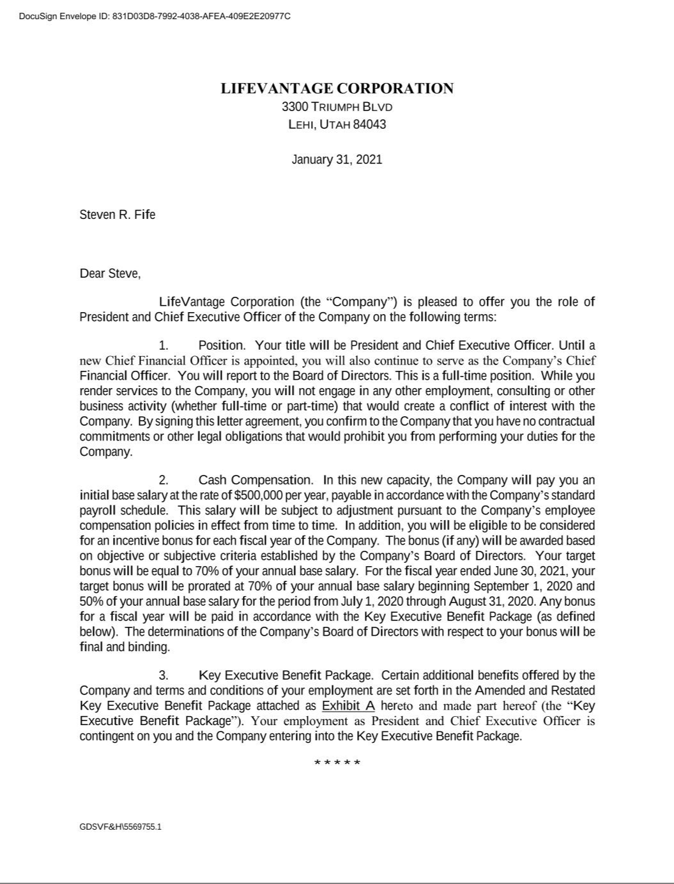

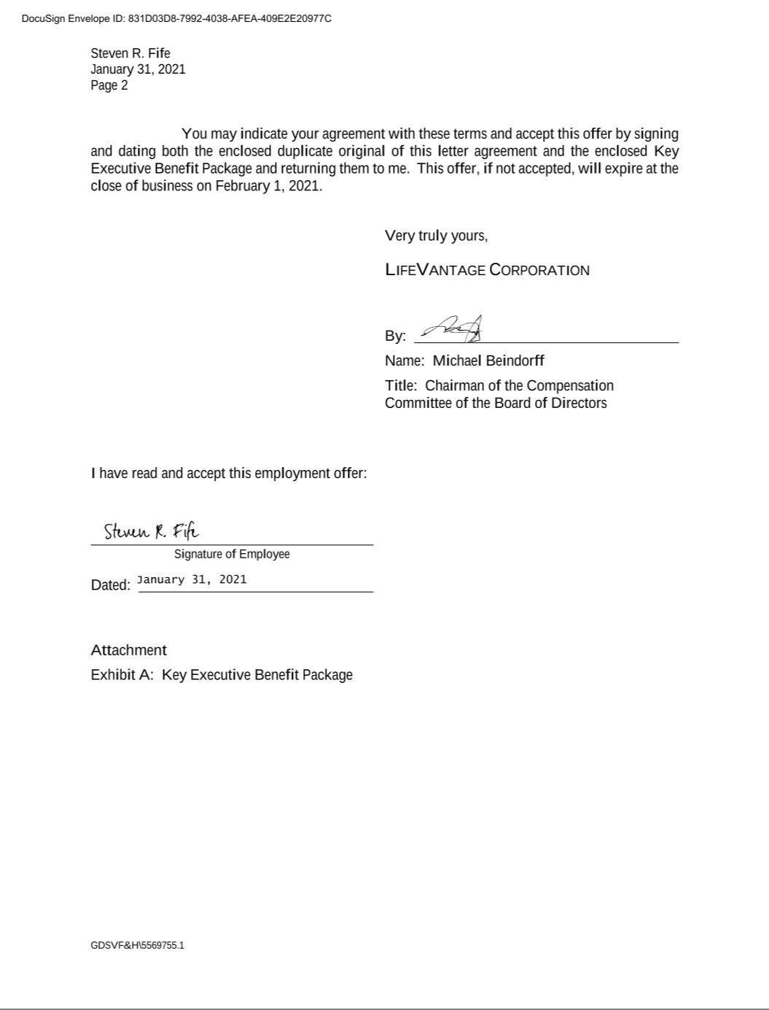

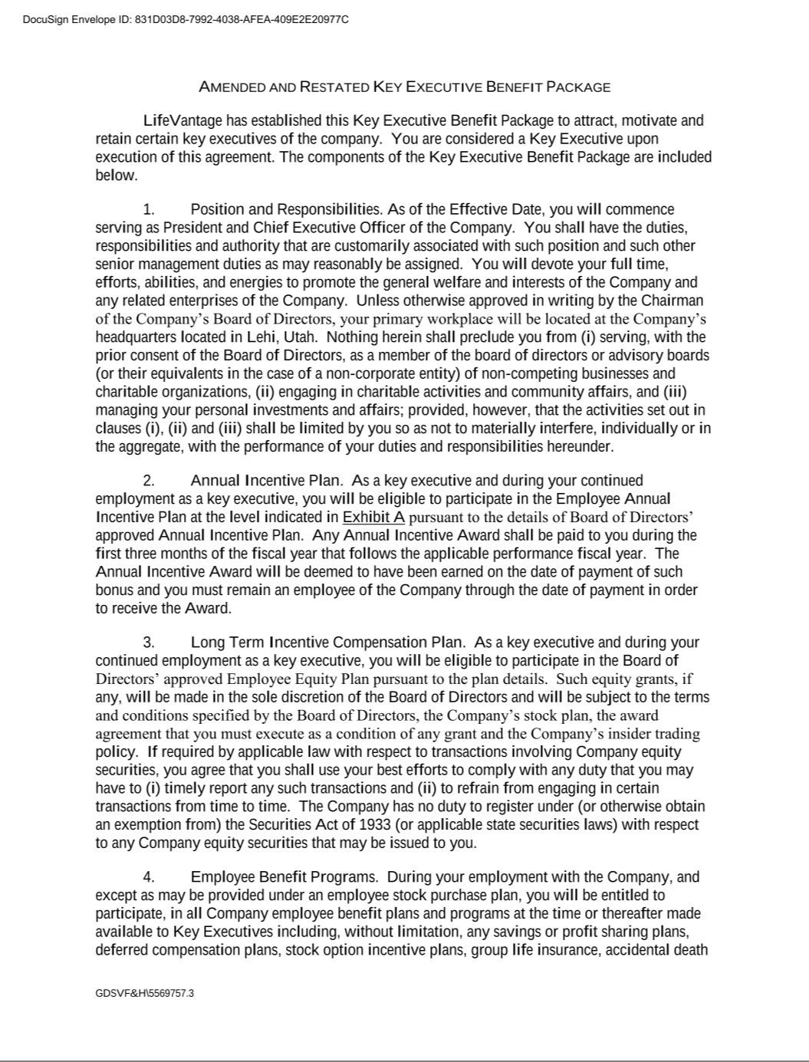

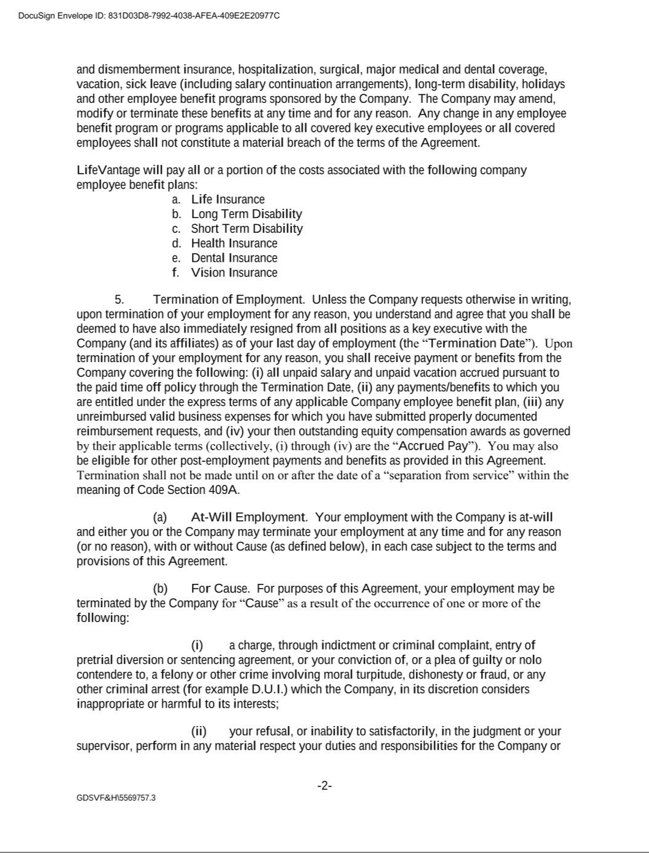

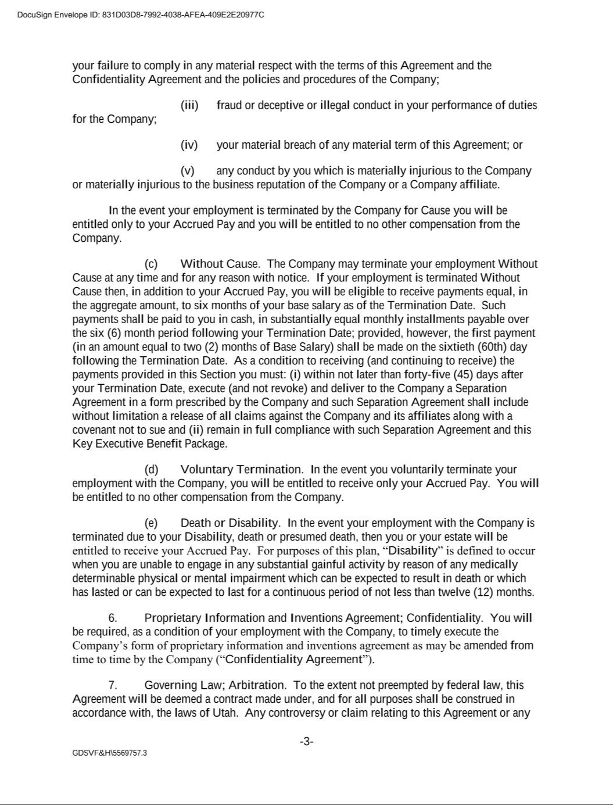

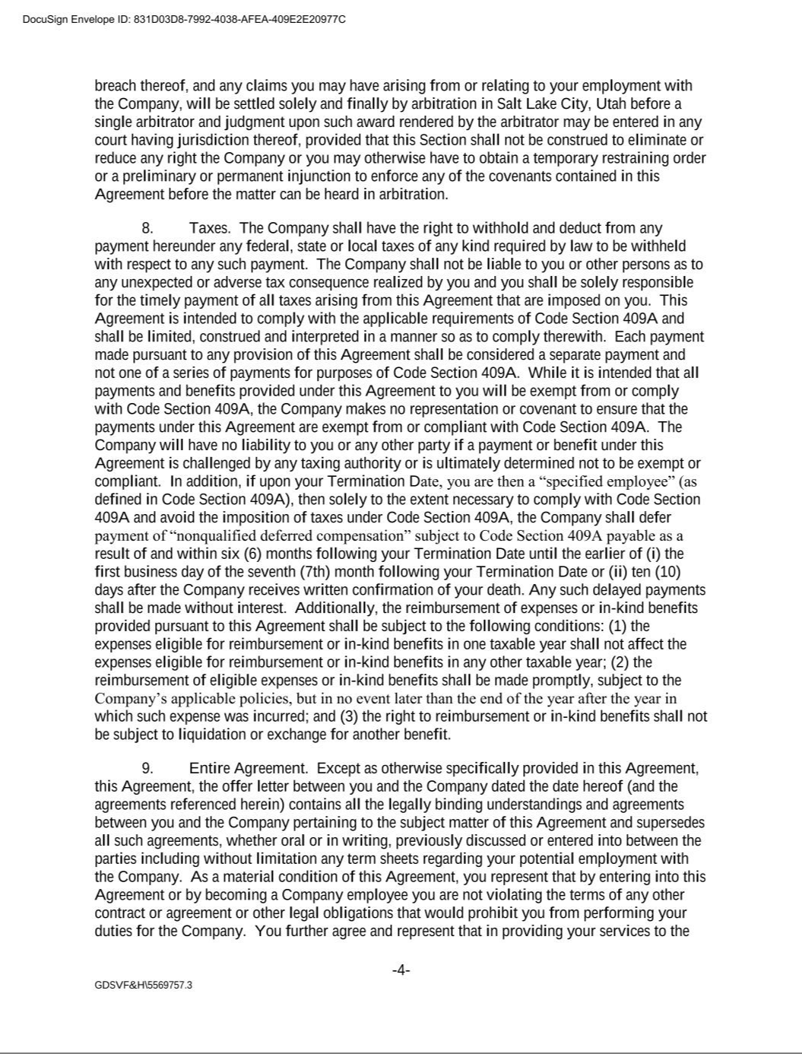

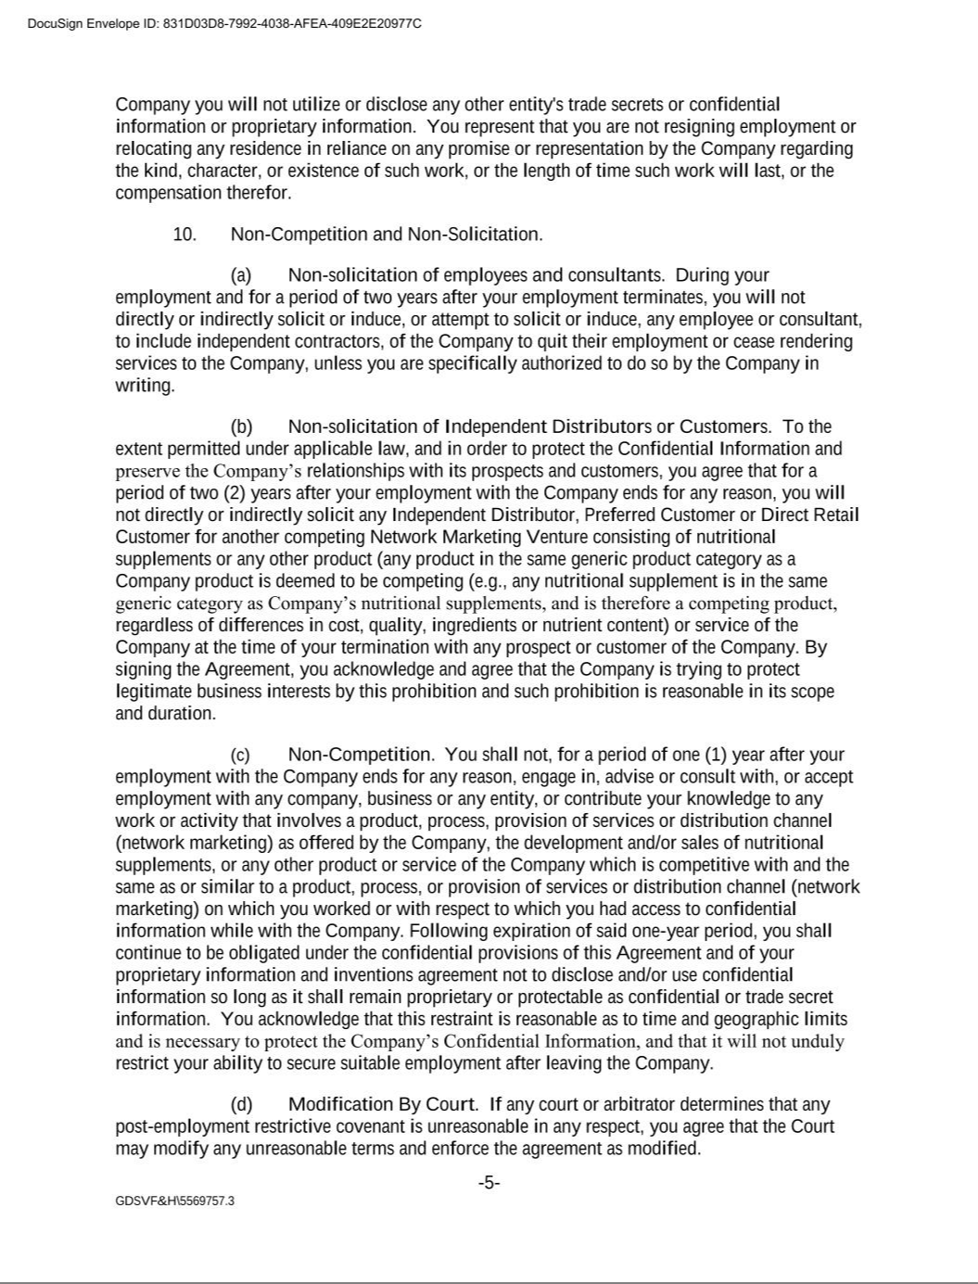

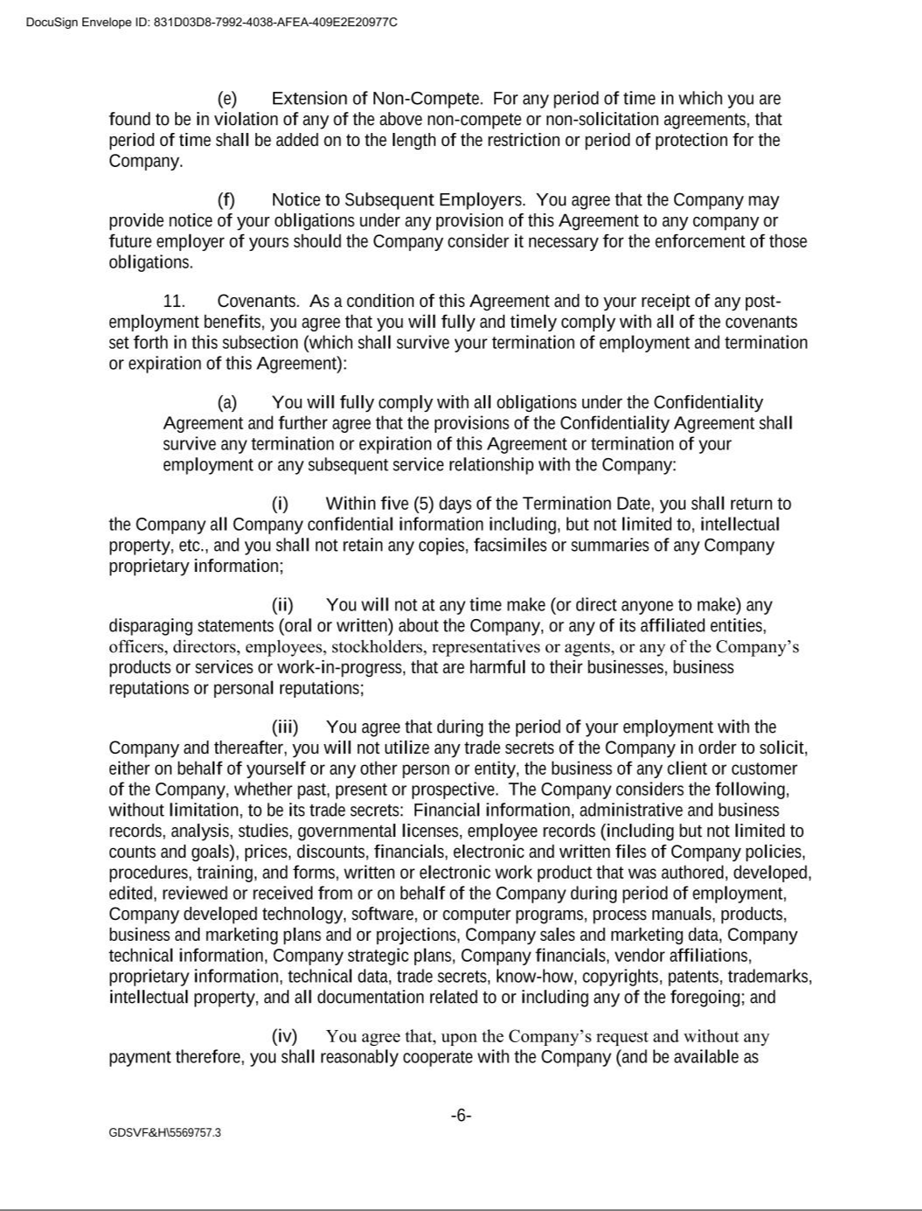

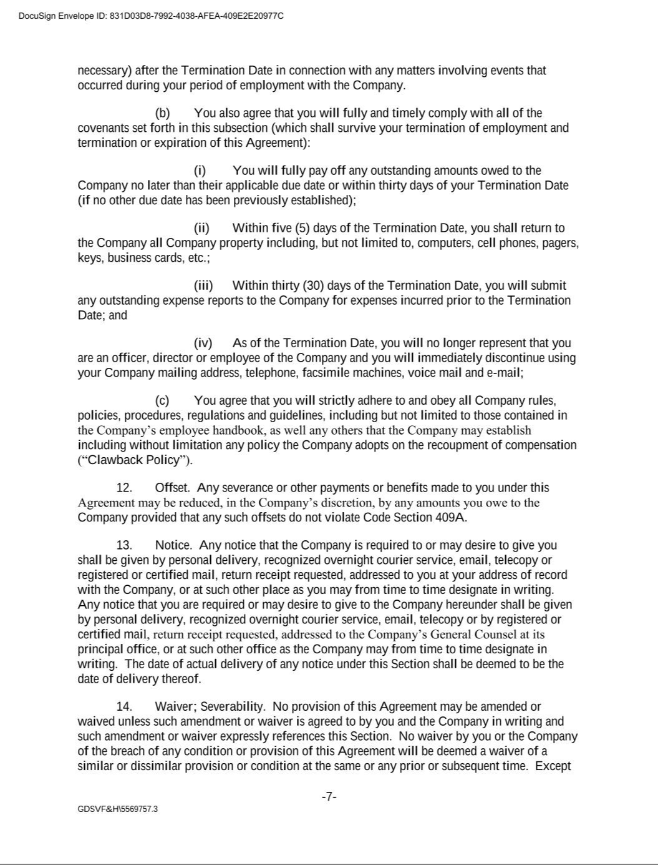

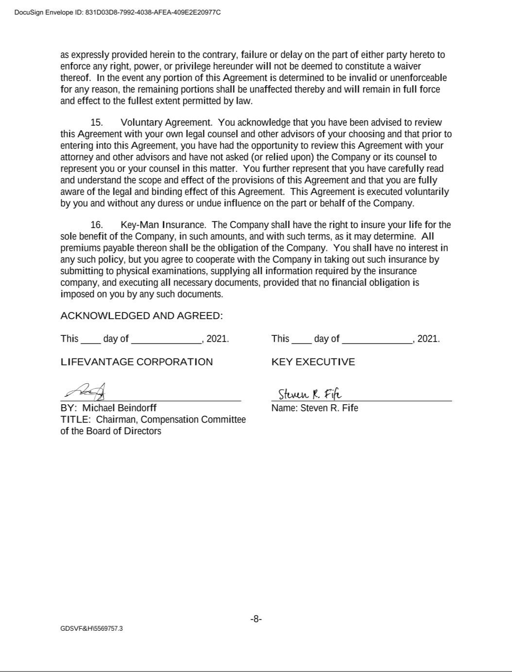

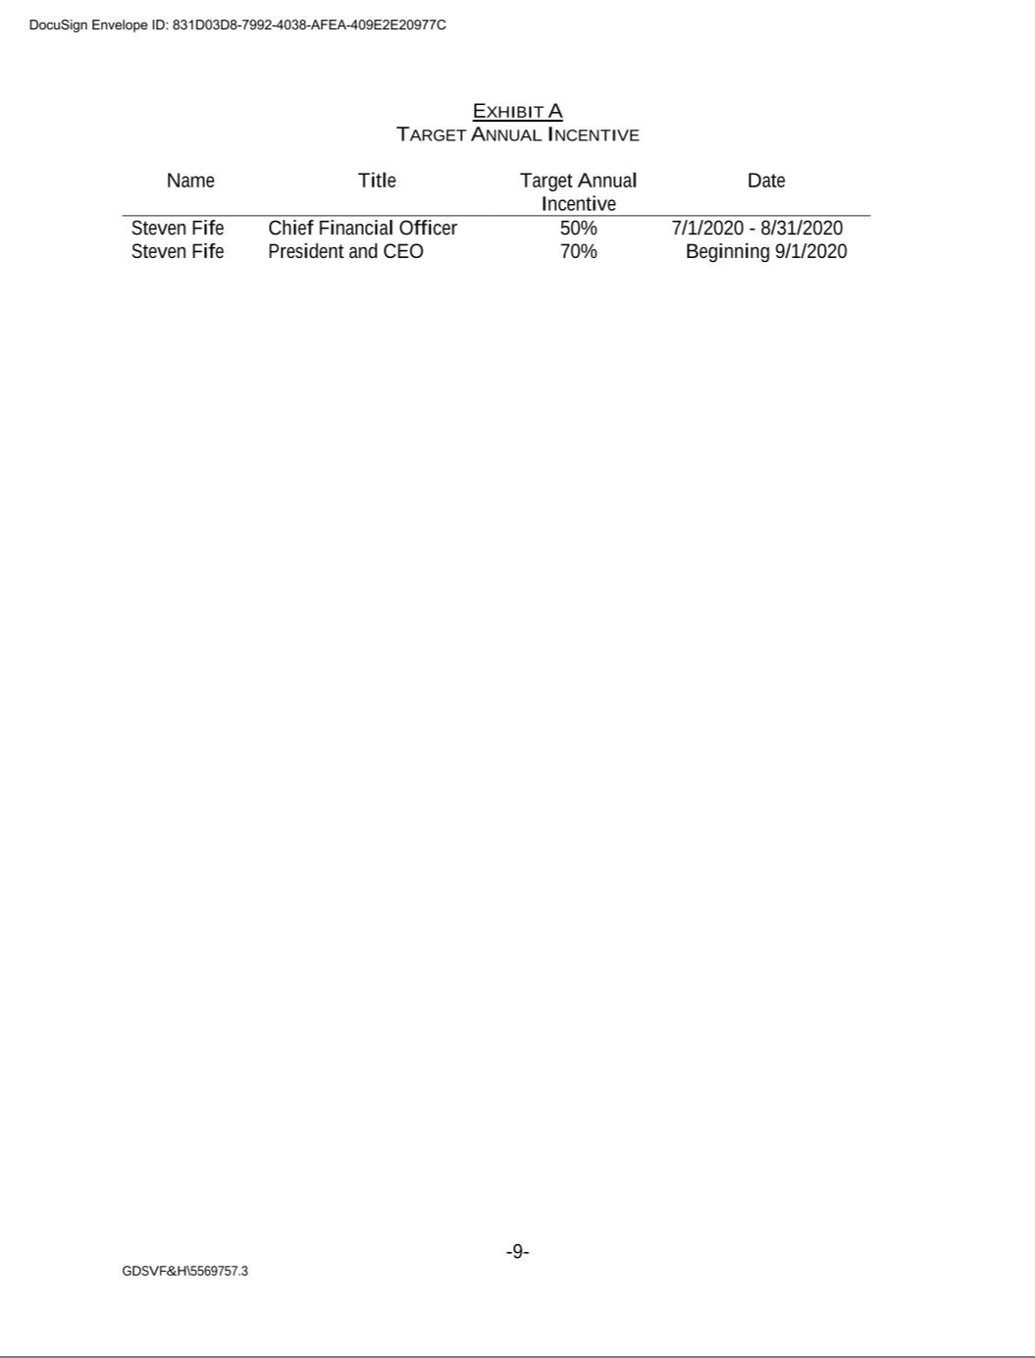

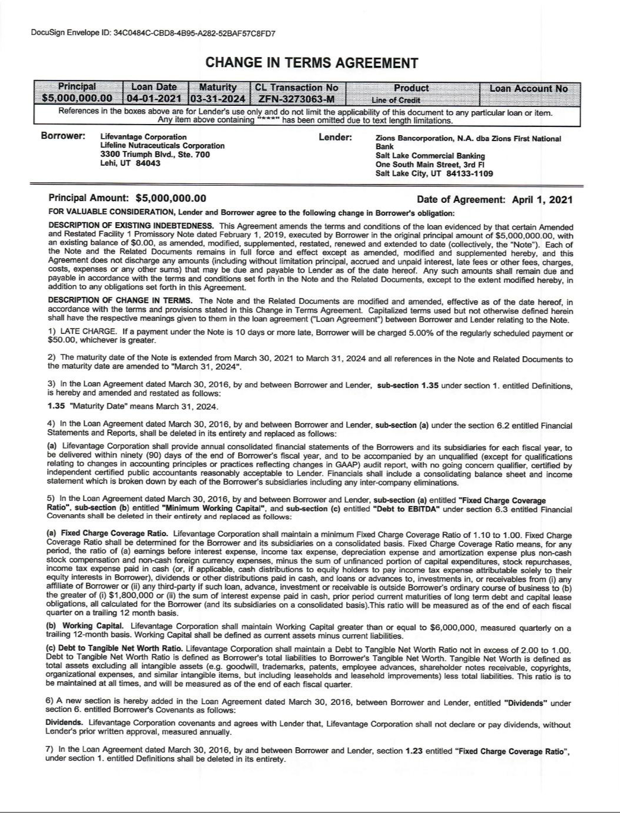

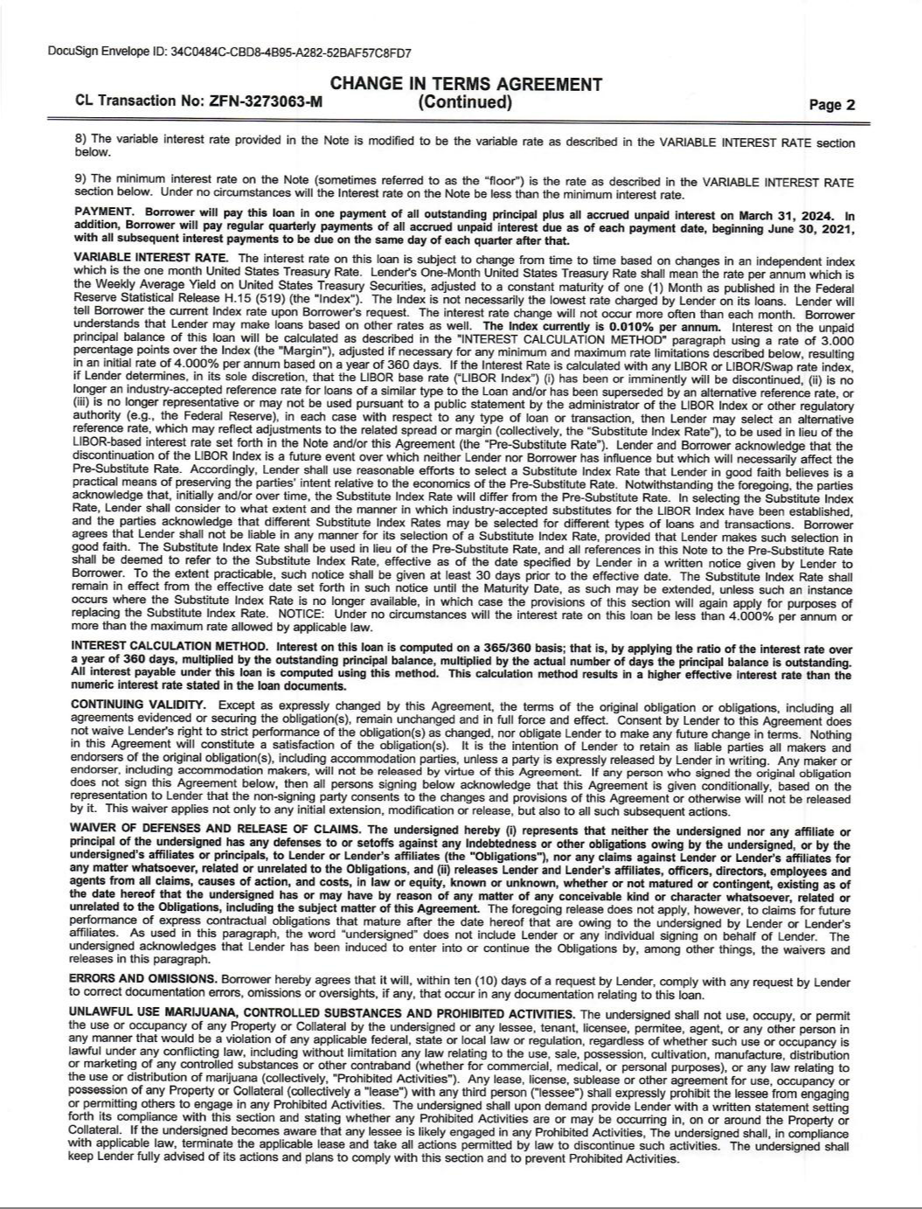

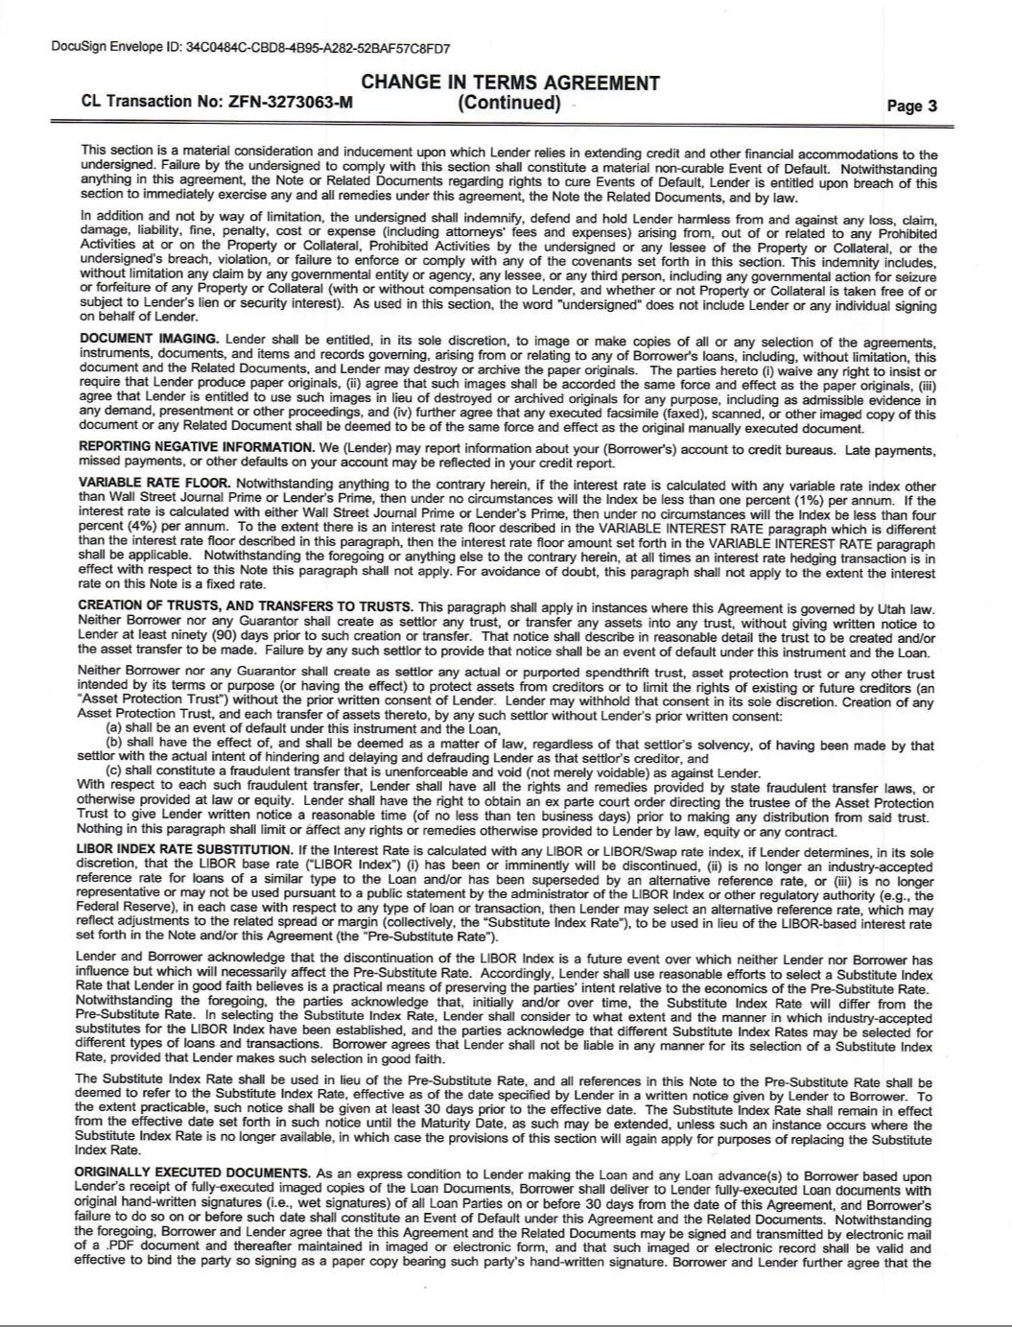

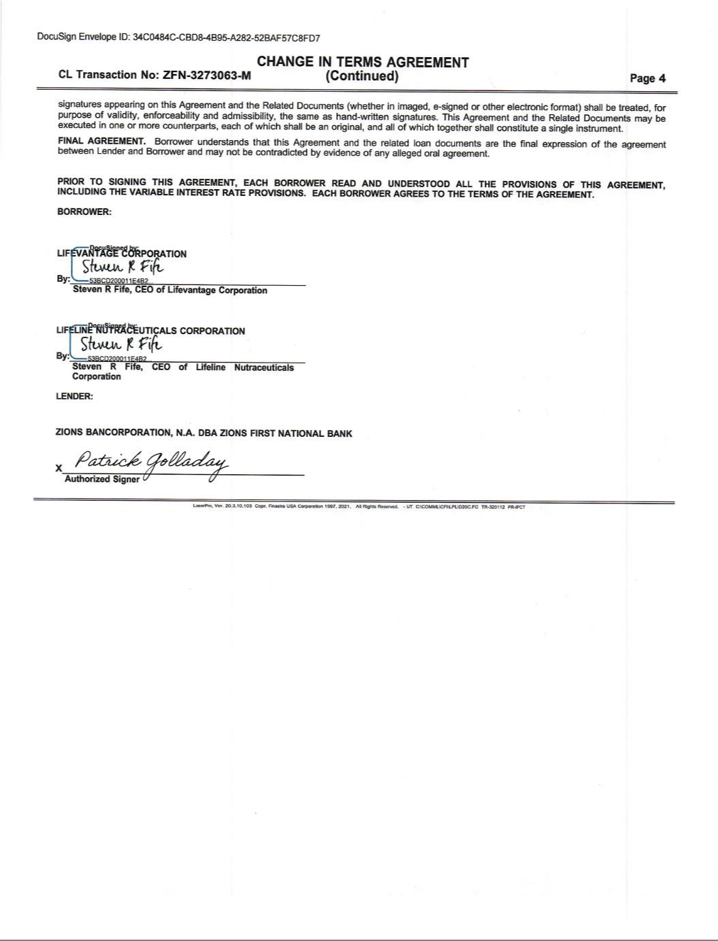

Exhibit 31.1

CERTIFICATION OF PRINCIPAL EXECUTIVE OFFICER

I, Steven R. Fife, certify that:

- I have reviewed this quarterly report on Form 10-Q of LifeVantage Corporation;

- Based on my knowledge, this report does not contain any untrue statement of a material fact or omit to state a material fact necessary to make the statements made, in light of the circumstances under which such statements were made, not misleading with respect to the period covered by this report;

- Based on my knowledge, the financial statements, and other financial information included in this report, fairly present in all material respects the financial condition, results of operations and cash flows of the registrant as of, and for, the periods presented in this report;

- The registrant’s other certifying officer and I are responsible for establishing and maintaining disclosure controls and procedures (as defined in Exchange Act Rules 13a-15(e) and 15d-15(e)) and internal control over financial reporting (as defined in Exchange Act Rules 13a-15(f) and 15d-15(f)) for the registrant and have:

  - Designed such disclosure controls and procedures, or caused such disclosure controls and procedures to be designed under our supervision, to ensure that material information relating to the registrant, including its consolidated subsidiaries, is made known to us by others within those entities, particularly during the period in which this report is being prepared;

  - Designed such internal control over financial reporting, or caused such internal control over financial reporting to be designed under our supervision, to provide reasonable assurance regarding the reliability of financial reporting and the preparation of financial statements for external purposes in accordance with generally accepted accounting principles;

  - Evaluated the effectiveness of the registrant’s disclosure controls and procedures and presented in this report our conclusions about the effectiveness of the disclosure controls and procedures, as of the end of the period covered by this report based on such evaluation; and

  - Disclosed in this report any change in the registrant’s internal control over financial reporting that occurred during the registrant’s most recent fiscal quarter (the registrant’s fourth fiscal quarter in the case of an annual report) that has materially affected, or is reasonably likely to materially affect, the registrant’s internal control over financial reporting; and

- The registrant’s other certifying officer and I have disclosed, based on our most recent evaluation of internal control over financial reporting, to the registrant’s auditors and the audit committee of the registrant’s board of directors (or persons performing the equivalent functions):

  - All significant deficiencies and material weaknesses in the design or operation of internal control over financial reporting which are reasonably likely to adversely affect the registrant’s ability to record, process, summarize and report financial information; and

  - Any fraud, whether or not material, that involves management or other employees who have a significant role in the registrant’s internal control over financial reporting.

Date: April 29, 2021

/s/ Steven R. Fife

Steven R. Fife

President and Chief Executive Officer

(Principal Executive Officer)

Exhibit 31.2

CERTIFICATION OF PRINCIPAL FINANCIAL OFFICER

I, Steven R. Fife, certify that:

- I have reviewed this quarterly report on Form 10-Q of LifeVantage Corporation;

- Based on my knowledge, this report does not contain any untrue statement of a material fact or omit to state a material fact necessary to make the statements made, in light of the circumstances under which such statements were made, not misleading with respect to the period covered by this report;

- Based on my knowledge, the financial statements, and other financial information included in this report, fairly present in all material respects the financial condition, results of operations and cash flows of the registrant as of, and for, the periods presented in this report;

- The registrant’s other certifying officer and I are responsible for establishing and maintaining disclosure controls and procedures (as defined in Exchange Act Rules 13a-15(e) and 15d-15(e)) and internal control over financial reporting (as defined in Exchange Act Rules 13a-15(f) and 15d-15(f)) for the registrant and have:

  - Designed such disclosure controls and procedures, or caused such disclosure controls and procedures to be designed under our supervision, to ensure that material information relating to the registrant, including its consolidated subsidiaries, is made known to us by others within those entities, particularly during the period in which this report is being prepared;

  - Designed such internal control over financial reporting, or caused such internal control over financial reporting to be designed under our supervision, to provide reasonable assurance regarding the reliability of financial reporting and the preparation of financial statements for external purposes in accordance with generally accepted accounting principles;

  - Evaluated the effectiveness of the registrant’s disclosure controls and procedures and presented in this report our conclusions about the effectiveness of the disclosure controls and procedures, as of the end of the period covered by this report based on such evaluation; and

  - Disclosed in this report any change in the registrant’s internal control over financial reporting that occurred during the registrant’s most recent fiscal quarter (the registrant’s fourth fiscal quarter in the case of an annual report) that has materially affected, or is reasonably likely to materially affect, the registrant’s internal control over financial reporting; and

- The registrant’s other certifying officer and I have disclosed, based on our most recent evaluation of internal control over financial reporting, to the registrant’s auditors and the audit committee of the registrant’s board of directors (or persons performing the equivalent functions):

  - All significant deficiencies and material weaknesses in the design or operation of internal control over financial reporting which are reasonably likely to adversely affect the registrant’s ability to record, process, summarize and report financial information; and

  - Any fraud, whether or not material, that involves management or other employees who have a significant role in the registrant’s internal control over financial reporting.

Date: April 29, 2021

/s/ Steven R. Fife

Steven R. Fife

Chief Financial Officer

(Principal Financial Officer)

Exhibit 32.1

CERTIFICATION PURSUANT TO 18 U.S.C. SECTION 1350, AS ADOPTED

PURSUANT TO SECTION 906 OF THE SARBANES-OXLEY ACT OF 2002

In connection with the filing of this quarterly report on Form 10-Q of LifeVantage Corporation (the “Company”) for the period ended March 31, 2021, with the Securities and Exchange Commission on the date hereof (the “report”), I, Steven R. Fife, Principal Executive Officer of the Company, certify, pursuant to 18 U.S.C. Section 1350, as adopted pursuant to Section 906 of the Sarbanes-Oxley Act of 2002, that:

- The report fully complies with the requirements of section 13(a) or 15(d) of the Securities Exchange Act of 1934; and

- The information contained in the report fairly presents, in all material respects, the financial condition and results of operations of the Company.

The foregoing certification is being furnished solely pursuant to 18 U.S.C. § 1350 and is not being filed as part of the report or as a separate disclosure document.

Date: April 29, 2021

/s/ Steven R. Fife

Steven R. Fife

President and Chief Executive Officer

(Principal Executive Officer)

A signed original of this written statement required by Section 906 has been provided to the Company and will be retained by the Company and furnished to the Securities and Exchange Commission or its staff upon request.

Exhibit 32.2

CERTIFICATION PURSUANT TO 18 U.S.C. SECTION 1350, AS ADOPTED

PURSUANT TO SECTION 906 OF THE SARBANES-OXLEY ACT OF 2002

In connection with the filing of this quarterly report on Form 10-Q of LifeVantage Corporation (the “Company”) for the period ended March 31, 2021, with the Securities and Exchange Commission on the date hereof (the “report”), I, Steven R. Fife, Principal Financial Officer of the Company, certify, pursuant to 18 U.S.C. Section 1350, as adopted pursuant to Section 906 of the Sarbanes-Oxley Act of 2002, that:

- The report fully complies with the requirements of section 13(a) or 15(d) of the Securities Exchange Act of 1934; and

- The information contained in the report fairly presents, in all material respects, the financial condition and results of operations of the Company.

The foregoing certification is being furnished solely pursuant to 18 U.S.C. § 1350 and is not being filed as part of the report or as a separate disclosure document.

Date: April 29, 2021

/s/ Steven R. Fife

Steven R. Fife

Chief Financial Officer

(Principal Financial Officer)

A signed original of this written statement required by Section 906 has been provided to the Company and will be retained by the Company and furnished to the Securities and Exchange Commission or its staff upon request.

